## Path Finding and Mapping Autonomous Ground Vehicle

*Developed by:* Hung Do (M.S.C.S)

Khiem Huynh (B.S.E.E)

Dr. Gene Hou (Department of Mechanical Engineer)

## Abstract- Will be added

## 

## 

## 

## 

## 

## 

## 

## 

## 

## 

## 

## 

## 

## 

## 

## 

## Table of Contents

1. Software requirements

1.1 CodeBlocks Installation

1.2 MinGW Installation

1.3 Arduino Libraries

2. Programs

3. Chess box design

4. Algorithms

4.1 Data Flow

4.2 First step (finding path)

4.3 Second step (Shortest path)

5. Coding explanation

5.1 Coding for the car (client)

5.2 Coding for computer (server)

6. Tasks Given

List of Tables:

1. Car Commands

List of Figures:

1. MinGW requirements

2. Overall Data Flow

3. Computer Data Flow

4. Arduino Data Flow

5. Chessboard design

6. First Trial Algorithms

7. Dijkstra's algorithm

References

1. Animation

# 

# 

# 1. Software requirements

## 1.1 CodeBlocks installation

Please visit the website below to install CodeBlocks. This software is highly recommended to use in this project.

Website: <http://www.codeblocks.org/downloads/26>

## 1.2 MinGW installation

MinGW is required when installing Codeblocks. The following link below is an address to download MinGW

Website:<https://sourceforge.net/projects/mingw/files/Installer/>

During the installation of MinGW please revise figure 1 given below to install MinGW correctly.

*Note:* Select options as the screenshot below:

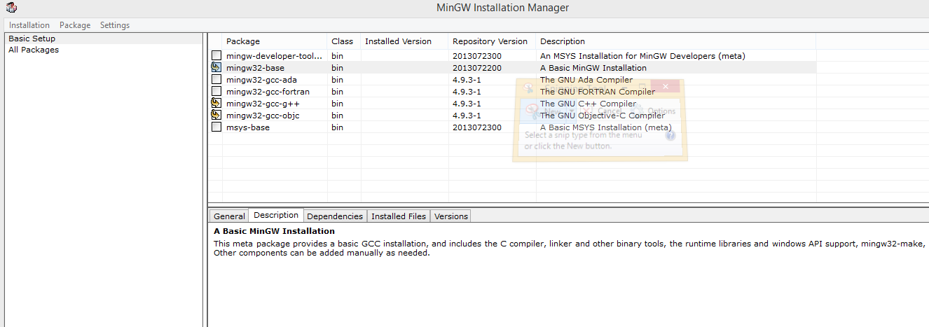

Figure 1: MinGW requirements

## 1.3 Arduino libraries

**NewPing:** This library gives the capability of using ultrasonic sensors.

**AccelStepper**, **AFMotor**: These libraries grant the accessibility to several functions which allow controlling stepper motors

These libraries are available on the internet. They can be easily found on Google, or Github.

*Note:* Github is highly recommended

# 2. Programs

* An example program is given in order to manually control the robot for testing purposes(Car-Control-Manually)
* An example for the first two tasks is available through Blackboard(Lucky-2Steps-2)
* Watch a demo on this video: <https://youtu.be/x5VYHYvMxWk>

# 3. Chess box design

This project will be accomplished by denoting the mapping area into a chessboard map. This chessboard map is used to identifying and locating the position and direction of the robot. The length and dimension of the chessboard can be preset which give the power to cover a specific area.

# 

Figure 2: Chessboard design

# 4. Algorithms

## 4.1 Data Flow

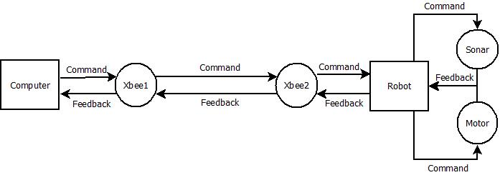

Figure 2: Overall Data Flow

The figure shown above explains how the data interacts between the computer and the Arduino using Xbee. First the computer will send a command to Xbee1, which is connected to the computer. Then, the Xbee1 will pass the command to Xbee2, which is connected to the Arduino. After receiving the command from Xbee1, Xbee2 will denote the information to Arduino language in order to operate the command. The denoted command then will be sent to either sonar or the motor. After completing the task, the sonar or motor will send a feedback signal back to the Arduino to notify the completion.The feedback will be sent to Xbee2, then Xbee1 and finally back to the computer to update the status

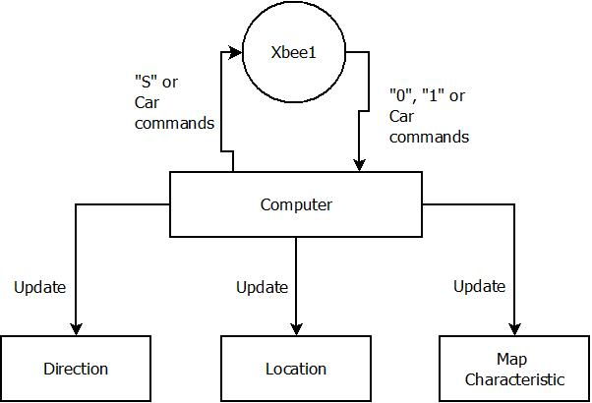

Figure 3: Computer Data Flow

Figure 3 shown above informs the data flow on the computer side. The computer will first order the commands to Xbee1. And, after receiving the feedback from the Xbee1. The data will be updated into three categories, such as Direction, Location, and Map characteristic.

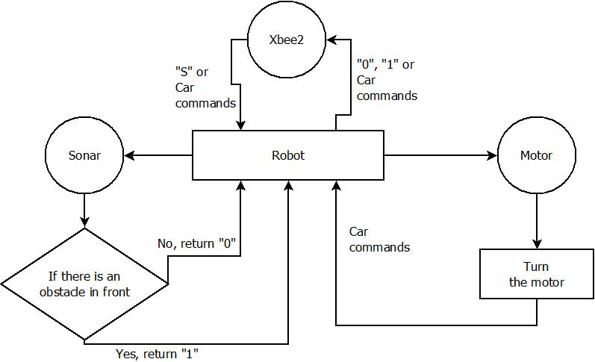

Figure 4: Arduino Data Flow

In figure 4, Xbee2 acts as an intermediate which communicates between Arduino and a computer wirelessly. The commands order from the computer will be denoted to Arduino language.

When receiving an "S", Arduino will get sensor value from sonar sensors to determine the availability of the front box. The sonar will send a feedback of “1” to the Arduino when there is an obstacle in front. And, “0” when there is not.

When receiving car commands, Arduino will order the motor to turn the robot according to the table shown below.

|  |  |
| --- | --- |
| **Car commands** | **Action** |
| “L” | Turn left |
| “R” | Turn right |
| “F” | Go Forward |
| “B” | Turn around |
| Integer | Go forward according to the integer |

Table 1: Car Commands

## 4.1 First Trial(finding path)

Will be added

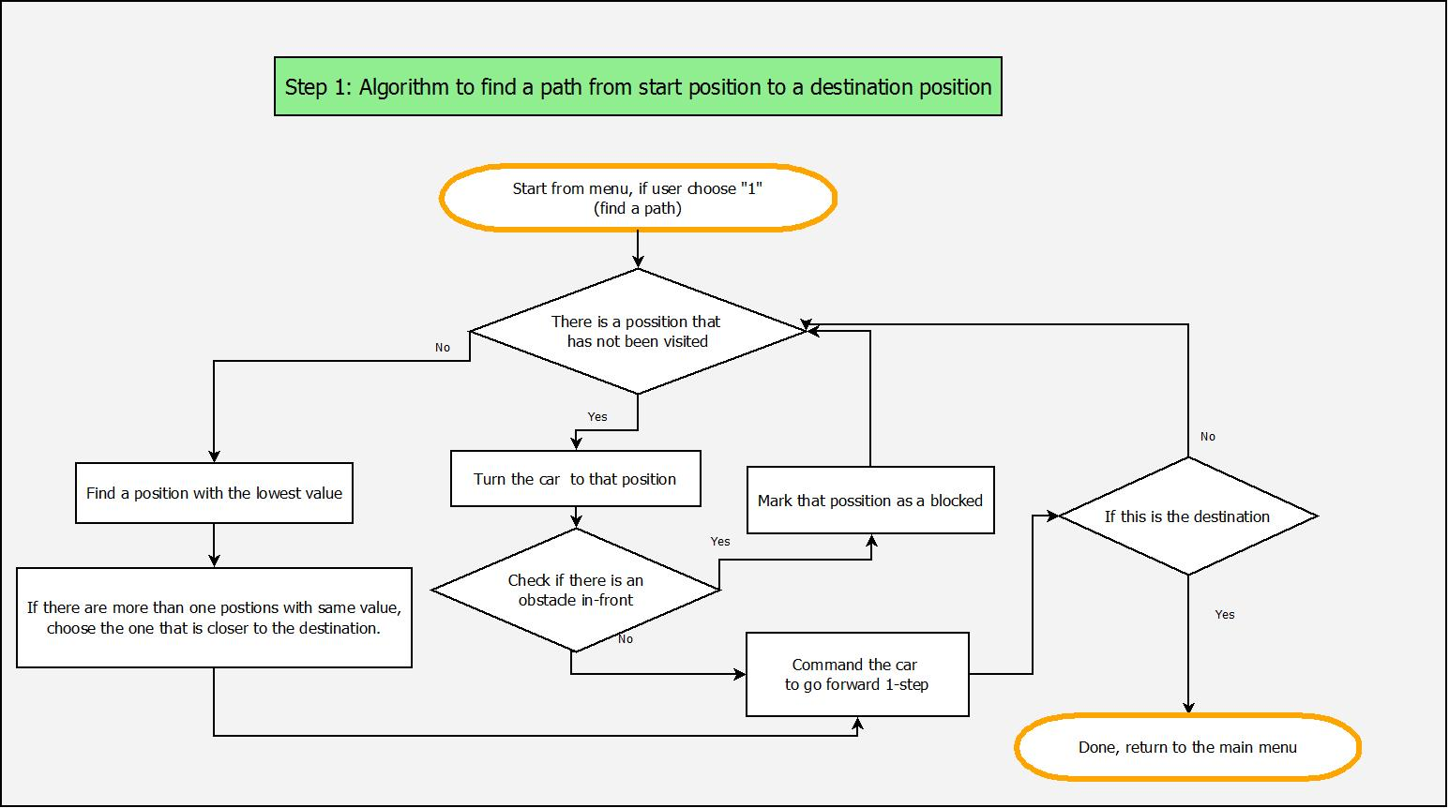

Figure 3: First Trial algorithms

## 4.2 Second Trial(Shortest path)

In this Trial, Dijkstra's algorithm is applied to determine to the shortest path from point to point. The collected data from the first trial will be used to calculate the shortest path from starting point to the destination.

*Reminder:* The route that the second trial takes might be the same as the first trial. The difference is the travel time will be shorter since there is no decision making.

*Note:* This document will not discuss about Dijkstra’s algorithm. For further explanation of Dijkstra’s algorithm, please visit Wikipedia or any other website.

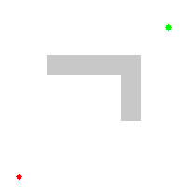

Figure 4: Dijkstra's algorithm illustration

# 5. Coding explanation

## 5.1 Coding in the robot (client)

## Will be added

## 5.2 Coding in computer (server)

Two parts:

* First trial: how to find a path from point to point
* Second trial: Based upon information collected from the first trial, find the shortest path from the starting point to the destination.

Server: main.cpp, runningcar.cpp, runningcar.h, Serial.cpp, Serial.h

**Main.cpp** has four functions:

main()

**void** step1_getmapinfo(Position CurrPosCar)

**void** step2_shortpath()

**char** Command_Sensor(char *ch)

**void** Command_Data (char *ch, int sleeptime)

**Runningcar.h** stores abstracts of functions and variables as follow:

//Reset data

**void** dataInitialize();

//Check the Final Destination.

**bool** checkFinishPos (Position v_Pos);

//Check the availability of the front box.

**bool** checkBlockPosition(Position v_Pos);

//Check chessboard boundary conditions.

**bool** checkBoundary(Position v_Pos);

//Mark the unavailable box.

**void** blockPosition(Position v_Pos);

//Set the status of current position as visited

**void** setVisit (Position *v_Pos);

//Print current map status

**void** PrintBoard();

//Get a shortest path based on Dijkstra's algorithm

**void** GetShortestPath();

//Get steps that the car can travel in one command

**int** GetNumberOfSteps (**int** v_travelPos);

//Determine the next step and direction using the current direction and position

**char** get_next_direction (**int** v_pos, **char** v_dir);

//Go forward

**void** GoForward(Position *v_currPos);

//Calculate the distance from current position to the destination

**int** CalDistance(Position v_Pos,Position v_FinishPos);

//Check the availability of nearby boxes.

**char** GetPosNotChecked(Position v_currPos);

//Translate a near-by box to position

//For example: a left position of current position (3,4,N) is (2,4)

Position getPos(Position v_Pos,**char** v_side);

//Check the min value (number of visits) of near-by positions

**char** GetMinValue (Position v_currPos);

//Turn the car to the Left ‘L’, Right ‘R’, or Turn Around ‘B’

**void** TurnTheCar(Position *v_currPos, **char** v_turn);

//Check if there is an obstacle in-front: sensor data (1) is blocked, (0) is free to go

**bool** checkBall(Position v_currPos, **char** v_sensor_data);

//A function in second step which displays the results

**void** setCurrentTravel(Position *v_currentPos,**int** i);

**Runningcar.cpp** stores functions content.

Please have some further reading into the content of each function.

# 6. Tasks Given

* Calculate total time for the shortest path run and print out the result.
* Make adjustments to make the robot move faster(Explain how).
* Be able to manipulate the size of the chessboard, and the starting and finish point of the project.
* Change distance of each step (Explain how).

References

1. Animation from <https://en.wikipedia.org/wiki/Dijkstra%27s_algorithm>