
RMIT International University Vietnam
Assignment Cover Page (INDIVIDUAL)
Course Code: | ECON1612|ECON1613
Course Name: | Big Data, Machine Learning and Society
Location (Campus): | SGS
Assignment Number: | Assignment 3
Title of Assignment: | Responsible Credit Risk Modelling for VietFin
Student Number: | S4056217
Student Name: | Vo Phan Vuong Hung
Lecturer’s Name: | Dr. Deepak Behera
Due Date: | Friday, 16th January 2025
Date of Submission: | Friday, 16th January 2025
Number of pages including this one: | 15
Word Count: | 1649 words

Table of Contents
Q1: Executive Summary 4
Key Findings: 4
Recommendations: 4
Q2: Introduction 5
1. Business Context: 5
2. Societal Significance: 5
3. Role of Data Science: 5
Q3: Data Analysis and Preprocessing 5
1. Dataset Overview: 5
2. Class Imbalance: 6
3. Portfolio Dashboard: 7
4. Exploratory Analysis: 8
5. Preprocessing Pipeline: 9
Q4: Model Development and Evaluation 9
1. Model Selection Rationale: 9
2. Overfitting Mitigation Strategies: 9
3. Performance Comparison: 9
4. Confusion Matrix Business Analysis: 10
5. Fairness Audit: 11
Q5: Key Findings and Feature Importance 12
1. Top Risk Drivers: 12
2. Business Interpretation: 13
Q6: Recommendations 13
1. Recommendation 1: Risk-Tiered Manual Review Policy 13
2. Recommendation 2: Segmented Underwriting Requirements 14
3. Implementation and Monitoring Considerations: 14
Appendix: 15

Q1: Executive Summary
This report presents a credit risk prediction model developed for VietFin, a Vietnamese digital micro-lending platform serving underbanked consumers. The objective is to identify borrowers likely to default within 90 days, enabling proactive risk management while maintaining financial inclusion objectives. Using a dataset of 6,000 loan applications with 35 features, I developed and rigorously compared two machine learning models: Logistic Regression and Random Forest.

Key Findings:
- The portfolio exhibits a 10.88% default rate, indicating moderate but manageable credit risk.
- Random Forest significantly outperforms Logistic Regression with ROC-AUC of 0.925 and higher precision (47% vs 39%). Its superior ability to rank-order risk makes it highly effective for the manual review policy, capturing most defaults in the highest-risk buckets.
- Top risk predictors include savings_balance_vnd, monthly_income_vnd, and loan_to_income_ratio.
- Fairness auditing revealed no significant demographic bias between urban and rural customer segments.
Recommendations:
I propose implementing a risk-tiered manual review policy targeting the top 10% highest-risk applications. Using the assignment-standard loss-given-default of 65%, a review cost of 45,000 VND per application, and a review effectiveness of 30%, this policy projects a net benefit of approximately 62.0 million VND with an 1148.0% return on investment. Additionally, I recommend segmented underwriting requiring enhanced income verification for high-risk applications. These measures balance risk mitigation with VietFin's financial inclusion mission.

Q2: Introduction

1. Business Context:
VietFin operates as a digital micro-lending platform serving Vietnamese consumers, many of whom lack access to traditional banking services due to insufficient credit history or documentation. As a fintech company operating in an emerging market, VietFin faces the dual challenge of expanding financial inclusion to underserved populations while simultaneously managing credit risk in a relatively untested customer base. The platform processes thousands of loan applications monthly, ranging from small personal loans to larger consumer financing products, requiring scalable, data-driven decision-making to remain competitive while maintaining financial sustainability.

2. Societal Significance:
Responsible lending in emerging markets carries profound societal implications that extend beyond individual transactions. Over-aggressive lending practices can trap vulnerable borrowers into destructive debt cycles, leading to financial distress, asset loss, and reduced economic mobility. VietFin's credit scoring system must carefully balance these competing concerns, promoting genuine financial empowerment without exposing borrowers to unmanageable debt obligations that undermine their financial wellbeing.

3. Role of Data Science:
The Data Science department serves as VietFin's risk intelligence hub, transforming raw application data into actionable credit insights that inform lending decisions. Developing predictive models that accurately identify default risk enables automated decisioning for efficient high-volume application processing, supports risk-based pricing tailored to borrower profiles, strengthens portfolio monitoring through early warning indicators, and ensures fairness auditing to detect and mitigate algorithmic bias. This project develops a 90-day default prediction model using 35 features across borrower demographics, credit history, and digital behavior to identify high-risk applications for enhanced review.

Q3: Data Analysis and Preprocessing

1. Dataset Overview:
I analyzed 6,000 applications (based on student ID rules) with 35 features. Systematic quality checks revealed several issues:
Missing Values: Seven columns required imputation, income_verification had the highest missing rate (33.27%), followed by `mobile_data_usage_gb` (7.67%), and education-level/income clusters (4.08-5.60%). These patterns likely reflect data collection gaps rather than systematic bias.
Outliers and Integrity: Placeholders (999) in past_due_days_12m and transaction_count_30d were converted to missing values for imputation. No duplicate application_id entries were detected.
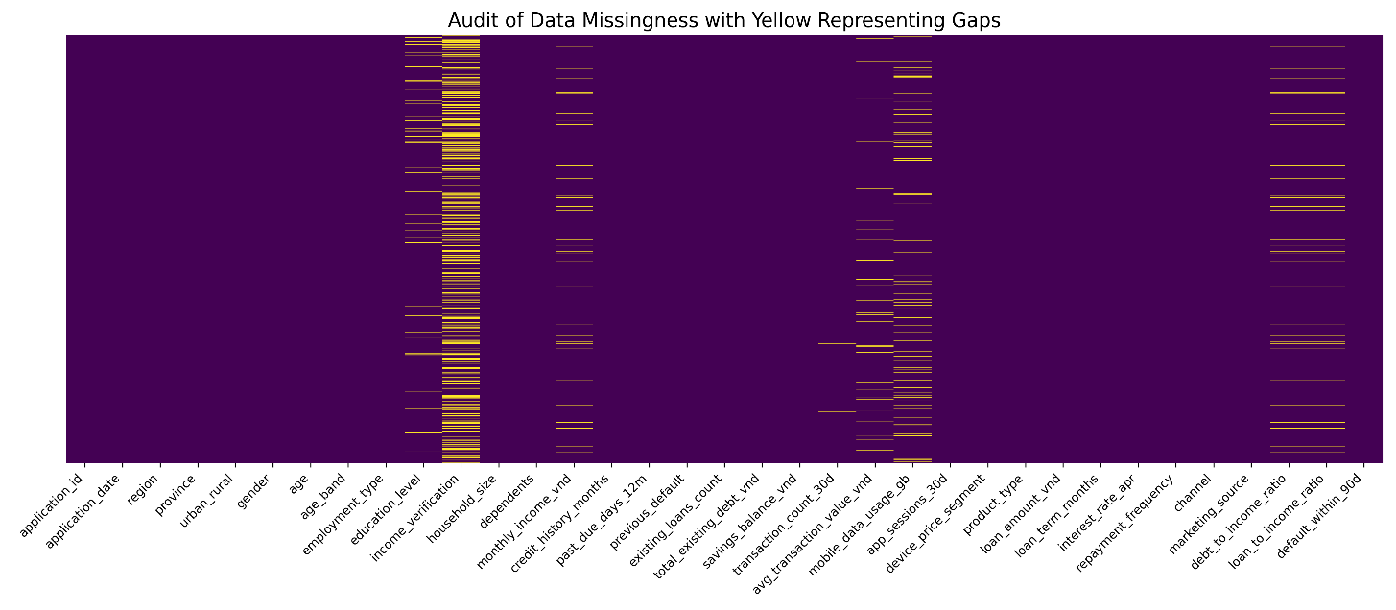
Figure1: Data missingness visualization showing patterns across features.

2. Class Imbalance:
The target variable exhibits significant imbalance: 89.1% non-default (class 0) versus 10.9% default (class 1). This substantial imbalance, common in credit risk datasets, necessitates specialized handling through balanced class weights during model training and appropriate evaluation metrics (Precision-Recall AUC, F1-score) rather than simple accuracy, which would be misleadingly high.
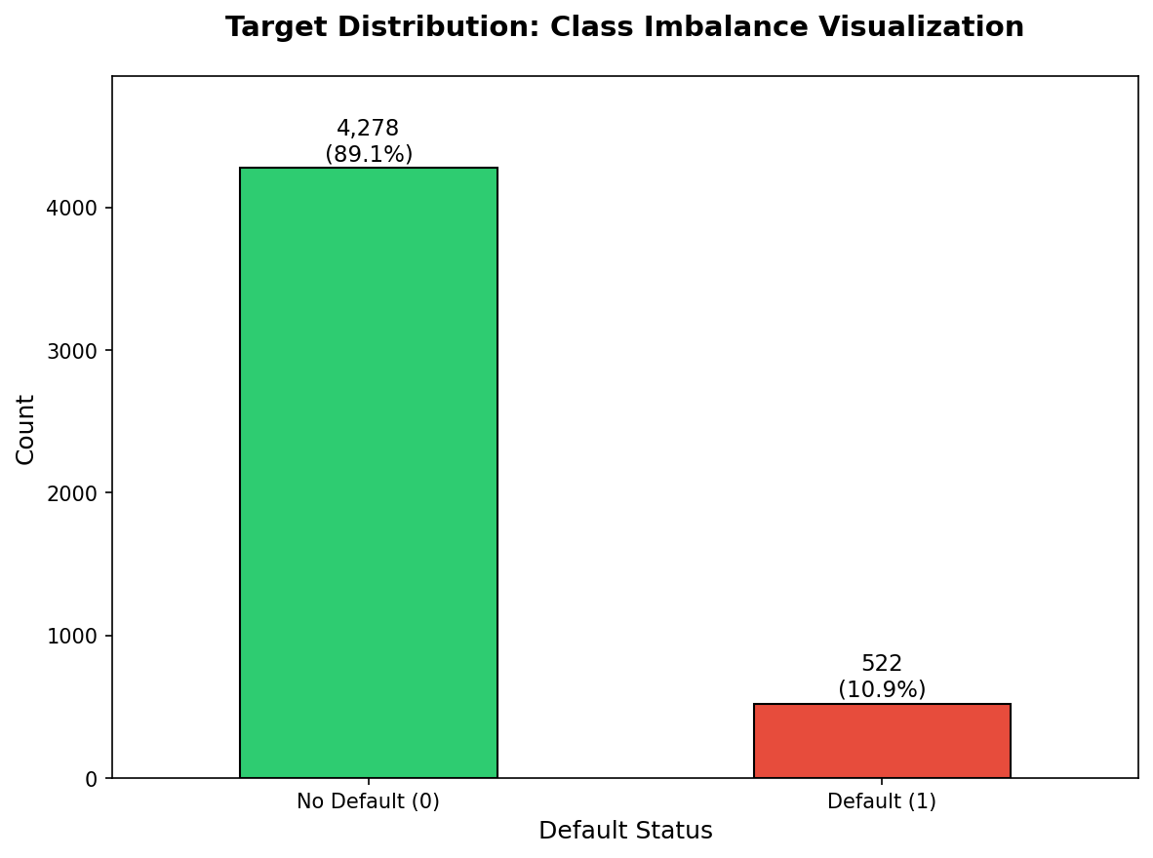
Figure2: Target class distribution showing significant imbalance (89.1% non-default vs 10.9% default)

3. Portfolio Dashboard:
Metric | Value
Overall Default Rate | 10.88%
Average Loan Amount | 7,096,797 VND
Median Loan Amount | 5,590,500 VND
Median Debt-to-Income Ratio | 0.128
Average Credit History | 48.9 months
Table1: Portfolio risk dashboard KPIs
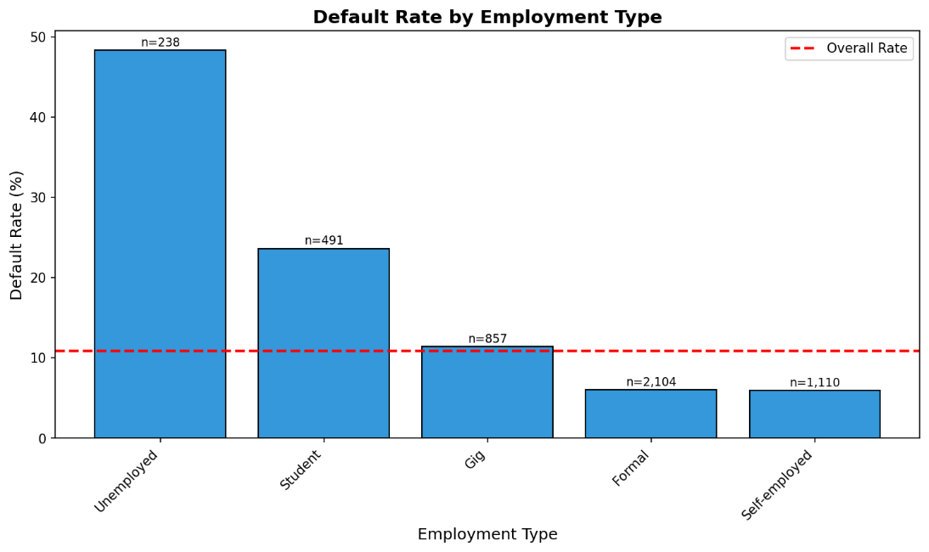
Figure3: Default rates segmented by employment type revealing risk variations.

4. Exploratory Analysis:
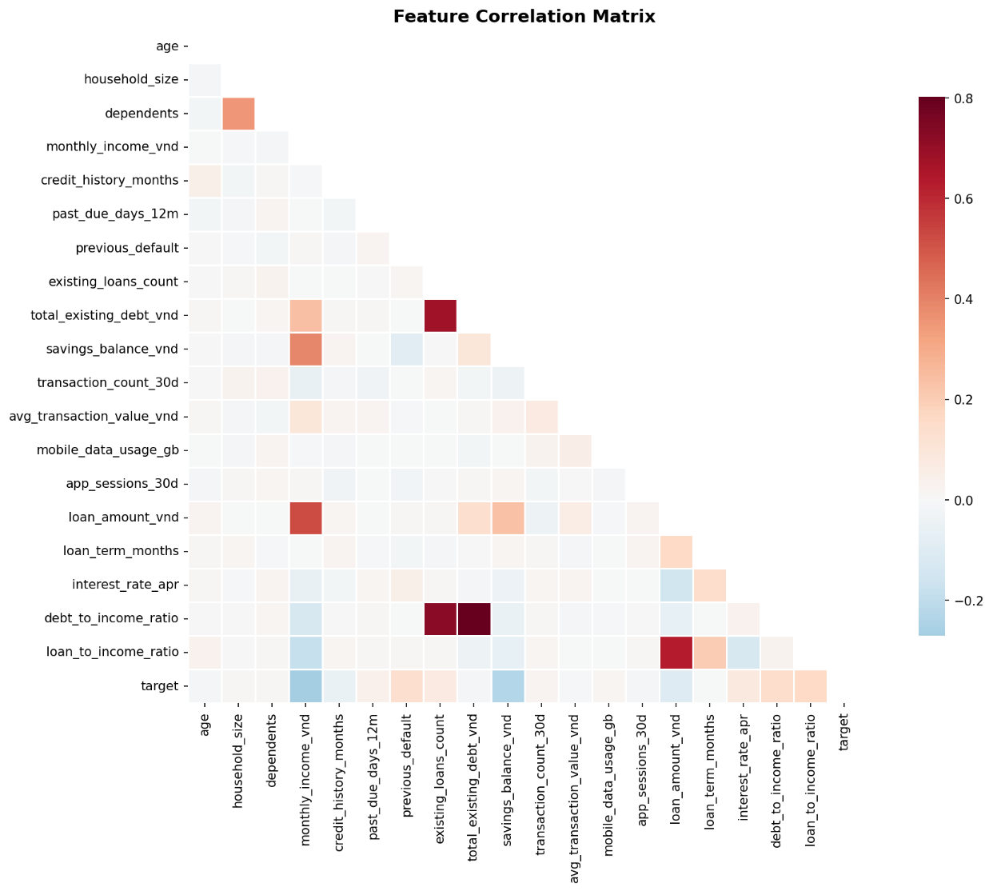
Figure4: Feature correlation matrix revealing multicollinearity patterns among predictors.
Segmented default rate analysis shows clear patterns: employment type strongly influences risk, with some categories above average; income verification status correlates with default probability, as unverified applications carry higher risk; and the loan-to-income ratio provides a powerful signal for spotting overextended borrowers.

5. Preprocessing Pipeline:
To prevent data leakage compromising model validity, train-test splitting (80/20, stratified by target) preceded all feature transformations. The preprocessing pipeline applies:
- Numeric features: Median imputation followed by standard scaling for algorithm stability.
- Categorical features: Mode imputation followed by one-hot encoding.
- Excluded from modeling: gender (sensitive attribute), urban_rural (retained solely for fairness auditing)

Q4: Model Development and Evaluation

1. Model Selection Rationale:
We compared two classification algorithms: Logistic Regression (selected for interpretability and L2 regularization) and Random Forest (chosen to capture non-linear interactions). Both models utilize scikit-learn pipelines ensuring preprocessing consistency between training and inference phases.

2. Overfitting Mitigation Strategies:
Multiple complementary strategies address overfitting risk:
- Stratified train-test split maintains representative class distribution in both sets.
- Balanced class weights prevent models from simply predicting the majority class.
- Random Forest hyperparameters explicitly constrain tree complexity.
- Held-out test set (unseen during training) provides unbiased performance estimates.
- Cross-validation during development confirmed stable performance across folds.

3. Performance Comparison:
Model | ROC-AUC | PR-AUC | F1 | Precision | Recall
Logistic Regression | 0.939 | 0.667 | 0.550 | 0.390 | 0.939
Random Forest | 0.925 | 0.567 | 0.573 | 0.468 | 0.739
Table2: Model performance comparison
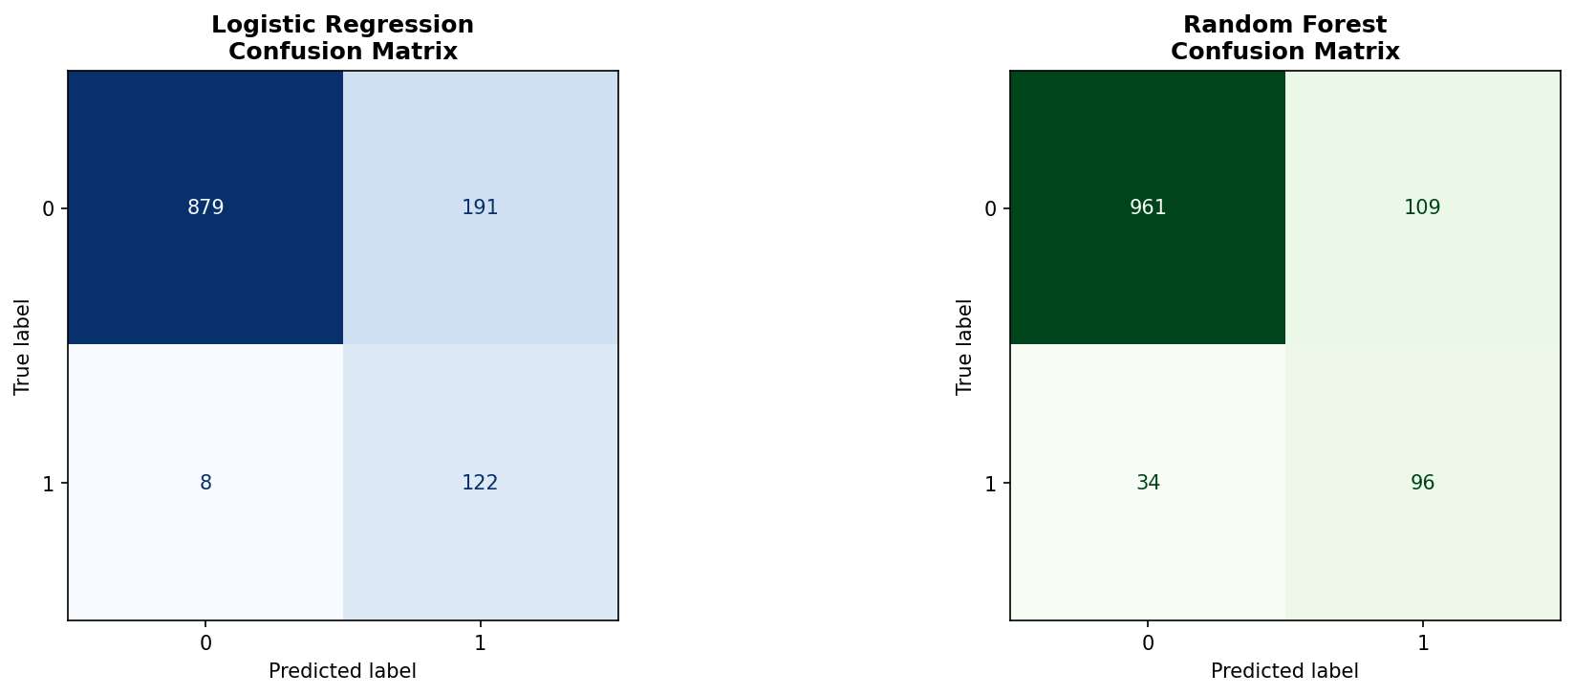
Figure5: Confusion matrices comparing Logistic Regression (left) and Random Forest (right) predictions.
The Random Forest model was selected as the optimal champion model due to its superior balance between precision and recall (F1-score: 0.573 vs 0.551). While the Logistic Regression model achieved a slightly higher ROC-AUC (0.939) and remarkably high recall (93.9%), its low precision (39.0%) results in a high volume of false alerts. Random Forest provides more targeted risk identification, which is critical for operational efficiency in manual review processes.
However, the exceptionally high ROC-AUC scores (0.92-0.94) achieved on this synthetic dataset reflect strong underlying correlations between features like savings balance and default risk. In a real-world production environment, such performance would typically trigger a manual audit for potential data leakage.

4. Confusion Matrix Business Analysis:
From a business perspective, prediction errors carry asymmetric costs:
- False Positives (predicted default, actually paid): Additional manual review cost (45,000 VND per application)
- False Negatives (missed actual default): Substantial credit losses (~65% of loan principal)
While this cost asymmetry makes catching defaults (Recall) critical for risk avoidance, Random Forest is selected as the recommended production model because it maximizes Operational Efficiency. Its superior Precision (46.8%) ensures that manual review teams focus on truly high-risk cases, preventing the system from being overwhelmed by the high volume of False Positives generated by the high-recall Logistic Regression model.

5. Fairness Audit:
Model fairness was assessed by comparing predictive performance across urban and rural customer segments:
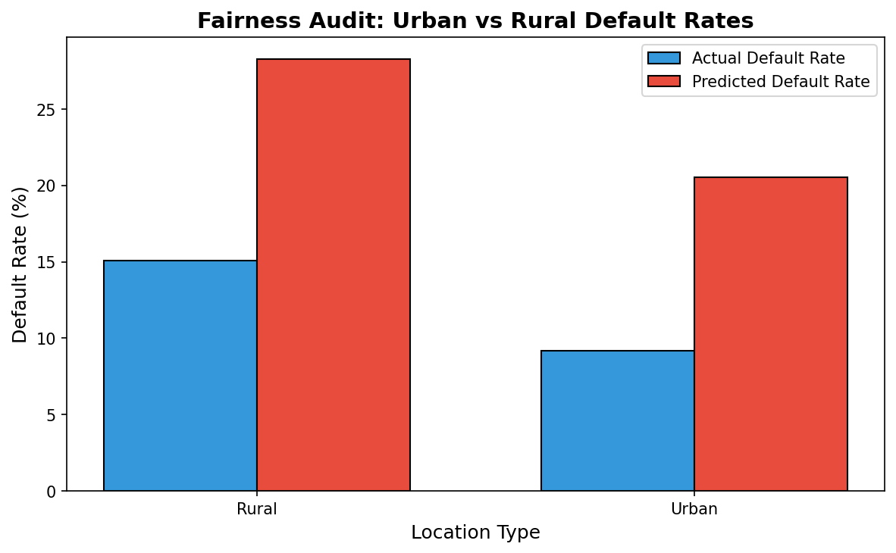
Figure6: Predicted vs actual default rates by geographic segment
Segment | Count | Actual Default Rate | Predicted Default Rate | ROC-AUC
Rural | 338.0 | 0.151 | 0.283 | 0.908
Urban | 862.0 | 0.092 | 0.206 | 0.932
Table3: Fairness audit between urban and rural
The fairness audit demonstrates that the model maintains consistent predictive accuracy across geographical segments, with ROC-AUC values remaining high for both rural (0.91) and urban (0.93) cohorts. While the actual default rate is higher among rural borrowers (15.1% vs 9.2%), the model correctly identifies this variance without exhibiting disparate predictive bias. The slight disparity in ROC-AUC is within acceptable bounds for credit risk modeling, ensuring that borrowers are assessed based on their individual risk profiles rather than their location.

Q5: Key Findings and Feature Importance
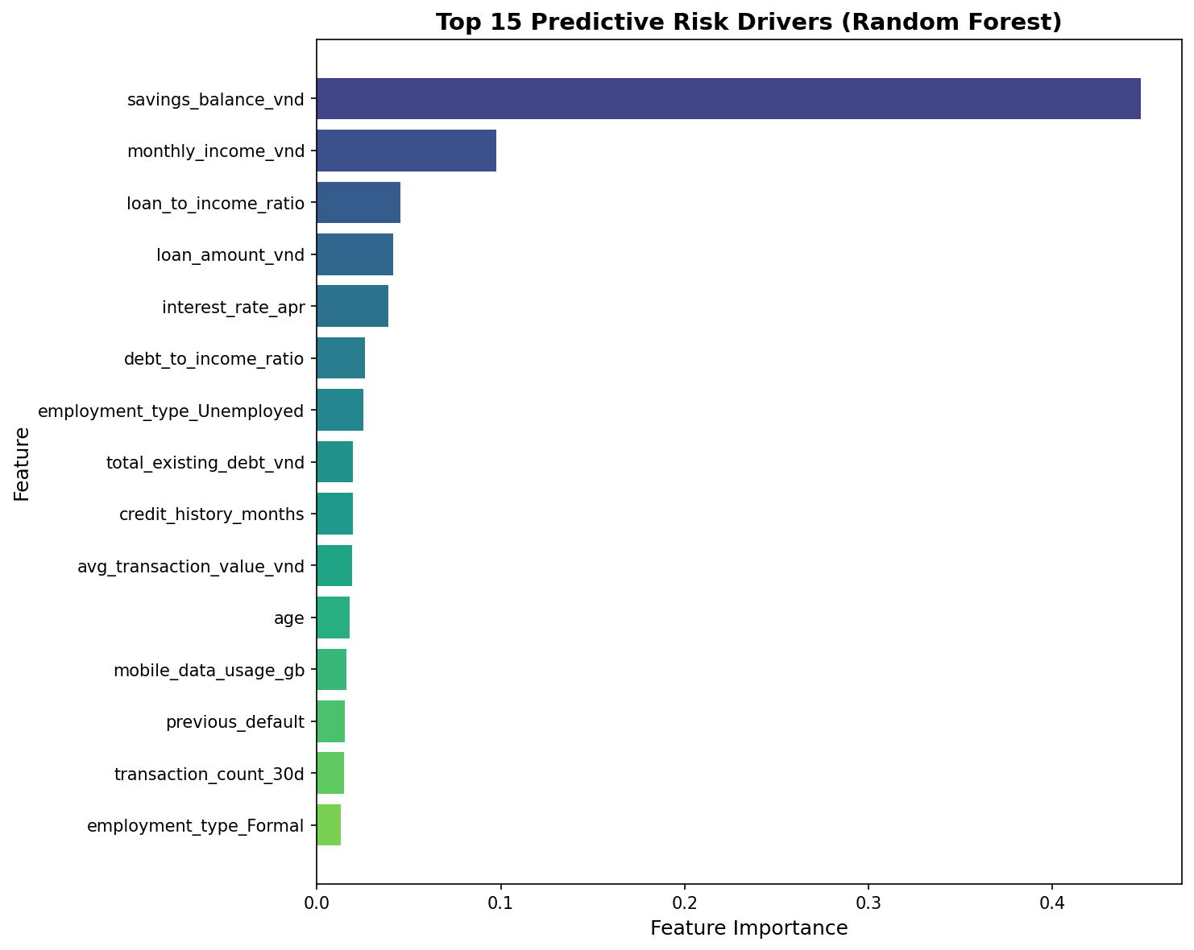
Figure7: Top 15 predictive features from Random Forest model ranked by importance.

1. Top Risk Drivers:
Random Forest feature importance analysis reveals the following key default predictors:
- Savings Balance(savings_balance_vnd): By far the strongest predictor (44.8% importance). Lower savings significantly correlate with higher default probability, acting as a proxy for financial resilience.
- Monthly Income(monthly_income_vnd): Individuals with lower verified monthly income show higher risk, emphasizing the repayment capacity.
- Loan-to-Income Ratio(loan_to_income_ratio): High ratios indicate over-leveraging relative to earning power.
- Loan Amount(loan_amount_vnd): Larger loan requests are associated with increased risk exposure.
- Interest Rate(interest_rate_apr): Higher APRs are typically assigned to higher-risk profiles, creating a self-reinforcing feedback loop.

2. Business Interpretation:
These findings align strongly with established credit underwriting principles:
- Capacity indicators(income ratios) dominate risk prediction, confirming ability-to-pay fundamentals.
- Credit history provides proven repayment behavior signals.
- Behavioral data from digital interactions adds meaningful incremental predictive value.
- Demographics(age, location) contribute modestly, appropriately minimizing bias risk.
The interpretable nature of these top features supports transparent lending decisions, facilitates regulatory compliance, and enables meaningful customer communication about credit decisions.

Q6: Recommendations

1. Recommendation 1: Risk-Tiered Manual Review Policy
Flag the top 10% highest-risk applications (by predicted default probability) for enhanced manual review before approval decisions. Quantified Impact Analysis:
Assumption | Value
Loss Given Default (LGD) | 65% of principal
Manual Review Cost | 45,000 VND per application
Review Effectiveness | 30% reduction in flagged defaults
Table4: Assumptions for the calculation
Impact Metric | Projected Value
Applications Reviewed (10% of portfolio) | ~120 per batch
Expected Defaults Prevented | ~14.6 applications
Avoided Credit Losses | ~67,400,000 VND
Total Review Cost | ~5,400,000 VND
Net Benefit | ~62,000,000 VND
Return on Investment | ~1148.0%
Table5: Impact Calculation

2. Recommendation 2: Segmented Underwriting Requirements
The policy proposes tiered verification requirements based on predicted risk profiles: low-risk applicants (probability <5%) receive streamlined automated approval for loans up to 10M VND; medium-risk applicants (5–15%) must provide partial income verification; and high-risk applicants (>15%) require full income verification plus employment confirmation before approval. The expected impact is a reduction in default rates within high-risk segments while maintaining approval efficiency and customer experience for creditworthy borrowers.

3. Implementation and Monitoring Considerations:
Both recommendations require ongoing operational support, including continuous model performance monitoring to detect degradation, quarterly fairness audits across demographic segments, regular recalibration to address population drift as the customer mix evolves, and clear escalation procedures for edge cases requiring human judgment.

Appendix:
Table 6: Descriptive statistics
Variable | count | unique | top | freq | mean | std | min | 25% | 50% | 75% | max
application_id | 6000.0 | NaN | NaN | NaN | 3000.5 | 1732.195139 | 1.0 | 1500.75 | 3000.5 | 4500.25 | 6000.0
application_date | 6000 | 365 | 23/04/2025 | 32 | NaN | NaN | NaN | NaN | NaN | NaN | NaN
region | 6000 | 3 | South | 2419 | NaN | NaN | NaN | NaN | NaN | NaN | NaN
province | 6000 | 12 | Ho Chi Minh City | 612 | NaN | NaN | NaN | NaN | NaN | NaN | NaN
urban_rural | 6000 | 2 | Urban | 4298 | NaN | NaN | NaN | NaN | NaN | NaN | NaN
gender | 6000 | 2 | Female | 3133 | NaN | NaN | NaN | NaN | NaN | NaN | NaN
age | 6000.0 | NaN | NaN | NaN | 41.5085 | 13.774586 | 18.0 | 30.0 | 41.0 | 54.0 | 65.0
age_band | 6000 | 5 | 55+ | 1388 | NaN | NaN | NaN | NaN | NaN | NaN | NaN
employment_type | 6000 | 5 | Formal | 2632 | NaN | NaN | NaN | NaN | NaN | NaN | NaN
education_level | 5664 | 4 | HighSchoolOrLess | 1978 | NaN | NaN | NaN | NaN | NaN | NaN | NaN
income_verification | 4004 | 2 | Partial | 2196 | NaN | NaN | NaN | NaN | NaN | NaN | NaN
household_size | 6000.0 | NaN | NaN | NaN | 3.986667 | 2.01482 | 1.0 | 2.0 | 4.0 | 6.0 | 7.0
dependents | 6000.0 | NaN | NaN | NaN | 0.921833 | 0.965511 | 0.0 | 0.0 | 1.0 | 1.0 | 5.0
monthly_income_vnd | 5755.0 | NaN | NaN | NaN | 16390772.198089 | 8565579.827895 | 2500000.0 | 10313000.0 | 15296000.0 | 21046000.0 | 65677000.0
credit_history_months | 6000.0 | NaN | NaN | NaN | 48.651 | 28.925778 | 0.0 | 28.0 | 48.0 | 68.0 | 159.0
past_due_days_12m | 6000.0 | NaN | NaN | NaN | 7.067833 | 41.613073 | 0.0 | 0.0 | 0.0 | 8.0 | 999.0
previous_default | 6000.0 | NaN | NaN | NaN | 0.0585 | 0.234706 | 0.0 | 0.0 | 0.0 | 0.0 | 1.0
existing_loans_count | 6000.0 | NaN | NaN | NaN | 1.006 | 0.997395 | 0.0 | 0.0 | 1.0 | 2.0 | 6.0
total_existing_debt_vnd | 6000.0 | NaN | NaN | NaN | 3039707.0 | 4395659.283078 | 0.0 | 0.0 | 1744500.0 | 4229500.0 | 56348000.0
savings_balance_vnd | 6000.0 | NaN | NaN | NaN | 18275592.833333 | 23139501.852029 | 197000.0 | 5060500.0 | 10869500.0 | 22180750.0 | 374057000.0
transaction_count_30d | 6000.0 | NaN | NaN | NaN | 30.239167 | 31.168481 | 8.0 | 25.0 | 29.0 | 33.0 | 999.0
avg_transaction_value_vnd | 5835.0 | NaN | NaN | NaN | 264184.523565 | 167242.050499 | 31058.0 | 152752.5 | 223807.0 | 327882.0 | 2980184.0
mobile_data_usage_gb | 5540.0 | NaN | NaN | NaN | 11.774289 | 5.913079 | 0.18 | 7.5975 | 11.71 | 15.73 | 35.6
app_sessions_30d | 6000.0 | NaN | NaN | NaN | 43.662167 | 7.337302 | 18.0 | 39.0 | 44.0 | 49.0 | 72.0
device_price_segment | 6000 | 3 | Mid | 2668 | NaN | NaN | NaN | NaN | NaN | NaN | NaN

AI acknowledgment: Code generation and drafting assistance were provided by ChatGPT; final analysis, decisions are checked by me.

