**Computer Organization**

**Architecture diagrams:**

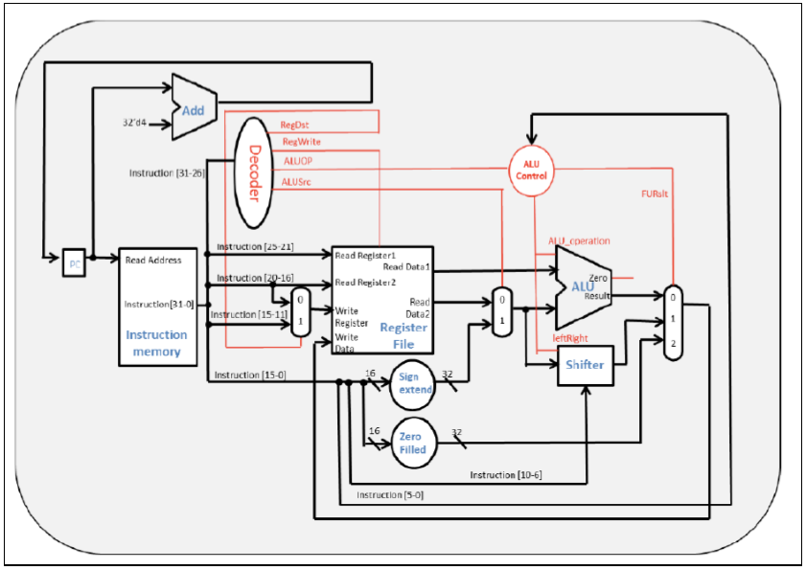

**Hardware module analysis:**

**Using combinational circuits to implement.**

**Using Decoder and ALU Control to control other modules.**

**Using MUX to choose which result we want to write back to the register.**

**Finished part:**

**Add,ALU, ALU Control, Decoder, MUX2to1, MUX3to1, Register File, Shifter, Sign Extend, Single Cycle CPU.**

**Problems you met and solutions:**

1. **SLT should support signed numbers. The default operation is for unsigned numbers, so I wrote “wire signed [32-1:0] signedSrc1=aluSrc1, signedSrc2=aluSrc2;” to fix it.**
2. **I forgot to add “begin” and “end” to the if-else structure with many lines and therefore got wrong answers.**

**Summary:**

**This single cycle CPU is a simplified CPU without supporting branch, store, and load. When I started to do this homework, I felt it so difficult and complicated. However, when I almost finished it, I had already understood it and been familiar with it. This lab is a good practice for us to learn how to build a simplified CPU. By this practice, it will be easier for us to build a more complete CPU in next labs.**