Hun Jae Lee (hxl224) EECS338 Homework 9 Due 161116 Wed

## How to run

* make to compile all files
* make q1 to run forking sum program.
  + If you are on HPC, run sbatch q1.slurm
* make q2 to run Shubert OMP timer program.
  + If you are on HPC, run sbatch q2.slurm
* make clean to clean up the output files

## Program Outputs & Discussion

### Q1. Forking sum

In the following output, the following procedure was repeated for 5 times for using 1, 2, 4, 8, 16 processes:

$ vi q1.c # change the NUM_PROCS value in q1.c  
$ sbatch q1.slurm  
Submitted batch job 2374789  
$ cat q1.output   
5 cores available.  
1 processes, sampled total time: 2.939381 seconds.

Omitting the commands, each run's output is collected as follows:

|  |  |
| --- | --- |
| Number of Processes | Sampled Total Time (s) |
| 1 | 2.939381 |
| 2 | 1.511539 |
| 4 | 0.778291 |
| 8 | 0.717784 |
| 16 | 0.697044 |

Which then can be graphed as following:

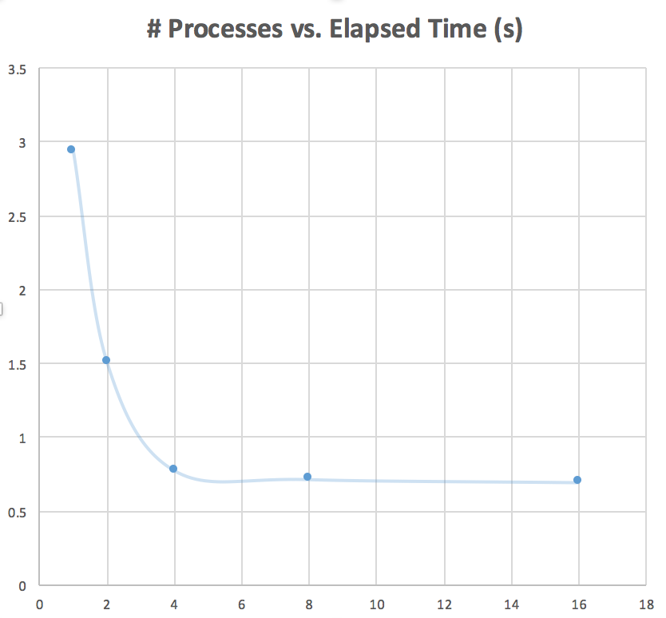

I was able to see a significant decrease in total time for increased number of processes.

### Q2. Shubert OMP timer

$ vi q2.slurm # change the cpus-per-task value in q2.slurm  
$ sbatch q2.slurm  
Submitted batch job 2374906  
$ cat q2.output  
5 cores available  
5 threads.  
Total time was 0.053814 seconds.  
min = -186.669291

Omitting the commands, each run's output is collected as follows:

|  |  |
| --- | --- |
| Number of CPUs | Sampled Total Time (s) |
| 1 | 0.056519 |
| 2 | 0.053684 |
| 3 | 0.028713 |
| 4 | 0.026464 |
| 5 | 0.053492 |

Which then can be graphed as following:

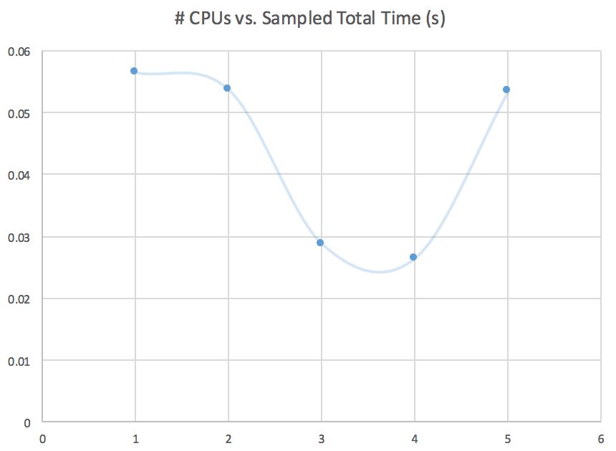

I was able to see a significant decrease in total time for increased number of CPUs; however, for 5 CPUs the total time increased, while hypothetically it was supposed to have less time elapsed than lower number of CPUs.

## Notes

* File naming convention:
  1. q1.c, q2.c: source code, each number corresponding to the question number in the assignment.
  2. q1.slurm, q2.slurm: the slurm batch files, each number corresponding to the question number in the assignment.
  3. makefile: the makefile, used to test running locally.
  4. README.md: what you are reading right now
  5. /src/: Original files given with the assignment and graph image files
* The number of cores is set in the slurm batch script.