**Abstract**

Introduction :

Laravel based ABC Restaurant web app for storing , retrieving records from database and Displaying them as Transactions , Line Graph , Bar Graph and Pie Chart.

Languages used :

HTML5 , CSS3 , javaScript , jQuerry , Php , SQlite , bootstrap.

Framework :

Laravel

Screenshots:

Default page :

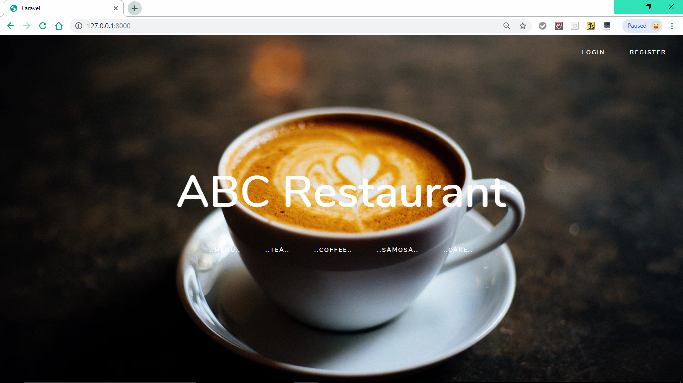

Login :

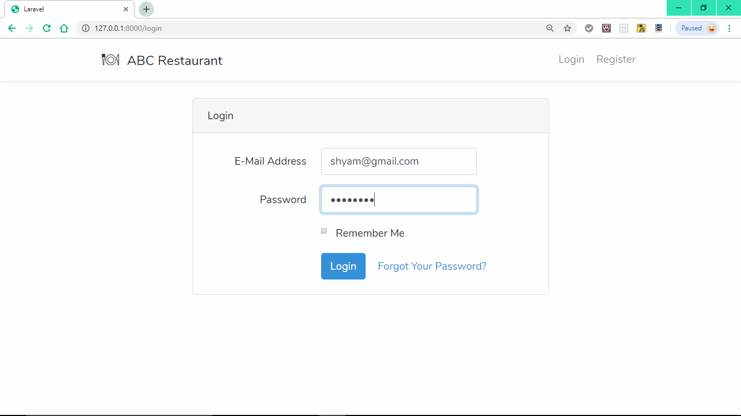

Register :

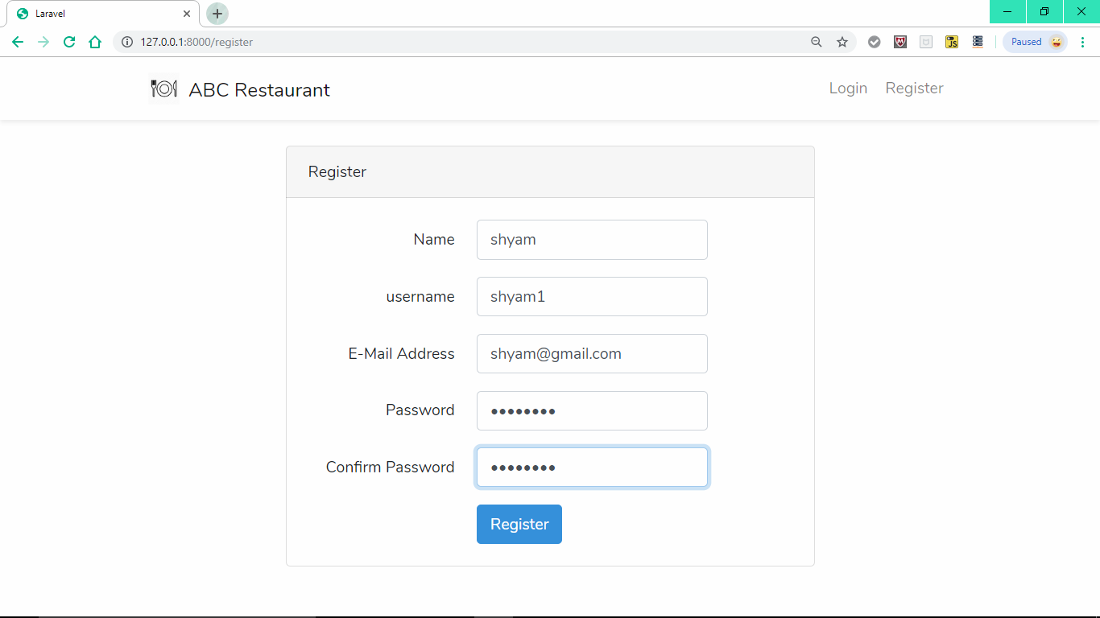

( Login ) Home :

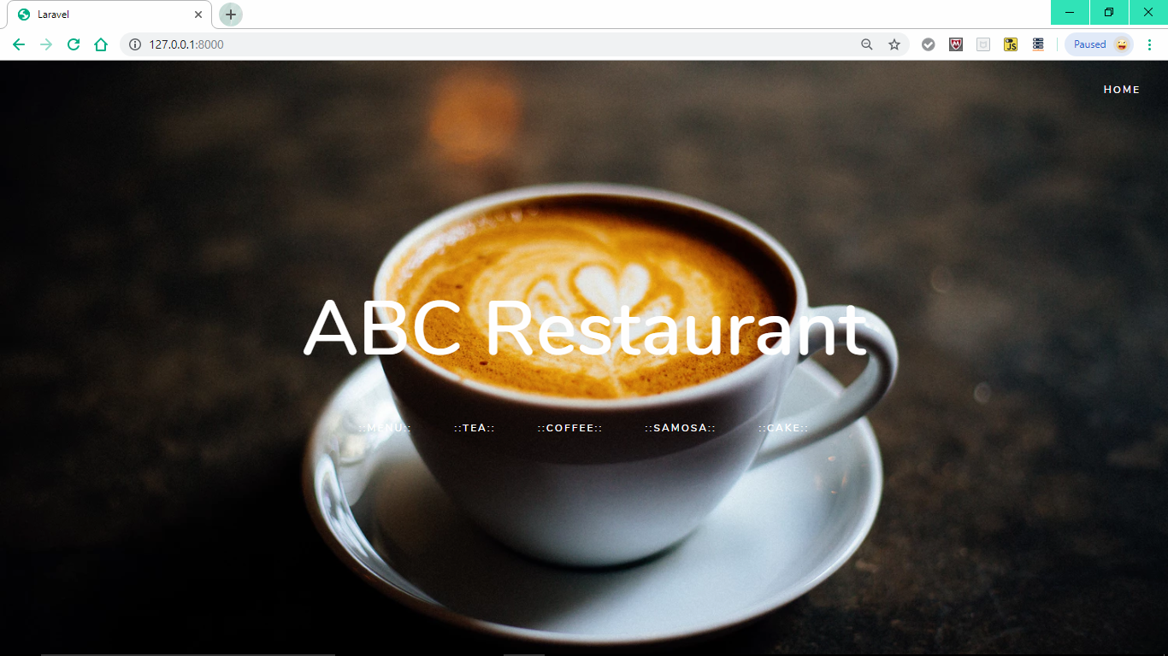

User Page :

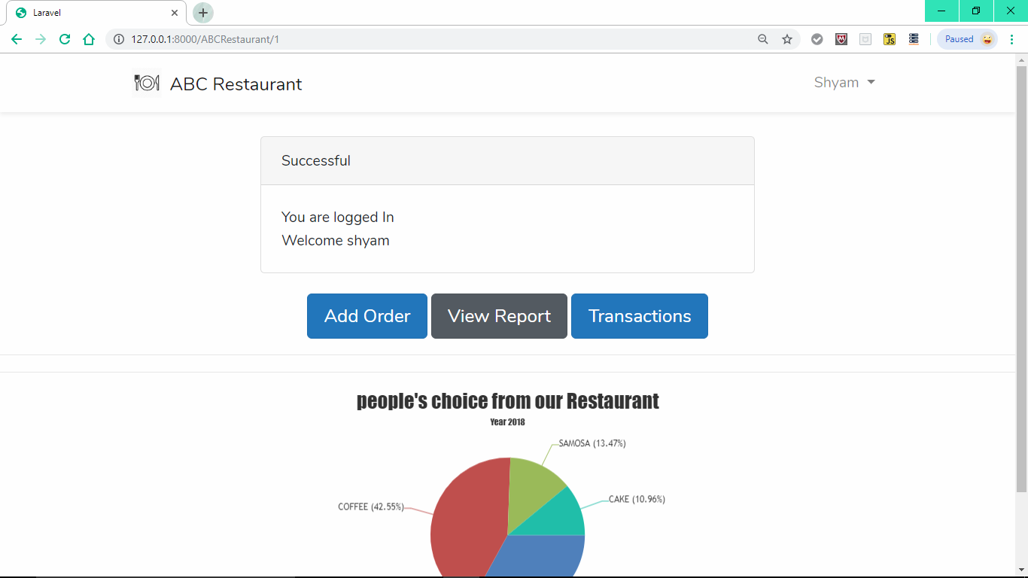

Add Order :

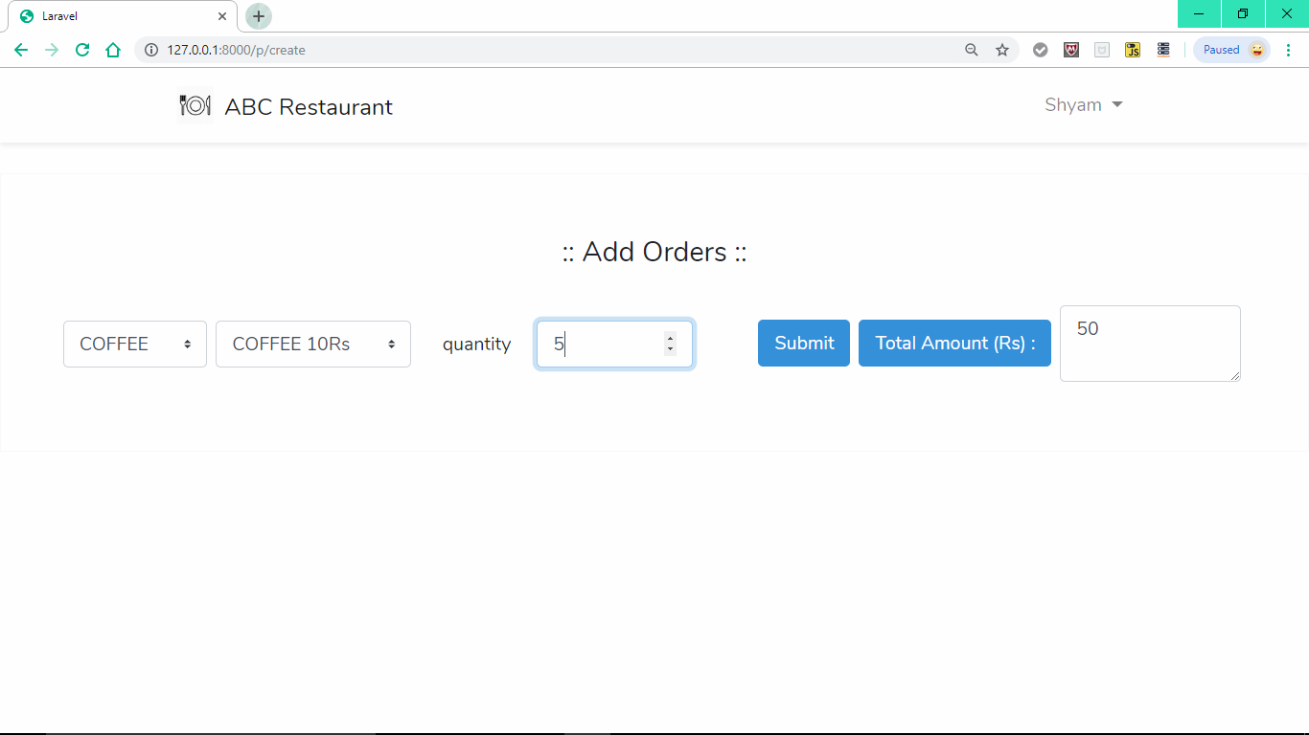

Transactions :

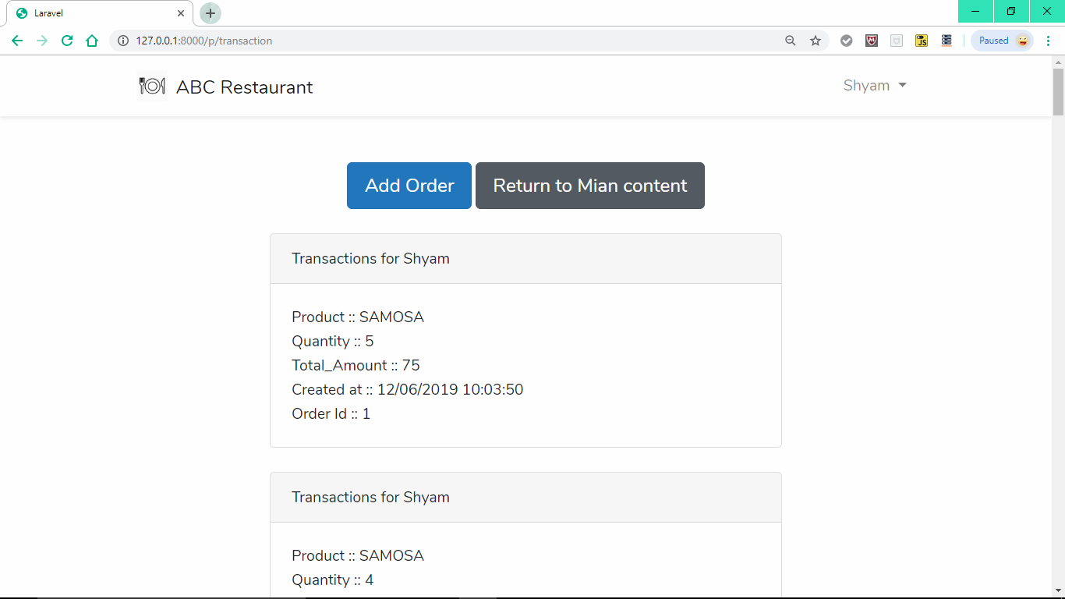

View Report :

Bar Graph :

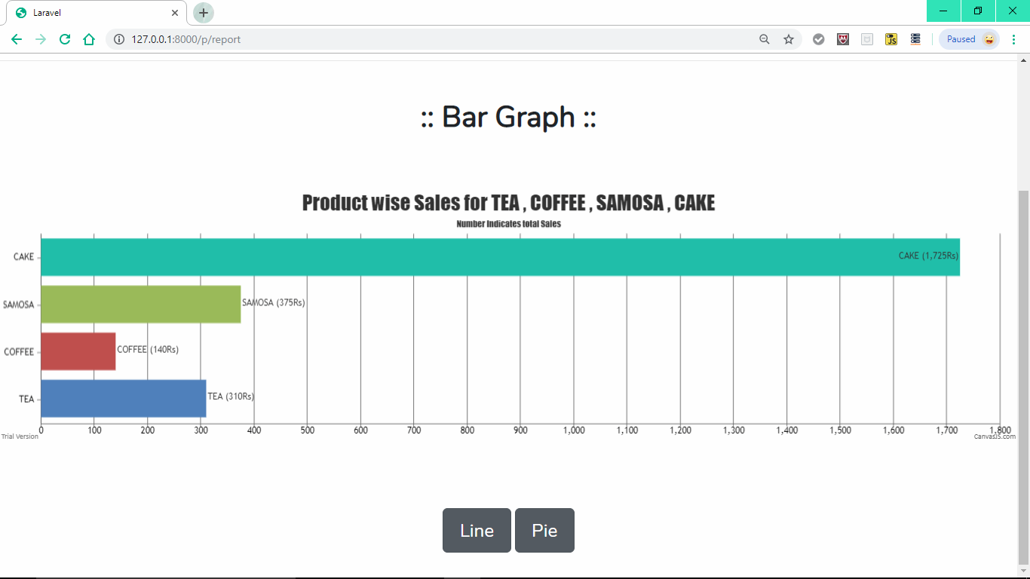

Line Graph :

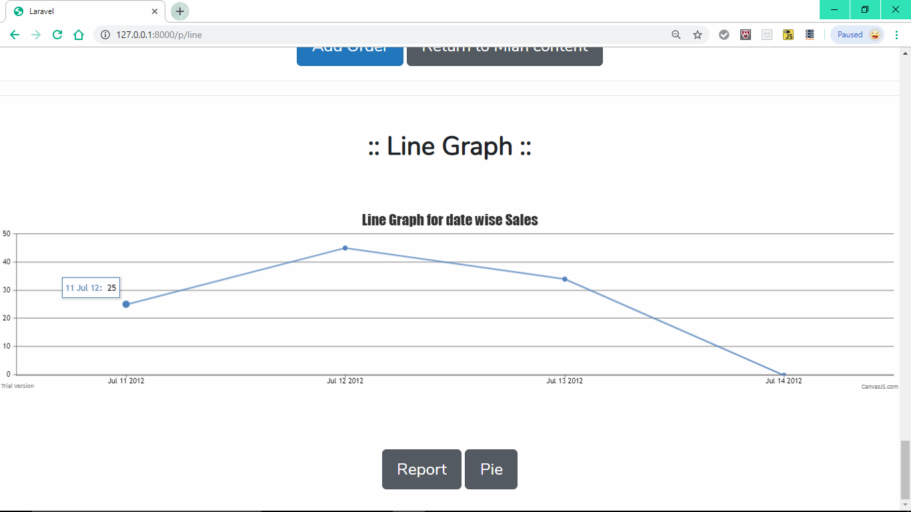

Pie Chart :

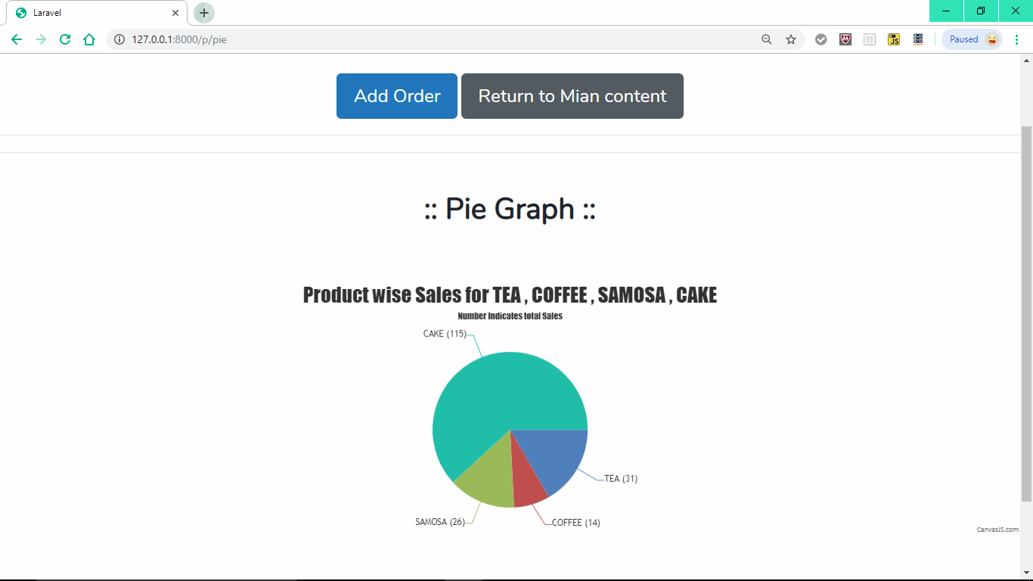

Logout :

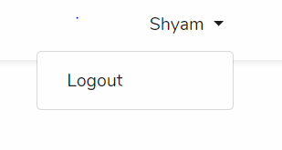

Database Records : SQLite

Table – users :

Format :

Id –

Name -

User_name –

Email –

Email_verified -

Created_at –

Updated_at –

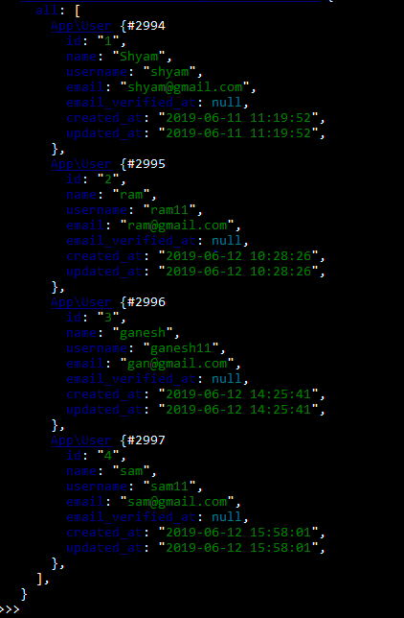

Table - Addorder :

Format :

Id –

User_id –

TEA –

COFFEE –

SAMOSA –

CAKE -

Created_at –

Updated_at –

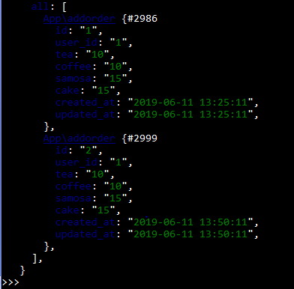

Table - data :

Format :

Id –

User_id –

Product –

Quantity –

Total_amount –

Created_at –

Updated_at –

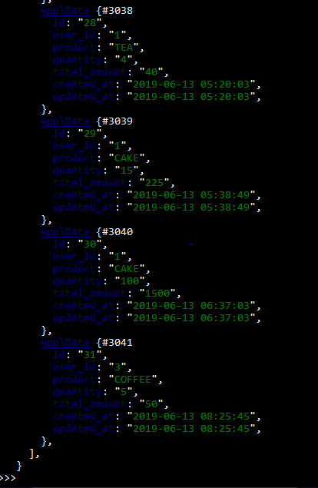

Code Section :

Controllers :

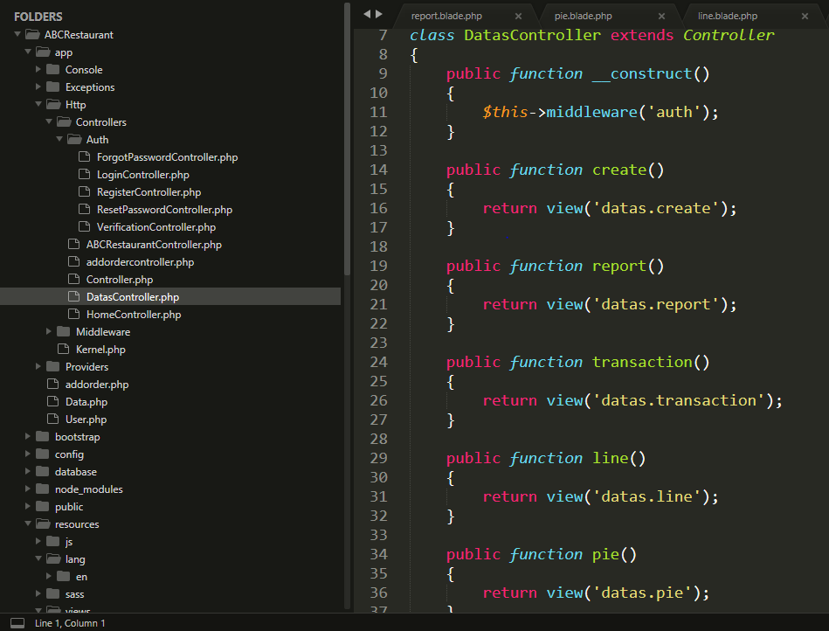

Code Hierarchy :

