

Fundamental Programming Techniques
Order Management
Assignment 3

Hunor Debreczeni
Group: 30423

Table of Contents
Objective 3
Problem Analysis, Modeling, Scenarios, Use cases 3
Design 4
Packages 5
Business Level Logic 5
Connection 5
Data Abstraction Layer 5
Model 5
Presentation 5
Start 6
Util 6
Implementation 6
Results 7
Conclusions 7
Bibliography 8

Objective
The objective of the application is to manage the orders for the customers in a warehouse. It should be allowed to add new product with specific quantities and specific prices. Clients are also needed to be saved for order generation.
To achieve this, relational databases are used to store the products, the clients and the orders. For an easier layout in the application, it is structured in packages using a layered architecture by using Model, Business Logic, Presentation and Data Access classes.
The software also allows processing commands from an input file whose name can be given as an argument to the program.

Problem Analysis, Modeling, Scenarios, Use cases
The application may be used to help smaller businesses to easily store data about orders, clients and also about products. Each order can have many invoices due to the multiple type of invoices (returned, canceled, normal, etc.).
Firstly, the user of the software should have a database set up ready to use. For this part, there is an SQL file, which creates the necessary database and the tables inside it upon import. In order to be able to connect to the database, there should be a user set up like described below:
The username must be root
The password must be secret
Secondly, commands should pe written in the input file, according to the user’s needs. These commands must follow the following formats:
- Insert
  - Client: <Name of Client>, <Address of Client>
    - Inserts a new client into the DB
  - Product: <Name of Product>, <Quantity of Product>, <Price of Product>
    - Inserts a new product if it doesn’t exist, otherwise the quantity of the original product is incremented
- Delete
  - Client: <Name of Client>
    - Deletes the client with the given name if found
  - Product: <Name of Product>
    - Deletes the product with the given name if found
- Order: <Name of Client>, <Name of Product>, <Quantity of Products to be bought>
  - If there is enough stock of the product to make the current order, then an invoice is made with the given details, otherwise an under-stock message is printed through a PDF file.
- Report
  - Client
    - Generates a PDF with all the current clients
  - Product
    - Generates a PDF with all the current products
  - Order
    - Generates a PDF with all the orders that were made
The outputs of the application are PDF files, that can be called following the commands listed above. Each file’s name contains details about the given command or the given situation (in case of the under-stock message) and a timestamp attached to it. This way, it makes easier to follow if multiple commands are used.
As arguments for the program, only one can be used, to specify the name of the input file, that must be in the same folder as the .jar file. In case it is not used, the program will search for the commands.txt file by default.

Design
For implementing the problem described above, the best and most efficient approach is to use reflectional techniques. Reflection gives us pieces of information about the class to which a given object belongs to. We may also get details about the methods of that class that can also be executed by referring to the object of that class. This way it’s easy to invoke methods at runtime without knowing the type of the current instantiated class object.
Using this technique, it’s easy to:
- Get information about the fields of an object even if they are private
- Use its constructors
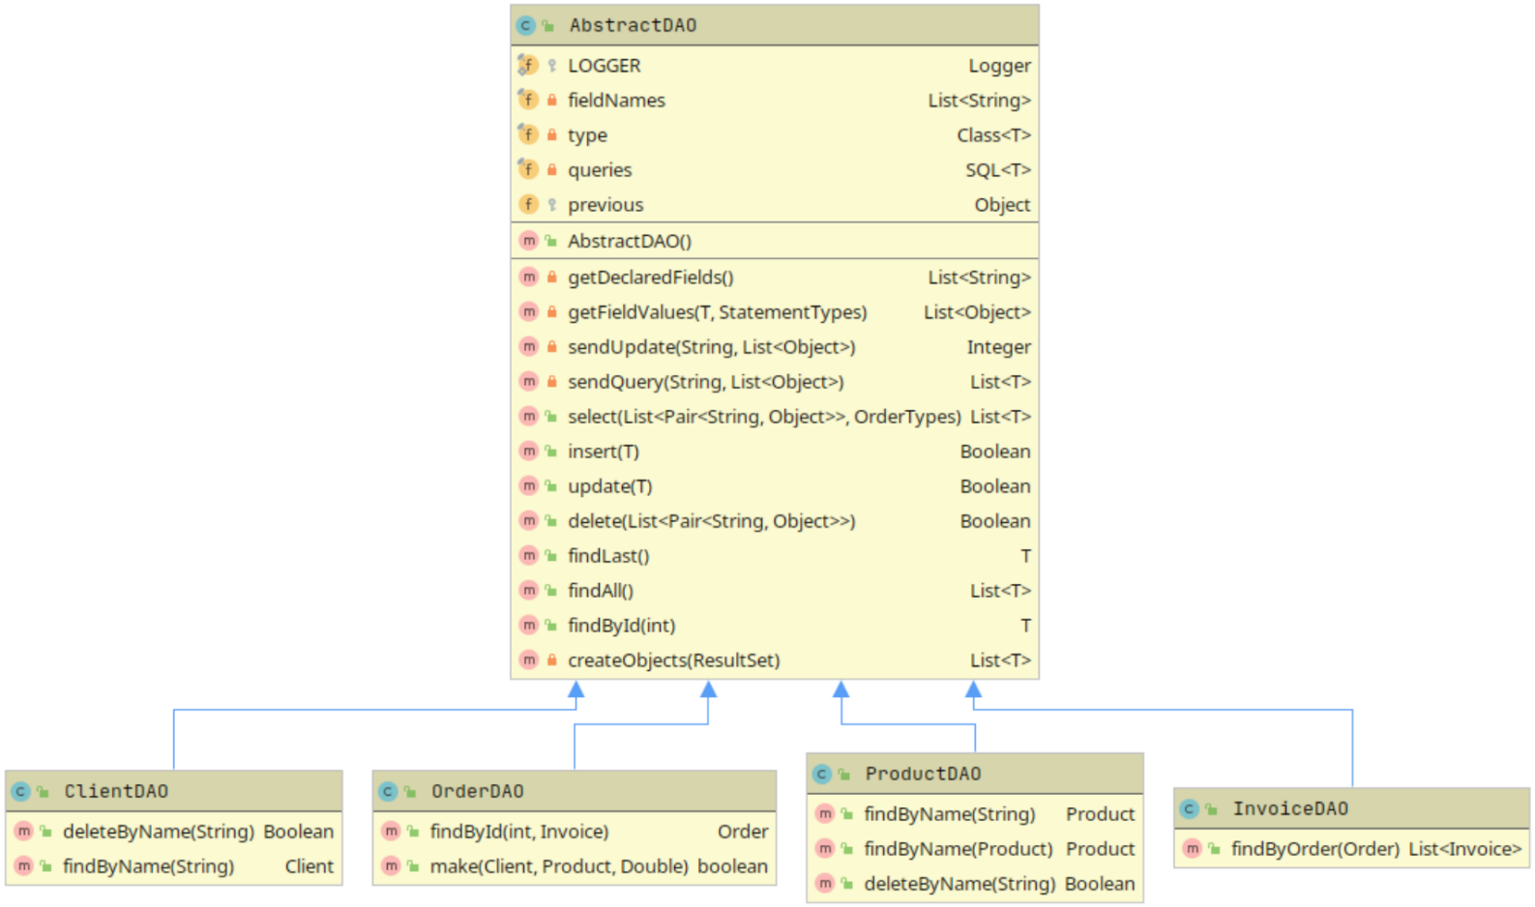
- Access any method and invoke them
This method came in handy while creating the data abstraction layer in this application.
As it can be seen in the figure on the right, the data abstraction classes for the model’s does not contain many methods, because most of them are being used from it’s super class (they inherit the AbstractDAO class).
The real use of the reflectional technique appears when the software transforms a given object to data that we can use to create our queries. These queries are then sent to the database, to get/ update/ delete data by following the given command. For each select statement that is send, it is needed to process the response from the database.
This is realised by getting the declared fields of the object and afterwards calling their getters in case if the value is needed. In case if the value should be set, then the setters are called.
As an example, in case of the update, the getters are called for the fields, that give back the value if it’s not a Model ( Product, Client, Order or Invoice), and if it’s a model, than the ID is given back, because we need to save the relation in the database. It’s not possible to save an object.
In case of the select, we get back a list of rows. For each row, it’s necessary to create an object. In case of simple objects, it’s easy to create, because we just simply get the value and give it to the setter. On the other hand, if there’s a relationship, then we get the ID of the child/ parent. To get the object with that ID, another select query is called with the findByID method for that specific model.
The whole project is made up by using layered architecture. Basically, it structures the software part into four main categories: presentation, application, domain and infrastructure.
- The presentation layer contains all of the classes responsible for presenting the UI to the end-user or sending the response back to the client. In our case it’s used to generate the PDFs/ Reports, etc. and to give commands from the user to the application.
- The application layer contains all the logic that is required by the application to meet its functional requirements and, at the same time, is not a part of the domain rules. In most systems that I've worked with, the application layer consisted of services orchestrating the domain objects to fulfill a use case scenario.
- The domain layer represents the underlying domain, mostly consisting of domain entities and, in some cases, services. Business rules, like invariants and algorithms, should all stay in this layer.
- The infrastructure layer (also known as the persistence layer) contains all the classes responsible for doing the technical stuff, like persisting the data in the database, like DAOs, repositories, or whatever else you’re using.
The benefits of a layered architecture consists of simplicity (easy to understand the code), consistent across different projects also and guarantees the seperation of concerns. Easy to decide which part of the code should be implemented in a specific package.

Packages

Business Level Logic
Contains classes that are specific to the business, more exactly 4 classes, each specific for the models that appear in the project (Client, Product, Order, Invoice). Each class contains methods that are at the same time, also specific only for the business logic, like making an order, finding a product/ client, etc. and they call the same method from the data abstraction layer, that is more technical.

Connection
Realizes the connection between the database and the application. Makes it easier to handle each SQL query and at the same time by also doing it safely (Opening and closing each connection).

Data Abstraction Layer
This is the more technical part of the application. Here appears every object creation mostly and the statement creation that will be executed later on. So we can say that this is the brain of the current project.

Model
Contains the models that are used throughout the whole application. The classes mostly contain the fields that also appear in the DB and the getters/ setters. Simple, yet the most essential part of the application.

Presentation
Contains the input/ output processing from/ for the end-user. Parses the input file to see what commands should be ran. And after those commands were ran, creates a new PDF and according to the results, makes a table/ single line output file, that notifies the end-user about a model/ action.

Start
Contains only the main class of the program, that is used to start the application.

Util
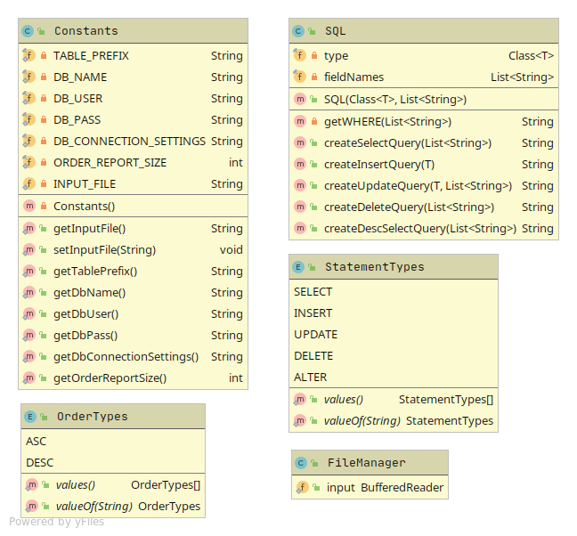
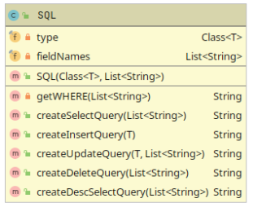
Most of the time, classes with static functions can be found in this package or Enum classes that help the other part of the program to be more readable or to be more easily customizable later.
The most noticeable class is the Constants one, that is used in order to make constant variables to not appear in random positions in random classes. By using a class for this, it’s a lot easier to customize some parts of the program as example the connection that is made to the Database.
The SQL Class is used to create the queries as a String which are then executed.
The others are just used to make the code less long and easier to read.
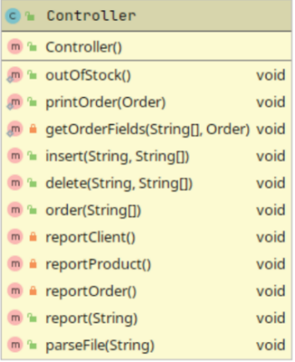

Implementation
The program starts with the Controller class, that parses the input file. The parseFile() is first called, which then checks for the main command (insert, delete, order, report) and calles a specific function for that command (insert(), delete(), report() ).
Those smaller functions yet again check for the specific model that was given, or make the order. And call the functions from the Business Logic Level Classes.
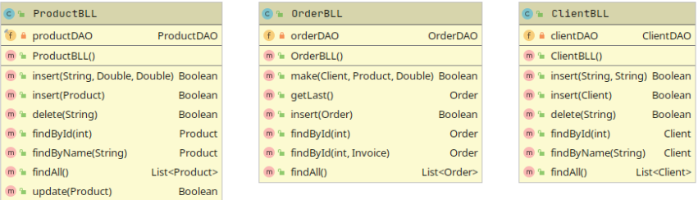
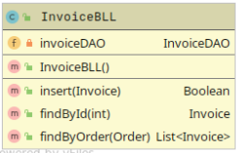
The next classes that are touched are the BLL classes. They simply make a call to tha Data Abstraction Layers, that do the technical part. The BLL classes function’s are used to visualize the logic of the given business and make it clear.
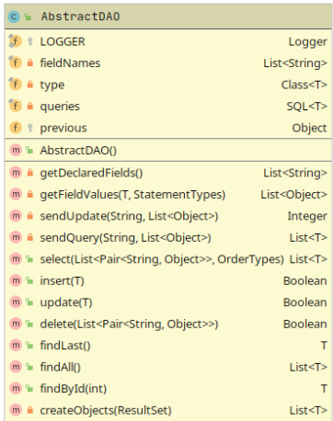
Next up are the DAOs, the core of the application. The AbstractDAO class implements most of the work, which are then re-used in the ModelDAOs.
The most used method is the select() one, that gets as parameters a List of Pairs where each Pair consists of a String and an Object. The string represents the attribute name, that should be searched for and the Object represents the value of that attribute. This list is used in the creation of the SQL Statement. By using this technique, it is easy to make a query that may contain an infinite number of filters/ references. There is also an OrderTypes paramater that is an Enum class, which tells us the order by the creation date (ordered by the ID field).
Similarly to this function, the delete() also uses the same technique to find the elements.
The insert() and update() method uses an object as parameter, which gets all of it’s fields and their values by using reflection, to insert or to find the element and update them.
The getDeclaredFields() method is used to prevent duplicate code. This method gets the names of the fields from the current type, by ignoring the ones that start with x_ . This was added only for the Order model, because of the one-to-many relationship, that shouldn’t appear in the Order table, but is needed in the application.
Each one of these methods uses a static function from the SQL class that creates the SQL statement by using either objects and reflection, either List of Pairs.
After we get the SQL Statement, there is need for the ConnectionFactory class, that establishes the connection to the Database and after a statement is executed, it safely closes everything that is needed to be closed.
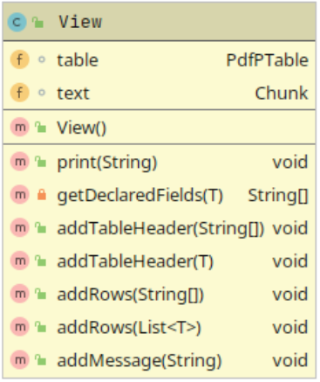
Lastly we need to convert the result set to a List of Objects. For this, the createObjects method is used. Due to the fact that we don’t know what type of object we should create, we create a new one using the current type with reflection. For each field we call the method that uses the setter with the specific type of parameter (Integer, Double or String in our case). Then the logic behind saving that value is implemented in the models. There are cases when we need to create an Object instead of an Integer (Relationships). There’s a tricky situation in the case of the Order, because it has a one-to-many relationship (It may have any number of Invoices). For this we do select every Invoice that is the child of the given order and add them to the Orders list of invoices.
From these we simply return the values back to the Controller, which finally calls the methods from the View, which gets the field names and values from the object and prints them into a PDF if possible. The values are added to the table or to the text. And in the print() method, the file is created, those values are added to that file and finally the file is saved/ closed.

Results
As results, the end-user gets a simple application where he/ she can control the products of a business and the orders of any numbers of customers.

Conclusions
I have learnt a very useful technique that could come in handy many times in object-oriented programming. By using reflection, it’s easy to prevent duplicated code fragments and make abstract classes that can be later on inherited. The only drawbacks of this method is that it is performing slower than normal non-reflective codes. In my eyes, the biggest drawback would be the exposure of the private/ protected fields/ methods, that can be used from any part of the code.
Further developments could be made at the commands part, to make the end-user to be able to make reports on specific clients also. Add a way for the end-user to filter the data.

Bibliography
- https://www.geeksforgeeks.org/blockingqueue-interface-in-java/
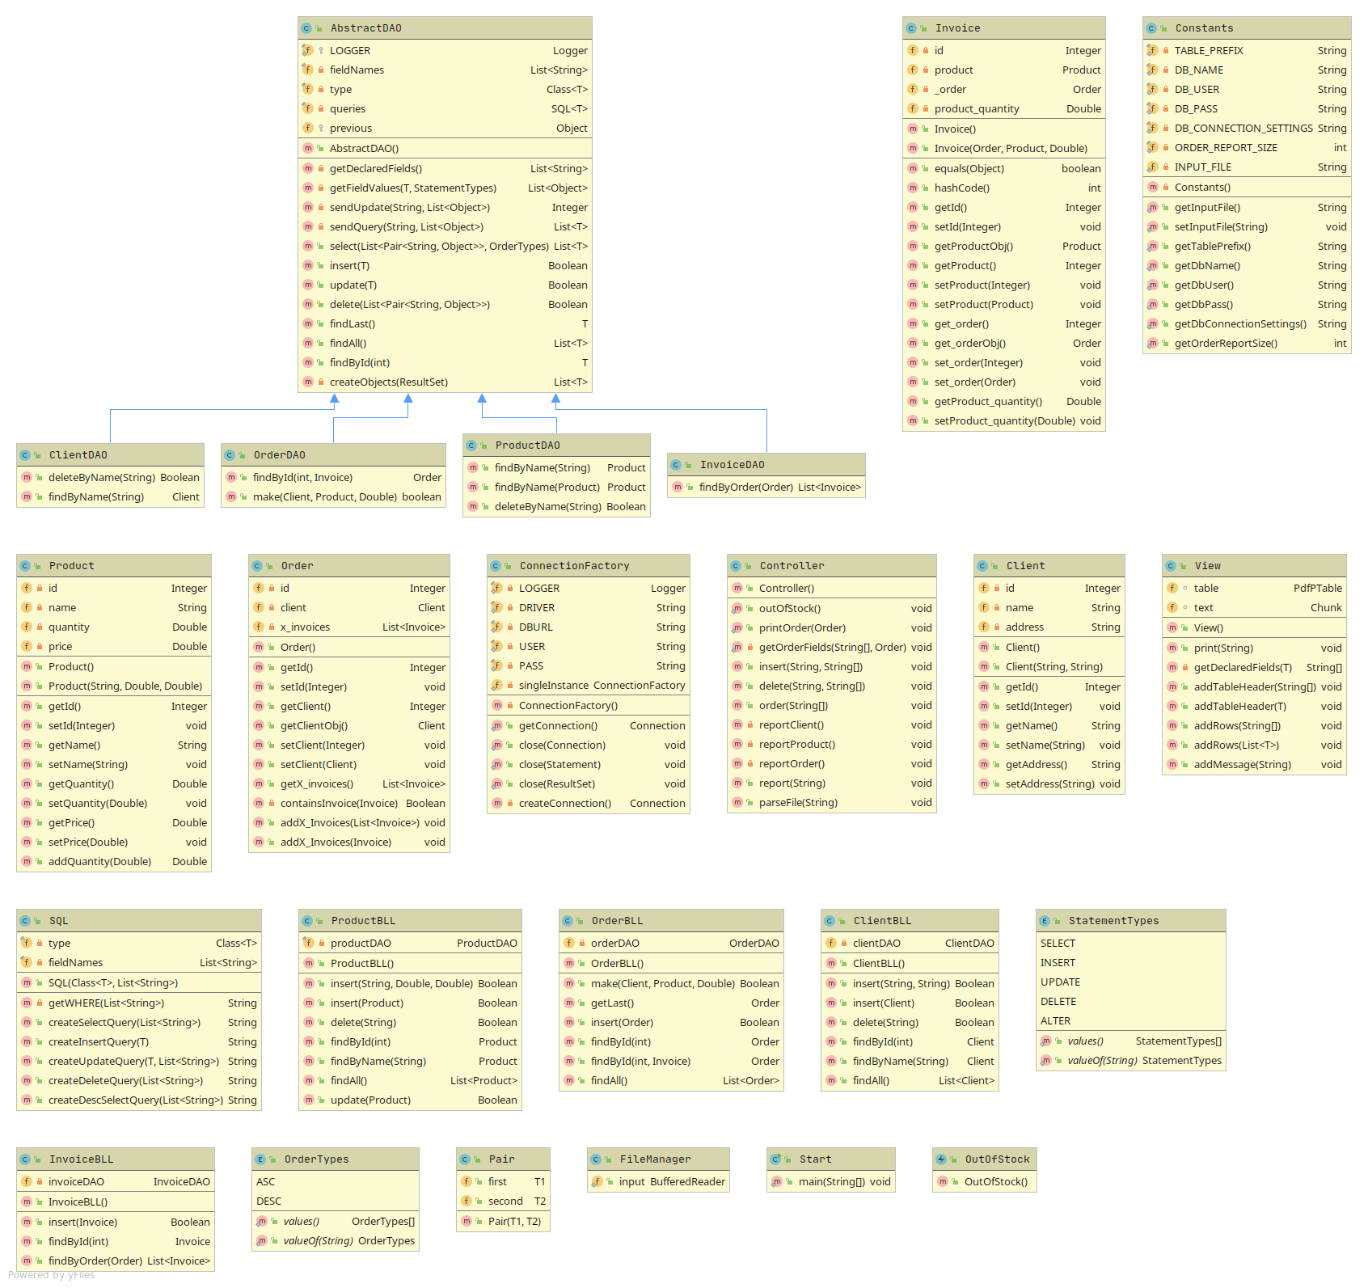
- https://dzone.com/articles/layered-architecture-is-good

