GEv1

|  |  |  |  |  |  |  |  |  |  |  |  |  |  |
| --- | --- | --- | --- | --- | --- | --- | --- | --- | --- | --- | --- | --- | --- |
| FEIT2PSv1**Sub#** | **UPN** | **Utility Program Name** | **Utility Name** | **Retail Account** | **Retailer NAme** |  |  |  |  |  |  |  |  |
| 7158-1 | 5962496792 | AMERICAN EFFICIENT-2012-2013 | AMERICAN EFFICIENT, INC | 323800 | AHOLD FINANCIAL SRVS |  |  |  |  |  |  |  |  |
| **Begin Date Range** | **End Date Range** | **Store #** | **Product Code** | **Product Description** | **Customer PC** | **Customer Product Description** | **QTY** | **Utility $/unit** | **UOM** | **Total Incentive** | **memo:Lamps SOld** | **memo: PackQty** | **Regular Retail Price** |
| 2015/05/01 | 2015/05/31 | 2800 | 42105 | FLE13HT3/2/BX2P |  | GE SFT WHT 13WT SPIRAL BLB 2pk Box | 1 | 0,4 | SLS | 0,4 | 2 | 2 | 8,99 |
| 2015/05/01 | 2015/05/31 | 2802 | 42105 | FLE13HT3/2/BX2P |  | GE SFT WHT 13WT SPIRAL BLB 2pk Box | 3 | 0,4 | SLS | 1,2 | 6 | 2 | 8,99 |
| 2015/05/01 | 2015/05/31 | 2805 | 42105 | FLE13HT3/2/BX2P |  | GE SFT WHT 13WT SPIRAL BLB 2pk Box | 3 | 0,4 | SLS | 1,2 | 6 | 2 | 8,99 |
| 2015/05/01 | 2015/05/31 | 2807 | 42105 | FLE13HT3/2/BX2P |  | GE SFT WHT 13WT SPIRAL BLB 2pk Box | 1 | 0,4 | SLS | 0,4 | 2 | 2 | 8,99 |
| 2015/05/01 | 2015/05/31 | 2809 | 42105 | FLE13HT3/2/BX2P |  | GE SFT WHT 13WT SPIRAL BLB 2pk Box | 3 | 0,4 | SLS | 1,2 | 6 | 2 | 8,99 |
| 2015/05/01 | 2015/05/31 | 2810 | 42105 | FLE13HT3/2/BX2P |  | GE SFT WHT 13WT SPIRAL BLB 2pk Box | 2 | 0,4 | SLS | 0,8 | 4 | 2 | 8,99 |
| 2015/05/01 | 2015/05/31 | 2811 | 42105 | FLE13HT3/2/BX2P |  | GE SFT WHT 13WT SPIRAL BLB 2pk Box | 3 | 0,4 | SLS | 1,2 | 6 | 2 | 8,99 |
| 2015/05/01 | 2015/05/31 | 2812 | 42105 | FLE13HT3/2/BX2P |  | GE SFT WHT 13WT SPIRAL BLB 2pk Box | 1 | 0,4 | SLS | 0,4 | 2 | 2 | 8,99 |
| 2015/05/01 | 2015/05/31 | 2814 | 42105 | FLE13HT3/2/BX2P |  | GE SFT WHT 13WT SPIRAL BLB 2pk Box | 11 | 0,4 | SLS | 4,4 | 22 | 2 | 8,99 |
| 2015/05/01 | 2015/05/31 | 800 | 42105 | FLE13HT3/2/BX2P |  | GE SFT WHT 13WT SPIRAL BLB 2pk Box | 4 | 0,4 | SLS | 1,6 | 8 | 2 | 8,99 |

PHILIPPSv1

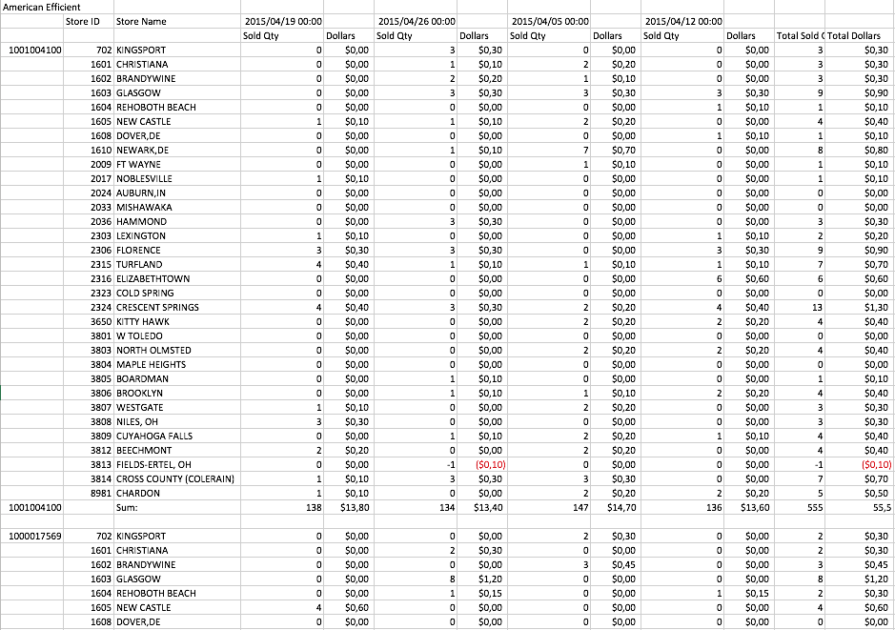

TCPv1

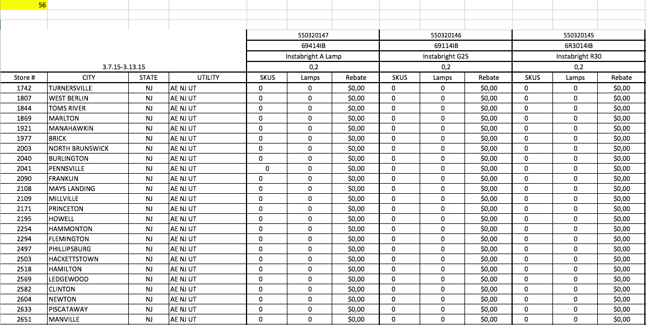

TCPv2

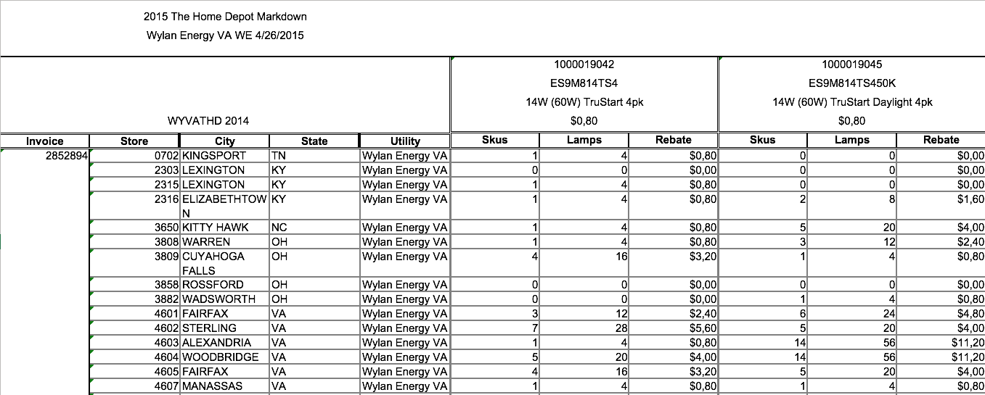

FEITv1

