# The Hardy-Weinberg Equilibrium (HWE)

1. A SNP has the following observed genotype frequencies:

|  |  |  |
| --- | --- | --- |
| **AA** | **AT** | **TT** |
| 0.400 | 0.463 | 0.137 |

What are the allele frequencies?

1. In a population of 300 individuals, we observe the following distribution of the SNP above. What is the expected genotype distribution?

|  |  |  |  |
| --- | --- | --- | --- |
|  | **AA** | **AT** | **TT** |
| Observed distribution | 120 | 139 | 41 |
| Expected distribution |  |  |  |

1. Calculate is the $χ^{2}$ test statistic for the above SNP. Is there evidence that the SNP is in HWE?

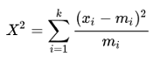

# Linkage Disequilibrium

Consider two loci on the same chromosomes: Locus 1 (alleles A and a) and locus 2 (alleles B and b). In a group of 1000 individuals, we observe the following number of individuals with the respective haplotypes:

|  |  |  |  |  |
| --- | --- | --- | --- | --- |
|  | AB | Ab | aB | ab |
| Observed number | 450 | 50 | 100 | 400 |

1. What are the allele frequencies for each of the four alleles?
2. What are the expected haplotype frequencies if the two loci are in linkage equilibrium?
3. Calculate the LD coefficient D and the standardized D’ for the alleles A and B. Are these alleles in LD?

# The genetic code and genetic variants

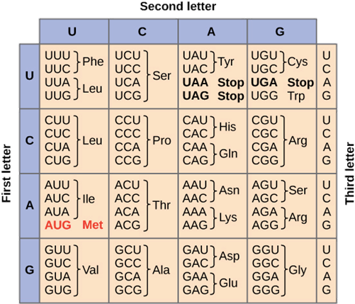

1. The following DNA sequence encodes a peptide (small protein). What is the corresponding mRNA sequence and the amino acid sequence of the peptide?

5’ TAC CGA GGT GTG GCA GCA CTC CAA AGT AGT TTT ATC 3’

1. If the above sequence is the reference DNA sequence for the peptide, can you find the SNPs in persons 1-3? What types of SNPs are they?

Person 1:

5’ TAC CGA GGT GTG GCA GCA ATC CAA AGT AGT TTT ATC 3’

Person 2:

5’ TAC CGA GGT GTG GCA GCA CTC CAA AGT AGG TTT ATC 3’

Person 3:

5’ TAC CGA GGT GTT GCA GCA CTC CAA AGT AGT TTT ATC 3’

1. What do you think would be the consequence of each SNPs? Which SNP will probably have the least severe consequence for the person?