One type of error code:

If problem with kernel, install WP3 kernel from link:

FIND LINK FROM ERROR CODE

Another type of error code:

1. Go to Settings < Update and security < For developers < Developer Mode < On
2. Press windows flag + R

Enter optionalfeatures and press enter

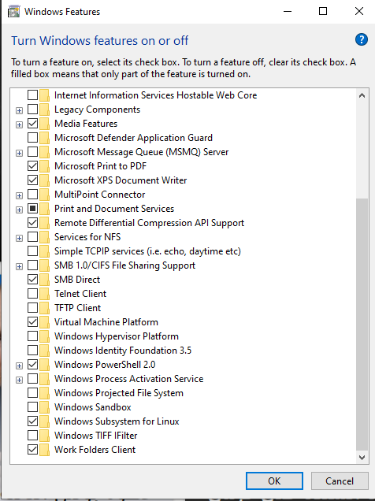

1. Press OK and let the PC restart
2. Start Ubuntu and let it start
3. When “Enter new username” appears that is a good sign and just exit the program and start it again
4. Then you should see this

