FUMA Practical 2026
FUMA GWAS uses information from publicly available annotation and mapping datasets
We will work with results from published GWAS studies – you can choose which trait to work on.
- Anxiety (ANX; Strom et al. 2026)
- Alzheimer’s disease (ALZ; Uffelmann and Wightman et al. 2025)
- Schizophrenia (SCZ; Ripke et al., 2014)
- Neuroticism (NEU; Nagel et al., 2018)

Due to privacy concerns the publicly available data (as used in this practical) is sometimes slightly different from the data on which published results are based. E.g., the personal genomics company 23andMe shares data, but researchers are not allowed to include the 23andMe participants in any data they make publicly available.

Finding your data
- Go to: http://fuma.ctglab.nl/
- We will use previously published GWAS results that have already been submitted to FUMA. Click ‘Browse Public Results’, search for your selected trait (Schizophrenia, Neuroticism, Anxiety, Alzheimer’s disease).
- For Anxiety, you should click this line:
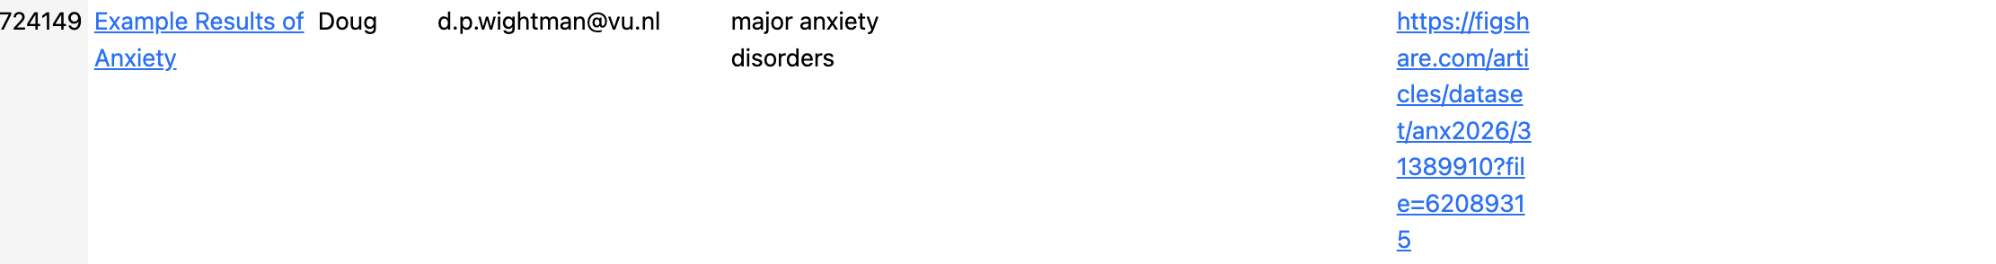
- For Alzheimer’s disease, you should click this line:

- For schizophrenia, you should click this line:
- For neuroticism, you should click this line:
For the older results (SCZ, NEU), you may get an AJAX warning that you can ignore.

Before you start answering question,
- Quickly look through what is covered in the tutorial page to get an idea of what FUMA can do
- Then click through the results and try to connect the results with the aspects of FUMA outlined in the presentation to get a better idea how the results were generated. If you don’t understand how results were generated, check the Tutorial Tab for methods descriptions.

As you saw in the presentation, SNPs located close to each other often show similar association signal (e.g., if SNP A is strongly associated then SNP B that lies right next to it will likely also show fairly strong association, i.e. low P-value). This has to do with the concept of linkage disequilibrium (LD).

Q1: What default LD threshold does FUMA apply to define independent significant SNPs? (see Watanabe et al. (2017) or tutorial).

Section: Summary of results
The questions below concern the ‘Summary of results’ section in FUMA.
Navigate to the Summary of Results tab.
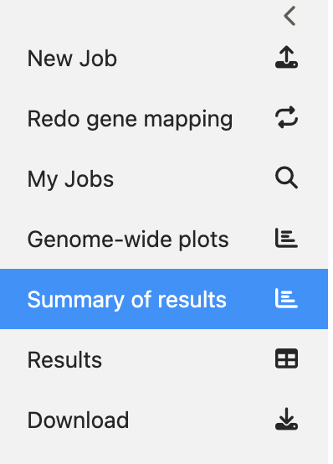
SNPs in exonic regions potentially affect the expression of the gene or the function of the gene product (protein).
Q2: How many SNPs are annotated to exonic regions in your example results? [Hint: hover over bar plot in Summary of Results Tab]

FUMA established genomic risk loci, based on the independent associations. If you scroll down you see four bar plots, showing information for each genomic locus.
Q3: What is the largest genomic locus? (Copy-paste the y-axis label). Is that a reasonable size for one locus? If not, what could have caused this?

Q4: Does this locus also contain the most SNPs? If not, which locus does? Why wouldn’t the largest locus always include the most SNPs?

Q5: Why does the number of genes physically located within a locus not always equal the number of genes that are mapped to the locus?

Section: Genome-wide plots
The questions below concern the ‘Genome-wide plots’ section in FUMA.
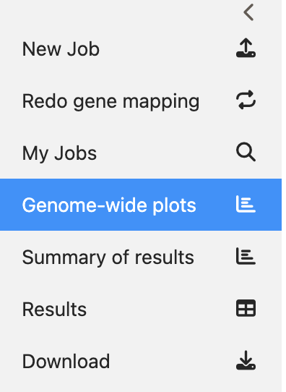
Below the SNP-level Manhattan plot you find the gene Manhattan plot. This figure shows the gene associations.
Q6: Why is the threshold for significance different from that in the SNP Manhattan plot?

Scrolling down you see a bar plot of 53 tissues, showing whether types of tissue are enriched for the genes associated to the trait of interest. In other words; this informs you on whether the identified genes are primarily expressed in a specific tissue type. For ANX and ALZ, there is also BrainSpan data with brain gene expression for different development stages. This analysis allows you to test whether gene expression at certain brain development stages are enriched for the genes associated to the trait of interest.
Q7: Is there a tissue type that shows significant enrichment? If so, which one(s)? Is this what you would expect, given the trait of interest? For ANX and ALZ, do any brain developmental stage results surprise you?

Section: Results
The questions below concern the ‘Results’ section in FUMA (note that this section has several tabs).
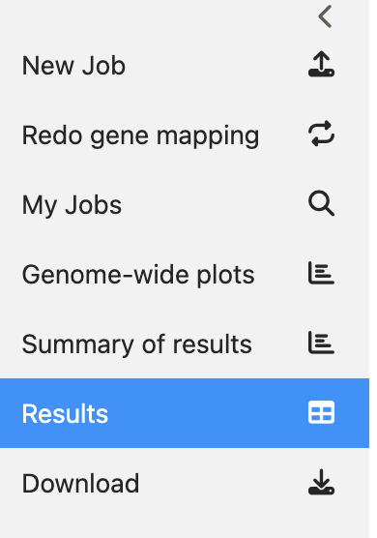
The ‘Genomic risk loci’ tab lists all genomic loci, and provides information on the location, the number of SNPs, the lowest SNP P-value etc. Moreover, if you click a locus, an interactive regional plot appears below the table (you can, for example, hover over a SNP for info on that particular SNP). Essentially this is a zoomed in version of the Manhattan plot, with each dot representing a SNP.
Depending on your trait of interest, create a regional plot for genomic locus number:
- Anxiety: 10
- Alzheimer’s disease: 98
- Schizophrenia: 97
- Neuroticism: 73
[If the plot does not appear, try refreshing the page and selecting the locus again]

Q8: What is the rsID of the top lead SNP? Which chromosome is it on? How many SNPs are in LD with this lead SNP? What is the minor allele frequency of the top lead SNP? [Hint: try hovering over the lead SNP]

Now click the ‘Plot’ button on the bottom to open a new window, showing the same regional plot with additional information. Try zooming, scrolling and clicking around to see what happens.
Q9: What is the nearest mapped gene to the lead SNP? [Hint: Click on the lead SNP]

The plot below shows the CADD score. Since GWAS often identifies many SNPs, we need a criterion to prioritize which ones to study further.
Q10: Why is the CADD score helpful for this? Which SNP has the highest CADD score in this locus? Is this below or above the threshold mentioned in Watanabe et al. (2017)?

Q11: Was the SNP with the highest CADD score genome-wide significant? Which gene was it in?

Q12: Are there any eQTLs in this locus? How specific are the eQTLs to a single gene?
You can search the specific SNPs in the results table eQTL tab using the chromosome and position (e.g. 3:52815905)

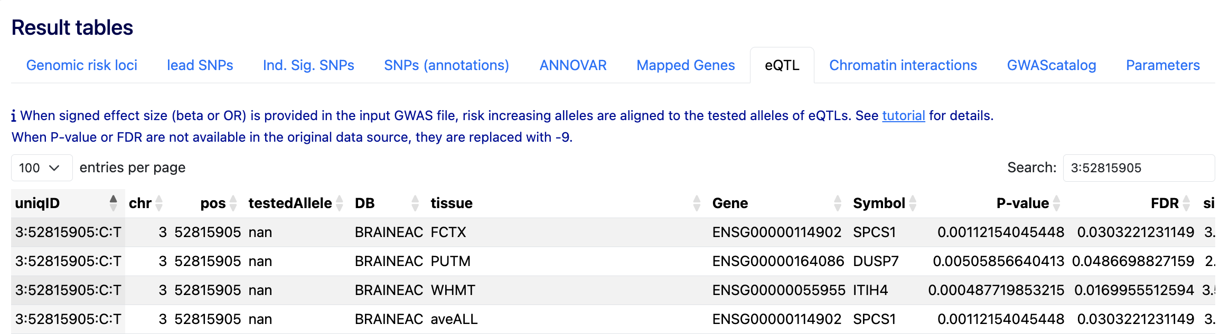

Q13: Based on these results, which gene would you recommend to study in more detail? Explain why. How does your recommendation change if you were to search for experimental literature about the genes in this locus?
Chromatin interactions
- In the ‘Results’ section, click ‘Chromatin interactions’. If you scroll down you find circos plots, showing eQTL and chromatin interactions per chromosome (read the info text on the circos plots). As mentioned earlier, this data allows SNPs in the locus to be mapped to distal genes.
[Hint: left click on the plot -> open image in new tab]
Q14: In the circos plots, do you find examples of these long-range interactions, where genes are implied through interactions with (physically) distant regions? How likely do you think these connections are to explain the causal chain from SNP to trait? What do the different layers and colors mean?

Section: GENE2FUNC
The GENE2FUNC module takes a list of genes, in this case all of the mapped genes from the SNP2GENE analysis, and then identifies the expression of those genes, whether drugs target these genes, and then performs hypergeometric tests to look for enrichment of the supplied genes in a range of gene-sets.
We will have a look at the ‘GWAS catalog reported genes’ (second-last), gene sets based on association with a large variety of traits (listed in the GWAS catalog).
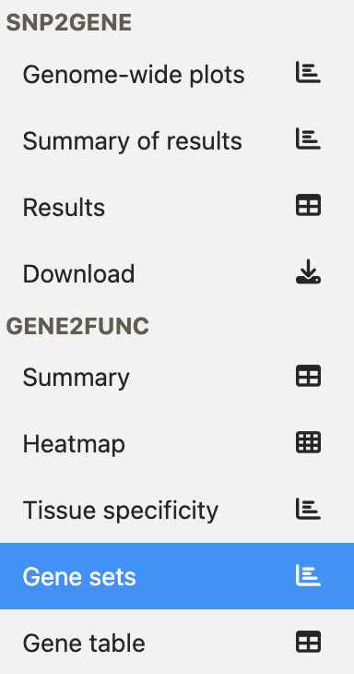
Q15: What are the top 3 gene sets reported for your trait? Does this surprise you? Look at the number of input genes in the GENE2FUNC summary tab. Do you think the number of genes is sensible given the number of loci and how do you think it affects the gene set results?

This is the end of the practical. If you have finished early, there are some bonus questions to think about and discuss below, along with some further reading.
Bonus Questions:
- How do gene-set enrichment analyses in MAGMA and GENE2FUNC compare?
- What are some limitations of FUMA?
- What are the assumptions behind the MAGMA gene property analysis implemented in FUMA?
- What is a limitation of using genes prioritised by FLAMES and PoPs as input for GENE2FUNC?
- What are some methods beyond FUMA to prioritise specific variant, genes, and pathways for experimental testing?
- Is every eQTL annotated in FUMA causally influencing gene expression?
- When finding multiple significant tissues in the tissue enrichment analyses, what are some follow-up steps you could perform?
- Below are some links to resources that have similar information to FUMA, try selecting a locus from the GWAS above and manually annotate information:
  - dbSNP – Search rsIDs to list SNP information including allele frequencies
  - LDlink – Perform multiple analyses that require a LD reference panel
  - GTEx – Search variants to identify whether they are eQTLs
  - OpenTargets – Search variants or genes for functional annotations

Further reading
FUMA:
- Watanabe (2017) - Functional mapping and annotation of genetic associations with FUMA
- Watanabe (2019) – FUMA cell type
Studies from which data was used:
- Ripke et al. (2014) - Biological insights from 108 schizophrenia-associated genetic loci
- Nagel et al., 2018 - Meta-analysis of genome-wide association studies for neuroticism in 449,484 individuals identifies novel genetic loci and pathways
Other tools
- de Leeuw et al. (2015) - MAGMA: Generalized Gene-Set Analysis of GWAS Data
- Schipper et al. (2025) - Prioritizing effector genes at trait-associated loci using multimodal evidence (FLAMES)
- Weeks et al. (2023) - Leveraging polygenic enrichments of gene features to predict genes underlying complex traits and diseases (PoPs)
- Avsec et al. (2026) - Advancing regulatory variant effect prediction with AlphaGenome

