Zelle ch2
Hunter Nelson

T/f 1-10

f

t

f

t

f

t

t

f

f

f

Problem1
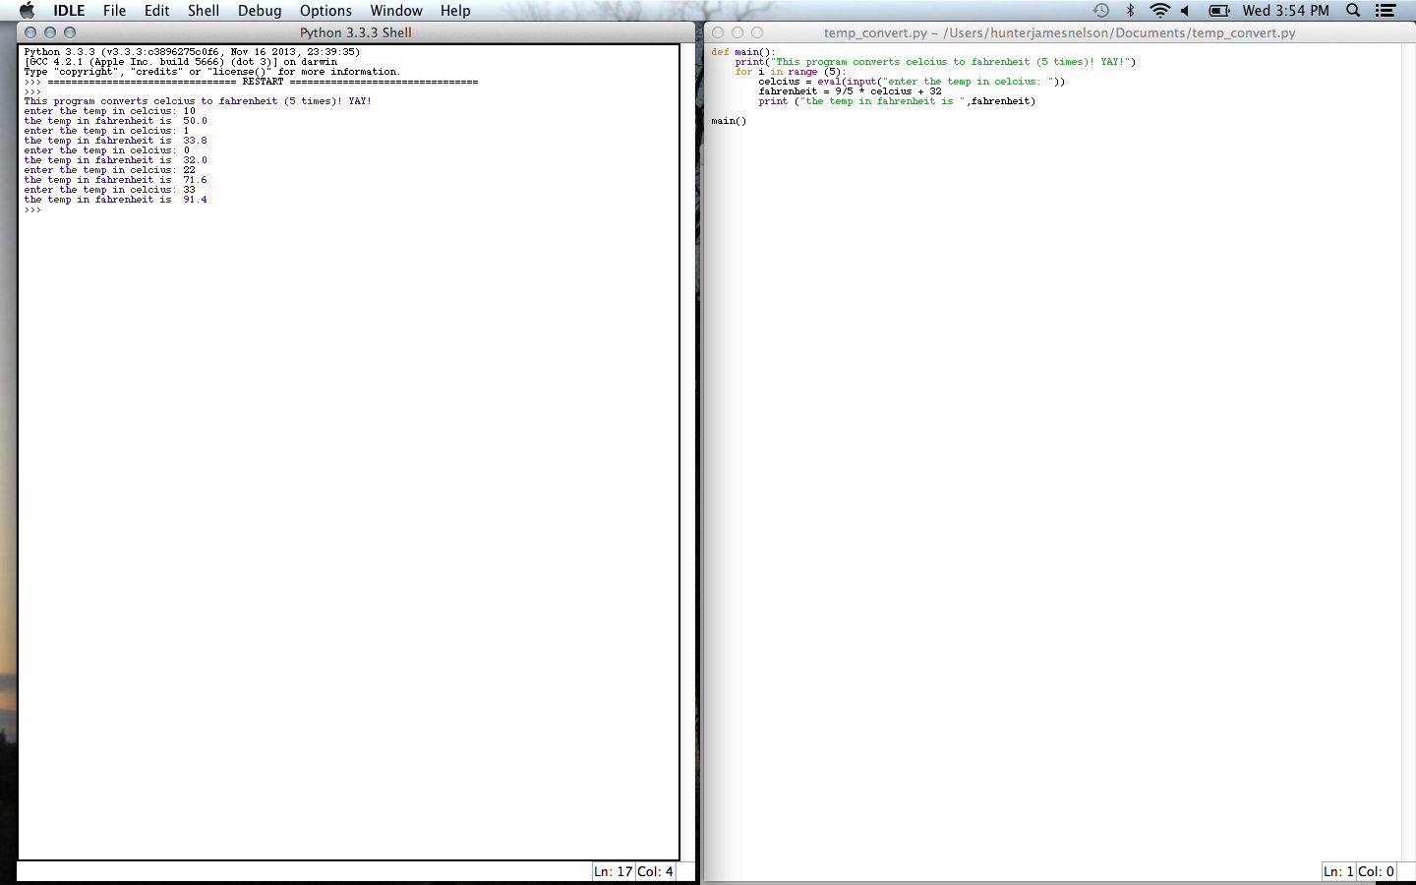

Problem3

Problem5 (I loved this one!) http://hunterjnelson.wordpress.com/2014/01/15/geeking-out-big-time/
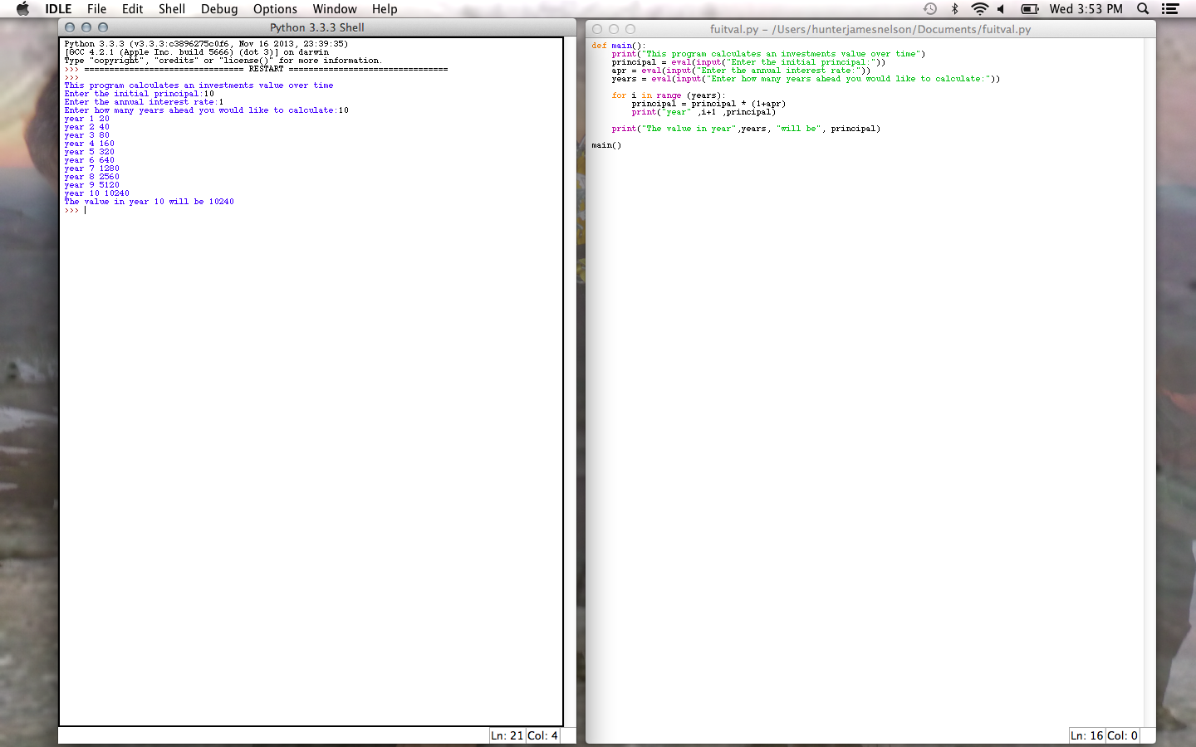

Problem7
