**00_IntroductionToObjects**

Main objective:

* Introduce what objects are
* Gain solid foundation of what creating an object is capable of doing

Standards (NYSED)

* 9-12.CT.4: Implement a program using a combination of student-defined and third-party functions to organize the computation.
* 9-12.CT.7: Design or remix a program that utilizes a data structure to maintain changes to related pieces of data

In class exercises

* Task 0: Introduce the idea of an object
  + Class definition of an object in real life (colloquial definition)
  + Show students example of a coded object using the examples from previous slides
* Task 1: Code bird objects
* Task 2: Create functions for bird objects
* Task 3: notes on functions statements vs function expressions
* Task 4: create more functions with function expressions
* Task 5: if time, start on homework

Notes/Handouts

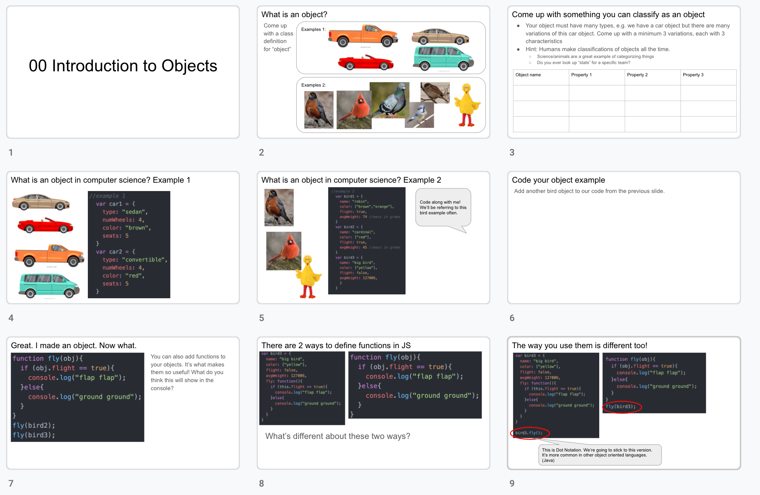

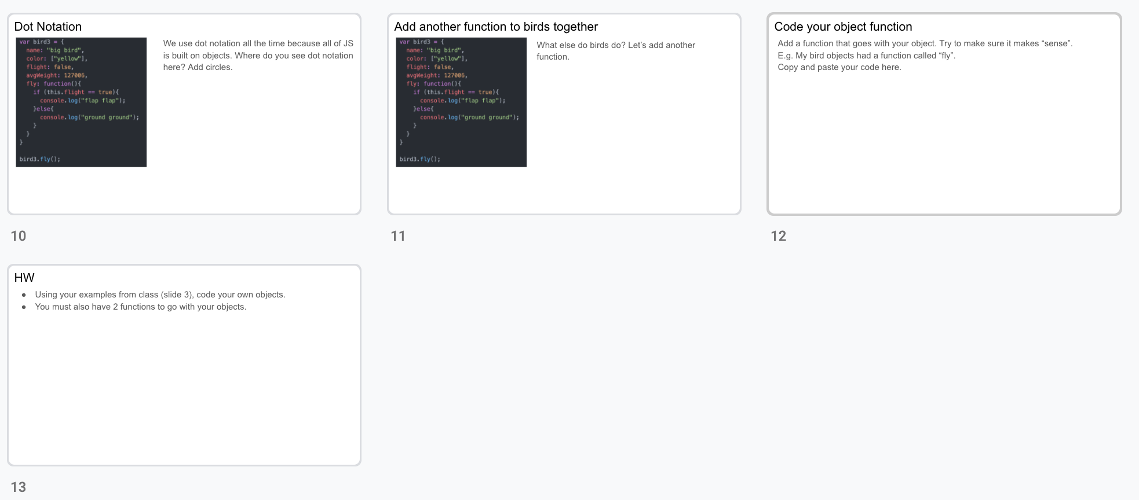



Resources:

* Object Introduction: <https://www.w3schools.com/js/js_objects.asp>
* Ways to declare functions: <https://www.telerik.com/blogs/four-ways-to-create-a-function-in-javascript>

Assignments: Practice with objects

* Students will think of a "set" of entities on a Ex: Superheroes, colleges, people, plants
* They will then come up with a bunch of properties superheroes have Ex: powers, origin, company, enemy, weakness
* Students will then create a set of objects (at least 5) using their example
* the students must be able to print their objects and their properties to their console using a loop.