**01_GettingComfortableWithObjects**

Main objective:

* Have students continue to practice using objects and thinking about their utility

Standards (NYSED)

* 9-12.CT.4: Implement a program using a combination of student-defined and third-party functions to organize the computation.
* 9-12.CT.7: Design or remix a program that utilizes a data structure to maintain changes to related pieces of data

In class exercises

* Students will get a re-cap of last class and what objects are
* Students will get an introduction of dot notation
* Students will have a code-along segment of teacher directed learning where students create a variety of objects and create functions for them.
* Students will problem solve through an array of object based problems requiring students to create objects and functions that go with objects. These will be student directed but teacher help available
* Students will then incorporate that problem solving logic with HTML DOM elements. This assignment is designed to prep them for their project with super heroes.

Notes

* 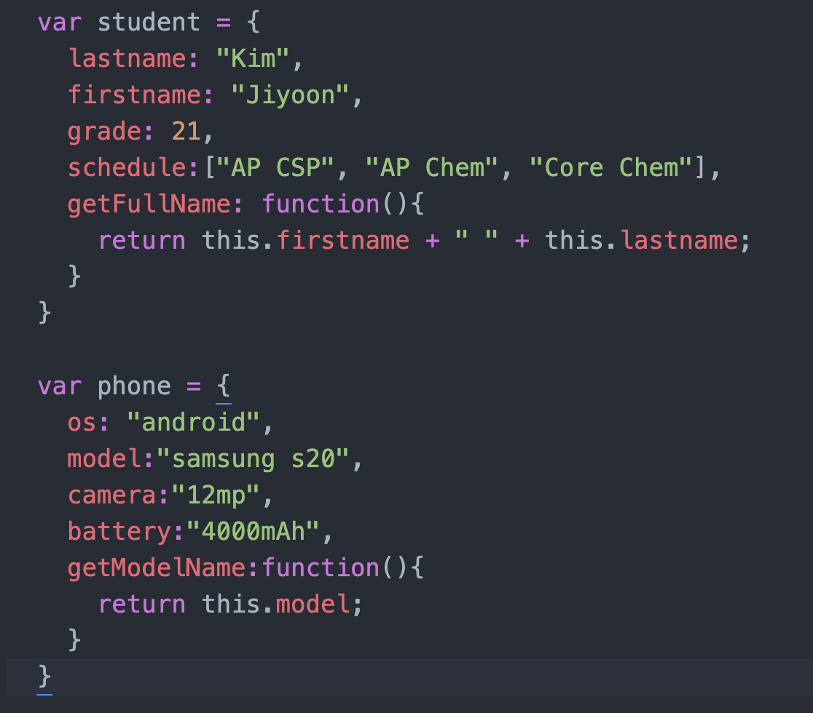

Handouts

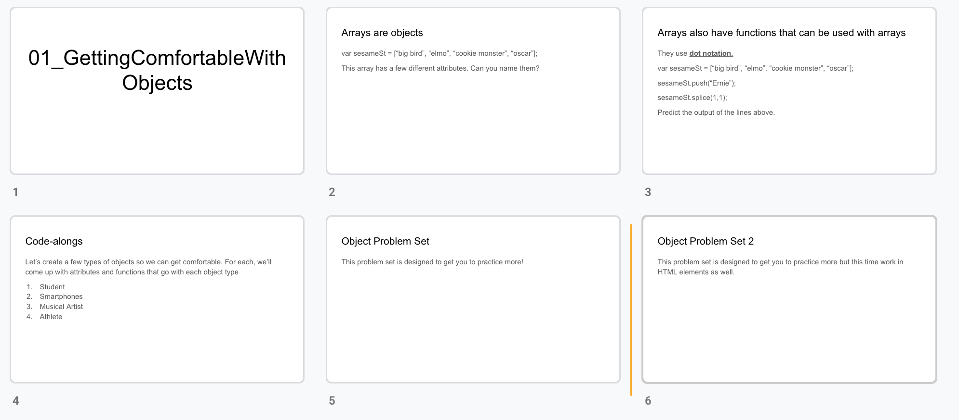

Resources

* Edabit Objects Challenges: <https://edabit.com/challenges>

Assignments:

* Study for quiz next class
* Finish whatever problem set wasn’t finished in class