**02_BrainstormingProject**

Main objective

* Assess students’ basic knowledge in constructing an object
* Introduce bootstrap as a designing library

Standards

* 9-12.CT.4: Implement a program using a combination of student-defined and third-party functions to organize the computation.
* 9-12.CT.7: Design or remix a program that utilizes a data structure to maintain changes to related pieces of data

In class exercises:

* Give students a quiz to assess beginning object knowledge
* Give students the project document to work on and brainstorm
* Students must have completed the project planning document and have coded 1 of their 10 objects before they leave class.

Notes/Handouts

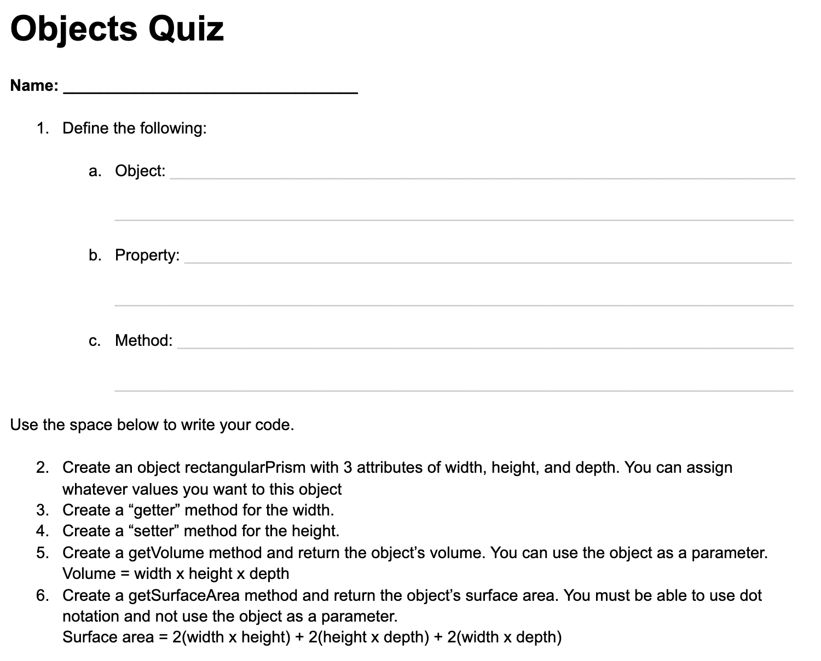

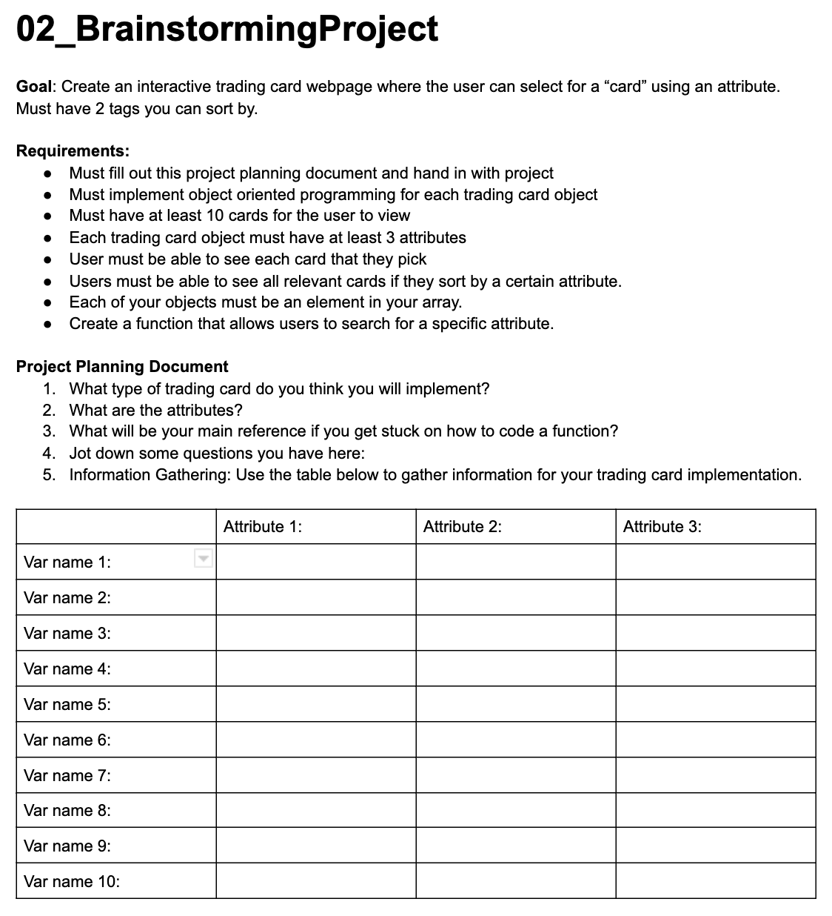

Resources

Assignments

* Finish project planning document for HW
* Code 1 out of 10 objects