Dear AMS Family,

Your well-being is our number one priority, and our goal this year is to provide you a rigorous and engaging education while also keeping our faculty, students, and families safe. To that end, we are asking all of our staff, students, and parents to download a contact tracer onto their smartphones that will allow us to keep track of possible COVID-19 infections.

**What is a contact tracing application?**

A contact tracer is a smart phone application that will send users alerts if they have come into contact with anyone who has become infected with COVID-19.

**A bit of background on contact tracer apps…**

There are two types of contact tracing applications: *centralized and decentralized.* Both send users alerts, but the difference between the two is who ultimately has access to your information.

With a **centralized** application, users are sent alerts when they have come into contact with COVID-19 and then a government agency, like the CDC, is alerted. The agency would then have access to the infected person’s name, phone number, and any other readily available information.

With a **decentralized** application, users are still sent alerts however the infected person’s information is not sent to any government regulated agency.

The image below breaks down the different between the two different types of apps:

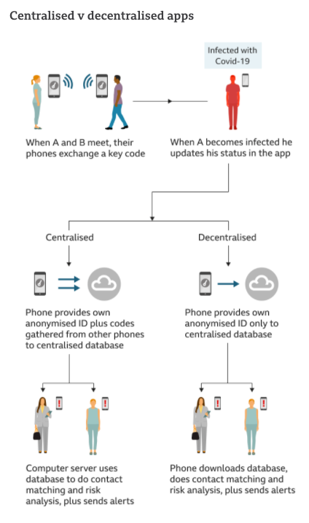

We understand that there are concerns around user privacy when it comes to applications like these, but we believe that downloading a **decentralized** application works to maintain the privacy of our AMS family and keep everyone safe.

**Who has to download an application?**

- All AMS staff. This includes all teachers, administrators, office staff, dean team, custodians, security guards, etc.

- All AMS students grades 6-12 who carry a smart phone with them through their day at school.

- All parents who will be coming to pick up their students from school.

**In short, anyone who is will be entering AMS will be asked to download a contact tracing application onto a device like a smart phone**

As always, if you have any questions or concerns please do not hesitate to reach out.

Thank you for your time and never ending commitment to keeping our AMS family safe,

- Jack Padalino