Example 6.2.6.1 — Marginal Zone Theory for Blood Flowing Down an Inclined Plane
Question
Red blood cells travel faster, on average, than plasma in small tubes, because red-cell centers cannot come closer to a wall than one cell radius, while plasma can. A thin region near the wall, the marginal zone, is therefore composed mainly of plasma. It can be modeled as a cell-free plasma layer of thickness $δ$ between the wall and the whole blood.
Blood flows down a plane inclined at angle $α$ to the horizontal, as a film of total thickness $h$ and width $W$ (Fig. 6.9). Treat the blood as a two-fluid system: a plasma layer “p” of viscosity $μ_{p}$ in $0≤y≤δ$, and whole blood “b” of viscosity $μ_{b}$ in $δ≤y≤h$, where $y$ is measured from the plate. Both fluids are Newtonian with the same density $ρ$.
Determine the velocity profile in each layer and the total volumetric flow rate. Compare the flow with that of a homogeneous Newtonian film of whole blood, and evaluate the comparison for $μ_{b}/μ_{p}=3$ with plasma layers $δ=2 μm$ and $δ=4 μm$.
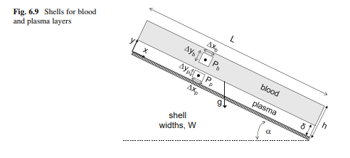
Shells in the plasma and blood layers of a film on an inclined plane
Given: $ρ$ (the same in both layers), $μ_{p}$, $μ_{b}$, $δ$, $h$, $W$ and $α$; for the comparison, $μ_{b}/μ_{p}=3$ and $δ=2$ or $4 μm$.
Additional assumptions: steady, laminar, fully developed parallel flow in both layers, so $v_{x}=v_{x}(y)$ only; the plasma and blood are immiscible and separated by a flat interface at $y=δ$; the gas above the film exerts no shear; entrance and exit effects are negligible.
Boundary conditions:
- No slip at the plate, from Equation (4.5): $v_{x,p}(0)=0$
- Zero shear stress at the free surface, from Equation (4.8): $τ_{yx,b}(h)=0$
- Continuity of velocity at the interface, from Equation (4.6): $v_{x,p}(δ)=v_{x,b}(δ)$
- Continuity of shear stress at the interface, from Equation (4.7): $τ_{yx,p}(δ)=τ_{yx,b}(δ)$

1 Find the shear-stress distribution in each layer
A momentum balance on a shell in either layer gives the same result as for the single-fluid film. Using Equation (6.22) in each layer
$$\frac{dτ_{yx}}{dy}=ρgsinα$$
Integrate in each layer, with a separate constant for each
$$τ_{yx,b}=\left(ρgsinα\right)y+C_{b} δ≤y≤h τ_{yx,p}=\left(ρgsinα\right)y+C_{p} 0≤y≤δ$$
Apply zero shear stress at the free surface, $τ_{yx,b}(h)=0$
$$0=\left(ρgsinα\right)h+C_{b} C_{b}=−ρghsinα$$
Apply continuity of shear stress at the interface, $τ_{yx,p}(δ)=τ_{yx,b}(δ)$
$$\left(ρgsinα\right)δ+C_{p}=\left(ρgsinα\right)δ−ρghsinα C_{p}=C_{b}=−ρghsinα$$
The shear stress is therefore the same linear function in both layers. This is Equation (6.25)
$$τ_{yx}=ρg\left(y−h\right)sinα 0≤y≤h$$
The shear stress depends only on the momentum balance and the free-surface condition, not on the viscosities.

2 Find the velocity profile in each layer
Substitute the Newtonian constitutive relation, using each layer’s viscosity. Using Equation (6.26)
$$−μ_{i}\frac{dv_{x}}{dy}=ρg\left(y−h\right)sinα \frac{dv_{x}}{dy}=\frac{ρgsinα}{μ_{i}}\left(h−y\right) i=p, b$$
Integrate with respect to $y$
$$v_{x,p}=\frac{ρgsinα}{μ_{p}}\left(hy−\frac{y^{2}}{2}\right)+C_{p2} v_{x,b}=\frac{ρgsinα}{μ_{b}}\left(hy−\frac{y^{2}}{2}\right)+C_{b2}$$
Apply no slip at the plate, $v_{x,p}(0)=0$
$$0=0+C_{p2} C_{p2}=0$$
Apply continuity of velocity at the interface, $v_{x,b}(δ)=v_{x,p}(δ)$
$$\frac{ρgsinα}{μ_{b}}\left(hδ−\frac{δ^{2}}{2}\right)+C_{b2}=\frac{ρgsinα}{μ_{p}}\left(hδ−\frac{δ^{2}}{2}\right)$$
Solve for $C_{b2}$ and factor out $ρgh^{2}sinα/μ_{b}$
$$C_{b2}=ρgsinα\left(hδ−\frac{δ^{2}}{2}\right)\left(\frac{1}{μ_{p}}−\frac{1}{μ_{b}}\right)=\frac{ρgh^{2}sinα}{μ_{b}}\left(\frac{μ_{b}}{μ_{p}}−1\right)\left(\frac{δ}{h}−\frac{1}{2}\frac{δ^{2}}{h^{2}}\right)$$
Substitute the constants. In each layer, factor $h^{2}$ out of $hy−y^{2}/2$
$$\boxed{0≤y≤δ: v_{x,p}=\frac{ρgh^{2}sinα}{μ_{p}}\left(\frac{y}{h}−\frac{1}{2}\frac{y^{2}}{h^{2}}\right)}$$
$$\boxed{δ≤y≤h: v_{x,b}=\frac{ρgh^{2}sinα}{μ_{b}}\left[\left(\frac{y}{h}−\frac{1}{2}\frac{y^{2}}{h^{2}}\right)+\left(\frac{μ_{b}}{μ_{p}}−1\right)\left(\frac{δ}{h}−\frac{1}{2}\frac{δ^{2}}{h^{2}}\right)\right]}$$
The blood layer moves as if it were a homogeneous film riding on a faster, less viscous plasma layer. The second term in the blood profile is a uniform velocity increase, carried up from the plasma layer.
Check the velocity gradient at the interface. The shear stress is continuous but the viscosities differ, so
$${\left.{\left(\frac{dv_{x}}{dy}\right)}_{b}\right|}_{y=δ}=\frac{μ_{p}}{μ_{b}}{\left.{\left(\frac{dv_{x}}{dy}\right)}_{p}\right|}_{y=δ}$$
The profile has a kink at $y=δ$: the plasma shears three times as steeply as the blood when $μ_{b}/μ_{p}=3$.

3 Calculate the total volumetric flow rate
Add the flow in the two layers
$$Q_{V}=\int_{0}^{δ}{v_{x,p}} W dy+\int_{δ}^{h}{v_{x,b}} W dy$$
Change to $ξ=y/h$, $dy=h dξ$, and write $d=δ/h$, $m=μ_{b}/μ_{p}$ and $f(ξ)=ξ−ξ^{2}/2$. Because $1/μ_{p}=m/μ_{b}$, both layers share the factor $ρgh^{2}sinα/μ_{b}$
$$Q_{V}=\frac{ρgWh^{3}sinα}{μ_{b}}\left[m\int_{0}^{d}{f}(ξ) dξ+\int_{d}^{1}{f}(ξ) dξ+\left(m−1\right)f(d)\left(1−d\right)\right]$$
Integrate $f$, using $F(ξ)=ξ^{2}/2−ξ^{3}/6$ with $F(1)=1/3$
$$m F(d)+\left[\frac{1}{3}−F(d)\right]+\left(m−1\right)f(d)\left(1−d\right)=\frac{1}{3}+\left(m−1\right)\left[F(d)+f(d)\left(1−d\right)\right]$$
Expand the bracket
$$F(d)+f(d)\left(1−d\right)=\frac{d^{2}}{2}−\frac{d^{3}}{6}+d−d^{2}−\frac{d^{2}}{2}+\frac{d^{3}}{2}=d−d^{2}+\frac{d^{3}}{3}$$
Collect terms and factor out $1/3$
$$\boxed{Q_{V}=\frac{ρgWh^{3}sinα}{3μ_{b}}\left\{1+3\left(\frac{μ_{b}}{μ_{p}}−1\right)\frac{δ}{h}\left[1−\frac{δ}{h}+\frac{1}{3}{\left(\frac{δ}{h}\right)}^{2}\right]\right\}}$$

4 Compare with a homogeneous blood film
For a homogeneous film of whole blood, the flow rate is Equation (6.31) with $μ=μ_{b}$
$$Q_{V,\text{hom}}=\frac{ρgWh^{3}sinα}{3μ_{b}}$$
Divide the bi-layer flow by the homogeneous flow
$$\boxed{\frac{Q_{V}}{Q_{V,\text{hom}}}=1+3\left(\frac{μ_{b}}{μ_{p}}−1\right)\frac{δ}{h}\left[1−\frac{δ}{h}+\frac{1}{3}{\left(\frac{δ}{h}\right)}^{2}\right]}$$
Check the limits:
- $μ_{b}=μ_{p}$ (no hematocrit difference): the ratio is 1, and Equation (6.31) is recovered.
- $δ/h→0$ (a film much thicker than the plasma layer): the ratio tends to 1.
- $δ=h$ (the whole film is plasma): the bracket equals $1/3$ and the ratio equals $μ_{b}/μ_{p}$, the flow of a plasma film.
Evaluate for $μ_{b}/μ_{p}=3$, so $3\left(μ_{b}/μ_{p}−1\right)=6$. For $δ=4 μm$ and $h=250 μm$, $δ/h=0.016$
$$\frac{Q_{V}}{Q_{V,\text{hom}}}=1+6\left(0.016\right)\left[1−0.016+\frac{1}{3}{\left(0.016\right)}^{2}\right]=1+\left(0.096\right)\left(0.9841\right)=1.094$$
For $δ=2 μm$ and $h=250 μm$, $δ/h=0.008$
$$\frac{Q_{V}}{Q_{V,\text{hom}}}=1+6\left(0.008\right)\left[1−0.008+\frac{1}{3}{\left(0.008\right)}^{2}\right]=1+\left(0.048\right)\left(0.9920\right)=1.048$$
The same formula at other film thicknesses gives:
$h$ ($μm$) | $δ=2 μm$ | $δ=4 μm$
10 | 1.98 | 2.57
50 | 1.23 | 1.44
100 | 1.12 | 1.23
250 | 1.05 | 1.09
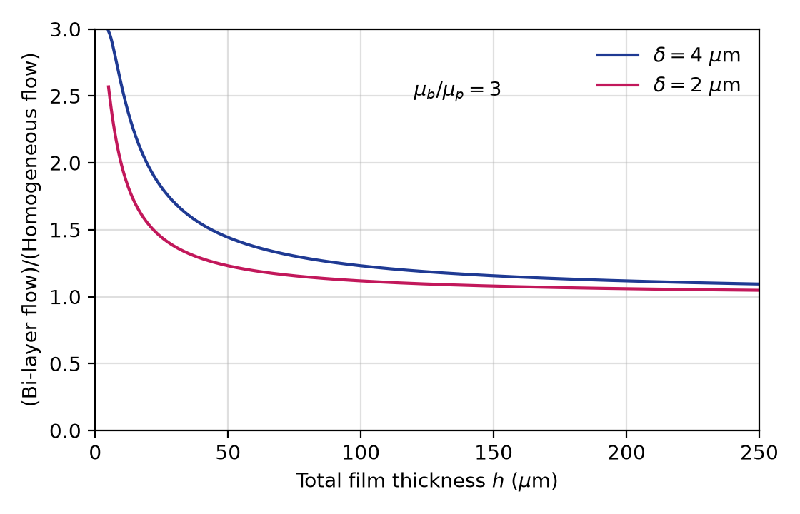
Flow ratio of a bi-layer film to a homogeneous blood film, computed from the result of Section 4 with μb/μp = 3
The plotted curves reproduce Fig. 6.10.
The cell-free plasma layer increases flow compared with a homogeneous blood film, because the low-viscosity plasma lubricates the wall region where the shear rate is highest. The increase is large for thin films (about 2 to 2.6 times at h = 10 μm) and falls to 5–9% at h = 250 μm for plasma layers of 2–4 μm. This “plasma skimming” effect lowers the apparent viscosity of blood in thin films and narrow tubes.
Check: the flow-rate formula was verified by numerically integrating both velocity profiles. Units: $\left(kg/m^{3}\right)\left(m/s^{2}\right)\left(m\right)\left(m^{3}\right)/\left(Pa⋅s\right)=m^{3}/s$, and the bracketed factor is dimensionless.
Check against the source solution: the flow rate, flow ratio and interpretation are correct. As transcribed, the source writes the constitutive relation as $μ dv_{x}/dy=ρg\left(y−h\right)sinα$, without the negative sign of Equation (6.26). Its velocity profiles then carry brackets of the form $\left(\frac{1}{2}\frac{y^{2}}{h^{2}}−\frac{y}{h}\right)$, which would give negative (up-slope) velocities. With the sign of Equation (6.26), the brackets are $\left(\frac{y}{h}−\frac{1}{2}\frac{y^{2}}{h^{2}}\right)$, as above, and the velocities are positive down the plane. The source also calls the interface velocity condition a “no-slip” condition; it is the velocity-continuity condition of Equation (4.6).
Model note: representing the marginal zone as a sharp plasma layer of fixed thickness is an idealization; in reality the hematocrit rises gradually away from the wall. The Newtonian assumption is reasonable near the plate, where shear rates are high. It fails near the free surface, where the shear stress falls to zero and the yield stress of blood can create a slowly sheared or plug-like layer.

