Problem 7 — Falling Film on an Inclined Plane
Question
The velocity profile of a liquid flowing down an inclined plane, as shown in the figure, is
$$v_{z}=\frac{ρgδ^{2}cosβ}{2μ}\left[1−{\left(\frac{x}{δ}\right)}^{2}\right]$$
- Where is the maximum velocity?
- What is the average velocity over the cross-section of the falling film?
- What is the mass flow?
- What is the film thickness?
- Confirm that the equation above applies
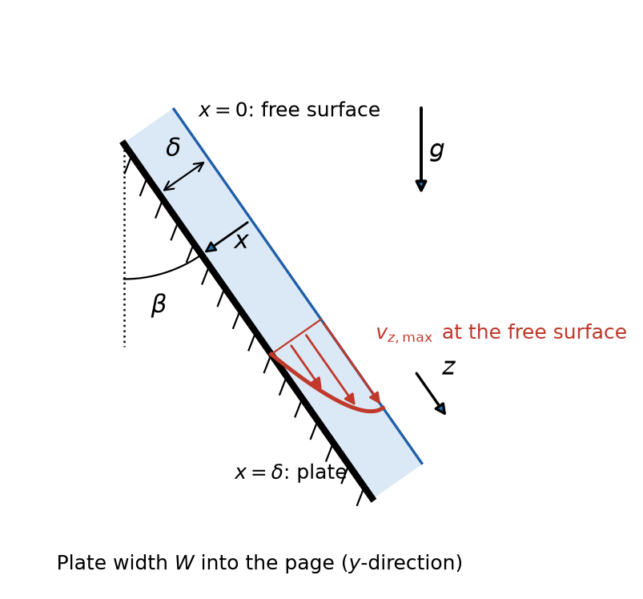
Liquid film of thickness δ flowing down a plate inclined at angle β from the vertical
Given: the velocity profile $v_{z}(x)$, in which $ρ$ is the liquid density, $μ$ its viscosity, $g$ the gravitational acceleration, $δ$ the film thickness and $β$ the angle between the plate and the vertical. No numerical values are given, so the solution stays symbolic.
Coordinates, as implied by the profile: $z$ points down the plate in the flow direction; $x$ is measured from the free surface ($x=0$) into the film to the plate ($x=δ$); $y$ runs across the plate width, $0≤y≤W$.
Additional assumptions: steady, fully developed, laminar flow of an incompressible Newtonian liquid with constant properties; the film is far from the entrance and exit, so end effects are negligible; the gas above the free surface exerts negligible shear.
Link to the slides: the slides solve the same falling film with $y$ measured from the plate, film thickness $h$ and inclination $α$ measured from the horizontal, in Equations (6.28)–(6.32). Because $α={90}^{∘}−β$, $sinα=cosβ$, and with $h=δ$ the results below reduce to those equations.

1 Locate the maximum velocity
Differentiate the profile with respect to $x$
$$\frac{dv_{z}}{dx}=\frac{ρgδ^{2}cosβ}{2μ}\left(−\frac{2x}{δ^{2}}\right)=−\frac{ρgcosβ}{μ}x$$
Set the derivative to zero
$$−\frac{ρgcosβ}{μ}x=0 x=0$$
The second derivative, $d^{2}v_{z}/dx^{2}=−ρgcosβ/μ$, is negative, so $x=0$ is a maximum. Substitute $x=0$ into the profile
$$\boxed{v_{z,max}=v_{z}(0)=\frac{ρgδ^{2}cosβ}{2μ} \text{at the free surface, }x=0}$$
The maximum velocity occurs at the free surface. There the shear stress is zero, the liquid–gas boundary condition of Equation (4.8), so the velocity gradient vanishes. This matches Equation (6.29) with $h=δ$ and $sinα=cosβ$.

2 Calculate the average velocity
Average the velocity over the film cross-section, $0≤x≤δ$ and $0≤y≤W$
$$⟨v_{z}⟩=\frac{\int_{0}^{W}{\int_{0}^{δ}{v_{z}}} dx dy}{\int_{0}^{W}{\int_{0}^{δ}{d}}x dy}$$
The velocity does not depend on $y$, so the $y$-integrals cancel
$$⟨v_{z}⟩=\frac{W\int_{0}^{δ}{v_{z}} dx}{Wδ}=\frac{1}{δ}\int_{0}^{δ}{v_{z}} dx$$
Substitute the profile and change to the dimensionless position $ξ=x/δ$, so $dx=δ dξ$ with limits $0$ and $1$
$$⟨v_{z}⟩=\frac{ρgδ^{2}cosβ}{2μ}\int_{0}^{1}{\left(1−ξ^{2}\right)}dξ$$
Integrate
$$\int_{0}^{1}{\left(1−ξ^{2}\right)}dξ={\left[ξ−\frac{ξ^{3}}{3}\right]}_{0}^{1}=1−\frac{1}{3}=\frac{2}{3}$$
Multiply by the prefactor
$$\boxed{⟨v_{z}⟩=\frac{ρgδ^{2}cosβ}{3μ}=\frac{2}{3}v_{z,max}}$$
The average velocity is two-thirds of the free-surface velocity. This matches Equation (6.30) with $h=δ$ and $sinα=cosβ$.

3 Calculate the mass flow rate
Integrate the mass flux, $ρv_{z}$, over the film cross-section. The integral of $v_{z}$ is the average velocity times the area $Wδ$
$$w=\int_{0}^{W}{\int_{0}^{δ}{ρ}}v_{z} dx dy=ρWδ⟨v_{z}⟩$$
Substitute the average velocity from Section 2
$$\boxed{w=\frac{ρ^{2}gWδ^{3}cosβ}{3μ}}$$
The mass flow rate grows with the cube of the film thickness. This equals $ρ$ times the volumetric flow rate of Equation (6.31), with $h=δ$ and $sinα=cosβ$.

4 Express the film thickness
Solve the average-velocity result of Section 2 for $δ$
$$δ^{2}=\frac{3μ⟨v_{z}⟩}{ρgcosβ} δ={\left(\frac{3μ⟨v_{z}⟩}{ρgcosβ}\right)}^{1/2}$$
Alternatively, solve the mass-flow result of Section 3 for $δ$, which is more useful when the flow rate is known
$$δ^{3}=\frac{3μw}{ρ^{2}gWcosβ}$$
$$\boxed{δ={\left(\frac{3μ⟨v_{z}⟩}{ρgcosβ}\right)}^{1/2}={\left(\frac{3μw}{ρ^{2}gWcosβ}\right)}^{1/3}}$$
For a given flow rate, the film thickness varies as the cube root of the flow per unit width. This matches Equation (6.32) with $Q_{V}=w/ρ$, $h=δ$ and $sinα=cosβ$.

5 Confirm that the velocity profile applies
The parabolic profile was derived for steady, laminar, rectilinear flow. It applies only if the Reynolds number of the film is low enough for the flow to be laminar. The Reynolds number compares convective and molecular transport of momentum. Using Equation (3.7), with the characteristic length taken as the hydraulic diameter $D_{h}$
$$Re=\frac{ρ⟨v_{z}⟩D_{h}}{μ}$$
The hydraulic diameter is four times the flow area $A$ divided by the wetted perimeter $P$. This definition does not appear on the slides
$$D_{h}=\frac{4A}{P}$$
The film has flow area $A=Wδ$. Only the plate surface is wetted, because the free surface is in contact with gas, so $P=W$
$$D_{h}=\frac{4Wδ}{W}=4δ$$
Substitute $D_{h}=4δ$, then use $⟨v_{z}⟩=w/\left(ρWδ\right)$ from Section 3
$$Re=\frac{4δ⟨v_{z}⟩ρ}{μ}=\frac{4δρ}{μ}⋅\frac{w}{ρWδ}=\frac{4w}{Wμ}$$
The profile applies when the film Reynolds number, Re = 4δ⟨v_z⟩ρ/μ = 4w/(Wμ), is below about 1500, so that the flow is laminar. For the film surface to stay smooth, as assumed in the derivation, Re should be below about 20. The film must also be far from the entrance and exit, and the fluid must be Newtonian with constant properties.
Interpretation: the upper limit of about 1500 marks the change from laminar to turbulent film flow. Between about 20 and 1500, the flow is still laminar, but ripples form on the free surface, so the flat-surface profile is only approximate. Below about 20, the profile applies exactly.
Check: units of $⟨v_{z}⟩$: $(kg/m^{3})(m/s^{2})(m^{2})/(Pa⋅s)=(kg/(m⋅s^{2})) m/(kg/(m⋅s))=m/s$. Units of $w$: $(kg/m^{3})(m)(m)(m/s)=kg/s$. The Reynolds number is dimensionless: $(kg/s)/(m⋅Pa⋅s)=(kg/s)/(kg/s)=1$. In the limit $β={90}^{∘}$ (horizontal plate), $cosβ=0$ and all flow stops, as expected.
Check against the source solution: all of the source’s results are correct. It cites “5.62 and 5.90” for the hydraulic diameter. Those equation numbers do not appear on the slides, so they are omitted here, and $D_{h}=4A/P$ is presented without a number. The limit of 1500 in the source is the laminar–turbulent transition. The profile is exact only for a smooth, ripple-free film, below $Re≈20$.

