数据库原理（1）期末报告

小组成员
姓名 | 学号
汪江豪 | 22121630
董晓鸥 | 22121397

- 题目选择：
实验4:Spark-SQL分布式数据库查询-推荐系统（大数据集）
- 实验思路：
使用两个中间表ref_count记录每个网站的外部标签数；common记录任意两个网站的公共标签数量。并集|A U B| = |A| + |B| - |A ^ B|,最后交集÷并集即为两个网站之间的相似度。
- 实验步骤：
- 准备工作：
与实验4步骤基本相同，在腾讯云上租用3台云服务器，先搭建好基于hadoop的分布式文件系统，在hadoop目录下运行sbin/start-all.sh，启动hadoop，三台节点master,slave01,slave02，查询jps，确保datanode等信息出现。
- 设置工作节点：
(1)将slave01,slave02设为工作节点，master默认作为任务调度和资源分配节点。以下给出方法：在spark目录下,cd conf,打开spark-env.sh，在头部新增
export HADOOP_CONF_DIR=/usr/local/hadoop/etc/hadoop
将hadoop下的配置文件保存到spark配置文件的环境变量中，以便启动spark-sql时使用资源分配命令。
- 启动spark-sql，将slave01,slave02设为工作节点：
在spark目录下运行命令：
bin/spark-sql –master yarn –num-executors 2
该命令指明启动spark-sql时，选择salve01,slave02作为工作节点。
- 将大数据集上床到hdfs上后，使用如下命令导入大数据集，并创建为relation表，列属性名为referrer,referree，数据类型为int。
create table relation(
referrer int,
referree int
)
using csv
options(
path "./large_relation",
delimiter ' ',
header 'false'
);
- 使用连接方式进行查询：
语句如下，由于结果有6400万多行，为了节省数据打印时间，这里限制返回最多500行：
with ref_count as (select referrer, count(distinct referree) as web_count
from relation group by referrer),
common as (select a.referrer as web1, b.referrer as web2, count(*) as com_cnt
from relation a join relation b
on a.referree = b.referree
where a.referrer < b.referrer
group by a.referrer, b.referrer)
select common.web1 as web1, common.web2 as web2,
case when r1.web_count + r2.web_count - common.com_cnt > 0
then common.com_cnt / (r1.web_count + r2.web_count - common.com_cnt)
else 0
end as similarity
from common join ref_count r1 on common.web1 = r1.referrer
join ref_count r2 on common.web2 = r2.referrer
order by similarity desc limit 500;
运行状况截图：
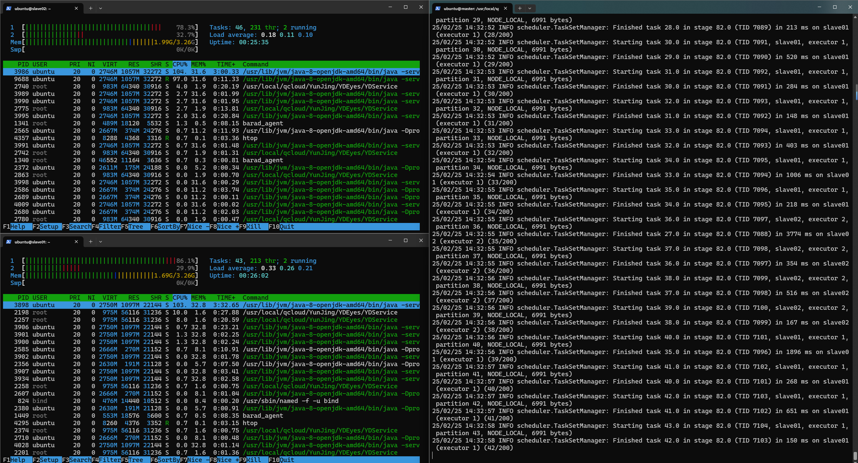截图显示：在执行查询过程中，slave01,slave02共4个CPU核心均处于工作状态，表明查询计算成功分布在两台机器上。
结果展示：
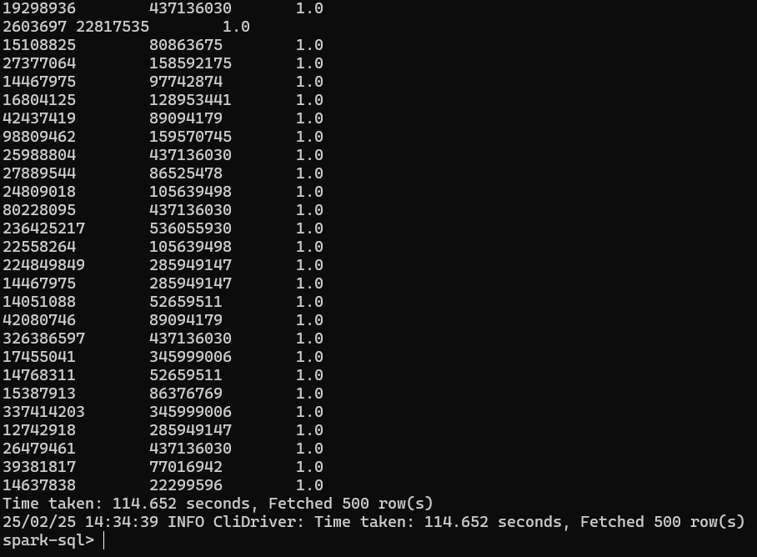
耗时114.652秒完成。
- 更多方式尝试
为了比较不同方式速度差异，我将实验4的其余几种查询语句也进行了测试，sql语句以及结果如下：
·嵌套相关子查询
查询语句：
WITH ref_count AS (
SELECT referrer, COUNT(DISTINCT referree) AS web_count
FROM relation
GROUP BY referrer
),
common AS (
SELECT
a.referrer AS web1,
b.referrer AS web2,
COUNT(*) AS com_cnt,
min((SELECT web_count FROM ref_count WHERE referrer = a.referrer)) AS web1_count,
min((SELECT web_count FROM ref_count WHERE referrer = b.referrer)) AS web2_count
FROM relation a
JOIN relation b ON a.referree = b.referree
WHERE a.referrer < b.referrer
GROUP BY a.referrer, b.referrer
)
SELECT
common.web1,
common.web2,
CASE
WHEN common.web1_count + common.web2_count - common.com_cnt > 0
THEN common.com_cnt / (common.web1_count + common.web2_count - common.com_cnt)
ELSE 0
END AS similarity
FROM common ORDER BY similarity DESC LIMIT 500;
查询结果：
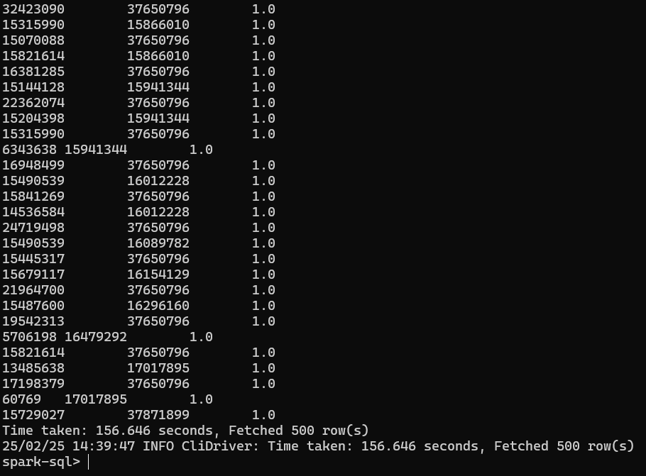
耗时156.646s完成。
·嵌套不相关子查询：
查询语句：
WITH ref_count AS (
SELECT referrer, COUNT(DISTINCT referree) AS web_count
FROM relation
GROUP BY referrer
),
common AS (
SELECT a.referrer AS web1, b.referrer AS web2, COUNT(*) AS com_cnt
FROM relation a
JOIN relation b ON a.referree = b.referree
WHERE a.referrer < b.referrer
GROUP BY a.referrer, b.referrer
)
SELECT common.web1, common.web2,
CASE WHEN r1.web_count + r2.web_count - common.com_cnt > 0
THEN common.com_cnt / (r1.web_count + r2.web_count - common.com_cnt)
ELSE 0 END AS similarity
FROM common JOIN (
SELECT referrer, web_count
FROM ref_count
WHERE referrer IN (SELECT web1 FROM common)
) r1 ON common.web1 = r1.referrer
JOIN (
SELECT referrer, web_count
FROM ref_count
WHERE referrer IN (SELECT web2 FROM common)
) r2 ON common.web2 = r2.referrer order by similarity desc limit 500;
查询结果：
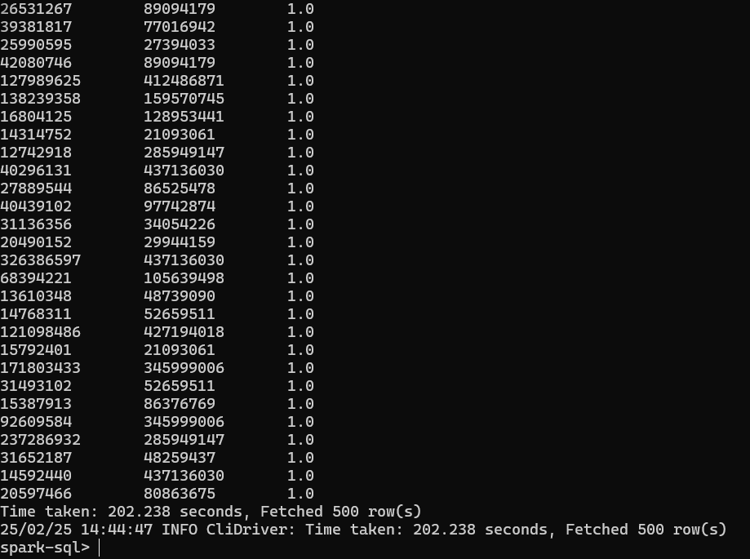
耗时202.238s完成
·intersect操作：
查询语句：
WITH ref_count AS (
SELECT referrer, COUNT(DISTINCT referree) AS web_count
FROM relation GROUP BY referrer),
common as (select a.referrer as web1, b.referrer as web2, count(*) as com_cnt
from relation a join relation b
on a.referree = b.referree
where a.referrer < b.referrer
group by a.referrer, b.referrer)
SELECT common.web1, common.web2,
CASE WHEN r1.web_count + r2.web_count - common.com_cnt > 0
THEN common.com_cnt / (r1.web_count + r2.web_count - common.com_cnt)
ELSE 0 END AS similarity
FROM common JOIN (
SELECT referrer, web_count FROM ref_count
WHERE referrer IN (
SELECT web1 FROM common
INTERSECT
SELECT referrer FROM ref_count)
) r1 ON common.web1 = r1.referrer
JOIN (
SELECT referrer, web_count
FROM ref_count
WHERE referrer IN (
SELECT web2 FROM common
INTERSECT
SELECT referrer FROM ref_count)
) r2 ON common.web2 = r2.referrer order by similarity desc limit 500;
查询结果：
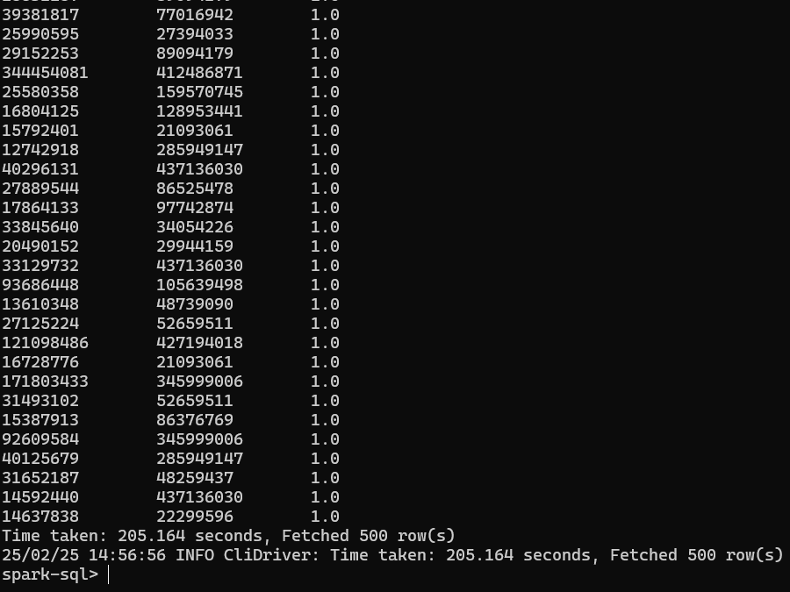
耗时205.164s完成
·exists方式：
查询语句：
WITH ref_count AS (
SELECT referrer, COUNT(DISTINCT referree) AS web_count
FROM relation
GROUP BY referrer),
common AS (
SELECT a.referrer AS web1, b.referrer AS web2, COUNT(*) AS com_cnt
FROM relation a
JOIN relation b ON a.referree = b.referree
WHERE a.referrer < b.referrer
GROUP BY a.referrer, b.referrer)
SELECT
common.web1,
common.web2,
CASE
WHEN r1.web_count + r2.web_count - common.com_cnt > 0
THEN common.com_cnt / (r1.web_count + r2.web_count - common.com_cnt)
ELSE 0
END AS similarity
FROM common JOIN (
SELECT referrer, web_count
FROM ref_count r
WHERE EXISTS (SELECT 1 FROM common c WHERE c.web1 = r.referrer)
) r1 ON common.web1 = r1.referrer
JOIN (
SELECT referrer, web_count
FROM ref_count r
WHERE EXISTS (SELECT 1 FROM common c WHERE c.web2 = r.referrer)
) r2 ON common.web2 = r2.referrer
ORDER BY similarity DESC LIMIT 500;
查询结果：
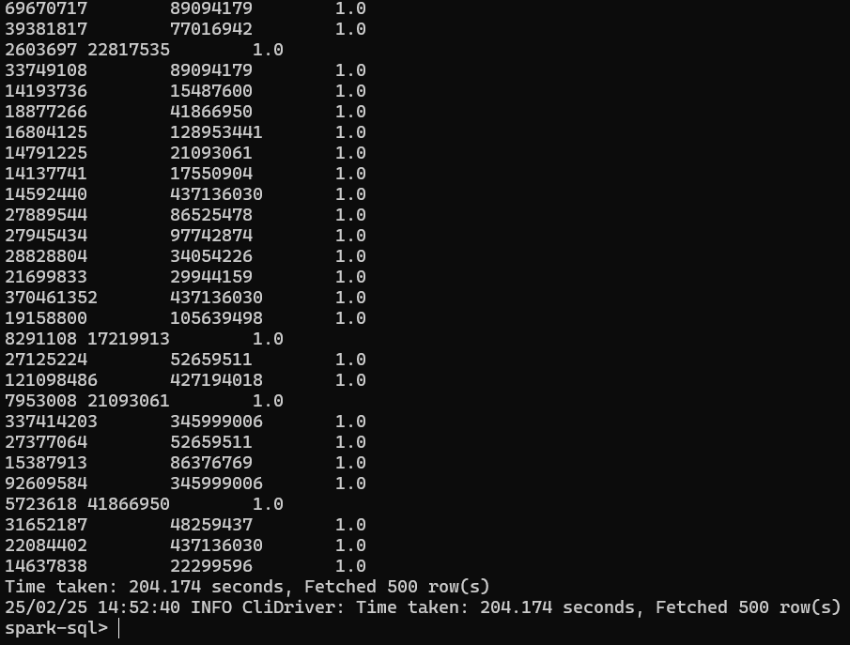
耗时204.174s完成。
- 查询验证
为了方便后续查询验证，我先前将临时表ref_count,common保存为了中间表tmp_ref_count,tmp_common，相似度计算结果表保存到了result。
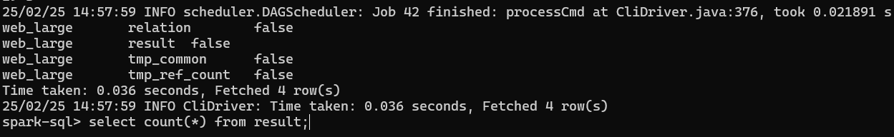

查询result表数据行数：
耗时7678s完成，显示结果64195979行，可见表及其庞大。
1.查询相似度位于0.72~0.73的记录，返回最多30条。
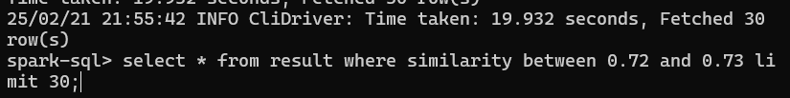
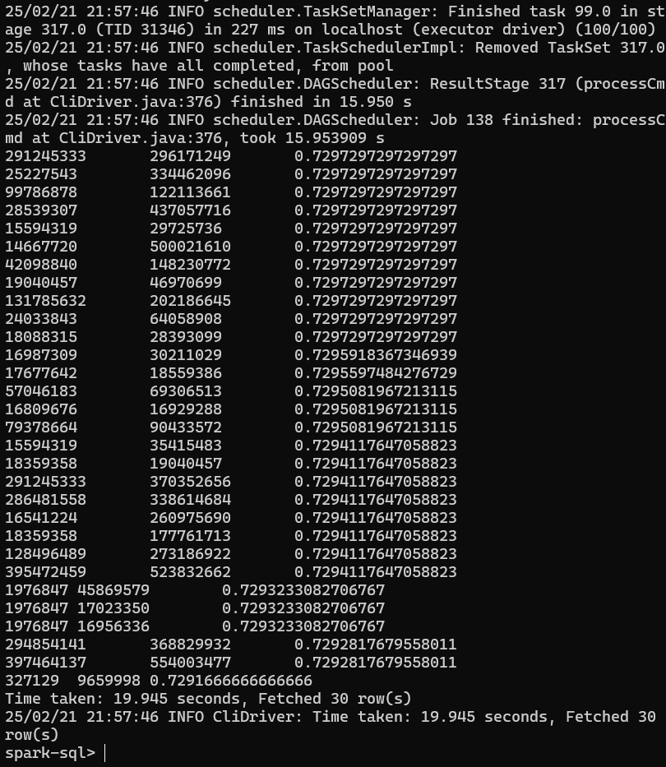
耗时19.945s完成查询，返回了30行数据。
2.查询相似度为0.9的记录，最多30条。
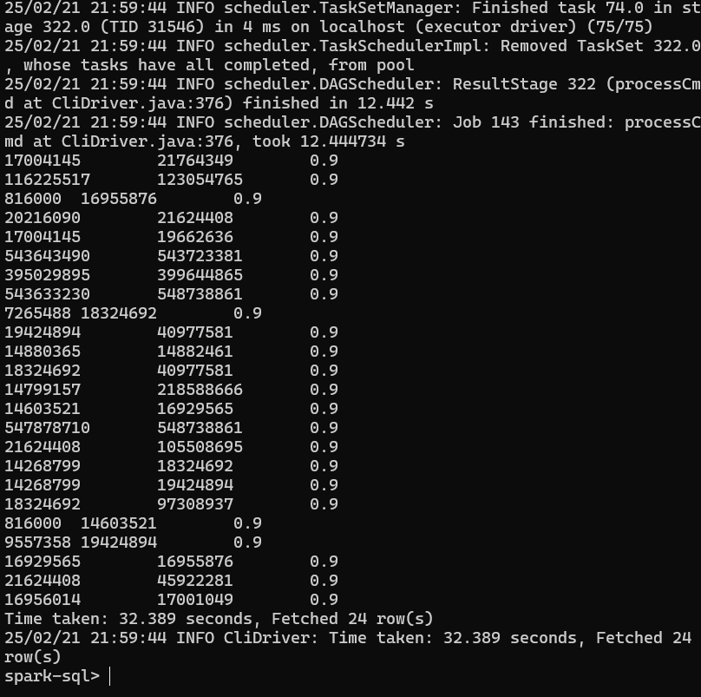
耗时32.389s完成查询，返回了24项相似度为0.9的数据。
至此，实验完成。
- 实验总结
本次实验基于Hadoop HDFS和Spark SQL构建分布式数据库查询系统，我深入理解了大数据存储与处理的分布式架构。通过实验，掌握了HDFS的文件存储机制及Spark SQL的分布式查询优化技术，体验了其在海量数据下的高效查询性能。实验过程中，数据分区、并行计算和内存优化等策略显著提升了查询效率，同时也认识到集群资源调度与数据倾斜问题的挑战。总体而言，我熟悉了手动搭建hadoop和spark-sql的基本流程，学会了对大数据集查询的sql语句进行一定程度优化，本学期的数据库实验让我受益匪浅！

