Duration, Step by Step (v1)
This lesson teaches duration from scratch using the Brewster bond from the mock midterm (Part 3). By the end you will be able to say what Macaulay and modified duration mean, build the table in Excel, and answer 3.E and 3.F. The finished table is in EC1745_Duration_Table_Brewster_v1.xlsx so you can compare it with yours cell by cell.
The bond. Brewster issued 10-year bonds two years ago with a 5% coupon paid twice a year, so 8 years (16 half-years) are left. The bond pays 2.50 every six months and 100 at the end. Its yield today is 7% a year, which is 3.5% per half-year. In 3.A you found its price: 87.906 per 100 of face value.

1. What 3.E is asking you to do
“Build the old bond’s cash-flow timeline. Calculate its Macaulay duration (in years) and modified duration. Check your answer with Excel’s DURATION function.” In plain words:
- List every payment the bond will make: 2.50 at 0.5 years, 2.50 at 1 year, and so on, then 102.50 at 8 years.
- Find what each payment is worth today by discounting it at 3.5% per half-year.
- Find the average time until you get your money, counting each payment by how much it is worth today. That average is the Macaulay duration.
- Convert it into modified duration with one division.
- Check both answers with Excel’s built-in DURATION and MDURATION functions.

2. What duration is, and why anyone cares
When interest rates rise, bond prices fall. Investors want one number that says how much a bond’s price will move. That number is duration. Two versions exist, and they answer two slightly different questions.

Macaulay duration: “On average, when do I get my money?”
Start with the simplest bond, a zero-coupon bond that pays 100 in 8 years and nothing before. All of your money arrives at year 8, so the average wait is 8 years. Its Macaulay duration is 8 years, exactly its maturity.
A coupon bond like Brewster pays some money early (the coupons), so the average wait is shorter than 8 years. But the payments are not equally important. The big payment at the end (102.50) is worth far more than any single 2.50 coupon, so it pulls the average toward year 8. Macaulay duration is an average of the payment times, where each time is weighted by how much that payment is worth today.

A tiny example you can do in your head
A 3-year bond pays a 10% coupon once a year and has a 10% yield. It pays 10, 10 and 110. Its price is 100.
Year t | Cash flow | PV today | Weight = PV / price | Year × weight
1 | 10 | 10 / 1.1 = 9.09 | 9.09% | 0.091
2 | 10 | 10 / 1.1² = 8.26 | 8.26% | 0.165
3 | 110 | 110 / 1.1³ = 82.64 | 82.64% | 2.479
Total |  | 100.00 | 100% | 2.736

Macaulay duration = 2.736 years. About 83% of the bond’s value arrives at year 3, so the average lands close to 3. The shortcut that gives the same number: add up (year × PV), then divide by the price. (1 × 9.09 + 2 × 8.26 + 3 × 82.64) / 100 = 273.55 / 100 = 2.736.
Formula: Macaulay D = Σ (t × PV of the cash flow at t) / price, with t in years.

Seeing it for Brewster
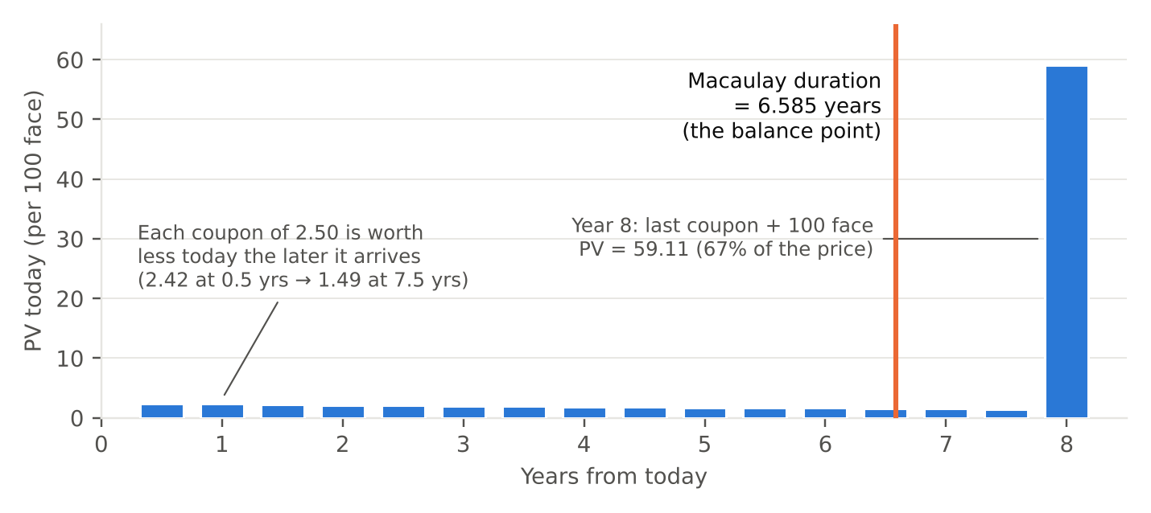
Figure 1. What each Brewster payment is worth today. The orange line is the balance point of the bars.
Picture each bar as a weight sitting on a seesaw that runs from year 0 to year 8. The point where the seesaw balances is the Macaulay duration. The sixteen small coupons pull a little to the left, the huge final payment pulls hard to the right, and the balance point lands at 6.585 years.

Modified duration: “If yields move 1%, how much does the price move?”
Modified duration turns Macaulay duration into a price sensitivity. For a bond that pays twice a year:
Modified duration MD = Macaulay D / (1 + y/2)
Brewster: 6.585 / (1 + 0.07/2) = 6.585 / 1.035 = 6.362. Then:
% change in price ≈ –MD × change in yield
If Brewster’s yield rises by 1 percentage point (0.01), its price falls by about 6.362 × 0.01 = 6.36%. If the yield falls by 1 point, the price rises by about 6.36%. The minus sign is there because price and yield move in opposite directions.
 | Macaulay duration | Modified duration
Unit | Years | Percent price change per 1-point yield change
Question it answers | On average, when do I get paid? | How sensitive is the price to yields?
Brewster | 6.585 years | 6.362
Excel | DURATION | MDURATION
Used for | Reporting “the duration” | Estimating price changes (3.F, and every past exam)

3. Build the table in Excel, step by step

Step 1: Inputs
Start a new tab. Type these three inputs so every formula can point at them.
Cell | Type this | What it is
A1 / B1 | Coupon rate / 0.05 | Annual coupon, as a decimal
A2 / B2 | Yield (APR) / 0.07 | Annual yield, as a decimal
A3 / B3 | Periods left / 16 | 8 years × 2 payments a year

Step 2: Column headers in row 5
A5 Period · B5 Years · C5 Cash flow · D5 PV · E5 Years × PV. (F5 Weight is optional; it helps you see the idea but the exam does not need it.)

Step 3: Type the first row (row 6)
Cell | Type exactly | What it does | Shows
A6 | 1 | The first half-year period | 1
A7 | =A6+1 | Each period is one more than the last | 2
B6 | =A6/2 | Turns periods into years (2 periods = 1 year) | 0.5
C6 | =$B$1*100/2+IF(A6=$B$3,100,0) | The coupon (2.50), plus 100 in the final period only | 2.50
D6 | =C6/(1+$B$2/2)^A6 | Discounts the payment at 3.5% per period | 2.4155
E6 | =B6*D6 | Time × value, the piece duration needs | 1.2077
F6 (optional) | =D6/$D$22 | Share of the price this payment represents | 2.75%

About the $ signs. $B$1, $B$2, $B$3 and $D$22 are inputs or totals that every row uses, so they are locked. A6, B6, C6 and D6 have no $ because they should move down one row each time you copy. Click inside a reference and press F4 (Mac: Cmd+T) to add the $ signs.
About the IF. IF(A6=$B$3,100,0) means “if this is period 16, add 100; otherwise add 0.” That puts the face value in the last row only.

Step 4: Copy down to row 21
- Copy A7 down to A21 so the periods run 1 to 16.
- Select B6:F6, then drag the small square at the bottom-right corner of the selection down to row 21. Or select B6:F21 and press Ctrl+D.
- Check row 21. It should show period 16, year 8.0, cash flow 102.50, PV 59.1124.

Step 5: Totals in row 22
Cell | Type | Shows | Why it matters
D22 | =SUM(D6:D21) | 87.9059 | The price. It must match 3.A. If it does not, a row is wrong.
E22 | =SUM(E6:E21) | 578.8689 | Sum of time × value
F22 (optional) | =SUM(F6:F21) | 100% | The weights must add to 100%

Step 6: The answers
Cell | Type | Shows | Answer to
B24 | =E22/D22 | 6.5851 | 3.E Macaulay duration, in years
B25 | =B24/(1+B2/2) | 6.3624 | 3.E Modified duration
B26 | =DURATION(DATE(2026,1,1),DATE(2034,1,1),B1,B2,2) | 6.5851 | 3.E check: matches B24
B27 | =MDURATION(DATE(2026,1,1),DATE(2034,1,1),B1,B2,2) | 6.3624 | 3.E check: matches B25

Why those dates? DURATION needs a settlement date and a maturity date. This bond has none, so make up any two dates exactly 8 years apart. Excel only cares about the gap between them. The last input, 2, means two coupons a year.

The full table, to check yours row by row
Row | A: Period | B: Years | C: Cash flow | D: PV | E: Years × PV | F: Weight
6 | 1 | 0.5 | 2.50 | 2.4155 | 1.2077 | 2.75%
7 | 2 | 1.0 | 2.50 | 2.3338 | 2.3338 | 2.65%
8 | 3 | 1.5 | 2.50 | 2.2549 | 3.3823 | 2.57%
9 | 4 | 2.0 | 2.50 | 2.1786 | 4.3572 | 2.48%
10 | 5 | 2.5 | 2.50 | 2.1049 | 5.2623 | 2.39%
11 | 6 | 3.0 | 2.50 | 2.0338 | 6.1013 | 2.31%
12 | 7 | 3.5 | 2.50 | 1.9650 | 6.8774 | 2.24%
13 | 8 | 4.0 | 2.50 | 1.8985 | 7.5941 | 2.16%
14 | 9 | 4.5 | 2.50 | 1.8343 | 8.2545 | 2.09%
15 | 10 | 5.0 | 2.50 | 1.7723 | 8.8615 | 2.02%
16 | 11 | 5.5 | 2.50 | 1.7124 | 9.4180 | 1.95%
17 | 12 | 6.0 | 2.50 | 1.6545 | 9.9267 | 1.88%
18 | 13 | 6.5 | 2.50 | 1.5985 | 10.3903 | 1.82%
19 | 14 | 7.0 | 2.50 | 1.5445 | 10.8112 | 1.76%
20 | 15 | 7.5 | 2.50 | 1.4922 | 11.1917 | 1.70%
21 | 16 | 8.0 | 102.50 | 59.1124 | 472.8988 | 67.25%
22 | Total |  |  | 87.9059 | 578.8689 | 100%

Notice two things. Each coupon is worth a little less than the one before, because it arrives later. And the last row alone is 67% of the price, which is why the duration (6.585) sits close to 8.

4. Answering 3.F: estimate, then check
3.F asks: if the yield rises from 7% to 7.5%, estimate the % price change with modified duration, then find the actual price and % change, and explain the difference.
Step | Type | Shows
New yield (B29) | 0.075 | 7.50%
Estimate (B30) | =-B25*(B29-B2) → –6.3624 × 0.005 | –3.181%
Actual new price (B31) | =PV(B29/2,B3,-B1*100/2,-100) | 85.1623
Actual % change (B32) | =B31/D22-1 | –3.121%

The estimate says the price falls 3.18%. It actually falls 3.12%, a little less. The difference is called convexity.
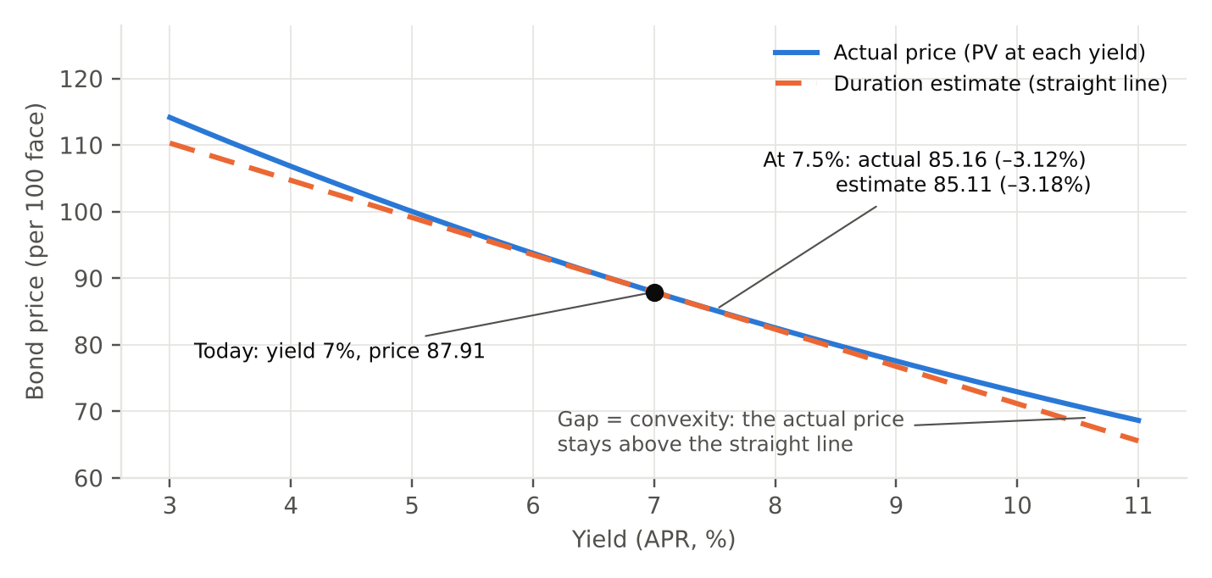
Figure 2. The real price-yield relationship is a curve (blue). Duration treats it as a straight line (orange).
Duration draws a straight line that touches the price curve at today’s yield. The real curve bends upward away from that line on both sides. So when yields rise, the real price falls less than the line predicts. When yields fall, the real price rises more than the line predicts. The estimate is very close for small moves like 0.5% and gets worse for big ones.
A one-sentence answer for “why do they differ?” “Duration is a straight-line approximation, but the price-yield relationship is convex, so the actual price falls by less than the duration estimate.”

5. Mistakes that cost points
- Forgetting the 100 in the last row. The sum of PVs comes out around 30.2 instead of 87.9. The price check in D22 catches this.
- Discounting at 7% instead of 3.5%. The bond pays every six months, so each period uses y/2.
- Using periods instead of years in column B. You get 13.17, which is the duration in half-years. Divide by 2, or use B = period / 2 from the start.
- Dividing by 1.07 for modified duration. For a semiannual bond, divide by 1 + 0.07/2 = 1.035.
- Forgetting the $ signs, so the rate or the period count drifts when you copy down. Row 7 will look fine and row 21 will be wrong.
- DURATION dummy dates not exactly 8 years apart, or leaving out the final 2 (frequency).
- Using Macaulay instead of modified duration to estimate a price change. Price changes always use modified duration.

6. When the bond has real dates
On the 2024 and 2025 exams, the bonds had real settlement and maturity dates, and the questions only asked for the numbers. Use the functions directly with the real dates: =DURATION(settle, maturity, coupon, yield, 2, basis) and =MDURATION(…). Then estimate the price change with –MD × Δy exactly as above. If you ever need the table with real dates, the only change is that the first payment is less than a full period away: periods to payment k = k – 1 + COUPDAYSNC / COUPDAYS. The “2025 P4 Bonds” tab of the practice answer key has that version built out.

7. Try one on your own
The 2024 exam’s Dioguardi bond, today: 17 years left (34 half-years), coupon 2.75 per half-year (5.5% a year), yield 7%. Build it on a new tab the same way, with B1 = 0.055 and B3 = 34. The table now runs from row 6 to row 39, so put the totals in row 40 and skip the optional weight column (or point it at $D$40).
Check | You should get
Sum of PVs (the price) | 85.224
Macaulay duration | 10.726 years
Modified duration | 10.364
Check with | =DURATION(DATE(2000,1,1),DATE(2017,1,1),0.055,0.07,2)

Compare 10.726 with the 9.67 you got in 2024 4.D from two prices. The two-price version is lower because a full 1-point jump (7% to 8%) is big enough for convexity to matter. Same idea as Figure 2.

