### U Type Wind Tunnel High Speed Automatic Dryer

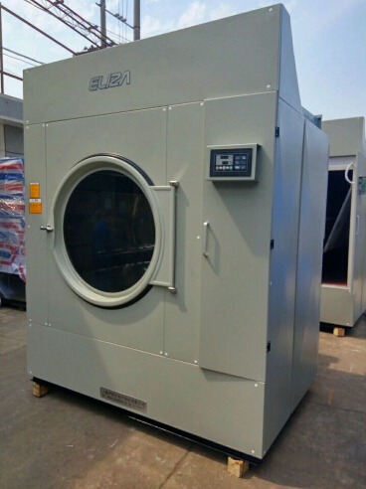  
Fastest in the industry, saving electricity by 40%, and saving energy by 50%  
  
Product Advantages  
1.Unique extra-size constant temperature heater. It gives higher temperature than ordinary heater and can cut down drying time and increase efficiency.  
2.Specially designed 270 degrees U type hot air tunnel is 50% of th 180 degree type in heating time. So within the same time, U type can take away more moisture.  
3.Extra size wind wheel and high density hole net allow more hot air to heat the textile, saving drying time by 1/3 and saving energy by 40%.  
4.Extra size fine hair filter reduces wind resistance and cuts down drying time. The computer can accurately control temperature. The cold wind compensation function can offer low temperature drying of soft textiles like silk.  
5.It is convenient to clean the fine net from middle.  
**Technical Parameters**(Power Source Voltage 380V)

|  |  |  |
| --- | --- | --- |
| **Model** | **HG-70** | **HG-120** |
| **Rated Drying Capacity(kg)** | 70 | 120 |
| **Electric Heater Power(kw)** | 40 (optional) | / |
| **Blower Power(kw)** | 2.2 | 5.5 |
| **Main Motor Power(kw)** | 2.2 | 2.2 |
| **Rated Voltage(v)** | 380 | 380 |
| **Steam Pressure(mpa)** | 0.4 | 0.4 |
| **Outside Dimensions(mm)** | 1650x1680x2100 | 2000x2150x2650 |
| **Machine Weight(kg)** | 1640 | 2050 |
| **Gas Heating** | Optional  (gas consumption:4cbm/cycle) | Optional  (gas consumption:7m3/cycle) |