### Flatwork Double Side Smoothing And Automatic Feeding Machine

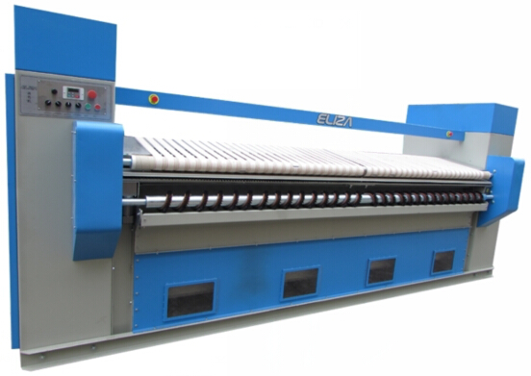   
Product Advantages:  
1.This double side smoothing automatic feeding machine smoothes and feeds textile to ironing machine. It is specially designed for worker’s safety, labor intensity reduction and the improvement of ironing quality.  
2.It is placed before ironing machine, enhancing safety, avoiding injury and lowering operation cost.  
3.It can reduce labor intensity and lower labor cost.  
4.With its high speed textile feeding, time is saved and efficiency is increased. The production capacity can be increased by 50%.  
5.Some moisture is pre-absorbed. The vacuum feeding mechanism can tightly hold bed sheet, quilt cover and pillow case so that these textiles   
will not be stuck up and feeding of textile is 100% assured.  
6.Vacuum automatic shake smoothing. There are hair brushes that can smooth both sides of the textile. While other machines don’t have hair brush and can only feed bed sheet. So our machine is unique in the industry. This contributes to customer’s satisfaction and competitiveness.  
7.A single line consisting of feeding unit, ironing unit and folding unit can process over 1000 bed sheets from hotel.

|  |  |  |
| --- | --- | --- |
| Model Number | SBJ3000 | SBJ3300 |
| Feeding Speed M/Min | 0~50 | 0~50 |
| Power Frequency | 0~50 | 0~50 |
| Power supply Voltage V  (Three-phase four lines) | 380 | 380 |
| Feeding Motor Power KW | 1.1 | 1.1 |
| Wind Turbine Power KW | 4.4 | 4.4 |
| Brush Motor Power KW | 0.49 | 0.49 |
| Total Power KW | 5.99 | 5.99 |
| Machine Weight T | 1.3 | 1.5 |
| External Dimension  Length*width*height(mm) | 4150*1500*1860 | 4500*1500*1860 |