### Industrial Flatwork Folding Machine - Professional Manufacturer

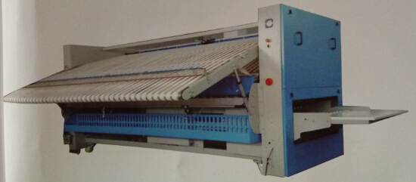   
Product Advantages:  
1.It can control textile sending speed and has correct positioning. It can correctly measure textile length and calculate folding length.  
2.Big screen LCD is adopted. It has fault self-detection and can show alarm.  
3.It has 2 sets independent driving motor. The folding speed is steplessly variable by converter within 50m/min.  
4.It can match with various types of ironing machines.  
5.The highly intelligent PLC and the touch screen are highly reliable, long in service life and offer convenient operation and error finding.  
6.Intelligent infrared ray checking system can measure speed and increase folding accuracy.  
7.It can judge if folding is qualified or not to assure folding quality.  
8.It has a complete self-checking and safety protection system, which facilitates daily maintenance.  
9.It has anti-static function, thoroughly solving textile’s warping and wrinkling.  
10.The only five knife folding mechanism is unique in the industry.  
11.It can fold 4 pillowcases at once (optional).  
**Technical Parameters**(Power Source Voltage 380V)

|  |  |  |
| --- | --- | --- |
| **Model** | **ZD3000** | **ZD3300** |
| **Folding Channel(mm)** | 1 | 1 |
| **Folding Layer/Time** | 5 | 5 |
| **Folding Length(mm)** | 3000 | 3300 |
| **Max Speed(m/min)** | 50 | 50 |
| **Compressed Air Pressure(mpa)** | 0.6 | 0.6 |
| **Compressed Consumption(l/min)** | 40 | 40 |
| **Total Power(kw)** | 2.25 | 2.25 |
| **Power Voltage(v)** | 380 | 380 |
| **Outside Dimensions(mm)** | 4150x2700x1800 | 4500x2700x1800 |
| **Machine Weight(kg)** | 1900 | 2100 |