### Multi-Roller High Speed Ironing Machine With Pressing Function

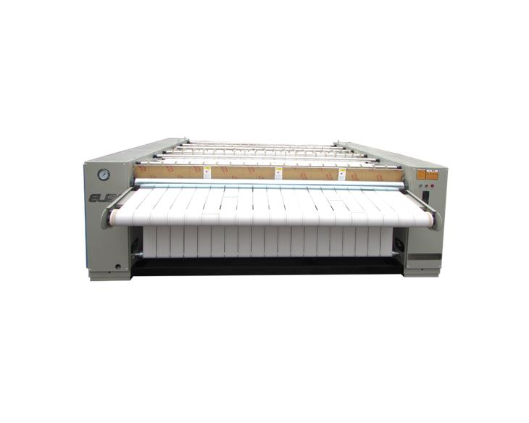  
  
Product Advantages:  
1. This heating and smoothing machine is driven by VF converter, which offers small shock starting current, smooth acceleration and economic energy consumption.  
2. Automatic tensioning function can assure smooth textile feeding so that textile is flat.  
3. The roller is 800mm in diameter and has a thickness of 4mm. It is made of SUS304 stainless steel.   
4. Textile can be heated on the big surface of the ironing drum so that textile’s moisture can be removed fast, steam consumption and electricity consumption are also reduced.  
5. It offers excellent smoothing quality that can satisfy the requirement of 5 star hotels.  
6. This heating and smoothing machine can normally work with even 0.2Mpa’s steam pressure.  
  
Technical Parameters

|  |  |  |  |  |
| --- | --- | --- | --- | --- |
| Model | Y3000 2 rollers | Y3300 2 rollers | Y3000 3 rollers | Y3300 3 rollers |
| Ironing Width(mm) | 3000 | 3300 | 3000 | 3300 |
| Ironing Speed(m/minute) | 0-50 | 0-50 | 0-50 | 0-50 |
| Roller Diameter(mm) | 800 | 800 | 800 | 800 |
| Steam Pressure(mpa) | 0.4-0.6 | 0.4-0.6 | 0.4-0.6 | 0.4-0.6 |
| Steam Consumption(kg/h) | 140 | 160 | 210 | 240 |
| Motor Power(kw) | 2.2 | 2.2 | 3 | 3 |
| Voltage (v) | 380 | 380 | 380 | 380 |
| Machine Weight(kg) | 3400 | 3800 | 5000 | 5600 |
| Outside Dimensions (mm) | 4200*3000*1350 | 4500*3000*1350 | 4200*4000*1350 | 4500*4000*1350 |
| LPG Consumption (optional) | 5m3/roller | 5.6m3/roller | 5m3/roller | 5.6m3/roller |