**Linux Lab (Lab 5) Worksheet** **Name ___Hunter Befort___________**

**Section ____007________**

Please complete the following steps to complete the lab:

1. Make sure you have read the information in the assignment to understand what commands to issue.
2. Use your RPi 4b that you have configured (not one you are sharing with another student). In other words, your RPi should have a hostname that matches your NetID.
3. Record the IP address of your PI’s wired Ethernet: ____192.168.1.144_________________
4. Record the Physical Address of your PI’s wired Ethernet: ___e4:5f:01:d4:9a:bb____________
5. Using the git commands covered in the assignment, mimic the series of commits and branches shown in the diagram below:

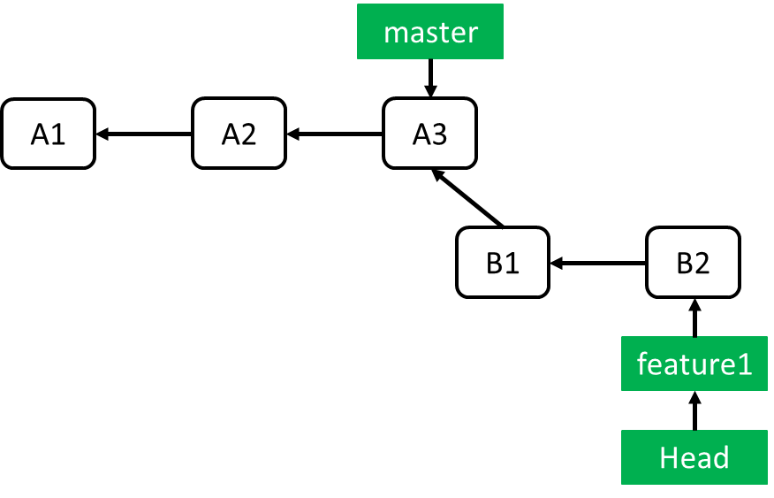

Alternate description. A file has been checked out on main 3 times (commits “A1”,”A2”,”A3”). At that point “Feature1” branch was created. Development continued on the feature branch with 2 more commits(“B1” and “B2”)

Actions:

(Note: Each action below may require several git commands to complete. Please refer to the assignment)

* 1. Create a git repository named GitPractice
  2. Create a file named sample.txt. It must not be empty.
  3. Add the file to the repository.
  4. Commit the file, using the message “A1” in the commit message
  5. Edit sample.txt
  6. Commit the file, using the message “A2” in the commit message
  7. Edit sample.txt
  8. Commit the file, using the message “A3” in the commit message
  9. Create a branch called Feature1.
  10. Change to that branch
  11. Edit sample.txt
  12. Commit the file, using the message “B1” in the commit message
  13. Edit sample.txt

N. Commit the file, using the message “B2” in the commit message

1. Configure Git to ignore any files with the .out extension.
2. Verify steps 5 and 6 are done correctly with the following commands:

% git log --oneline

% cat .gitignore

It should look like this:

% git log --oneline

03ff344 (HEAD -> Feature1) B2

0d2c3e4 B1

940f084 (master) A3

67b1b0b A2

56040cd A1

% cat .gitignore

*.out

The working directory does not need a specific name and the values of the hashes should be ignored.

1. Take a screenshot of your terminal window by pressing “Print Screen” on your keyboard or using the command scrot. It should capture the commands of step 7.
2. Rename the screenshot created to:

lastname_netid_lab5.png

1. Upload the following items to canvas:
   * This worksheet with your name and section number completed
   * The 1 screenshot listed above

**You must show your assignment to the grader before uploading it to Canvas.**

Thank you for attending the lab.

In the next lab, we will explore interfacing the PI to the external world.

* + Professors Davis and Losh

**Lab 5 Rubric**

Assignment:

-40: Hostname something other than student’s NetID

-30: Screenshots taken without using 'screenshot’ function of OS

(i.e., using a phone camera)

-20: Image not in .png file format.

-10: Wrong file name

-10: Wrong IP / Physical address

-20: Incorrect git branching