BIO 1201 Phylogenetics Lab

Supplemental Worksheet

Please fill out the following questions as you go through the Phylogenetics Lab Introduction video and PowerPoint.

1. Great Tree of Life Video:

Why do scientists use computers to create phylogenetic trees? Circle the best answer.

1. There are so many possible trees to explain all of the species relationships, that a human cannot possibly examine all of them without help from a computer.
2. Phylogenetic trees cannot be constructed without the use of computers.
3. Mid-Introductory PowerPoint:

A clade is a group of organisms that includes a common ancestor and all of its descendent species. Of the following groups highlighted in colored boxes, which one(s) would be considered a clade? (Circle the best answer(s). There may be more than one correct answer.)

1. Mid-Introductory PowerPoint:

Examine the vertebrate cladogram below. When people refer to reptiles, they are commonly referring to non-avian reptiles (all reptiles but birds). Is it appropriate to refer to non-avian reptiles as a clade? Circle the best answer.

Image from: http://fsc.fernbank.edu/STT/VertBio/vertebrate_classes.htm

1. Yes, because birds have their own distinct lineage, separate from other reptiles.
2. Yes, because birds are not reptiles.
3. No, because birds share a closer common ancestor with crocodilians than crocodilians share with other reptiles.
4. No, because birds are descended from crocodilians.
5. Post-Introductory PowerPoint:

Examine the image below, depicting an early interpretation of the Tree of Life by Ernst Haeckel from his book, The Evolution of Man (1879). While there are some incorrect details that exemplify common misconceptions about evolution, this was an important and influential concept that helped to shape the fields of evolutionary biology and phylogenetics. 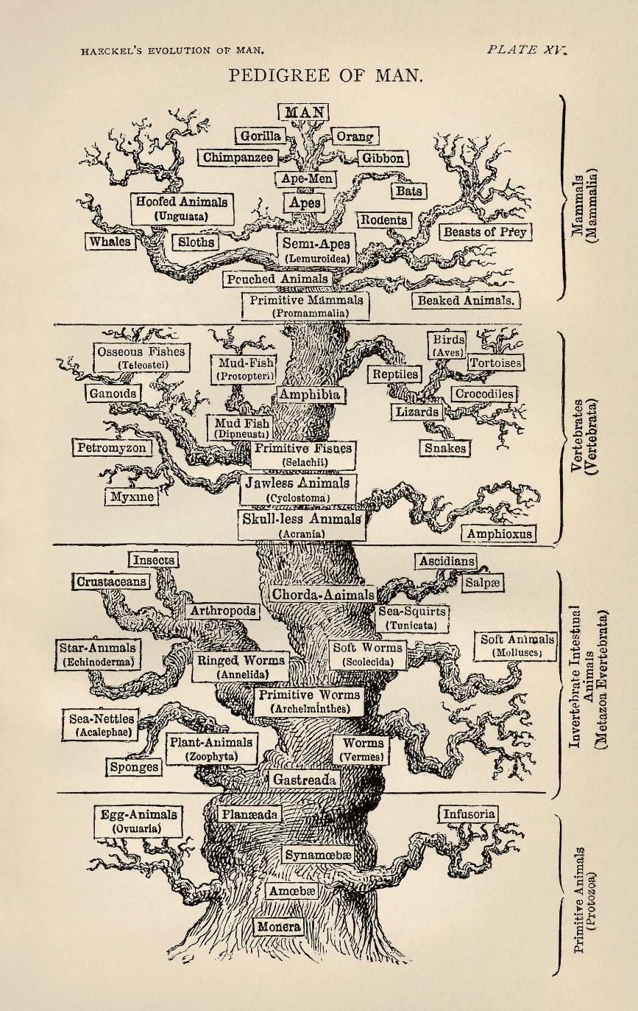

From the list below, circle all of the details from this tree that are **TRUE** about evolution as we understand it today. There may be more than one answer.

1. Man (humans) is at the top of the tree because we are the pinnacle of all evolution.
2. Ape-men (e.g. *Australopithecus*) are located below Man (humans) because ape-men evolved into modern day humans.
3. Birds are placed alongside reptiles because they belong in that clade.
4. All life today stems from a common “root” ancestor.