SAE Aero Design West 2023

Micro Class Final Report

University of West Florida, Pensacola

UWF Argonautics

Team 314

Faculty Advisor: Dr. Carolyn Mattick

Team Members: Caleb Opava, Ryan Ebbighausen, Lily Haddock, Skyler Hoskins, Thao Duell, Nikolai Miller, Matthew Hoffman, Thomas Morgan, Ryder Swan, D’Andre Walden, Greg Miller, Caleb Jackson, Hayden Pursell, Joseph Pusateri, Connor Yourist, Alyssia Bryson, Brett Brustad



**Statement of compliance**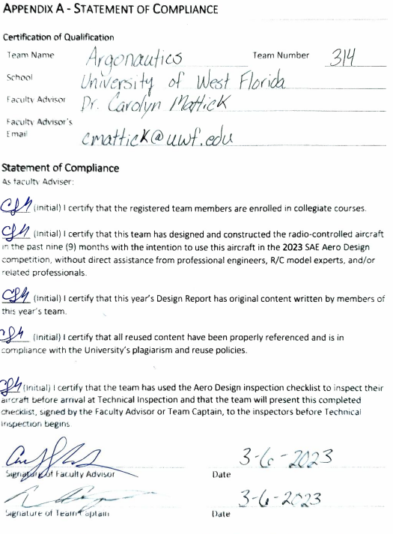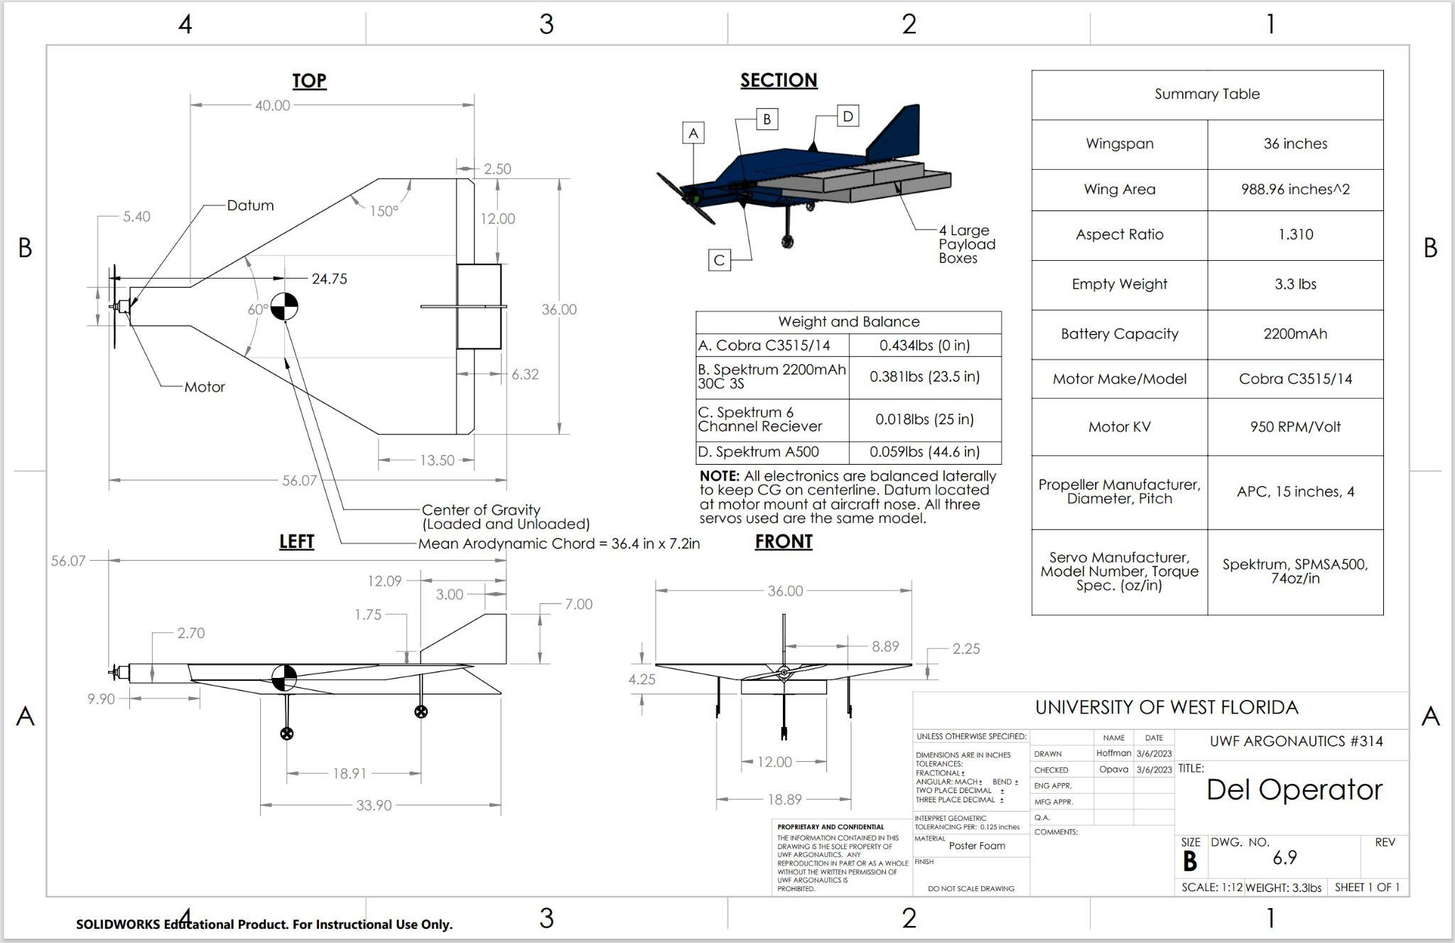

**Technical Data Sheet**

**Team Name Argonautics**

**Team School Name University of West Florida**

**Team Number 314**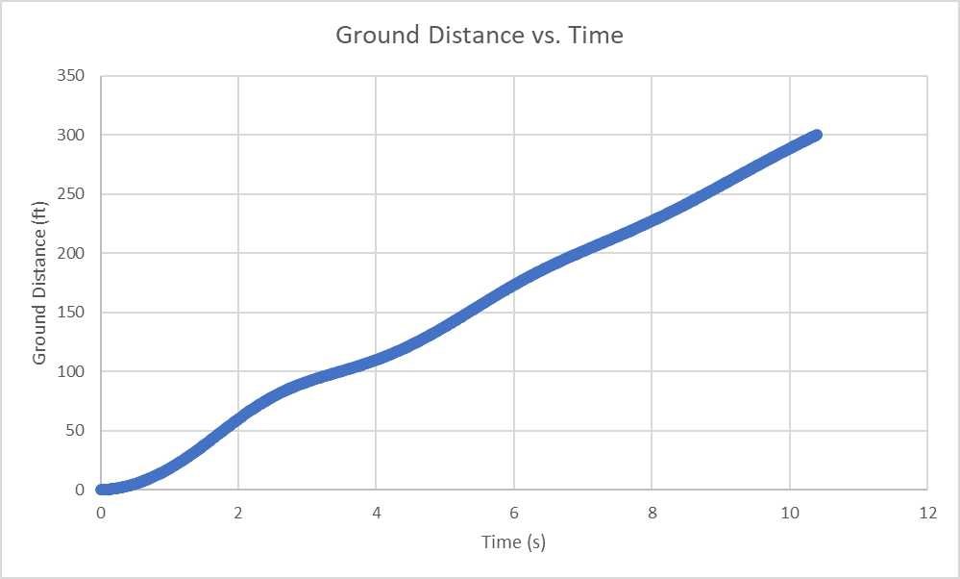

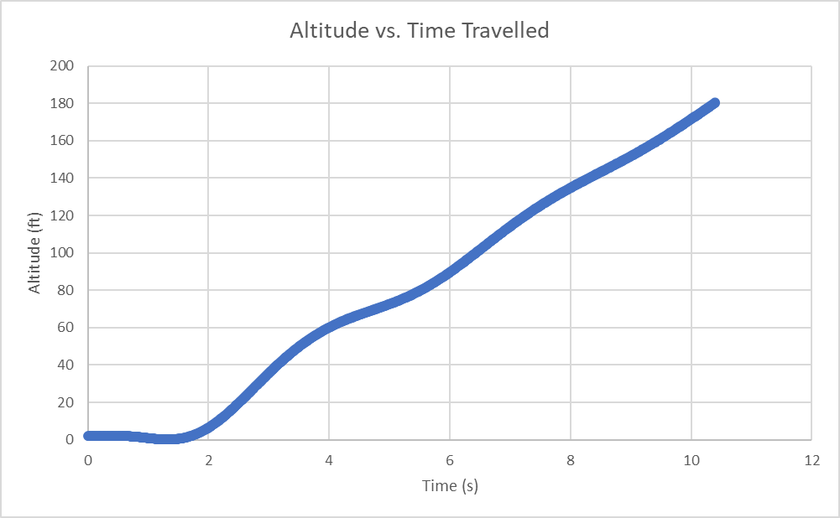

# **Table of Contents**

**Table of Figures** **2**

**Table of Tables** **3**

**Table of Acronyms** **3**

**1** **Introduction 4**

1.1 Understanding Requirements 4

1.2 Understanding Risk 4

1.3 Project Overview 6

**2 Analysis** **10**

2.1 Configuration Selection and Trade Studies 10

2.2 Scoring Analysis 11

2.3 Refinement 13

2.4 Propulsion System 16

2.5 Finite Element Analysis 18

2.6 Stability and Control 18

2.7 Take-Off & Climb Out Performance 24

**3** **Implementation 25**

3.1 Manufacturing 25

**4** **Testing 27**

4.1 Flight Testing 27

**References** **29**

# **Table of Figures**

| [1] Team Organization Flow Chart | 7 |
| --- | --- |
| [2] Gantt Chart | 8 |
| [3] Design Morphological Matrix | 11 |
| [4] Flight Score Equation | 11 |
| [5] Bonus Equation | 11 |
| [6] Graph of Flight Score vs. % Change of Variable from Baseline | 12 |
| [7] Comparison of Cropped Delta Wing and Monoplane Prototypes | 15 |
| [8] Thrust vs. Velocity | 17 |
| [9] Ansys Fluid Flow simulation at 45 degree AOA | 18 |
| [10] First Prototype of Cropped Delta Wing | 20 |
| [11] Control Surfaces Free Body Diagram | 22 |
| [12] Finished Prototype on the Runway and in Flight | 27 |
| [13] Finished Prototype on the Runway and in Flight | 27 |
| [14] Test Flight on March 5, 2023 | 28 |

# 

# 

# Table of Tables

| [1] Risk Assessment | 5 |
| --- | --- |
| [2] Organizational Chart Descriptions | 6 |
| [3] Project Budget for Three Competition Planes | 9 |
| [4] Fundraising Progress | 10 |
| [5] Expected Travel Expenses | 10 |
| [6] Final Design Characteristics | 18 |
| [7] Calculated Data for needed Torque using the Final Formula | 23 |
| [8] Battery Selection Variables | 24 |
| [9] Physical and Mechanical Properties of Balsa Wood and Foam Boards | 26 |

# Table of Acronyms

PLA - Polylactic acid

CAD - Computer Aided Design

LERX- Leading-edge Extension

CG - Center of Gravity

RC - Radio Control

UWF - University of West Florida

AOA- Angle of Attack

# **1 Introduction**

## **1.1 Understanding Requirements**

The 2023 SAE Micro Class competition challenges engineering students to design an electric RC aircraft with a 3-foot wingspan, to overcome various conflicting design and performance requirements. The aircraft is restricted to electric motor propulsion only, it must use Lithium Polymer batteries with a maximum of 4 cells, and it must use a 2021 or newer version 450-watt power limiter provided by Neumotors. The aircraft must be able to carry payload weights in the form of metal plates that will be bolted to the inside of the fuselage. The team must bring their own payload weights. The aircraft will have to carry and fully enclose small (6x6x4 in) or large (12x12x2 in) payload boxes that will take up volume within the body of the aircraft. The payload boxes are provided at competition and cannot be modified. Only one cargo bay is allowed.

The objective for the plane is to take off from a 8 ft by 4 ft platform that is raised 2 ft off the ground. The take off direction will be into the oncoming wind. The aircraft will be timed from takeoff at 0ft to 300ft section as soon as the plane rolls under its own power. The plane completes a full 360° circuit to then land within a 200 ft landing zone [1]. The team must be able to take out the payload boxes and weight after the flight in a time of 60 seconds or less.

## **1.2 Understanding Risk**

The UWF Argonautics team is a relatively new team with limited experience and resources available for our use. The team is composed of UWF’s mechanical engineering students who are interested in aerospace. Therefore, the majority of team members are inexperienced with the physics and formulas required for proper empirical calculations associated with aircraft design. This places the team with a starting disadvantage compared to that of more experienced and more knowledgeable teams. To mitigate this, the faculty sponsor provided us with an abundance of learning material including textbooks, RC aircraft guides, and teaching sessions to make up for this inexperience so we could make the most educated decisions possible for a successful competition aircraft. Another way the knowledge gap was mitigated included the team captain assigning research sub-teams to develop trade studies and research documents for specific aspects of the aircraft. Each sub-team had more experienced members take lead and the newer members would shadow.

The team captain split the team into two sub-groups to produce the two prototypes. This activity required team members to learn and apply their knowledge in real world application. This knowledge gathering activity is how the team was set up for the Fall semester. Each group is split into half experienced and half non experienced members. Both subteams built, designed, and finished a prototype at the end of the Fall semester. Both prototypes had a successful flight on December 12th. The team decided to take a risk in choosing a more experimental aircraft design to achieve a score that will place the team in the top 10 at SAE Aero Design West in 2023. The Risk assessment table 1 is shown below .

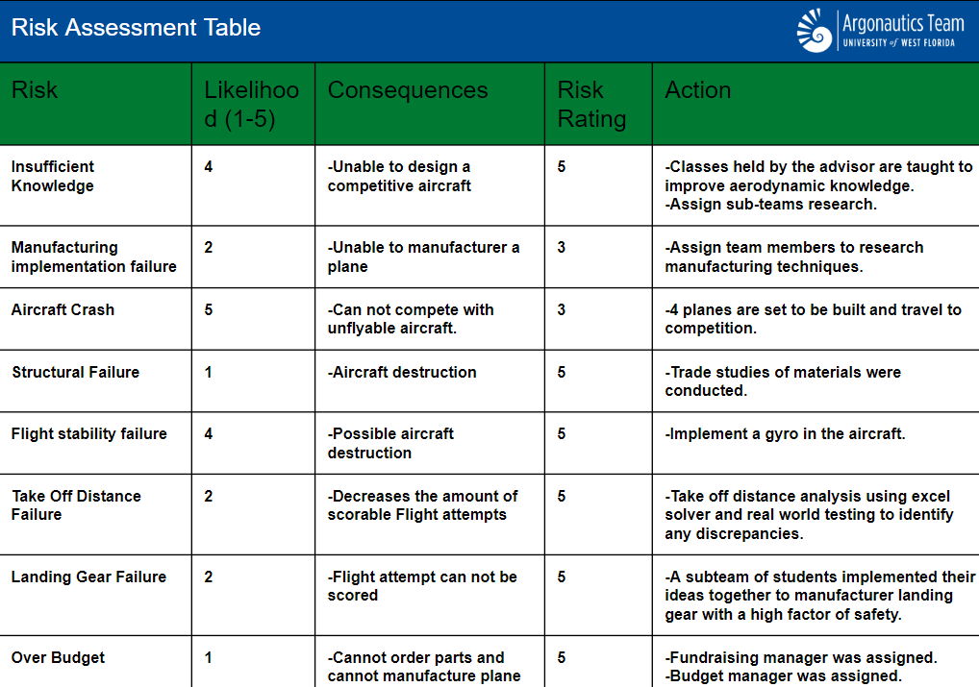

Table 1: Risk Assessment

## **1.3 Project Overview**

To ensure a successful project, the UWF Argonautics team divided into various roles with a chain-of-command structure, with major decisions fielded through the team captain. The team captain and project manager served to set tasks and delegate work to maximize workflow and ensure deadlines were met. Specific engineering roles were designated to structures, propulsion, aerodynamics, flight mechanics, and electronics. These roles served to conceptualize, design, and build the prototypes with the different aspects of its flight characteristics assigned to their respective engineers. Additional roles included writing and social media. A budget manager was also assigned to keep track of funds accrued through registration fees, travel fees, and resources needed for the aircraft. 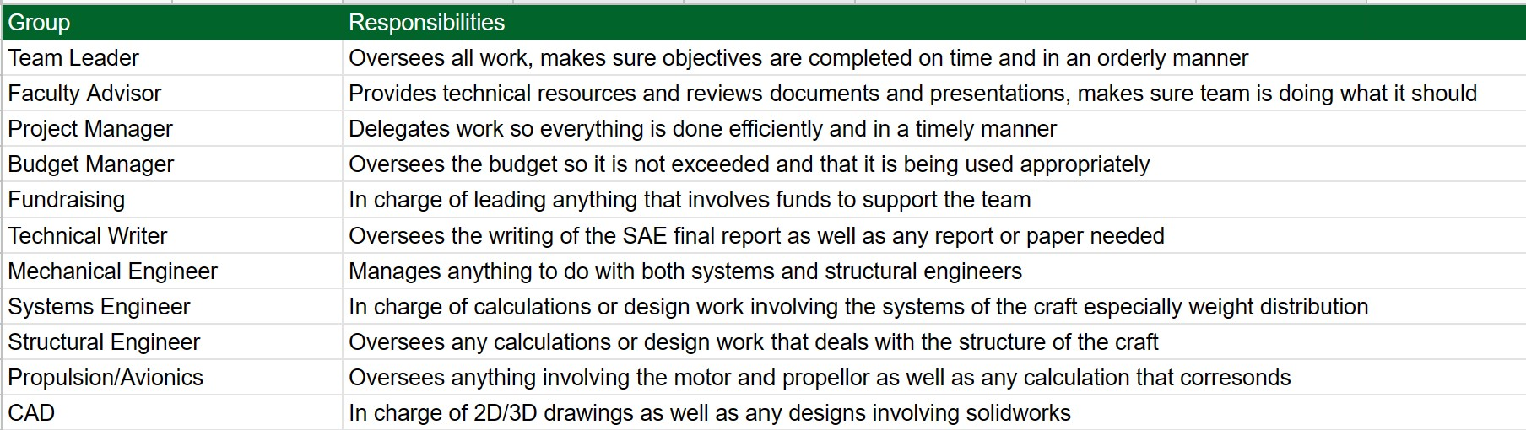

Table 2: Organization Chart Descriptions

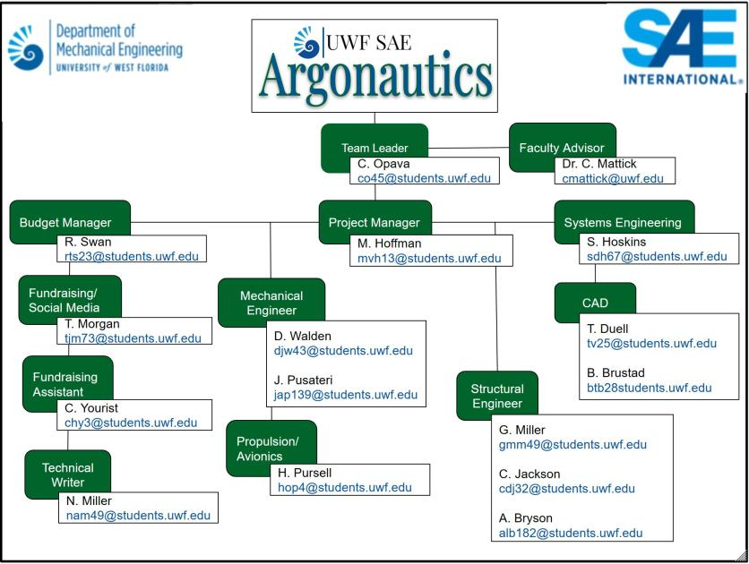

Figure 1. Team Organization Flow Chart

A schedule was set at the beginning of each semester with all due dates and progression posted as well as documentation of tasks completed. This created a workflow that promoted individual member cohesion that allowed every member of the team to engage in their expertise area while also strengthening the team as a whole. Each team member was encouraged by senior members to complete their tasks on time and all goals set by the team were completed in a timely manner. The schedule is displayed below. One key difference between this year’s schedule and last year’s schedule is the inclusion of an additional prototyping stage. In previous years, the team completed only one prototype and then built the final design. By developing a second prototype phase before building the final design, the team was able to have more creativity with the prototypes and make more improvements to the design.

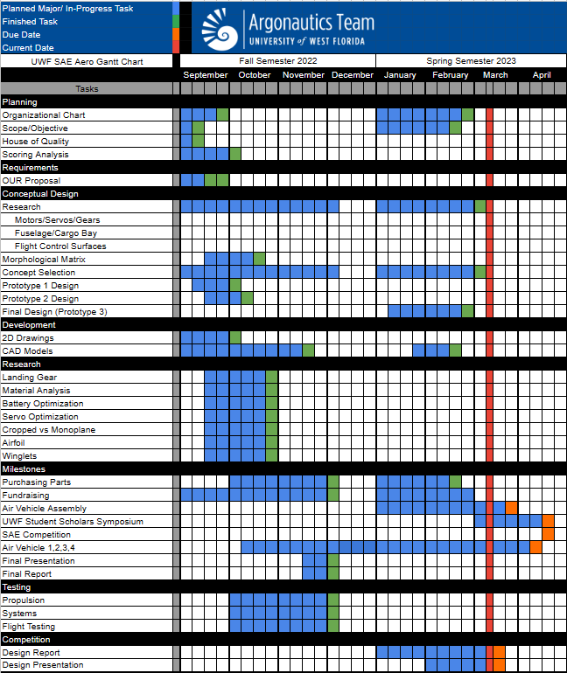

Figure 2: Gantt Chart

To financially prepare for the 2023 SAE Aero competition the team broke the budget into two components, the project budget, and the travel budget. For the project budget, the team used the previous year’s expenses and increased the necessary categories to allow for the additional prototype stage (as seen on Figure 3). The result of this itemized increase is documented in table 1 below with a total of $4,413.40. While this budget would provide the necessary funding to fully design, build, and test our final plane, it is only the bare minimum, and any extra funds raised would allow the team to purchase spare parts, upgrade current tooling, or complete additional research.

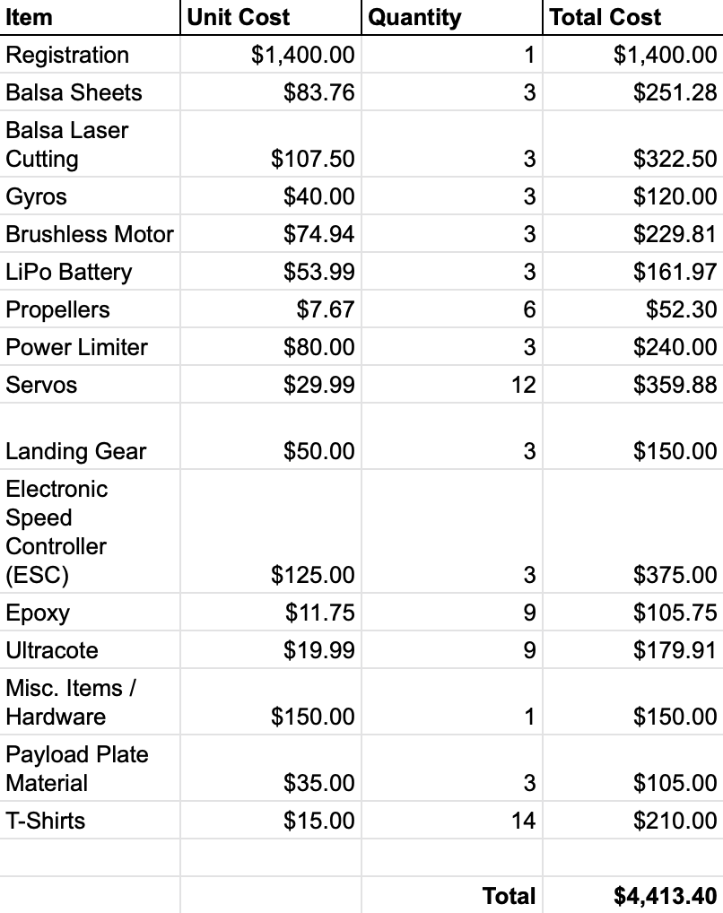

Table 3: Project Budget for Three Competition Planes

With the budget in place, the team then moved onto the fundraising process. The University of West Florida (UWF) Mechanical Engineering Department provided the team with a base amount of $1,500 and up to $500 to match any external funding. Thus far, the team has been awarded a $750 grant from the UWF Office of Undergraduate Research (OUR) and is working with multiple local companies to raise the additional $1,663.40.

As seen in figure 4, the breakdown of travel expenses for 8 team members to attend the competition are expected to total $6,019.28. The team was able to secure $4500 from the Office of Undergraduate Research, and is working with the Student Government Association to cover the remaining $1,519.28 (table 3).

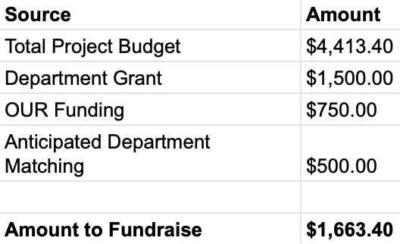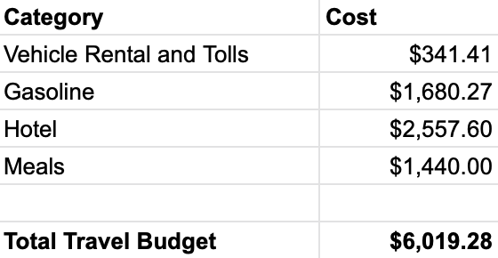

Table 4: Fundraising Progress Table 5: Expected Travel Expenses

# **2 Analysis**

## **2.1 Configuration Selection and Trade Studies**

At the beginning of the design process, the team created a morphological matrix based on different aspects of the competition requirements. The configurations for the plane design was based on the different aircraft at the competition held in 2021 and 2022. The tail sections considered are based on having yaw control for potential aircraft design. The planform wings displayed in the morphological matrix were considered based on ease of construction and drag related to the shape of the wing. The payload bay configurations for internal or external were considered if the team went with the monoplane or biplane design. Ultimately, the internal payload storage was chosen due to the rules stating the payload boxes must be fully enclosed. This decision helped formulate other design decisions that needed to be made regarding the shape of the aircraft. The morphological matrix is displayed below in figure 4.

Figure 3: Design Morphological Matrix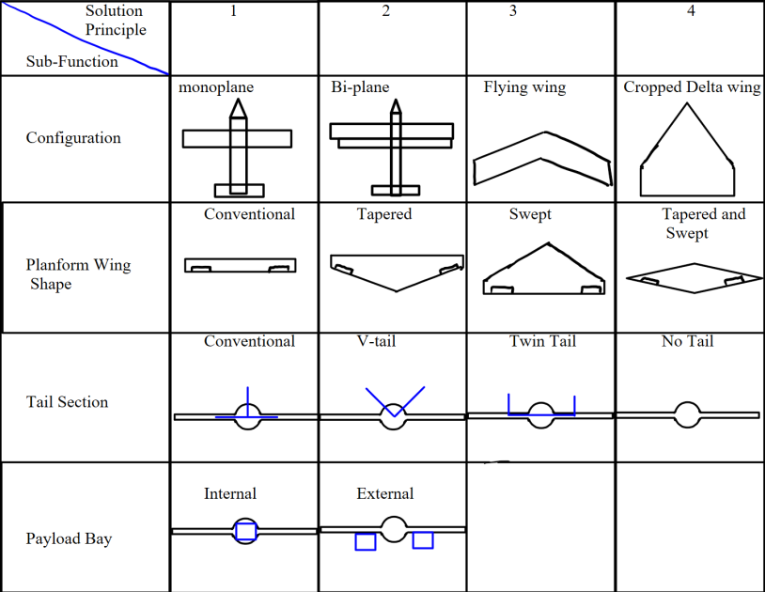

## **2.2 Scoring Analysis**

The team based their analysis on the scoring equations used by SAE to determine the score awarded to each flight.

 Figure 4: Flight Score Equation

 Figure 5: Bonus Equation

The team was also able to figure out how each payload type would individually affect the score when changed by holding the other variables to the base payload configuration and graphing the score obtained while increasing the selected variable. The baseline configuration was found by establishing a weight budget using the Technical Data Sheet simulation, then using Excel solver to find the payload configuration that maximized score while remaining within the weight budget. The time to 300 feet was also obtained from the Technical Data Sheet. The baseline configuration was found to be one large box and a 0.355 pound payload plate carried to 300 feet within 10.4 seconds, which resulted in a final flight score of 16.8398 points.

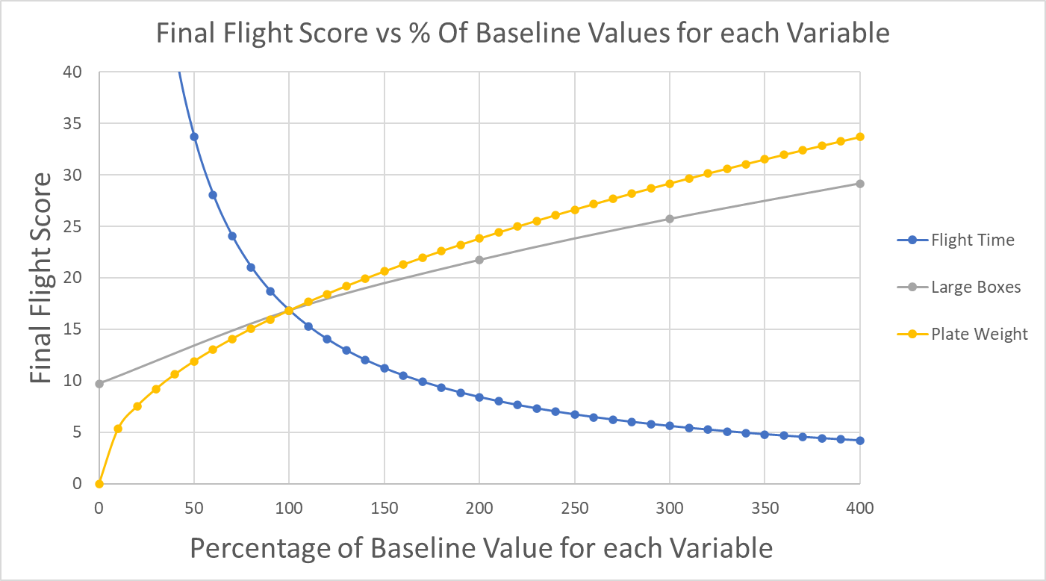

Figure 6. Graph of Flight Score vs. % Change of Variable from Baseline

The graph and scoring equation show that the flight score is inversely proportional to flight time. The flight score is very sensitive to the time to 300’ meaning that a lower flight time could greatly increase our score. When analyzing the payload types on the graph, it would appear that the team’s score would be maximized by carrying only large boxes as payload. However, this would result in a score of 0, as the numerator of the scoring equation is the square root of the product of the payload weight and the “Bonus” variable. This feature of the scoring equation means that the team should carry a mix of bonus boxes and payload plate weight to achieve the highest score per pound. By plotting the score received against the percentage of payload weight budget carried as plate weight, it can be seen that the score reaches a maximum when a combination of plate weight and bonus boxes are carried.

The takeoff platform outlined in the rules is set 2’ above the ground, and has a width of 2’ and a length of 8’. The team used the performance predicted by the Technical Data Sheet simulation to determine a payload budget. The team considered using an equation for takeoff distance but decided that the simulation would be a more thorough analysis. Within the simulation, the plane is represented as a point at the aerodynamic center. To account for this, the team only applied the normal force to the first 6 feet of the x-distance traveled. The team adjusted the plane’s weight until the numerical simulation showed an acceptable drop in altitude after leaving the table. Once the weight limit for this takeoff distance was determined, the team subtracted the estimated weight of the unloaded plane from this limit, resulting in a payload specific weight budget. The team used Excel solver to determine the payload configuration allowed by this weight budget that would result in the highest score. Last year, the team received a 38.75 Presentation score and a 6.8353 Design Report score. The team would have received a 31.8353 Report score if they had submitted the report before the unpenalized deadline, and will ensure to submit our report earlier this competition. Also, the team plans to improve our presentation and design report by utilizing the feedback provided by the judges last year. The team predicts these improvements will earn them a Presentation score of approximately 40 points and a design report score of approximately 35 points. The team currently predicts an overall score of 91.8398, which would have earned us a 3rd place spot. If the team received a final flight score of 0, our predicted report and presentation scores would still put our team in 3rd place.

## **2.3 Refinement**

At the beginning of the year, the design process began with two plane designs. A monoplane was considered due to readily available published data on monoplane designs. The other design considered was the cropped delta wing. The design decision was based on the winning team from the 2022 micro-class competition. That team got a mission performance score of 50 points higher than any monoplane or biplane design. The cropped delta wing platform is able to hold more volume due to the non-conventional fuselage. The concern of proceeding with the cropped delta wing is the inexperience of the team’s knowledge of flight mechanics specifically concerning delta wings. To mitigate the concern, prototyping and testing the design variant helped the team gain knowledge and incite. The team constructed two prototypes to compete. The main criteria was scoring and stability of aircraft. Prototype 1 is a cropped delta wing design named the “Del Operator”. Prototype 2 is a more conventional monoplane design. Overall during the design process, the team found that the aircraft’s first iteration of the cropped delta wing needed better stability in flight due to a stall that occurred in the first test flight. The prototype recovered and landed safely, but definitely showed a reason for concern on choosing the cropped delta wing. To mitigate this problem and refine the design, the cropped delta wing iteration will be equipped with a spektrum AR630 receiver/gyro for slight adjustments that the pilot can not adjust for in real time. The spektrum AR630 was chosen based on the reduced amount of weight for the combination of the gyro and receiver. Other gyros were put into consideration, however the amount of wires would be doubled due to wires having to be run from the servos to the gyro, then additional wires would have to be run from the gyro to the receiver. The decision to choose the AR630 reduced weight and added complexity to the overall design of the aircraft.

The second design focused on a conventional monoplane aircraft configuration with a standard wing and tail setup. This prototype variation is called the “Flying Guppy”. This aircraft is inherently more stable than the delta wing, to further increase stability, the center of gravity was measured and placed slightly ahead of the aerodynamic center of pressure. This results in and does not require a gyro and its accompanying operational systems, further reducing weight; however, due to the wingspan limitation, the aircraft suffers from increased drag as its fuselage is disproportionately larger with respect to the wing in order to carry the planned number of 3 small bonus boxes. To mitigate this problem the second configuration was designed to limit interference and parasite drag. The fastening between the wing and the fuselage will be smooth and curved to reduce interference drag. The body will be wrapped in ultracoat to reduce parasite drag.

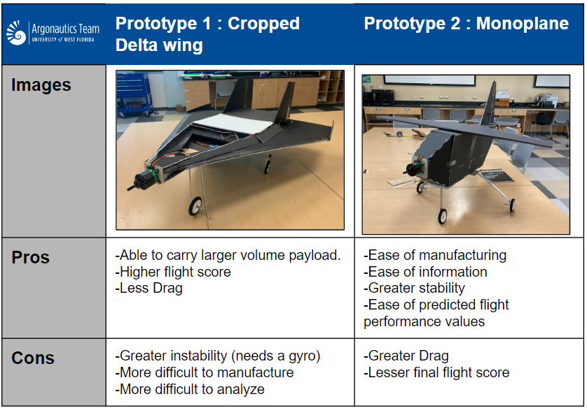

Figure 7: Comparison of Cropped Delta Wing and Monoplane Prototypes

The test flights for the two designs occurred December 12, 2022. Both test flights were successful, however the cropped delta met the requirements set by SAE better, resulting in a higher flight score. The design of the Del Operator was able to hold 2 large payload boxes compared to 3 small bonus boxes for the Flying Guppy. The cropped delta wing prototype was later refined to be able to hold 4 large payload boxes, resulting in a higher projected flight score. The trade off for the additional 2 large boxes include added drag, but since the aircraft is a lifting body, an increase in lift was observed. This change in design increased both lift and drag; however, the lift increase was significantly greater than the downside of additional drag. The team decided to go with the cropped delta wing variant for the final design based on the flight performance of both aircraft and their projected flight scores.

A trade study was conducted on the use of lerx vs canards after the cropped delta design was chosen for the teams aircraft. The design was finalized with the idea of using a LERX instead of a canard. This is due to Lerx creating a substantial amount of extra lift, which with the limit of the take-off distance was needed to create a maximum amount of lift. A canard, while efficient for most conventional designs, would add complexity and weight due to an additional servo needed to control the canard surfaces. A trade study was completed to better understand the weight to add lift and the benefit of being able to pitch the plane up on take off by acting as a tail. LERX was the best option for added lift without adding too much additional weight. Another benefit of LERX is the additional extension of the nose cone of the aircraft. The CG for the cropped delta wing is at about 1/4th of the surface area of the wing starting from the front of the aircraft. The CG for the cropped delta wing is found through the dimension of the aircraft in ECALC. For prototype 1.3 that was tested on December 12th shown in figure 8, the battery had to be placed so far forward to counteract the moment caused by the weight of the rear of the aircraft. The battery was almost touching the motor. In the case of a catastrophic failure of the aircraft, the battery could be pierced or deformed in the crash. This was a big safety concern and needed to be addressed immediately. The addition of LERX provided additional space for the battery and extra lift.

## **2.4 Propulsion System**

The propulsion system was chosen by the team through skimming through different manufacturer’s published data on motors with matching propellers.The motors chosen for the best application for the team propulsion system was based on the 450 W power limiter. The final motor chosen was the C3515/14 900Kv motor. This is due to the watt output being just under the 450W limit. Compared to the previous argonautics competition plane (Cobra C-4120-18, 540 Kv) motor, The C-3525/14 decreased the weight by 0.269lb and increased the static thrust at 450W from 3.97 lbf of thrust with the previous configuration to 5.73 lbf combined with an APC 15x4E propeller. With the additional benefits of more thrust, other factors were concluded to help reduce the weight due to the selection of the C-3515/14 motor. The optimal battery for the motor is a 3S 11.1V battery compared to 4S 14.8V battery. This reduced the weight by another 0.5lb. Another benefit of the optimized motor is the higher Kv value. The increase in Kv value from the previous motor added additional thrust at higher speeds. This is due to the trade off between lower and higher Kv values. Lower Kv values produce higher torque, but suffer due to the rpm of the motor cannot spin as fast to grip the air at higher speeds. Higher Kv motors tend to have lower torque but have a higher top speed due to the propeller spinning faster. Table 6 below shows the manufacturing data[3] on the C-3515/14 motor and APC 15 x 4-E propeller.

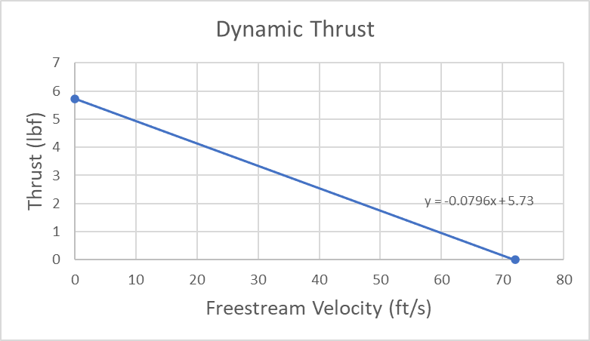

Figure 8: Thrust vs. Velocity

The team recognized that thrust decreases as freestream velocity increases and accounted for this in the Technical Data Sheet using the plot above. Static thrust was found from the motor manufacturer’s website, and zero thrust speed was found using the performanceCalc evaluation from eCalc.

## **2.5 Finite Element Analysis**

The plane model was designed in SolidWorks and imported to ANSYS to calculate the lift coefficient, lift force, drag coefficient, and drag force at 30mph. Simulation studies were conducted with the blended body of the cropped delta without the landing gear.. The table below shows the final design flight characteristics of the plane.

| **Angle of attack** | **Lift (lbf)** | **cl** | **Drag (lbf)** | **Cd** | **L/D** |
| --- | --- | --- | --- | --- | --- |
| **0** | 0.6561959 | 0.026495764 | 0.59741575 | 0.024122349 | 1.09839069 |
| **7.5** | 1.6491542 | 0.066589261 | 0.63652746 | 0.02570159 | 2.59086104 |
| **15** | 2.6975465 | 0.10892107 | 0.64938132 | 0.026220606 | 4.15402540 |
| **25** | 4.4542939 | 0.17985471 | 0.67912189 | 0.027421466 | 6.55890196 |
| **35** | 6.1541729 | 0.24849212 | 0.68792159 | 0.027776778 | 8.94603831 |
| **45** | 9.4139802 | 0.38011605 | 0.79860046 | 0.03224575 | 11.7880976 |
| **55** | 7.0841484 | 0.2860425 | 0.67488419 | 0.027250357 | 10.4968335 |
| **65** | 0.68790732 | 0.027776202 | 0.071374487 | 0.0028819466 | 9.63860614 |

Table 6: Final Design Flight Characteristics

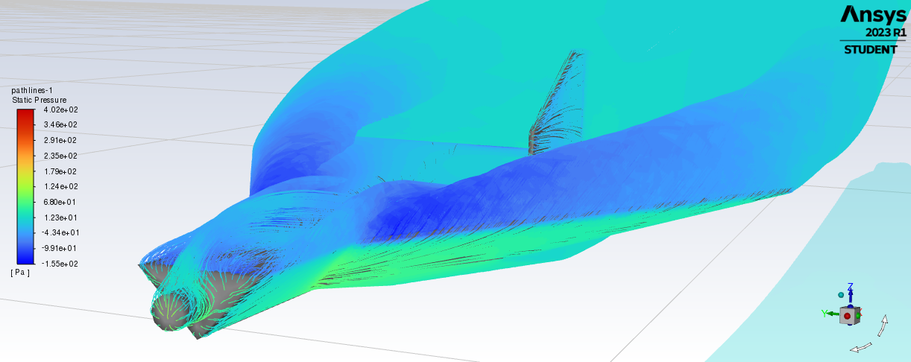

Figure 9 : Ansys Fluid Flow simulation at 45 degree AOA

## **2.6 Stability and Control**

There are multiple factors that will affect the stability of an aircraft in flight. The team decided that the implementation of a gyroscopic assist was the best path going forward to help the pilot of the plane deal with the instability of the aircraft and to negate the effects of wind. A gyro is a device that increases stability and control of the aircraft by detecting the deviation of an object from the programmed orientation. Furthermore, implementation of this assist was going to counteract the motion and turbulence created by wind, allowing the user to control the flight path more easily. The “Del operator” benefits the most from a gyro due to the lift characteristics of the plane. The major lift component is lattice vortex lift. This form of lift causes the flow over the aircraft to create vortices by The vortices are produced at the leading edge that travel down the length of the wing to speed up the air maintaining lift at slower speeds and higher AOA. The vortex lift can be seen in the ANSYS simulation in figure 10 . The “Del Operator” benefits from having the CG farther back increasing lift, but decreasing stability.This is because of the tendency for the aircraft's tail to push down due to it being tail heavy. This benefits the cropped delta wing design by placing it at a higher AOA at lower airspeeds. The vortex lift is achieved up to a 63 degree AOA. An increase in AOA after 63 degrees will make the plane stall based on ANSYS simulations. The downside to pushing the CG farther back is the inherent instability of a tail heavy aircraft. To mitigate this issue, a gyroscopic assist was implemented into the aircraft.

Other potential designs using vertical stabilizers were considered and implemented on the prototypes. The first prototype used a twin tail design. The two vertical stabilizers for the twin tail design were unnecessary for yaw control. The same effect can be achieved with a single stabilizer, which reduces drag and complexity of manufacturing. Flying wings do not need the use of a vertical stabilizer, however the team decided to implement a vertical stabilizer with a rudder for yaw control in flight. The use of a vertical stabilizer was implemented to help the pilot of the aircraft yaw into wind while landing.

**2.6.1 Wing Planform**

The wing planforms for both of the 1st prototypes were designed to maintain the maximum allowable wingspan of 3 feet, or 36 inches, to help achieve higher wing aspect ratios and to aid in generating sufficient lift necessary for lifting the aircraft at a maximum takeoff weight. The cropped delta wing was configured around a 60-degree sharp leading edge sweep angle, which produces vortex lift. The 60-degree sweep angle was chosen based on real world manufactured aircraft data and ANSYS fluid flow simulations. Vortex lift is generated by capturing vortices generated by the sharp 60 degree leading edge sweep of the wing. The vortices occur due to the higher pressure on the bottom of the wing trying to curl around the leading of the wing where the lower pressure air is occurring.

**2.6.2 Winglets**

Winglets were initially considered due to the decrease in drag for a conventional aircraft. Winglets were implemented into the first prototype of the “Del Operator” as shown in figure 11 below. As the team's knowledge of lattice vortex lift grew, the team learned the exact reasoning for winglets. The reason for the decrease in drag for conventional aircraft is that the winglets act as a streamline for the vortices to follow instead of causing induced drag. For conventional aircraft wings, this is a desirable characteristic. For cropped deltas wings this only hurts lift by disrupting the vortices forming along the leading edge of the aircraft. The configuration of the cropped delta was modified based on performance and ANSYS calculations. A very dramatic decrease in lift was observed when the final iteration of the Del Operator was simulated with winglets. Compared to the baseline model, it was observed that the addition of winglets did not improve aerodynamic efficiency due to disruption of the leading edge vortex near the wingtips. At 0 degree angle of attack with winglets, the lift produced by the aircraft was 0.627(lbf) compared to the baseline of 0.656 (lbf). The most significant drop off of efficiency happened at a 45 degree AOA. The baseline lift at 45 AOA was 9.414 (lbf). With winglets, the lift decreased to 6.999 (lbf).

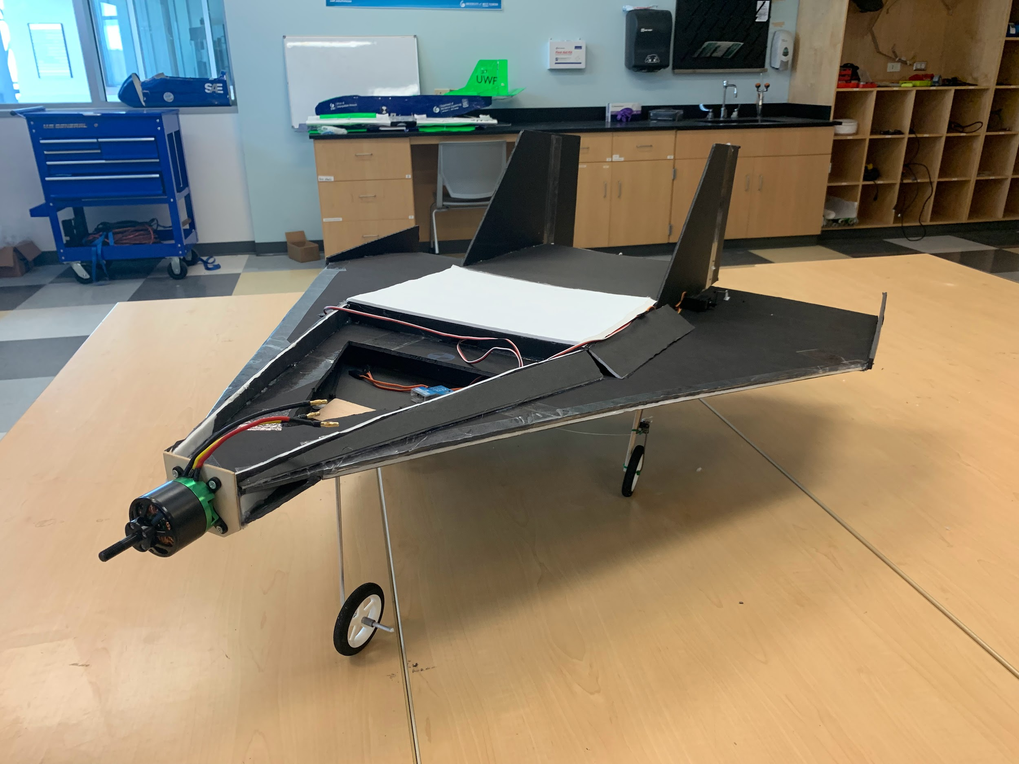

Figure 10: The First Prototype of Cropped Delta Wing

**2.6.3 Elevons**

In order to ensure the delta wing aircraft design is effective in flight it is essential elevons are proportionally sized so that the aircraft will handle well in flight. To do this the aspect ratio was used in conjunction with the following formulas [4] to calculate correct elevon sizing and determine what servos would be best suited for this purpose.

=

=

=

)

C =

0.5

Elevons Should each be 5.5 11 or 62.15

**2.6.4 Servo Selection**

In the free body diagram below, the poster board is the main material which makes the weight of the control surface significantly smaller than other forces impacting on the pivot point. There are some assumptions that should be applied for the free body diagram below [5].

* Ignoring the weight of control surface because the lightweight of poster board material
* Assuming the total of moment of the pivot point is 0
* Assuming Flift is straight up and Fdrag is horizontal to the airplane
* Assuming the angle of between F and r is equal to the servo deflection angle
* Assuming the servo shaft is equal to the distance from pivot point the force F
* The aircraft is not accelerating, not rotating, the wing has an AOA of 0 degrees, the hinges are frictionless, the control horns are massless

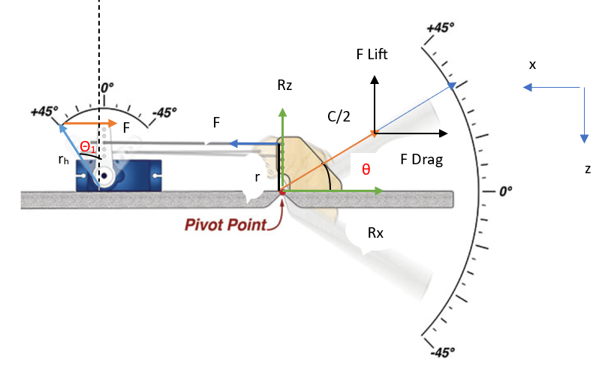

Figure 11: Control Surfaces Free Body Diagram

Basing on the assumption, the equation becomes:

Torque needed will be calculated as the below equation

]

Because, the final equation for needed torque will be

Where: C: Control surface chord (m)

L: Control surface length (m)

A: Control surface Area () = Control surface chord Control surface length

V: Speed (m/s)

Drag Coefficient

Lift Coefficient

Maximum deflection angle of the control surface (degree)

:Maximum deflection angle of the servo (degree)

r: The distance from pivot point to the force F (m)

: Air density 1.293

The right hand side of the final equation will be computed as table below

| **Aircraft Parameters** | **Number** |
| --- | --- |
| Aileron Length (m) (L) | 0.287 |
| Aileron Chord (m) (C) | 0.1397 |
| Speed (m/s) (V) | 22 |
| Max Control Surface  Deflection (degree) | 15 |
| Max Servo Deflection  Angle ) (degree) | 15 |
| Air Density (kg/) | 1.204 |
| Drag Coefficient (Cd) | 1.28 |
| Lift Coefficient (Cl) | 0.033 |
| **Torque (oz-in)** | **37.95** |
|

Table 7. Calculated Data for needed Torque using the Final Formula

Based on the calculated data from Table 4, the needed torque for the servos should be at least 0.3 Nm. The data for drag coefficient for the aileron could be estimated using the figure of shape.In this case, the aileron can be assumed to be a flat shape which has Cd = 1.28. Based on the calculations the spektrum A500 servos were selected for the aircrafts elevons, rudder, and positive mechanical steering.

**2.6.5 Battery selection**

To optimize the battery for weight reduction and power required, the team selected a battery that contains only the bare minimum power required in an effort to reduce weight. The calculations for the aircraft’s battery size were based on the power consumption of the motor, anticipated flight time, the power limiter, and the voltage of the battery. Table 9 below shows the variables needed to select a battery for max optimization for flight score while reducing the weight of the aircraft.

According to Watt’s Law (), the motor is capable of utilizing 44.1 Amps of current. Assuming the aircraft will be flown at full power for the duration of the flight, the equation , shows that a 1.7 Ah is the bare minimum required.. Comparing this to batteries currently on the market led to the decision to purchase the common 2.2 Ah battery. Using the same equation, this 2.2 Ah battery is expected to allow for a 2.7 minute flight at full power. Based on these parameters in table 5, the spectrum 2200 mah, 3S, 30C, 11.1V battery was chosen.

| **Battery Selection Variables** | **Value** |
| --- | --- |
| Anticipated Flight Time (based on previous year’s plane) | 120 sec |
| System Voltage | 11.1 volts |
| Power Limiter | 450 watts |
| Motor Max Continuous Power | 490 watts |
| Usable Capacity of Lipo Battery | 80% of rated capacity |

Table 8: Battery Selection Variables

## **2.7 Take-Off & Climb Out Performance**

Currently, the team’s takeoff and climb out performance is based on a numerical solution of the aircraft 2D equations of motion using Euler’s method in conjunction with the forces exerted on the monoplane during flight. One major design constraint mentioned above is the takeoff distance of 8’. Another design constraint is the 3’ wingspan limit. These serve to limit the amount of weight and volume the plane can carry. The takeoff distance is challenging to work with because the lift produced by a wing is proportional to the freestream velocity. The cropped delta was chosen for the final design due to the volume of payload it could carry and lift characteristics at low speeds and high AOA.

# **3 Implementation**

The software tools used for designing the aircraft were Microsoft Excel, SolidWorks, and ANSYS Fluent. Excel was used to develop a take off distance analysis and scoring analysis, which helped determine optimal payload configurations for each prototype as well as to estimate desired takeoff parameters which was necessary to size components such as the wing. Initial designs were also based on an allocated weight budget for each aircraft, which was found using the calculated takeoff parameters. ANSYS played a key role in predicting aerodynamic performance for each aircraft by providing lift and drag coefficient values for a given angle of attack, velocity, and model iteration.

**3.1 Manufacturing**

The cropped delta wing was constructed out of foam poster board, ranging with a thickness of 0.15 inches to 0.20 inches, which provided a good strength-to-weight ratio of 137 psi of tensile strength. The fuselage sizing for the plane is the optimized payload configurations found from the scoring analysis. The cropped delta wing was designed to house two large payload boxes. The large boxes, which had a flatter shape, were more aerodynamically suited to fit the aircraft’s swept shape.Physical deflection tests were also performed on potential spar materials, such as aluminum and balsa rods.

The main frame of the proto type planes is cut poster board. Poster board was used for prototypes due to the price and strength of the material. The posterboard is $1.50 per sheet, which makes it cost effective and readily available. The adhesive used for the planes was hot glue which was chosen for its high adhesion strength and ease of application. Hot glue can hold up to the strength of 10 lb/in2.

Proprietary front and rear landing gear assemblies were designed in SolidWorks. Using finite element analysis, the assemblies were designed to withstand a 5G vertical impact as well as an equivalent horizontal force with the maximum stress point located along the upper radius closest to the fuselage. The landing gear was manufactured using Fused Deposition modeling. Acrylonitrile Butadiene Styrene was selected as the material due to its low density and high yield strength.

For the two prototype planes used for the Fall semester, poster board is the main construction material. Poster board was used for the wings, tail, and fuselage of both planes. The benefit of posterboard is that at around , which is lightweight and does not cause any weight problems. The material can handle about 7.88 of tension on average which supports the collective load of the Del operator..

As for landing gear, both 1.1 prototypes of the “Del Operator” and the “Flying Guppy” used aluminum. The table below shows the comparison between two main materials that will be applied for the aircraft model in Spring 2023. Aluminum was later replaced with ABS 3D printed plastic landing gear due to its high strength and ease of manufacturing of complex shapes.

| **Properties** | **Balsa Wood** | **Poster Foam** |
| --- | --- | --- |
| Density | 0.16 lb/in³ | 0.00145 - 0.0564 lb/in³ |
| Bending Strength | 2,550 psi – 3,170 psi (370 ksi – 460 ksi) | 24.946 psi |
| Tensile Strength | 145 psi | 137 psi |
| Melting Temperature | 250°C | 93°C |
| Price per foot | $5 - $8 | $1 |

Table 9. Table of Physical and Mechanical Properties of Balsa Wood and Foam Boards [6]

Although balsa wood was considered, based on analysis through testing flight as well as properties table, the wood will not be used due to its expensive price which is about from $5 - $60 per square foot depending on its thickness [7]. The cropped delta wing and monoplane prototypes were both constructed out of foam poster board because of its lightweight and low density index and affordable cost.

The design of the rear landing gear gives the aircraft effective stability by providing a wider wheel base. This is done by having the CG be just in front of the front landing gear. A test was produced in solidworks to analyze how the rear landing gear strut would deflect under force to simulate it having to support the aircraft on the taxiway and during landing.

# **4 Testing**

## **4.1 Flight Testing**

A test flight for the finished prototype 1.1 of the Del Operator was conducted on December 12th to focus on design implementation into the real world. To conduct the test, the completed prototype was taken to a RC airfield local to UWF. The finished prototype is displayed below.The aircraft was first taxied for testing the flight characteristics of the plane. The prototype was placed on the runway and did a hop for the first flight. The 2nd flight occurred and the plane flew phenomenally.This test flight confirmed that the original concept of the cropped delta wing is capable of competing at the micro class competition and the results of this test will utilize design aspects in the final design that will be taken to Fort Worth, Texas.

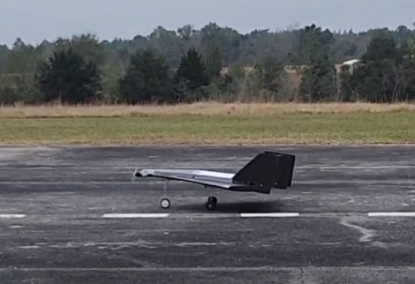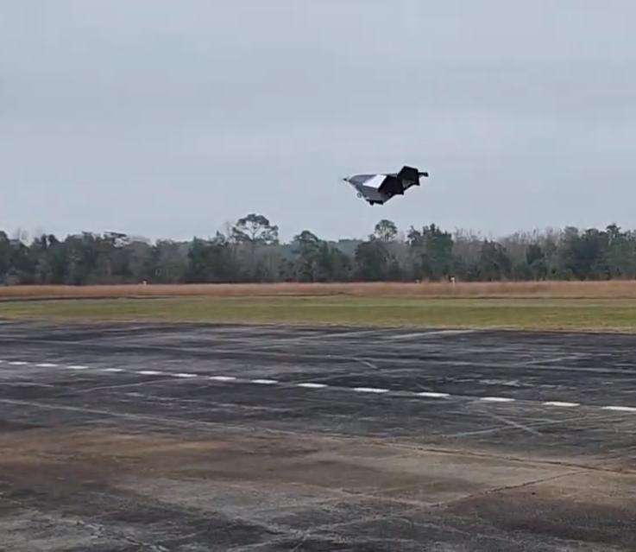

Figure 12 and 13: Finished Prototype On the Runway and in Flight.

Another Flight test was performed on 3-5-2023 to test the take-off performance of the final design and flying characteristics. The Del Operator took off within the 8ft take-off distance and performed well in flight without a gyro. This test showed the cropped delta wing design will be able to carry 4 large payload boxes with a 3ft wingspan.

# **References**

[1] Motor Propeller Data. *Cobra.* <https://www.innov8tivedesigns.com/images/specs/Cobra_4120-18_Specs.htmCobra>

[2] Daniel P. Raymer, 1<https://www.innov8tivedesigns.com/images/specs/Cobra_4120-18_Specs.htmCobra>992. *Aircraft Design: A Conceptual Approach*

[3] *CobraMotorsUSA.com - cobra C-3515/14*. [Online]. Available: https://www.cobramotorsusa.com/motors-3515-14.html. [Accessed: 06-Mar-2023].

<https://www.innov8tivedesigns.com/images/specs/Cobra_3515-14_Specs.htm> \

[4] Martínez Eber Maciel, August 2020 *Project Boom* DEVELOPMENT OF A CALCULATOR FOR CONTROL SURFACE SIZING ON A SUPERSONIC DELTA WING AIRCRAFT

<https://theprojectboom.org/journal/control-surface-sizing-on-supersonic-delta-wing-aircraft/>

[5]. “New Technology Weakley,” The Park Pilot, 27-Oct-2021. <https://www.theparkpilot.org/new-technology-weakley>

[6]. Overview of materials for PVC, foam grade. <https://www.matweb.com/search/datasheet_print.aspx?matguid=e19bc7065d1c4836a89d41ff23d47413>

[7]. “Balsa plywood & Panels,” Custom Balsa Wood Plywood -- Specialized Balsa Wood, LLC. [Online]. <https://specializedbalsa.com/products/balsa_plywood.php>