Title: The Topic

By Hunter Dyar. IMM103 Section 000.

The Report. This is a paragraph of text. I am writing a paragraph of text here to fill up space for this page to be a visual. This template is only a guideline. The title should be bigger, in fact. This text should not be taken as a guide or expectation of length. Your report should contain more words than this single paragraph. I say “should” because there is no minimum word count. I will just be looking for you to include the content required, presented professionally.

Now, a new paragraph. Speaking of professional, this paragraph of filler text should not be interpreted as an indication of appropriate tone. Doodlywoodly. Fiddly Widdly. These are filler words, and unprofessional ones at that. Your report should demonstrate a no-nonsense and pragmatic style of effective communication. Do not forget to attempt this. Historically, students let their sentences run-on too long and forget to use a spellcheck. Using spell-check is such an easy win. Let the computer fix your mistakes for you. Have I written enough filler text? Probably not. Even though I explicitly mention otherwise, if I do not write enough words here in the template, students will take it as a sign they can submit just as few words. Thus: filler filler filler filler filler filler. Et cetera. This is not a real topic, so enjoy these images of my cat as example images. His name is agent 86.

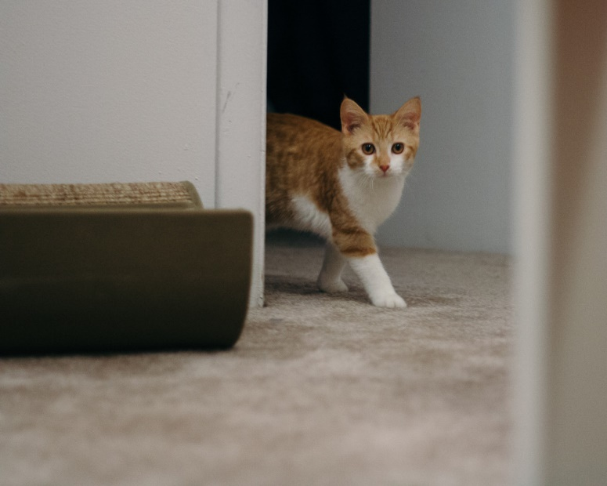

At the very bottom should be the date/dates. If we are all consistent with putting the dates large and on the bottom, it will help when all of the documents are printed and displayed as a timeline. I changed the bottom margin in word from 1” to ½”.

June 2015 -Present