Read Me File
Hunter Ewin
Project 2

The application is great since it has had the capacity to achieve the needed requirement that a client can request. The application’s design was made possible through Python 3 by using Jupiter Notebook. The above makes it possible for Jupiter Notebook to execute the app.
Two modules make up the application and the backend. In turn, it serves as a bridge connecting both the database and the front end. It also has its importance in retrieving the data that is used in the database.
The application has the capacity to eliminate the possibility of using SQL and Mongo databases in relation to either structured or relational query-based databases. Mongo database possesses several advantages such that:
- It deals with large data volumes.
- It also ensures easy updates to schema and associated fields.
- Ensures friendly development to users.
- It takes advantage of the cloud.
The project serves as a simple application with the objective of providing data to any user with the capacity to meet certain requirements. According to the requirements, the user can see the only desired data. The displayed data can be filtered based on the command sent to the server.
Concerning the Project
The below image shows windows that is employed for filtering data. It shows that whenever a user checks a radio button, the result includes the table displaying all animals in specific categories.
Image_1
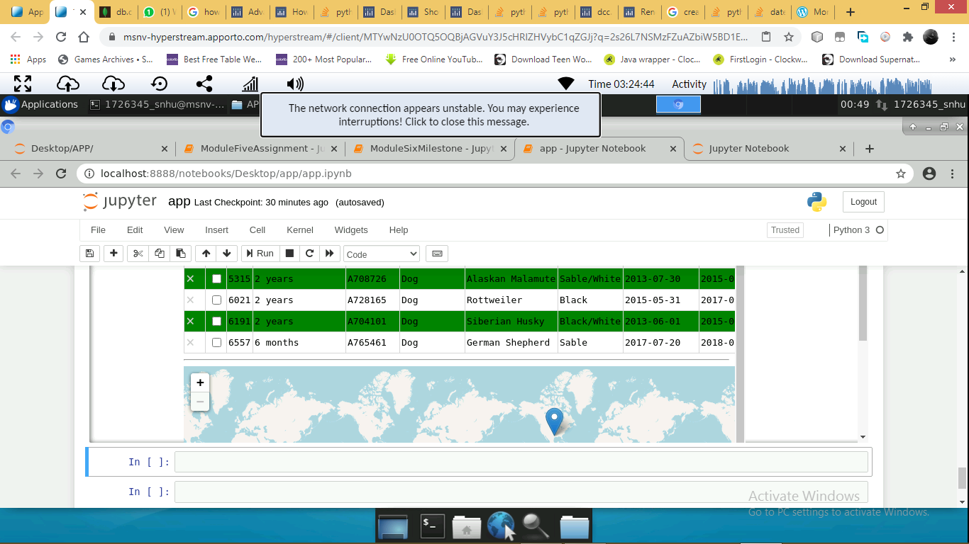
Additionally, there are graphs and geocharts at the bottom. They show data associated with the selected animal, but represented on the table.
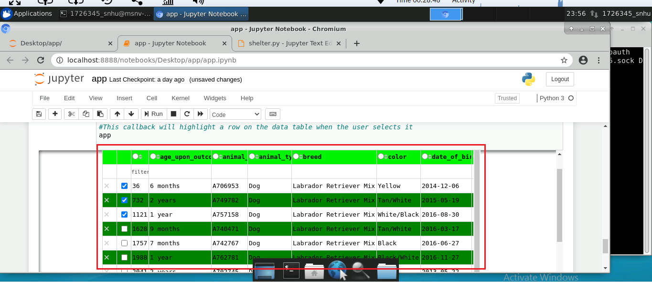
The table only represents the animal associated with the category selected above. The table only represents the animal needed, reducing the time required to understand the information on the table scrolled from the database.
Another important chart is the geo chart, which shows the location of the company. It also provides details related to the selected animal. The map provides individuals with a direction and may ensure that it communicates about an idea of where the animal is located.
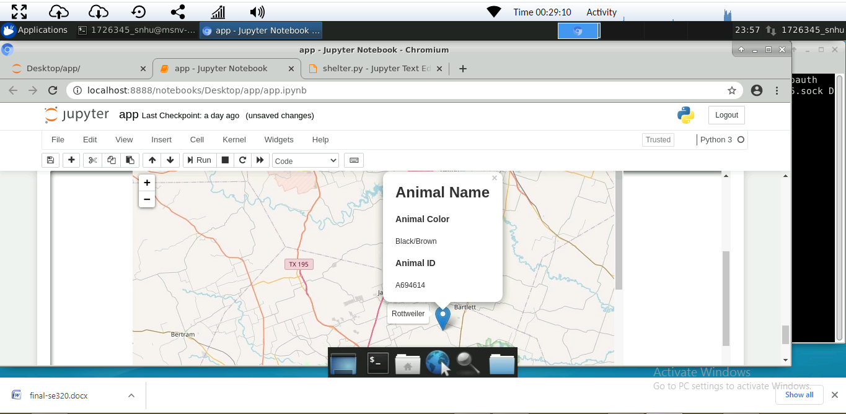
The last significant part that is displayed includes a visual representation of the selected data. Interpretation of the data makes it possible for it to become more known and understood.
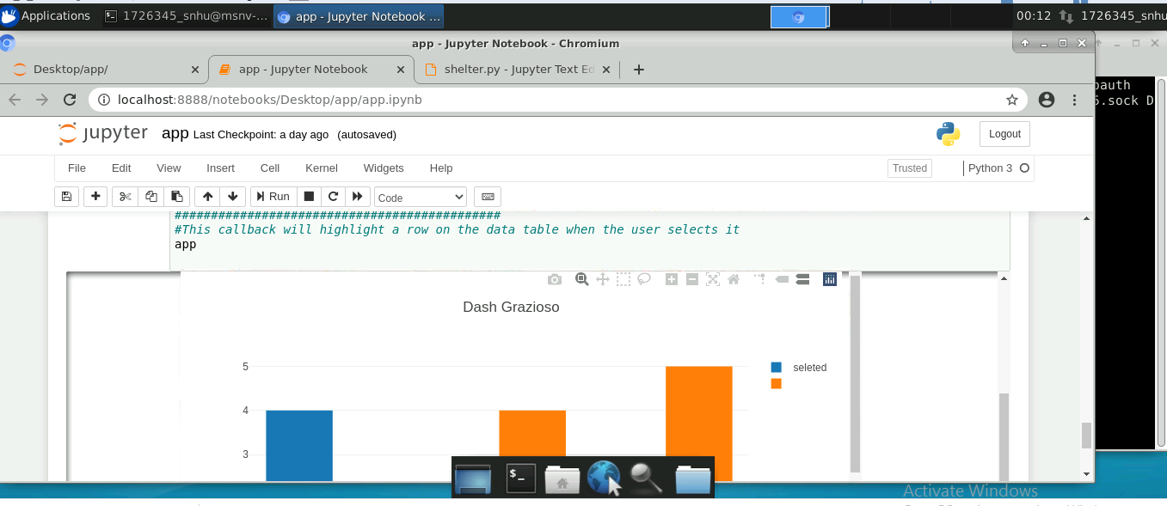
Followed Steps
- The server comprises all the available materials. Hence, there is no need for installation. When it comes to new users, Mongo databases and Jupiter Notebook are important tools.
- Connection files, with the capacity of undertaking the connection to the database are important in enhancing data retrieval possibilities. The file exists to connect the new file to a system such as the database.
- The last development included the application that generated frameworks such as data maps, charts, and tables.
Concerning the Dash Library
It serves as one of the easiest tools that anyone can use due to its capacity to contain large documentation status in the web. The Dash Library ensures easy learning among users and facilitates more tools to support data representation, visualization, and promoting capturing input from different users. CSS can be used to format the components, which creates their appealing status. The main challenge in the project includes the error handling issue. The situation has influenced a problem of capturing exceptions in the same manner as other languages. Regarding graphs display, in the case of an error, it becomes difficult to display it on the screen. Hence, the problem of creating corrections is made difficult too.

