Table 1. Summary of results based on the 5-fold cross validation on the training dataset.

|  |  |  |  |  |  |  |
| --- | --- | --- | --- | --- | --- | --- |
| Outcome | Quality measure | Baseline result | Design 1 | Design 2 | Design 3 | Best Design |
| DNA | Sensitivity | 6.9 | 0.0 | 24.8 | 2.55 |  |
| Specificity | 99.3 | 100.0 | 96.1 | 99.8 |  |
| PredictiveACC | 95.2 | 95.6 | 92.9 | 95.5 |  |
| **MCC** | **0.132** | **nan** | **0.2** | **0.097** |  |
| RNA | Sensitivity | 39.6 | 28.0 | 52.1 | 8.4 |  |
| Specificity | 98.9 | 97.7 | 97.3 | 99.1 |  |
| PredictiveACC | 95.3 | 94. | 94.1 | 94.1 |  |
| **MCC** | **0.501** | **0.306** | **.529** | **0.148** |  |
| DRNA | Sensitivity | 4.5 | 0.0 | 45.0 | 0.0 |  |
| Specificity | 100.0 | 100.0 | 100.0 | 100.0 |  |
| PredictiveACC | 99.7 | 99.7 | 99.7 | 99.7 |  |
| **MCC** | **0.122** | **nan** | **0.670** | **nan** |  |
| nonDRNA | Sensitivity | 98.6 | 96.6 | 55.8 | 96.3 |  |
| Specificity | 29.8 | 1.3 | 4.9 | 1.1 |  |
| PredictiveACC | 91.3 | 10.6 | 10.6 | 10.6 |  |
| **MCC** | **0.428** | **-0.051** | **-0.429** | **-0.068** |  |
| **averageMCC** | | **0.296** | **0.128** | **0.243** | **.059** |  |
| *accuracy* | | 90.8 | 90.04 | 87.24 | 89.55 |  |

|  |  |  |  |  |  |
| --- | --- | --- | --- | --- | --- |
|  | | **predicted** | | | |
|  | | DNA | RNA | DRNA | nonDRNA |
| **actual** | DNA | 27 | 20 | 0 | 344 |
| RNA | 21 | 207 | 1 | 294 |
| DRNA | 0 | 2 | 1 | 19 |
| nonDRNA | 36 | 71 | 1 | 7751 |

Confusion matrix that corresponds to the baseline result

Confusion matrix that corresponds to design 1

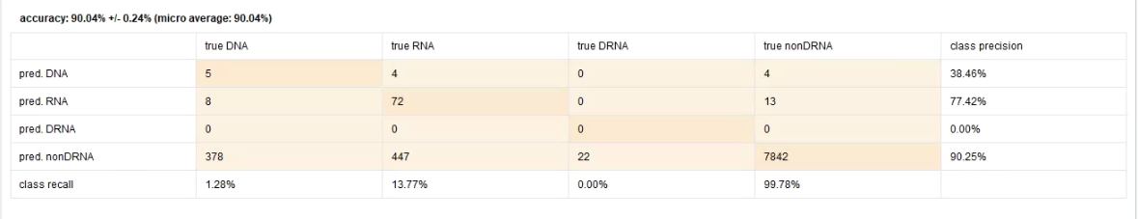

Confusion matrix that corresponds to design 2

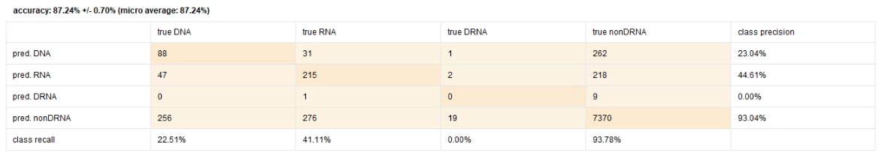

Confusion matrix that corresponds to design 3