|  |
| --- |
| Species distribution and temperature range of select Pacific groundfish species occurring in Queen Charlotte Sound and Hecate Strait, British Columbia |
| Jean-Baptiste Lecomte and Karen Hunter |
| Fisheries and Oceans Canada  Science Branch,  Pacific Region  Pacific Biological Station  3190 Hammond Bay Road  Nanaimo, BC V9T 6N7 |
| 2019 |
| **Canadian Technical Report of Fisheries and Aquatic Sciences XXXX** |

**Canadian Technical Report of Fisheries and Aquatic Sciences**

Technical reports contain scientific and technical information that contributes to existing knowledge but which is not normally appropriate for primary literature. Technical reports are directed primarily toward a worldwide audience and have an international distribution. No restriction is placed on subject matter and the series reflects the broad interests and policies of Fisheries and Oceans Canada, namely, fisheries and aquatic sciences.

Technical reports may be cited as full publications. The correct citation appears above the abstract of each report. Each report is abstracted in the data base *Aquatic Sciences and Fisheries Abstracts*.

Technical reports are produced regionally but are numbered nationally. Requests for individual reports will be filled by the issuing establishment listed on the front cover and title page.

Numbers 1-456 in this series were issued as Technical Reports of the Fisheries Research Board of Canada. Numbers 457-714 were issued as Department of the Environment, Fisheries and Marine Service, Research and Development Directorate Technical Reports. Numbers 715-924 were issued as Department of Fisheries and Environment, Fisheries and Marine Service Technical Reports. The current series name was changed with report number 925.

**Rapport technique canadien des sciences halieutiques et aquatiques**

Les rapports techniques contiennent des renseignements scientifiques et techniques qui constituent une contribution aux connaissances actuelles, mais qui ne sont pas normalement appropriés pour la publication dans un journal scientifique. Les rapports techniques sont destinés essentiellement à un public international et ils sont distribués à cet échelon. II n'y a aucune restriction quant au sujet; de fait, la série reflète la vaste gamme des intérêts et des politiques de Pêches et Océans Canada, c'est-à-dire les sciences halieutiques et aquatiques.

Les rapports techniques peuvent être cités comme des publications à part entière. Le titre exact figure au-dessus du résumé de chaque rapport. Les rapports techniques sont résumés dans la base de données *Résumés des sciences aquatiques et halieutiques.*

Les rapports techniques sont produits à l'échelon régional, mais numérotés à l'échelon national. Les demandes de rapports seront satisfaites par l'établissement auteur dont le nom figure sur la couverture et la page du titre.

Les numéros 1 à 456 de cette série ont été publiés à titre de Rapports techniques de l'Office des recherches sur les pêcheries du Canada. Les numéros 457 à 714 sont parus à titre de Rapports techniques de la Direction générale de la recherche et du développe­ment, Service des pêches et de la mer, ministère de l'Environnement. Les numéros 715 à 924 ont été publiés à titre de Rapports techniques du Service des pêches et de la mer, ministère des Pêches et de l'Environnement. Le nom actuel de la série a été établi lors de la parution du numéro 925.

Canadian Technical Report of Fisheries and Aquatic Sciences xxxx

2019

Species distribution and temperature range of select Pacific groundfish species occurring in Queen Charlotte Sound and Hecate Strait, British Columbia

by

Jean-Baptiste Lecomte1 and Karen Hunter2

1 Jean Baptiste location

2 Fisheries and Oceans Canada, Pacific Biological Station, Nanaimo, BC

© Her Majesty the Queen in Right of Canada, 2019

Cat. No. Fs 97‐6/3256E‐PDF; ISSN 1488‐5379; ISBN 978-0-660-25481-4

Correct citation for this publication:

Lecomte, J-B. and K.L. Hunter. XXXX. Species distribution and temperature range of select Pacific groundfish species occurring in Queen Charlotte Sound and Hecate Strait, British Columbia. Cdn Tech Rep. Fish. Aquat. Sci. XXXX

**Table of Contents**

Abstract 6

Introduction 7

Methods 7

Biological data 7

Regional Ocean Model System ………………………………………………………………………….7

Species distribution model 8

Model convergence …………………………………………………………………………………...…9

Temperature range and probability of presence ………………………………………………………..10

Selected species 10

Results 12

Arrowtooth flounder (*Atheresthes stomias*) 14

Bocaccio (*Sebastes paucispinis*) 16

Canary rockfish (*Sebastes pinniger*) 18

Dogfish (*Squalus acanthias* ) 20

Dover sole (*Microstomus pacificus* ) 22

English sole (*Parophrys vetulus*) 24

Greenstripe rockfish (*Sebastes elongates*) 26

Pacific cod (*Gadus macrocephalus*) 28

Petrale sole (*Eopsetta jordani*) 30

Pacific Ocean perch (*Sebastes alutus*) 32

Spotted ratfish (*Hydrolagus colliei*) 34

Rock sole (*Lepidopsetta bilineata*) 36

Redstripe rockfish (*Sebastes proriger*) 38

Rex sole (*Glyptocephalus zachirus*) 40

Sablefish (*Anoplopoma fimbria*) 42

Silvergray rockfish (*Sebastes brevispinis*) 44

Shortspine thornyhead (*Sebastolobus alascanus*) 46

Widow rockfish (*Sebastes entomelas*) 48

Conclusion 50

References 51

Appendices: Model parameter testing for each species 52

Appendix 1: Mean catches per year 52

Appendix 2: Locations and quantities of catches per year in the study area 57

Appendix3: Potential Scale Reduction Factor for hyper-parameters 62

Appendix 4: Posterior distributions of model hyper-parameters 67

Appendix 5: Pairs plot of posterior distributions of model hyper-parameters 76

Appendix 6: Model parameters and estimates for each species 81

# Abstract

We apply a published, hierarchical Bayesian model to represent the spatial structure of fish biomass and analyze the spatial distribution and habitat associations of 18 species sampled by DFO’s Synoptic Trawl Surveys across the northern coast of British Columbia (Canada) accounting for spatial correlation among observations. A zero-inflated distribution based on a compound Poisson with Gamma marks is used for the observation layer, and a linear model with spatial correlated errors accounting for the role of habitat variables (temperature, depth) in the process layer. Outputs of quantities of interest (e.g. probability of presence, estimated historical distribution of each species) were produced, taking into account the uncertainty of the estimated parameters and observation errors. Outputs of probability of presence at temperature are useful for estimating thermal optimum of species where no other information exists.

Resume – translation

# Introduction

To address potential ocean climate effects on commercially important fishery species we require an improved understanding of species spatial distribution and habitat associations. Distributions and habitat preferences have often been inferred through the development of linear or additive models that rely on survey and ecological data (Guisan and Thuiller 2005). However, outputs created by such models may not sufficiently address spatial autocorrelation or skewness in the data thereby providing analyses that do not inform appropriately on areas of the distribution that could be vulnerable to the changing climate (e.g. shifts in distribution, changes to suitable habitat).

In the marine environment especially, the high proportion of zero observations in survey data can be limiting to standard species distribution models that are not designed to compute zero values effectively (Martin et al. 2005). Lecomte et al. (2013) developed and tested a hierarchical Baysian spatial model for biomass data that overcomes shortcomings of zero-biased methods that are traditionally applied to fish survey data. This method can also be used to estimate habitat associations with variables of interest. This method informs on species physiological range limits or ecological niche by adding locally recorded covariates to the model in order to describe the habitat associations as well as complex spatial dependence structures. This approach provides a probability of association with habitat features (i.e. temperature, depth, habitat structure, etc.).

We applied the Lecomte et al. (2013) hierarchical Bayesian model to represent the spatial structure of fish biomass and analyze the spatial distribution and habitat associations of 18 species sampled by DFO’s Synoptic Trawl Surveys across the northern coast of British Columbia accounting for spatial autocorrelation among observations. Assessed species included both common commercially valuable species and rare species that are important to the BC Groundfish fleet. Model outputs included species probability of presence related to temperature and the estimated historical distribution of each species. These quantities took into account the uncertainty of the estimated parameters and observation errors.

This Technical Report presents results from model runs on 18 Pacific groundfish species distributed across Hecate Strait and Queen Charlotte Sound, British Columbia. Outputs may further support the development of climate vulnerability assessments needing estimates of species thermal optimum information.

**Methods**

## 1.1 Biological data description

Fisheries and Oceans Canada (DFO) has implemented four stratified random bottom trawl surveys which collectively cover the continental shelf off the coast of British Columbia. These surveys were initiated between 2003 and 2005. Each of the four surveys is repeated every two years.

Trawl surveys were conducted in July and August of 2003, 2004, 2005, 2007, 2009 and 2011. The whole study area was first covered by the 4 surveys in 2005. Data collected in year 2003 and 2004 are not taken in account in this study. Species abundance and habitat variables (i.e. temperature, salinity, depth at the net) were recorded for each tow. The survey tows had an average duration of 20 minutes.

Mean catch per year and the locations and quantities of catches per year in the study area are presented in Appendix1 and 2.

**1.2 Regional Ocean Model System**

The Regional Ocean Model System (ROMS) is a terrain following, primitive equation model which has been used extensively to model various regions of the world’s oceans (Haidvogel et al. 2008). The BC coast implementation is forced by NARR (North American Regional Reanalysis 2004) atmospheric data, and lateral boundary conditions are extracted from the Simple Ocean Data Assimilation project, or SODA (Carton and Giesse 2008). Tidal forcing is applied at the open boundaries using the output from a North-East Pacific tidal model (Foreman et al. 2000). In addition, the ocean model is forced by freshwater monthly discharge from BC major rivers, derived as in Morrison et al. (2012). Details of the model setup as well as an extensive model validation can be found in Masson and Fine (2012).

The model domain extends from the Columbia River to the Alaska Panhandle and is used to hindcast the 33 year period 1979–2011. This represents a significant extension of the original hindcast of Masson and Fine (2012) which covered the 14-year period 1995-2008. The horizontal grid resolution is 3 km, with 60 levels in the vertical. In addition to the increase in vertical resolution, the updated BC model uses an improved sigma coordinate transformation (Shchepetkin et al. 2009).

A specific output of the BC ROMS model was applied for this study. The required temperature fields were extracted from the 15-day average output file, for each of the 33 year simulation. Data near the northern, southern and western boundaries were excluded because they are more likely contaminated by spurious boundary effects. Also we excluded land data using the land-sea mask.

## 1.3 Species distribution model

The spatial distribution and habitat associations for select species were investigated by using a Bayesian hierarchical model which accounts for zero-inflation in the data (Lecomte et al. 2013). The model was run at the resolution of 3km x 3km using observations of fish abundance from DFO’s Synoptic Groundfish Trawl Surveys. Temperature and depth are included in each model using temperature outputs from the Regional Oceanographic Model System (ROMS) and depth data from the BCMCA database. A zero-inflated distribution based on a compound Poisson with Gamma marks was used for the observation layer and a linear model with spatial correlated errors accounted for the role of habitat variables (temperature, depth) in the process layer.

***1.3.1 Observation model and assumptions***

The Compound Poisson-Gamma model (CPG) is based on the Poisson sum of gammas of the Tweedie distribution (Foster and Bravington 2012; Lecomte et al. 2013). This modeling approach mimics the process involved in the sampling of living organisms when the observation variable is strictly positive and continuous (Foster and Bravington 2012; Lecomte et al. 2013). The unknown number of aggregations , also called number of patches of organisms, is Poisson distributed and has an intensity parameter . Gamma marks account for the biomass within a patch. We assumed that the marks follow a gamma distribution and are independent and identically distributed with and the shape and rate gamma parameters. The CPG model was characterized by these three parameters () and additivity properties (Jorgensen 1987), which includes in natural manner the sampling effort in the modeling approach by scaling the Poisson parameter:

***1.3.2 Latent model***

***Environmental variables***

Covariates that potentially explain the distribution of the studied species are introduced in the model by having an effect on intensity :

Where is the intercept, is a variable recorded at year and site and is the coefficient associated to this variable.

In this study, depth and temperature are introduced to explain the distribution of the selected species. An environmental covariate has an effect on the distribution of the studied species when the credibility interval at 95% of does not contain 0. If the posterior distribution of does not contain 0 and is smaller than 0, the variable has a negative effect on the species distribution; whereas a positive effect on the species distribution is detected when is greater than 0 and its credibility interval at 95% does not contain 0.

A year effect can also be added to the modeling of when multiple years are used in the same model. To do so, the first year is designated as the baseline year and its effect is set to 0. The effects of the consecutive years are estimated based on the first year. If the credibility interval at 95% of (i.e. the effect of the second year) contains 0, then there is no difference detected by the model between year 1 and year 2. On the opposite, if the credibility interval at 95% of does not contain 0, there is a difference between the 2 years. The model parameters are summarized in Table 1.

Table 1: Model parameters, their role and priors used in the model

|  |  |  |
| --- | --- | --- |
| Parameter | Role | Prior |
|  | positive biomass |  |
|  | positive biomass |  |
|  | intercept |  |
|  | linear depth effect |  |
|  | linear temperature effect |  |
|  | linear year effect |  |

***1.3.3 Predictions***

The main advantage of the model applied here is its capability of making predictions, , conditional on the observations, . The predictive distribution of the biomass quantity is given by:

where represents a vector of estimated parameters.

For this study, for each iteration of the Markov chain Monte Carlo (MCMC) chains, we performed a prediction of the quantity of biomass on a regular grid of 3 by 3km covering the entire study area. Prediction for a new site requires knowledge of the values of the environmental covariates at this site. Covariates were obtained from ROMS output. Then, the latent layer was generated for all the new sites to account for the effects of the covariates. The biomass of the selected species in un-sampled locations, *Ynew* , was then drawn from the observation model sub-component.

**1.4 Model convergence**

Model convergence for each estimated hyper-parameter was assessed graphically by plotting posterior distributions, and numerically by calculating the potential Scale Reduction Factor (Rhat).

***1.4.1 Potential scale reduction factor***

Rhat compares the between-chain variation with the within-chain variation (Gelman et al. 2004). A value close to 1 and not greater than 1.1 signifies that convergence is obtained for the parameter. When one or more parameters estimates do not converge, the results of the model should be discarded (Appendix 3).

## *1.4.2 Posterior distribution*

The posterior distributions of the hyper-parameters were produced for each species. Colors represent the posterior distribution obtained for each MCMC chain (Appendix 4). Model convergence is attained when the posterior distribution of each MCMC chain and parameter are centered on the same value. Parameters accounting for environmental variable or year effects (s) should be interpreted as follows: if the posterior distribution contains 0, there is no effect of the associated variable. If the posterior distribution does not contain zero, there is a significant effect of the variable (i.e. negative or positive). Pairs plots showing the posterior distributions of all hyper-parameters and correlation between estimated parameters demonstrates the effectiveness of the model for individual species (Appendix 5). Strong correlation (r > 0.6) between two or more parameters should be avoided. In cases where the model predicts a strong correlation among parameters, results should be interpreted with caution.

## 

## 1.5 Temperature range and probability of presence

Temperature was included in the latent model as a linear effect and can therefore be used to describe the relationship between temperature and species probability of presence in the study area. Temperature range was computed for values sampled during the Synoptic Groundfish Trawl surveys (range: 4.46 -12.9 °C). The probability of presence of the selected species was then computed from thermal range outputs for each cell of the ROMS grid.

**1.6 Selected species**

Groundfish harvested in Pacific fisheries include over 200 species. Several species play particularly important roles in terms of commercial value, whereas others are rare in number and have associated conservation objectives including fisheries regulations. Eighteen commercially important or rare species were selected for the model runs (Table 2).

Table 2: Selected Pacific groundfish economic or rare species

|  |  |  |
| --- | --- | --- |
| **Species common name** | **Scientific name** | **Selection criteria** |
| Arrowtooth Flounder | *Atheresthes stomias* | Commercially important |
| Bocaccio | *Sebastes paucispinis* | Rare |
| Canary Rockfish | *Sebastes pinniger* | Rare |
| Spiny Dogfish | *Squalus acanthias* | Commercially important |
| Dover Sole | *Microstomus pacificus* | Commercially important |
| English Sole | *Parophrys vetulus* | Commercially important |
| Greenstripe Rockfish | *Sebastes elongates* | Commercially important |
| Pacific Cod | *Gadus macrocephalus* | Commercially important |
| Petrale Sole | *Eopsetta jordani* | Commercially important |
| Pacific Ocean Perch | *Sebastes alutus* | Commercially important |
| Spotted Ratfish | *Hydrolagus colliei* | Commercially important |
| Rock Sole | *Lepidopsetta bilineata* | Commercially important |
| Redstripe Rockfish | *Sebastes proriger* | Commercially important |
| Rex Sole | *Glyptocephalus zachirus* | Commercially important |
| Sablefish | *Anoplopoma fimbria* | Commercially important |
| Silvergray Rockkfish | *Sebastes brevispinis* | Commercially important |
| Shortspine Thornyhead | *Sebastolobus alascanus* | Commercially important |
| Widow Rockfish | *Sebastes entomelas* | Rare |

# 

# Results

**1.1 Temperature range**

Temperature (°C) was calculated from the number of 3km by 3 km grid cells over the study area (Table 3).

Table 3: Percent frequency of seawater temperature (°C) observed for all trawl surveys

|  |  |
| --- | --- |
| Temperature | Frequency |
| 5 | 0.05 |
| 6 | 0.30 |
| 7 | 0.25 |
| 8 | 0.17 |
| 9 | 0.12 |
| 10 | 0.06 |
| 11 | 0.03 |
| 12 | 0.01 |

**1.2 Model performance**

For all species, model convergencevalues were close to 1 suggesting that the model parameters converged sufficiently for the analysis (Appendix 3). Posterior distributions and parameter correlations presented in Appendices 4 and 5 show the strength of each latent variable on species distributions (i.e. positive or negative effect for temperature or depth) and where correlations among parameter are sufficiently large (>0.6) to suggest the model was unsuccessful in predicting distribution.

For Bocaccio, Canary Rockfish, and Widow Rockfish the model did not produce reliable results because of a very high proportion of zeros in the observation data. For Petrale Sole, Greenstripe Rockfish, and Redstripe Rockfish, the proportion of zeroes in the dataset were high and results are to be interpreted with caution.

**1.3 Abundance, predictions, and presence**

The amount of biomass was smaller in 2007, 2009 and 2011 than in 2005 for all species except Rock Sole (highest biomass = 2007). Seven of the 18 species were observed with high frequency across a large portion of the study area (>50% coverage).

Posterior predictive joint distributions (i.e. species distributions) are summarized by maps showing various statistics (mean, median and coefficient of variation; see individual species results). The probability of presence at temperature for individual species presented in each species section below and summarized in Table 4.

**1.5 Results Summary**

Table 4: Summary of temperature (ºC) range of selected species and effect of temperature and depth based on model output. Table contents derived partially from model outputs in Appendix 6.

|  |  |  |  |  |  |  |  |
| --- | --- | --- | --- | --- | --- | --- | --- |
| Species | Percent absence | Effect of temperature | Effect of depth | Year(s) of highest biomass | Temperature at probability of presence (50%) | Temperature at maximum probability of presence (in brackets) | Percent of study area |
| Arrowtooth Flounder | 14.97 | negative | negative | 2005 | 10.02 | 4.63 (99) | 95 |
| Boccacio | 94.69 | negative | negative | 2005 | no output | no output | very low |
| Canary Rockfish | 83.32 | negative | negative | 2005 | no output | no output | very low |
| Spiny Dogfish | 37.59 | negative | strong, negative | 2005 | 5.78 | 8.38 (72) | 95 |
| Dover Sole | 34.68 | negative | positive | 2005 | 7.82 | 4.46 (99) | 49 |
| English Sole | 55.02 | negative | strong, negative | 2005 | 7.07 | 11.07 (89) | 75 |
| Greenstripe Rockfish | 80.92 | negative | negative | 2005 | no output | no output | very low |
| Pacific Cod | 45.23 | negative | strong, negative | 2005 | 6.20-12.17 | 8.45 (75) | 95 |
| Petrale Sole | 60.58 | negative | negative | 2005 | 6.65-8.74 | 7.87 (64) | 40 |
| Pacific Ocean Perch | 51.67 | strong, negative | negative | 2005 | 6.75 | 4.46 (100) | 65 |
| Spotted Ratfish | 15.41 | strong, negative | negative | 2005 | 5.2 | 12.27 (99) | 95 |
| Rock Sole | 70.18 | negative | strong, negative | 2005 | 7.96 | 9.1- 12.9 (100) | 39 |
| Redstripe Rockfish | 81.17 | strong, negative | negative | 2005 | no output | 6-7 (29) | very low |
| Rex Sole | 24.89 | negative | negative | 2005 | 8.71 | 4.63 (96) | 39 |
| Sablefish | 55.84 | negative | strong, positive | 2005 | 6.22 | 4.46 (100) | 35 |
| Silvergrey Rockfish | 51.04 | negative | negative | 2005 | 7.56 | 4.63 (85) | 60 |
| Shortspine Thornyhead | 71.76 | strong, negative | negative | 2005 | 6.09 | 4.46 (100) | 35 |
| Widow Rockfish | 94.5 | negative | negative | 2005 | no output | no output | very low |

## Arrowtooth Flounder (*Atheresthes stomias*)

Absence of data in the dataset used to study the distribution of Arrowtooth flounder was low which produced high confidence in the results of the analysis for this species.

The effect of the temperature on the probability of presence of Arrowtooth Flounder is negative. This means that the presence of Arrowtooth Flounder is associated with colder temperatures. The effect of the depth is also negative which means that the presence of Arrowtooth Flounder is associated with relatively shallow waters. Finally, there are differences between years. The years 2007, 2009 and 2011 have a negative effect on the probability of presence and the positive biomass. This means that the amount of biomass was smaller in 2007, 2009 and 2011 than in 2005.

**Predictions of species distribution**

**i)**

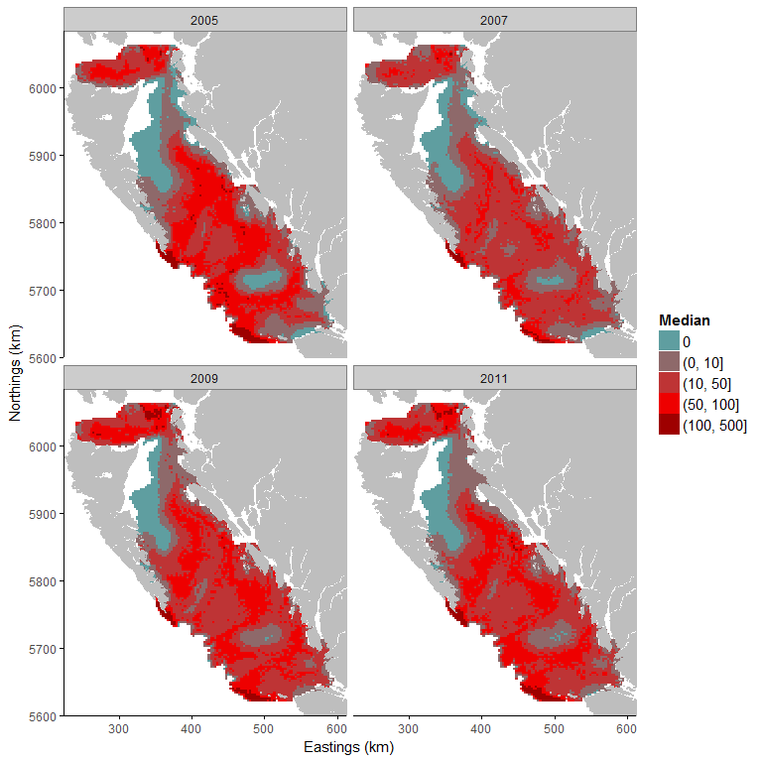

**ii)**

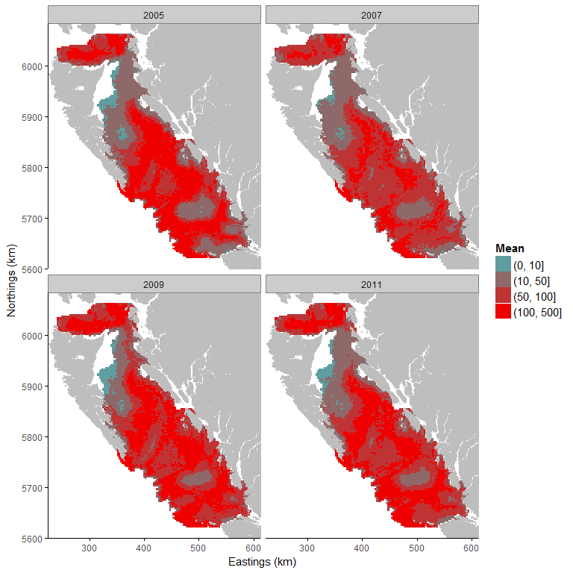

**iii)**

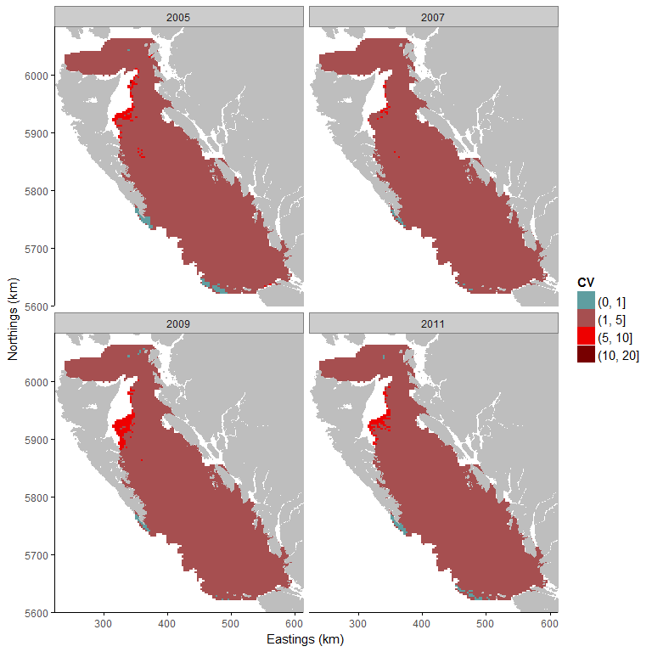

Figure a1. i) Median, ii) mean and iii) coefficient of variation of the posterior predictive distribution (kg) of Arrowtooth flounder. The predictive distribution (kg) is cut into classes: Blue represents an absence of the species. Red areas have positive biomass and are cut into intervals: 1 = biomass up to 10kg; 2 = 50kg to 100kg; and 3 = biomass is above 100kg. A small coefficient of variation means that model uncertainty is small for the predicted area.

**Temperature range**

The temperature range of Arrowtooth Flounder in our study area is wide since 95 % of the study area has a probability of presence equal or above 50% (Fig. a2). The temperature range is estimated between 4.63 (probability of presence at 99%) and 10.02 °C (probability of presence at 50%).

Table a: Temperature (°C) and the associated mean and standard deviation of the predictive probability of presence.

|  |  |  |
| --- | --- | --- |
| Temperature | Mean | Standard deviation |
| 5 | 0.77 | 0.18 |
| 6 | 0.95 | 0.03 |
| 7 | 0.93 | 0.05 |
| 8 | 0.83 | 0.06 |
| 9 | 0.65 | 0.07 |
| 10 | 0.47 | 0.06 |
| 11 | 0.29 | 0.04 |
| 12 | 0.15 | 0.03 |

**Probability of Presence**

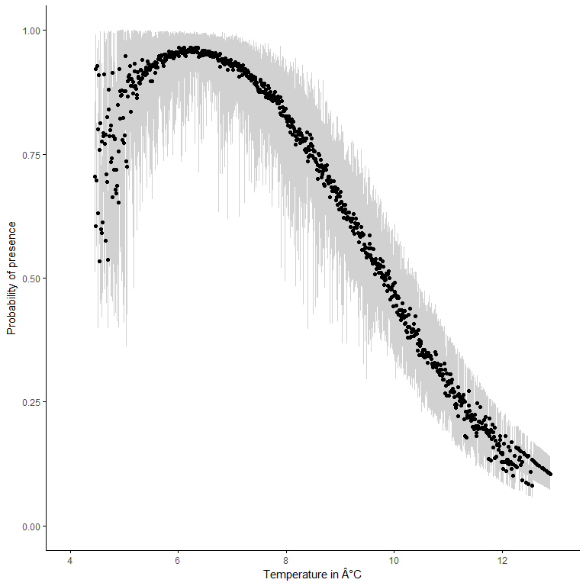

Figure a2 Arrowtooth flounder probability of presence based on sea temperature (°C). The black points represent the median of the posterior predictive distribution of the probability of presence and the grey area represents the 95% credibility interval.

## Bocaccio (*Sebastes paucispinis*)

The amount of zeroes (absence) in the dataset used to study the temperature range of Bocaccio is 94.69%. It is very important to note that the amount of zeroes in the dataset is problematic and results obtained from this analysis should be taken with great care.

The effect of the temperature on the probability of presence of Bocaccio is negative. This means that the presence of Bocaccio is associated with colder temperatures. The effect of the depth is also negative which means that the presence of Bocaccio is associated with relatively shallow waters. Finally, there are differences between years. The years 2007, 2009 and 2011 have a negative effect on the probability of presence and positive biomass. It means that the amount of biomass was smaller in 2007, 2009 and 2011 than in 2005.

**Predictions of species distribution**

**i)**

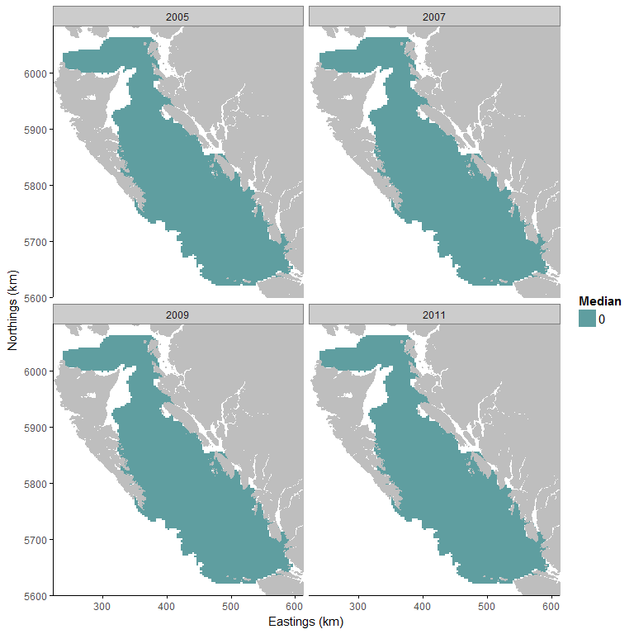

**ii)**

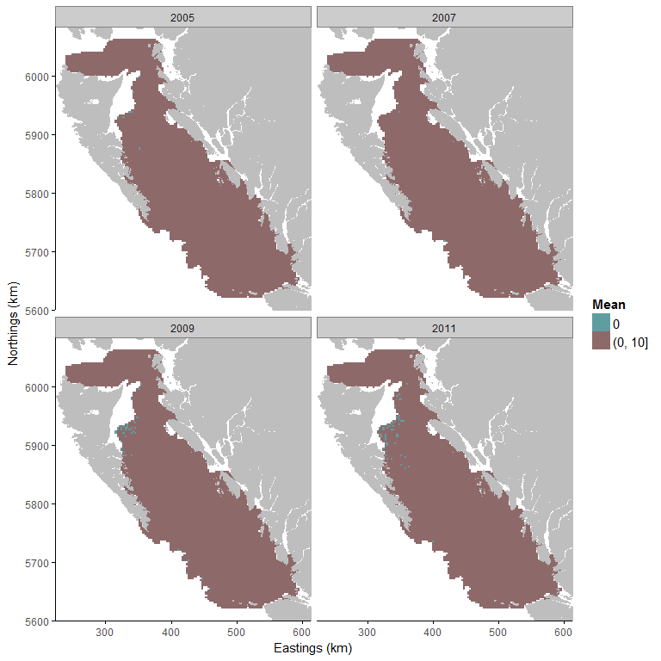

**iii)**

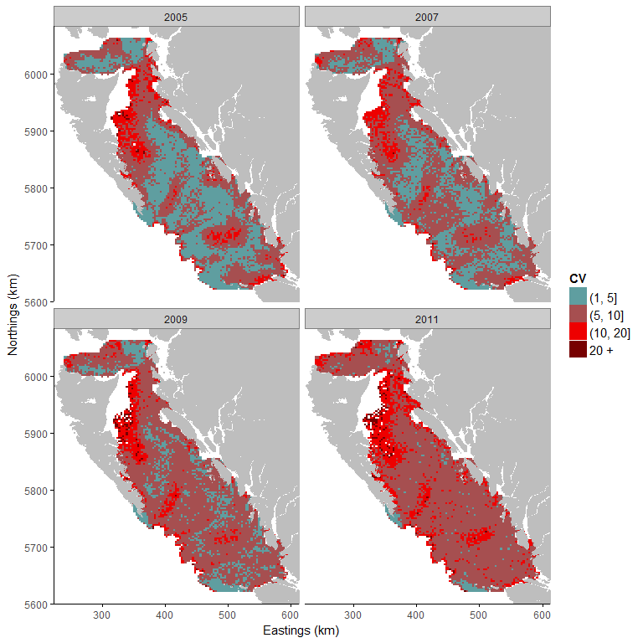

Figure b1. i) Median, ii) mean and iii) coefficient of variation of the posterior predictive distribution (kg) of Boccacio. The predictive distribution (kg) is cut into classes: Blue represents an absence of the species. Red areas have positive biomass and are cut into intervals: 1 = biomass up to10kg; 2 = 50kg to 100kg; and 3 = biomass is above 100kg. A small coefficient of variation means that model uncertainty is small for the predicted area.

**Temperature range**

Table b and Figure 2b show that the probability of presence is low for every temperature in our study area. The absence of constrained temperature range is due to the small amount of strictly positive observations which do not allow to estimate accurately the temperature range of Bocaccio.

Table b: Temperature (°C) and the associated mean and standard deviation of the predictive probability of presence.

|  |  |  |
| --- | --- | --- |
| Temperature | Mean | Standard deviation |
| 5 | 0.02 | 0.02 |
| 6 | 0.06 | 0.03 |
| 7 | 0.07 | 0.04 |
| 8 | 0.05 | 0.03 |
| 9 | 0.03 | 0.02 |
| 10 | 0.02 | 0.01 |
| 11 | 0.01 | 0.01 |
| 12 | 0.00 | 0.00 |

**Probability of Presence**

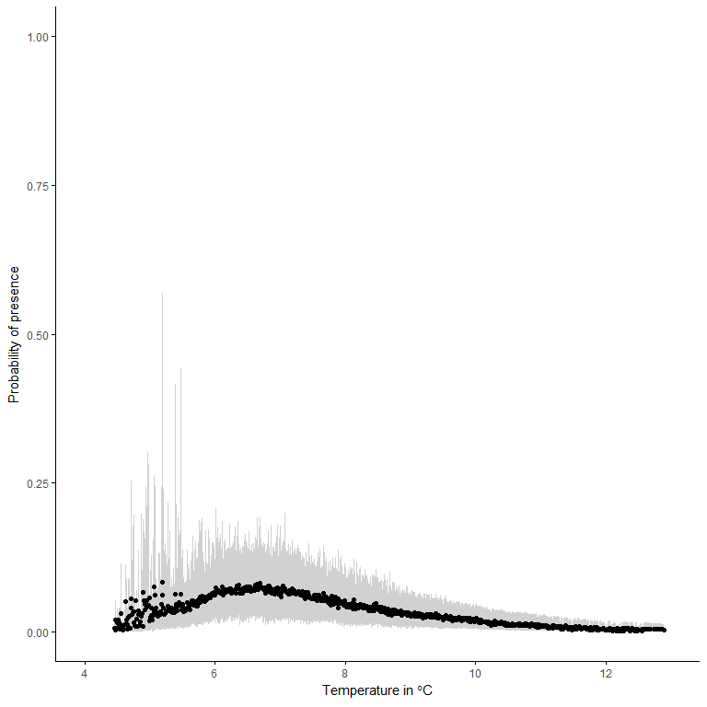

Figure b2 Bocaccio probability of presence based on sea temperature (°C). The black points represent the median of the posterior predictive distribution of the probability of presence and the grey area represents the 95% credibility interval.

## 

## Canary Rockfish (*Sebastes pinniger*)

The amount of zeroes (absence) in the dataset used to study the temperature range of Canary Rockfish is 83.32%. It is very important to note that the amount of zeroes in the dataset is problematic and results obtained from this analysis should be taken with great care. Depth and temperature were included as explanatory variables in our model.

The effect of the temperature on the probability of presence of Canary Rockfish is negative. This means that the presence of Canary Rockfish is associated with colder temperatures. The effect of the depth is also negative which means that the presence of Canary Rockfish is associated with relatively shallow waters. Finally, there are differences between years. The years 2007, 2009 and 2011 have a negative effect on the probability of presence and the positive biomass. It means that the amount of biomass was smaller in 2007, 2009 and 2011 than in 2005.

**Predictions of species distribution**

**i)**

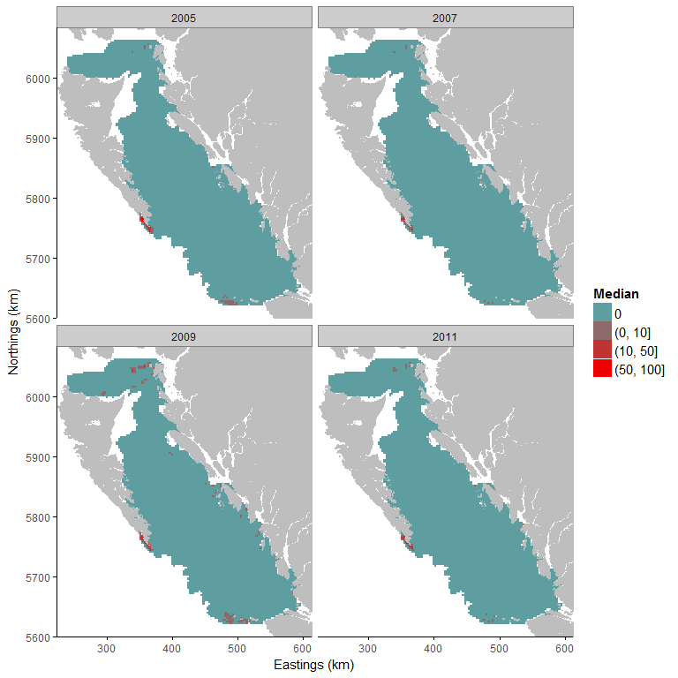

**ii)**

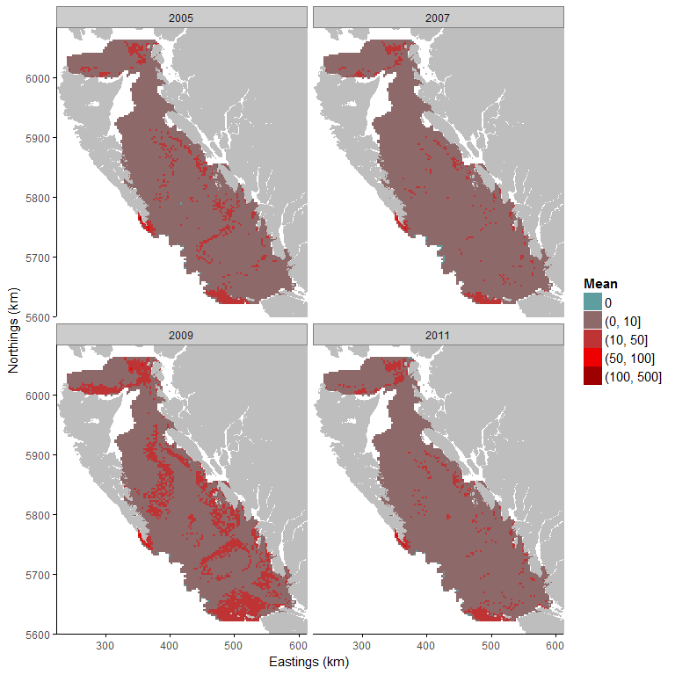

**iii)**

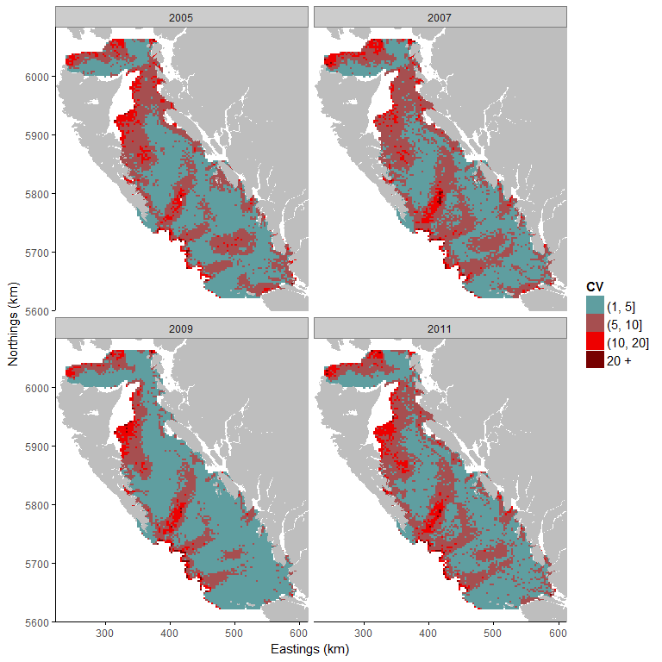

Figure c1. i) Median, ii) mean and iii) coefficient of variation of the posterior predictive distribution (kg) of Canary Rockfish. The predictive distribution (kg) is cut into classes: Blue represents an absence of the species. Red areas have positive biomass and are cut into intervals: 1 = biomass up to 10kg; 2 = 50kg to 100kg; and 3 = biomass is above 100kg. A small coefficient of variation means that model uncertainty is small for the predicted area.

**Temperature range**

Table c and Figure c2 show that the probability of presence is low for every temperature in our study area. The absence of constrained temperature range is due to the small amount of strictly positive observations which do not allow to estimate accurately the temperature range of Canary Rockfish.

Table c: Temperature (°C) and the associated mean and standard deviation of the predictive probability of presence.

|  |  |  |
| --- | --- | --- |
| Temperature | Mean | Standard deviation |
| 5 | 0.03 | 0.03 |
| 6 | 0.15 | 0.09 |
| 7 | 0.23 | 0.11 |
| 8 | 0.19 | 0.08 |
| 9 | 0.12 | 0.05 |
| 10 | 0.08 | 0.02 |
| 11 | 0.04 | 0.01 |
| 12 | 0.02 | 0.01 |

**Probability of Presence**

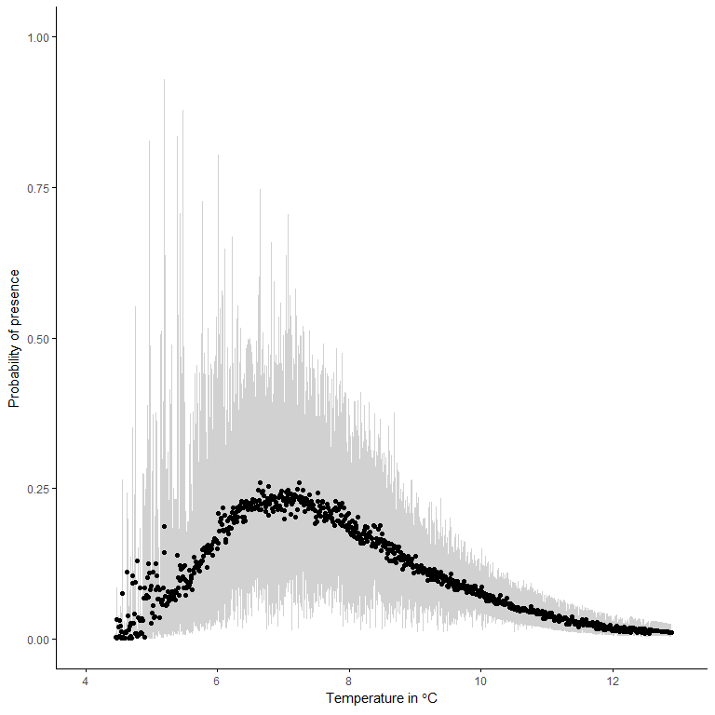

Figure c2. Canary Rockfish probability of presence based on sea temperature (°C). The black points represent the median of the posterior predictive distribution of the probability of presence and the grey area represents the 95% credibility interval.

## 

## Spiny Dogfish (*Squalus acanthias*)

The amount of zeroes (absence) in the dataset used to study the temperature range of Spiny Dogfish is 37.59%. This is a large proportion of zeros but a zero-inflated model is able to handle this percentage of absence.

The effect of the temperature on the probability of presence of Spiny Dogfish is negative. This means that the presence of Spiny Dogfish is preferably associated with colder temperatures. The effect of the depth on the probability of presence of Spiny Dogfish is also negative and has a stronger effect than the temperature. This means that presence of Spiny Dogfish is associated with shallower waters. Finally, there are differences between years. The years 2007, 2009 and 2011 have a negative effect on the probability of presence and the positive biomass. This means that the amount of biomass was smaller in 2007, 2009 and 2011 than in 2005.

**Predictions of species distribution**

**i)**

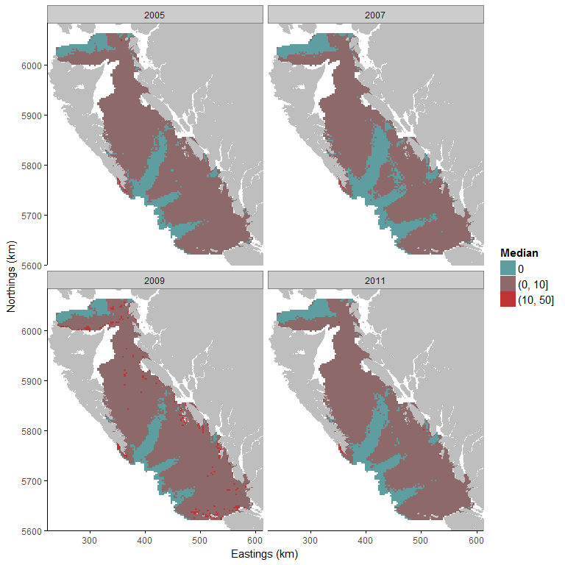

**ii)**

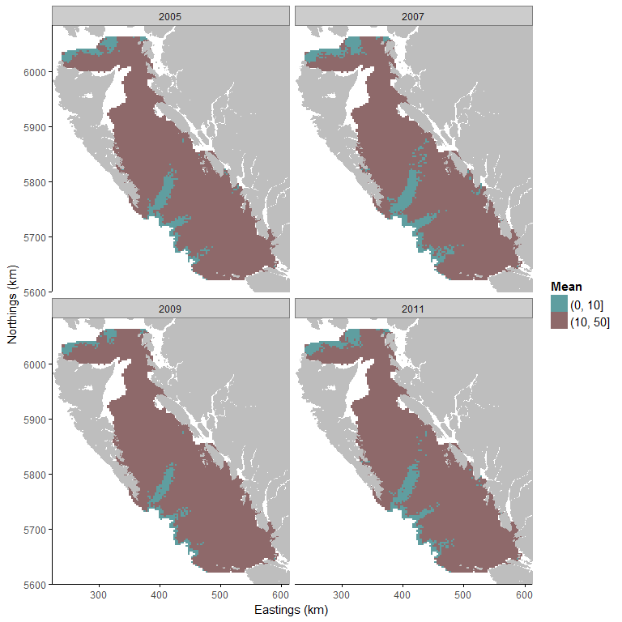

**iii)**

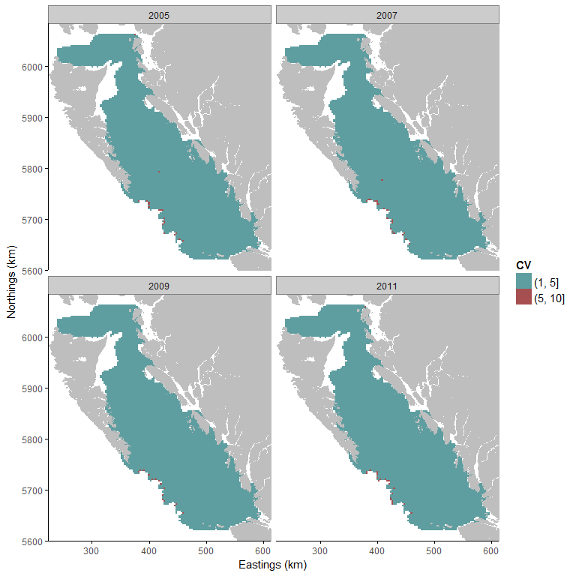

Figure d1. i) Median, ii) mean and iii) coefficient of variation of the posterior predictive distribution (kg) of Spiny Dogfish. The predictive distribution (kg) is cut into classes: Blue represents an absence of the species. Red areas have positive biomass and are cut into intervals: 1 = biomass up to 10kg; 2 = 50kg to 100kg; and 3 = biomass is above 100kg. A small coefficient of variation means that model uncertainty is small for the predicted area.

**Temperature range**

The temperature range of Spiny Dogfish in our study area is wide since 95 % of the study area has a probability of presence equal or above 50%. The temperature range is estimated above 5.78 °C (probability of presence at 50%; Fig d2) and 8.38 °C for probability of presence at 72% (maximum probability of presence predicted by the model).

Table d: Temperature (°C) and the associated mean and standard deviation of the predictive probability of presence.

|  |  |  |
| --- | --- | --- |
| Temperature | Mean | Standard deviation |
| 5 | 0.24 | 0.12 |
| 6 | 0.52 | 0.10 |
| 7 | 0.64 | 0.08 |
| 8 | 0.68 | 0.08 |
| 9 | 0.67 | 0.07 |
| 10 | 0.68 | 0.04 |
| 11 | 0.65 | 0.04 |
| 12 | 0.63 | 0.06 |

**Probability of Presence**

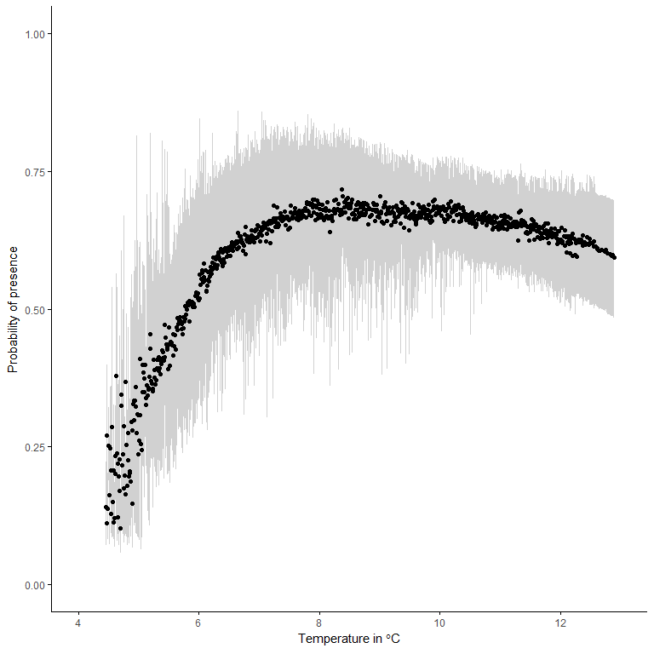

Figure d2. Spiny Dogfish probability of presence based on sea temperature (°C). The black points represent the median of the posterior predictive distribution of the probability of presence and the grey area represents the 95% credibility interval.

## Dover sole (*Microstomus pacificus*)

The amount of zeroes (absence) in the dataset used to study the temperature range of Dover Sole is 34.68%. This is a large proportion of zeros but a zero-inflated model is able to handle this percentage of absence.

The effect of the temperature on the probability of presence of Dover Sole is negative. This means that the presence of Dover Sole is preferably associated with colder temperatures. The effect of the depth on the probability of presence of Dover Sole is positive but smaller than the effect of the temperature. This means that Dover Sole is associated with deeper waters. Finally, there are differences between years. The years 2007, 2009 and 2011 have a negative effect on the probability of presence and the positive biomass. This means that the amount of biomass was smaller in 2007, 2009 and 2011 than in 2005.

**Predictions of species distribution**

**i)**

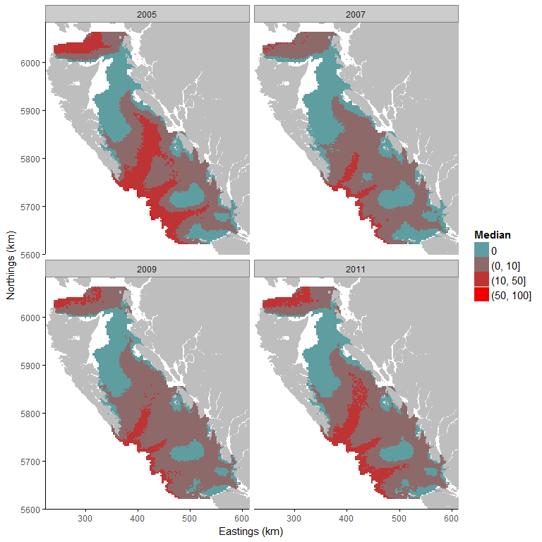

**ii)**

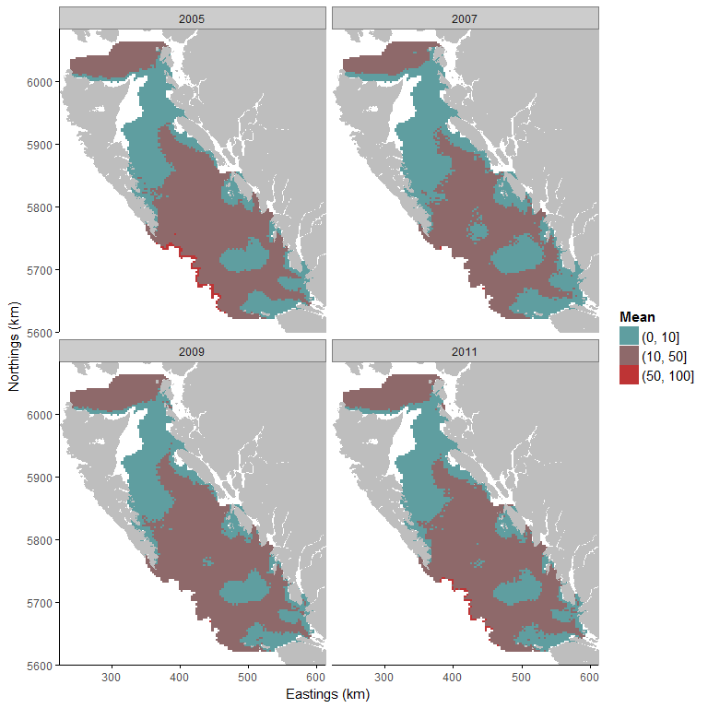

**iii)**

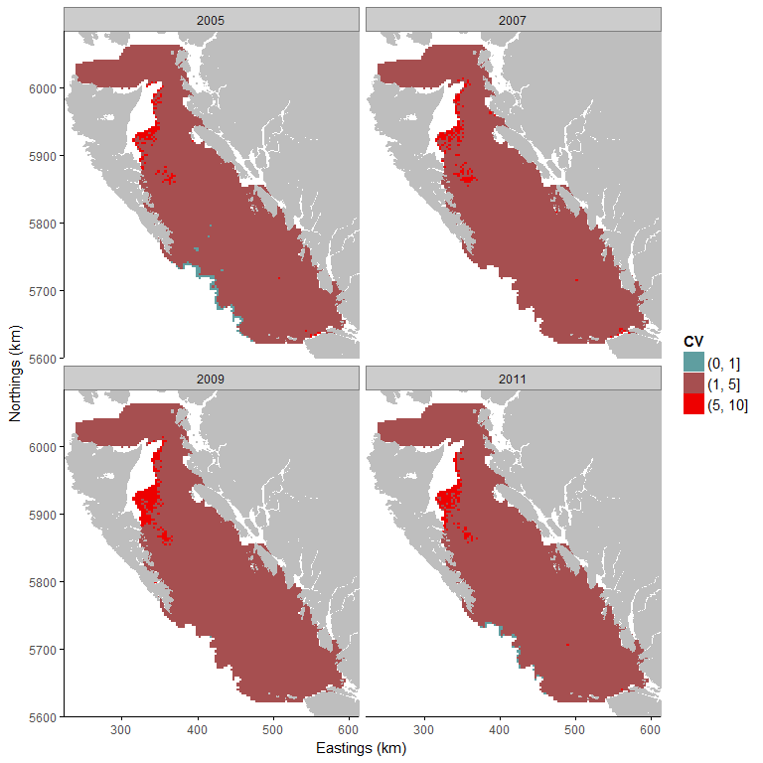

Figure e1: i) Median, ii) mean and iii) coefficient of variation of the posterior predictive distribution (kg) of Dover Sole. The predictive distribution (kg) is cut into classes: Blue represents an absence of the species. Red areas have positive biomass and are cut into intervals: 1 = biomass up to 10kg; 2 = 50kg to 100kg; and 3 = biomass is above 100kg. A small coefficient of variation means that model uncertainty is small for the predicted area.

**Temperature range**

The temperature range of Dover Sole strongly influences its distribution in the study area. The temperature range is estimated between 4.46 (probability of presence at 99%) and 7.82 °C (probability of presence at 50% in 49% of study area; Fig e2).

Table e: Temperature (°C) and the associated mean and standard deviation of the predictive probability of presence.

|  |  |  |
| --- | --- | --- |
| Temperature | Mean | Standard deviation |
| 5 | 0.96 | 0.03 |
| 6 | 0.83 | 0.07 |
| 7 | 0.66 | 0.08 |
| 8 | 0.48 | 0.07 |
| 9 | 0.36 | 0.07 |
| 10 | 0.24 | 0.06 |
| 11 | 0.17 | 0.04 |
| 12 | 0.11 | 0.03 |

**Probability of Presence**

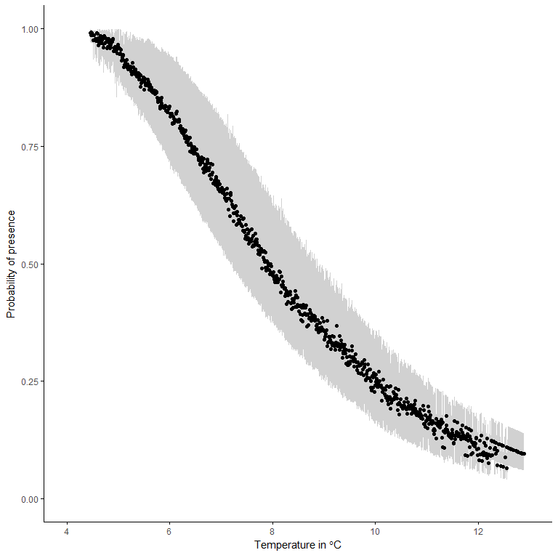

Figure e2: Dover Sole probability of presence based on sea temperature (°C). The black points represent the median of the posterior predictive distribution of the probability of presence and the grey area represents the 95% credibility interval.

## 

**English sole (*Parophrys vetulus*)**

The amount of zeroes (absence) in the dataset used to study the temperature range of English Sole is 55.02%. This is a large proportion of zeros but a zero-inflated model is able to handle this percentage of absence.

The effect of the temperature on the probability of presence of English Sole is negative. This means that the presence of English Sole is preferably associated with colder temperatures. The effect of the depth on the probability of presence of English Sole is also negative and has a stronger effect than the temperature. This means that presence of English Sole is associated with shallower waters. Finally, there are differences between years. The years 2007, 2009 and 2011 have a negative effect on the probability of presence and the positive biomass. This means that the amount of biomass was smaller in 2007, 2009 and 2011 than in 2005.

**Predictions of species distribution**

**i)**

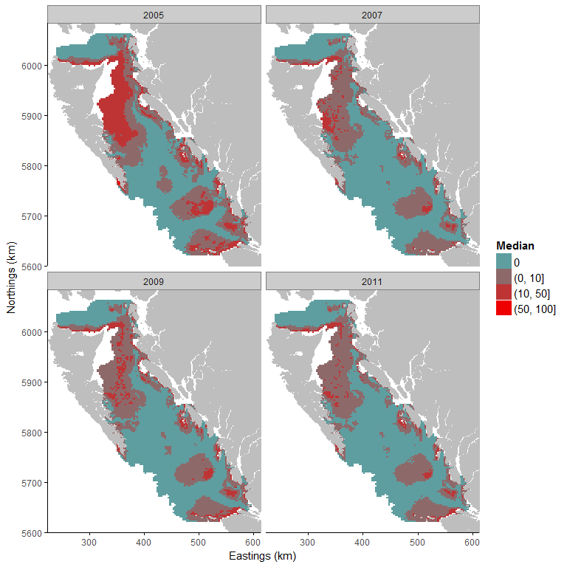

**ii)**

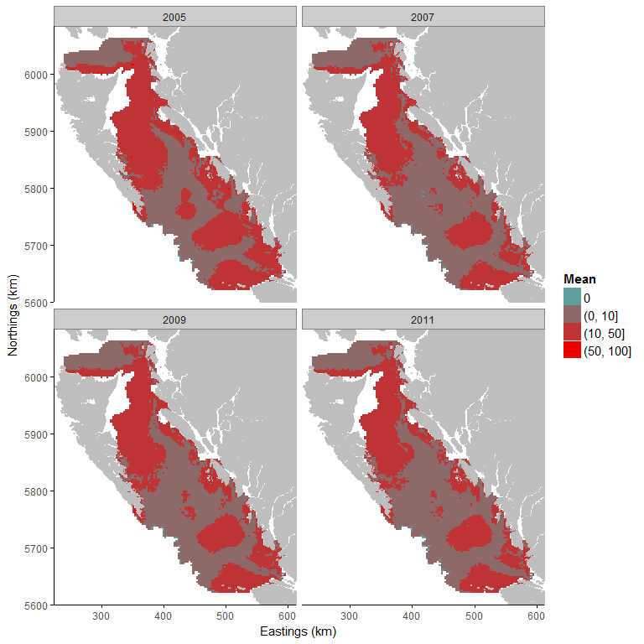

**iii)**

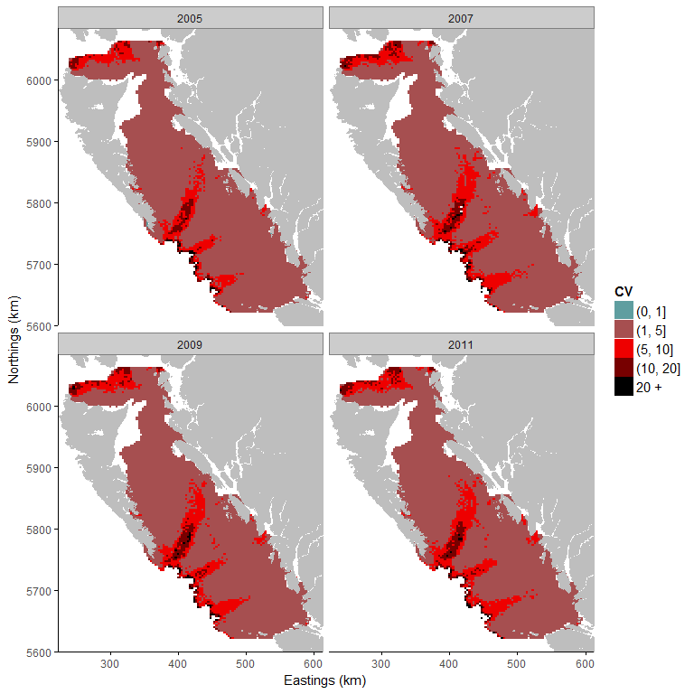

Figure f1. i) Median, ii) mean and iii) coefficient of variation of the posterior predictive distribution (kg) of English Sole. The predictive distribution (kg) is cut into classes: Blue represents an absence of the species. Red areas have positive biomass and are cut into intervals: 1 = biomass up to 10kg; 2 = 50kg to 100kg; and 3 = biomass is above 100kg. A small coefficient of variation means that model uncertainty is small for the predicted area.

**Temperature range**

The temperature range of English Sole in our study area is quite large since only 75 % of the study area has a probability of presence equal or above 50%. The temperature range is estimated above 7.07 °C (probability of presence at 50%; Fig. f2) and for probability of presence at 89% (maximum probability of presence predicted by our model) at 11.07 °C.

Table f: Temperature (°C) and the associated mean and standard deviation of the predictive probability of presence.

|  |  |  |
| --- | --- | --- |
| Temperature | Mean | Standard deviation |
| 5 | 0.02 | 0.02 |
| 6 | 0.18 | 0.11 |
| 7 | 0.47 | 0.17 |
| 8 | 0.65 | 0.17 |
| 9 | 0.72 | 0.14 |
| 10 | 0.83 | 0.06 |
| 11 | 0.82 | 0.06 |
| 12 | 0.78 | 0.07 |

**Probability of Presence**

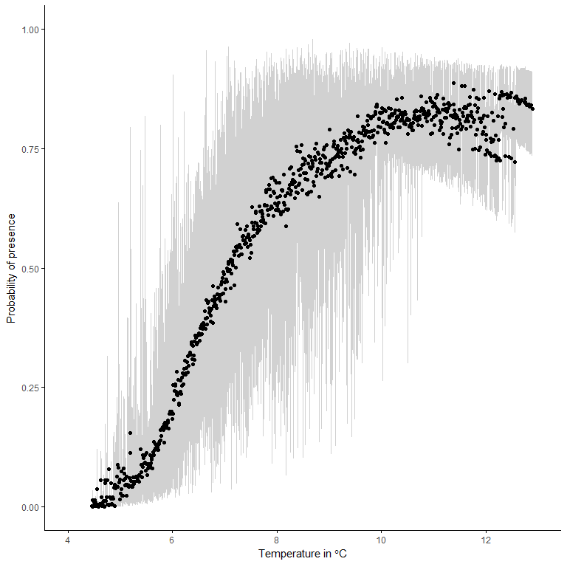

Figure f2. English Sole probability of presence based on sea temperature (°C). The black points represent the median of the posterior predictive distribution of the probability of presence and the grey area represents the 95% credibility interval.

**Greenstripe rockfish (*Sebastes elongates*)**

The amount of zeroes (absence) in the dataset used to study the temperature range of Greenstripe Rockfish is 80.29%. It is very important to note that the amount of zeroes in the dataset is problematic and results obtained from this analysis should be taken with great care.

The effect of the temperature on the probability of presence of Greenstripe Rockfish is negative. This means that the presence of Greenstripe Rockfish is associated with colder temperatures. The effect of the depth is also negative which means that the presence of Greenstripe Rockfish is preferably associated with relatively shallow waters. Finally, there are differences between years. The years 2007, 2009 and 2011 have a negative effect on the probability of presence and the positive biomass. It means that the amount of biomass was smaller in 2007, 2009 and 2011 than in 2005.

**Predictions of species distribution**

**i)**

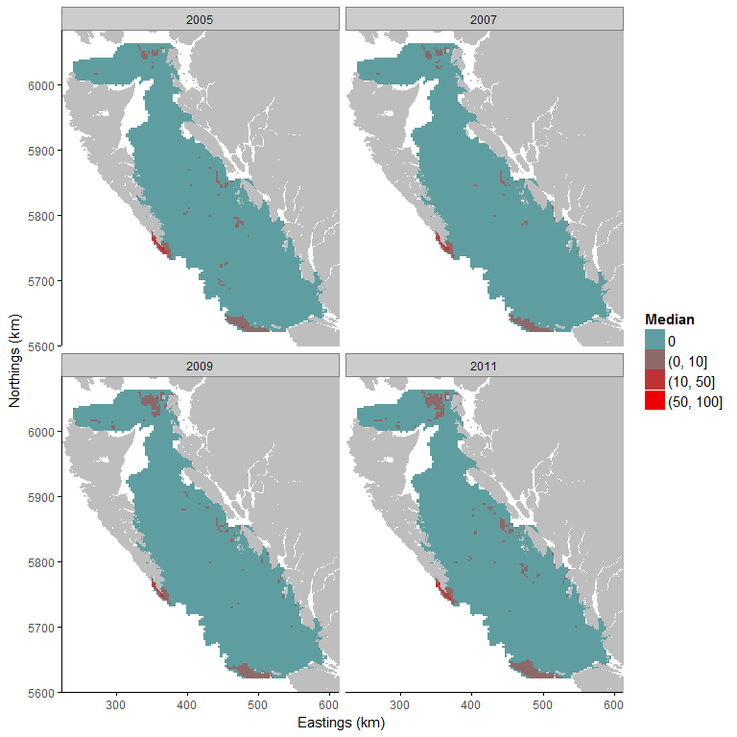

**ii)**

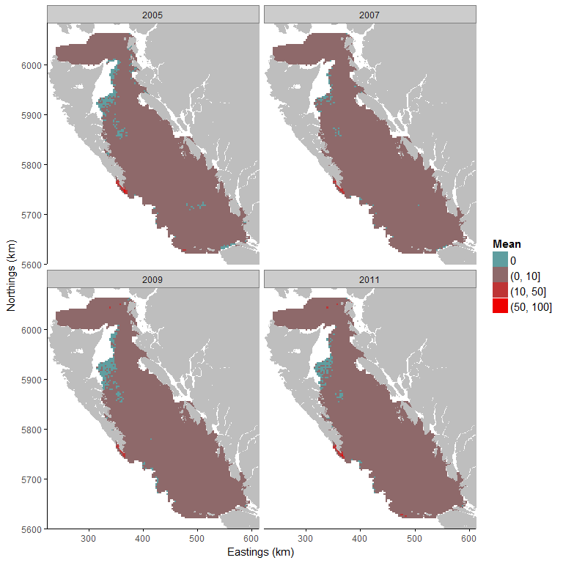

**iii)**

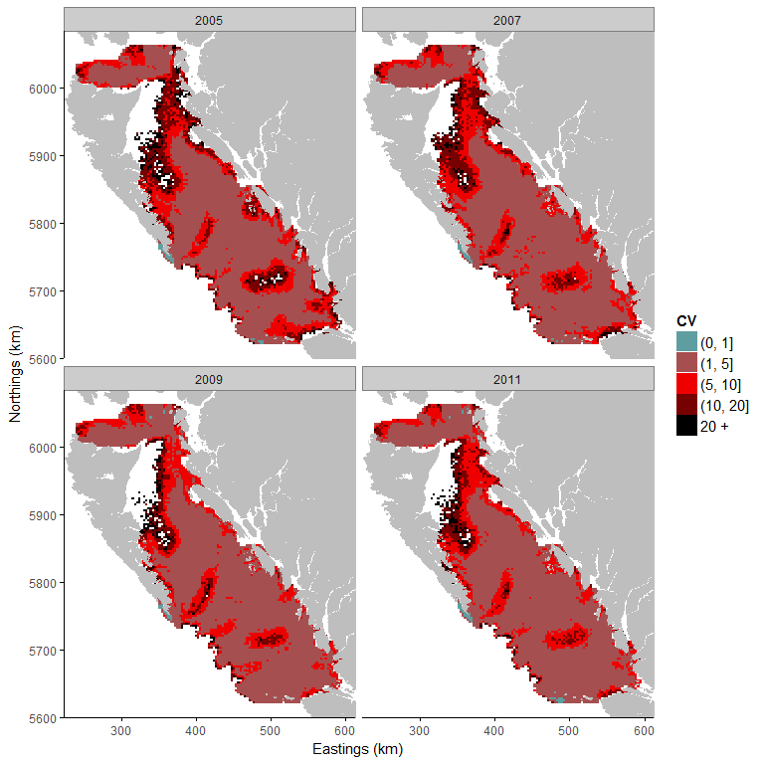

Figure a: i) Median, ii) mean and iii) coefficient of variation of the posterior predictive distribution. The blue represents area with a posterior predictive median at 0 (absence of the species). The red represents area with a strictly positive biomass. The strictly positive biomass is cut into intervals to be easier to read. The first class represents strictly positive biomass up to 10kg. The second class represents biomass from 50kg to 100kg, and the final class represents large amount of biomass above 100kg. A small coefficient of variation means that model uncertainty is small for the predicted area.

**Temperature range**

Table g and Figure g2 show that the probability of presence is low for every temperature in our study area. The absence of constrained temperature range is due to the small amount of strictly positive observations which do not allow to estimate accurately the temperature range of Greenstripe Rockfish.

Table g: Table X: Temperature (°C) and the associated mean and standard deviation of the predictive probability of presence.

|  |  |  |
| --- | --- | --- |
| Temperature | Mean | Standard deviation |
| 5 | 0.05 | 0.07 |
| 6 | 0.24 | 0.15 |
| 7 | 0.28 | 0.16 |
| 8 | 0.13 | 0.08 |
| 9 | 0.04 | 0.02 |
| 10 | 0.01 | 0.01 |
| 11 | 0.00 | 0.00 |
| 12 | 0.00 | 0.00 |

**Probability of Presence**

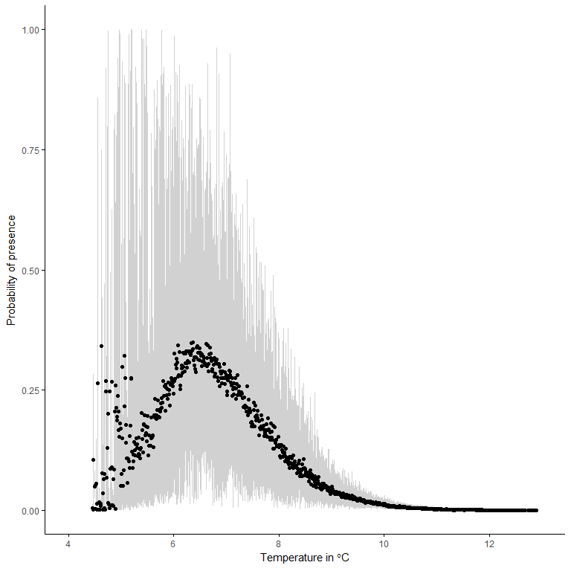

Figure g2: Probability of presence given the temperature (°C). The black points represent the median of the posterior predictive distribution of the probability of presence and the grey area represents the 95% credibility interval.

## Pacific cod (*Gadus macrocephalus*)

The amount of zeroes (absence) in the dataset used to study the temperature range of Pacific Cod is 45.23%. This is a large proportion of zeros but a zero-inflated model is able to handle this percentage of absence.

The effect of the temperature on the probability of presence of Pacific Cod is negative. This means that the presence of Pacific Cod is preferably associated with colder temperatures. The effect of the depth on the probability of presence of Pacific Cod is also negative and has a stronger effect than the temperature. This means that presence of Pacific Cod is preferably associated with shallower waters. There are differences between years. The years 2007, 2009 and 2011 have a negative effect on the probability of presence and the positive biomass. This means that the amount of biomass was smaller in 2007, 2009 and 2011 than in 20

**Predictions of species distribution**

**i)**

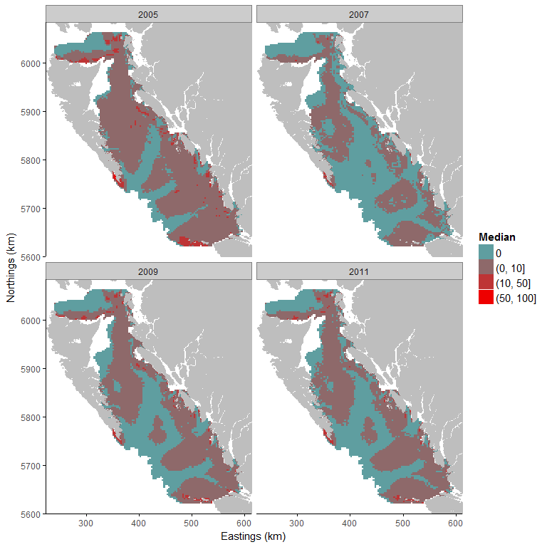

**ii)**

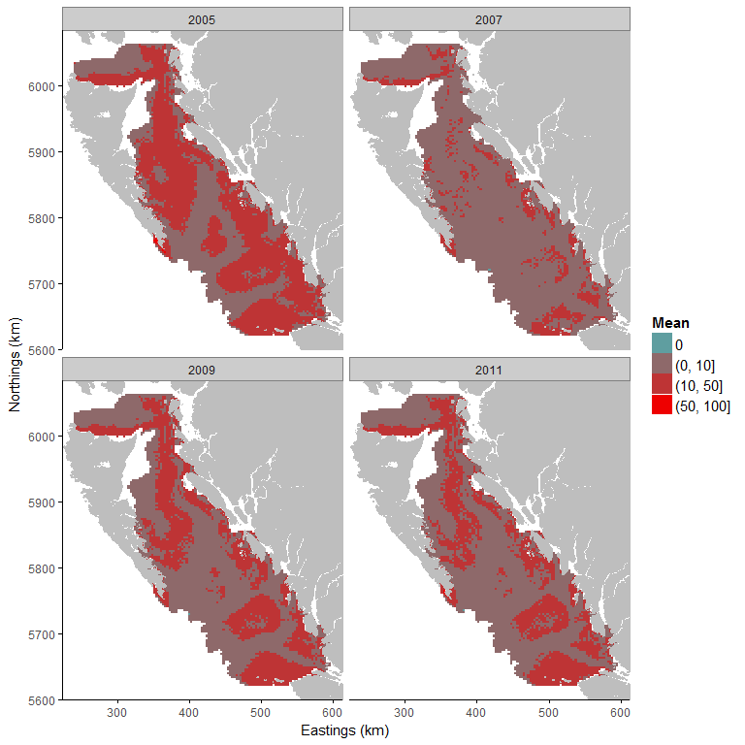

**iii)**

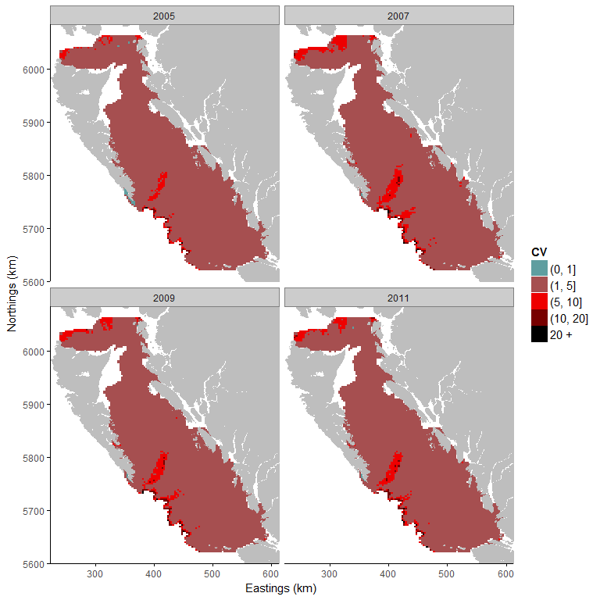

Figure g1: i) Median, ii) mean and iii) coefficient of variation of the posterior predictive distribution. The blue represents area with a posterior predictive median at 0 (absence of the species). The red represents area with a strictly positive biomass. The strictly positive biomass is cut into intervals to be easier to read. The first class represents strictly positive biomass up to 10kg. The second class represents biomass from 50kg to 100kg, and the final class represents large amount of biomass above 100kg. A small coefficient of variation means that model uncertainty is small for the predicted area.

**Temperature range**

The temperature range is large since 95 % of the study area has a probability of presence equal or above 50%. The temperature range is estimated between 6.20 and 12.17 °C (probability of presence above 50%; Fig. g2) and the maximum probability of presence is predicted at 8.45 °C for probability of presence of 75%.

Table g: Temperature (°C) and the associated mean and standard deviation of the predictive probability of presence.

|  |  |  |
| --- | --- | --- |
| Temperature | Mean | Standard deviation |
| 5 | 0.07 | 0.07 |
| 6 | 0.38 | 0.14 |
| 7 | 0.61 | 0.17 |
| 8 | 0.66 | 0.15 |
| 9 | 0.64 | 0.13 |
| 10 | 0.62 | 0.10 |
| 11 | 0.51 | 0.10 |
| 12 | 0.39 | 0.09 |

**Probability of presence**

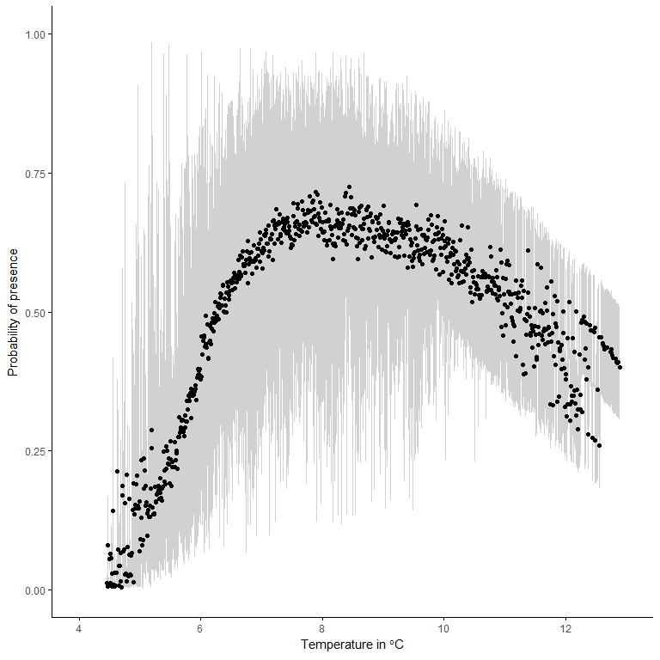

Figure g2: Probability of presence given the temperature (°C). The black points represent the median of the posterior predictive distribution of the probability of presence and the grey area represents the 95% credibility interval.

## 

## Petrale sole (*Eopsetta jordani*)

## The amount of zeroes (absence) in the dataset used to study the temperature range of Petrale Sole is 60.58%. Even if a zero-inflated model is able to handle a large percentage of absence, this amount of absence can be problematic and results should be interpreted with caution.

The effect of the temperature on the probability of presence of Petrale Sole is negative. This means that the presence of Petrale Sole is associated with colder temperatures. The effect of the depth is also negative which means that the presence of Petrale Sole is preferably associated with relatively shallow waters. Finally, there are differences between years. The years 2007, 2009 and 2011 have a negative effect on the probability of presence and the positive biomass. This means that the amount of biomass was smaller in 2007, 2009 and 2011 than in 2005

**Predictions of species distribution**

**i)**

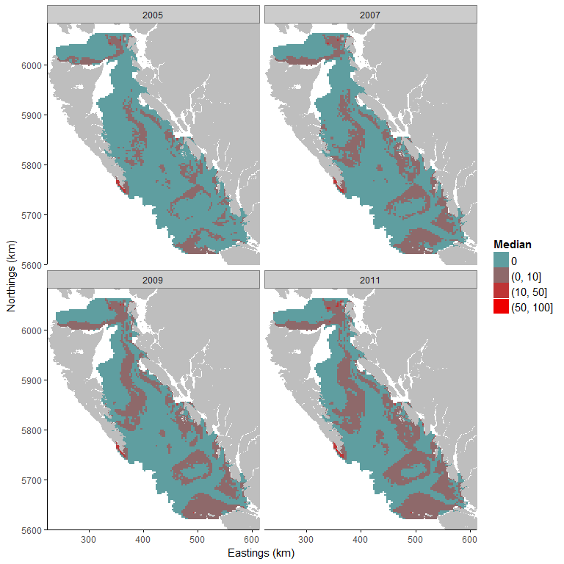

**ii)**

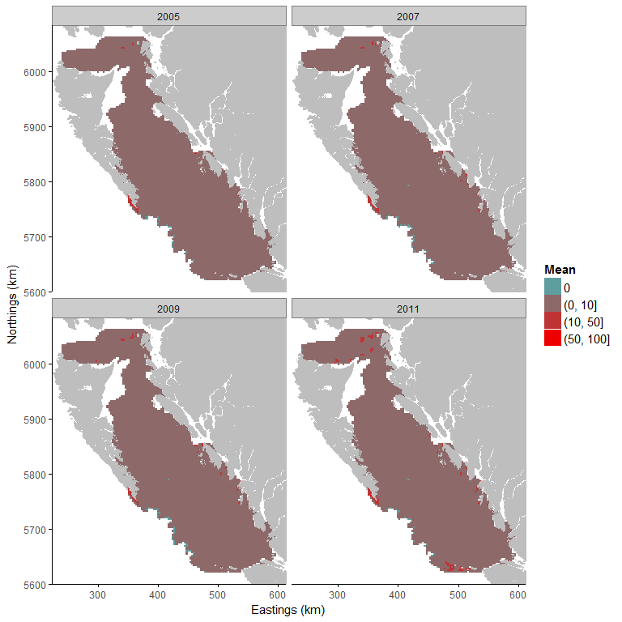

**iii)**

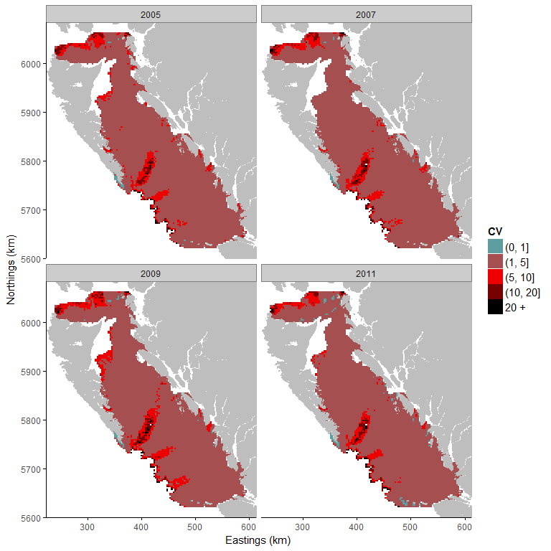

Figure h1: i) Median, ii) mean and iii) coefficient of variation of the posterior predictive distribution. The blue represents area with a posterior predictive median at 0 (absence of the species). The red represents area with a strictly positive biomass. The strictly positive biomass is cut into intervals to be easier to read. The first class represents strictly positive biomass up to 10kg. The second class represents biomass from 50kg to 100kg, and the final class represents large amount of biomass above 100kg. A small coefficient of variation means that model uncertainty is small for the predicted area.

**Temperature range**

**Probability of presence**

Table h and Figure h2 show that the probability of presence at 50% is estimated between 6.65 and 8.74 degrees Celsius. It represents more than 40 % of the whole study area. The maximum probability of presence is predicted at 7.87 °C for probability of presence of 64%.

Table h: Temperature (°C) and the associated mean and standard deviation of the predictive probability of presence.

|  |  |  |
| --- | --- | --- |
| Temperature | Mean | Standard deviation |
| 5 | 0.03 | 0.04 |
| 6 | 0.25 | 0.16 |
| 7 | 0.51 | 0.20 |
| 8 | 0.54 | 0.19 |
| 9 | 0.41 | 0.15 |
| 10 | 0.33 | 0.08 |
| 11 | 0.20 | 0.03 |
| 12 | 0.09 | 0.03 |

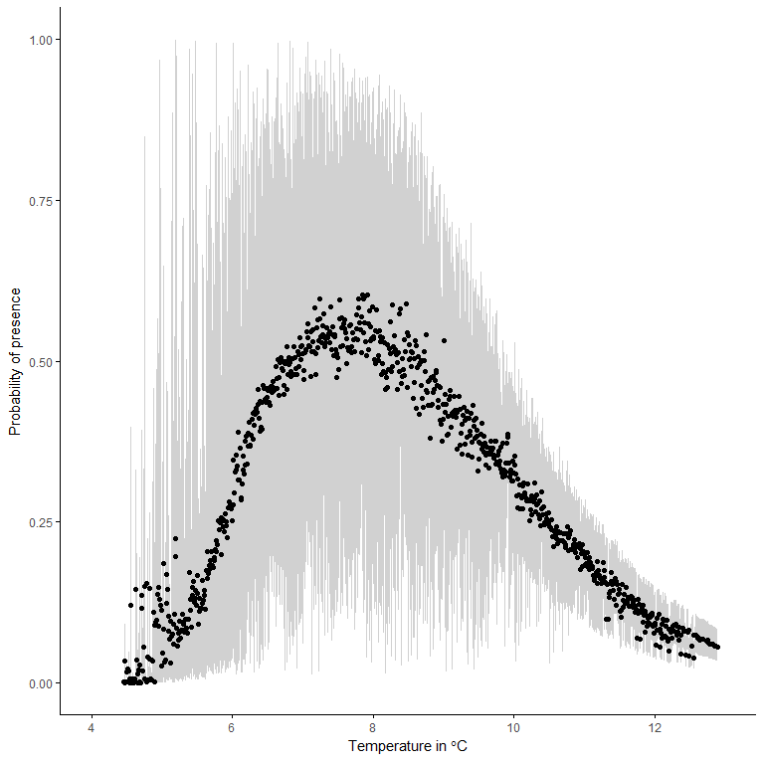

Figure h2: Probability of presence given the temperature (°C). The black points represent the median of the posterior predictive distribution of the probability of presence and the grey area represents the 95% credibility interval.

## Pacific Ocean perch (*Sebastes alutus*)

The amount of zeroes (absence) in the dataset used to study the temperature range of Pacific Ocean Perch is 51.67%. This is a large proportion of zeros but a zero-inflated model is able to handle this percentage of absence.

The effect of the temperature on the probability of presence of Pacific Ocean Perch is negative. This means that the presence of Pacific Ocean Perch is associated with colder temperatures. The effect of the depth is also negative but smaller than the temperature effect. This means that the presence of Pacific Ocean Perch is preferably associated with relatively shallow waters. Finally, there are differences between years. The years 2007, 2009 and 2011 have a negative effect on the probability of presence and the positive biomass. This means that the amount of biomass was smaller in 2007, 2009 and 2011 than in 2005.

**Predictions of species distribution**

**i)**

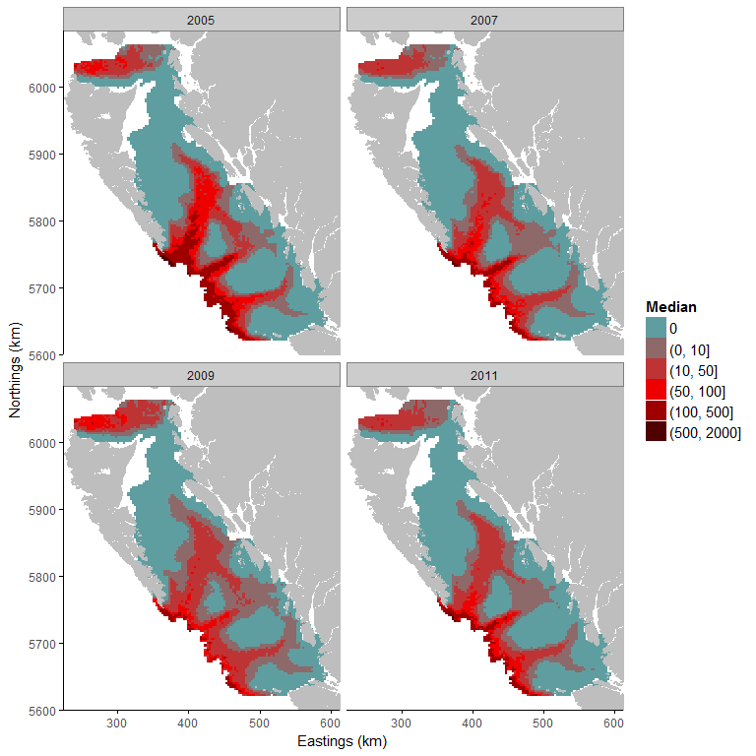

**ii)**

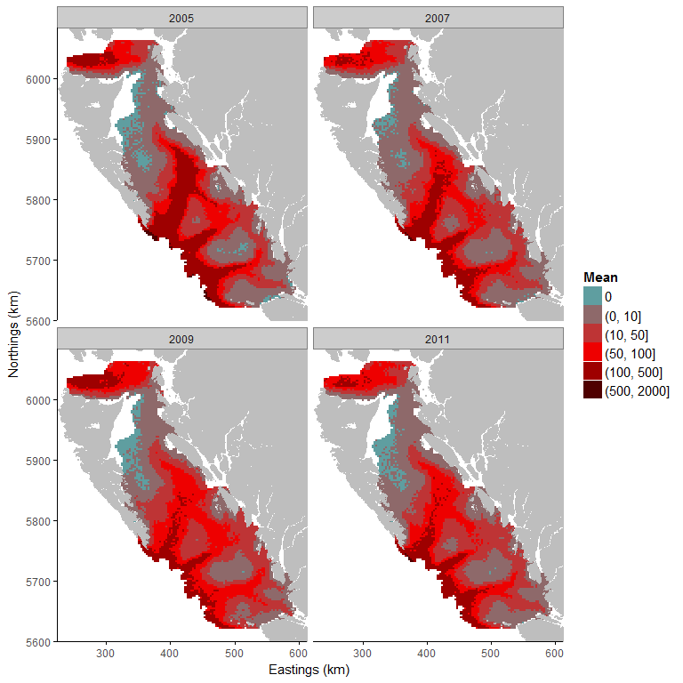

**iii)**

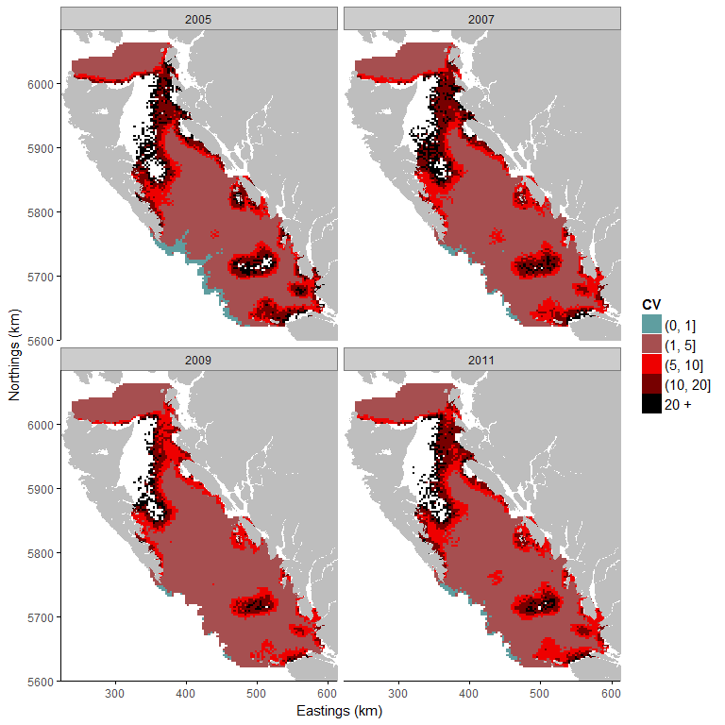

Figure i1: i) Median, ii) mean and iii) coefficient of variation of the posterior predictive distribution. The blue represents area with a posterior predictive median at 0 (absence of the species). The red represents area with a strictly positive biomass. The strictly positive biomass is cut into intervals to be easier to read. The first class represents strictly positive biomass up to 10kg. The second class represents biomass from 50kg to 100kg, and the final class represents large amount of biomass above 100kg. A small coefficient of variation means that model uncertainty is small for the predicted area.

**Temperature range**

Table i and Figure i2 show that the probability of presence at 50% is estimated at 6.75 degrees Celsius. It represents 65 % of the whole study area. The temperature range is estimated between 4.46 (probability of presence at 100%) and 6.75 °C (probability of presence at 50%).

Table i: Temperature (°C) and the associated mean and standard deviation of the predictive probability of presence.

|  |  |  |
| --- | --- | --- |
| Temperature | Mean | Standard deviation |
| 5 | 0.98 | 0.05 |
| 6 | 0.87 | 0.09 |
| 7 | 0.43 | 0.13 |
| 8 | 0.11 | 0.04 |
| 9 | 0.03 | 0.01 |
| 10 | 0.01 | 0.00 |
| 11 | 0.00 | 0.00 |
| 12 | 0.00 | 0.00 |

**Probability of presence**

## 

Figure i2: Probability of presence given the temperature (°C). The black points represent the median of the posterior predictive distribution of the probability of presence and the grey area represents the 95% credibility interval.

## Spotted ratfish (*Hydrolagus colliei*)

The amount of zeroes (absence) in the dataset used to study the temperature range of Spotted Ratfish is 15.41%. It allows us to be confident with the results obtained from our model, which included depth and temperature as explanatory variables.

The effect of the temperature on the probability of presence of Spotted Ratfish is negative. This means that the presence of Spotted Ratfish is associated with colder temperatures. The effect of the depth is also negative but smaller than the temperature effect. This means that the presence of Spotted Ratfish is preferably associated with relatively shallow waters. Finally, there are differences between years. The years 2007, 2009 and 2011 have a negative effect on the probability of presence and the positive biomass. This means that the amount of biomass was smaller in 2007, 2009 and 2011 than in 2005.

**Predictions of species distribution**

**i)**

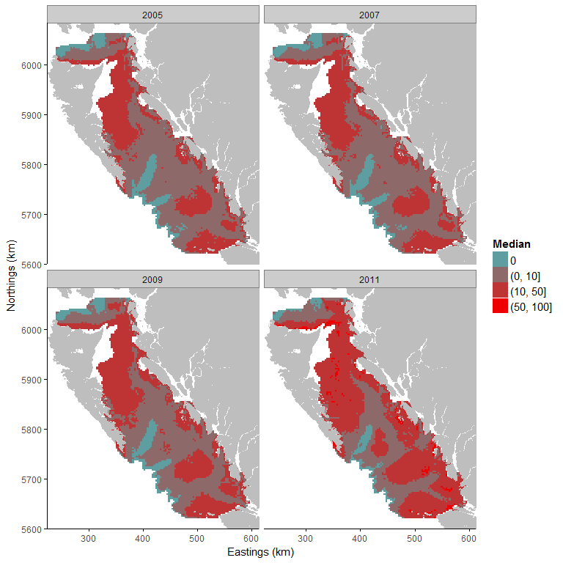

**ii)**

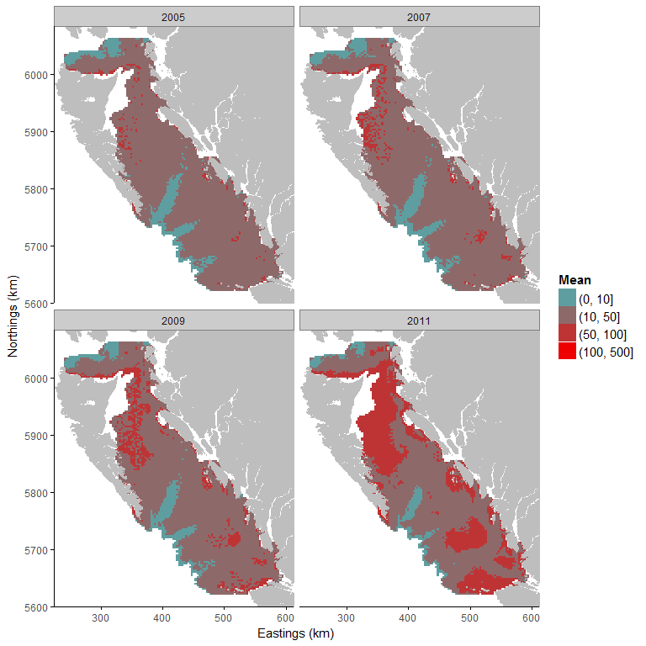

**iii)**

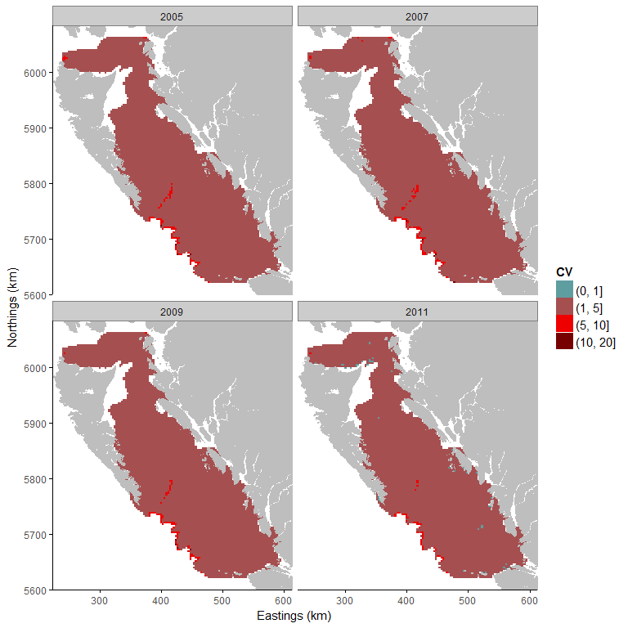

Figure j1: i) Median, ii) mean and iii) coefficient of variation of the posterior predictive distribution. The blue represents area with a posterior predictive median at 0 (absence of the species). The red represents area with a strictly positive biomass. The strictly positive biomass is cut into intervals to be easier to read. The first class represents strictly positive biomass up to 10kg. The second class represents biomass from 50kg to 100kg, and the final class represents large amount of biomass above 100kg. A small coefficient of variation means that model uncertainty is small for the predicted area.

**Temperature range**

The probability of presence at 50% is estimated at 5.20 degrees Celsius. It represents 95 % of the whole study area. The temperature range of Spotted Ratfish in our study area is quite large since 95 % of the study area has a probability of presence equal or above 50%. The temperature range is estimated between 12.27 (probability of presence at 99%) and 5.20 °C (probability of presence at 50%).

Table j: Temperature (°C) and the associated mean and standard deviation of the predictive probability of presence.

|  |  |  |
| --- | --- | --- |
| Temperature | Mean | Standard deviation |
| 5 | 0.25 | 0.19 |
| 6 | 0.68 | 0.14 |
| 7 | 0.88 | 0.09 |
| 8 | 0.95 | 0.04 |
| 9 | 0.95 | 0.04 |
| 10 | 0.97 | 0.02 |
| 11 | 0.97 | 0.02 |
| 12 | 0.98 | 0.02 |

**Probability of presence**

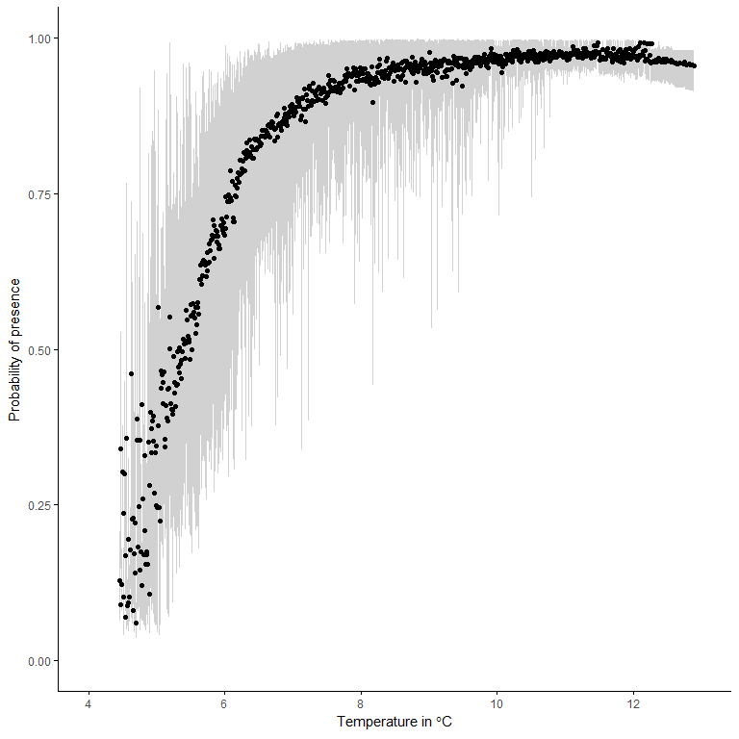

Figure j2: Probability of presence given the temperature (°C). The black points represent the median of the posterior predictive distribution of the probability of presence and the grey area represents the 95% credibility interval.

**Rock sole (*Lepidopsetta bilineata*)**

The amount of zeroes (absence) in the dataset used to study the temperature range of Rock Sole is 70.18%. It is important to note that the amount of zeroes in the dataset is problematic and results obtained from this analysis should be interpreted with caution.

The effect of the temperature on the probability of presence of Rock Sole is negative. This means that the presence of Rock Sole is associated with colder temperatures. However, the effect of the depth is stronger than the effect of the temperature and has negative effect. This means that the presence of Rock Sole is preferably associated with shallow waters. Finally, there are differences between years. In 2007, the presence and amount of biomass is greater than in 2005 (positive effect for the year 2007). The years 2009 and 2011 have a negative effect on the probability of presence and the positive biomass. This means that the amount of biomass was smaller in 2009 and 2011 than in 2005.

**Predictions of species distribution**

**i)**

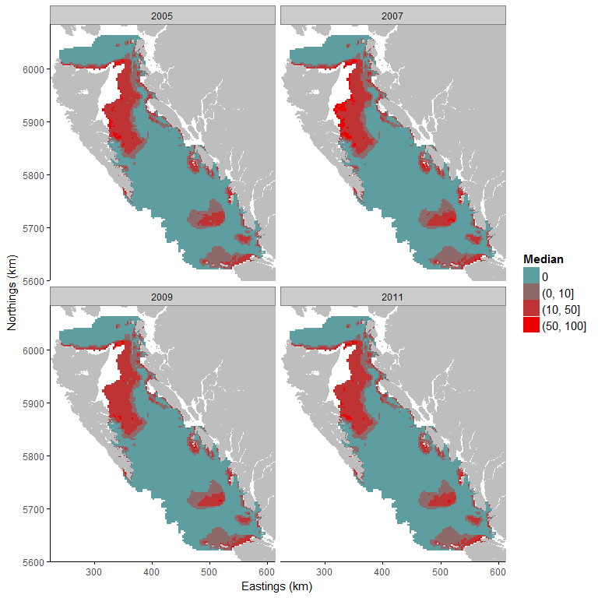

**ii)**

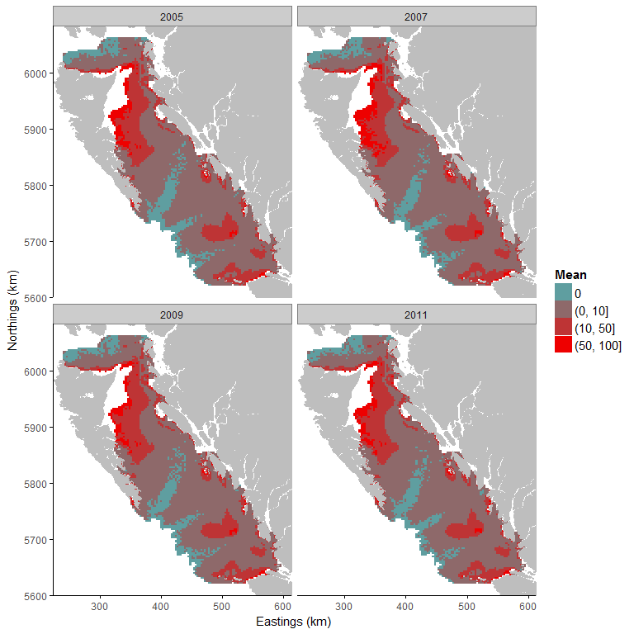

**iii)**

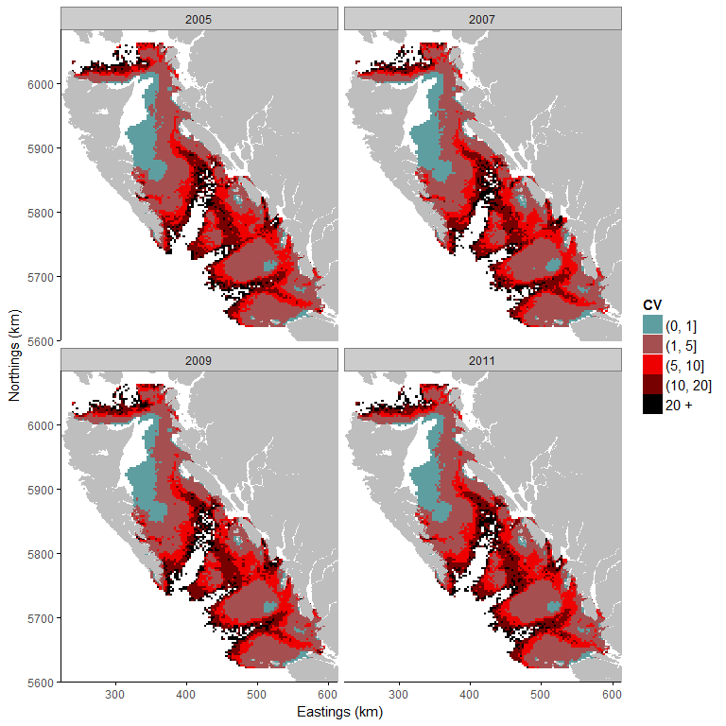

Figure k1: i) Median, ii) mean and iii) coefficient of variation of the posterior predictive distribution. The blue represents area with a posterior predictive median at 0 (absence of the species). The red represents area with a strictly positive biomass. The strictly positive biomass is cut into intervals to be easier to read. The first class represents strictly positive biomass up to 10kg. The second class represents biomass from 50kg to 100kg, and the final class represents large amount of biomass above 100kg. A small coefficient of variation means that model uncertainty is small for the predicted area.

**Temperature range**

Table k and Figure k2 show that the temperature range is estimated for a probability of presence at 100% between 9.91 and 12.9 °C and for a probability at 50% is above 7.96 degrees Celsius. It represents 39% of the study area.

Table k: Temperature (°C) and the associated mean and standard deviation of the predictive probability of presence.

|  |  |  |
| --- | --- | --- |
| Temperature | Mean | Standard deviation |
| 5 | 0.00 | 0.00 |
| 6 | 0.02 | 0.05 |
| 7 | 0.22 | 0.19 |
| 8 | 0.58 | 0.30 |
| 9 | 0.73 | 0.26 |
| 10 | 0.96 | 0.09 |
| 11 | 0.99 | 0.01 |
| 12 | 1.00 | 0.00 |

**Probability of presence**

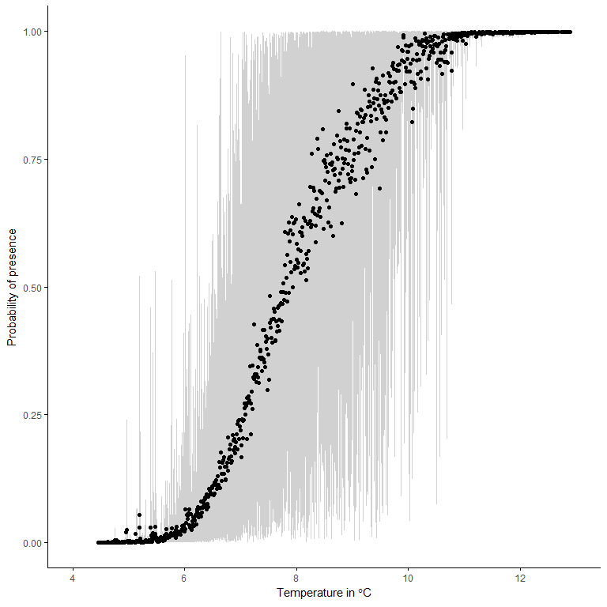 Figure k2: Probability of presence given the temperature (°C). The black points represent the median of the posterior predictive distribution of the probability of presence and the grey area represents the 95% credibility interval.

**Redstripe rockfish (*Sebastes proriger*)**

The amount of zeroes (absence) in the dataset used to study the temperature range of Redstripe Rockfish is 81.17%. It is very important to note that the amount of zeroes in the dataset is problematic and results obtained from this analysis should be taken with great care. Depth and temperature were included as explanatory variables in our model.

The effect of the temperature on the probability of presence of Redstripe Rockfish is negative. This means that the presence of Redstripe Rockfish is associated with colder temperatures. The effect of the depth is also negative which means that the presence of Redstripe Rockfish is preferably associated with relatively shallow waters. Finally, there are differences between years. The years 2007, 2009 and 2011 have a negative effect on the probability of presence and the positive biomass. It means that the amount of biomass was smaller in 2007, 2009 and 2011 than in 2005.

**Predictions of species distribution**

**i)**

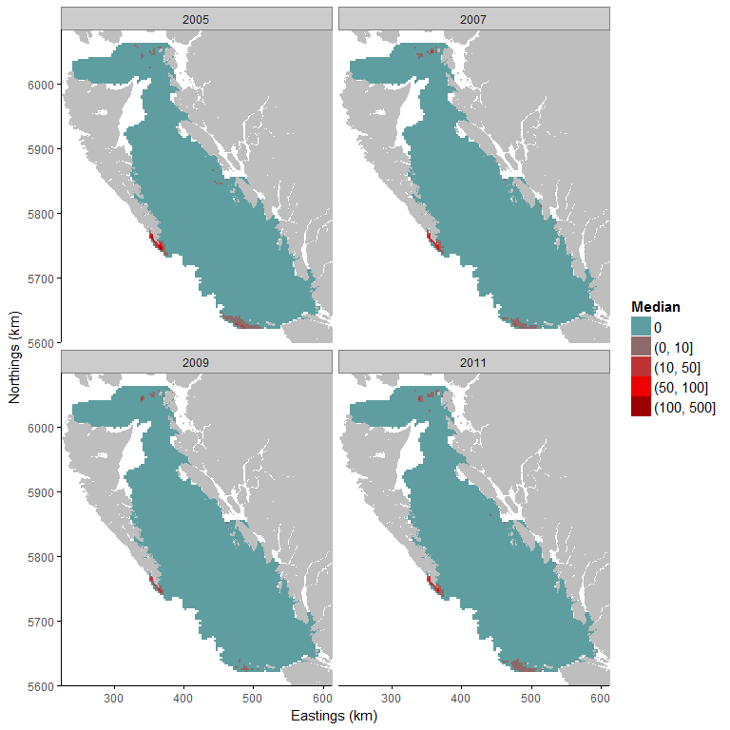

**ii)**

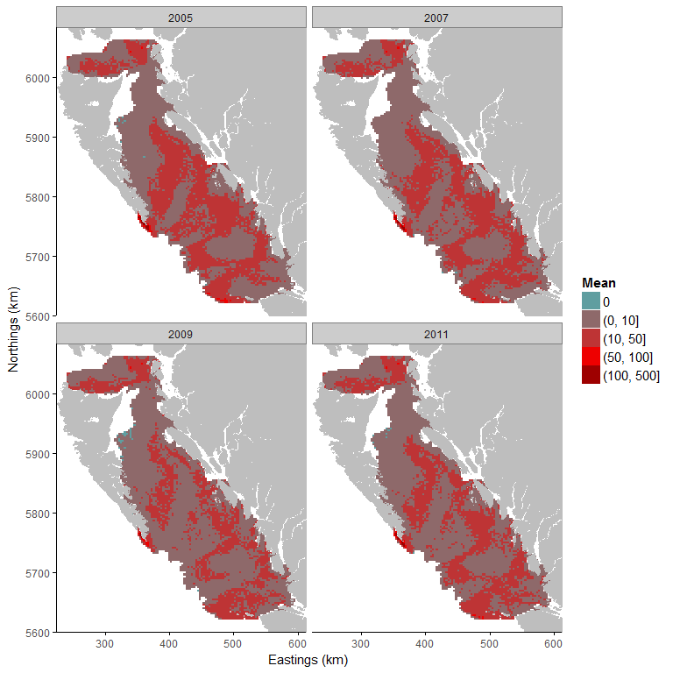

**iii)**

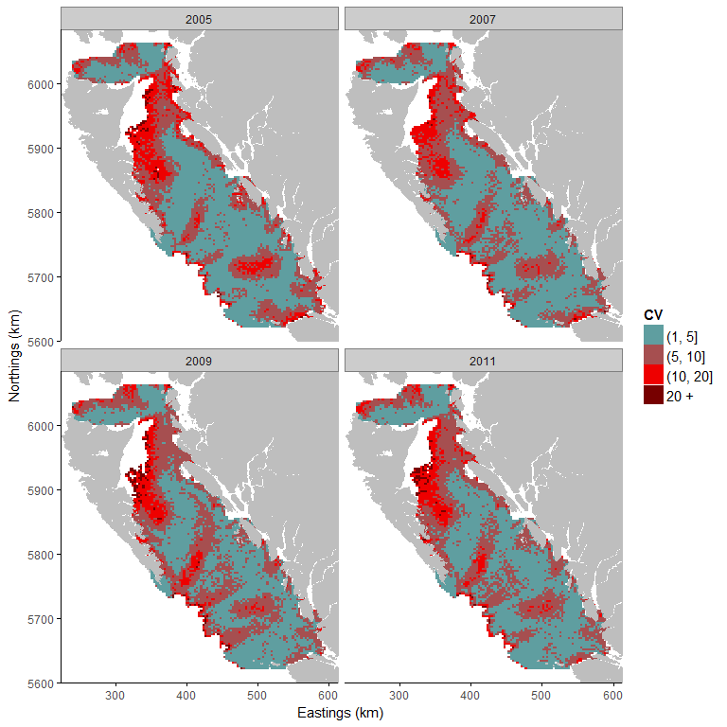

Figure l1: i) Median, ii) mean and iii) coefficient of variation of the posterior predictive distribution. The blue represents area with a posterior predictive median at 0 (absence of the species). The red represents area with a strictly positive biomass. The strictly positive biomass is cut into intervals to be easier to read. The first class represents strictly positive biomass up to 10kg. The second class represents biomass from 50kg to 100kg, and the final class represents large amount of biomass above 100kg. A small coefficient of variation means that model uncertainty is small for the predicted area.

**Temperature range**

Table l and Figure l2 show that the probability of presence is low for every temperature in our study area. The absence of constrained temperature range is due to the small amount of strictly positive observations which do not allow to estimate accurately the temperature range of Redstripe Rockfish.

Table l: Temperature (°C) and the associated mean and standard deviation of the predictive probability of presence.

|  |  |  |
| --- | --- | --- |
| Temperature | Mean | Standard deviation |
| 5 | 0.05 | 0.05 |
| 6 | 0.21 | 0.09 |
| 7 | 0.26 | 0.12 |
| 8 | 0.16 | 0.08 |
| 9 | 0.08 | 0.04 |
| 10 | 0.04 | 0.02 |
| 11 | 0.02 | 0.01 |
| 12 | 0.00 | 0.00 |

**Probability of presence**

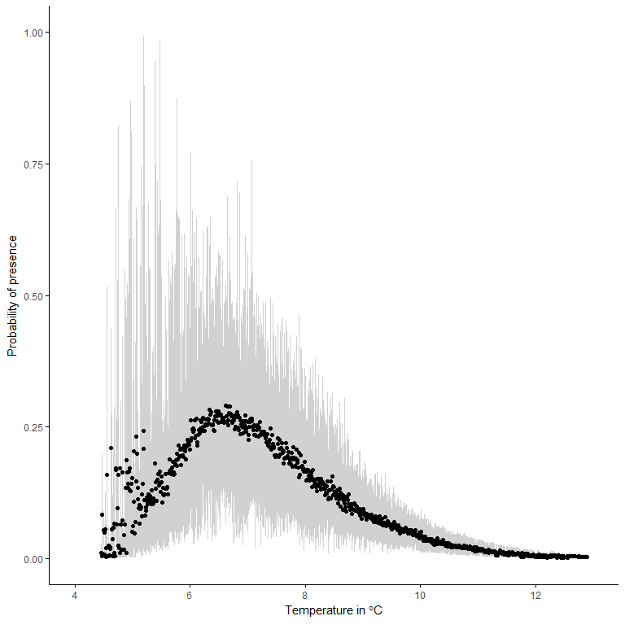

Figure l2: Probability of presence given the temperature (°C). The black points represent the median of the posterior predictive distribution of the probability of presence and the grey area represents the 95% credibility interval.

## 

**Rex sole (*Glyptocephalus zachirus*)**

The amount of zeroes (absence) in the dataset used to study the temperature range of Rex Sole is 24.89%. It allows us to be confident with the results obtained from our model, which included depth and temperature as explanatory variables.

The effect of the temperature on the probability of presence of Rex Sole is negative. This means that the presence of Rex Sole is associated with colder temperatures. The effect of the depth is also negative which means that the presence of Rex Sole is preferably associated with relatively shallow waters. Finally, there are differences between years. The years 2007, 2009 and 2011 have a negative effect on the probability of presence and the positive biomass. This means that the amount of biomass was smaller in 2007, 2009 and 2011 than in 2005.

**Predictions of species distribution**

**i)**

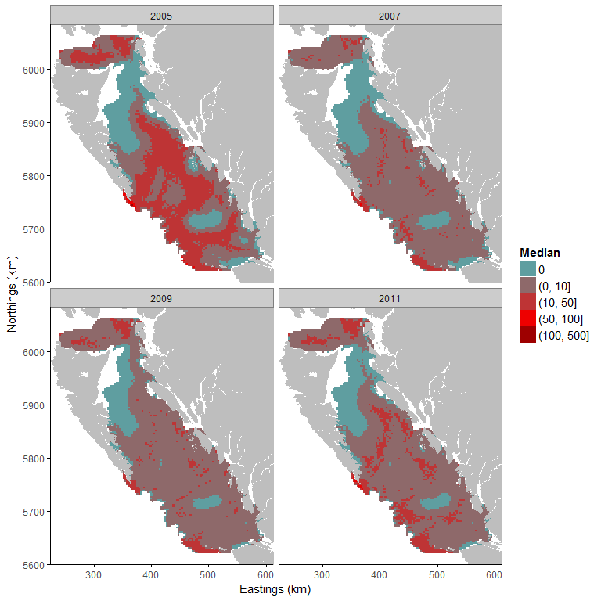

**ii)**

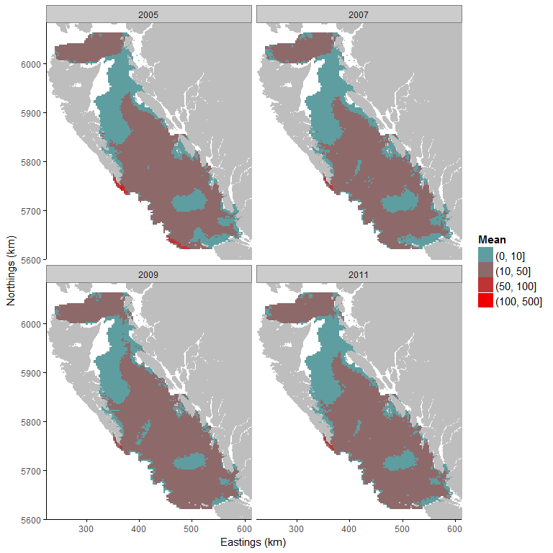

**iii)**

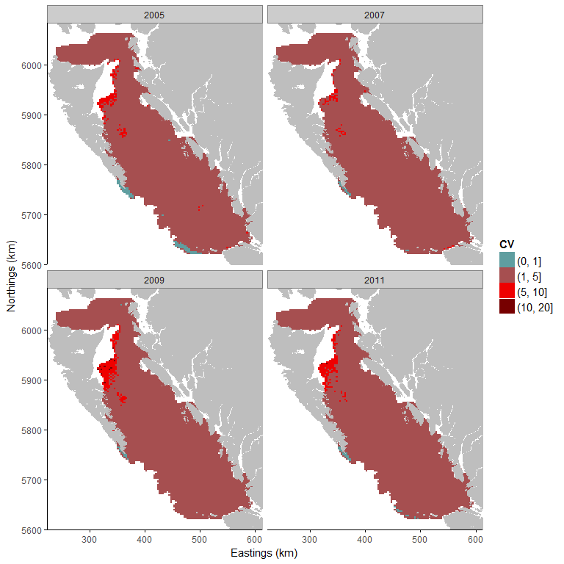

Figure m1: i) Median, ii) mean and iii) coefficient of variation of the posterior predictive distribution. The blue represents area with a posterior predictive median at 0 (absence of the species). The red represents area with a strictly positive biomass. The strictly positive biomass is cut into intervals to be easier to read. The first class represents strictly positive biomass up to 10kg. The second class represents biomass from 50kg to 100kg, and the final class represents large amount of biomass above 100kg. A small coefficient of variation means that model uncertainty is small for the predicted area.

**Temperature range**

Table m and Figure m2 show that the probability of presence at 50% is estimated between 8 and 9 degrees Celsius. It represents 39 % of the whole study area. The temperature range is estimated between 4.63 °C (probability of presence at 96%) and 8.71 °C (probability of presence at 50%).

Table m: Temperature (°C) and the associated mean and standard deviation of the predictive probability of presence.

|  |  |  |
| --- | --- | --- |
| Temperature | Mean | Standard deviation |
| 5 | 0.66 | 0.21 |
| 6 | 0.88 | 0.07 |
| 7 | 0.82 | 0.09 |
| 8 | 0.66 | 0.10 |
| 9 | 0.49 | 0.09 |
| 10 | 0.32 | 0.08 |
| 11 | 0.18 | 0.04 |
| 12 | 0.08 | 0.03 |

**Probability of presence**

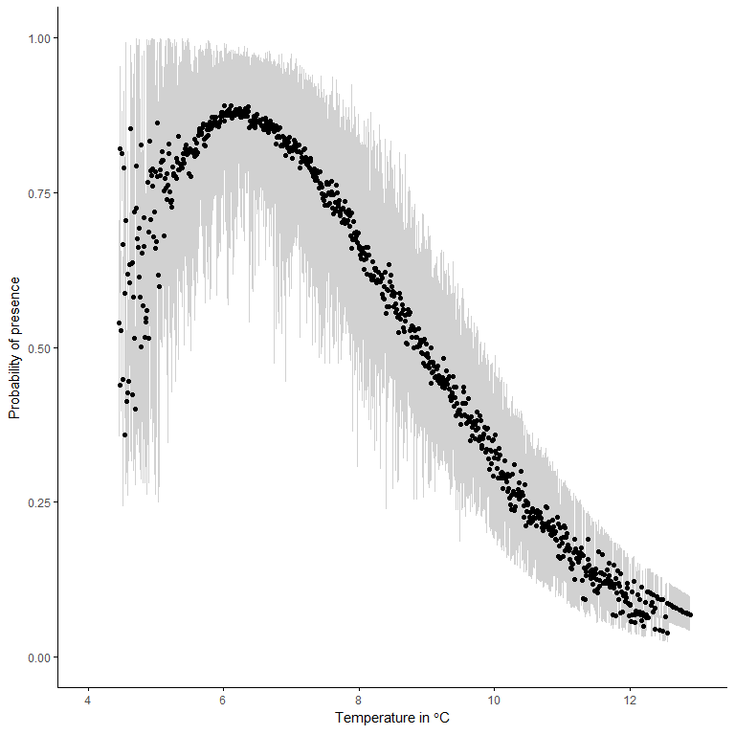

Figure m2: Probability of presence given the temperature (°C). The black points represent the median of the posterior predictive distribution of the probability of presence and the grey area represents the 95% credibility interval.

## Sablefish (*Anoplopoma fimbria*)

The amount of zeroes (absence) in the dataset used to study the temperature range of Sablefish is 55.84%. This is a large proportion of zeros but a zero-inflated model is able to handle this percentage of absence.

The effect of the temperature on the probability of presence of Sablefish is negative. This means that the presence of Sablefish is associated with colder temperatures. However, the effect of the temperature is small compared to the effect of the depth. The depth had a positive effect which means that the presence of Sablefish is preferably associated with deeper waters. Finally, there are differences between years. The years 2007, 2009 and 2011 have a negative effect on the probability of presence and the positive biomass. This means that the amount of biomass was smaller in 2007, 2009 and 2011 than in 2005.

**Predictions of species distribution**

**i)**

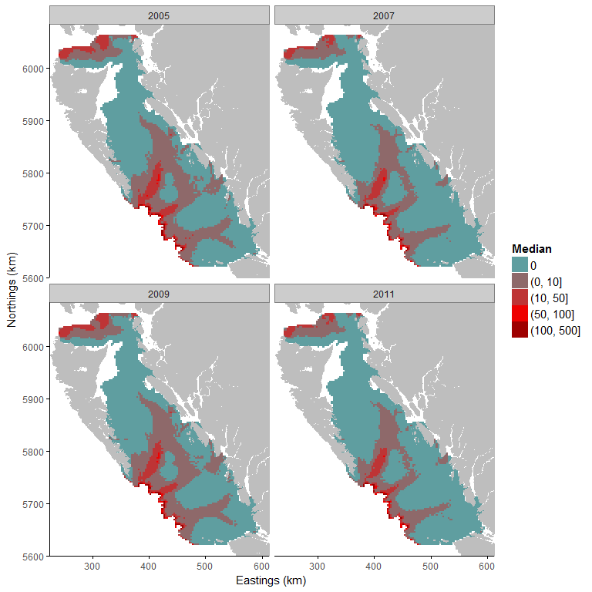

**ii)**

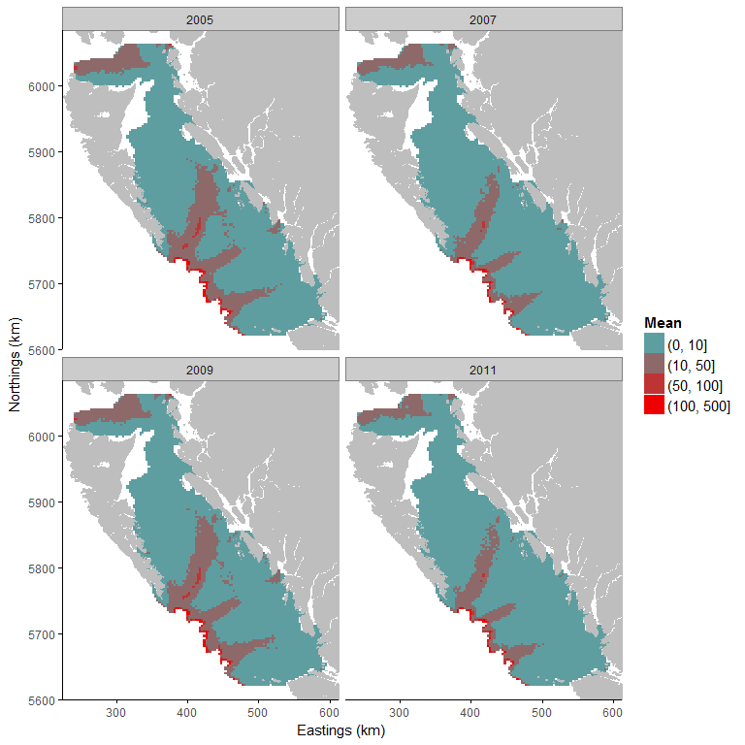

**iii)**

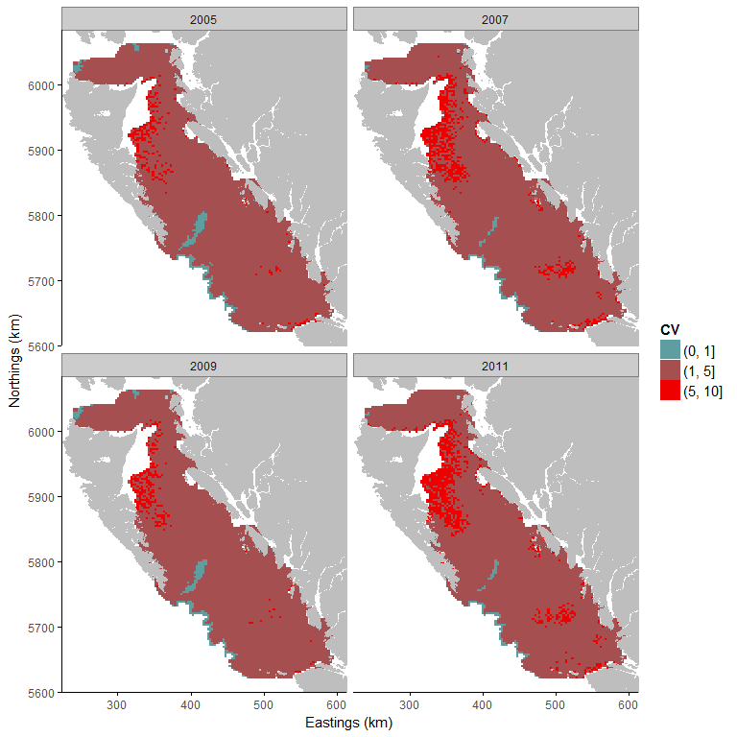

Figure n1: i) Median, ii) mean and iii) coefficient of variation of the posterior predictive distribution. The blue represents area with a posterior predictive median at 0 (absence of the species). The red represents area with a strictly positive biomass. The strictly positive biomass is cut into intervals to be easier to read. The first class represents strictly positive biomass up to 10kg. The second class represents biomass from 50kg to 100kg, and the final class represents large amount of biomass above 100kg. A small coefficient of variation means that model uncertainty is small for the predicted area.

**Temperature range**

Table n and Figure n2 show that the temperature range is estimated between 4.46 °C (probability of presence at 100%) and 6.22 °C (probability of presence at 50%). It represents approximately 35% of the study area.

Table n: Temperature (°C) and the associated mean and standard deviation of the predictive probability of presence.

|  |  |  |
| --- | --- | --- |
| Temperature | Mean | Standard deviation |
| 5 | 0.97 | 0.05 |
| 6 | 0.66 | 0.15 |
| 7 | 0.38 | 0.11 |
| 8 | 0.25 | 0.07 |
| 9 | 0.21 | 0.06 |
| 10 | 0.16 | 0.04 |
| 11 | 0.12 | 0.03 |
| 12 | 0.11 | 0.03 |

**Probability of presence**

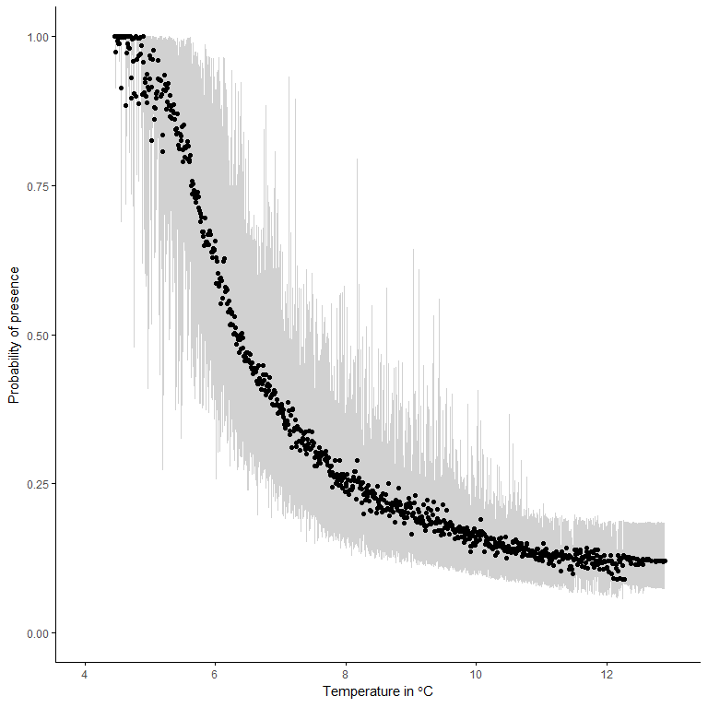

Figure n2: Probability of presence given the temperature (°C). The black points represent the median of the posterior predictive distribution of the probability of presence and the grey area represents the 95% credibility interval.

## Silvergray rockfish (*Sebastes brevispinis*)

The amount of zeroes (absence) in the dataset used to study the temperature range of Silvergray Rockkfish is 51.04%. This is a large proportion of zeros but a zero-inflated model is able to handle this percentage of absence.

The effect of the temperature on the probability of presence of Silvergray Rockkfish is negative. This means that the presence of Silvergray Rockkfish is associated with colder temperatures. The effect of the depth is also negative which means that the presence of Silvergray Rockkfish is preferably associated with relatively shallow waters. Finally, there are differences between years. The years 2007, 2009 and 2011 have a negative effect on the probability of presence and the positive biomass. This means that the amount of biomass was smaller in 2007, 2009 and 2011 than in 2005.

**Predictions of species distribution**

**i)**

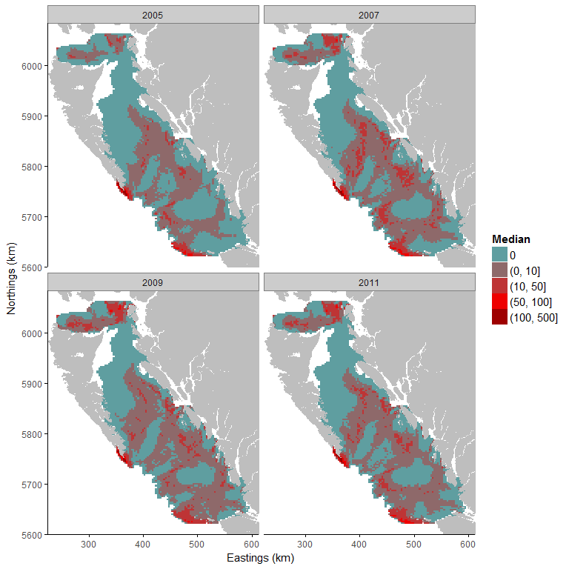

**ii)**

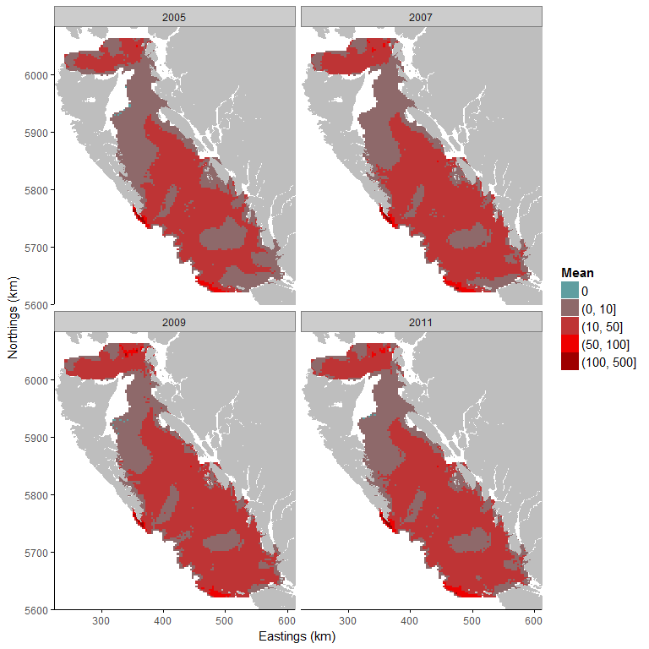

**iii)**

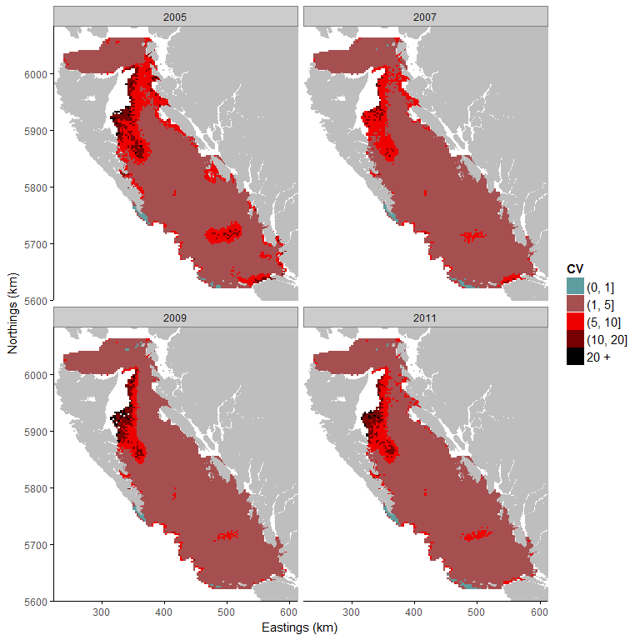

Figure o1: i) Median, ii) mean and iii) coefficient of variation of the posterior predictive distribution. The blue represents area with a posterior predictive median at 0 (absence of the species). The red represents area with a strictly positive biomass. The strictly positive biomass is cut into intervals to be easier to read. The first class represents strictly positive biomass up to 10kg. The second class represents biomass from 50kg to 100kg, and the final class represents large amount of biomass above 100kg. A small coefficient of variation means that model uncertainty is small for the predicted area.

**Temperature range**

Table o and Figure o2 show that the probability of presence at 50% is estimated between 4.91 and 7.56 °C. It represents 60% of the whole study area. The temperature range is estimated between 4.63 °C (probability of presence at 85%) and 7.56 °C (probability of presence at 50%).

Table o: Temperature (°C) and the associated mean and standard deviation of the predictive probability of presence.

|  |  |  |
| --- | --- | --- |
| Temperature | Mean | Standard deviation |
| 5 | 0.26 | 0.22 |
| 6 | 0.61 | 0.15 |
| 7 | 0.58 | 0.15 |
| 8 | 0.36 | 0.11 |
| 9 | 0.17 | 0.05 |
| 10 | 0.08 | 0.02 |
| 11 | 0.03 | 0.01 |
| 12 | 0.01 | 0.00 |

**Probability of presence**

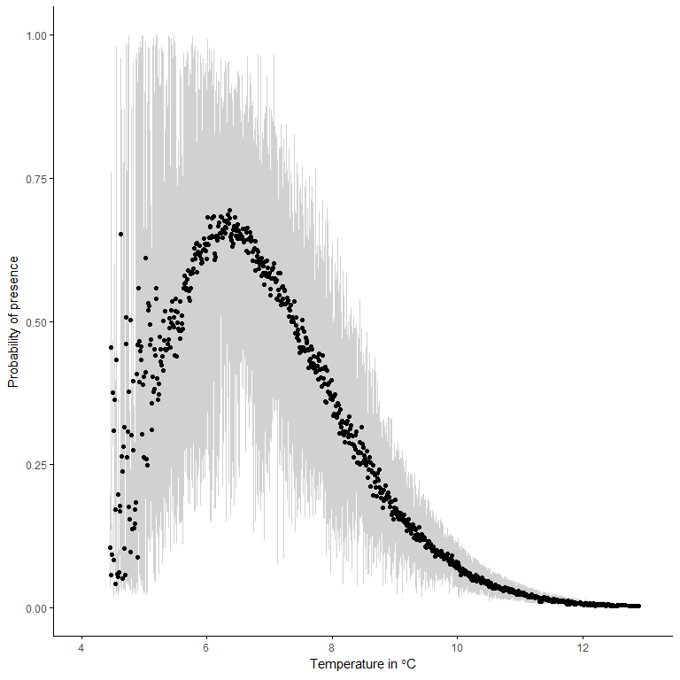

Figure o2: Probability of presence given the temperature (°C). The black points represent the median of the posterior predictive distribution of the probability of presence and the grey area represents the 95% credibility interval.

## Shortspine thornyhead (*Sebastolobus alascanus*)

The amount of zeroes (absence) in the dataset used to study the temperature range of Shortspine Thornyhead is 71.76%. It is important to note that the amount of zeroes in the dataset is important and results obtained from this analysis should be interpreted cautiously.

The effect of the temperature on the probability of presence of Shortspine Thornyhead is strong and negative. This means that the presence of Shortspine Thornyhead is associated with colder temperatures. The effect of the depth was also negative but smaller than temperature. This means that the presence of Shortspine Thornyhead is preferably associated with relatively shallow waters. Finally, there are differences between years. The years 2007, 2009 and 2011 have a negative effect on the probability of presence and the positive biomass. It means that the amount of biomass was smaller in 2007, 2009 and 2011 than in 2005.

**Predictions of species distribution**

**i)**

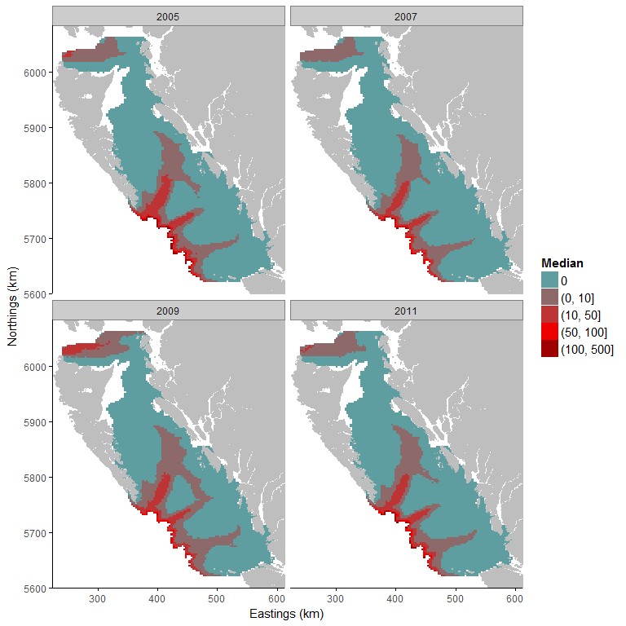

**ii)**

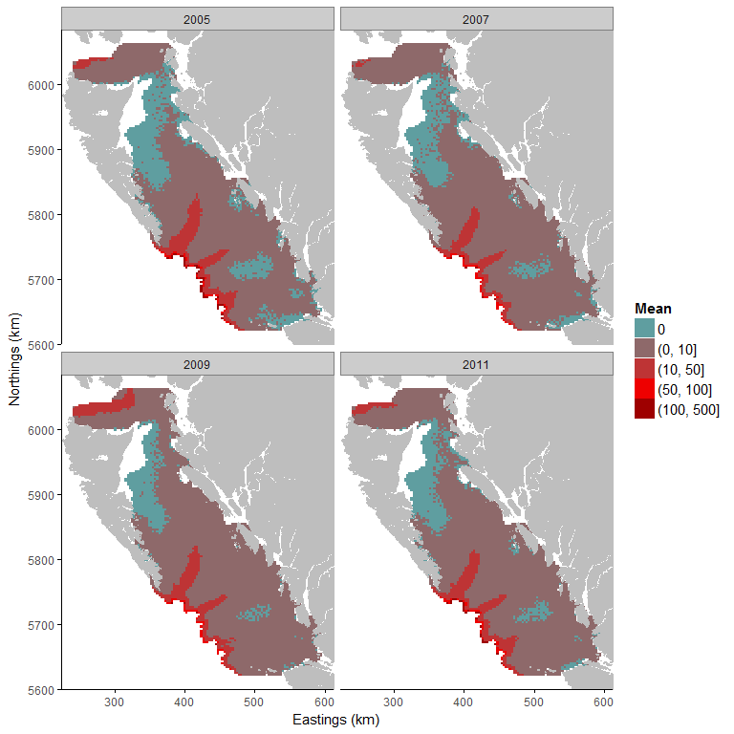

**iii)**

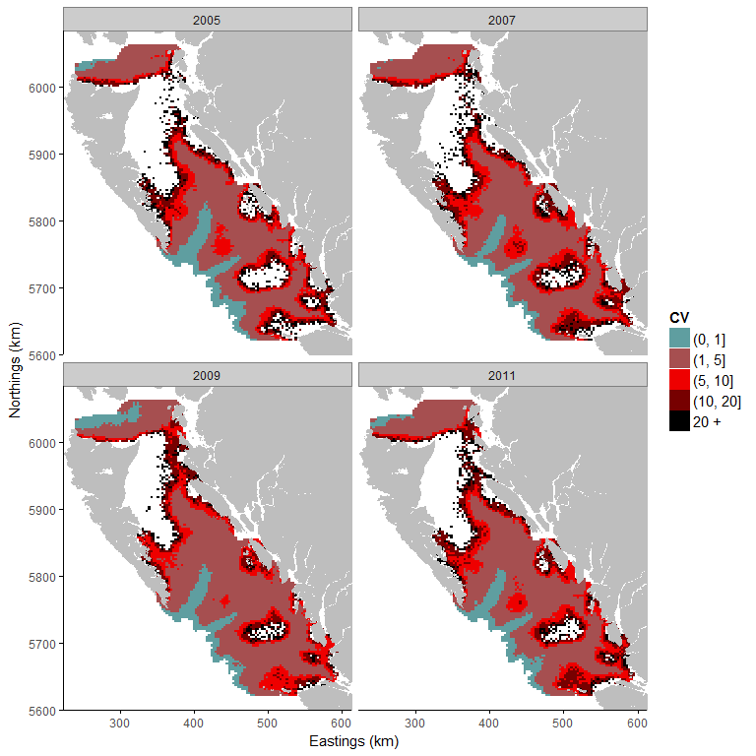

Figure p1: i) Median, ii) mean and iii) coefficient of variation of the posterior predictive distribution. The blue represents area with a posterior predictive median at 0 (absence of the species). The red represents area with a strictly positive biomass. The strictly positive biomass is cut into intervals to be easier to read. The first class represents strictly positive biomass up to 10kg. The second class represents biomass from 50kg to 100kg, and the final class represents large amount of biomass above 100kg. A small coefficient of variation means that model uncertainty is small for the predicted area.

**Temperature range**

Table p and Figure p2 show that the temperature range is estimated between 4.46 °C (probability of presence at 100%) and 6.09 °C (probability at 50%). It represents 35% of the study area.

Table p: Temperature (°C) and the associated mean and standard deviation of the predictive probability of presence.

|  |  |  |
| --- | --- | --- |
| Temperature | Mean | Standard deviation |
| 5 | 1.00 | 0.00 |
| 6 | 0.66 | 0.15 |
| 7 | 0.12 | 0.05 |
| 8 | 0.01 | 0.01 |
| 9 | 0.00 | 0.00 |
| 10 | 0.00 | 0.00 |
| 11 | 0.00 | 0.00 |
| 12 | 0.00 | 0.00 |

**Probability of presence**

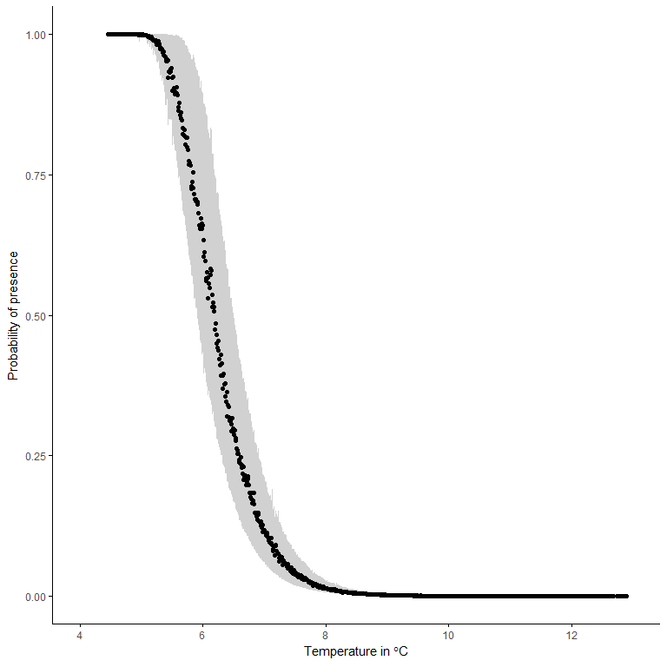

Figure p2: Probability of presence given the temperature (°C). The black points represent the median of the posterior predictive distribution of the probability of presence and the grey area represents the 95% credibility interval.

**Widow rockfish (*Sebastes entomelas*)**

The amount of zeroes (absence) in the dataset used to study the temperature range of Widow Rockfish is 94.5%. It is very important to note that the amount of zeroes in the dataset is problematic and results obtained from this analysis should be taken with great care. Depth and temperature were included as explanatory variables in our model.

The effect of the temperature on the probability of presence of Widow Rockfish is negative. This means that the presence of Widow Rockfish is associated with colder temperatures. The effect of the depth is also negative which means that the presence of Widow Rockfish is preferably associated with relatively shallow waters. Finally, there are differences between years. The years 2007, 2009 and 2011 have a negative effect on the probability of presence and the positive biomass. It means that the amount of biomass was smaller in 2007, 2009 and 2011 than in 2005.

**Predictions of species distribution**

**i)**



**ii)**

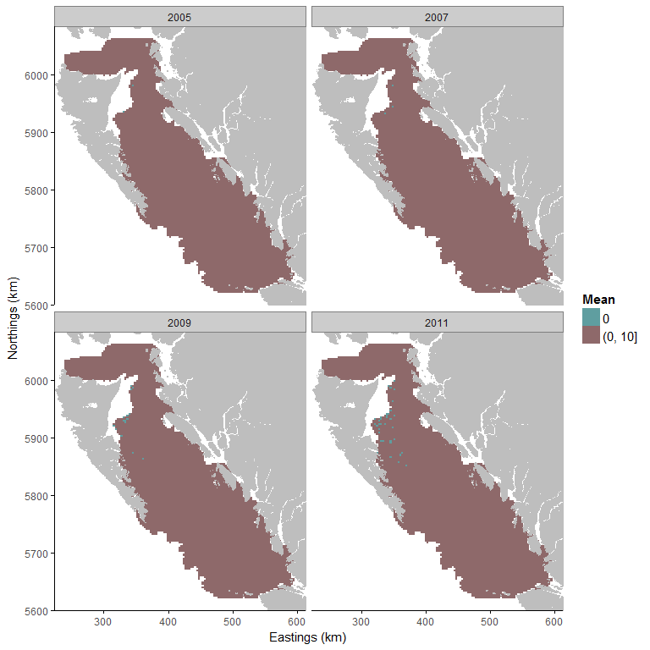

**iii)**

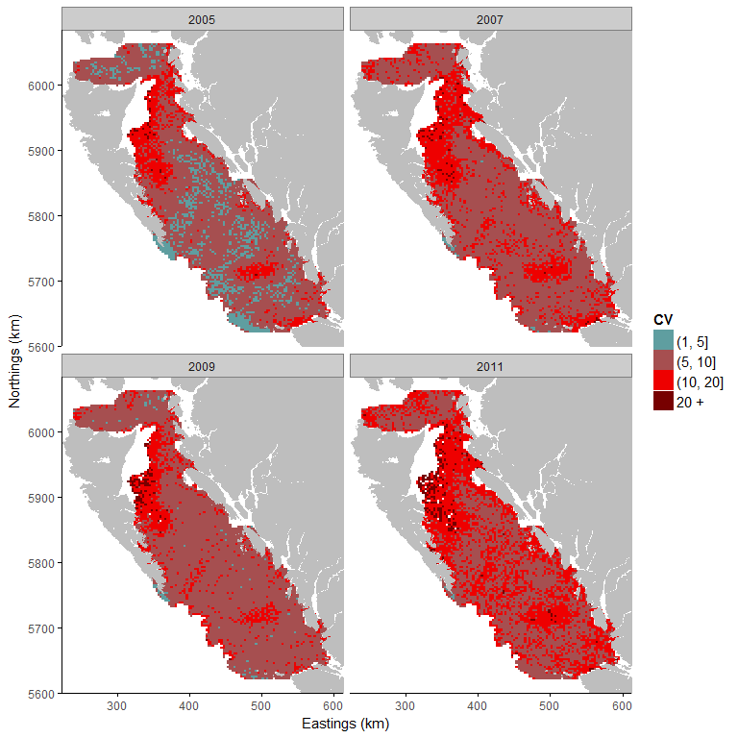

Figure q1: i) Median, ii) mean and iii) coefficient of variation of the posterior predictive distribution. The blue represents area with a posterior predictive median at 0 (absence of the species). The red represents area with a strictly positive biomass. The strictly positive biomass is cut into intervals to be easier to read. The first class represents strictly positive biomass up to 10kg. The second class represents biomass from 50kg to 100kg, and the final class represents large amount of biomass above 100kg. A small coefficient of variation means that model uncertainty is small for the predicted area.

**Temperature range**

Table q and Figure q2 show that the probability of presence is low for every temperature in our study area. The absence of constrained temperature range is due to the small amount of strictly positive observations which do not allow to estimate accurately the temperature range of Widow Rockfish.

Table q: Temperature (°C) and the associated mean and standard deviation of the predictive probability of presence.

|  |  |  |
| --- | --- | --- |
| Temperature | Mean | Standard deviation |
| 5 | 0.04 | 0.03 |
| 6 | 0.07 | 0.03 |
| 7 | 0.07 | 0.04 |
| 8 | 0.04 | 0.03 |
| 9 | 0.03 | 0.02 |
| 10 | 0.02 | 0.01 |
| 11 | 0.01 | 0.01 |
| 12 | 0.01 | 0.01 |

**Probability of presence**

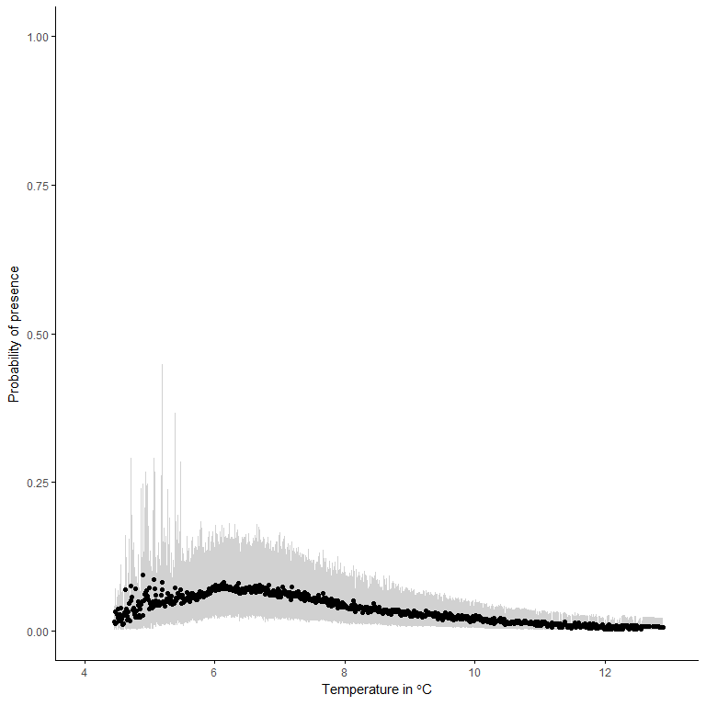

Figure q2: Probability of presence given the temperature (°C). The black points represent the median of the posterior predictive distribution of the probability of presence and the grey area represents the 95% credibility interval.

# Conclusion

To estimate distribution and temperature preference of Canada’s Pacific Groundfish species we employed a hierarchical Bayesian species distribution model designed to handle large gaps in observations. For the majority of commercially targeted species investigated, the model was suitable for the data source (i.e. cases with fewer than 60% of zeroes in the dataset). Outputs for three species (Petrale sole, Greenstripe Rockfish, Redstripe Rockfish, XXX) are to be cautiously interpreted due to higher absence of zero observations. Biomass datasets for several of the non-commercially targeted/rare Groundfish species contained such large percentages of absences in survey observations (>90% of zeroes in the dataset) that the model procedures were ineffective. Outputs for Bocaccio, Canary Rockfish, and Widow Rockfish were not viable and although presented here, should not be considered further.

The distribution model included temperature and depth as latent variables. Of the species for which the model achieved viable outputs, all but two species were negatively associated with both temperature and depth. These outputs suggest that the majority of the species we investigated prefer cooler temperature and relatively shallower water. Dover sole and Sablefish were negatively associated with temperature and positively associated with depth and are thus associated with cooler temperature and deeper habitat. Temperature was an especially strong driver of distribution for Pacific Ocean Perch and Spotted Ratfish. Depth was a stronger driver than temperature for Dogfish, Pacific cod, Rock sole and Sablefish species. The amount of biomass was smaller in 2007, 2009 and 2011 than in 2005 for all species except Rock sole which had the highest biomass in 2007.

Species distribution models are important tools used to study the distribution and abundance of organisms relative to abiotic variables. Dynamic local interactions among species in a community can affect abundance and the abundance of a single species may not be at equilibrium with the environment. Advancements in species distribution modelling have occurred since the development of the modeling approach employed in this study. Future attempts to estimate species distribution using environmental variables to predict occurrence could include random effects to account for local dynamics or non-equilibrium responses to ecosystem changes (e.g. invasive species, climate-tracking).

# 

# References

Carton, J. A., and B. S. Giese (2008), A reanalysis of ocean climate using Simple Ocean Data Assimilation (SODA), Mon. Weather Rev., 136, 2999–3017, doi:10.1175/2007MWR1978.1.

Foreman, M. G. G., W. R. Crawford, J. Y. Cherniawsky, R. F. Henry, and M. R. Tarbotton (2000), A high-resolution assimilating tidal model for the northeast Pacific Ocean, J. Geophys. Res., 105, 28,629–28,651, doi:10.1029/1999JC000122.

Haidvogel, D. B., et al. (2008), Ocean forecasting in terrain-following coordinates: Formulation and skill assessment of the Regional Ocean Modeling System, *J. Comput. Phys.*, **227**, 3595–3624, doi:[10.1016/j.jcp.2007.06.016](http://dx.doi.org/10.1016/j.jcp.2007.06.016).

Masson, D., and I. Fine (2012), Modeling seasonal to interannual ocean variability of coastal British Columbia, J. Geophys. Res., 117, C10019, doi:10.1029/2012JC008151.

Morrison J., M.G.G. Foreman, and D. Masson, 2012. A method for estimating monthly freshwater discharge affecting British Columbia coastal waters. Atmosphere-Ocean, 50, 1-8. 7

North, E.W., E.E. Adams, S. Schlag, C.R. Sherwood, R. He, S. Socolofsky, 2011. Simulating oil droplet dispersal from the Deepwater Horizon spill with a Lagrangian approach. AGU Book Series: Monitoring and Modeling the Deepwater Horizon Oil Spill: A Record Breaking Enterprise.

North American Regional Reanalysis (2004) A long-term, consistent, high-resolution climate dataset for the North American domain, as a major improvement upon the earlier global reanalysis datasets in both resolution and accuracy, Fedor Mesinger et. al, submitted to BAMS 2004, <http://www.emc.ncep.noaa.gov/mmb/rreanl/narr.bams.Aug19.pdf>

Shchepetkin, A. F., J. Molemaker, F. Colas, E. Mason, Y. Uchiyama, J. Kurian, and J. C. McWilliams: Recent Developments of ROMS at UCLA. Physical Oceanography Review Symposium Chicago, IL, June 7-13, 2009

Foster, Scott D., and Mark V. Bravington. 2012. “A Poisson–Gamma model for analysis of ecological non-negative continuous data.” *Environmental and Ecological Statistics* 19 (4): 1–20. doi:[10.1007/s10651-012-0233-0](https://doi.org/10.1007/s10651-012-0233-0).

Gelman, A, JB Carlin, HS Stern, and DB Rubin. 2004. *Bayesian data analysis*. CRC press. [http://scholar.google.fr/scholar?hl=fr{\&}q=Gelman+Bayesian+data+analysis{\&}btnG={\&}lr={\#}0](http://scholar.google.fr/scholar?hl=fr%7b&%7dq=Gelman+Bayesian+data+analysis%7b&%7dbtnG=%7b&%7dlr=%7b%22%20l%20).

Jorgensen, B. 1987. “Exponential dispersion models.” *Journal of the Royal Statistical Society. Series B (Methodological)* 49 (2): 127–62. <http://www.jstor.org/stable/10.2307/2345415>.

Lecomte, J.B., H. P. Benoît, M. P. Etienne, L. Bel, and E. Parent. 2013. “Modeling the habitat associations and spatial distribution of benthic macroinvertebrates: A hierarchical Bayesian model for zero-inflated biomass data.” *Ecological Modelling* 265 (September): 74–84. doi:[10.1016/j.ecolmodel.2013.06.017](https://doi.org/10.1016/j.ecolmodel.2013.06.017).

Lecomte, Jean-Baptiste, Hugues P. Benoît, Sophie Ancelet, Marie-Pierre Etienne, Liliane Bel, and Eric Parent. 2013. “Compound Poisson-gamma vs. delta-gamma to handle zero-inflated continuous data under a variable sampling volume.” Edited by Robert B. O’Hara. *Methods in Ecology and Evolution* 4 (12): 1159–66. doi:[10.1111/2041-210X.12122](https://doi.org/10.1111/2041-210X.12122).

**Appendices: Model parameter testing for each species**

## Appendix 1: Mean catches per year. Dots represent mean catches per year with their associated 95% confidence interval of the catches (Figs A1:1-18).

A1- 1 Arrowtooth Flounder

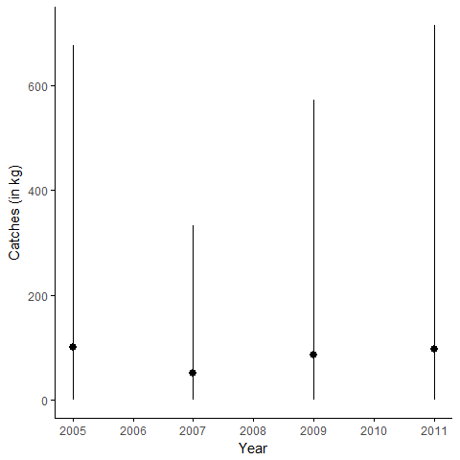

A1- 2 Bocaccio

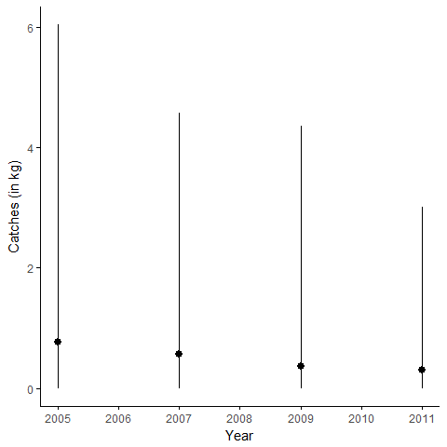

A1- 3 Canary Rockfish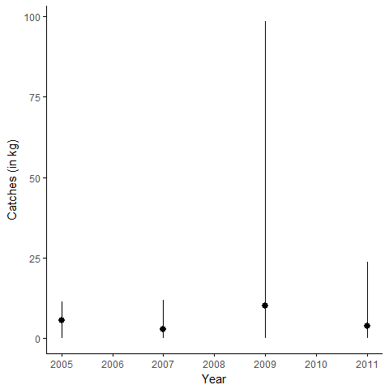

A1-4 Dogfish

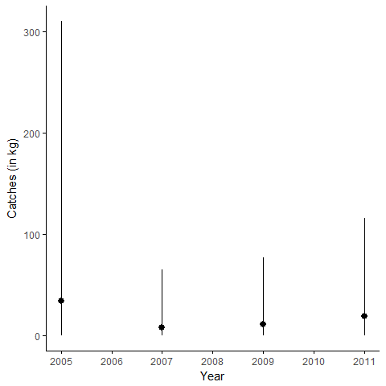

A1-4 Dover sole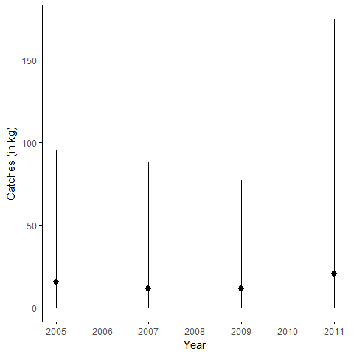

A1- 5 English sole

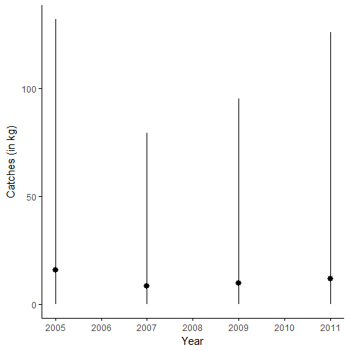

A1- 6 Greenstripe rockfish

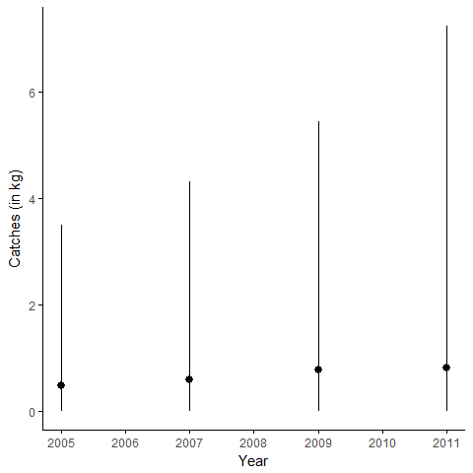

A1- 7 Pacific cod

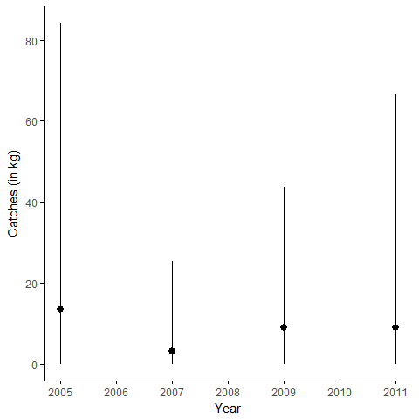

*A1- 8 Petrale sole*

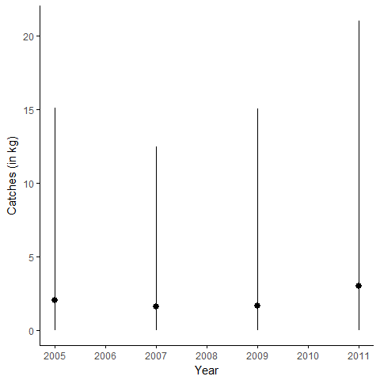

A1- 9 Pacific Ocean perch

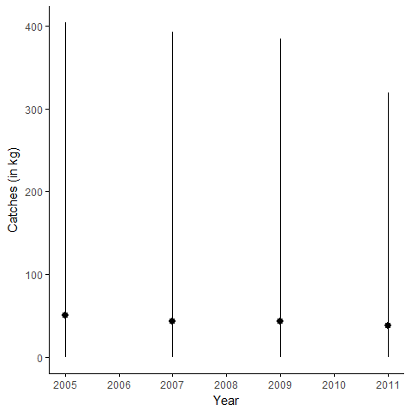

*A1- 10 Spotted ratfish*

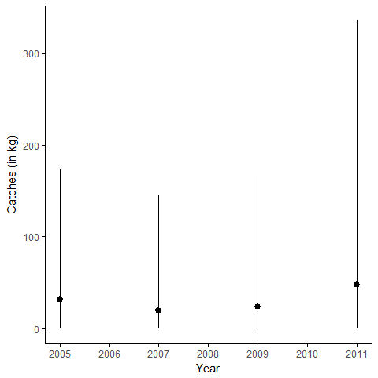

A1- Redstripe rockfish

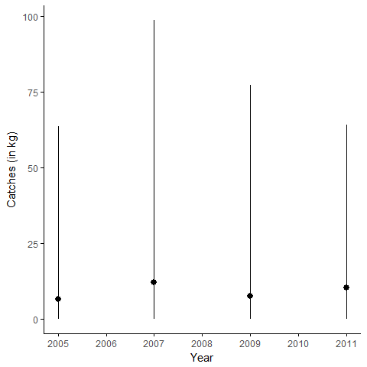

A1- : Rex sole

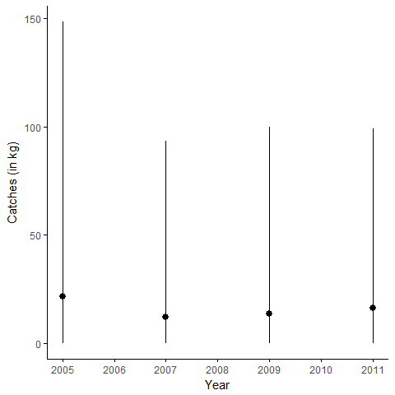

A1- Rock sole

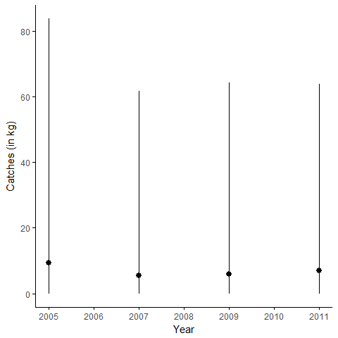

A1- : Sablefish

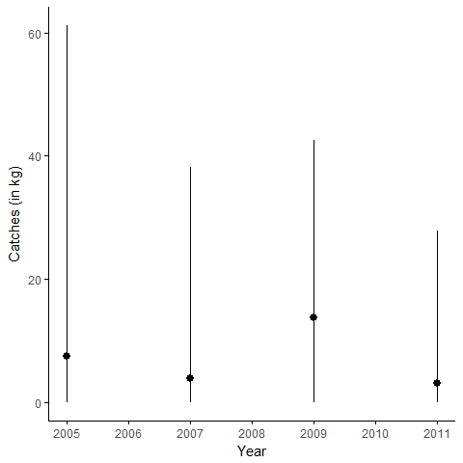

A1- : Silvergray rockfish

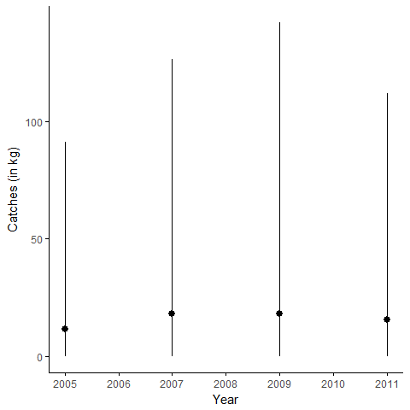

A1- Shortspine thornyhead

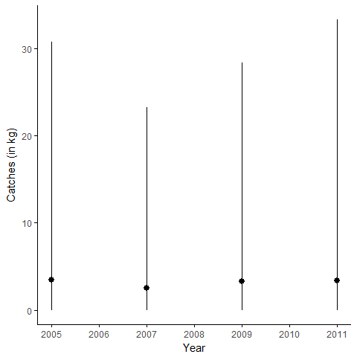

A1- Widow rockfish

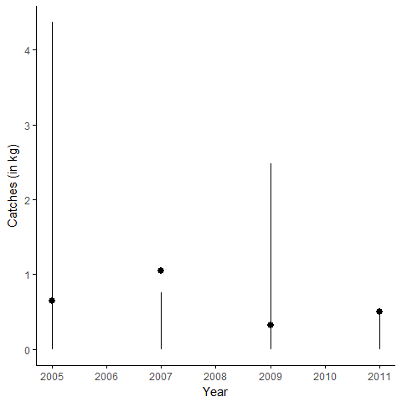

## 

## Appendix 2: Locations and quantities (kg) of catches per year in the study area. Red crosses represent null catch. Black triangles represent strictly positive biomass. Large triangles represent large catches. Figures A2-1 - A2-18.

A2- 1 Arrowtooth Flounder

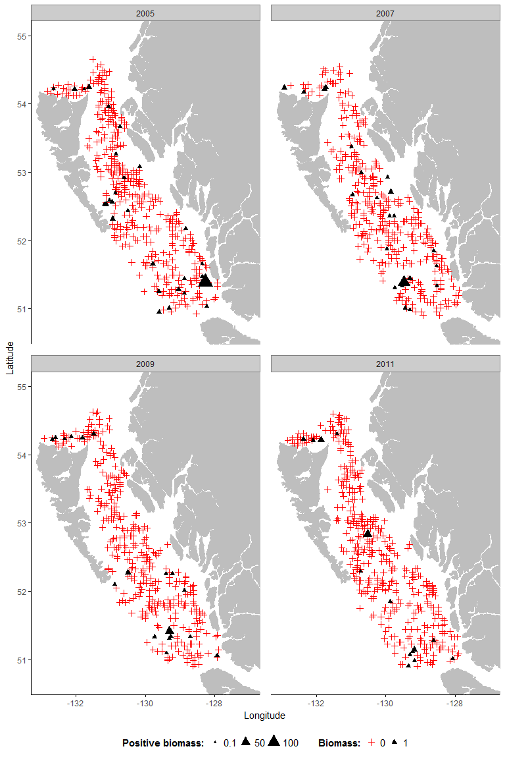

A2- 2 Bocaccio



A2- 3 Canary Rockfish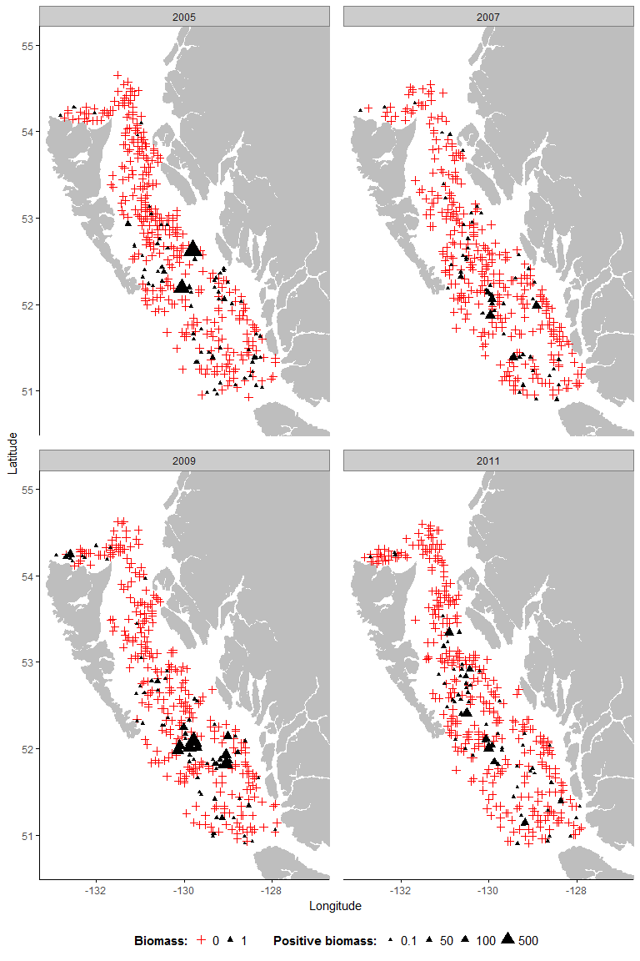

A2-4 Dogfish

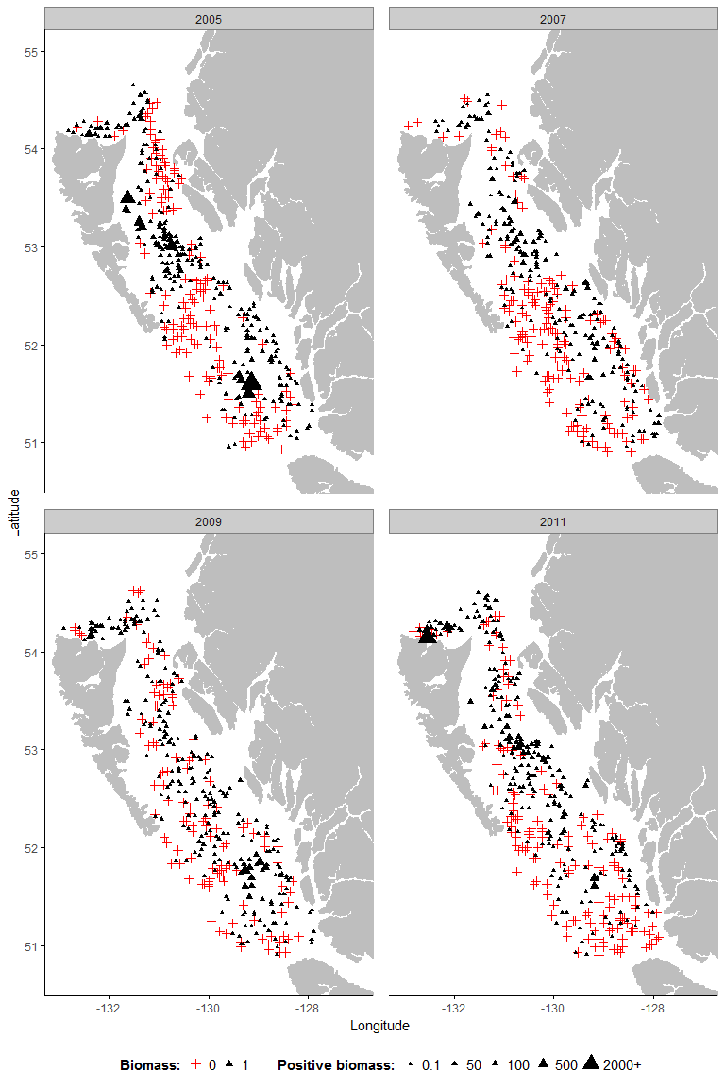

A2-5 Dover sole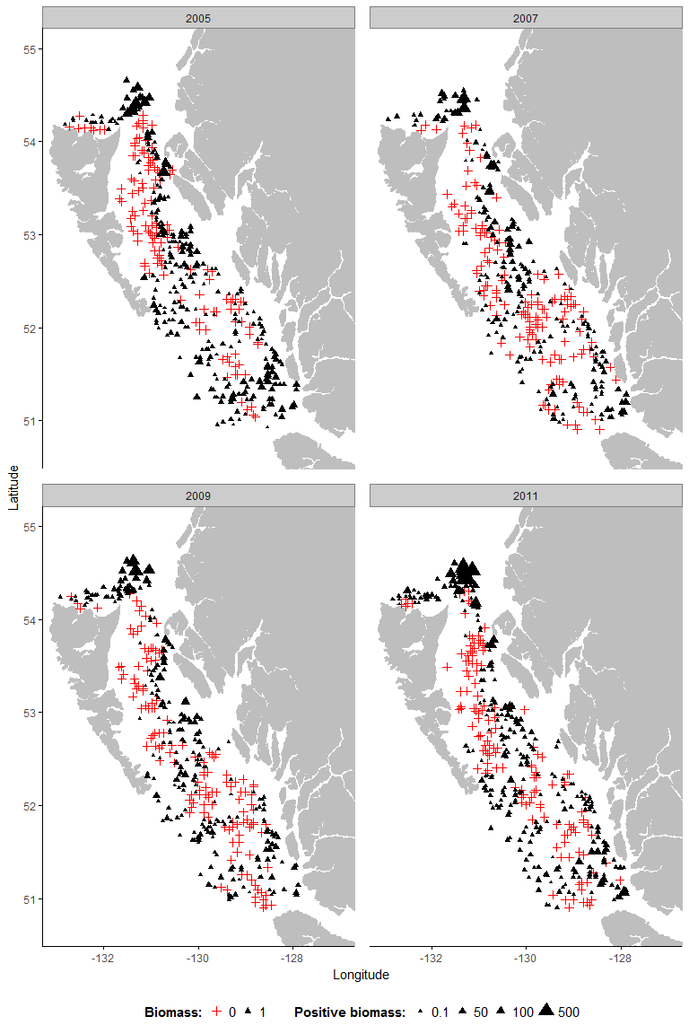

A2- 7 English sole

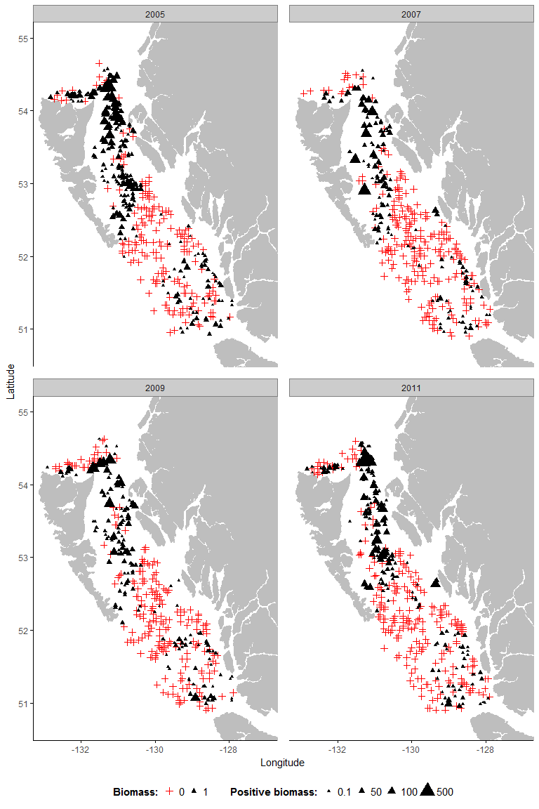

A2- 6 Greenstripe rockfish

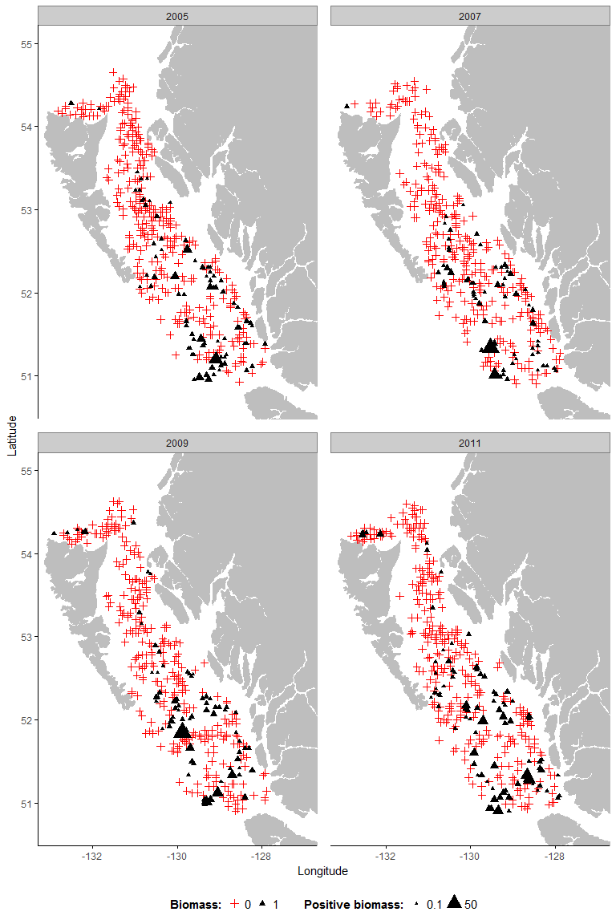

A2- 8 Pacific cod

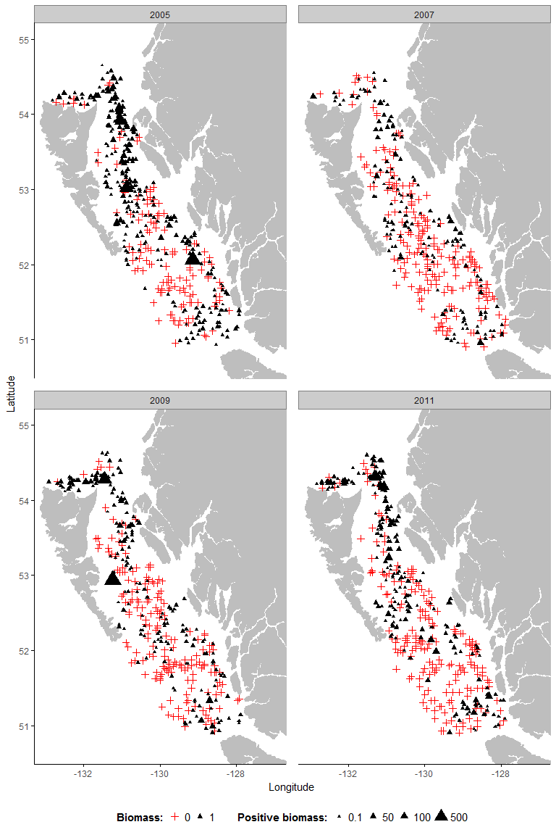

*A2 - 9 Petrale sole*

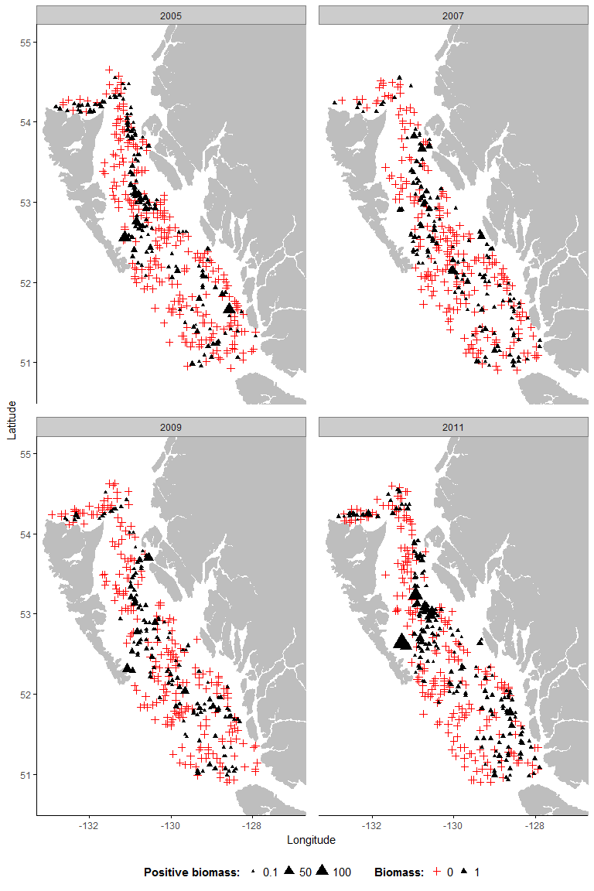

A2- 10 Pacific Ocean perch

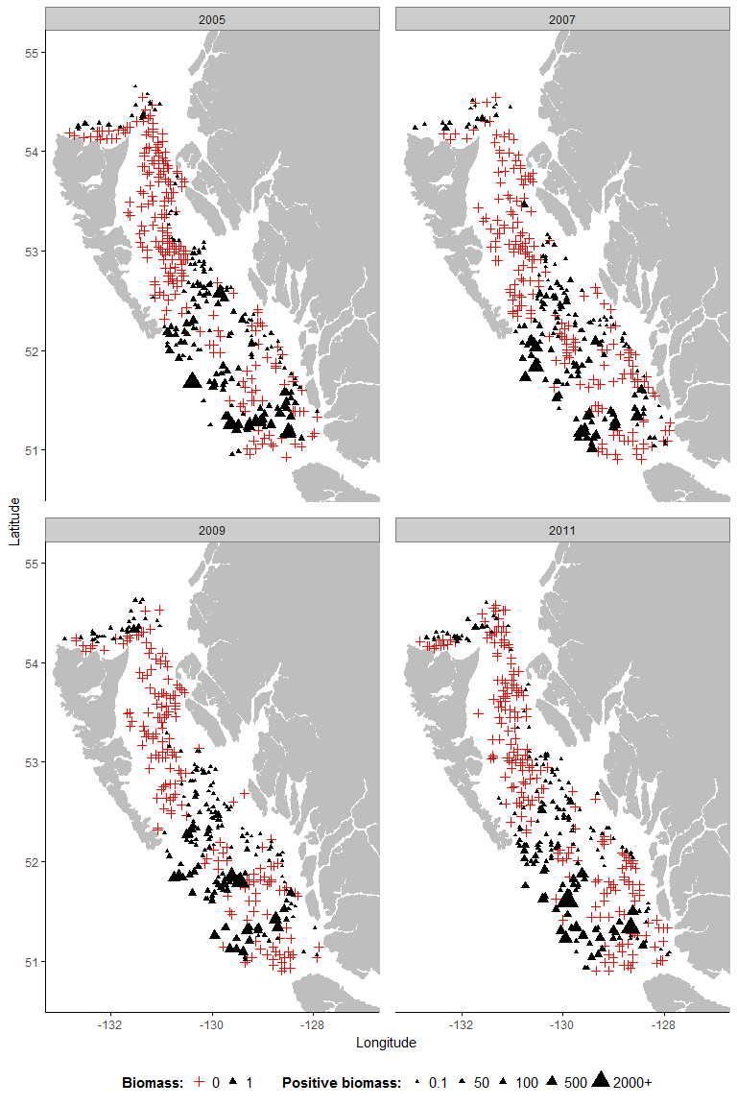

*A2- 11 Spotted ratfish*

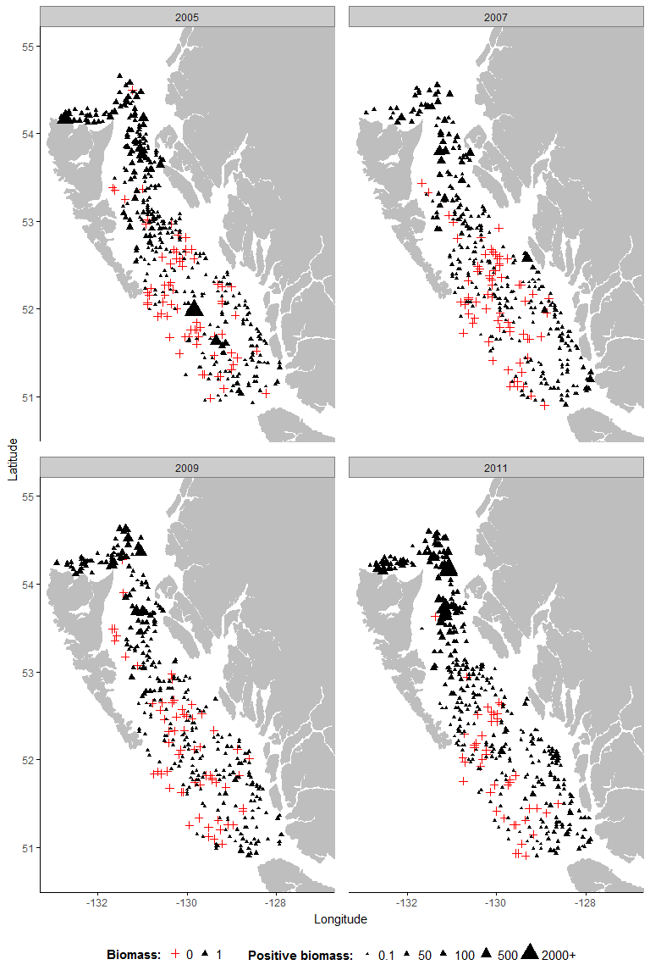

A2- 12 Redstripe rockfish

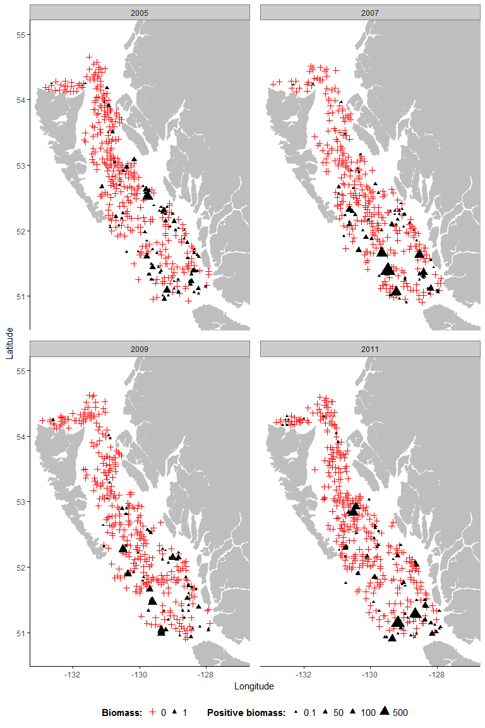

A2- 13 Rex sole

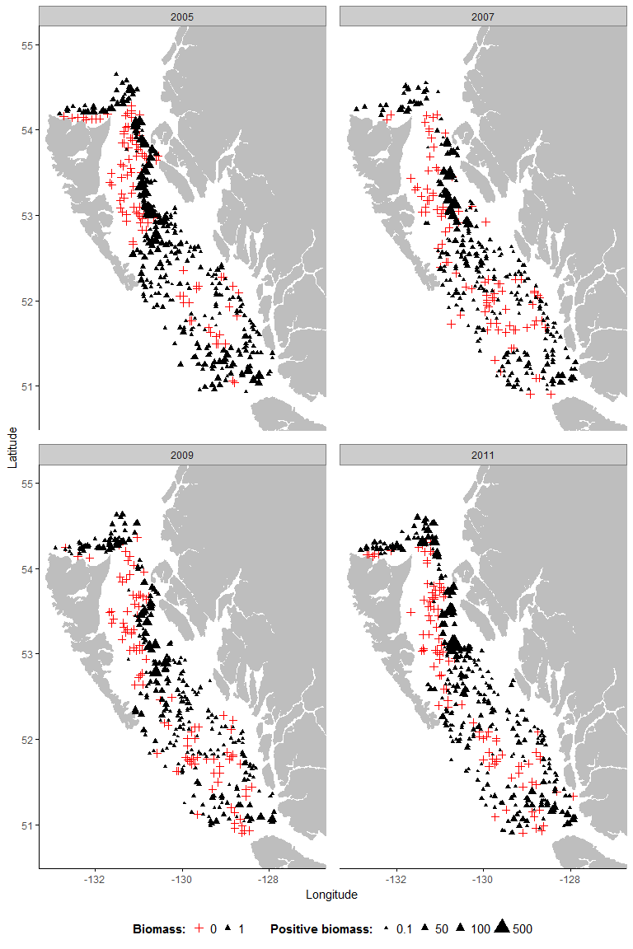

A2- 14 Rock sole

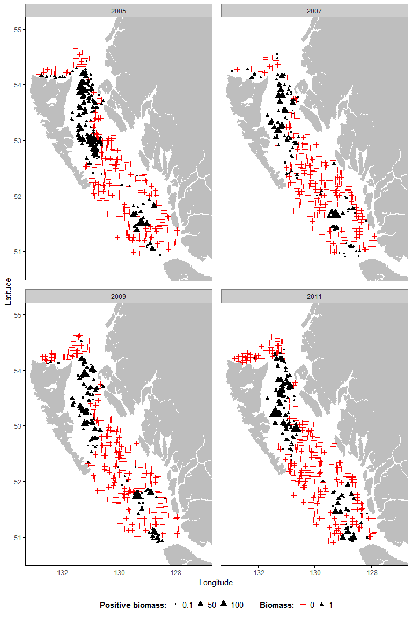

A2- 15 Sablefish

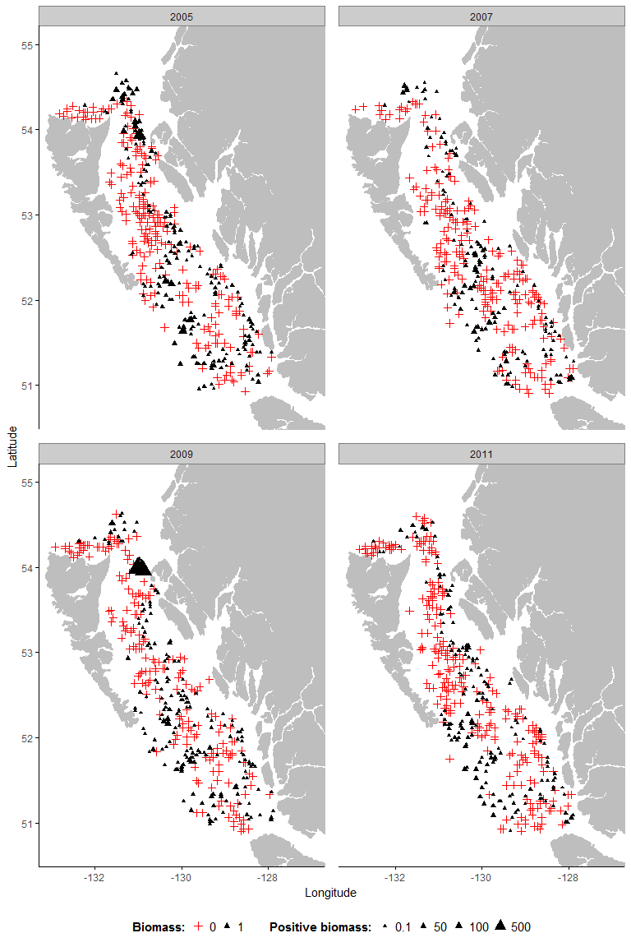

A2- 16 Silvergray rockfish

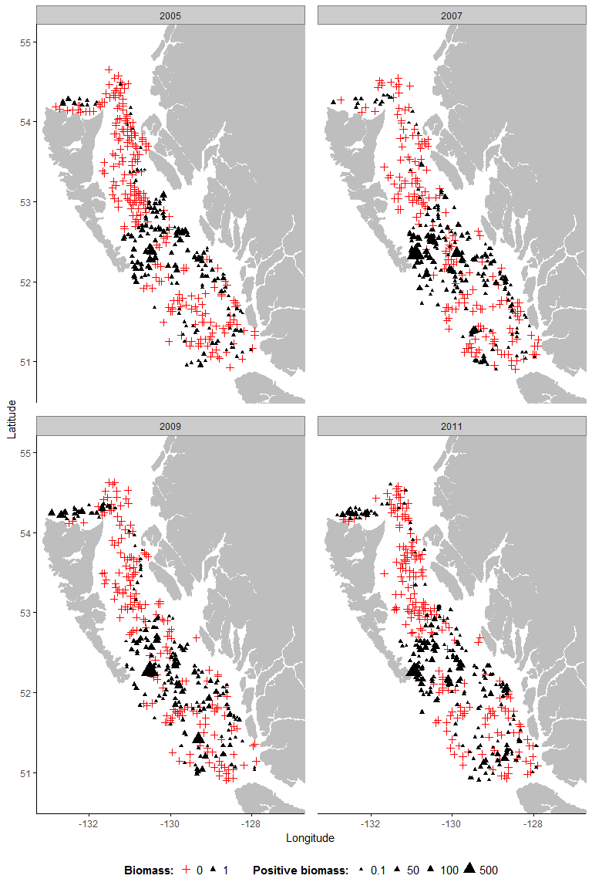

A2- 17 Shortspine thornyhead

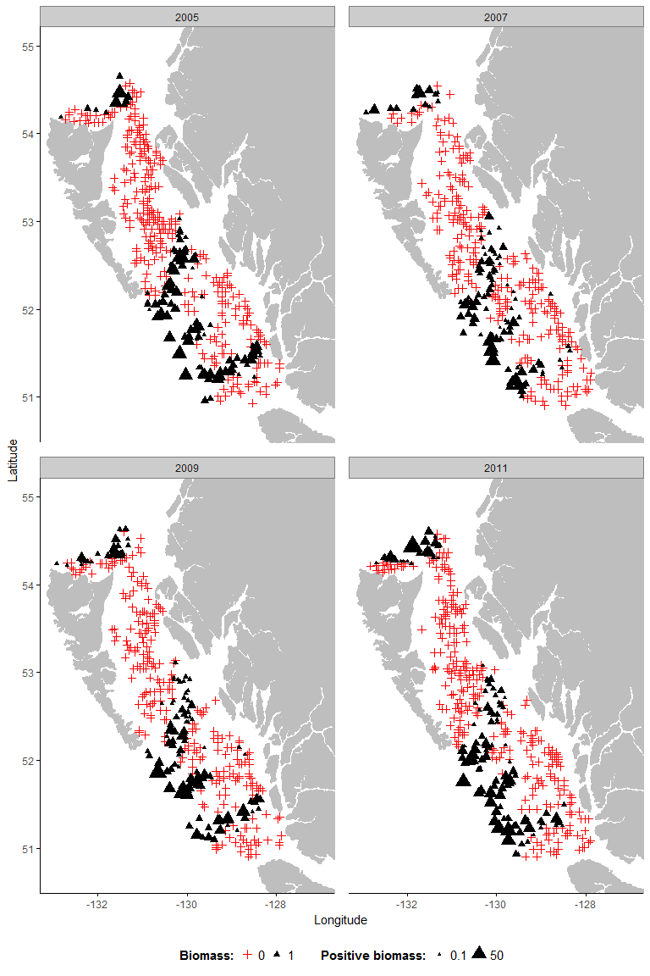

A2- 18 Widow rockfish

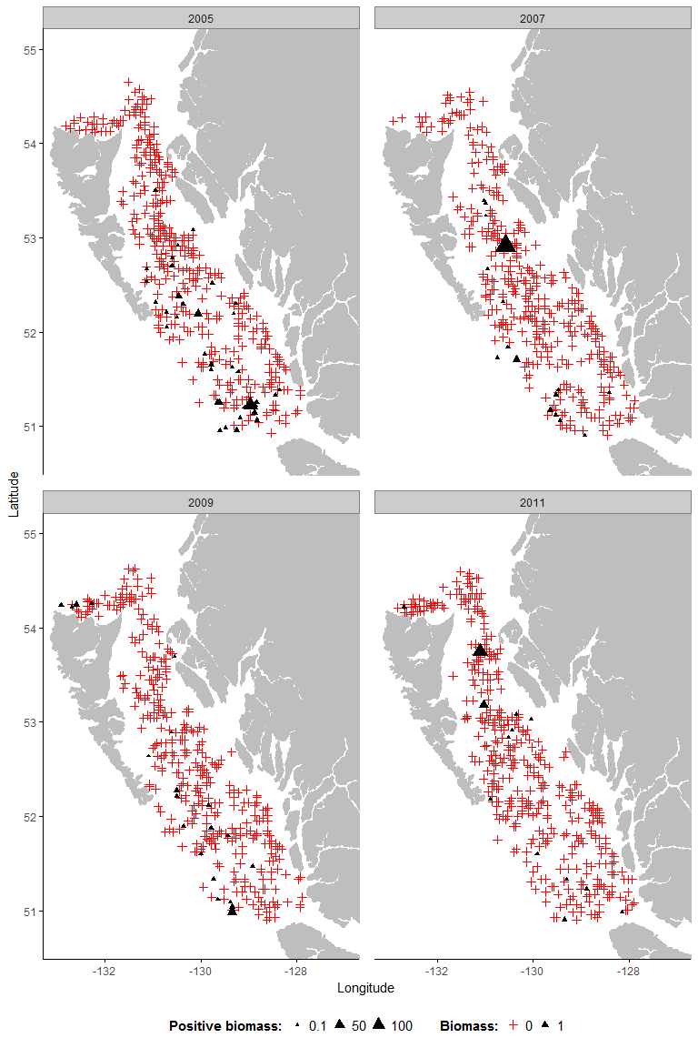

## 

Appendix 3: Potential Scale Reduction (PSRF) for hyper-parameters. PSRF above 1.1 shows that convergence has not been reached for the parameter.

A3- 1 Arrowtooth Flounder

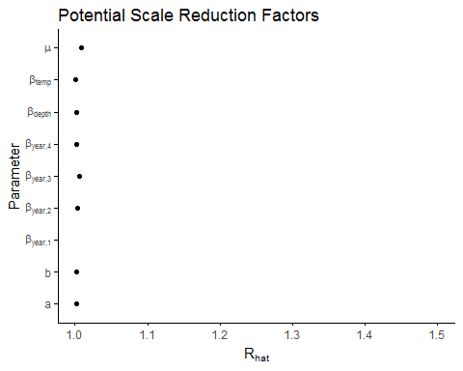

A3 -2 Bocaccio

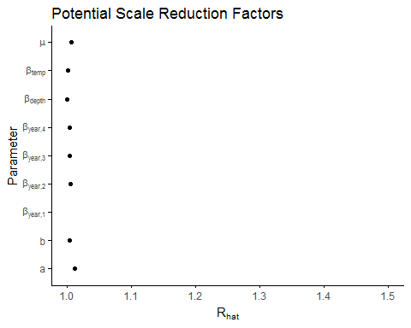

A3- 3 Canary Rockfish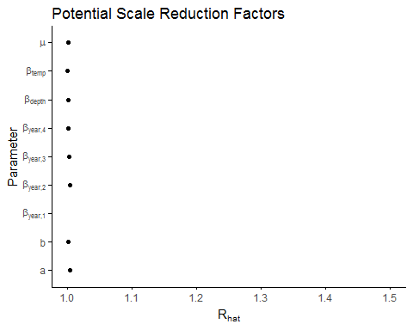

A3 -4 Dogfish

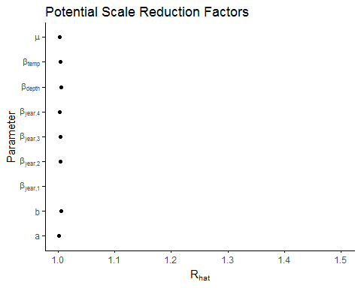

A3 -5 Dover sole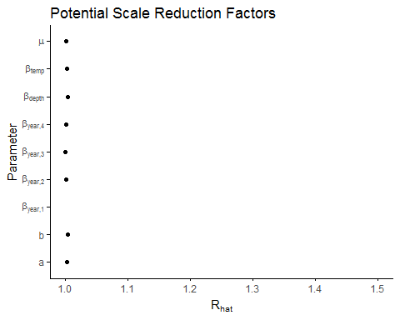

A3- 7 English sole

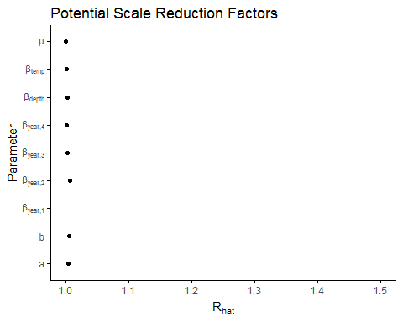

A3- 6 Greenstripe rockfish

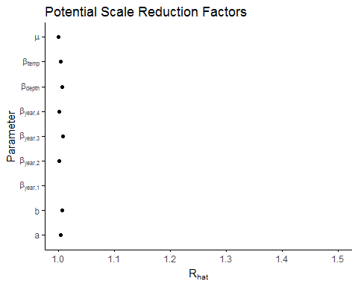

A3- 8 Pacific cod

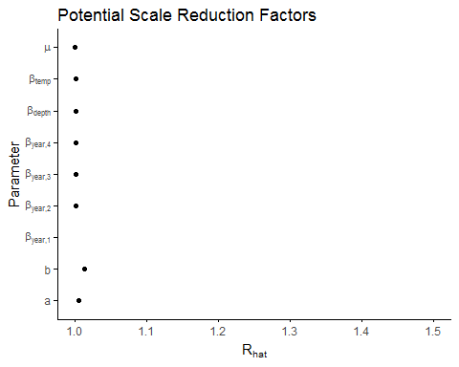

*A3- 9 Petrale sole*

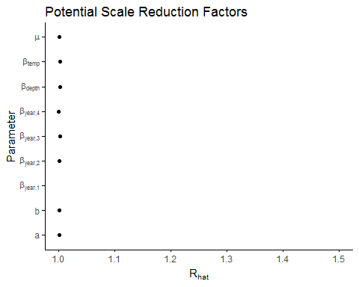

A3 -10 Pacific Ocean perch

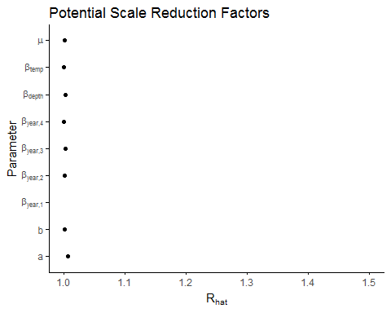

*A3- 11 Spotted ratfish*

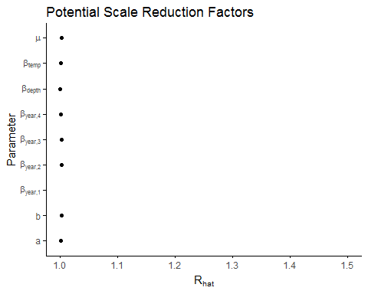

A3- Redstripe rockfish

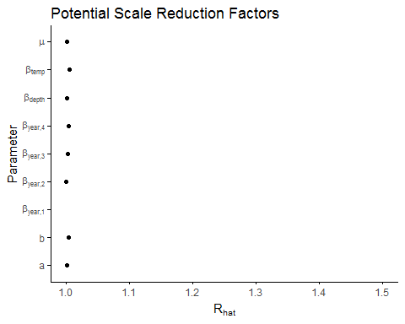

A3- 13 Rex sole

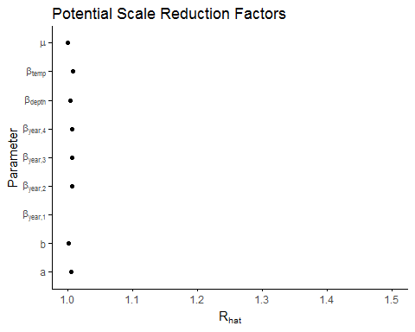

A3- 14 Rock sole

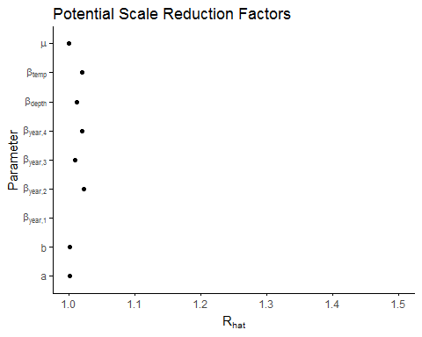

A3 - 15 Sablefish

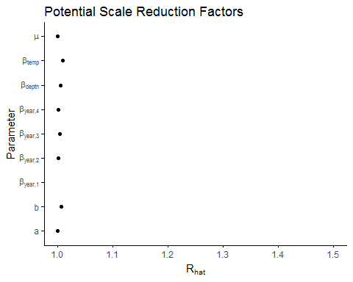

A3- 16 Silvergray rockfish

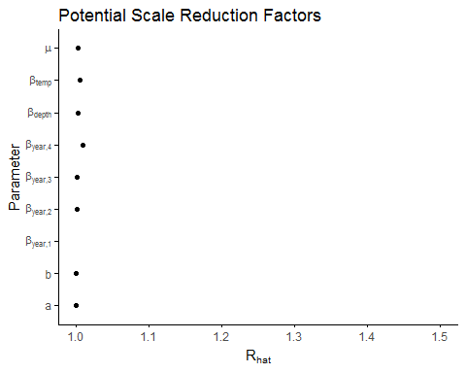

A3- 17 Shortspine thornyhead

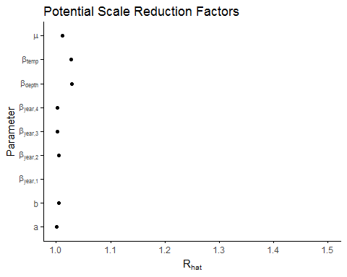

A3 - 18 Widow rockfish

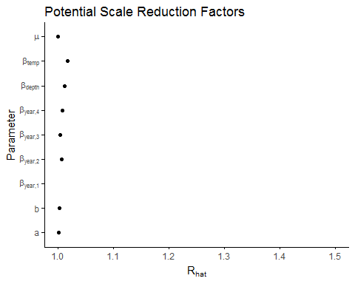

## 

## Appendix 4: Posterior distributions of model's hyper-parameters

A4- 1 Arrowtooth Flounder

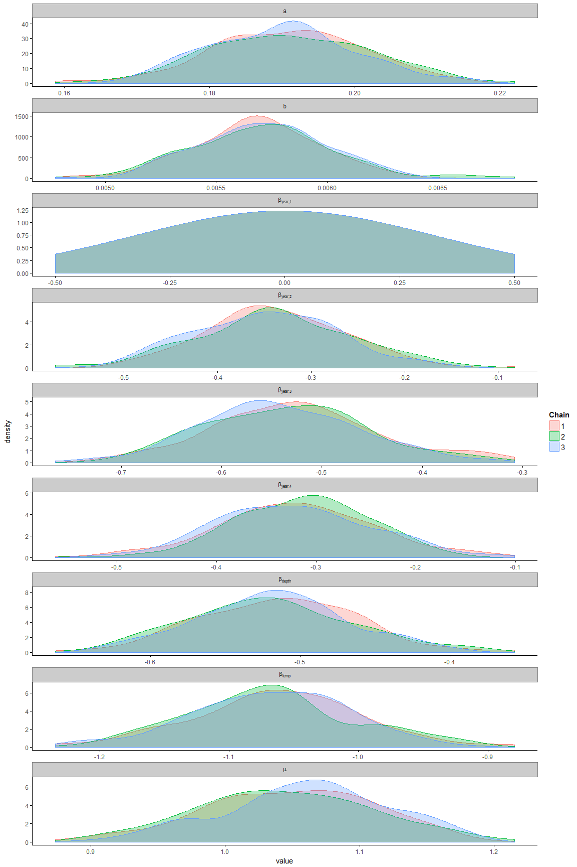

A4-2 Bocaccio

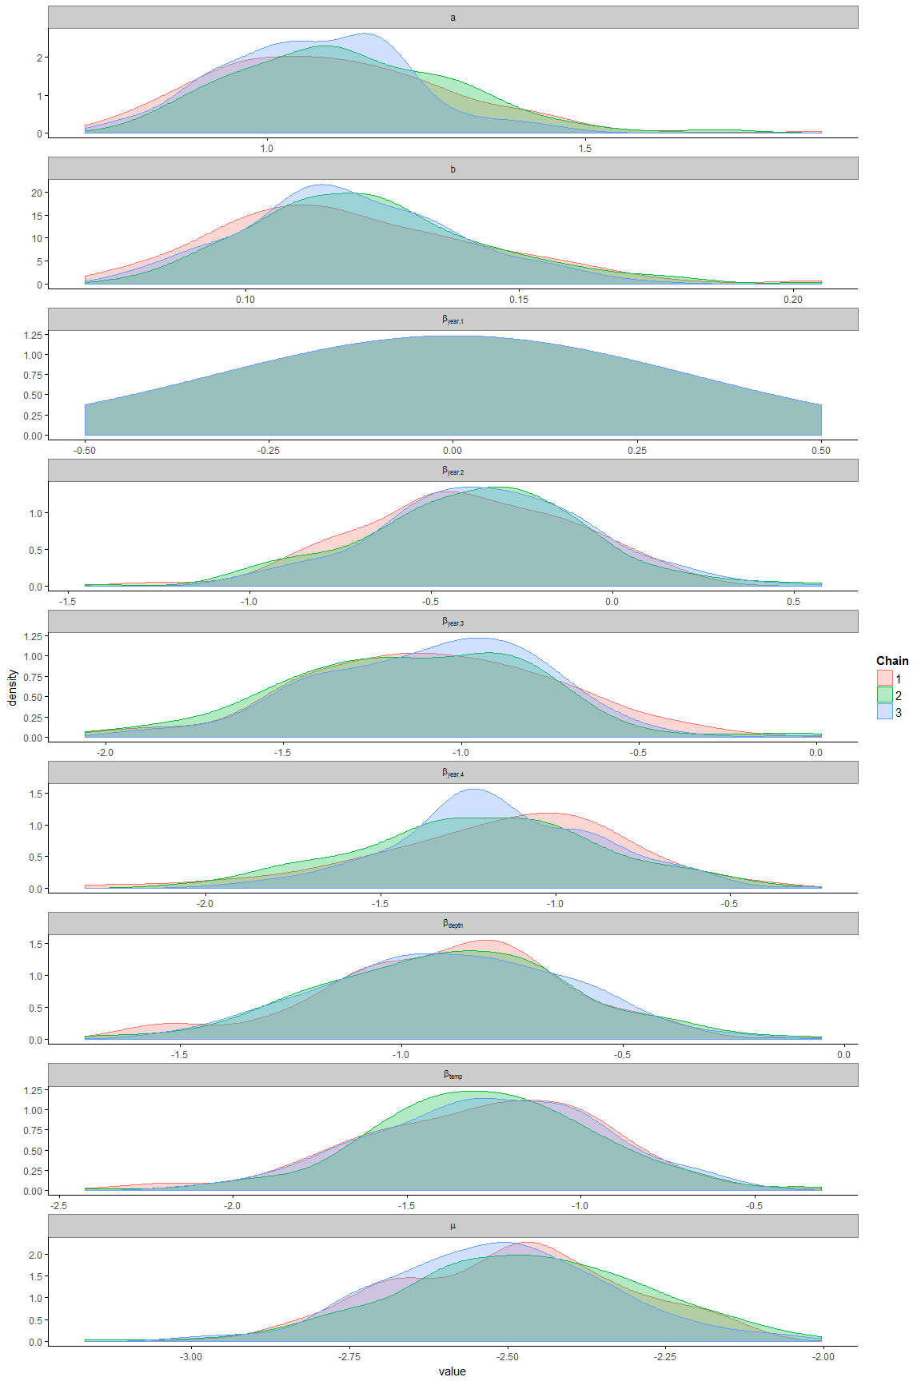

A4- 3 Canary Rockfish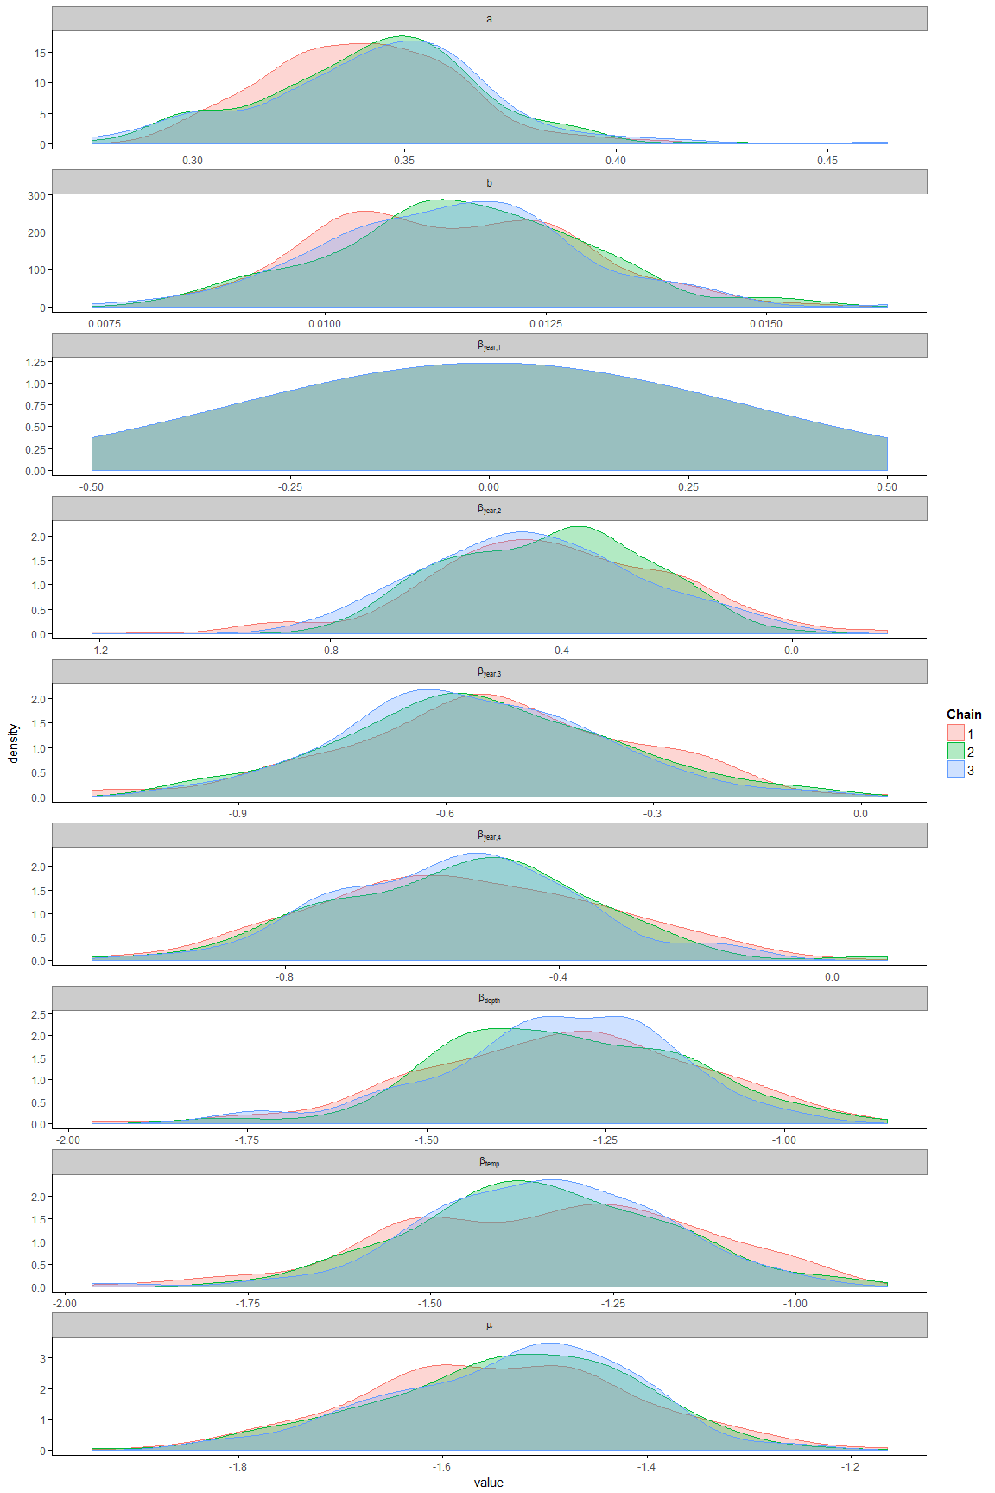

A4 -4 Dogfish

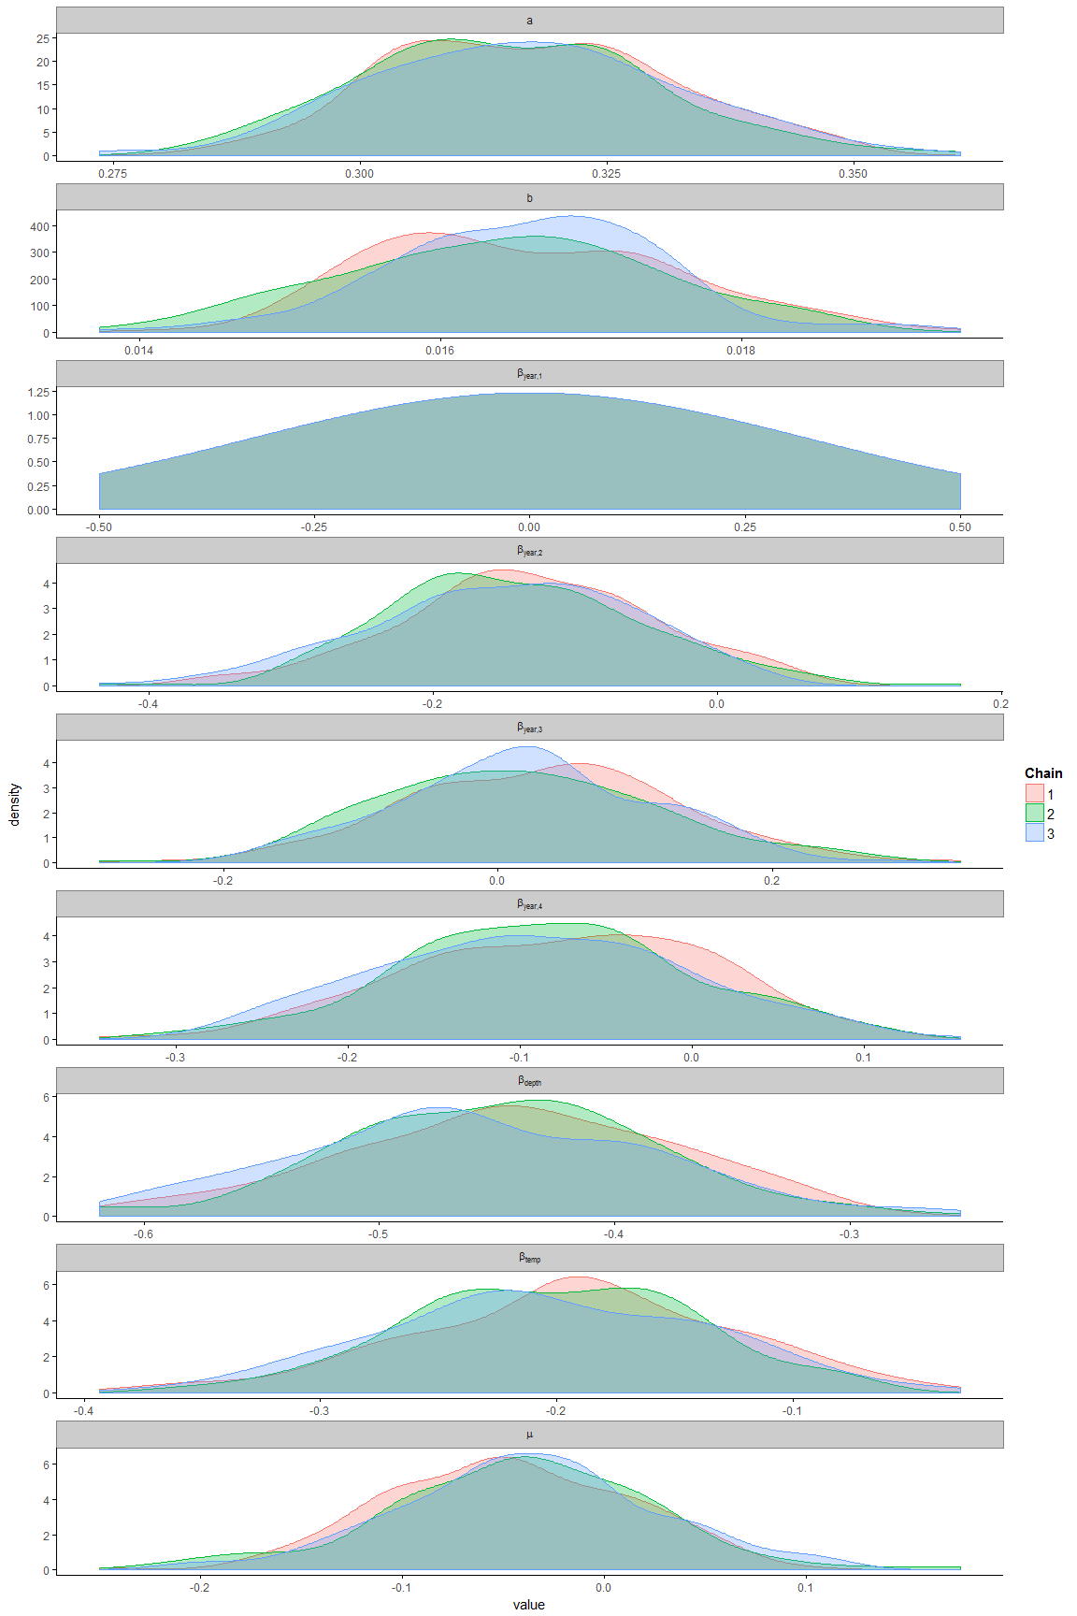

A4 - 5 Dover sole

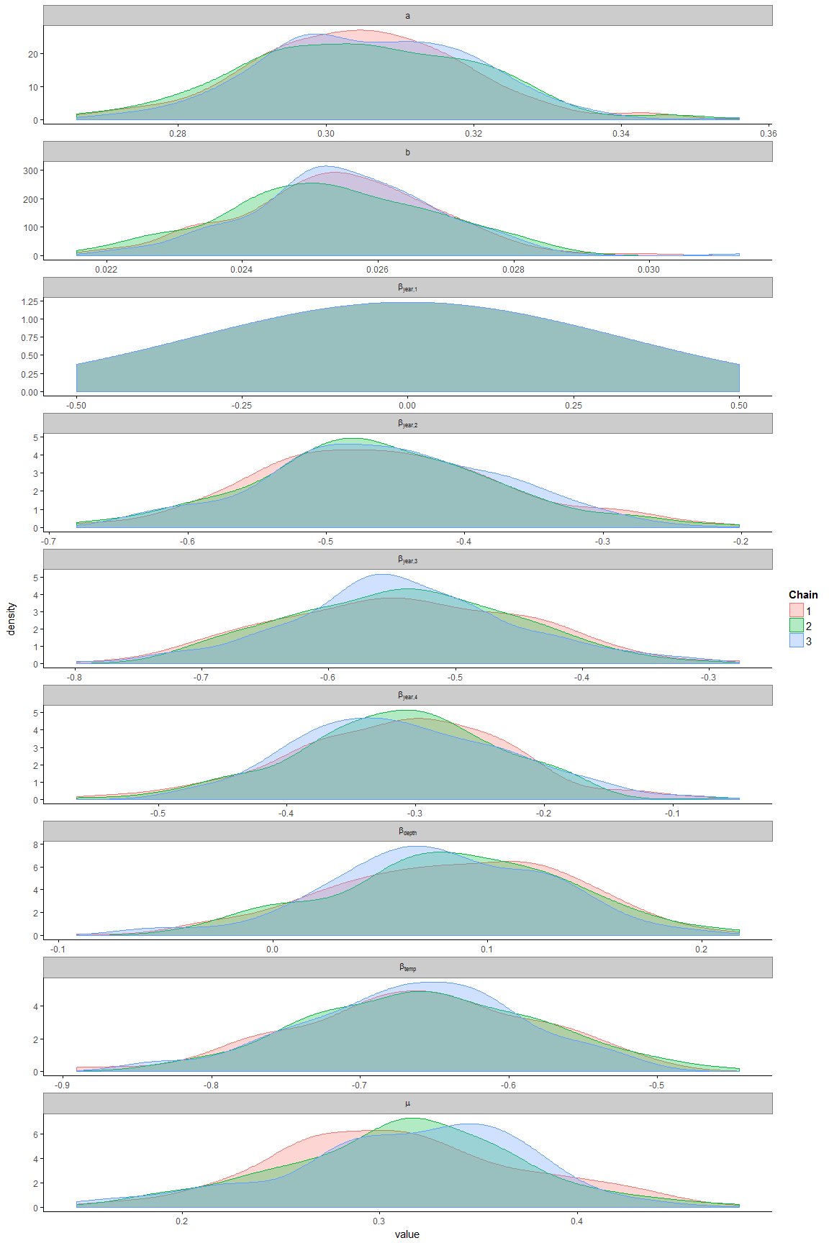

A4– 6 English sole

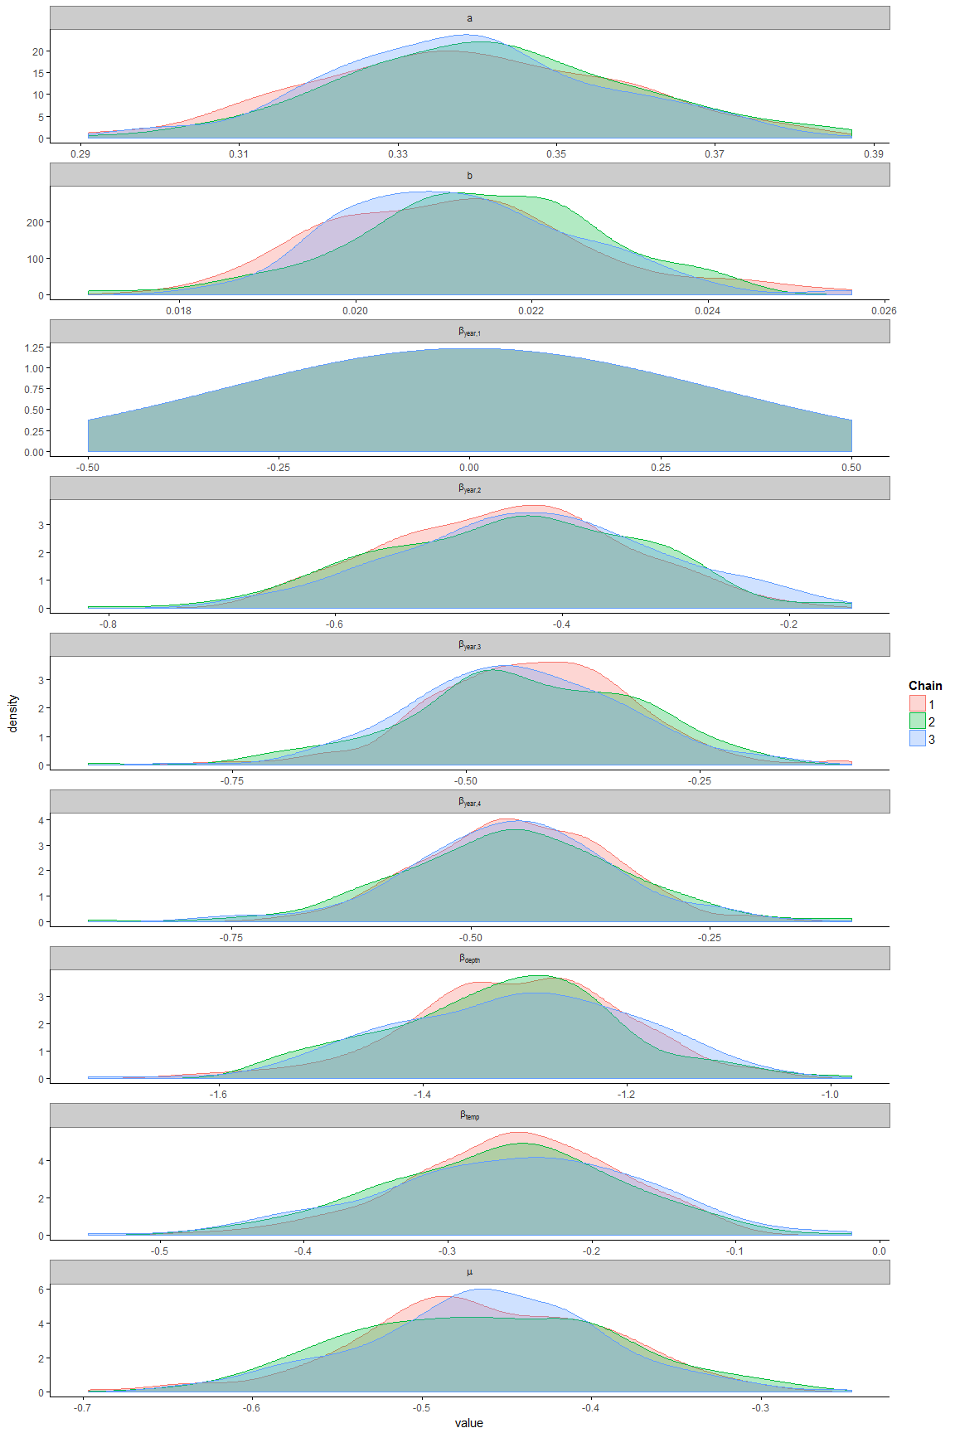

A4- 6 Greenstripe rockfish

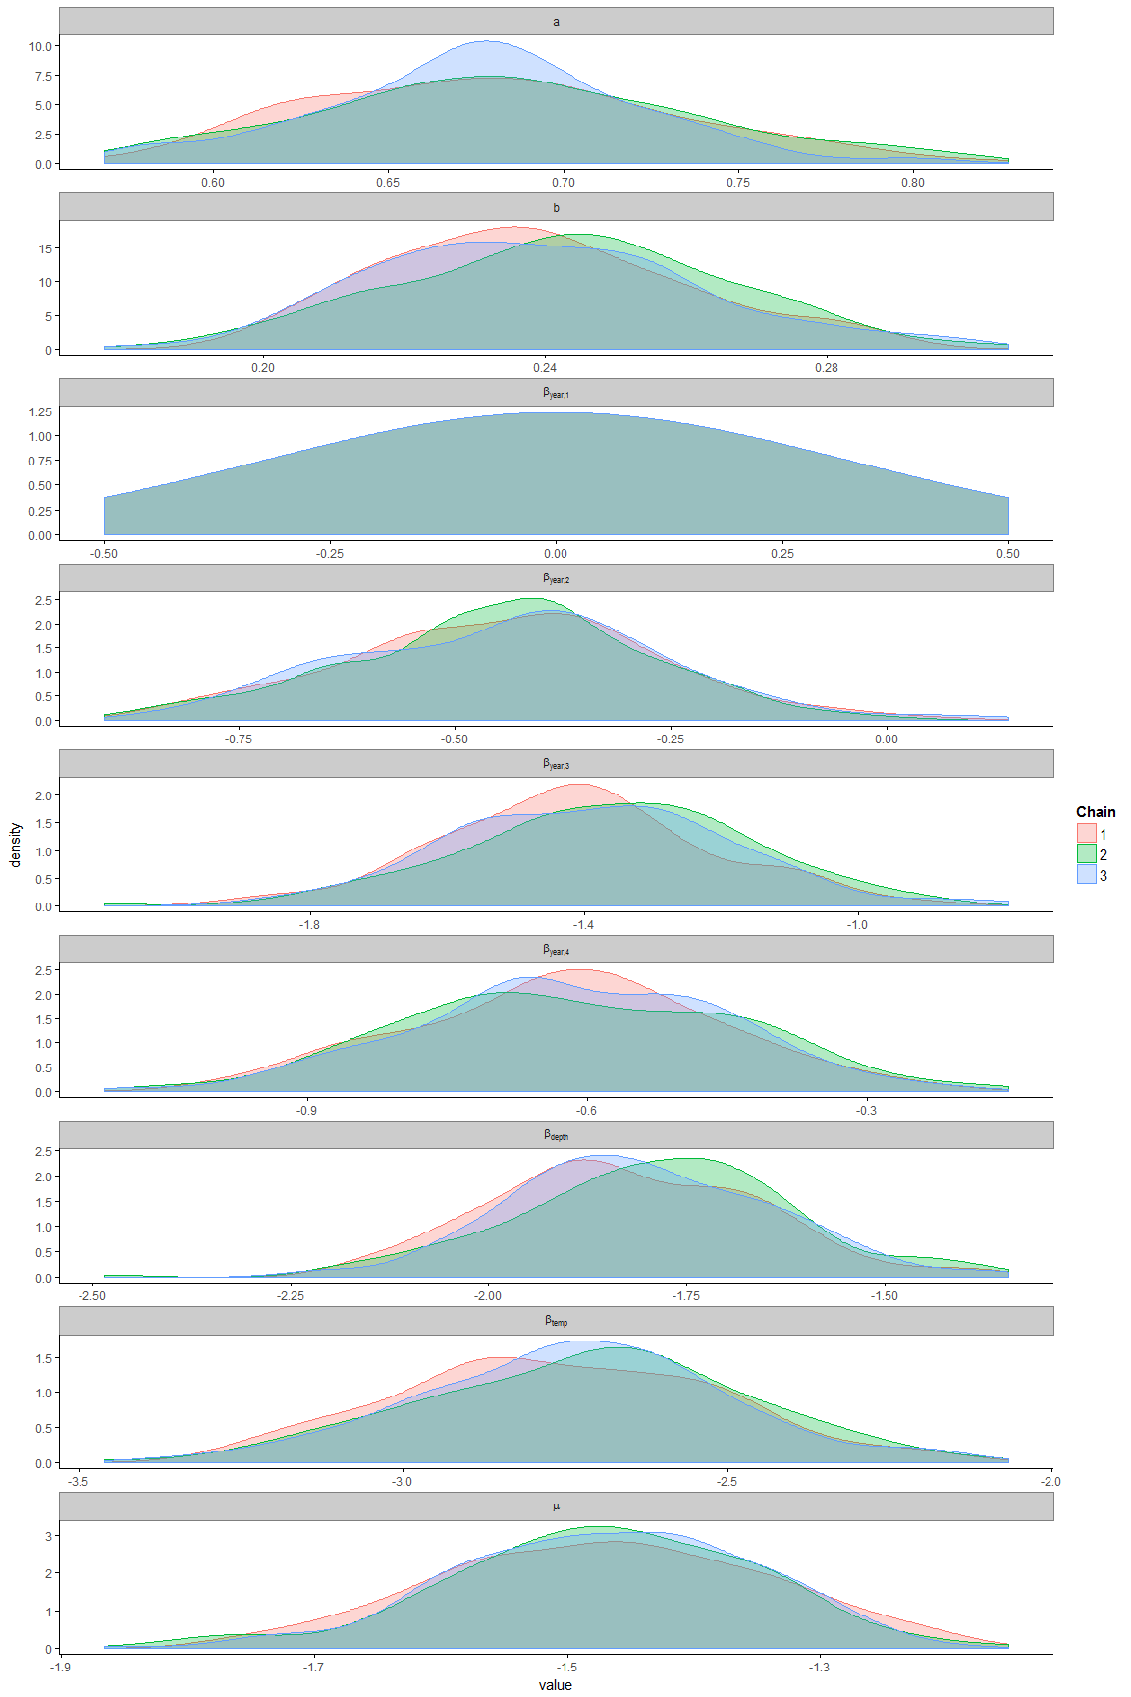

A4- 8 Pacific cod

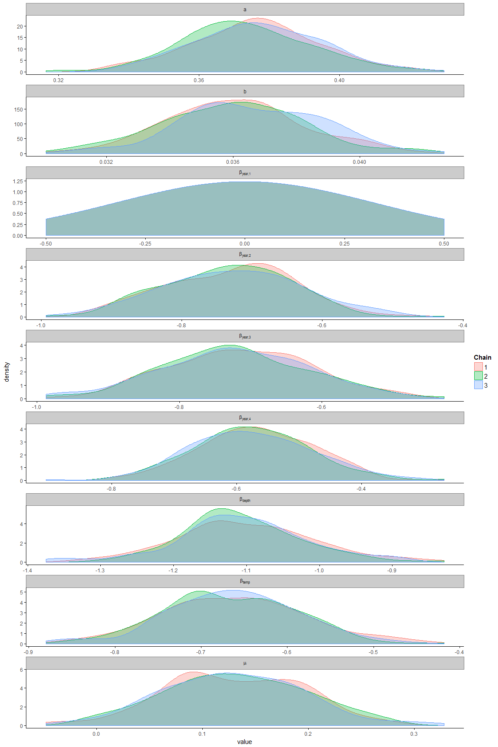

*A4- 9 Petrale sole*

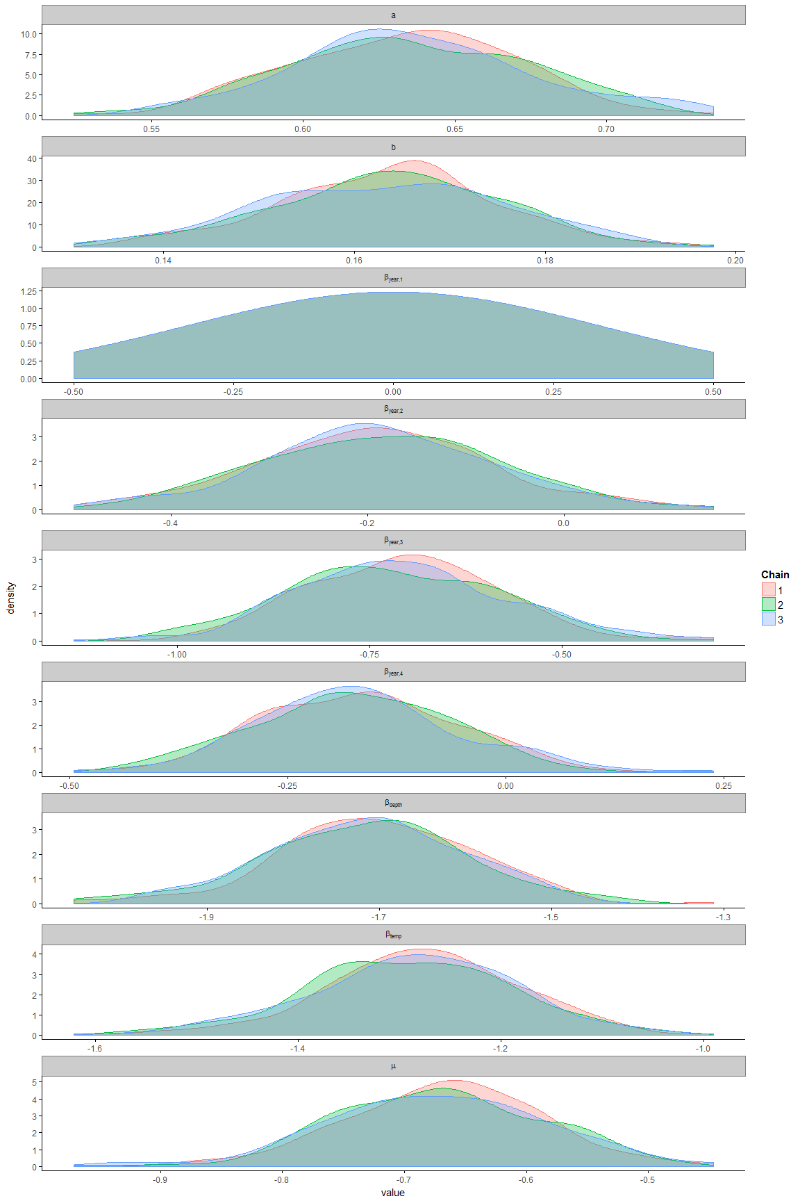

A4 -10 Pacific Ocean perch

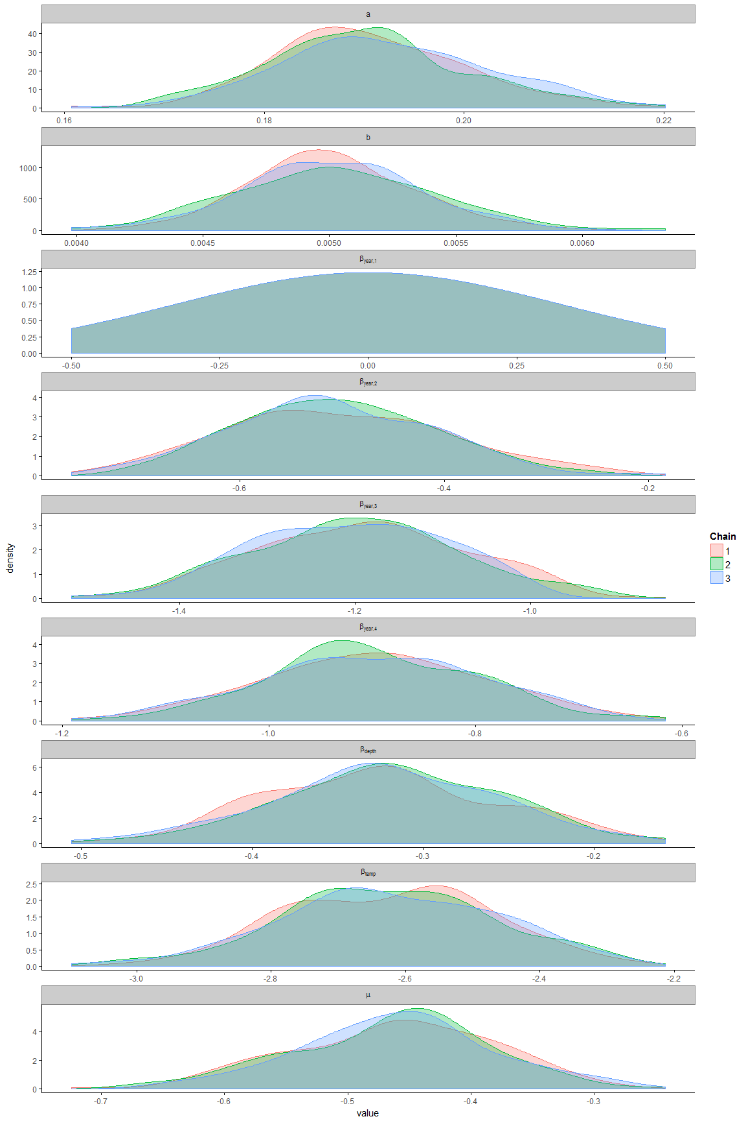

*A4- 11 Spotted ratfish*

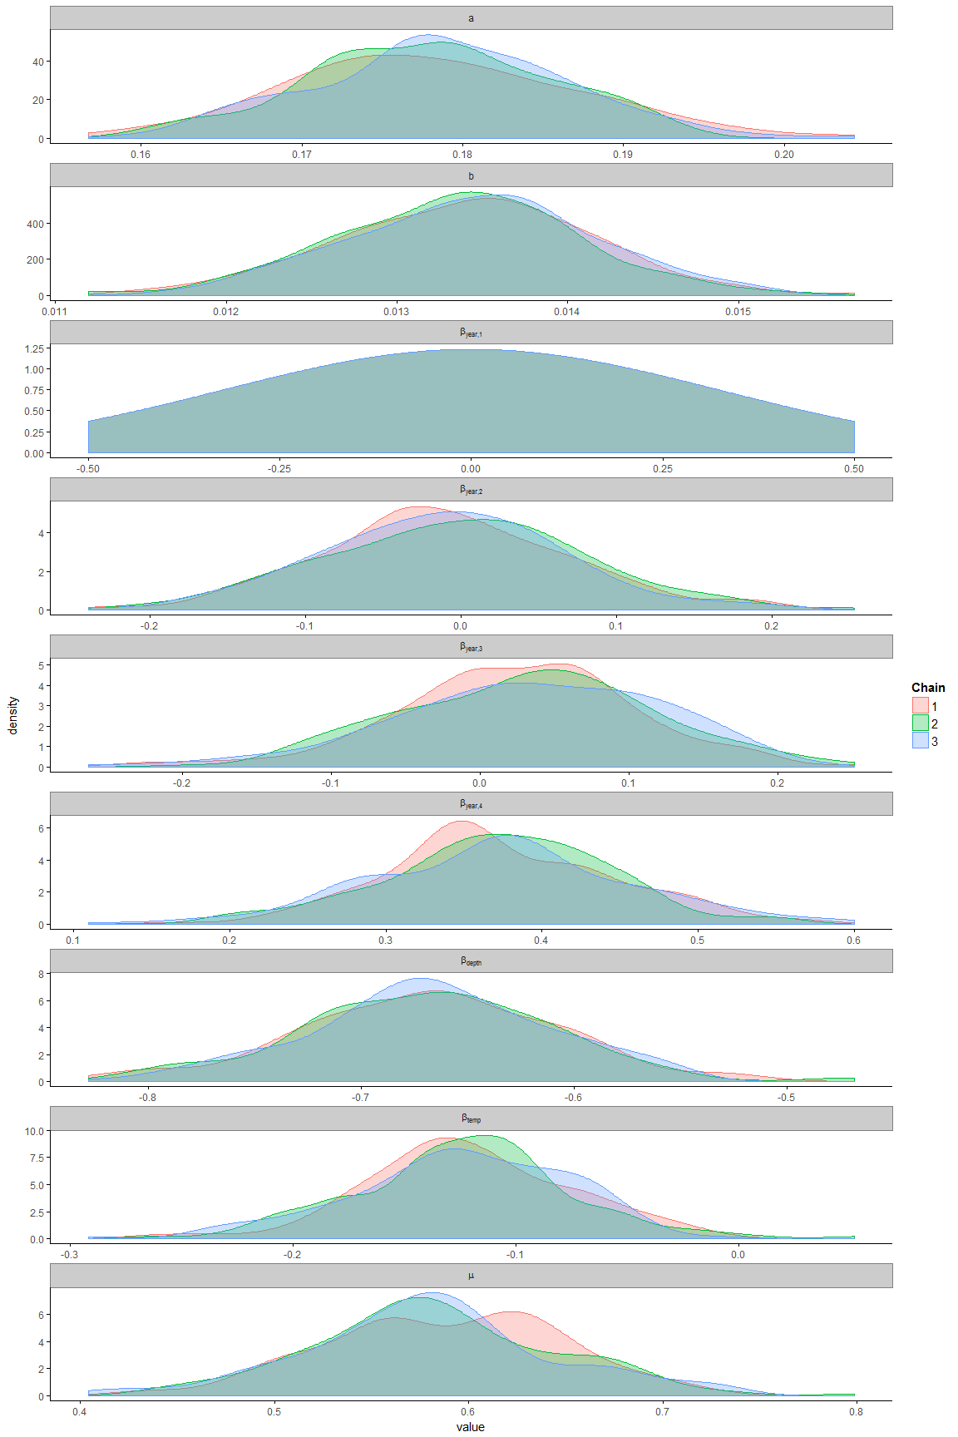

A4- Redstripe rockfish

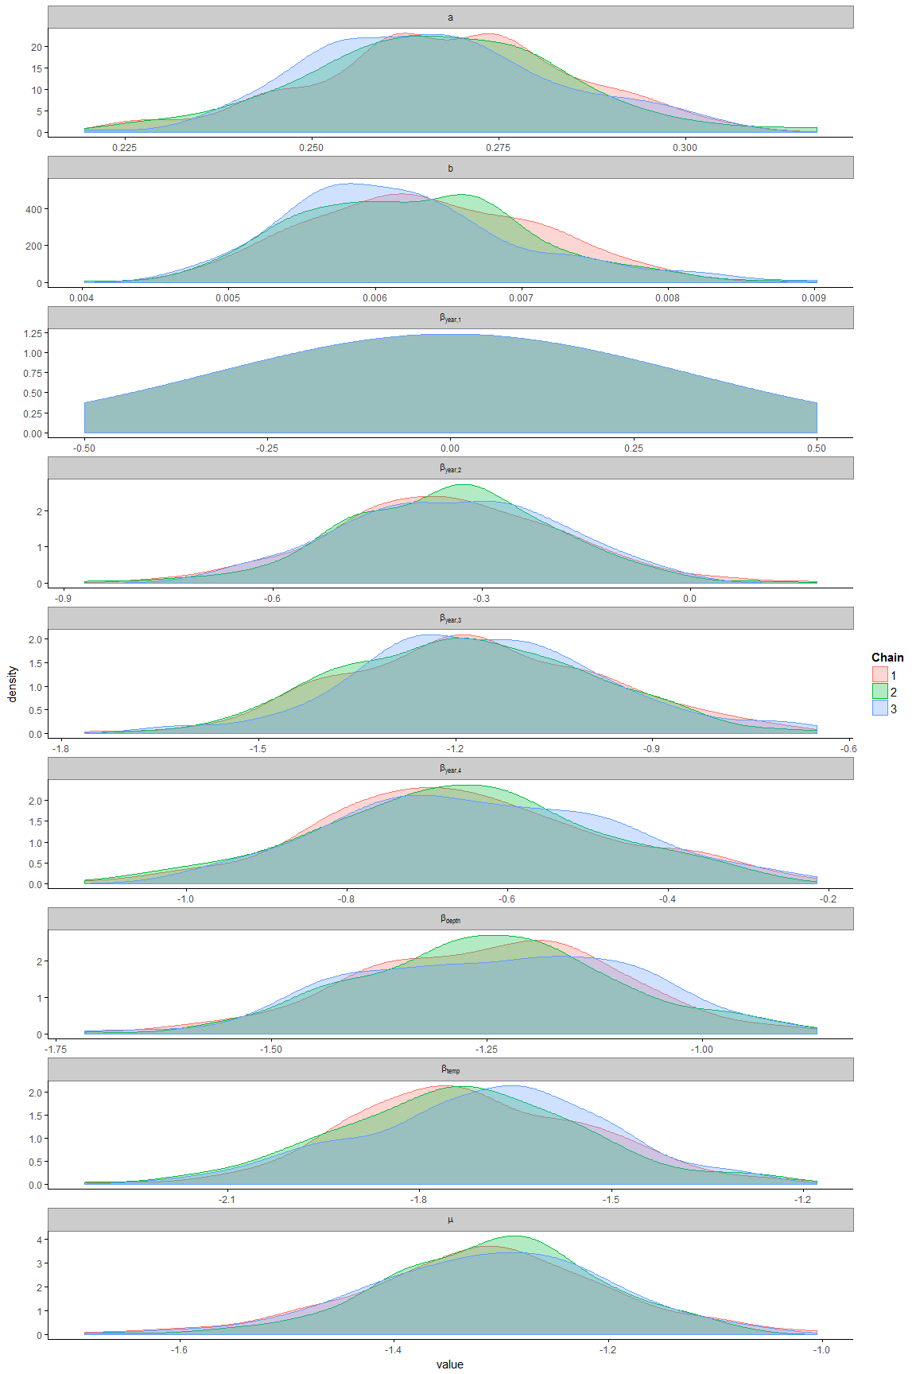

A4- 13 Rex sole

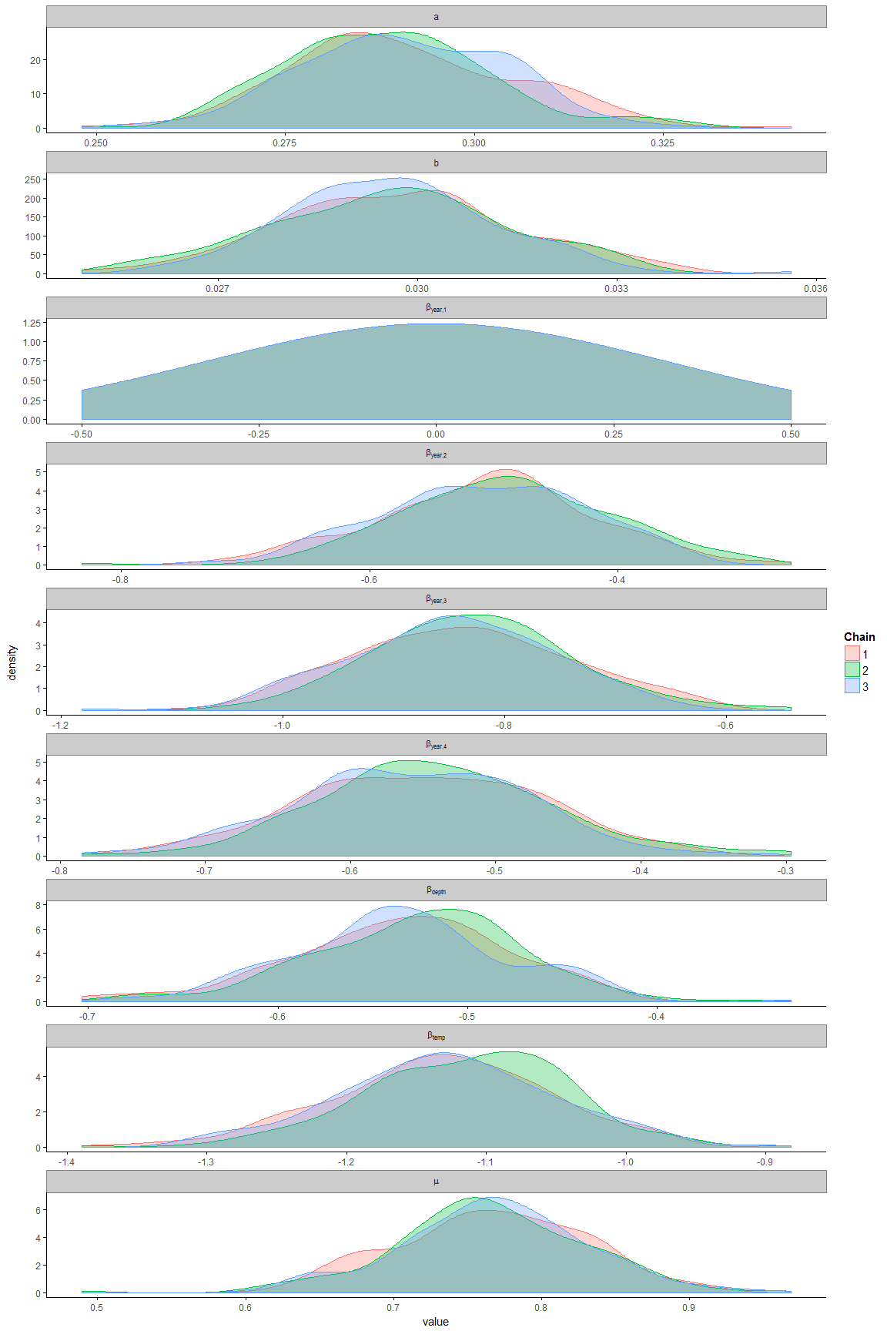

A4- 14 Rock sole

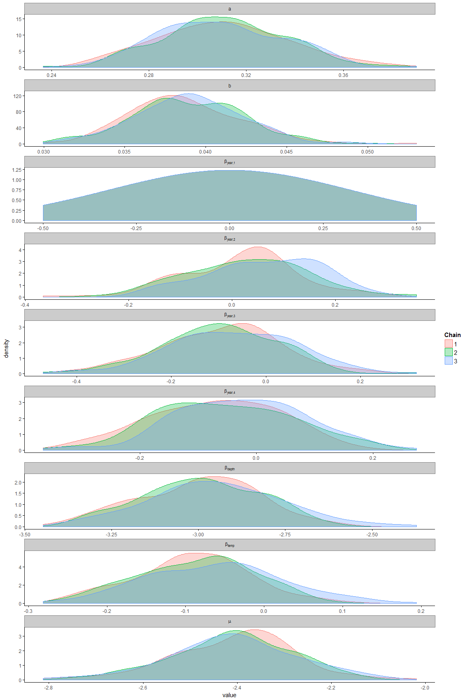

A4 - 15 Sablefish

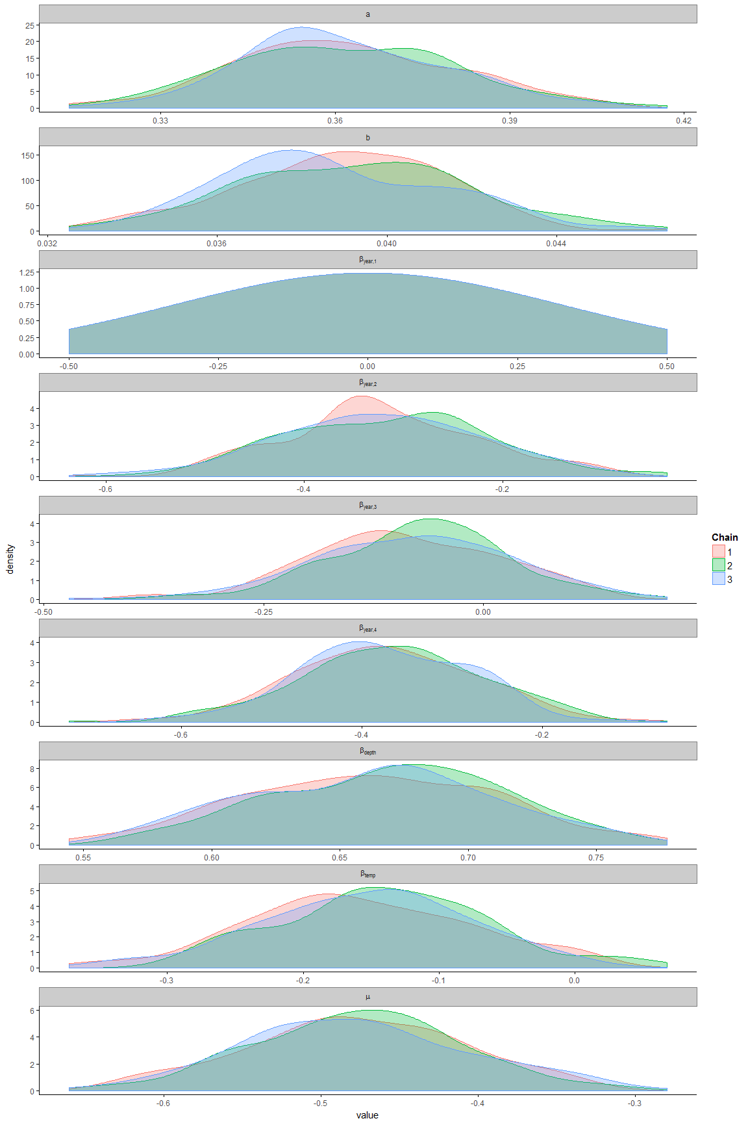

A4- 16 Silvergray rockfish

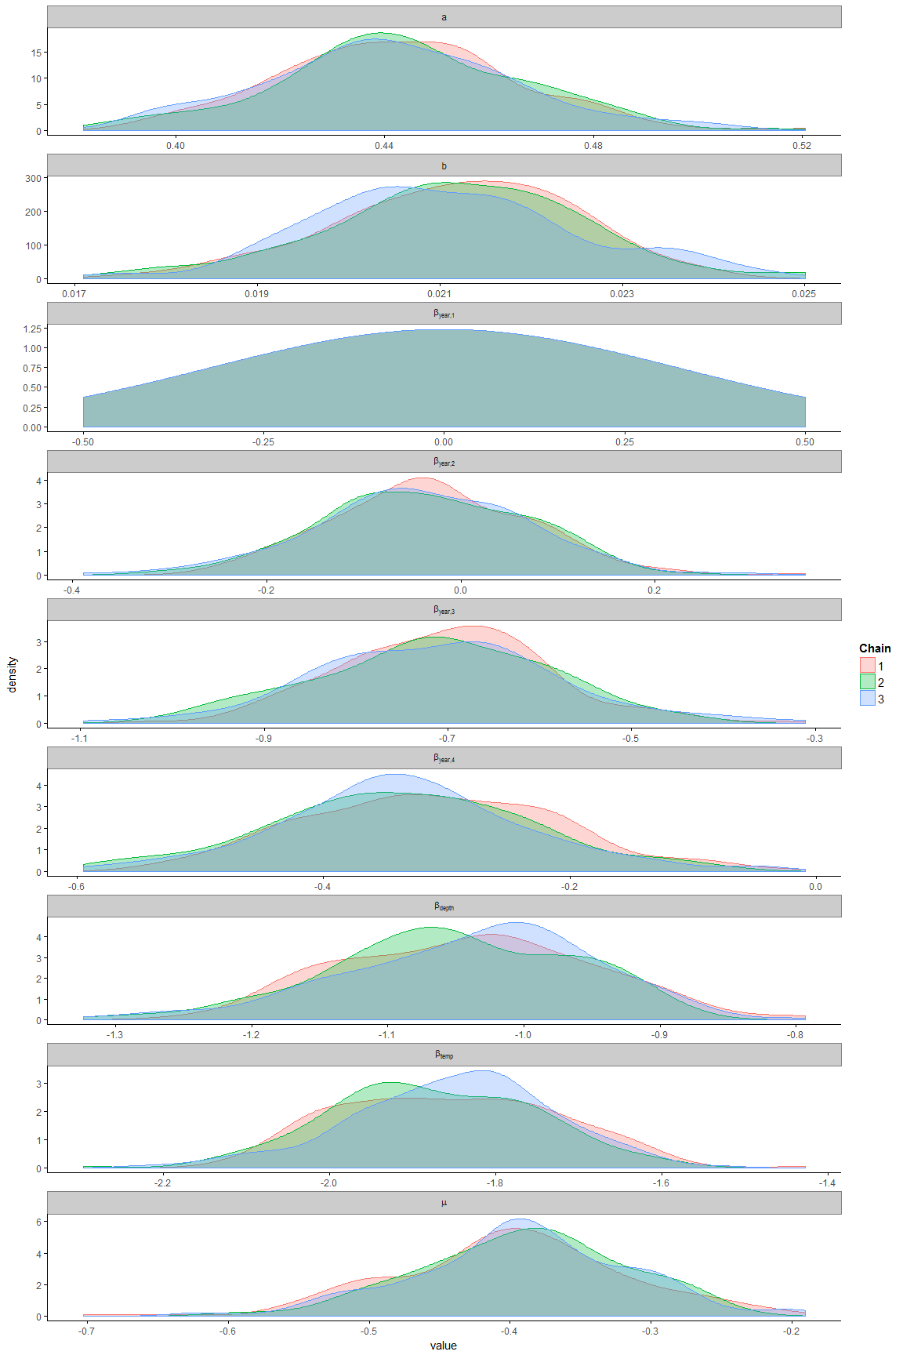

A4- 17 Shortspine thornyhead

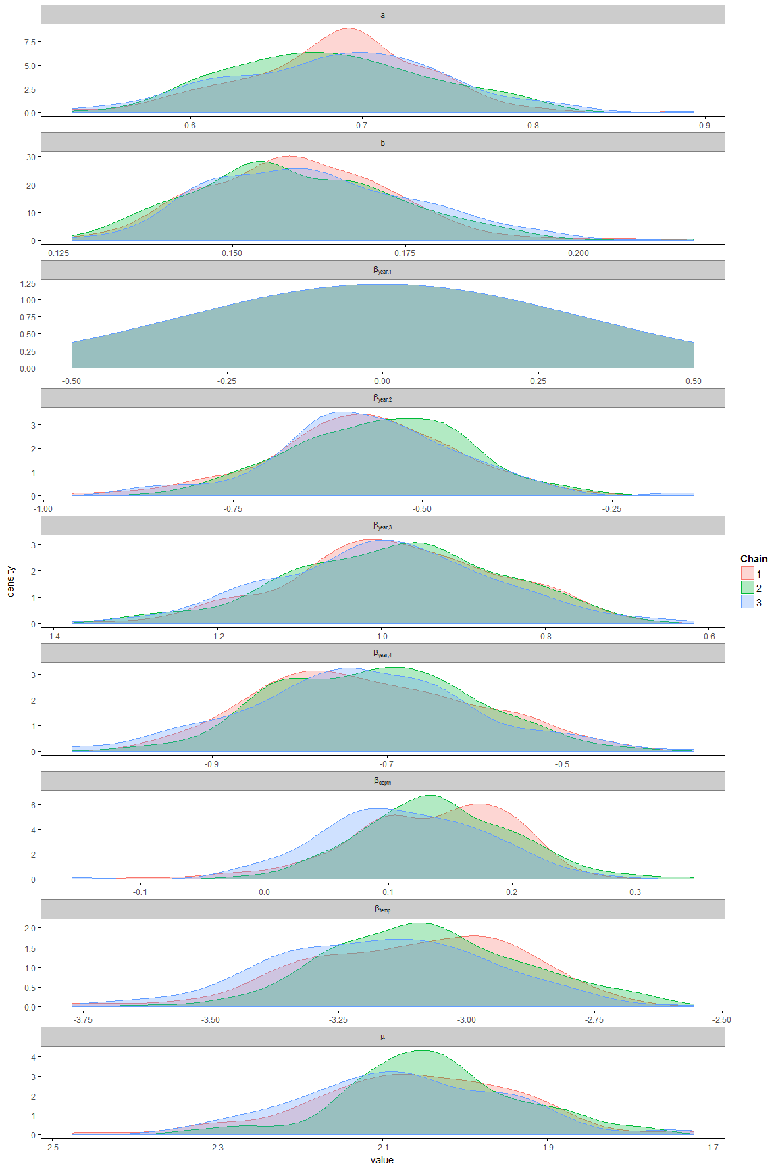

A4 - 18 Widow rockfish

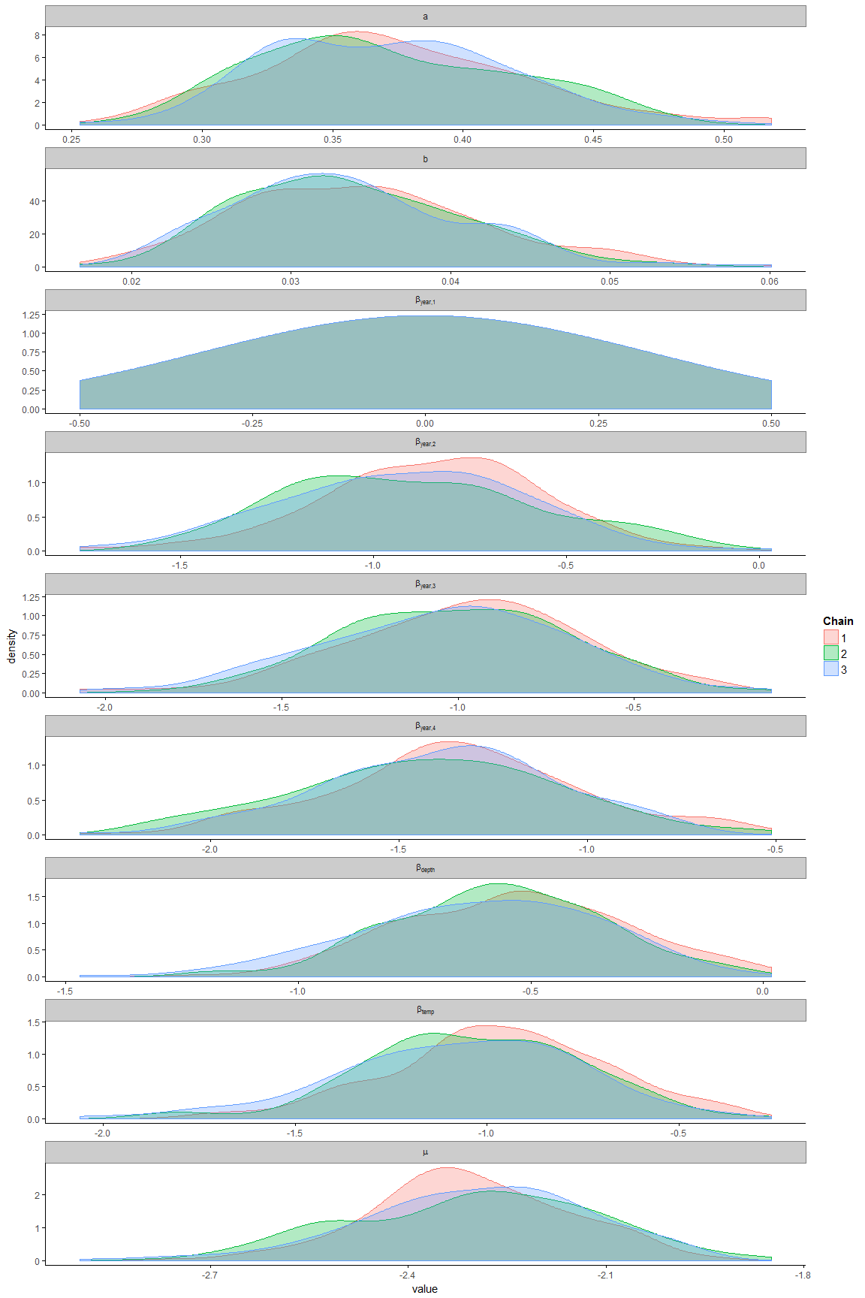

## 

## Appendix 5: Pairs plot of posterior distributions of model's hyper-parameters

A5- 1 Arrowtooth Flounder

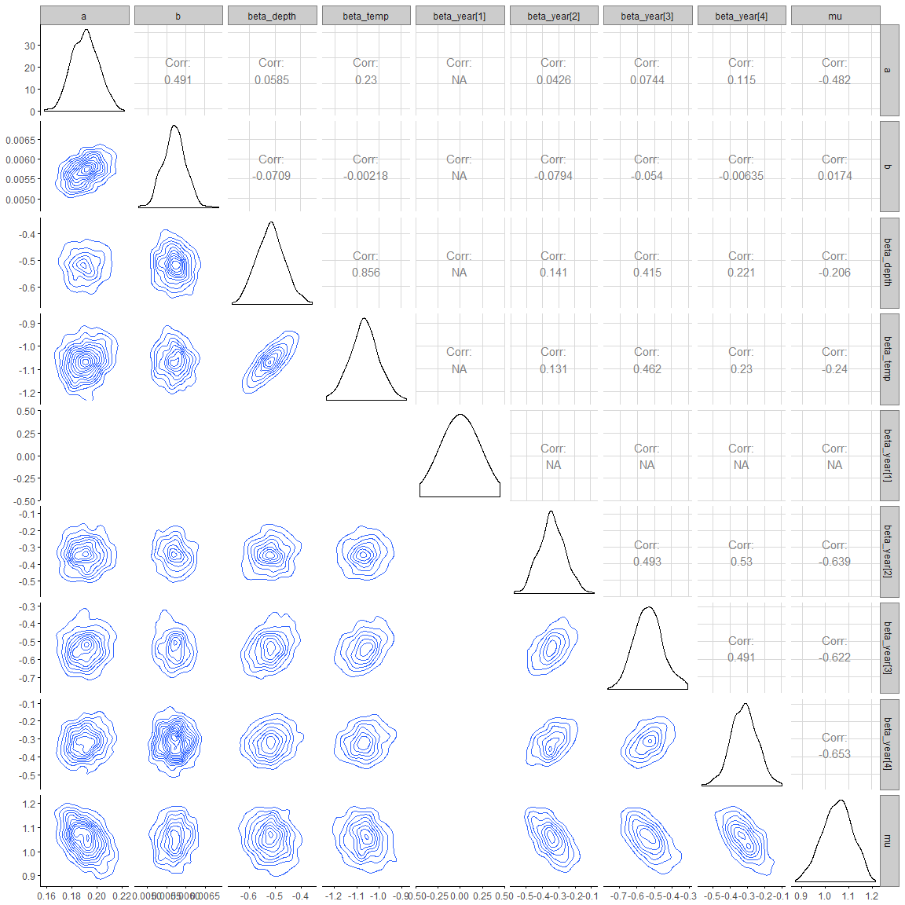

A5 -2 Bocaccio

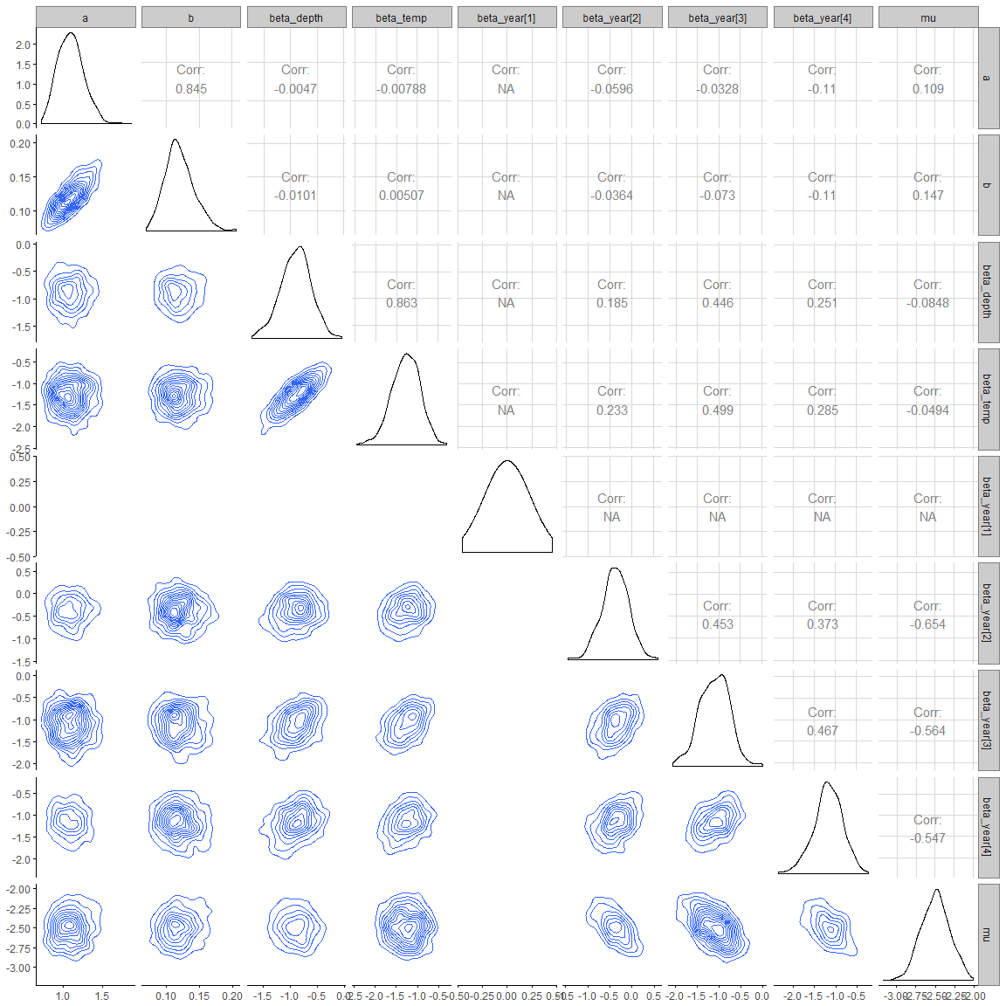

A5- 3 Canary Rockfish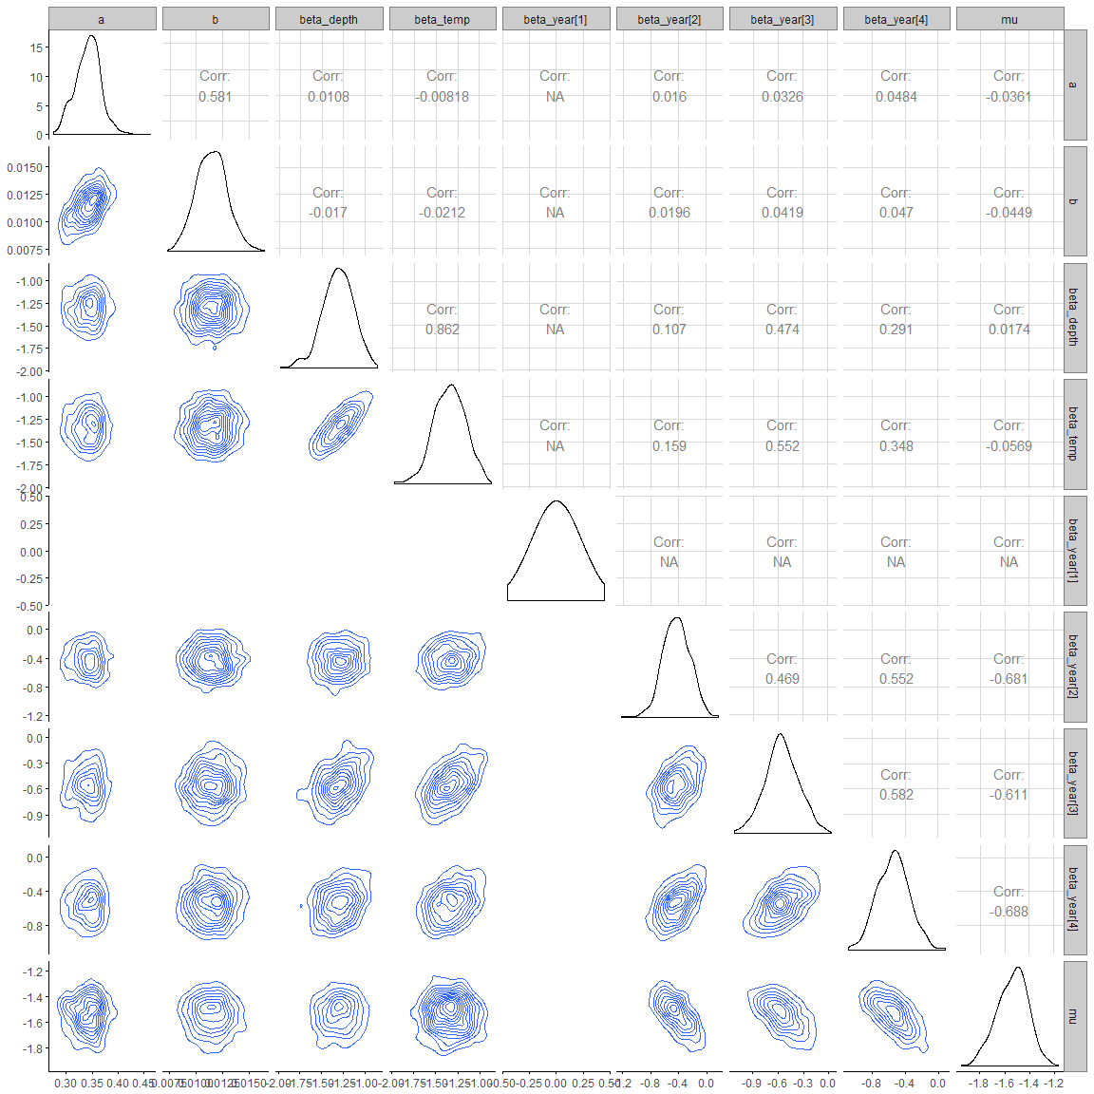

A5 -4 Dogfish

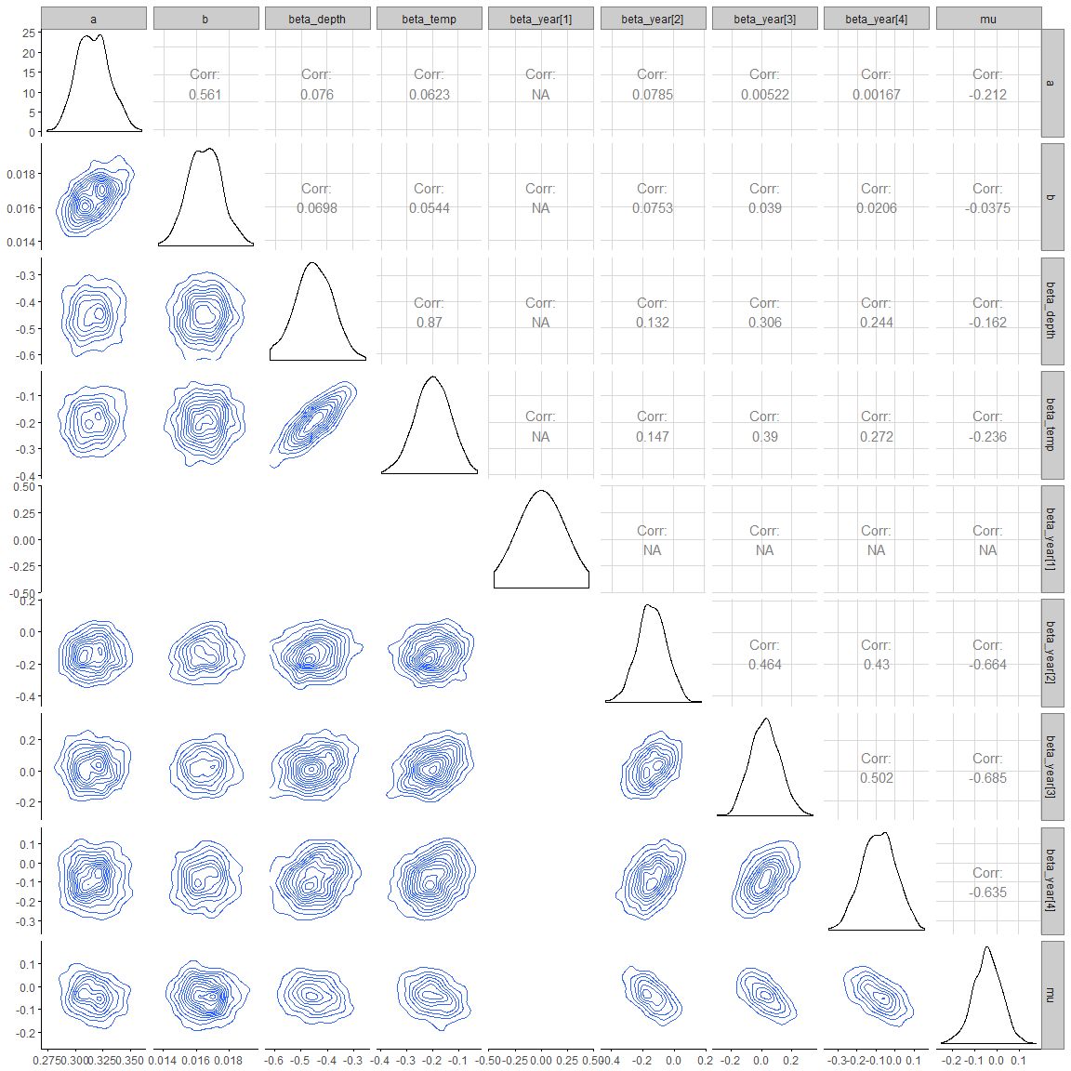

A5 -5 Dover sole

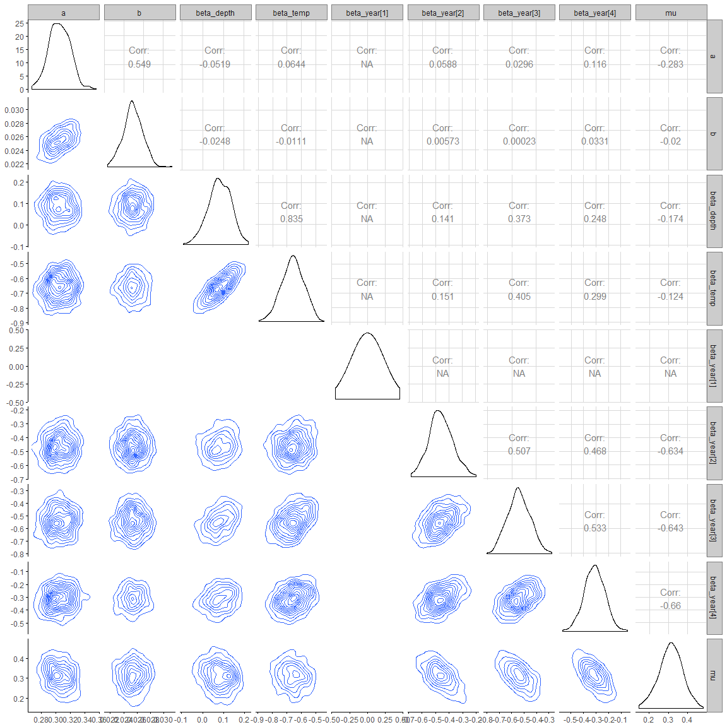

A5 – 6 English sole

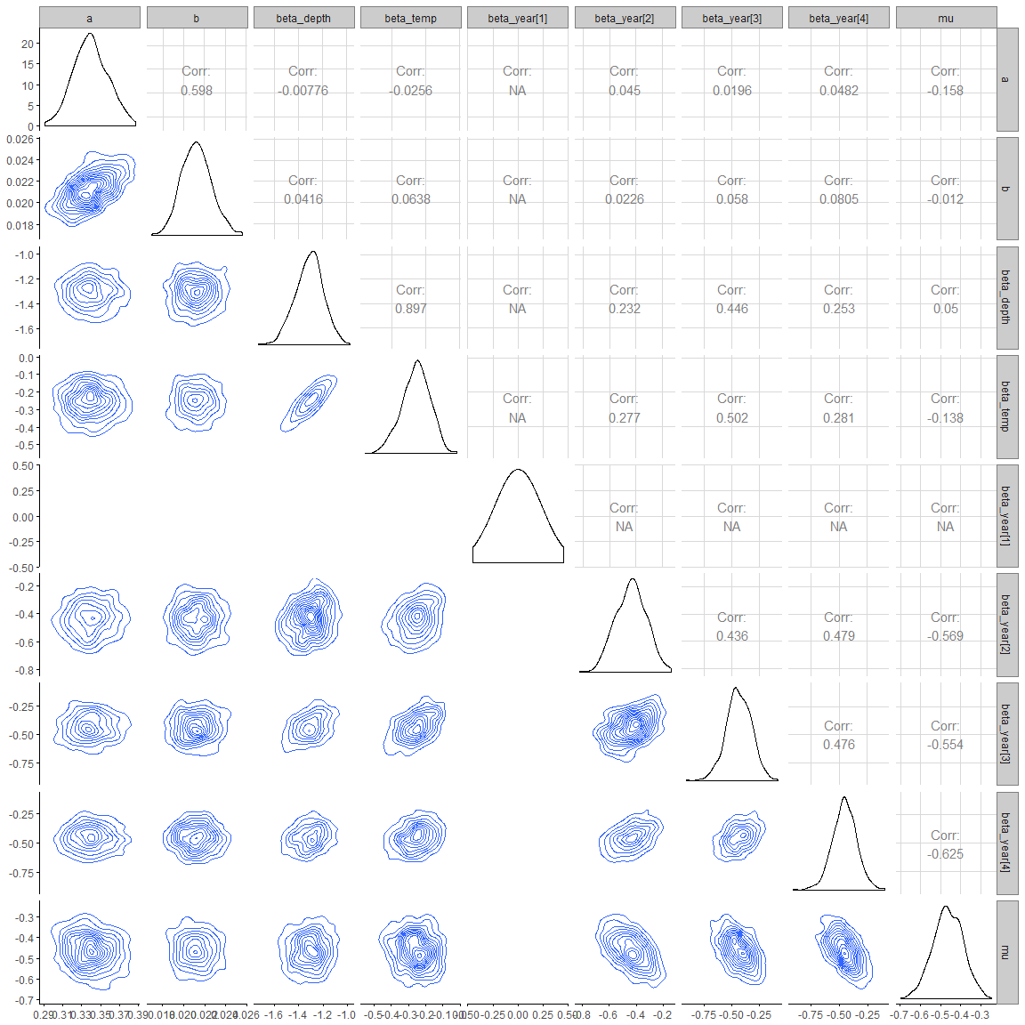

A5- 6 Greenstripe rockfish

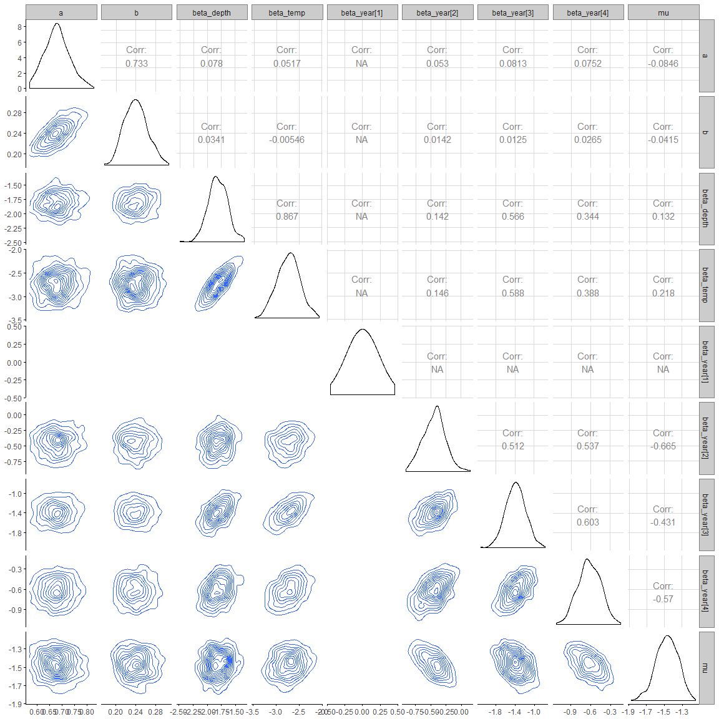

A5- 8 Pacific cod

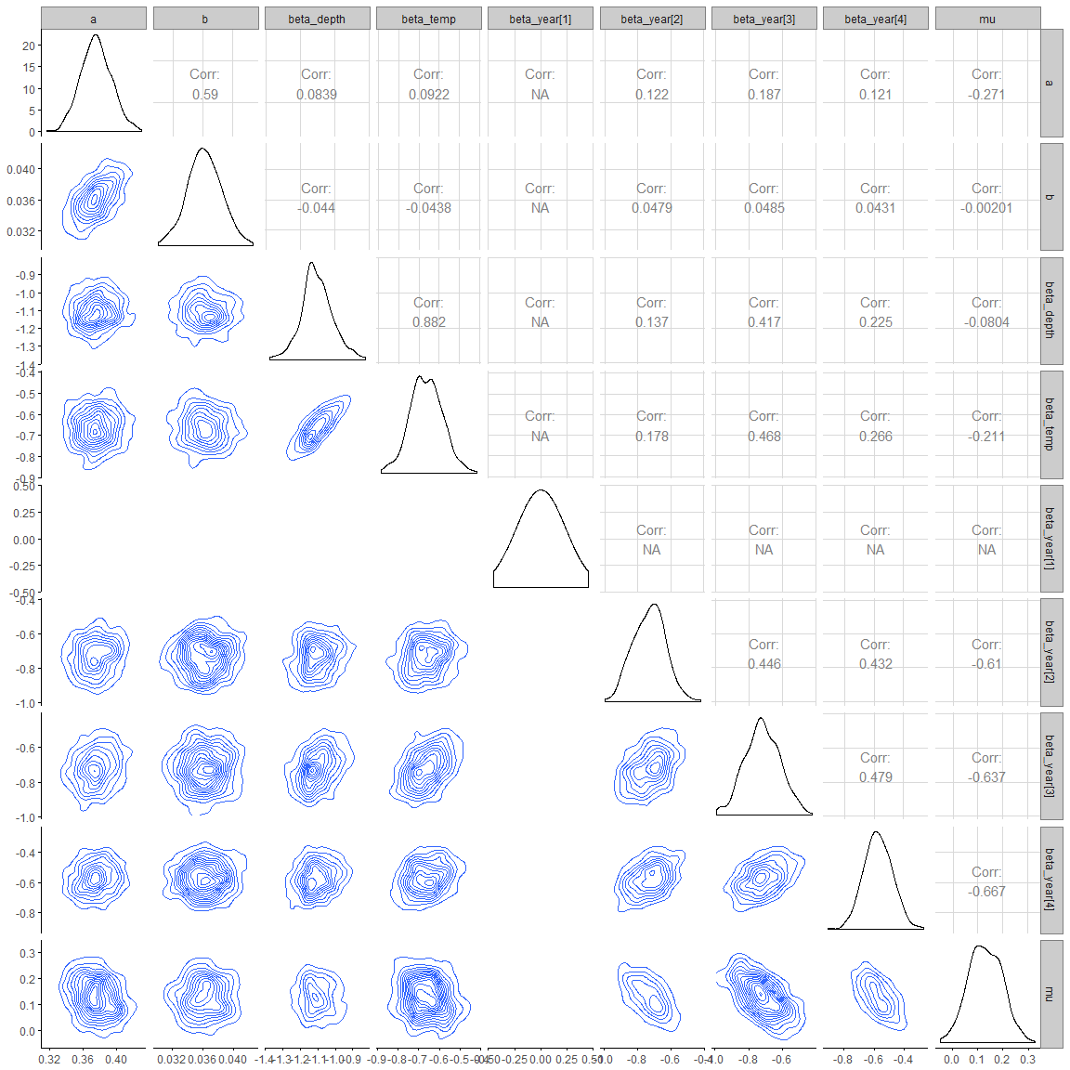

*A5- 9 Petrale sole*

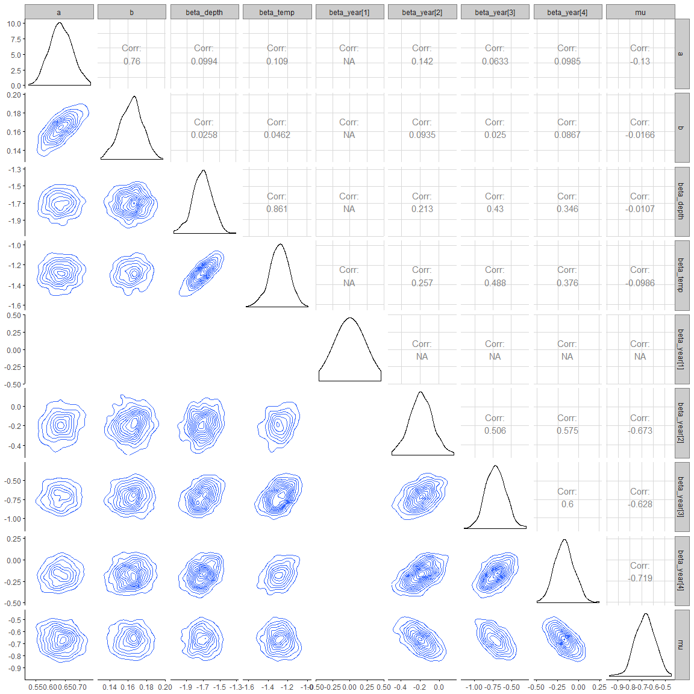

A5 -10 Pacific Ocean perch

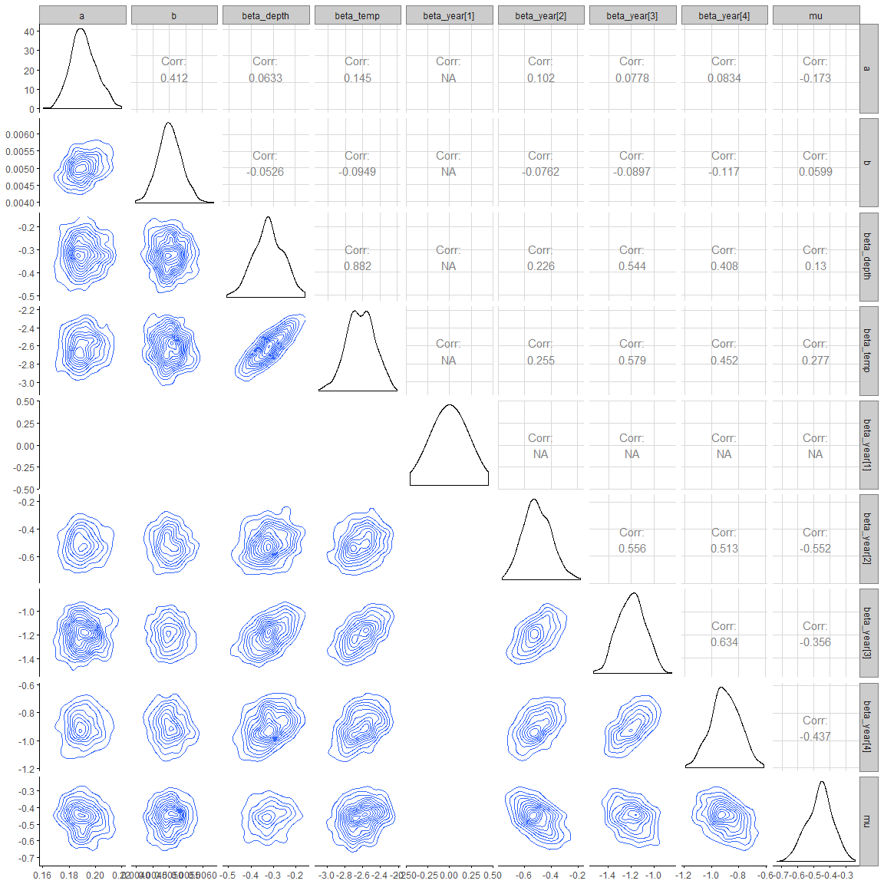

*A5- 11 Spotted ratfish*

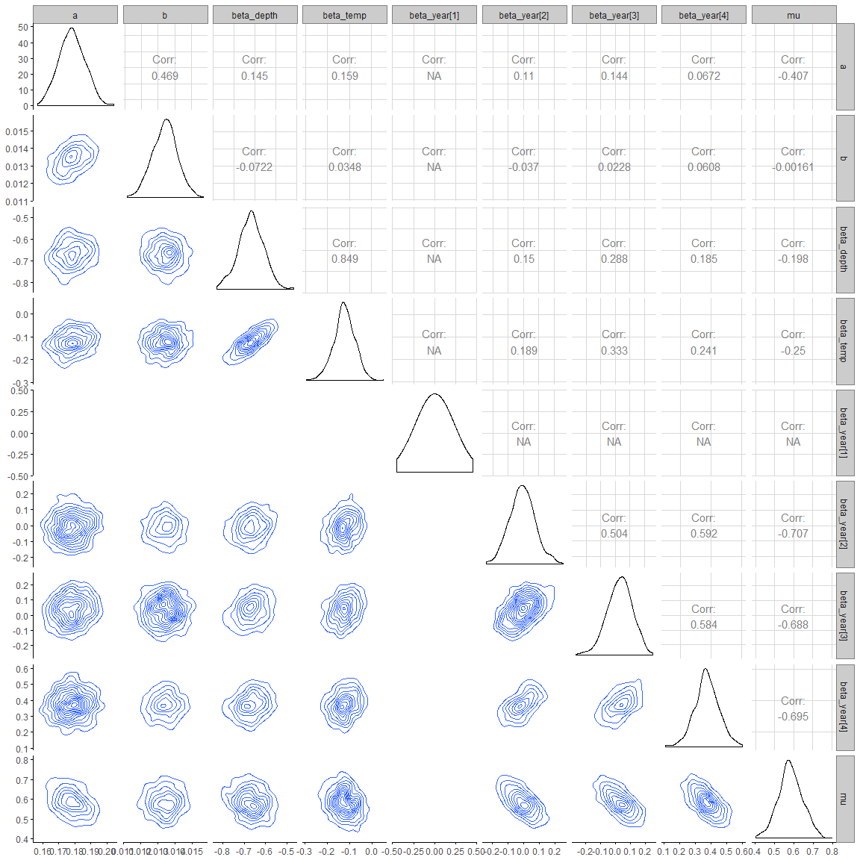

A5- Redstripe rockfish

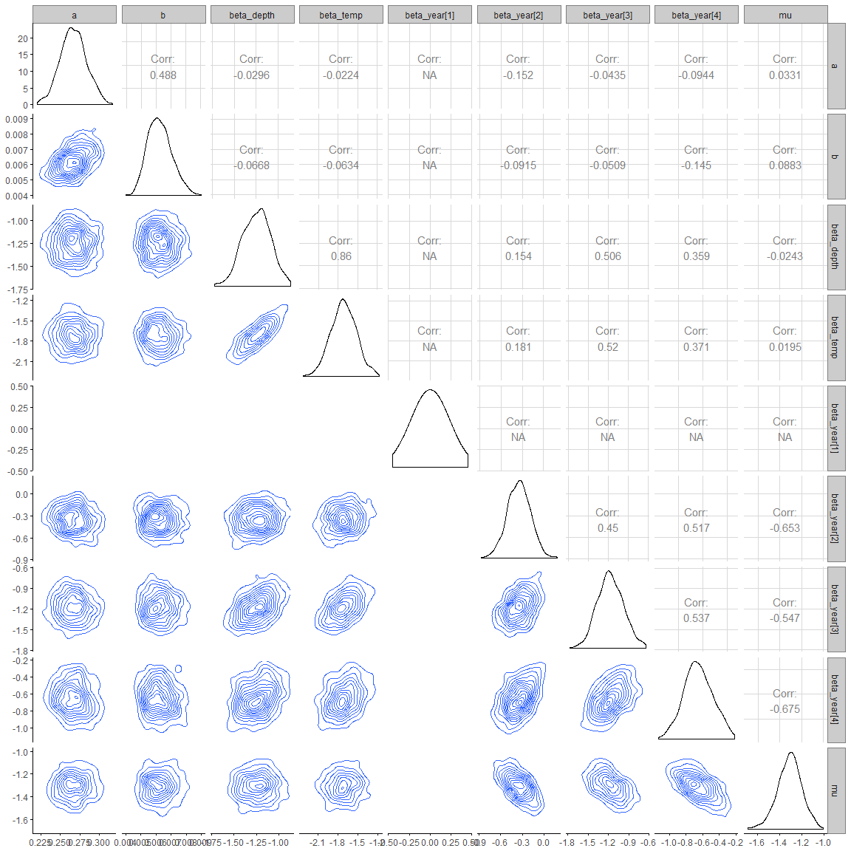

A5- 13 Rex sole

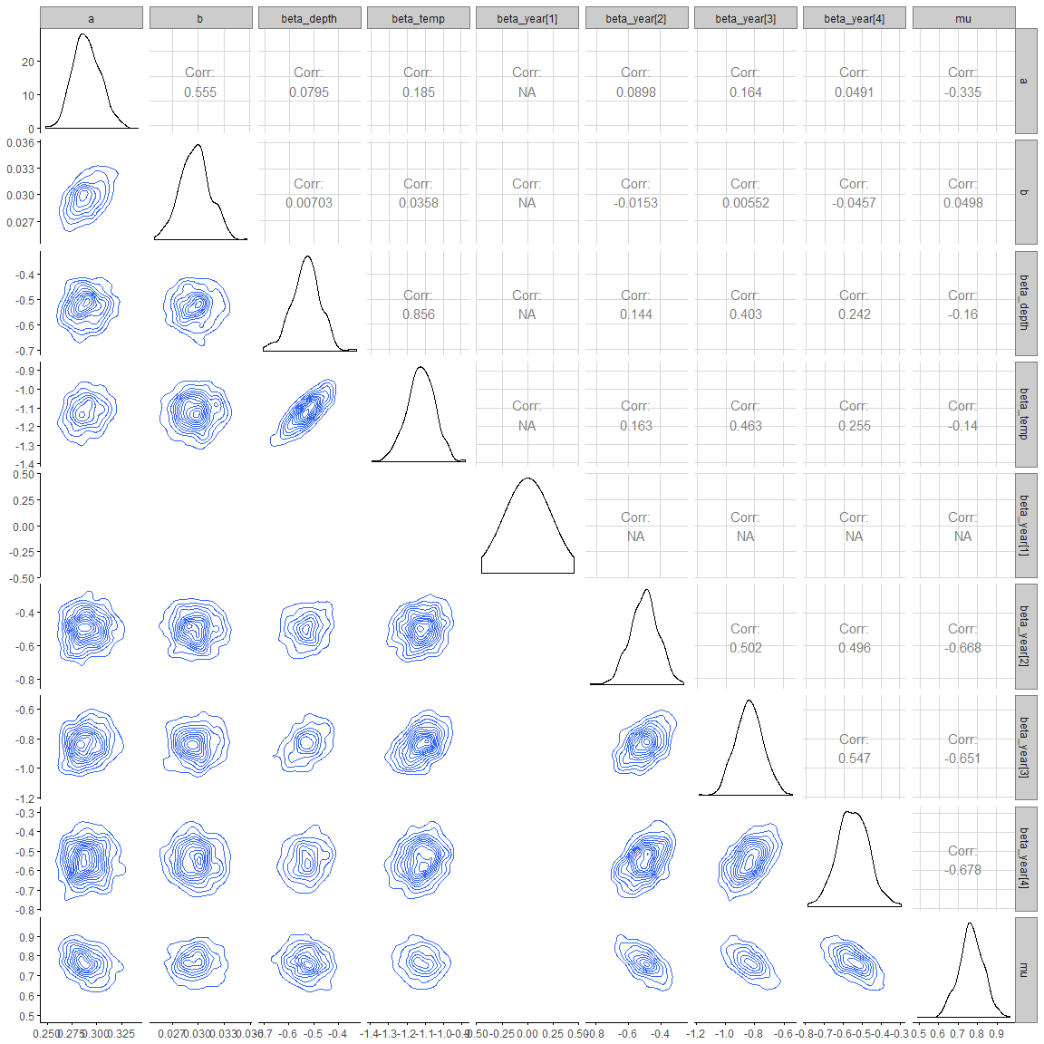

A5- 14 Rock sole

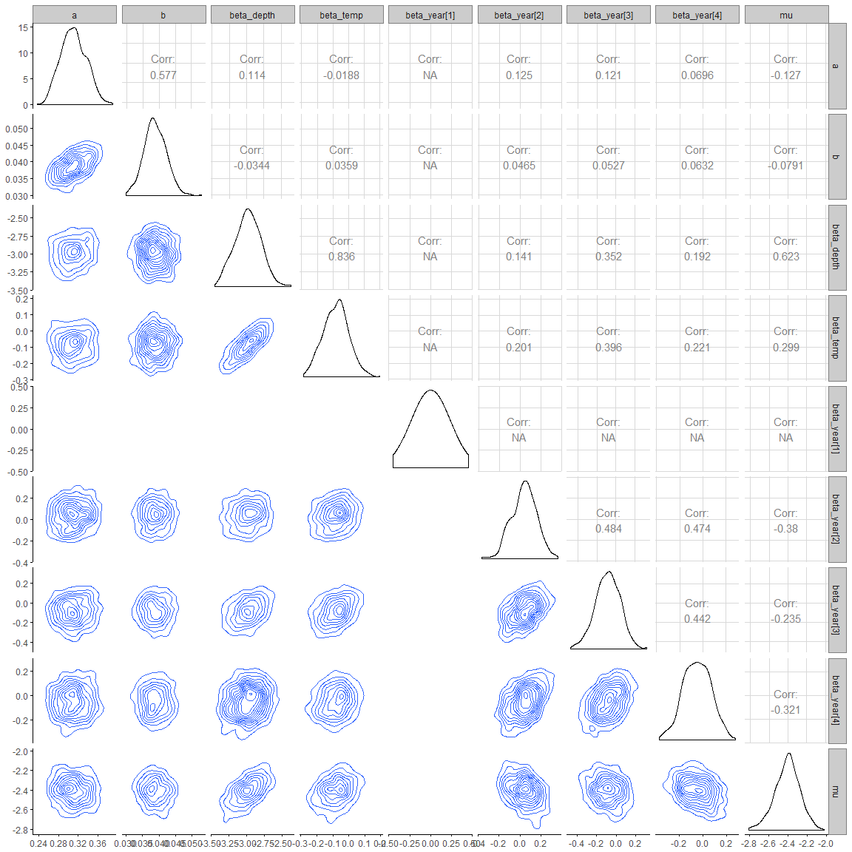

A5 - 15 Sablefish

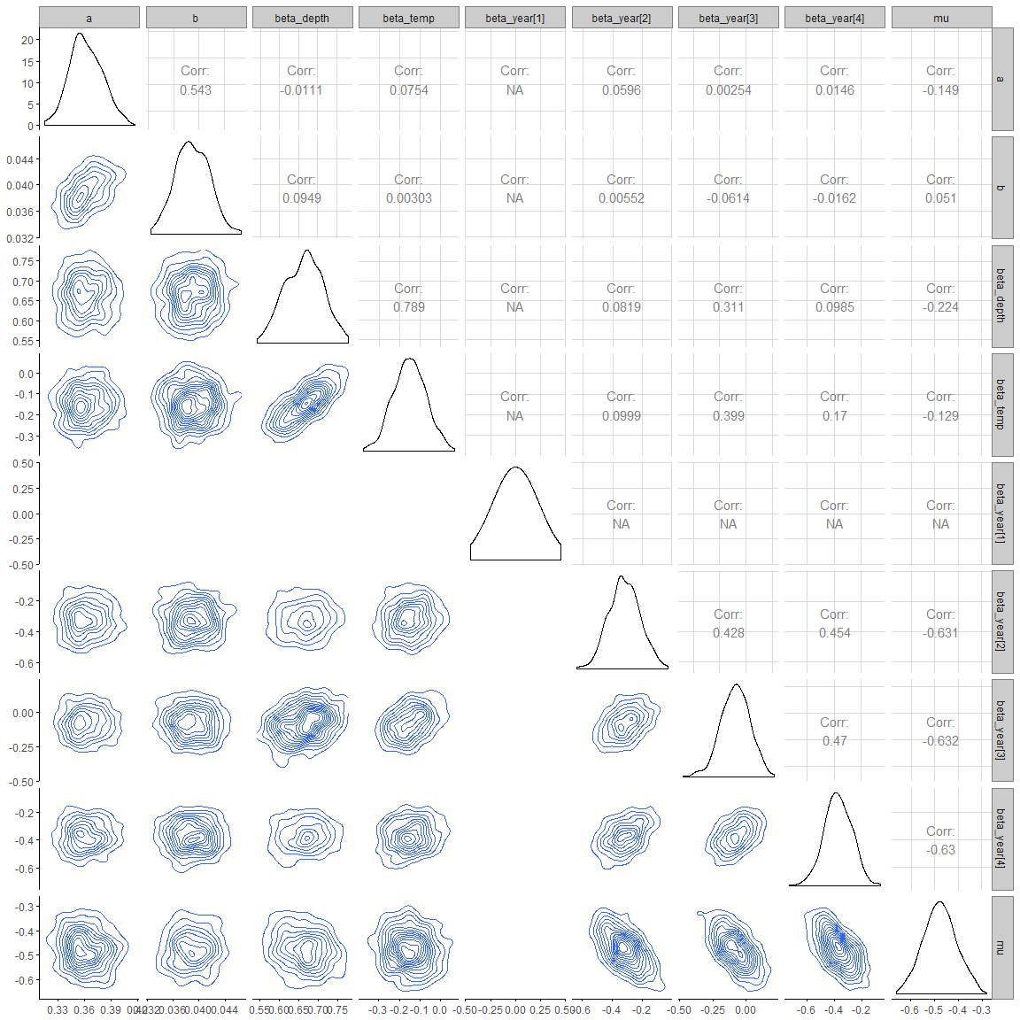

A5- 16 Silvergray rockfish

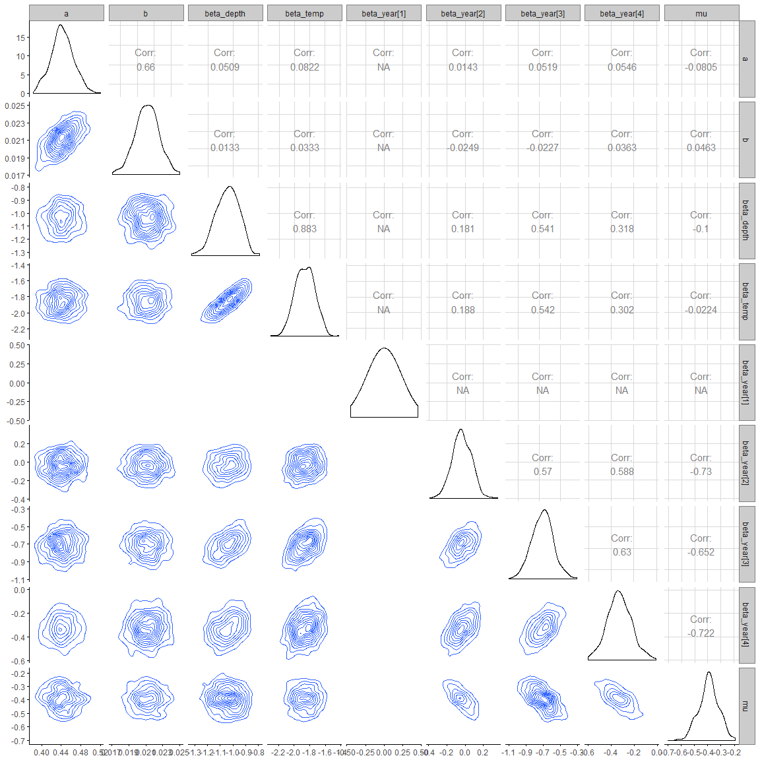

A5- 17 Shortspine thornyhead

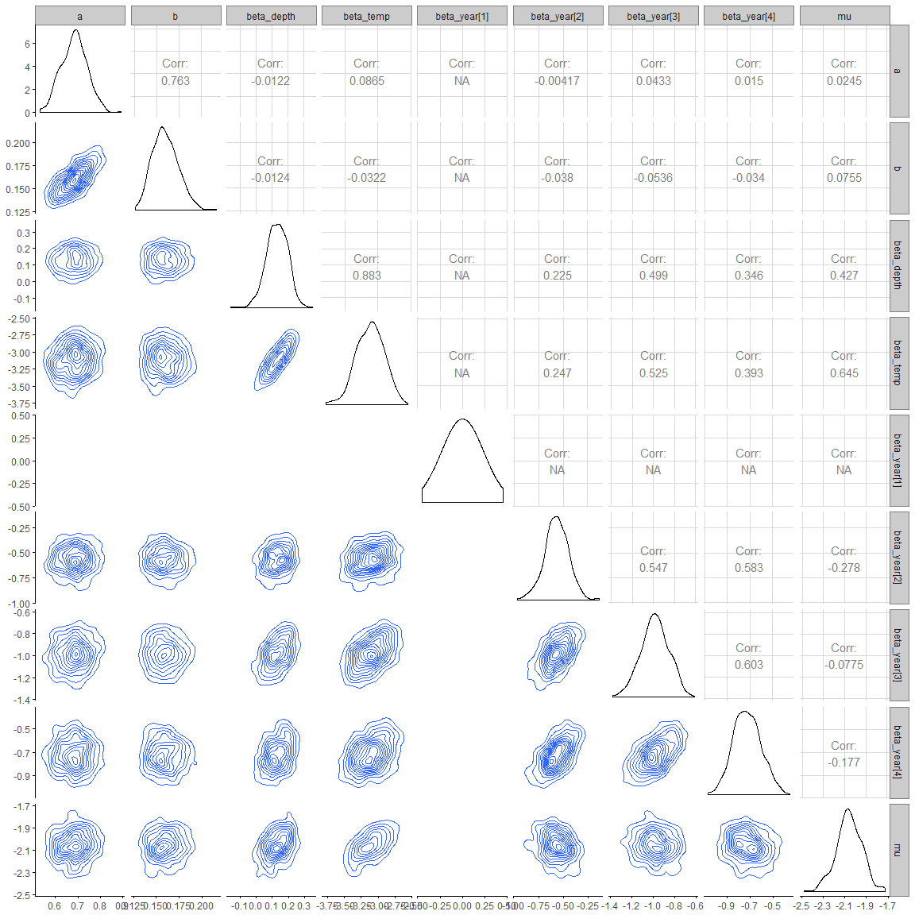

A5 - 18 Widow rockfish

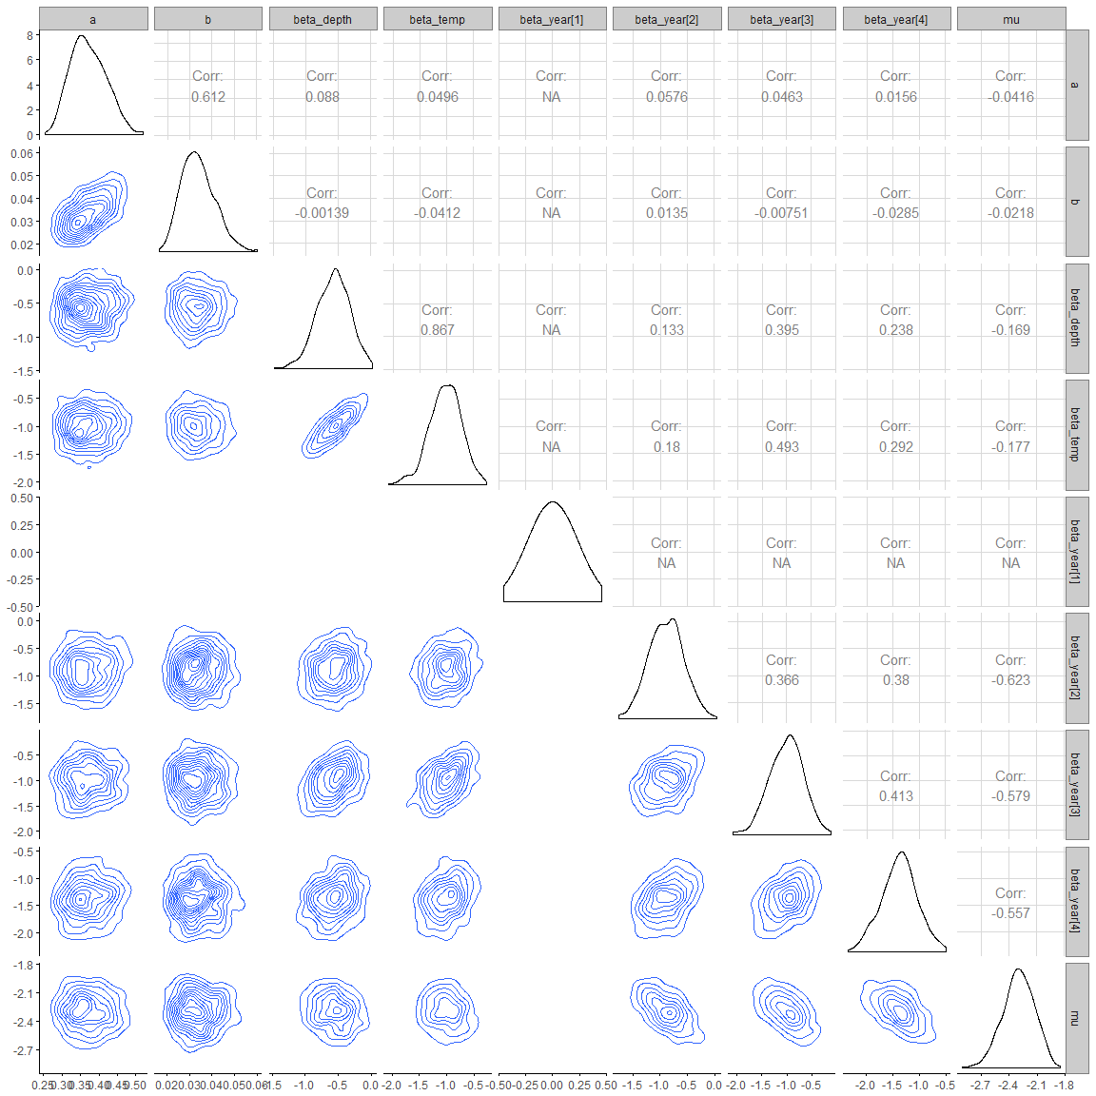

Appendix 6: Model parameters and estimates for each species. Mean, standard deviation (sd), quantile at 2.5% (q2.5), median and quantile at 97.5% (q97.5)

## *A6 – 1 Arrowtooth flounder*

|  |  |  |  |  |  |
| --- | --- | --- | --- | --- | --- |
| Parameter | mean | sd | q2.5 | median | q97.5 |
|  | 0.191 | 0.011 | 0.171 | 0.191 | 0.212 |
|  | 0.006 | 0.000 | 0.005 | 0.006 | 0.006 |
|  | -0.517 | 0.053 | -0.620 | -0.517 | -0.404 |
|  | -1.066 | 0.064 | -1.193 | -1.068 | -0.945 |
|  | 0.000 | 0.000 | 0.000 | 0.000 | 0.000 |
|  | -0.341 | 0.078 | -0.482 | -0.344 | -0.186 |
|  | -0.533 | 0.082 | -0.680 | -0.534 | -0.354 |
|  | -0.319 | 0.075 | -0.473 | -0.320 | -0.173 |
|  | 1.051 | 0.063 | 0.926 | 1.053 | 1.164 |

A6- 2 Bocaccio

|  |  |  |  |  |  |
| --- | --- | --- | --- | --- | --- |
| Parameter | mean | sd | q2.5 | median | q97.5 |
|  | 1.099 | 0.168 | 0.808 | 1.089 | 1.440 |
|  | 0.121 | 0.022 | 0.081 | 0.118 | 0.166 |
|  | -0.897 | 0.276 | -1.486 | -0.884 | -0.378 |
|  | -1.279 | 0.331 | -1.946 | -1.264 | -0.662 |
|  | 0.000 | 0.000 | 0.000 | 0.000 | 0.000 |
|  | -0.378 | 0.300 | -0.966 | -0.373 | 0.168 |
|  | -1.101 | 0.343 | -1.835 | -1.093 | -0.463 |
|  | -1.179 | 0.335 | -1.865 | -1.166 | -0.562 |
|  | -2.497 | 0.184 | -2.846 | -2.491 | -2.147 |

A6- 3 Canary rockfish

|  |  |  |  |  |  |
| --- | --- | --- | --- | --- | --- |
| Parameter | mean | sd | q2.5 | median | q97.5 |
|  | 0.342 | 0.025 | 0.294 | 0.344 | 0.391 |
|  | 0.011 | 0.001 | 0.009 | 0.011 | 0.014 |
|  | -1.314 | 0.176 | -1.724 | -1.310 | -0.994 |
|  | -1.345 | 0.180 | -1.716 | -1.337 | -1.000 |
|  | 0.000 | 0.000 | 0.000 | 0.000 | 0.000 |
|  | -0.429 | 0.190 | -0.792 | -0.432 | -0.071 |
|  | -0.552 | 0.197 | -0.953 | -0.563 | -0.175 |
|  | -0.545 | 0.190 | -0.892 | -0.544 | -0.174 |
|  | -1.537 | 0.125 | -1.792 | -1.527 | -1.311 |

A6- 4 Dogfish

|  |  |  |  |  |  |
| --- | --- | --- | --- | --- | --- |
| Parameter | mean | sd | q2.5 | median | q97.5 |
|  | 0.316 | 0.015 | 0.290 | 0.316 | 0.345 |
|  | 0.017 | 0.001 | 0.015 | 0.017 | 0.018 |
|  | -0.451 | 0.070 | -0.598 | -0.452 | -0.318 |
|  | -0.200 | 0.066 | -0.330 | -0.199 | -0.076 |
|  | 0.000 | 0.000 | 0.000 | 0.000 | 0.000 |
|  | -0.142 | 0.090 | -0.315 | -0.142 | 0.028 |
|  | 0.024 | 0.097 | -0.156 | 0.024 | 0.217 |
|  | -0.085 | 0.087 | -0.249 | -0.086 | 0.078 |
|  | -0.043 | 0.063 | -0.175 | -0.042 | 0.078 |

A6- 5 Dover sole

|  |  |  |  |  |  |
| --- | --- | --- | --- | --- | --- |
| Parameter | mean | sd | q2.5 | median | q97.5 |
|  | 0.305 | 0.015 | 0.277 | 0.305 | 0.332 |
|  | 0.025 | 0.001 | 0.023 | 0.025 | 0.028 |
|  | 0.082 | 0.053 | -0.029 | 0.081 | 0.180 |
|  | -0.661 | 0.076 | -0.815 | -0.659 | -0.520 |
|  | 0.000 | 0.000 | 0.000 | 0.000 | 0.000 |
|  | -0.460 | 0.086 | -0.622 | -0.463 | -0.283 |
|  | -0.541 | 0.091 | -0.714 | -0.544 | -0.362 |
|  | -0.312 | 0.081 | -0.469 | -0.313 | -0.157 |
|  | 0.312 | 0.061 | 0.187 | 0.313 | 0.431 |

A6- 6 English sole

|  |  |  |  |  |  |
| --- | --- | --- | --- | --- | --- |
| Parameter | mean | sd | q2.5 | median | q97.5 |
|  | 0.340 | 0.018 | 0.305 | 0.339 | 0.376 |
|  | 0.021 | 0.001 | 0.019 | 0.021 | 0.024 |
|  | -1.312 | 0.113 | -1.536 | -1.305 | -1.102 |
|  | -0.257 | 0.082 | -0.425 | -0.253 | -0.111 |
|  | 0.000 | 0.000 | 0.000 | 0.000 | 0.000 |
|  | -0.438 | 0.110 | -0.647 | -0.436 | -0.228 |
|  | -0.437 | 0.114 | -0.662 | -0.441 | -0.213 |
|  | -0.454 | 0.107 | -0.661 | -0.455 | -0.245 |
|  | -0.464 | 0.073 | -0.607 | -0.464 | -0.316 |

A6- 7 Greenstripe rockfish

|  |  |  |  |  |  |
| --- | --- | --- | --- | --- | --- |
| Parameter | mean | sd | q2.5 | median | q97.5 |
|  | 0.680 | 0.050 | 0.586 | 0.680 | 0.786 |
|  | 0.240 | 0.023 | 0.200 | 0.239 | 0.287 |
|  | -1.808 | 0.169 | -2.132 | -1.816 | -1.455 |
|  | -2.740 | 0.244 | -3.220 | -2.733 | -2.233 |
|  | 0.000 | 0.000 | 0.000 | 0.000 | 0.000 |
|  | -0.444 | 0.177 | -0.795 | -0.432 | -0.099 |
|  | -1.388 | 0.204 | -1.780 | -1.390 | -0.987 |
|  | -0.619 | 0.169 | -0.941 | -0.623 | -0.301 |
|  | -1.471 | 0.121 | -1.737 | -1.472 | -1.250 |

A6- 8 Pacific cod

|  |  |  |  |  |  |
| --- | --- | --- | --- | --- | --- |
| Parameter | mean | sd | q2.5 | median | q97.5 |
|  | 0.376 | 0.018 | 0.341 | 0.375 | 0.413 |
|  | 0.036 | 0.002 | 0.032 | 0.036 | 0.041 |
|  | -1.105 | 0.089 | -1.278 | -1.113 | -0.904 |
|  | -0.663 | 0.078 | -0.821 | -0.663 | -0.503 |
|  | 0.000 | 0.000 | 0.000 | 0.000 | 0.000 |
|  | -0.731 | 0.094 | -0.903 | -0.725 | -0.544 |
|  | -0.719 | 0.102 | -0.914 | -0.721 | -0.518 |
|  | -0.573 | 0.094 | -0.749 | -0.574 | -0.391 |
|  | 0.130 | 0.066 | 0.003 | 0.129 | 0.255 |

A6- 9 Petrale sole

|  |  |  |  |  |  |
| --- | --- | --- | --- | --- | --- |
| Parameter | mean | sd | q2.5 | median | q97.5 |
|  | 0.635 | 0.038 | 0.564 | 0.634 | 0.712 |
|  | 0.163 | 0.012 | 0.139 | 0.164 | 0.187 |
|  | -1.712 | 0.116 | -1.952 | -1.708 | -1.499 |
|  | -1.285 | 0.099 | -1.496 | -1.282 | -1.100 |
|  | 0.000 | 0.000 | 0.000 | 0.000 | 0.000 |
|  | -0.189 | 0.119 | -0.423 | -0.191 | 0.054 |
|  | -0.711 | 0.134 | -0.961 | -0.715 | -0.440 |
|  | -0.170 | 0.114 | -0.380 | -0.173 | 0.047 |
|  | -0.671 | 0.084 | -0.835 | -0.669 | -0.513 |

A6- 10 Pacific Ocean perch

|  |  |  |  |  |  |
| --- | --- | --- | --- | --- | --- |
| Parameter | mean | sd | q2.5 | median | q97.5 |
|  | 0.191 | 0.010 | 0.173 | 0.190 | 0.211 |
|  | 0.005 | 0.000 | 0.004 | 0.005 | 0.006 |
|  | -0.322 | 0.065 | -0.444 | -0.322 | -0.200 |
|  | -2.624 | 0.157 | -2.919 | -2.618 | -2.325 |
|  | 0.000 | 0.000 | 0.000 | 0.000 | 0.000 |
|  | -0.506 | 0.102 | -0.694 | -0.512 | -0.298 |
|  | -1.198 | 0.115 | -1.404 | -1.196 | -0.983 |
|  | -0.898 | 0.105 | -1.100 | -0.902 | -0.692 |
|  | -0.462 | 0.080 | -0.624 | -0.459 | -0.313 |

A6- 11 Spotted ratfish

|  |  |  |  |  |  |
| --- | --- | --- | --- | --- | --- |
| Parameter | mean | sd | q2.5 | median | q97.5 |
|  | 0.178 | 0.008 | 0.163 | 0.178 | 0.194 |
|  | 0.013 | 0.001 | 0.012 | 0.013 | 0.015 |
|  | -0.668 | 0.058 | -0.791 | -0.667 | -0.559 |
|  | -0.123 | 0.048 | -0.224 | -0.123 | -0.030 |
|  | 0.000 | 0.000 | 0.000 | 0.000 | 0.000 |
|  | -0.008 | 0.080 | -0.159 | -0.009 | 0.161 |
|  | 0.030 | 0.084 | -0.144 | 0.035 | 0.180 |
|  | 0.373 | 0.077 | 0.218 | 0.372 | 0.533 |
|  | 0.584 | 0.062 | 0.461 | 0.581 | 0.707 |

A6- 12 Rock sole

|  |  |  |  |  |  |
| --- | --- | --- | --- | --- | --- |
| Parameter | mean | sd | q2.5 | median | q97.5 |
|  | 0.311 | 0.026 | 0.264 | 0.311 | 0.361 |
|  | 0.039 | 0.003 | 0.032 | 0.039 | 0.046 |
|  | -2.980 | 0.180 | -3.317 | -2.976 | -2.643 |
|  | -0.080 | 0.079 | -0.228 | -0.076 | 0.076 |
|  | 0.000 | 0.000 | 0.000 | 0.000 | 0.000 |
|  | 0.038 | 0.115 | -0.169 | 0.045 | 0.254 |
|  | -0.086 | 0.128 | -0.339 | -0.082 | 0.152 |
|  | -0.050 | 0.115 | -0.281 | -0.052 | 0.172 |
|  | -2.409 | 0.131 | -2.689 | -2.402 | -2.158 |

A6- 13 Redstripe rockfish

|  |  |  |  |  |  |
| --- | --- | --- | --- | --- | --- |
| Parameter | mean | sd | q2.5 | median | q97.5 |
|  | 0.267 | 0.017 | 0.233 | 0.266 | 0.300 |
|  | 0.006 | 0.001 | 0.005 | 0.006 | 0.008 |
|  | -1.247 | 0.154 | -1.547 | -1.238 | -0.948 |
|  | -1.718 | 0.190 | -2.090 | -1.718 | -1.312 |
|  | 0.000 | 0.000 | 0.000 | 0.000 | 0.000 |
|  | -0.348 | 0.156 | -0.645 | -0.346 | -0.039 |
|  | -1.170 | 0.190 | -1.518 | -1.177 | -0.775 |
|  | -0.652 | 0.171 | -0.984 | -0.657 | -0.317 |
|  | -1.312 | 0.111 | -1.537 | -1.310 | -1.095 |

A6- 14 Rex sole

|  |  |  |  |  |  |
| --- | --- | --- | --- | --- | --- |
| Parameter | mean | sd | q2.5 | median | q97.5 |
|  | 0.290 | 0.014 | 0.266 | 0.289 | 0.319 |
|  | 0.030 | 0.002 | 0.026 | 0.030 | 0.033 |
|  | -0.532 | 0.058 | -0.660 | -0.529 | -0.430 |
|  | -1.125 | 0.077 | -1.278 | -1.123 | -0.980 |
|  | 0.000 | 0.000 | 0.000 | 0.000 | 0.000 |
|  | -0.501 | 0.085 | -0.663 | -0.498 | -0.344 |
|  | -0.838 | 0.094 | -1.007 | -0.840 | -0.647 |
|  | -0.550 | 0.081 | -0.708 | -0.550 | -0.386 |
|  | 0.767 | 0.064 | 0.643 | 0.766 | 0.895 |

*A6- 15 Sablefish*

|  |  |  |  |  |  |
| --- | --- | --- | --- | --- | --- |
| Parameter | mean | sd | q2.5 | median | q97.5 |
|  | 0.362 | 0.018 | 0.326 | 0.360 | 0.401 |
|  | 0.039 | 0.003 | 0.034 | 0.039 | 0.044 |
|  | 0.664 | 0.047 | 0.575 | 0.667 | 0.755 |
|  | -0.150 | 0.079 | -0.302 | -0.150 | 0.001 |
|  | 0.000 | 0.000 | 0.000 | 0.000 | 0.000 |
|  | -0.320 | 0.101 | -0.510 | -0.323 | -0.125 |
|  | -0.081 | 0.108 | -0.299 | -0.077 | 0.120 |
|  | -0.372 | 0.100 | -0.568 | -0.374 | -0.184 |
|  | -0.477 | 0.069 | -0.611 | -0.476 | -0.339 |

A6- 16 Silvergrey rockfish

|  |  |  |  |  |  |
| --- | --- | --- | --- | --- | --- |
| Parameter | mean | sd | q2.5 | median | q97.5 |
|  | 0.442 | 0.023 | 0.397 | 0.441 | 0.487 |
|  | 0.021 | 0.001 | 0.018 | 0.021 | 0.024 |
|  | -1.044 | 0.090 | -1.217 | -1.039 | -0.888 |
|  | -1.861 | 0.126 | -2.102 | -1.861 | -1.629 |
|  | 0.000 | 0.000 | 0.000 | 0.000 | 0.000 |
|  | -0.036 | 0.105 | -0.242 | -0.039 | 0.152 |
|  | -0.709 | 0.124 | -0.946 | -0.704 | -0.460 |
|  | -0.327 | 0.103 | -0.529 | -0.330 | -0.111 |
|  | -0.394 | 0.077 | -0.549 | -0.393 | -0.253 |

A6-17 Shortspine thornyhead

|  |  |  |  |  |  |
| --- | --- | --- | --- | --- | --- |
| Parameter | mean | sd | q2.5 | median | q97.5 |
|  | 0.684 | 0.058 | 0.579 | 0.686 | 0.796 |
|  | 0.160 | 0.014 | 0.136 | 0.159 | 0.190 |
|  | 0.129 | 0.065 | -0.007 | 0.132 | 0.252 |
|  | -3.117 | 0.207 | -3.530 | -3.110 | -2.730 |
|  | 0.000 | 0.000 | 0.000 | 0.000 | 0.000 |
|  | -0.568 | 0.119 | -0.812 | -0.567 | -0.344 |
|  | -0.986 | 0.129 | -1.238 | -0.985 | -0.758 |
|  | -0.723 | 0.119 | -0.946 | -0.731 | -0.479 |
|  | -2.058 | 0.119 | -2.301 | -2.061 | -1.833 |

*A6- 18 Widow rockfish*

|  |  |  |  |  |  |
| --- | --- | --- | --- | --- | --- |
| Parameter | mean | sd | q2.5 | median | q97.5 |
|  | 0.372 | 0.048 | 0.292 | 0.368 | 0.474 |
|  | 0.034 | 0.007 | 0.022 | 0.033 | 0.050 |
|  | -0.572 | 0.244 | -1.060 | -0.553 | -0.100 |
|  | -1.025 | 0.295 | -1.695 | -1.010 | -0.466 |
|  | 0.000 | 0.000 | 0.000 | 0.000 | 0.000 |
|  | -0.888 | 0.312 | -1.482 | -0.878 | -0.280 |
|  | -1.007 | 0.337 | -1.662 | -0.985 | -0.378 |
|  | -1.382 | 0.330 | -2.029 | -1.367 | -0.727 |
|  | -2.300 | 0.169 | -2.647 | -2.294 | -2.000 |