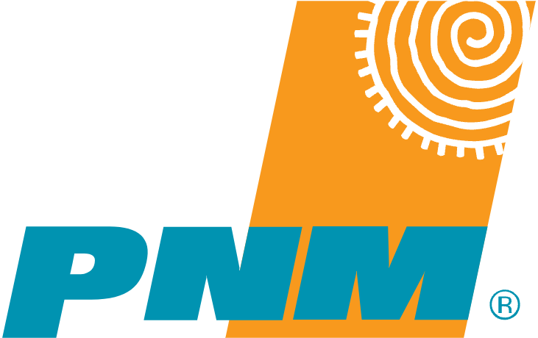  
Date: {date}  
  
Name: {name}  
  
Construction Coordinator: {coordinator}  
  
Subject: {permitNumber}  
  
NAME: {address}  
  
Dear Sir or Madam:

The following make-ready work needs to be performed before the requested new attachments or upgrades can be made. An inspection must be performed upon notification of make-ready work completion and prior to new installation approval. Do not make any new attachments to PNM poles until this make-ready process is complete and the approval for new attachments has been formally given.

**PNM will provide “preliminary estimate” of construction make ready costs (if applicable) within 14 days. PNM Communication must accept or deny make ready estimate within 14 days thereafter or PNM will actively withdraw make ready estimate.**

This Make-Ready report is an outline of the minimum work that would need to be performed in order to bring the PNM owned structures on this application into compliance with the NESC, based upon the sags existing at the time of inspection. It is the applicant’s responsibility to ensure that work needed is engineered in such a way that all requirements as outlined in the NESC are met on these structures at largest final sag (NESC 232).

The applicant is responsible for the completion of all other third-party attachment adjustments and pole transfers, (as outlined in the joint use agreement.)

The route represented in this Make-Ready Report may contain poles owned by third parties, designated as “Foreign Owned”. Any make-ready work requirements associated with this route are documented *only* for those structures owned by PNM and *do not include* “Foreign Owned” structures. It shall be the responsibility of the applicant to contact the third-party owner of any “Foreign Owned” structures for joint use requirements on these structures.

|  |  |  |
| --- | --- | --- |
| **#** | **Pole** | **Comments** |

{#results}

|  |  |  |
| --- | --- | --- |
| **{scid}** | **{PoleNumber} {noAccess}** | {#comments}   * {.}   {/comments} |

{/results}

**Approximate cost of PNM make-ready work: _____________**Please email if you have any questions:  
  
Respectfully submitted,  
{name}

Pole Engineering  
TechServ Engineering & Consulting   
3258 Earl Campbell Pkwy  
{userEmail}