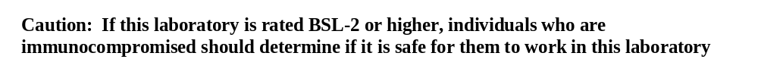

CAUTION

AUTHORIZED PERSONNEL ONLY

LABORATORY HAZARDS
NO EATING
NO DRINKING
NO SMOKING
NO SANDALS
NO SHORTS
NO HORSEPLAY

BIOSAFETY LEVEL
CANCER HAZARD

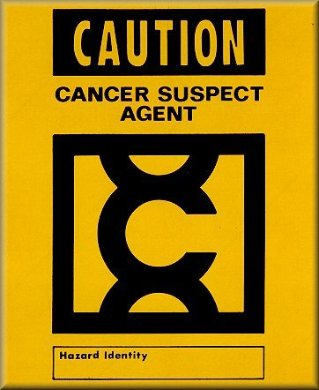
See caution below


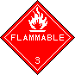

FLAMMABLES

CORROSIVES

PRINCIPAL INVESTIGATOR:

ALTERNATE POINT OF CONTACT:

LABORATORY MANAGER:

DEPARTMENT:

ALARMS IN THIS ROOM ARE FOR:

Ping Xu

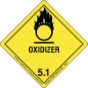

OXIDIZERS/
REACTIVES
COMPRESSED

GAS
Xiuchun Ge

Xiuchun Ge

OTHER


RADIATION
The Philips Institute
Caution: If this laboratory is rated BSL-1 or higher, individuals who are immunocompromised should determine if it is safe for them to work in this laboratory
Fire, -80C Freezer

REQUIRED PERSONAL PROTECTIVE EQUIPMENT OR SPECIAL PROCEDURES FOR THIS LABORATORY

