E-Commerce Review Prediction: A CRISP-DM Analysis of Customer Satisfaction

Hunter Sarkis
Grand Canyon University
MIS-665: Prescriptive Analytics and Advanced Topics
James Dzikunu
5/12/2026

Abstract
This project applies the Cross-Industry-Standard Process for Data Mining (CRISP-DM) framework to analyze 95,000+ delivered e-commerce orders from Olist (a Brazilian online retail marketplace). The business objective is to predict whether or not a customer will leave a negative review based on characteristics of the orders. The characteristics include delivery time, price, freight cost, and payment method. Understanding the drivers of customer satisfaction presents a vital operational opportunity for retailers. By identifying orders at risk before a review gets submitted, businesses can proactively intervene through customer service outreach, expedited shipping, target compensation, and more. This project demonstrates all for analytics types (descriptive, diagnostic, predictive, and prescriptive), concluded with a decision tree classification model which achieves 82.6% accuracy in predicting customer satisfaction.

Business Understanding
E-commerce has been continuously rising, making customer reviews one of (if not the most) influential factors in retail success. Even one single negative review not only reflects poor customer experience that can reduce conversion rates in the future, damage brand reputation, and increase customer acquisition costs. For Olist, other marketplace platforms, and by extension large retailers like Target, the ability to predict which orders are likely to result in dissatisfaction creates a huge competitive advantage.
There are a few business questions that drive this project. First, what order characteristics are most strongly associated with the low review scores? Second, can a model be built that accurately predicts whether an order will receive a negative review before the customer actually submits it? Lastly, what operational changes would maximize predicted customer satisfaction the most effectively?

Data Understanding
The dataset that was used in this project is the Olist Brazilian E-Commerce Public Dataset, which is available publicly on Kaggle. The data was actually collected from real commercial transactions on the Olist marketplace between the years of 2016 and 2018. It has also been fully anonymized. The dataset consists of nine relational CSV files that cover orders, customers, products, sellers, payments, and customer reviews. For this project, six out of the nine were merged into a single master data frame containing 95,832 delivered orders. The dataset can be found and accessed at https://www.kaggle.com/datasets/olistbr/brazilian-ecommerce.

Data Dictionary
The following features were selected for analysis based on their expected influence on customer satisfaction:
Feature | Data Type | Description
price | Continuous (Float) | Total item sale price per order in Brazilian Real (BRL)
freight_value | Continuous (Float) | Total shipping cost per order in BRL
payment_value | Continuous (Float) | Total amount paid including all installments
delivery_days | Integer | Days elapsed from purchase to delivery (engineered)
days_early_late | Integer | Days ahead of or behind estimated delivery date (engineered)
payment_type | Categorical | Method of payment: credit card, boleto, voucher, or debit card
product_category | Categorical | English-translated product category name
review_comment_message | Unstructured Text | Free-text customer review comment
review_score | Integer (1–5) | Original star rating left by the customer
satisfied | Binary (0/1) | Label — 1 if review score ≥ 4, otherwise 0

Univariate Analyses
Univariate statistics were generated for the four most influential numeric features and the label. Table 2 summarizes the key metrics:
Feature | Count | Missing | Unique | Min | Q1 | Median
delivery_days | 95,832 | 0 | 43 | 0.00 | 6.00 | 10.00
days_early_late | 95,832 | 0 | 196 | -189.00 | 6.00 | 11.00
price | 95,832 | 0 | 6,236 | 0.85 | 45.90 | 86.25
satisfied | 95,832 | 0 | 2 | 0.00 | 1.00 | 1.00

Q3 | Max | Mean | Std | Skewness | Kurtosis
15.00 | 42.00 | 11.85 | 8.21 | 1.498 | 2.508
16.00 | 146.00 | 10.91 | 10.11 | -1.942 | 27.254
149.90 | 461.90 | 119.84 | 108.74 | 1.731 | 2.586
1.00 | 1.00 | 0.79 | 0.41 | -1.420 | 0.017

The payment type column contained 4 unique values with credit_card as the mode, which appeared in 72,733 out of 95,832 orders (75.9%).
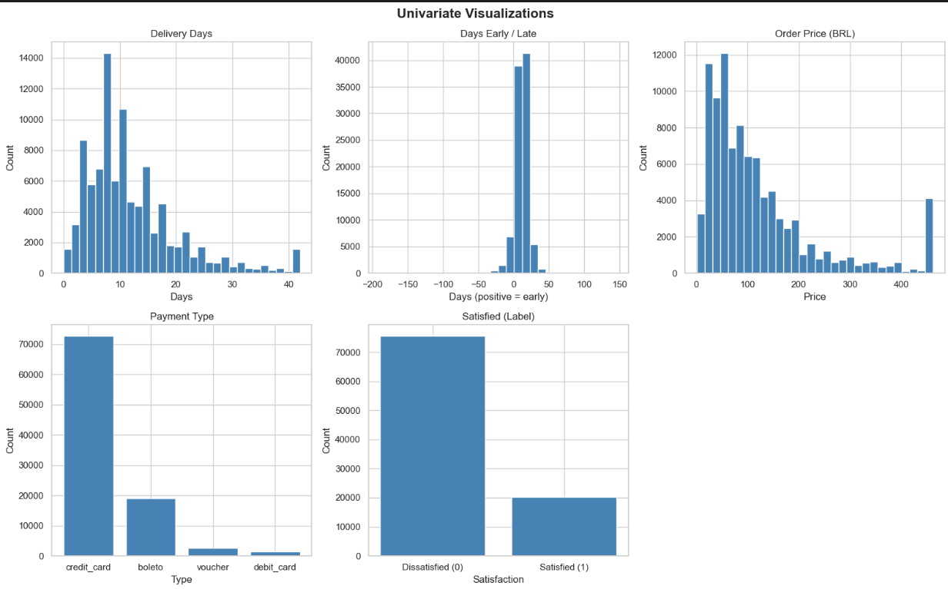

Bivariate Analyses
Bivariate tests were conducted between each feature and the satisfaction label. T-tests were used for the numeric features and chi-squared test was used for the categorical payment_type feature since the label is categorical.
Feature | Test | Statistic | p-value | Significant
delivery_days | t-test | -99.354 | < 0.001 | Yes
days_early_late | t-test | 74.362 | < 0.001 | Yes
price | t-test | -10.743 | < 0.001 | Yes
payment_type | Chi-square | 7.914 | 0.048 | Yes

Each of the four features had a statistically significant relationship with customer satisfaction. Delivery time showed the strongest effect. Dissatisfied customers waited an average of 16.71 days and satisfied customers waited 10.56 days.
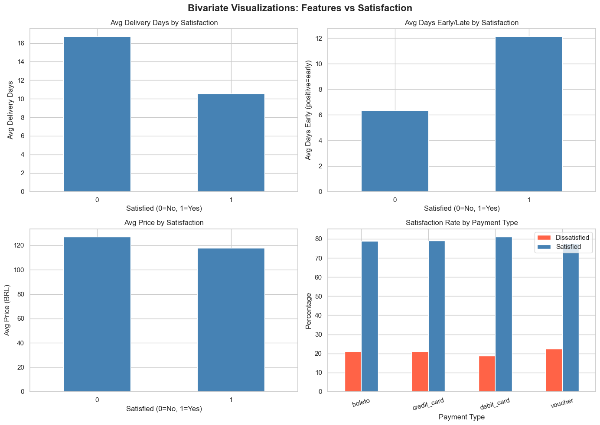
Data Preparation
Before modeling, the following data cleaning and feature engineering steps were applied to the merged dataset:
- Datetime parsing and feature engineering: Order date columns were converted from a string format to datetime objects. This led to two new features being engineered from these columns: delivery_days (representing the number of days between purchase and delivery), and days_early_late (representing the number of days an order arrived ahead/behind its estimated delivery date. Positive values indicate early delivery and negative values indicate late delivery.
- Filtering to delivered orders only: Originally, the dataset had 98,673 orders from canceled, shipped, and unavailable. The 95,832 orders with the “delivered” status were reported because non-delivered orders lacked delivery date information needed for feature engineering.
- Missing value imputation: Numeric columns (price, freight value, payment value, delivery days, and days early/late were filled using the column median. Categorical columns (payment_type, product_category) were filled using the mode as well (most common value). Customer review comments with no written text were filled with an empty string because a missing comment means that the customer left a star rating without written feedback.
- Outlier capping using IQR fencing: Numeric columns (price, freight value, and delivery days columns were identified using the IQR (interquartile range) method with a factor of 3.0. Values beyond the fence were capped at the boundary instead of just removing the rows. This limited the influence that extreme observations had.
- Binning low-count product categories: Any product categories with less than 300 orders were placed into a single “other” category. This reduced the number of categories from 70 to 32 clean, meaningful groups and prevented noise from any sparse categories that could affect the models.
- Binary label creation: The original five-point review score was converted into a binary satisfaction label. Orders that had a review of 4 or 5 were encoded as satisfied (1) and orders with a score of 1, 2, or 3 were encoded as dissatisfied (0). This transformation resulted in a dataset where 78.9% of orders were classified as satisfied compared to 21% as dissatisfied.
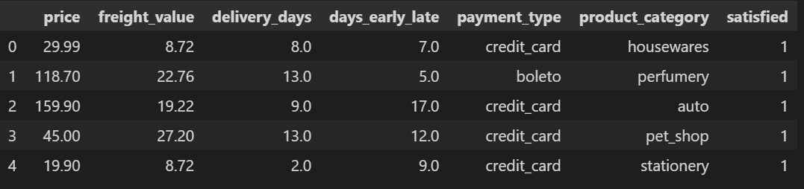
Modeling and Evaluation
Predictive Modeling
Two classification models were built to predict customer satisfaction using the features identified during the exploratory data analysis. The dataset was split to 80% training (76,665 rows) and 20% testing (19,167 rows). The features used as the model inputs were delivery_days, days early/late, price, freight value, and payment_type. Payment type was encoded prior to the modeling. Logistic Regression inputs were standardized using a Standard Scaler to ensure proper model convergence.
The two models evaluated were Logistic Regression and a Decision Tree classifier with a maximum depth of five levels. Table 3 summarizes the performance of both models on the test set.
Model | Accuracy | F1 | Recall | Precision
Logistic Regression | 0.817 | 0.895 | 0.984 | 0.821
Decision Tree | 0.826 | 0.900 | 0.988 | 0.827

The Decision Tree outperformed the Logistic Regression across every metric and is the recommended model for future predictions. Both of the models achieved high recall scores (above 98%), indicating strong ability to identify satisfied customers correctly. Precision of approximately 82% indicated that 18% of orders or so predicted as satisfied were actually dissatisfied. This represented the primary area for model improvement in the future.
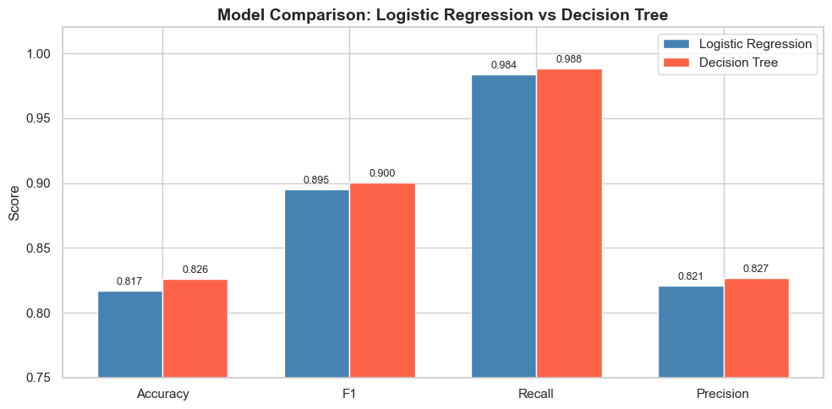
Prescriptive Modeling
A Monte Carlo simulation was conducted to hypothetically model the impact of delivery time reductions on customer satisfaction. Using 10,000 simulated orders per scenario, delivery days were reduced from 0-10 days incrementally below the average (11.85 days). The trained Decision Tree model generated satisfaction predictions, and the satisfaction rate was recorded for each scenario.
The results of the simulation showed that predicted satisfaction rates remained stable for the most part at ~ 93% across the delivery reduction scenarios. This suggests that the Decision Tree model reached a predictive ceiling with the feature set at hand, and that customer satisfaction is driven by a combination of factors rather than by delivery time alone. The key prescriptive insight is that retailers should focus on eliminating severely late deliveries (orders with negative days early/late values), rather than reducing the delivery time across all orders.
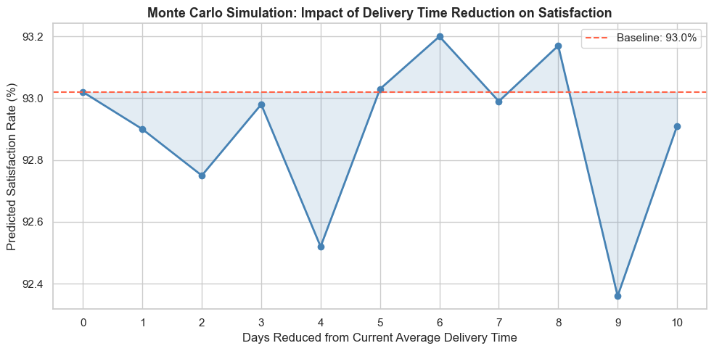
Discussion
The results of this analysis provide meaningful/actionable insights for e-commerce retailers that are looking to improve customer satisfaction. The exploratory analysis brought out the fact that delivery time is the strongest predictor of whether a customer will leave a positive or negative review. Dissatisfied customers waited an average of 16.71 days for their orders and satisfied customers waited an average of 10.56 days (a difference of over six days). Satisfied customers received their order an average of 12 days ahead of the estimated delivery date. Dissatisfied customers received theirs only 6 days early. Delivery speed and reliability consistently rank among the top drivers of online shopping satisfaction and repeat purchase behavior (Baynard Institute, 2023).
The predictive models confirmed that order characteristics can predict customer satisfaction reliably with over 82% accuracy. The Decision Tree model is recommended due to its superior performance across the four evaluation metrics. In practice, this model could be integrated into an order management system to find high-risk orders proactively. It could trigger expedited shipping before a negative experience occurs. A high majority of customers expect immediate engagement when they encounter a problem with an order, underscoring the business value of predictive early warning systems (Salesforce, 2025).
The Monte Carlo simulation revealed that predicted satisfaction rate remained consistent at approximately 93% regardless of how much the delivery time was reduced. This suggests that cutting delivery times alone isn’t enough to meaningfully improve customer satisfaction. Satisfaction is shaped by a combination of factors working together. Retailers should focus on eliminating orders that arrive later than the promised delivery date because the gap between the expected and actual delivery date is what drives satisfaction the most. Closing the gap between promise and actual delivery date has a greater impact on customer loyalty than reducing the average delivery speed altogether (Conexiom Marketing, 2024).
Price was also found to be a statistically significant predictor of dissatisfaction. Dissatisfied customers paid an average of 127 BRL compared to 117 BRL for satisfied customers. Customers who spend more on a purchase are more likely to have higher expectations, and any delivery failure is more likely to end with a negative review. Customers are significantly more likely to leave negative feedback when their expectations are not met on higher-value purchases (PWC, 2023). Retailers can definitely benefit from this by paying closer attention to high-value orders during the fulfilment process.
In summary, three business recommendations are supported by this analysis. Delivery time should be monitored early, with alerts being triggered when predicted deliver days exceed 14 days. Orders arriving later than their estimated delivery date should be prioritized for customer communication, and high-value orders above 150 BRL should receive additional fulfillment oversight because of their elevated dissatisfaction risk. These interventions informed by the predictive model in this project represent a practical and data-driven path toward improving customer satisfaction at scale.

References
Baymard Institute. (2025). 49 Cart Abandonment Rate Statistics 2025. Baymard.com. https://baymard.com/lists/cart-abandonment-rate
Conexiom Marketing. (2024, October 4). The Role of On-Time Delivery in Logistics Management. Conexiom.com; Conexiom. https://conexiom.com/blog/the-role-of-on-time-delivery-in-logistics-management
PWC. (2023). Global Consumer Insights Pulse Survey. PWC. https://www.pwc.com/gx/en/industries/consumer-markets/consumer-insights-survey.html
Salesforce. (2025). Salesforce. Salesforce. https://www.salesforce.com/small-business/what-are-customer-expectations/

