Course Name | ITD 2343 – Object Oriented Programming with C#
Instructor | Mark L. Pranger
Student Name | Hunter Standifer
Due date | September 29, 2025
Grade | <grade earned here>
Grading Comments | <instructor comments here>

Exam 1 Lab

Build Screenshots

Width and Background Screenshot
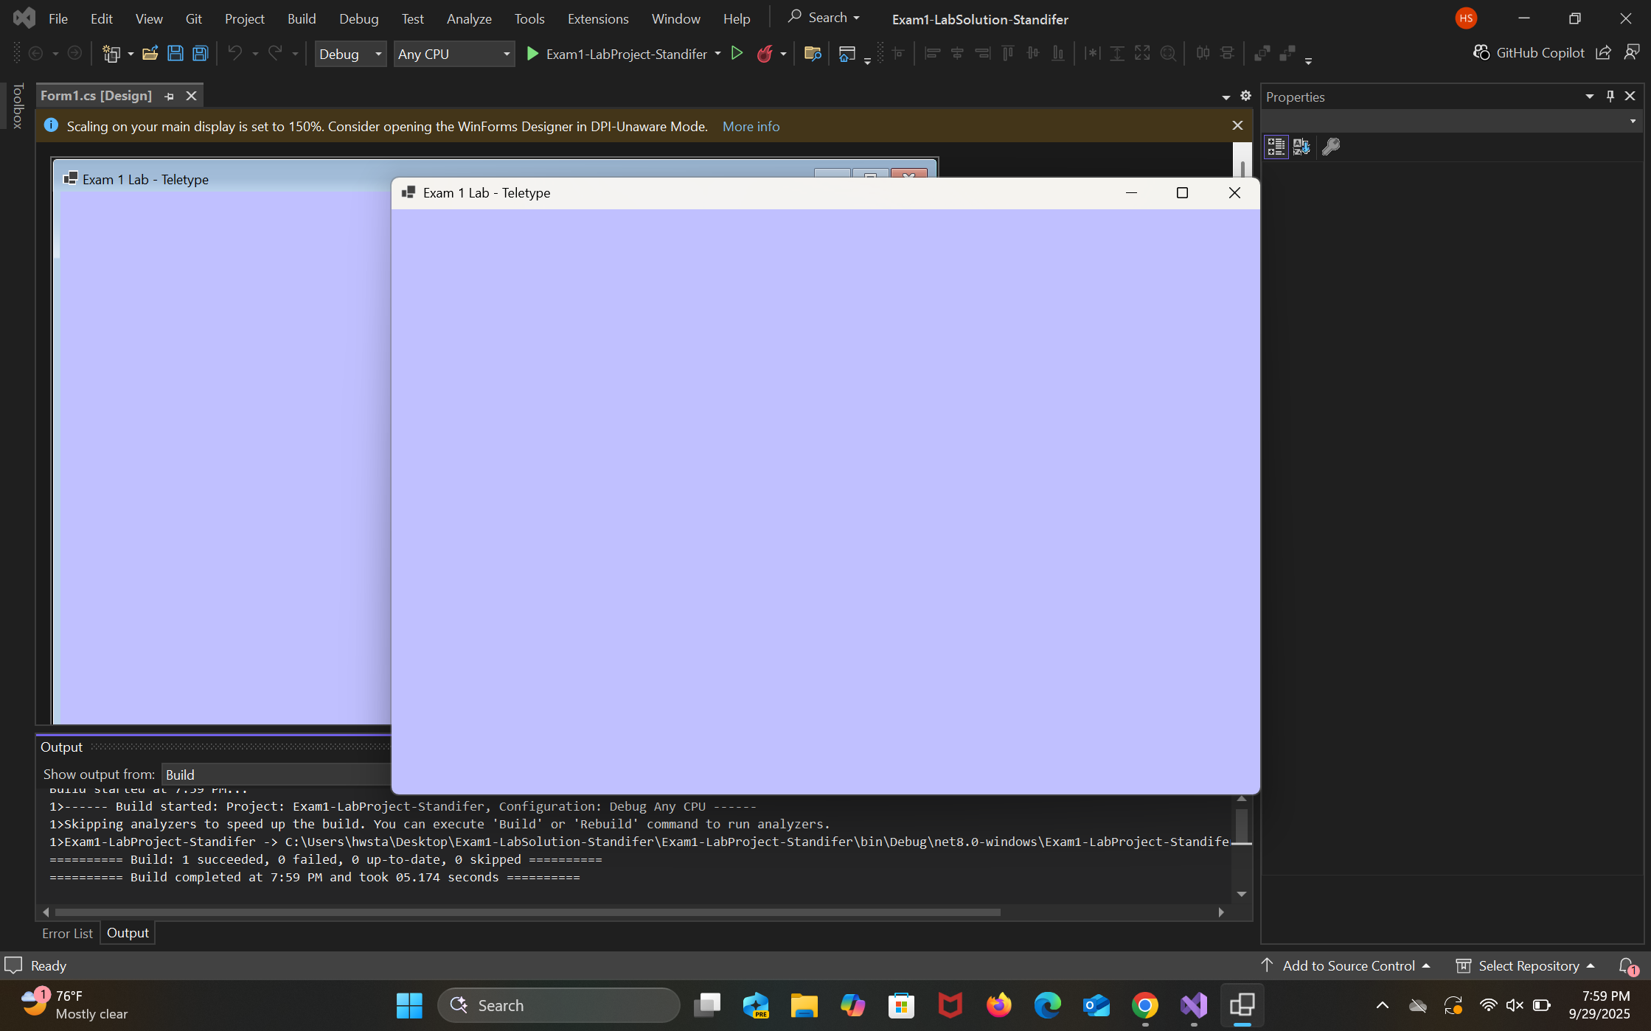

Text Buttons
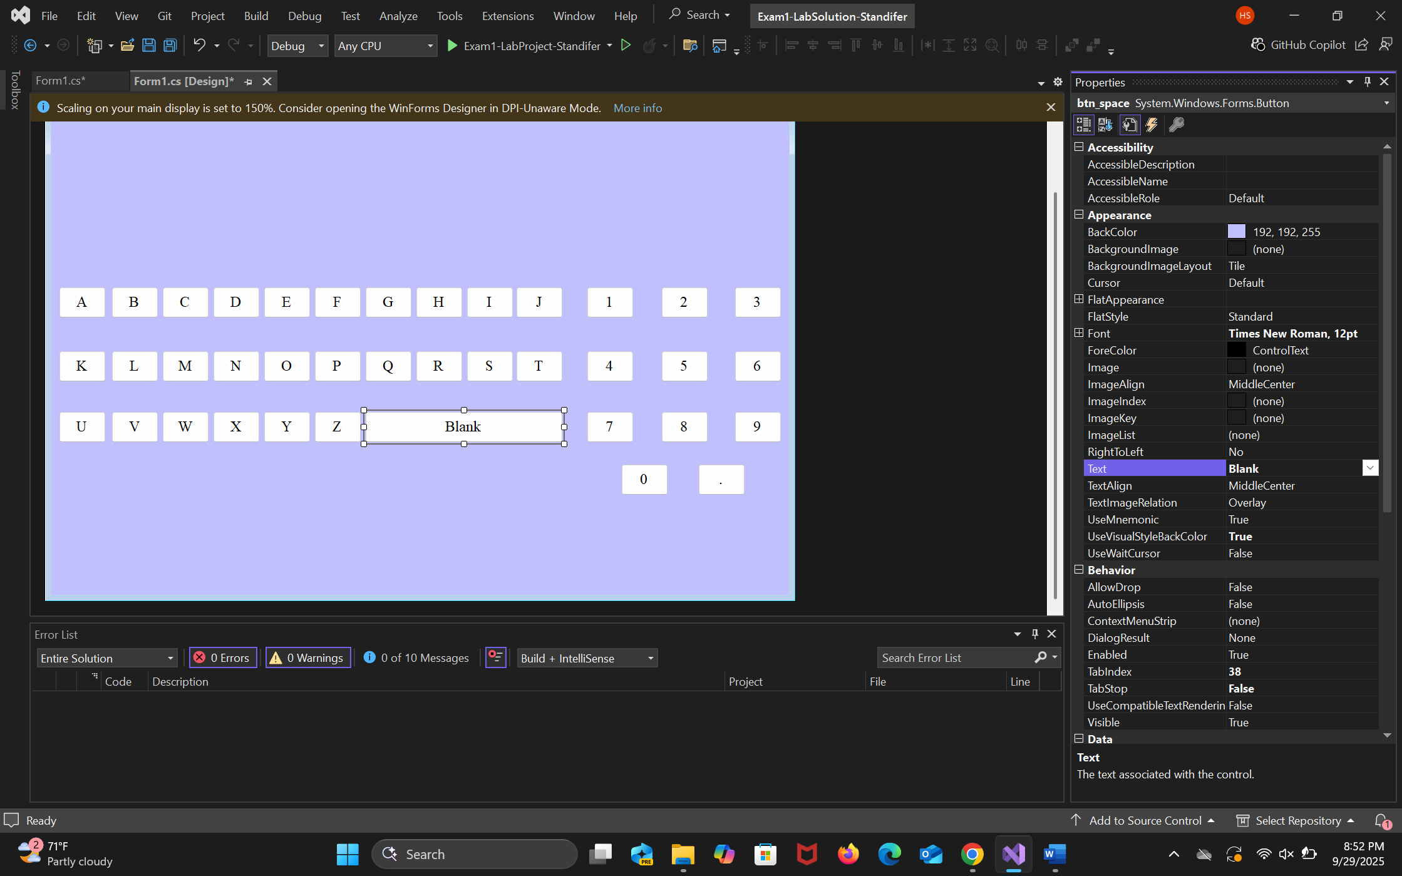

Clear and Send Buttons
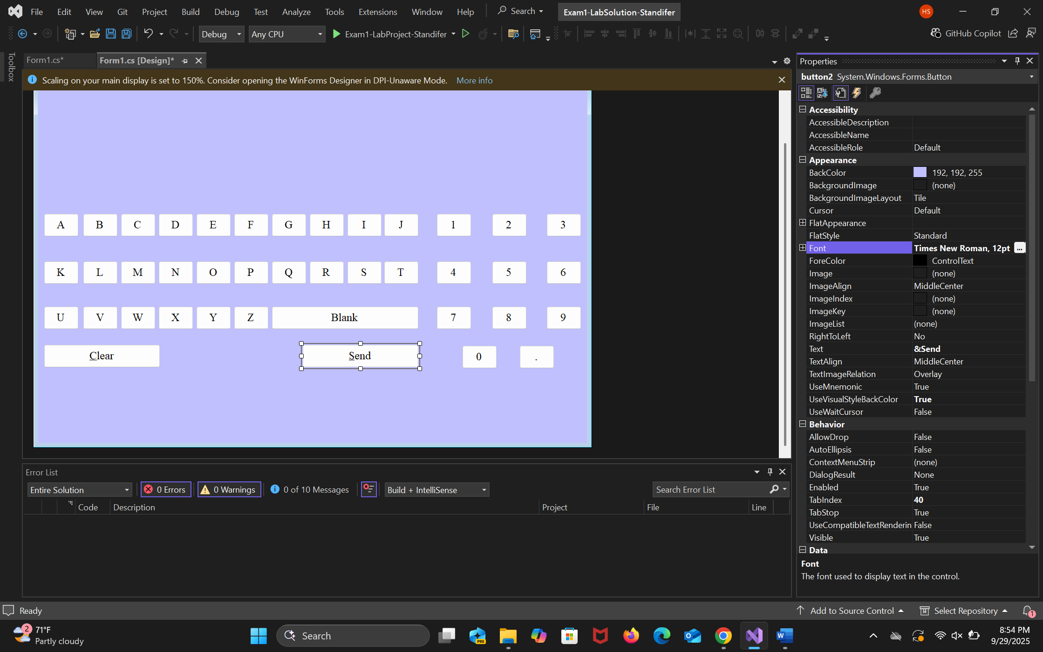
Textbox and label
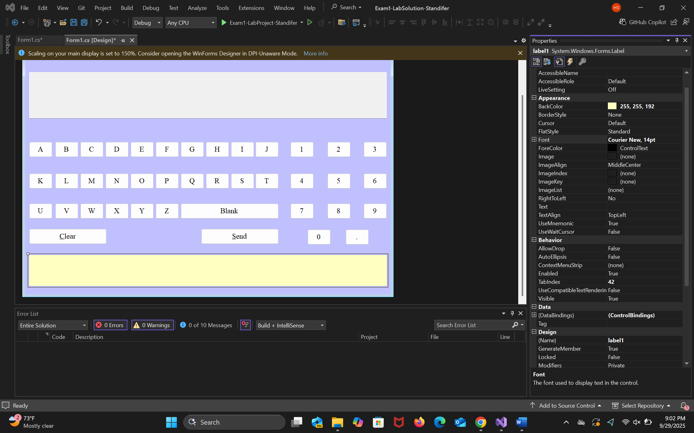

Completed
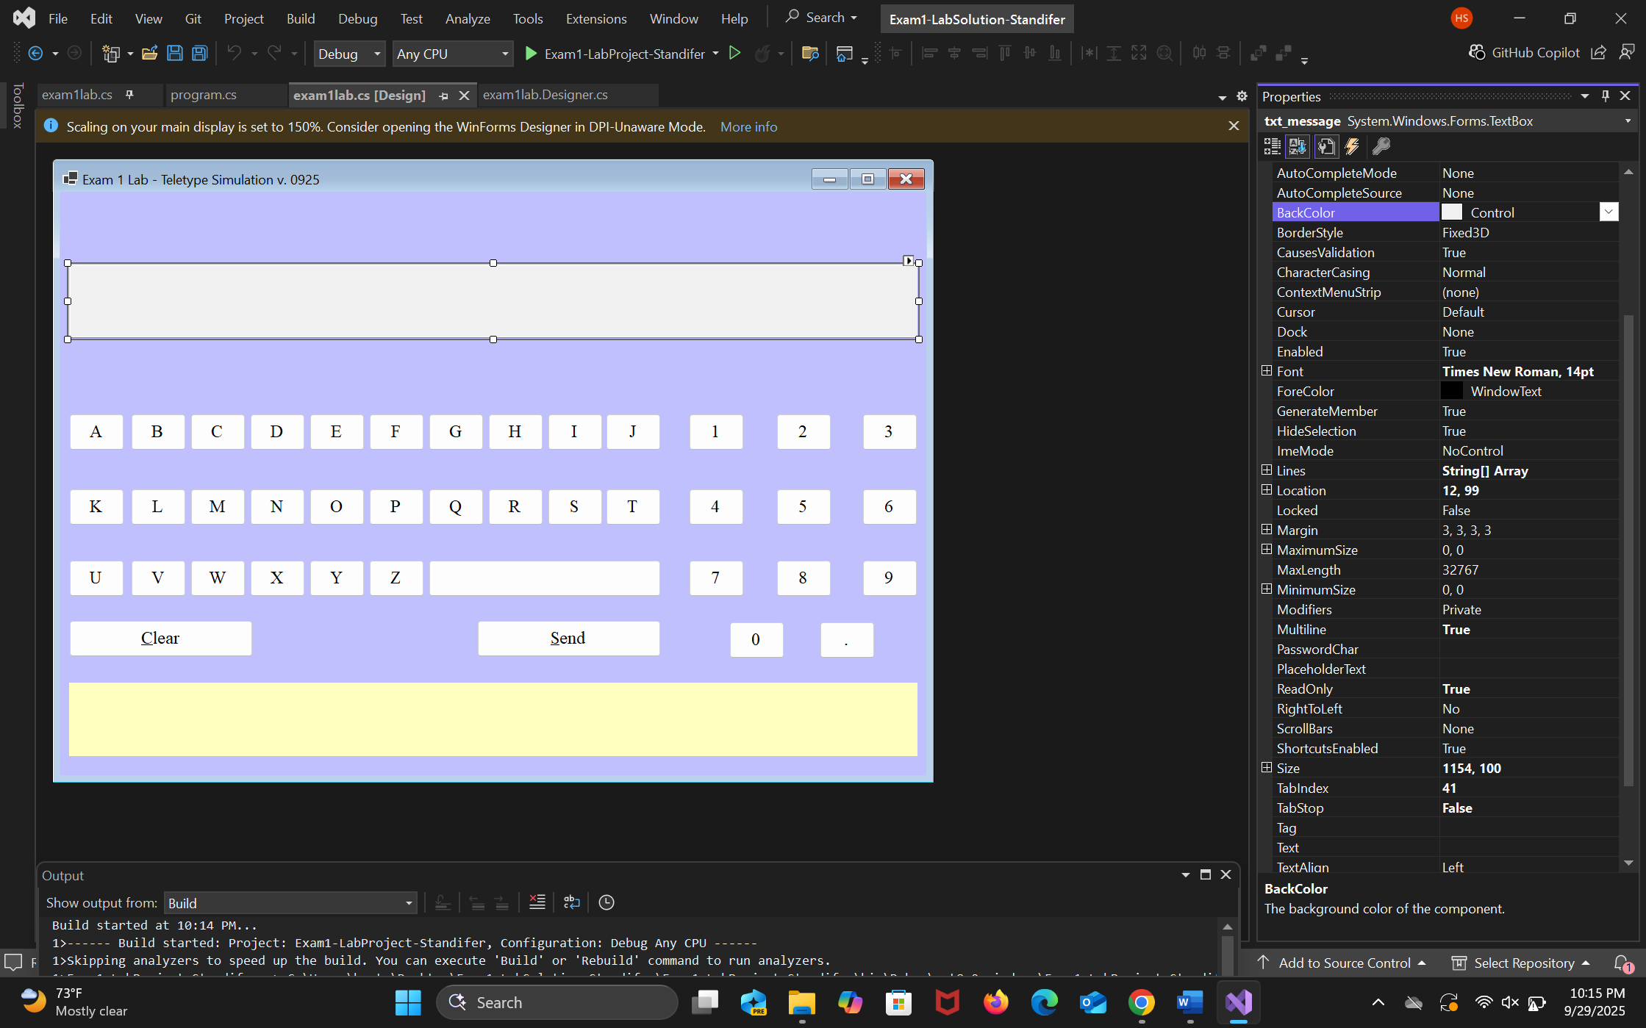

Functionality
Running
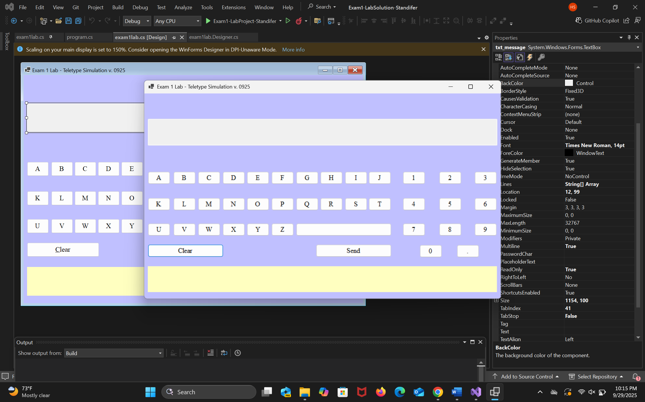

Textbox only partial
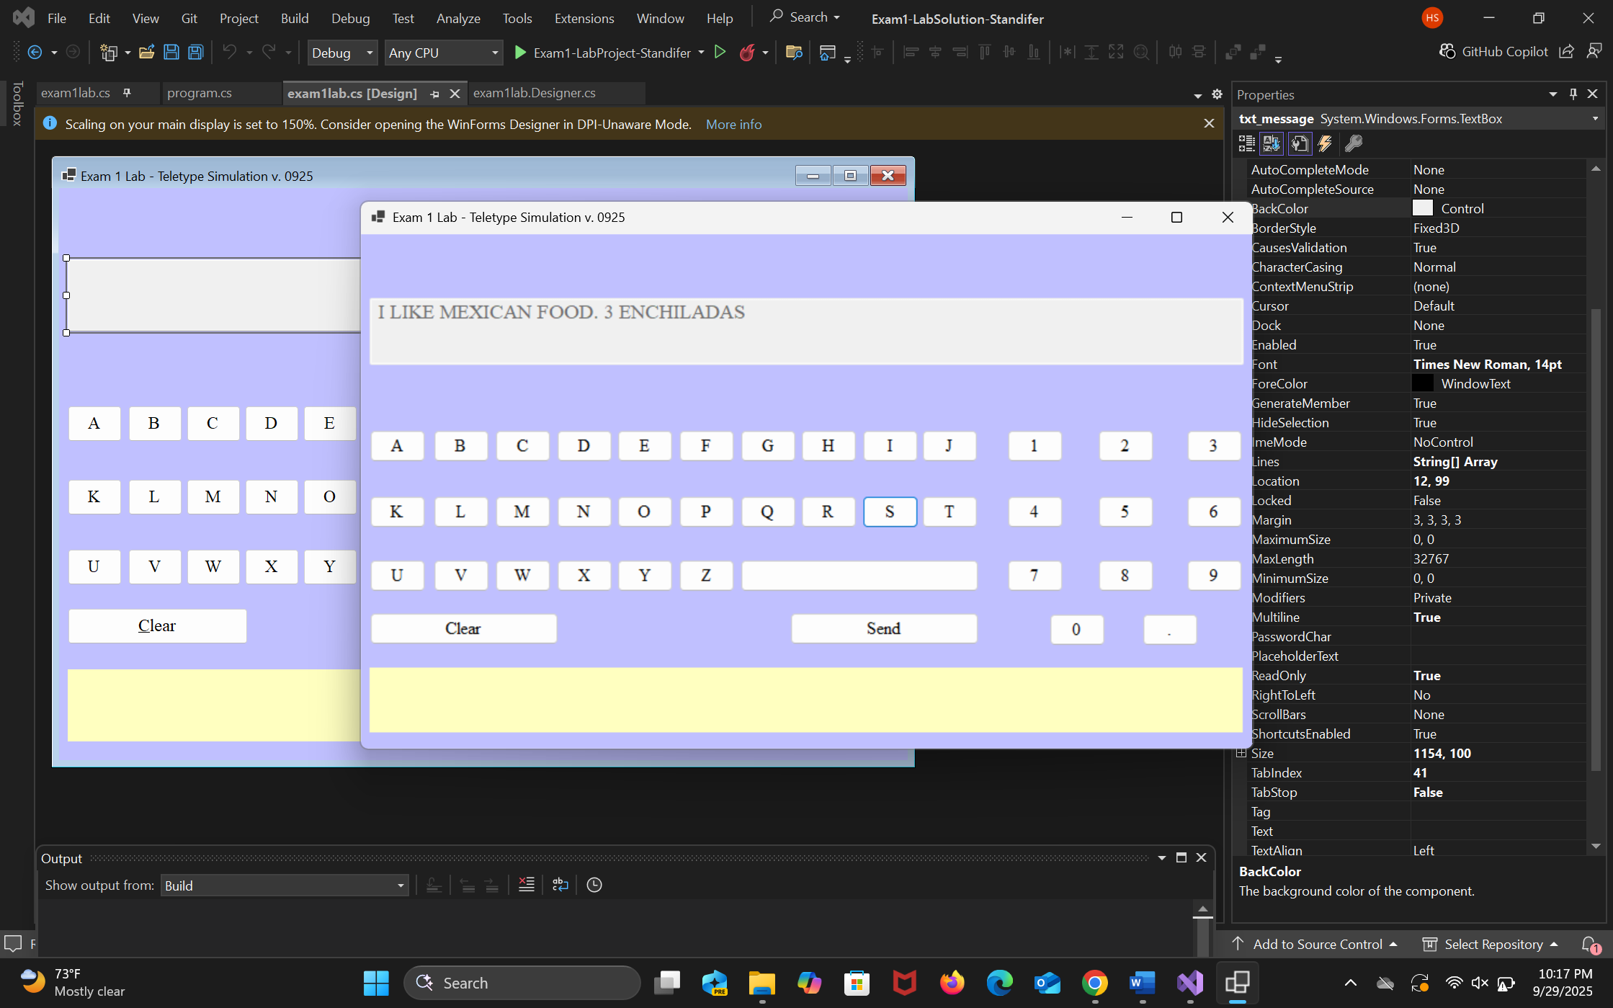

Textbox only full
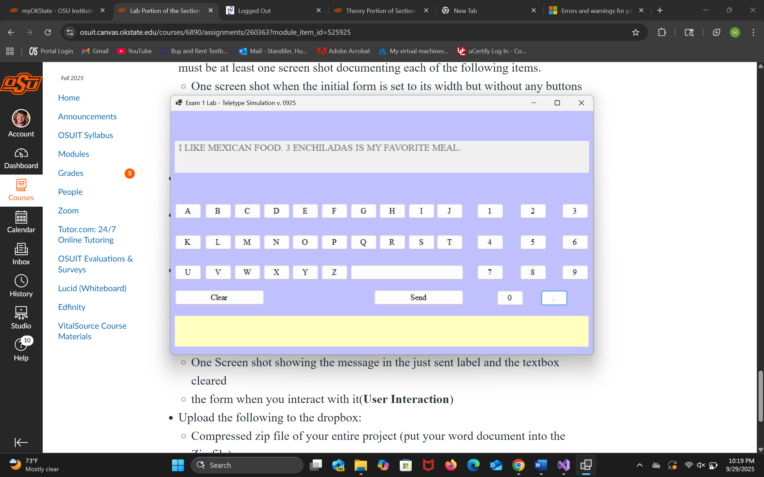

Label only
