Course Name | ITD 2343 – Object Oriented Programming with C#
Instructor | Mark L. Pranger
Student Name | Hunter Standifer
Due date | September 23, 2025
Grade | <grade earned here>
Grading Comments | <instructor comments here>

Week 1 to 3 Lab
Building Screenshots
Label Screenshot
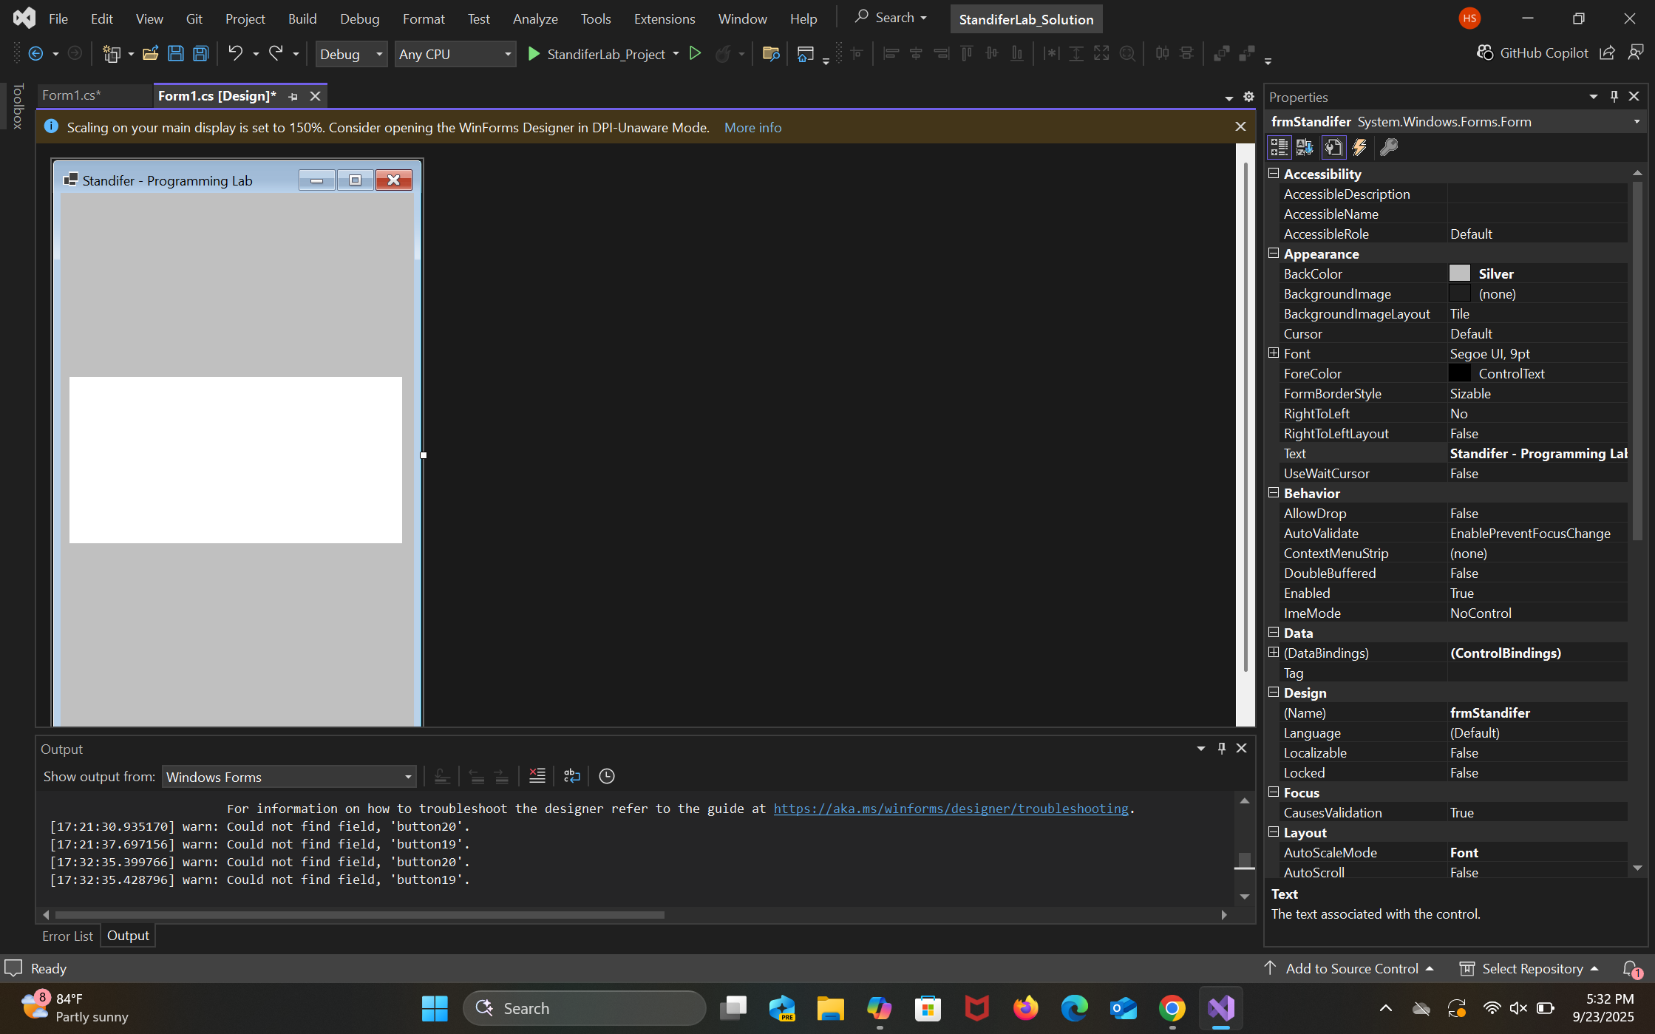

Screenshot Button set 1
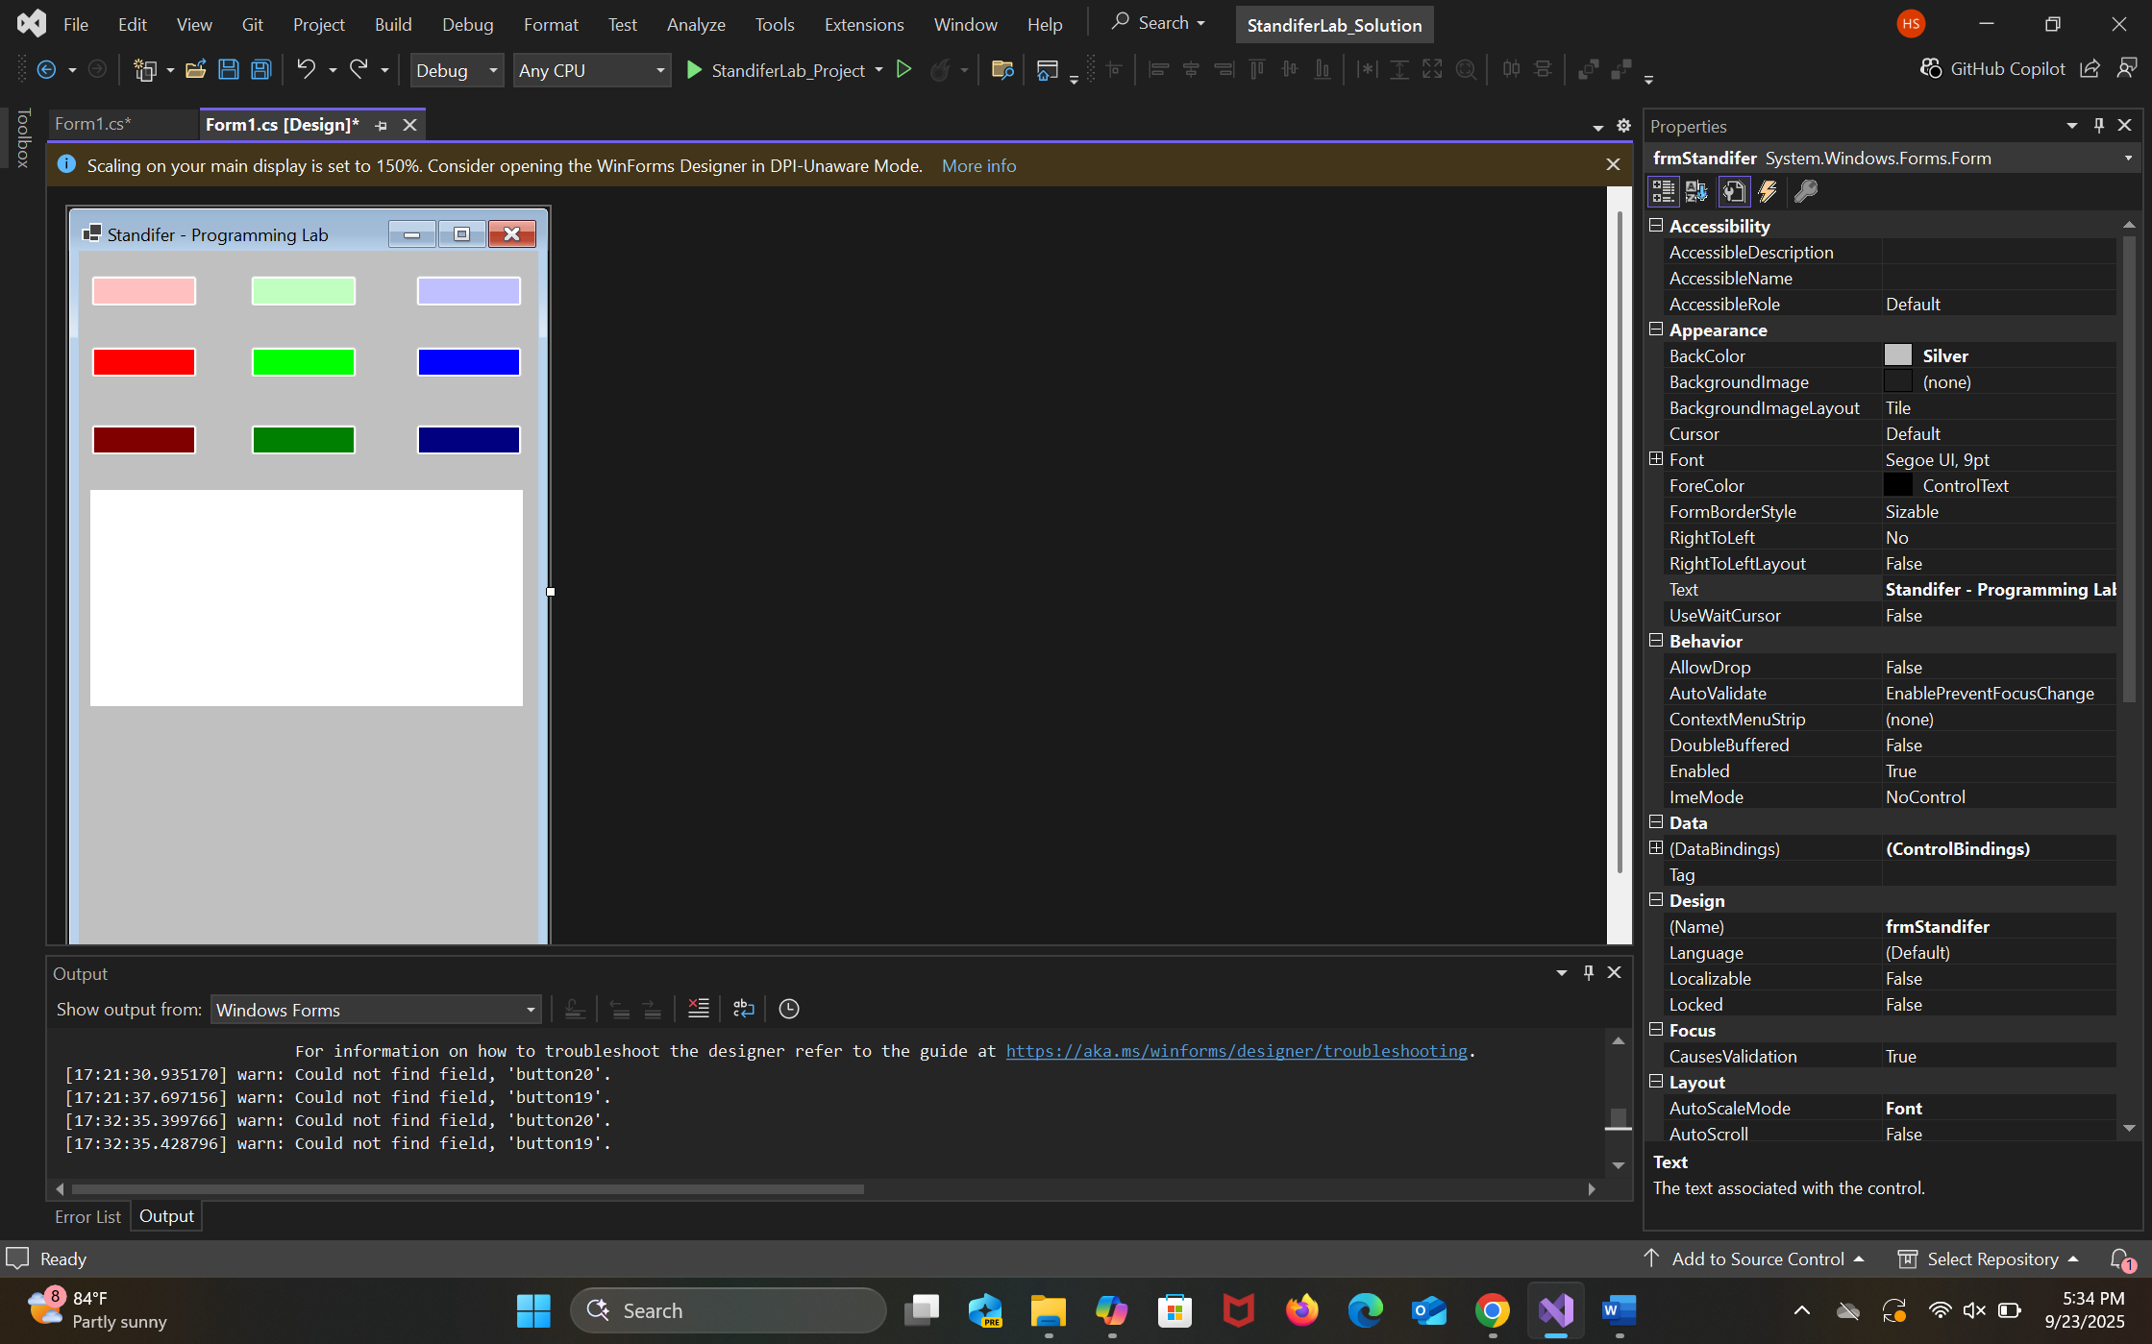

Screenshot Button Set 2
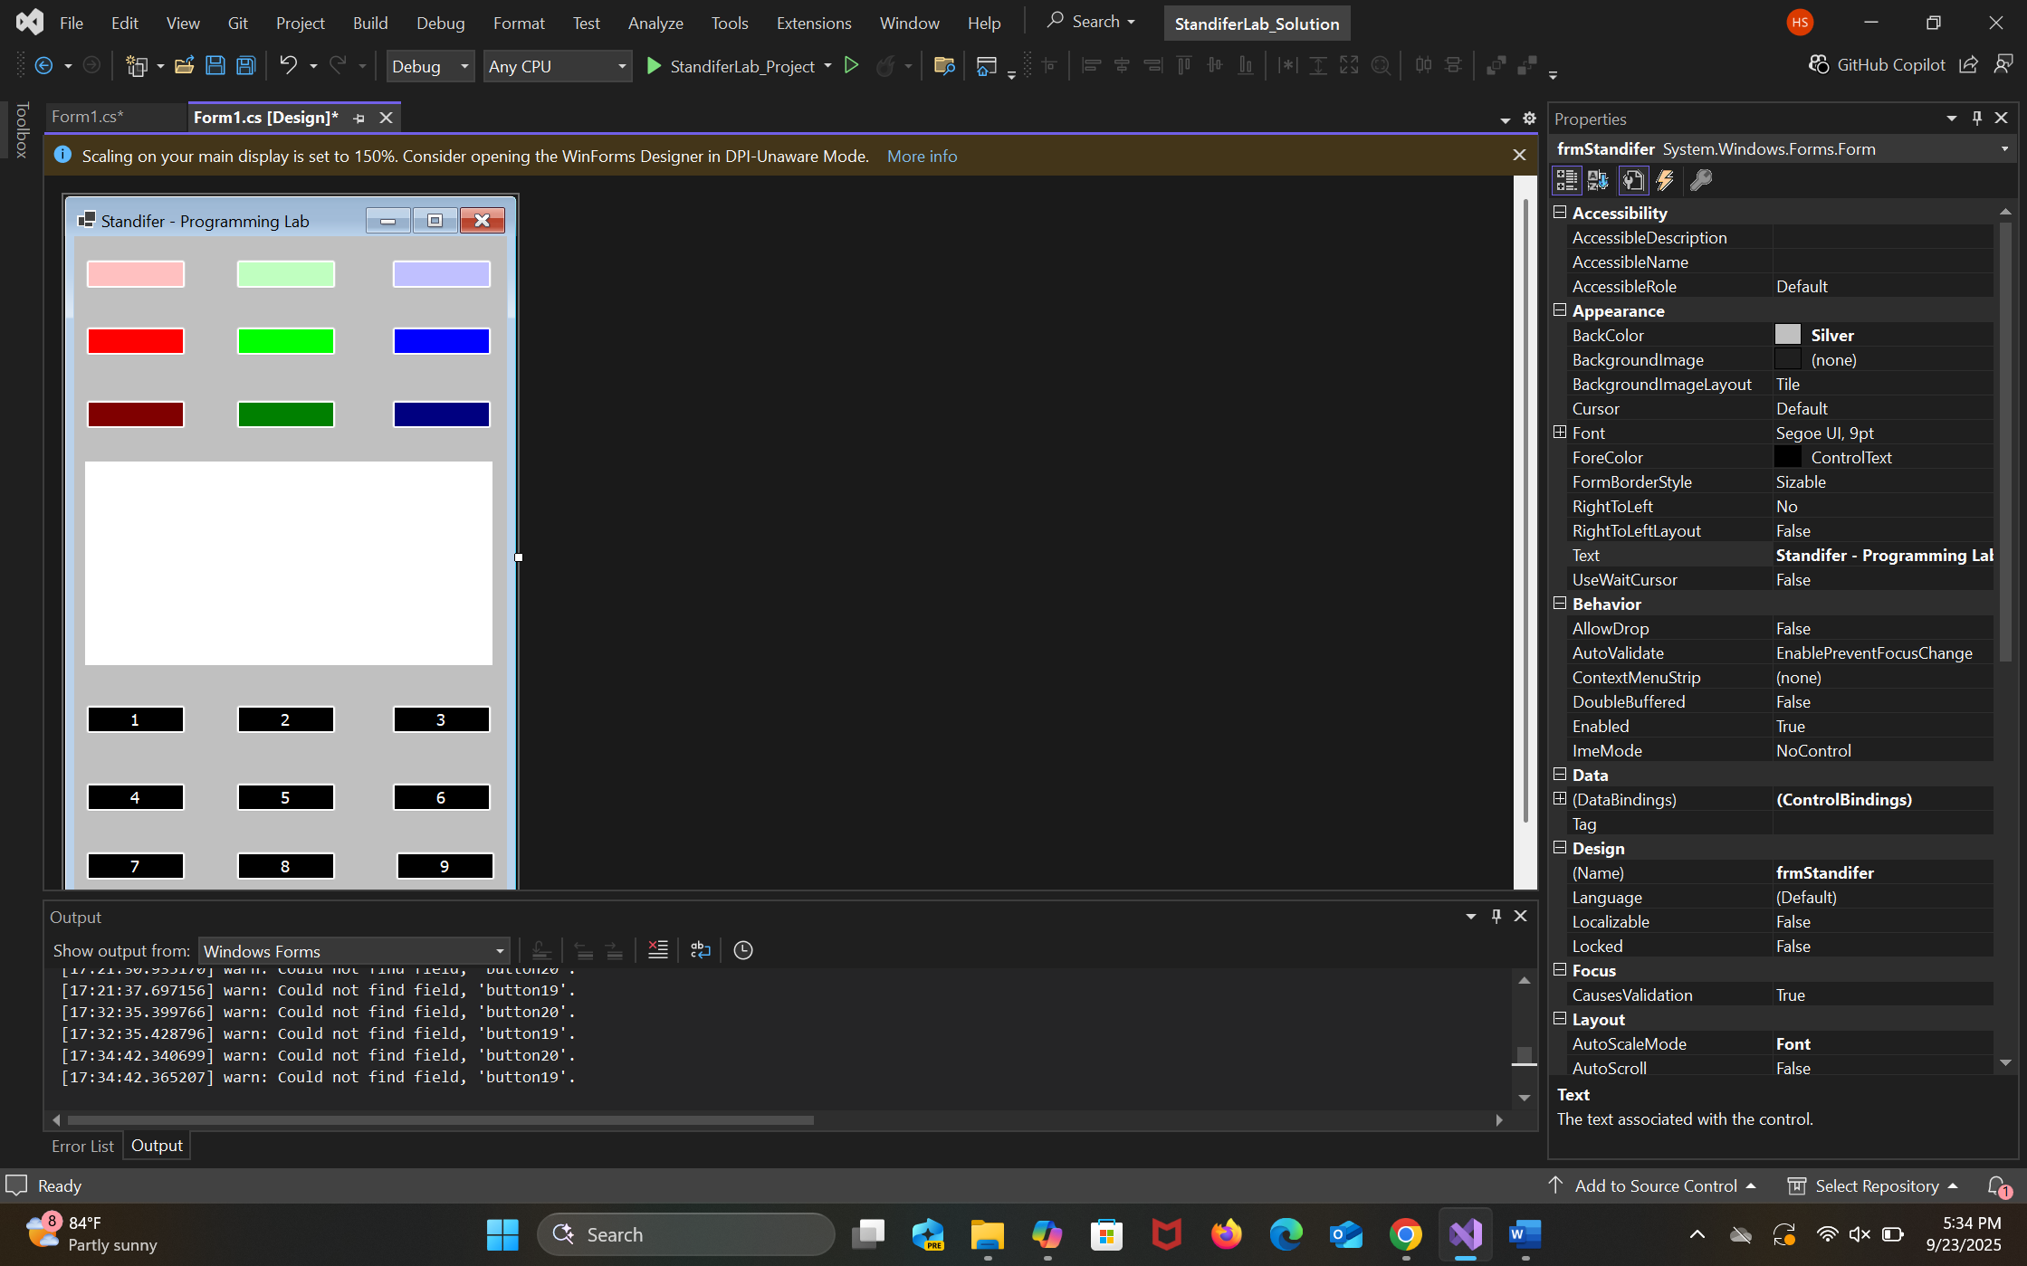

Control Buttons Screenshot
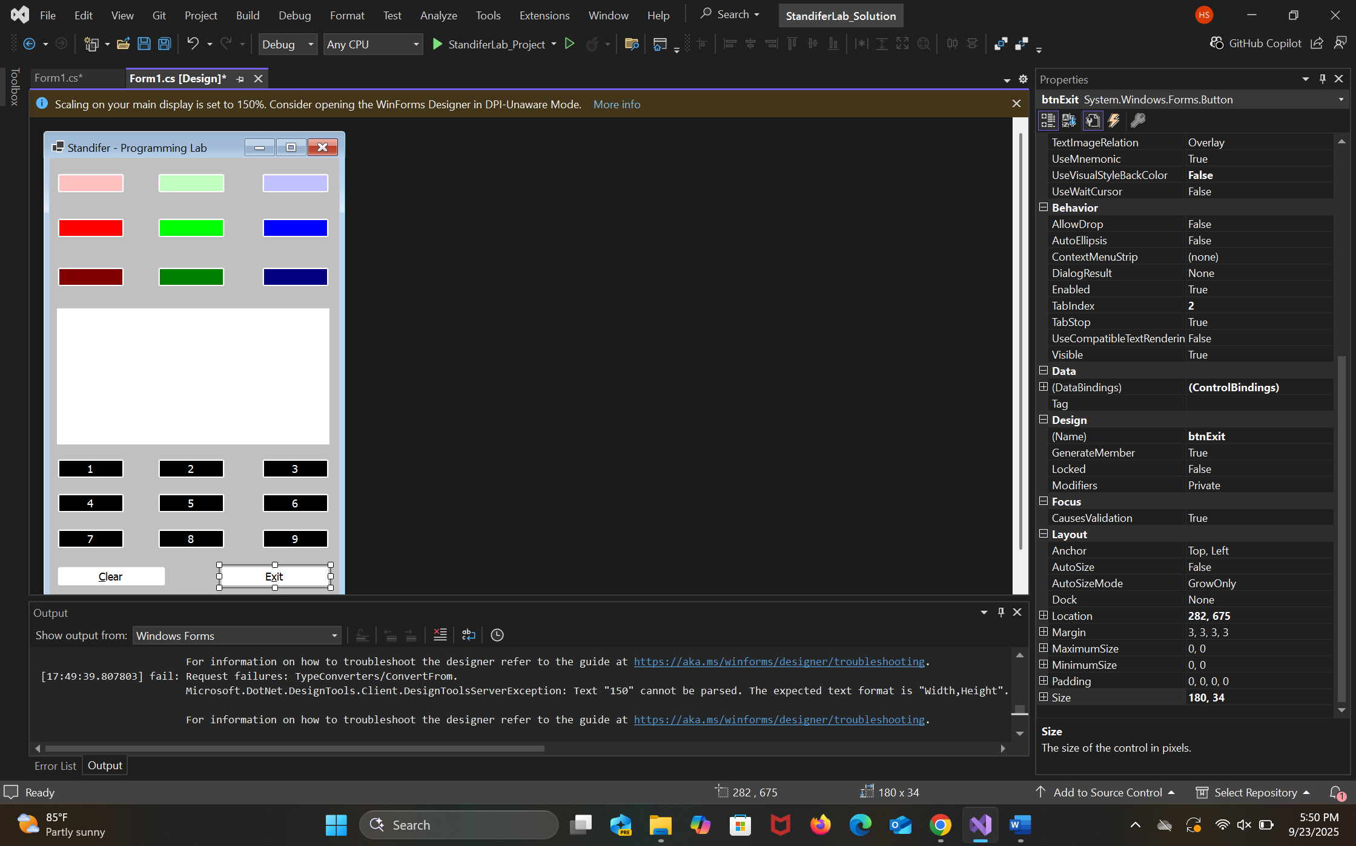

Running Screenshots

Initialization Screenshot
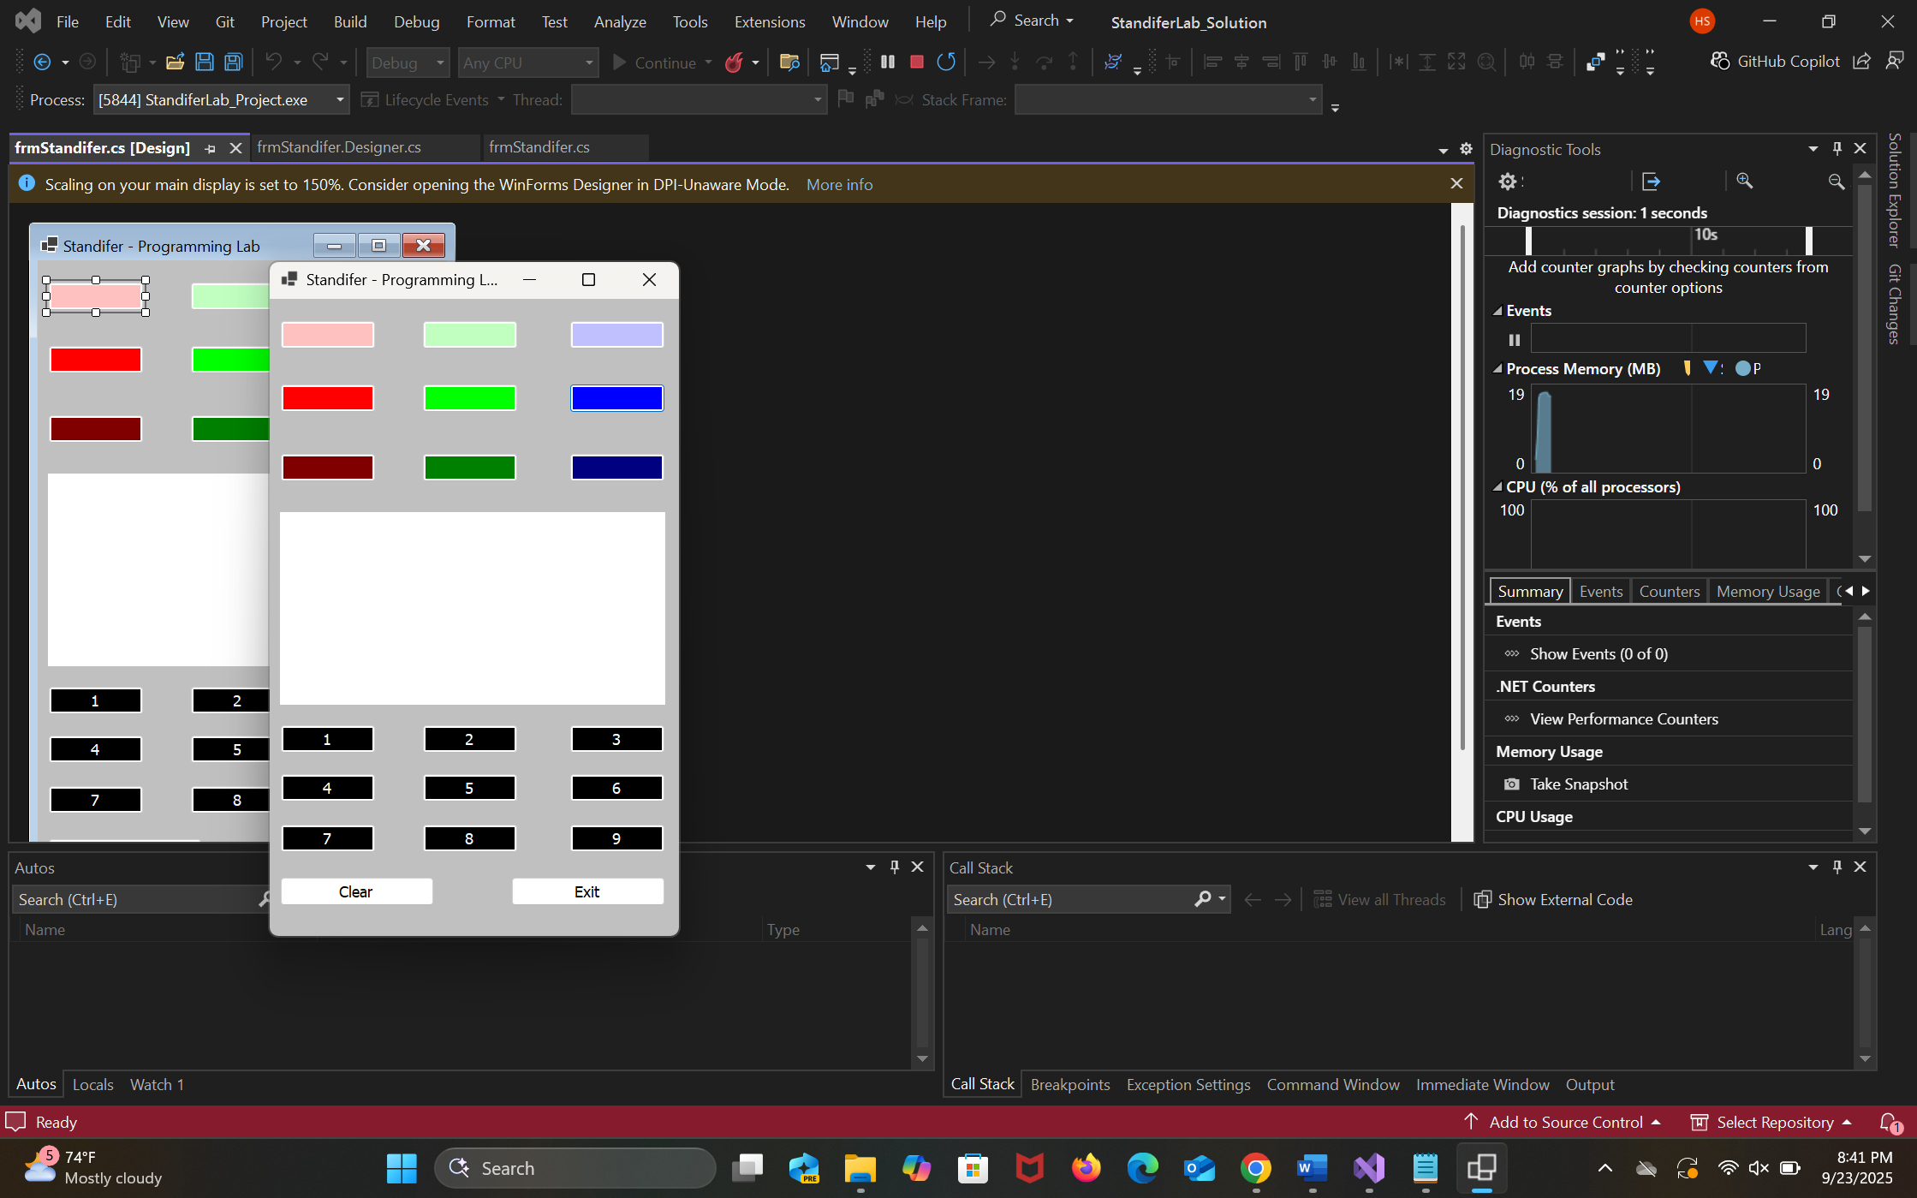

Color Only
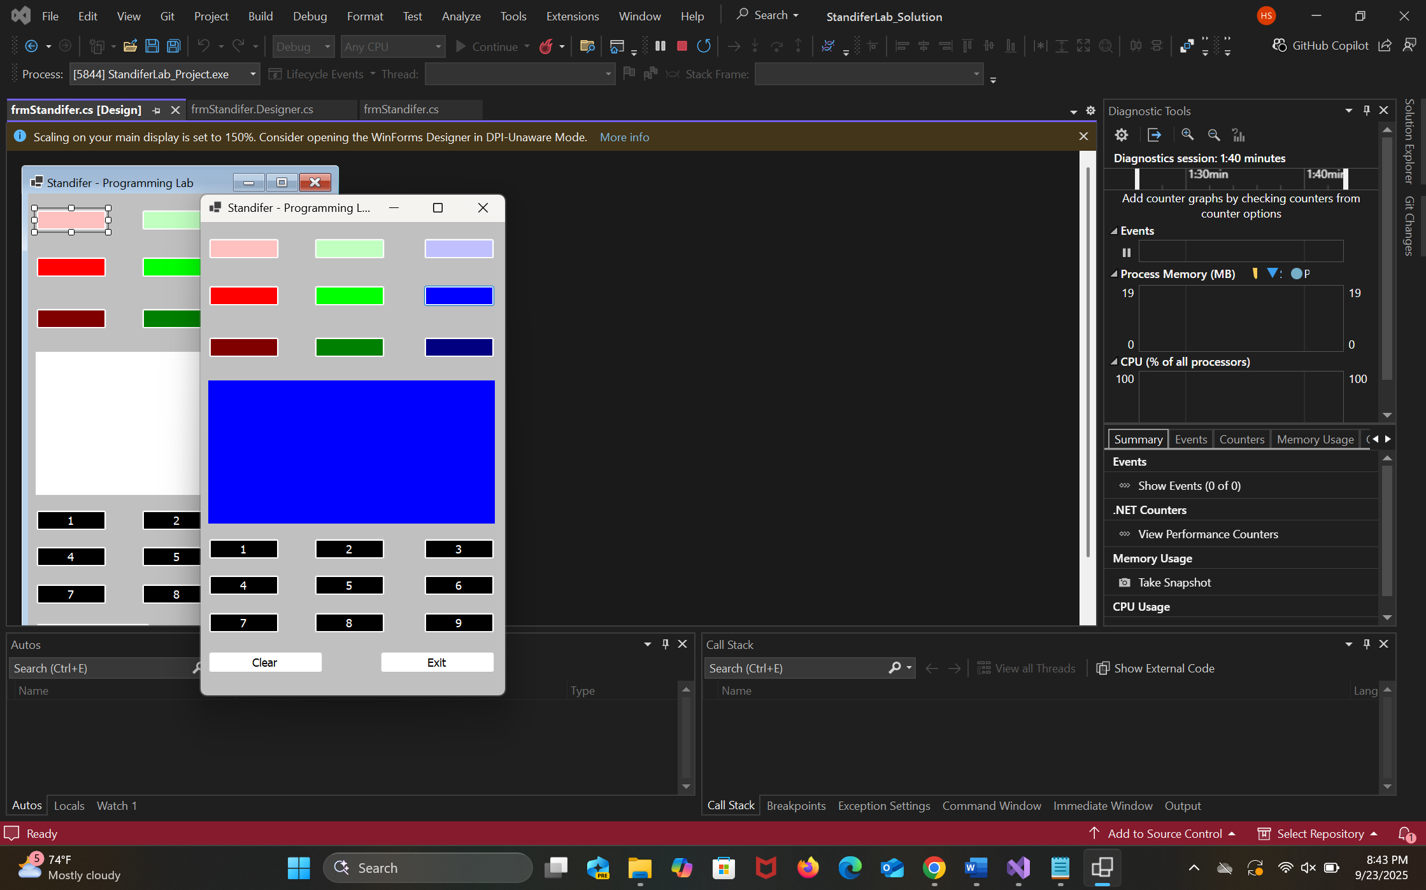

Number Only
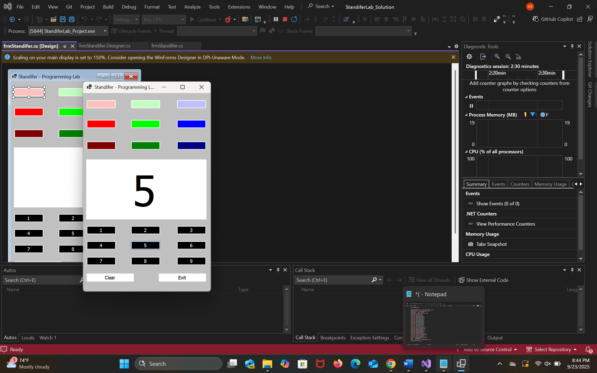
Both Screenshot
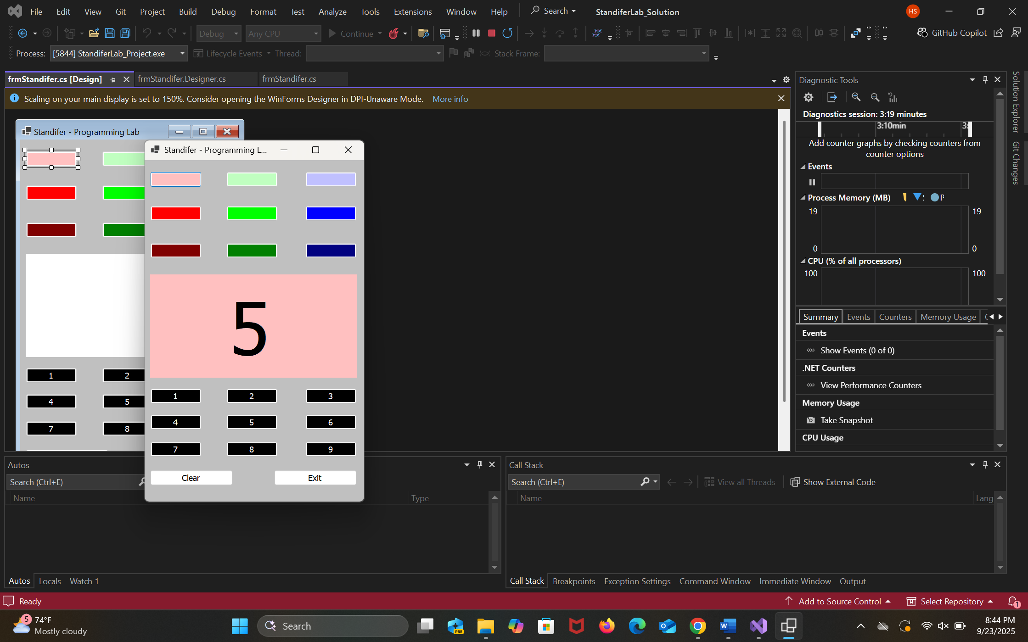

Clear Screenshot
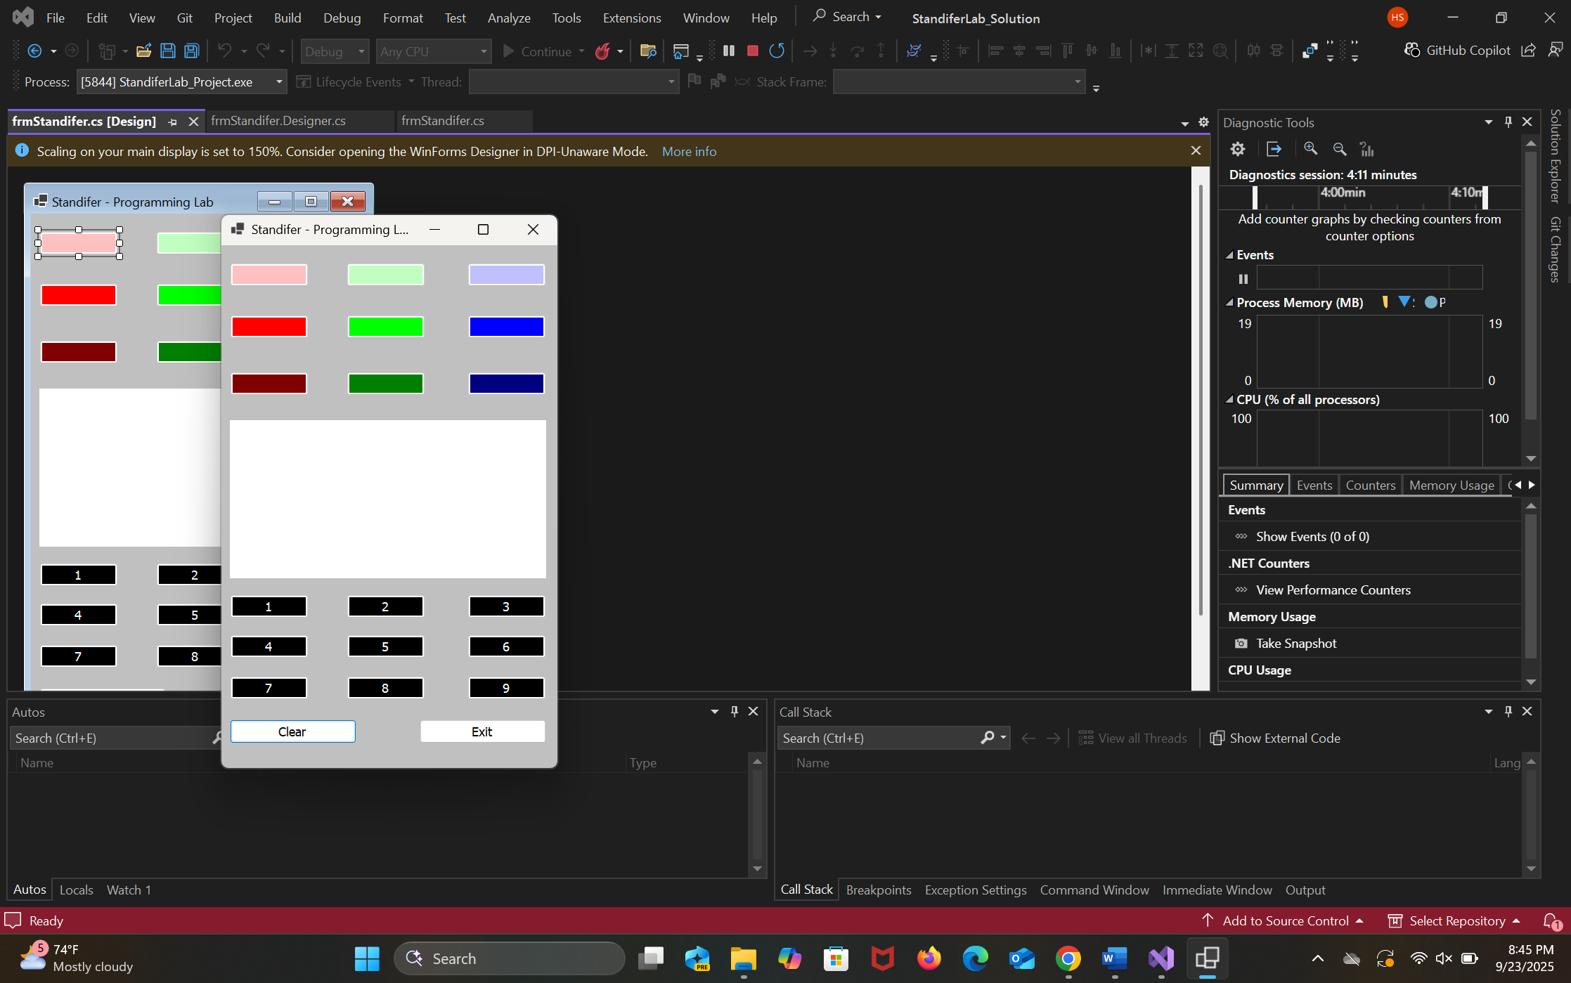

Contrasting colors Screenshot

