Course Name | ITD 2343 – Object Oriented Programming with C#
Instructor | Mark L. Pranger
Student Name | Hunter Standifer
Due date | <assignment due date here>
Grade | <grade earned here>
Grading Comments | <instructor comments here>

Module 8 Lab

Design Screenshot
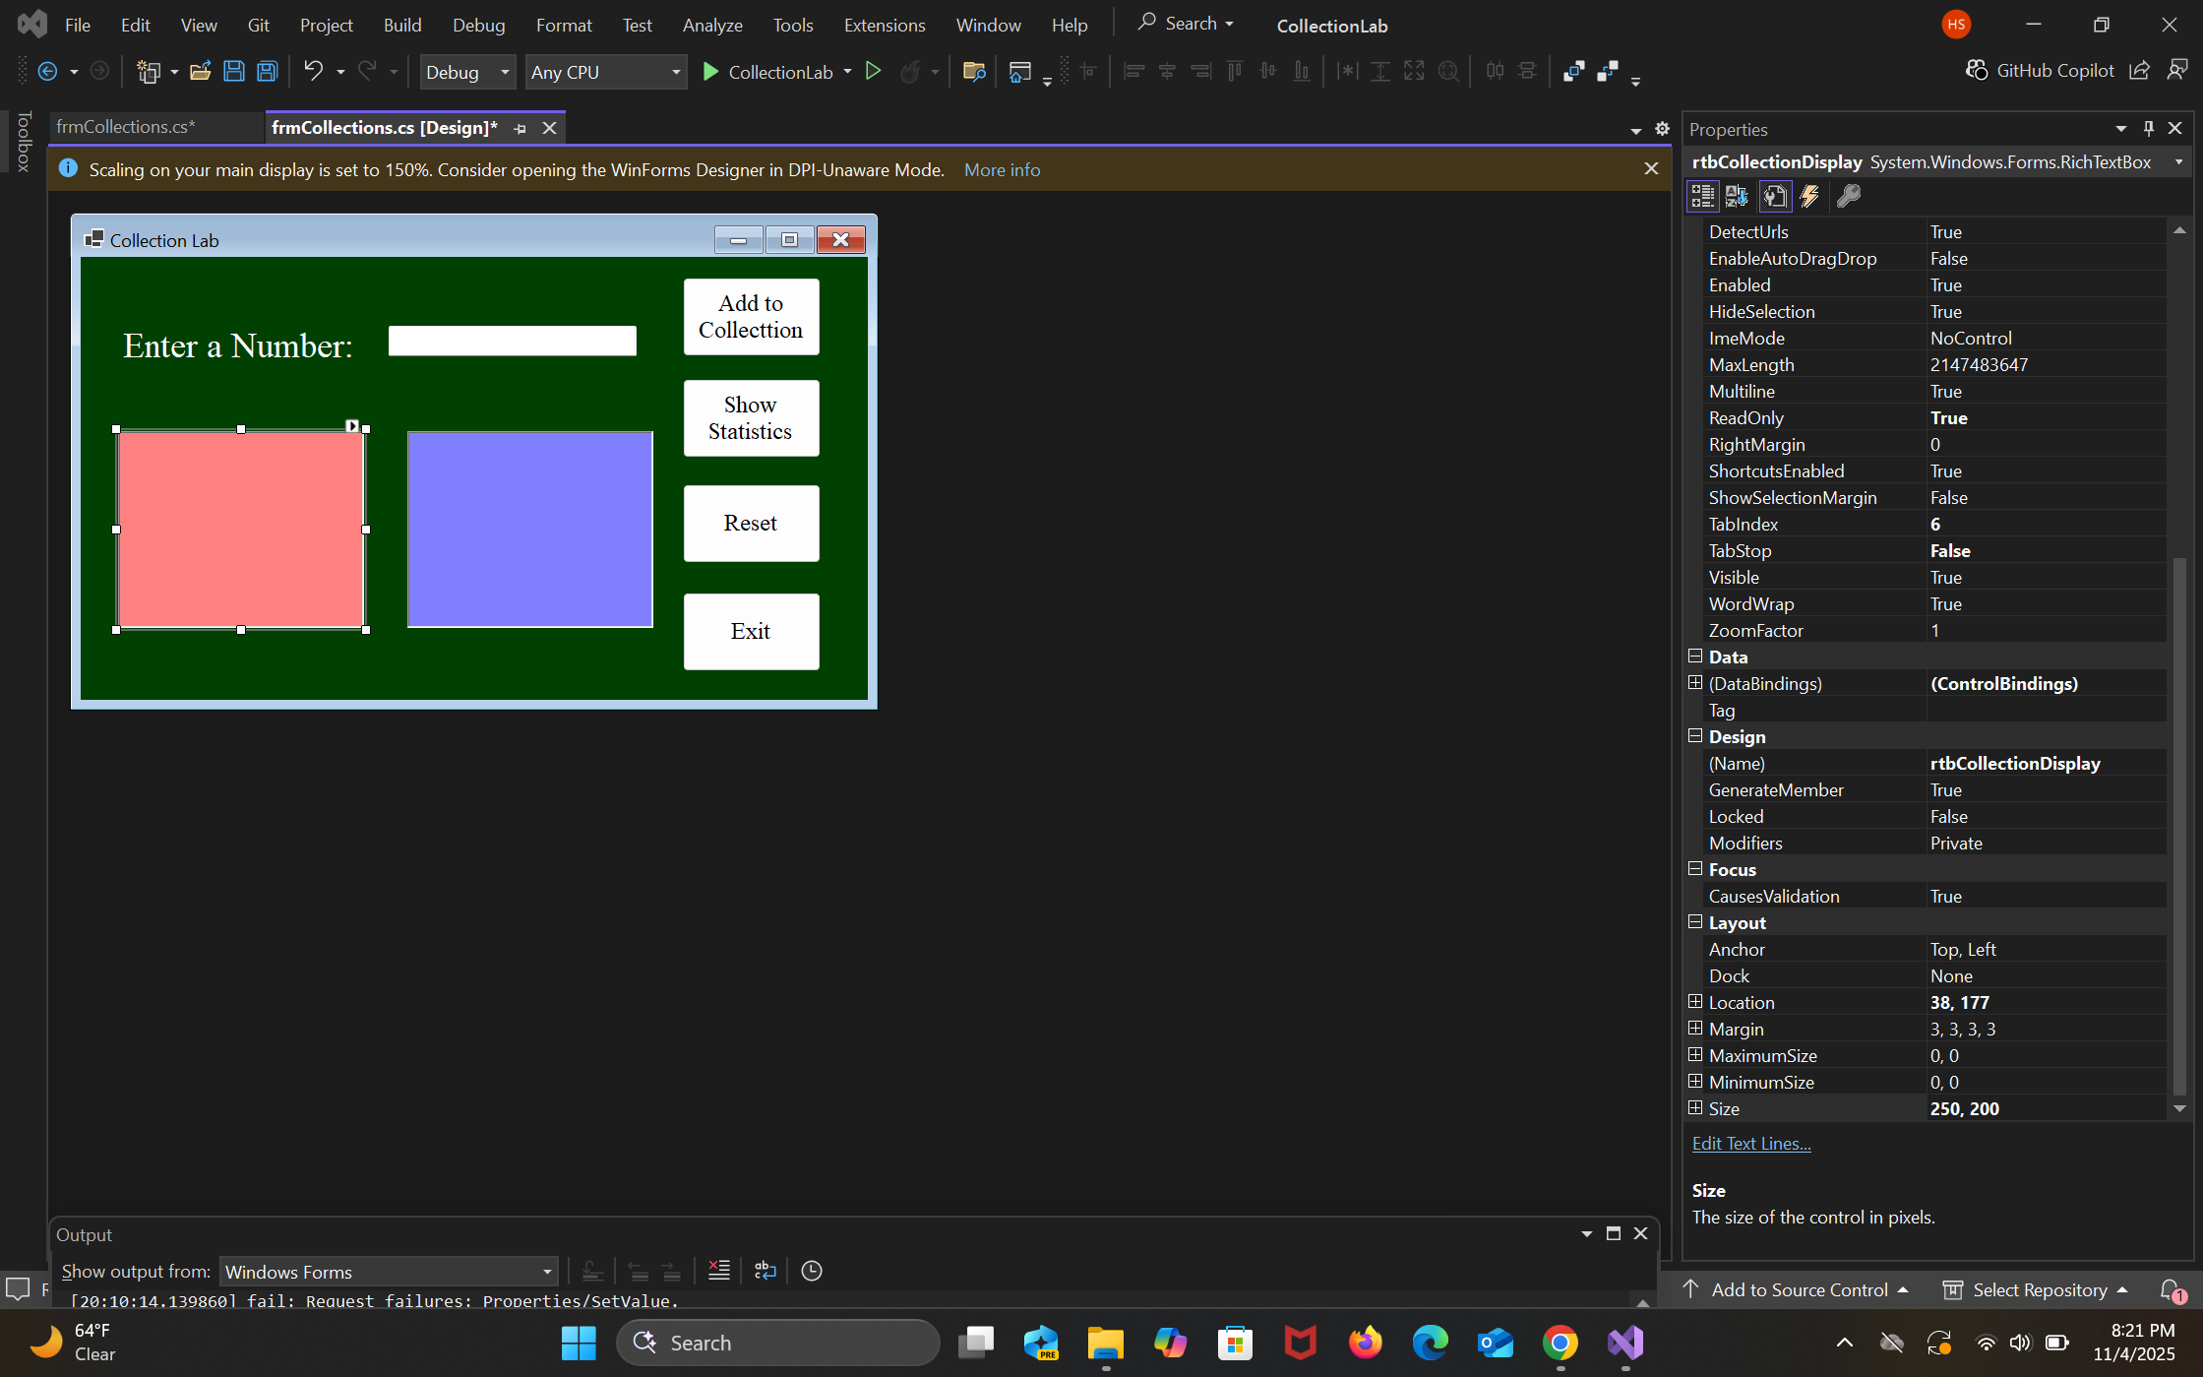

Startup Screenshot
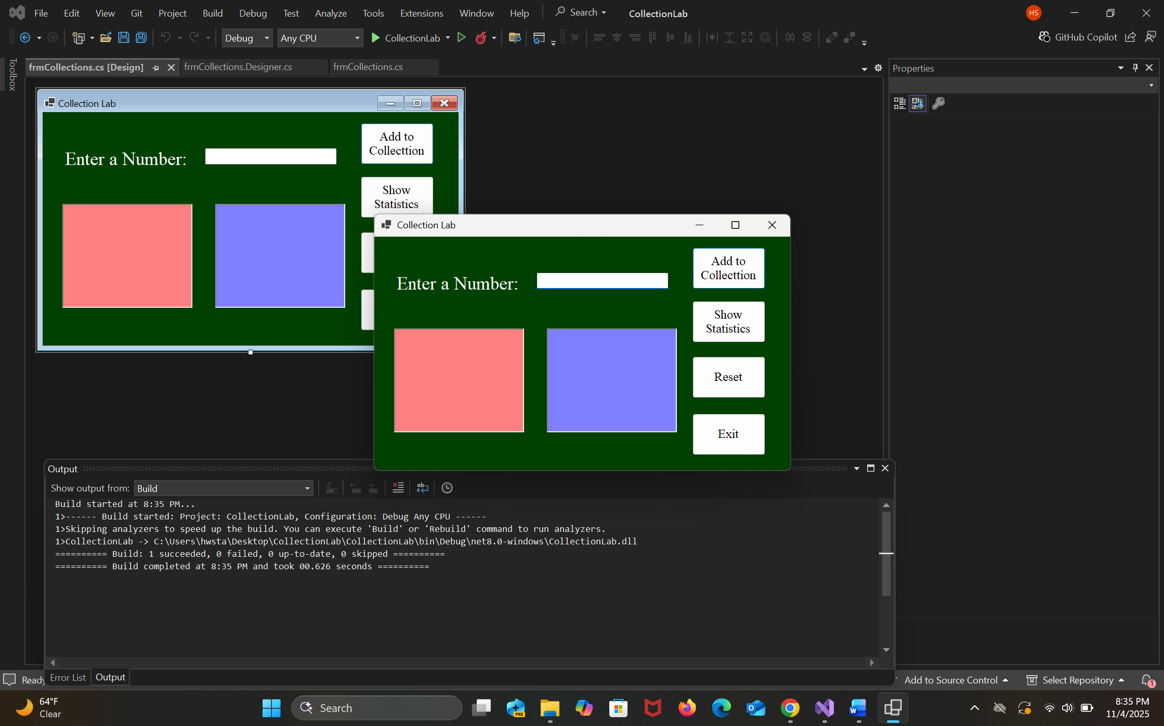

Operation Screenshots

Array with at least 9 Numbers
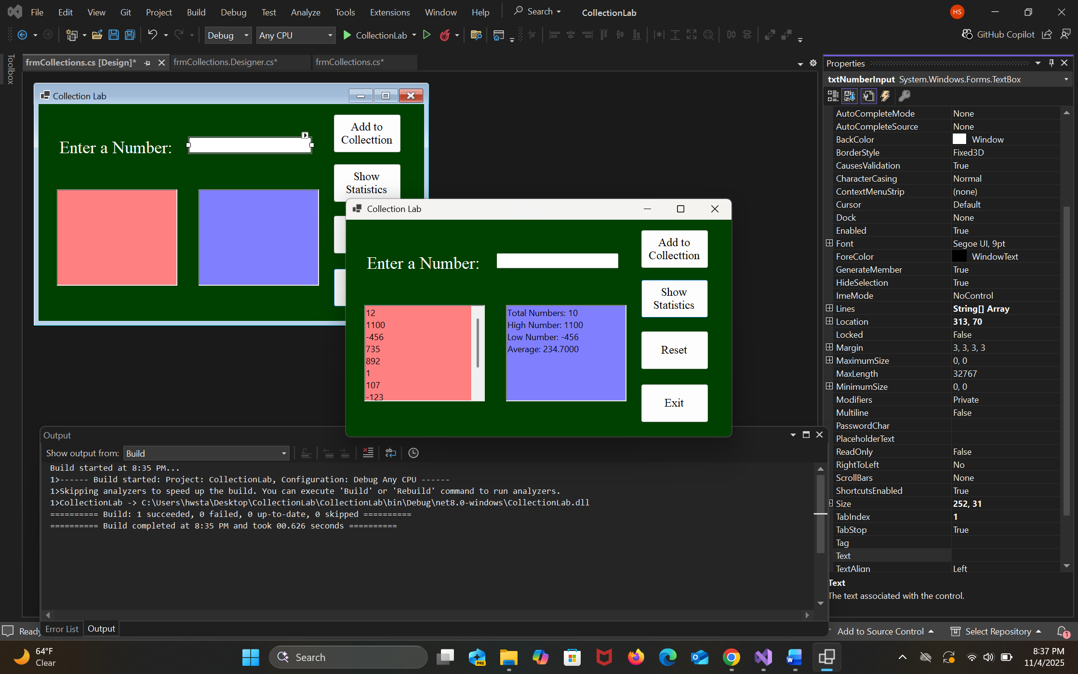
Full Collection Screenshot
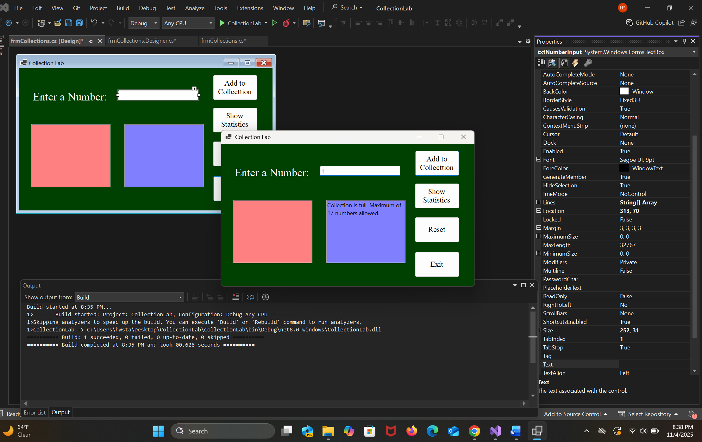

Word Input Screenshot

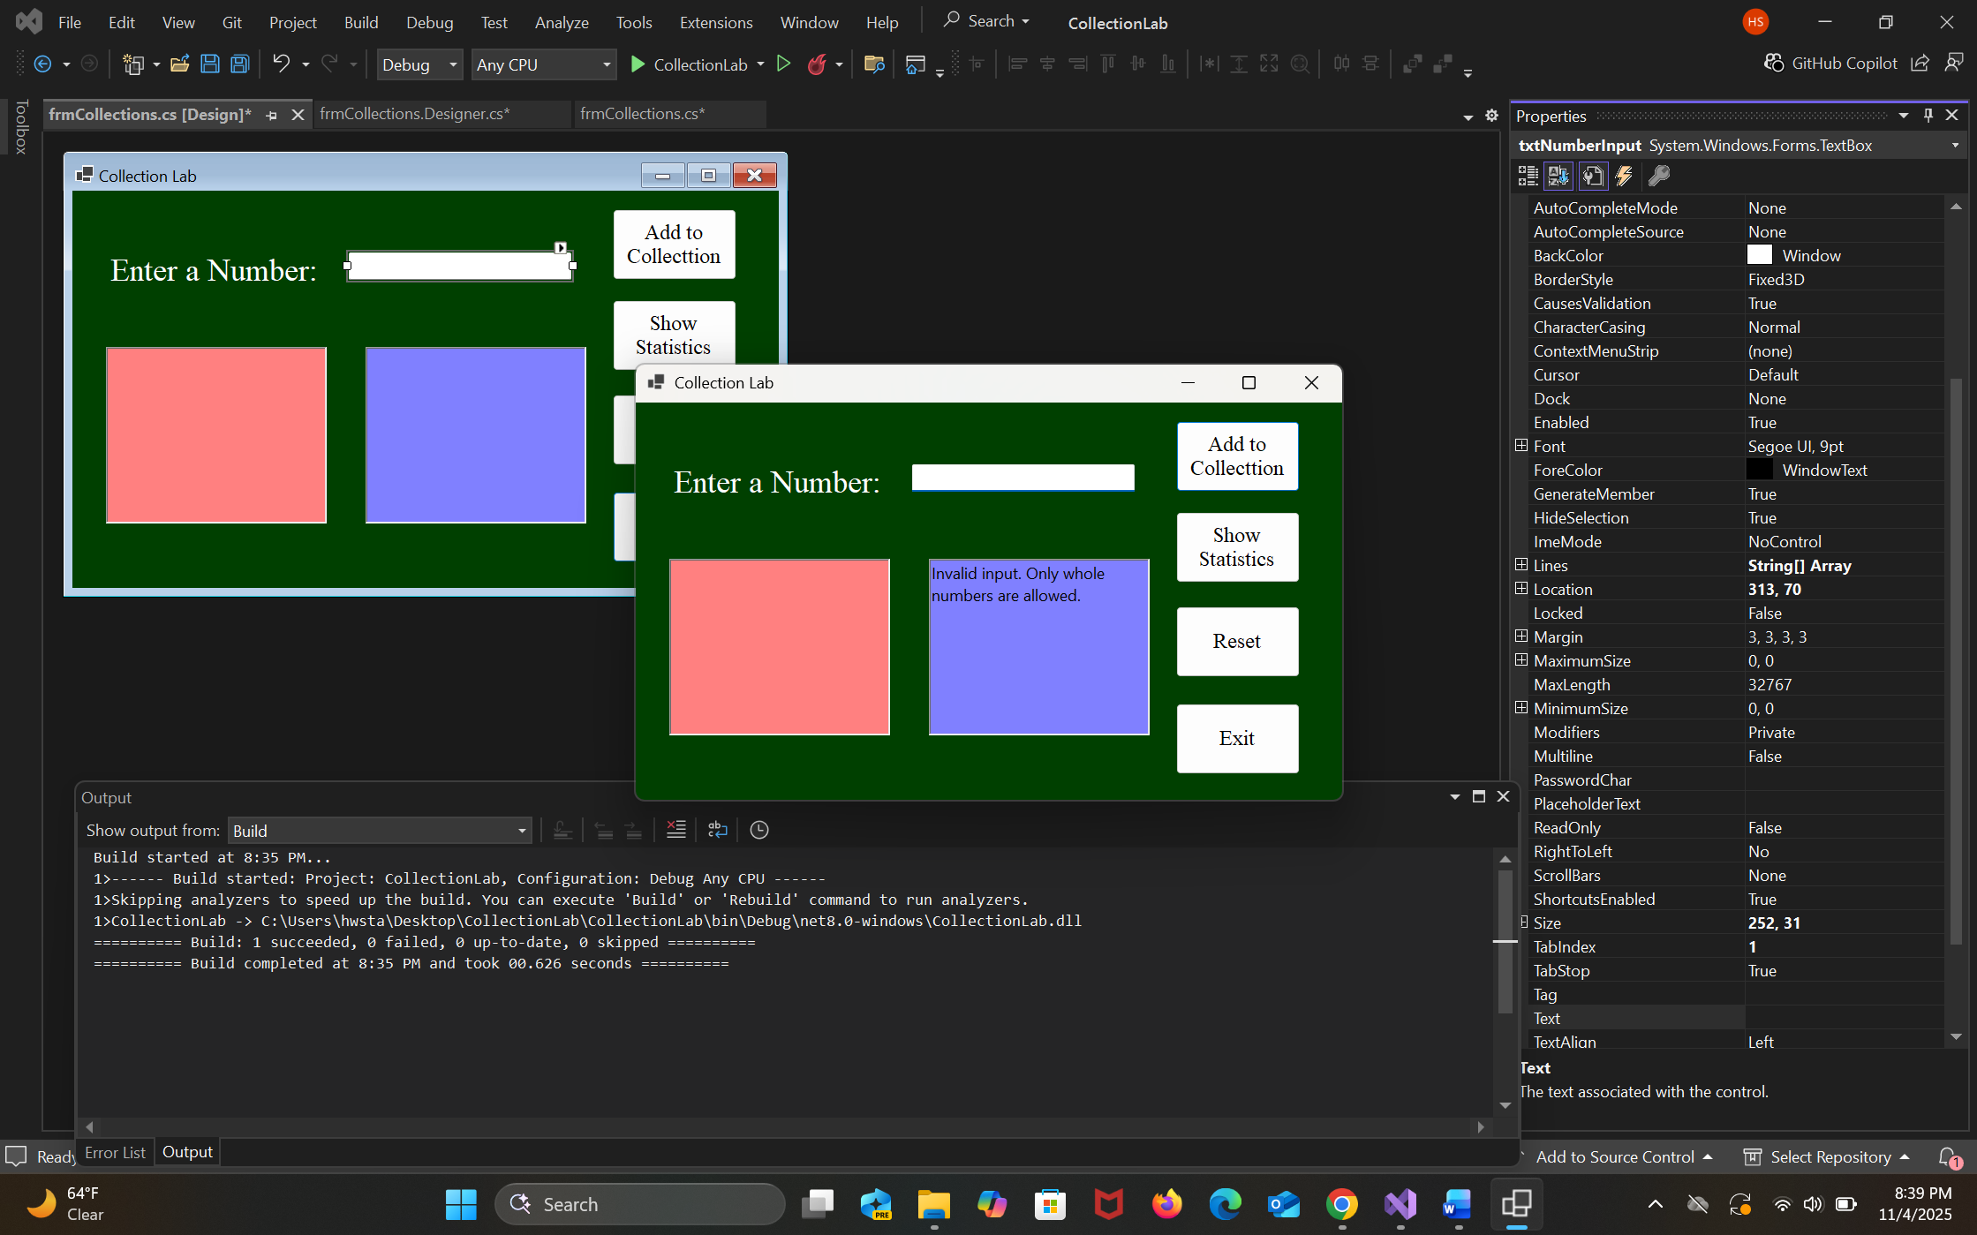

Decimal Screenshot

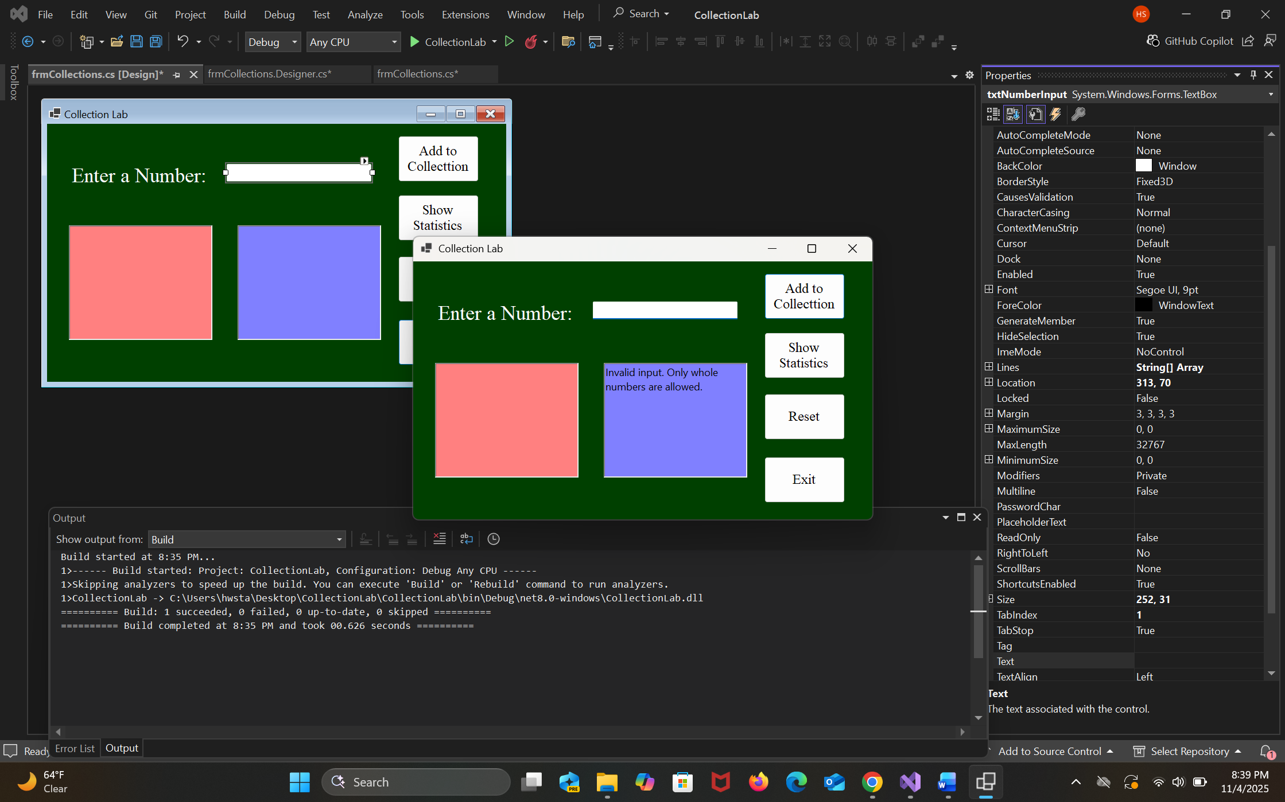

To Small

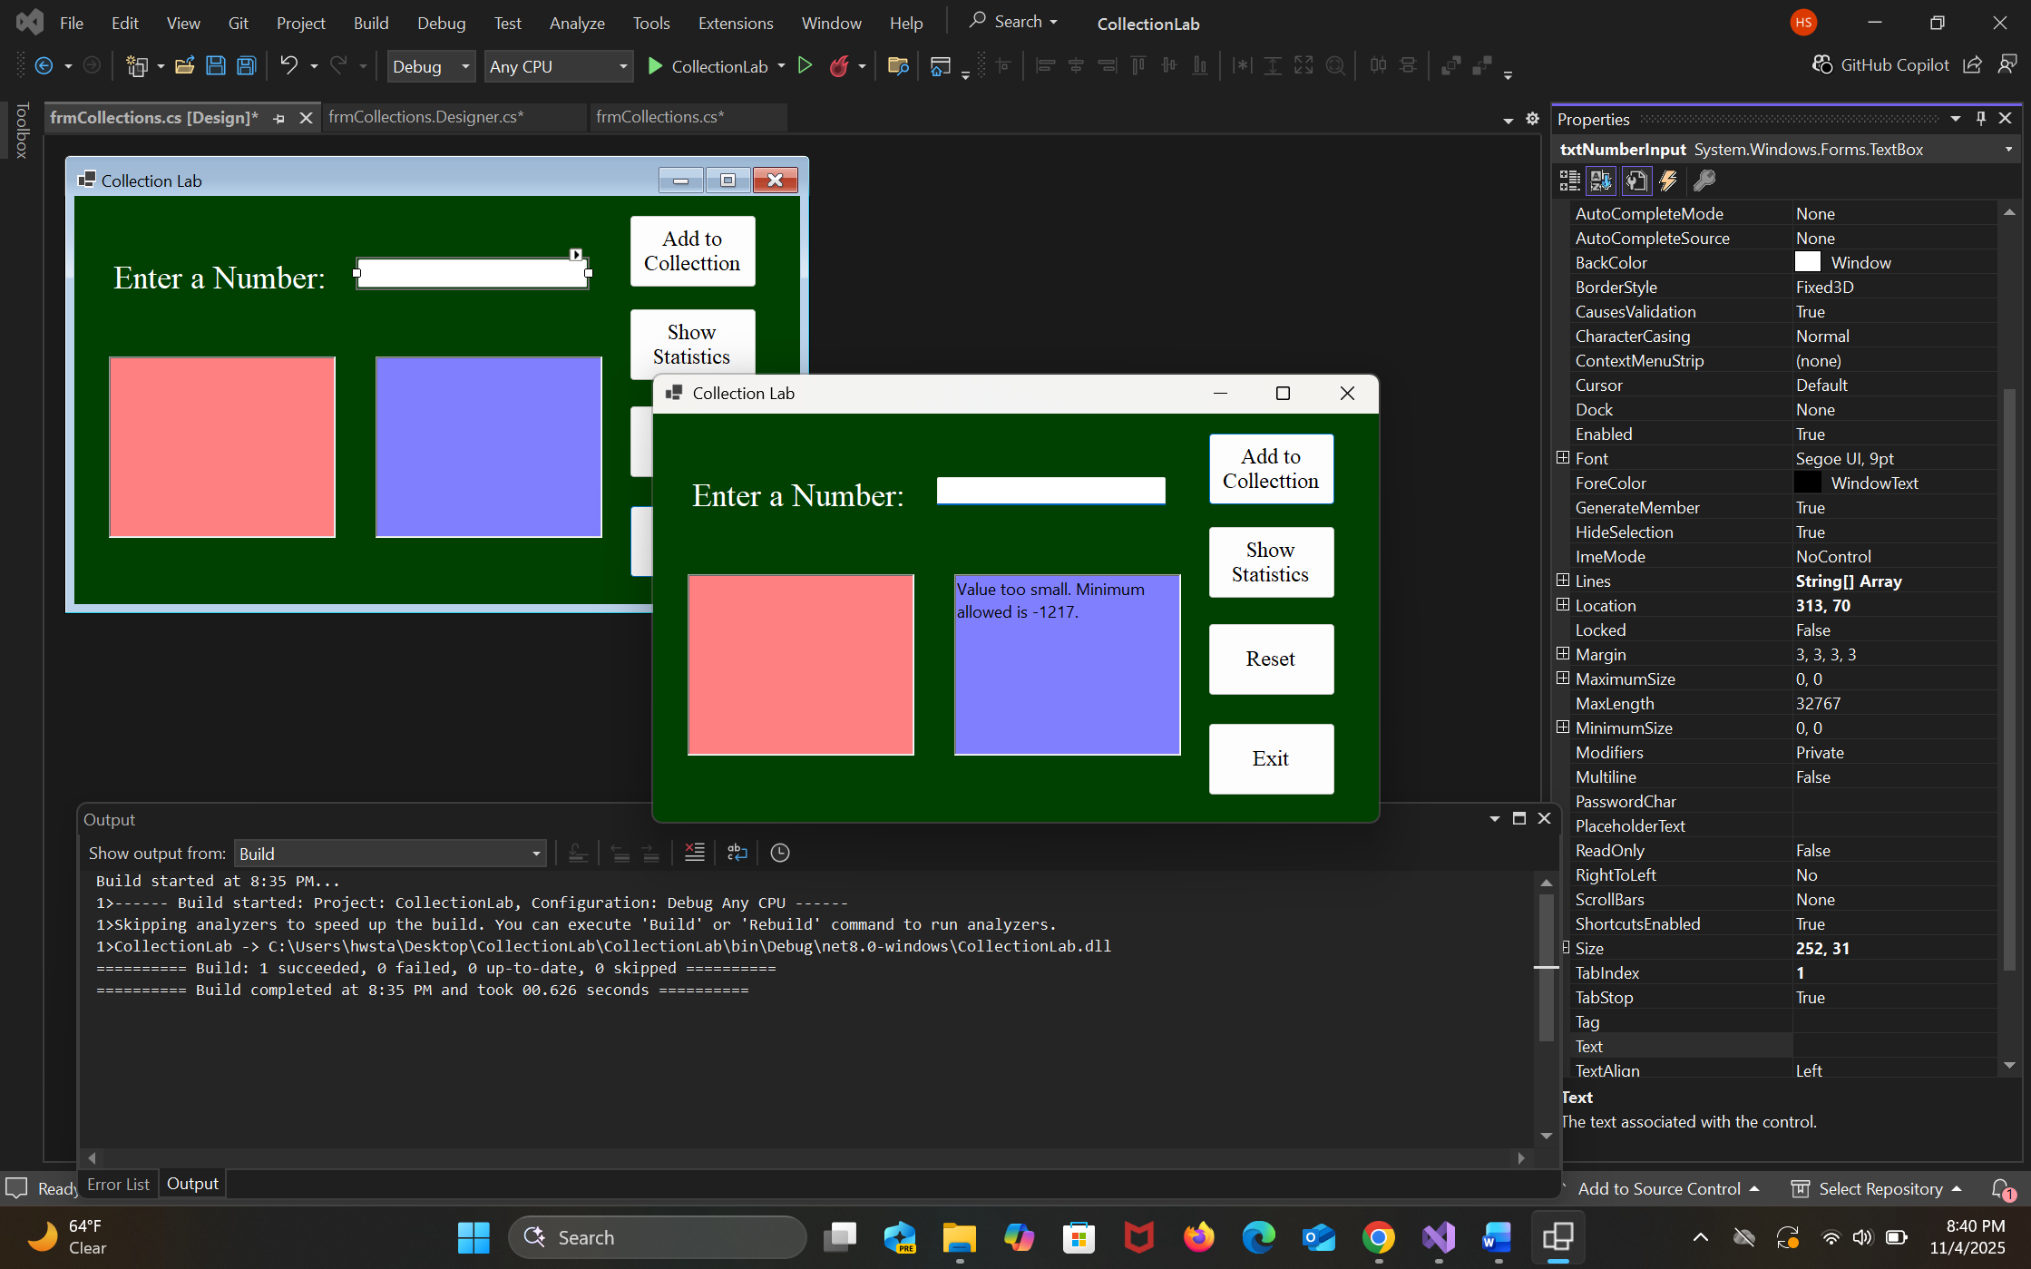

To Large

