**Contents**

1 The development of DOT (summary of four editions) 1

2 Data structure of DOT 4

2.1 Edition 1 (1939-1944) 4

2.1.1 DOT code 4

2.1.2 Entry occupational classification 5

2.2 Edition 2 (1949-1955) 5

2.2.1 DOT code 5

2.3 Edition 3 (1965-1966) 5

2.3.1 DOT code 6

2.3.2 Worker trait components (1965) 7

2.3.3 Characteristics of occupations (1966) 8

2.4 Edition 4 (1977-1991) 11

2.4.1 DOT code 11

2.4.2 Occupational title 12

2.4.3 Characteristics of occupations (1981) 12

2.4.4 Characteristics of occupations (1993) 15

2.4.5 HAJ (Handbook for Analyzing Books) 17

3 Transition from DOT to the O*NET system 17

# The development of DOT (summary of four editions)

The Dictionary of Occupational Titles (DOT) refers to a publication produced by the [United States Department of Labor](https://en.wikipedia.org/wiki/United_States_Department_of_Labor) which helped employers, government officials, and workforce development professionals to define over 13,000 different types of work, from 1938 to the late 1990s.

|  |  |  |  |  |  |
| --- | --- | --- | --- | --- | --- |
| Edition | Version | Year | No. Job titles | DOT Excel | DOT Book |
| 1 | 1 | 1939 | 32608 | *Crosswalk\DOT\Excel\DOT_1ed_1939.xlsx* | *Crosswalk\DOT\DOTbook\1939_1edition.pdf (Definition of Titles),*  *…\1939_1edition_2.pdf,*  *…\DOT_1939_Suppl.pdf,*  *…\DOT_1939_Part_I_June.pdf,*  *…\DOT_1939_Part_II_June.pdf*  *（Group Arrangement of Occupational Titles and Codes）,*  *…\DOT_1939_Part_II_June.pdf (2) (Same),*  *…\DOT_1939_Part_II_June.pdf (3) (Same),*  *…\DOT_1939_Part_III_June.pdf*  *(Conversion Table)[1]* |
| 2 (suppl.) | 1943 | 7310 | *Crosswalk\DOT\Excel\DOT_1ed_1943_Suppl.xlsx* | *Crosswalk\DOT\DOTbook\1943_1ed_suppl.pdf,*  *…\1943_1ed_suppl_2.pdf* |
| 3 (suppl.) | 1944 | / | */* | *Crosswalk\DOT\DOTbook\DOT_1944_Part_IV.pdf*  *(Entry Occupational Classification)*  *…\1944_1edition_4_dup.pdf (Same)* |
| 2 | 1 | 1949 | 43845 | *Crosswalk\DOT\Excel\DOT_2ed_1949.xlsx* | *Crosswalk\DOT\DOTbook\1949_2ed_1.pdf,*  *…\DOT_2ed_1949_V1 (2).pdf,*  *…\DOT_2ed_1949_V1 (3).pdf,*  *…\DOT_2ed_1949_V1 (4).pdf,*  *…\DOT_2ed_1949_V1_UMinnesota.pdf,*  *…\DOT_2ed_1949_V2.pdf,*  *…\DOT_2ed_1949_V2_UMinnesota.pdf* |
| 2 (suppl.) | 1955 | 5829 | *Crosswalk\DOT\Excel\DOT_2ed_1955 suppl..xlsx* | *Crosswalk\DOT\DOTbook\1955_2ed_suppl.pdf*  *(1322 new code numbers)*  *…\DOT_2ed_1955_Suppl_1.pdf (Same)* |
| 3 | 1 | 1965 | 23334 | *Crosswalk\DOT\Excel\Crosswalk_1949 2ed_to_1965 3ed(XG&XY).xlsx* | *Crosswalk\DOT\DOTbook\1965_3edition.pdf,*  *…\DOT_3ed_1965_v1.pdf,*  *…\DOT_3ed_1965_V2.pdf,* |
| 2 (suppl.) | 1966 | 13718 | *Crosswalk\DOT\Excel\DOT_3ed_1966.xls* | *Crosswalk\DOT\DOTbook\DOT_3ed_rev_1966.pdf,*  *…\1966_3edition_supp.pdf, (****SCO****[2])*  *…\DOT_3ed_rev_1966_Suppl.pdf (Same)* |
| 2 (suppl.) | 1968 | / | */* | *Crosswalk\DOT\DOTbook\DOT_3ed_1968_Suppl_II.pdf (****SCO****)* |
| 4 | 1 | 1977 | 28601 | *Crosswalk\DOT\Excel\DOT_4ed_1977.xlsx* | *Crosswalk\DOT\DOTbook\1977_4edition.pdf,*  *…\DOT_4ed_rev_1977.pdf* |
| 2 (suppl.) | 1979 | / | */* | *Crosswalk\DOT\DOTbook\DOT_3ed_to_4ed_1979.pdf*  *(Conversion Table of Code and Title Changes 3ed to 4ed)* |
| 3 (suppl.) | 1981 | / | */* | *Crosswalk\DOT\DOTbook* *DOT_1981_Suppl.pdf (****SCO****)* |
| 4 (suppl.) | 1991 | 29384 | *Crosswalk\DOT\Excel\DOT_4ed_1991.xlsx* | *Crosswalk\DOT\DOTbook\DOT_4ed_rev_1991_v1.pdf,*  *…\DOT_4ed_rev_1991_v2.pdf,*  *Crosswalk\DOT\DOTbook*DOT1991-4ed-v1-v2\1DictionaryofOccupational (1).pdf,  *…*1DictionaryofOccupational (12).pdf,  *…*1DictionaryofOccupational (13).pdf,  *…*2DictionaryofOccupational (6).pdf,  *…*2DictionaryofOccupational (7).pdf |
| 5(suppl.) | 1993 | / | */* | *Crosswalk\DOT\DOTbook\DOT_1993_Suppl.pdf (****SCO****)* |

# Data structure of DOT

## Edition 1 (1939-1944)

Example:

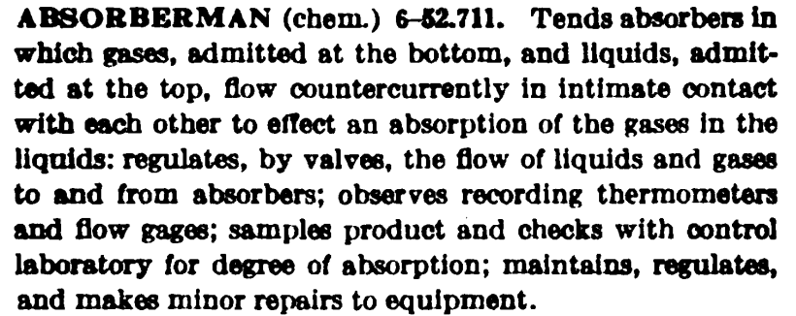

Where you can find:

All occupations with code and title, listed numerically

*Crosswalk\DOT\DOTbook\DOT_1939_Part_II_June.pdf, p32-339.*

### DOT code[3]

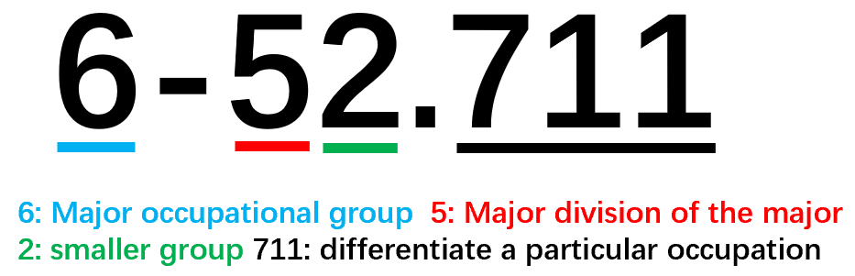

5-6 digits (6 digits only used for skilled and semiskilled occcupations)

7 major occupational groups (differentiated by the first digit):

0 – Professional and managerial occupations

1 – Clerical and sales occupations

2 – Service occupations

3 – Agricultural, fishery, forestry, and kindred occupations

**4&5 – Skilled occupations**

**6&7 – Semiskilled occupations**

**8&9 – Unskilled occupations**

Example:

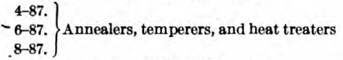 

### Entry occupational classification[4]

For applicants who lack significant work experience or who have noy reached occupational maturity, describing fields of work, not specific occupations.

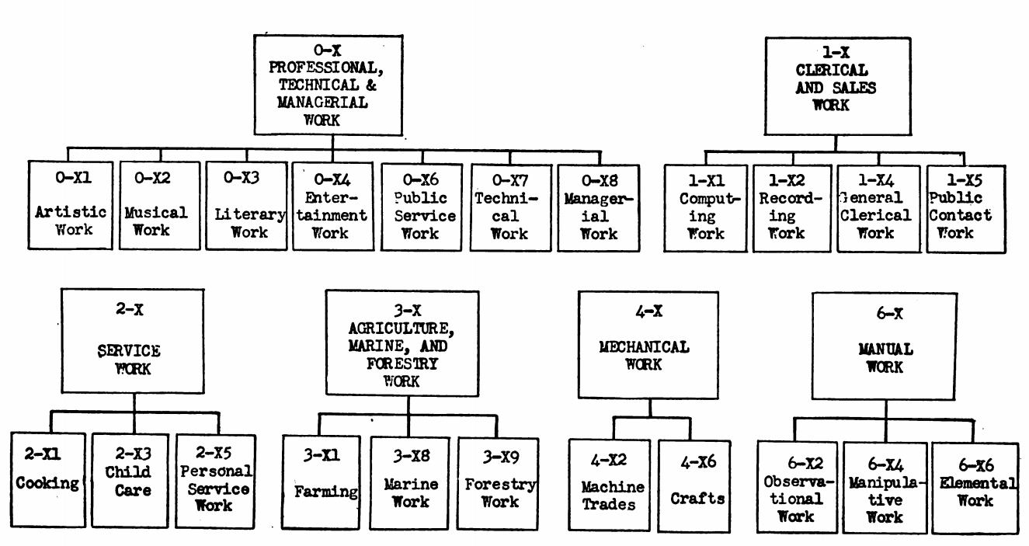

## Edition 2 (1949-1955)

Example:

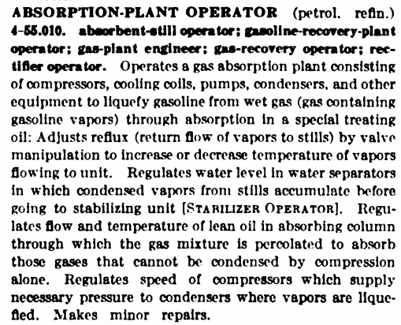

### DOT code

The same as Edition 1.

## Edition 3 (1965-1966)

Example:

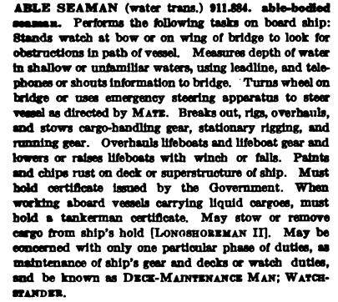

### DOT code[5]

1. **Occupational Group Arrangement** (refer to the first 3 digits)



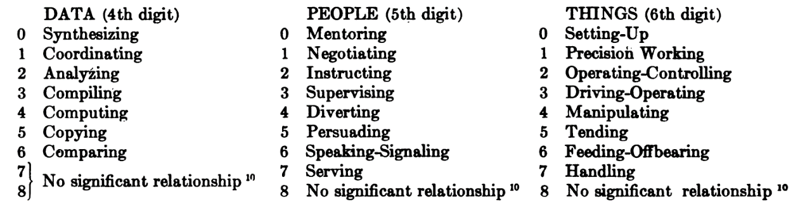

For each relationship, the smaller the number is, the complex the occupation is.

1. **Worker Traits Arrangement** (refer to the last 3 digits)

Jobs are grouped according to some combination of required GED, SVP, aptitudes, interests, temperaments, and physical demands. There are 114 such worker trait groups, organized within the 22 broad areas of work.

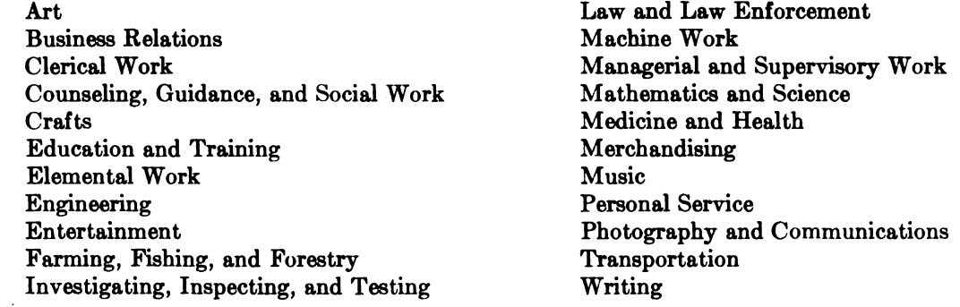

### Worker trait components (1965)[6]

Where you can find the profile for each worker trait group:

*Crosswalk\DOT\DOTbook\DOT_3ed_1965_v2.pdf, P239-542.*

Example:

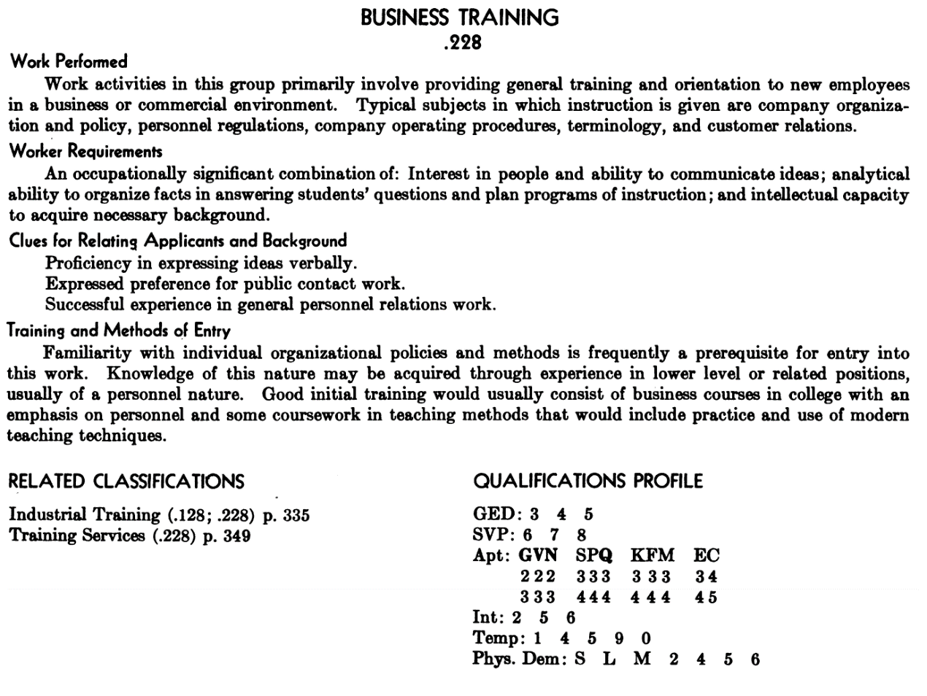

1. **Training time – GED\***
2. **Training time – SVP\***
3. **Aptitudes(11)**

G–intelligence, V–verbal, N-numerical, S-Spatial, P-form perception, Q-clerical perception, K-motor coordination, F-finger dexterity, M-manual dexterity, E-eye-hand-foot coordination, C-color discrimination

Levels: 1-the top 10% of the population

2-the highest third exclusive of the top 10%

3-the middle third of the population

4-the lowest third exclusive of the bottom 10%

5-the lowest 10%

1. **Interests**

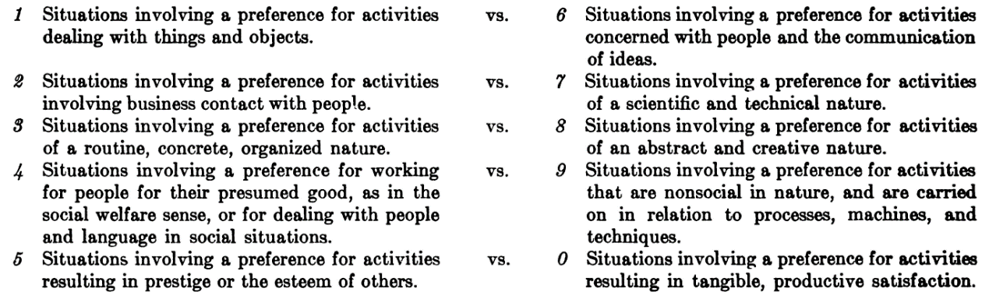

1. **Temperaments**

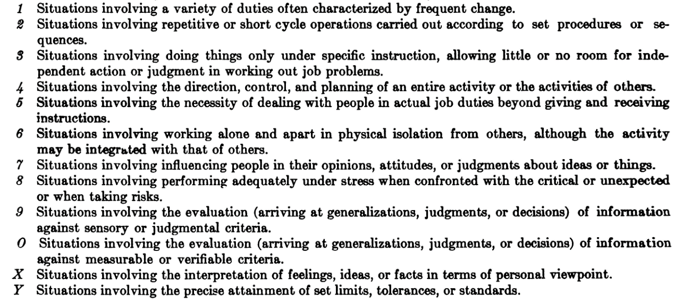

1. **Physical demands\***
2. **Working conditions\***

* The same as SCO.

### Characteristics of occupations (1966)[7]

Components of the definition trailer (1991)[8] & Characteristics of occupations (1966 & 1981)[9]

|  |  |  |  |  |  |  |
| --- | --- | --- | --- | --- | --- | --- |
|  | (1965) | 1966 | 1968 | 1981 | 1991 | 1993 |
| GOE |  |  |  | √ | √ | √ |
| SL | √ | √ | √ | √ | √ | √ |
| GED | √ | √ | √ | √ | √ (only M & L) |  |
| SVP | √ | √ | √ | √ | √ | √ |
| Environmental conditions | √ | √ | √ |  | √ | √ |

1. **Physical demands[10]**
2. Lifting, carrying, pushing, and/or pulling (Strength Level)
3. Climbing and/or balancing
4. Stooping, kneeling, crouching, and/or crawling
5. Reaching, handling, fingering, and/or feeling
6. Talking and/or hearing
7. Seeing

S-Sedentary, L-Light Work, M-Medium Work, H-Heavy Work, V-Very Heavy Work

1. **Working conditions[11]**

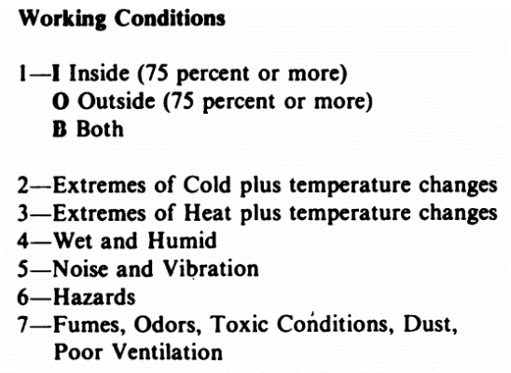

1. **Training time – GED (general educational development)[12]**

Aspects of education (formal and informal) which contributes to the worker’s (a) reasoning development and ability to follow instructions, and (b) acquisition of “tool” knowledges, such as language and mathematical skills.

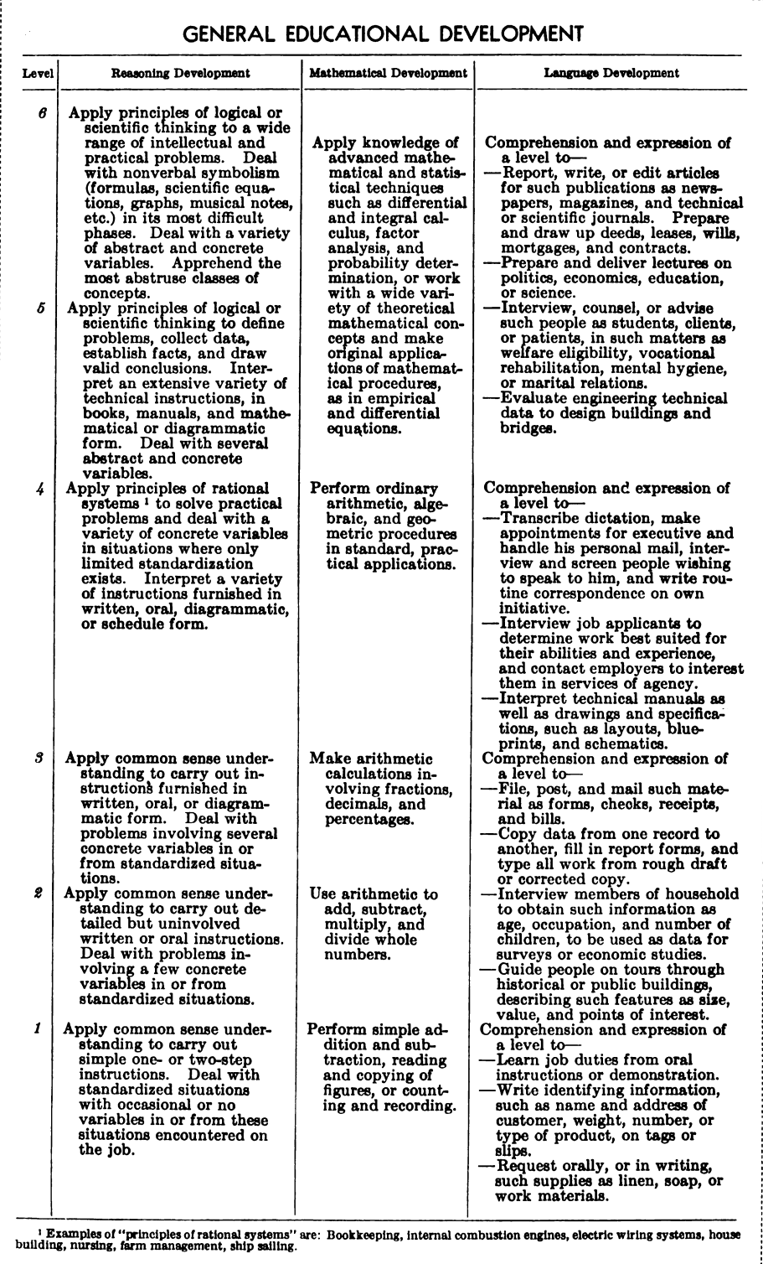

1. **Training time – SVP (specific vocational preparation)[13]**

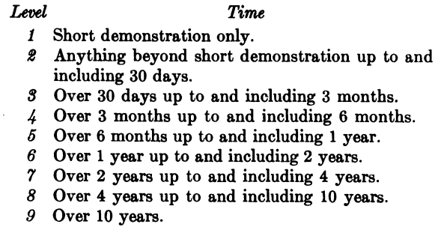

## Edition 4 (1977-1991)

Example:

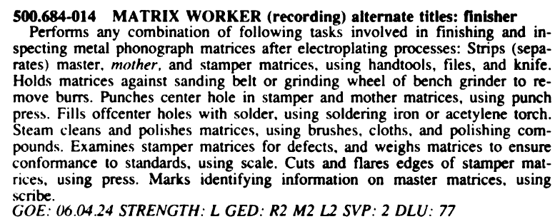

Where you can find:

All occupations with code, title, definition, and components of the definition trailer

*Crosswalk\DOT\DOTbook\DOT_4ed_rev_1991_v1.pdf, p54-450.* &

*Crosswalk\DOT\DOTbook\DOT_4ed_rev_1991_v2.pdf, p8-486.*

### DOT code

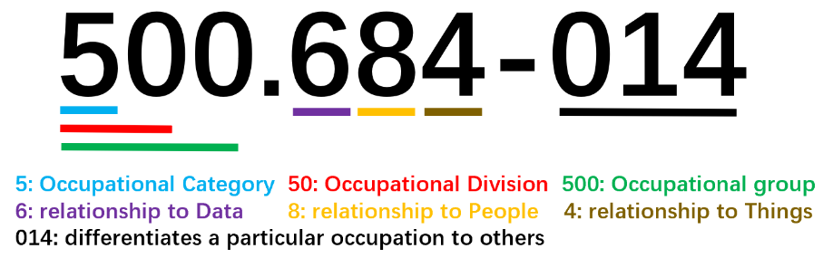

*New divisions added to the DOT classification structure[14]

|  |  |  |
| --- | --- | --- |
| Division | Group | Year |
| 03 COMPUTER-RELATED OCCUPATIONS |  | 1991 |

The fourth, fifth, and sixth digits of the code reflect relationships to **Data, People, and Things.[15]**

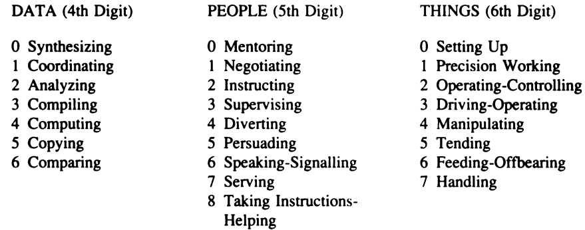

For each relationship, the smaller the number is, the complex the occupation is.

### Occupational title

1. Base title: most common type of title.
2. Master title: at the end of each individual occupation, the reader is referred to the master definition, in order to eliminate unnecessary repetition of tasks common to a large number of occupations.

Example:

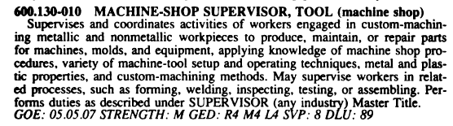

1. Term title: occupations with the same title but few common duties.
2. Alternate titles: synonym for the base title (e.g. finisher)
3. Undefined related titles: indicates a variation or specialization of the base occupation.
4. Industry designation: in parentheses following the base title, differentiating between occupations with identical titles but different duties. (e.g. machine shop)

### Characteristics of occupations (1981)

1. **GOE (Guide for occupational exploration)**

Designed by the US Employment Service to provide career counselors and other DOT users with additional information about their interests, aptitudes, entry level preparation and other traits required for successful performance in various occupations.

The GOE coding structure classified jobs at three levels[16]:

1st level: 12 interest areas (the first two-digit code)

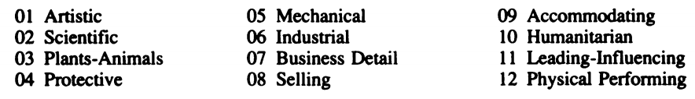

2nd level: subdivides interest areas into work groups (the second two-digit code)

Occupations with smaller number require more education, training, and experience.

3rd level: subdivided work groups into subgroups (the third two-digit code)

Individual occupations are listed alphabetically.

1. **SL (Strength level / physical demands)**

Three groups of activities:

1. Standing, Walking, Sitting
2. Lifting, Carrying, Pushing, Pulling
3. Controls

Five levels of rating:

S-Sedentary, L-Light Work, M-Medium Work, H-Heavy Work, V-Very Heavy Work

1. **GED (General educational development)**

Indicates the aspects the education (formal & informal) which are required of the worker for satisfactory job performance.

Three divisions: reasoning, mathematical, language

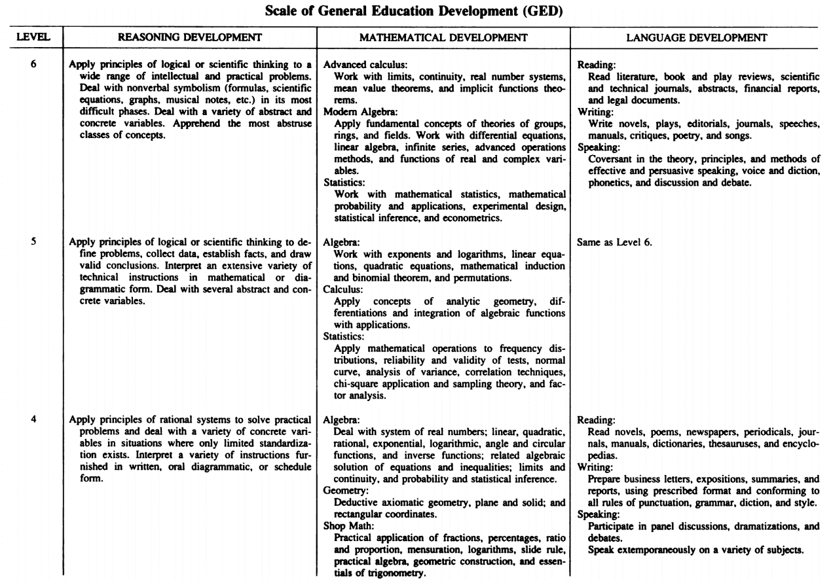

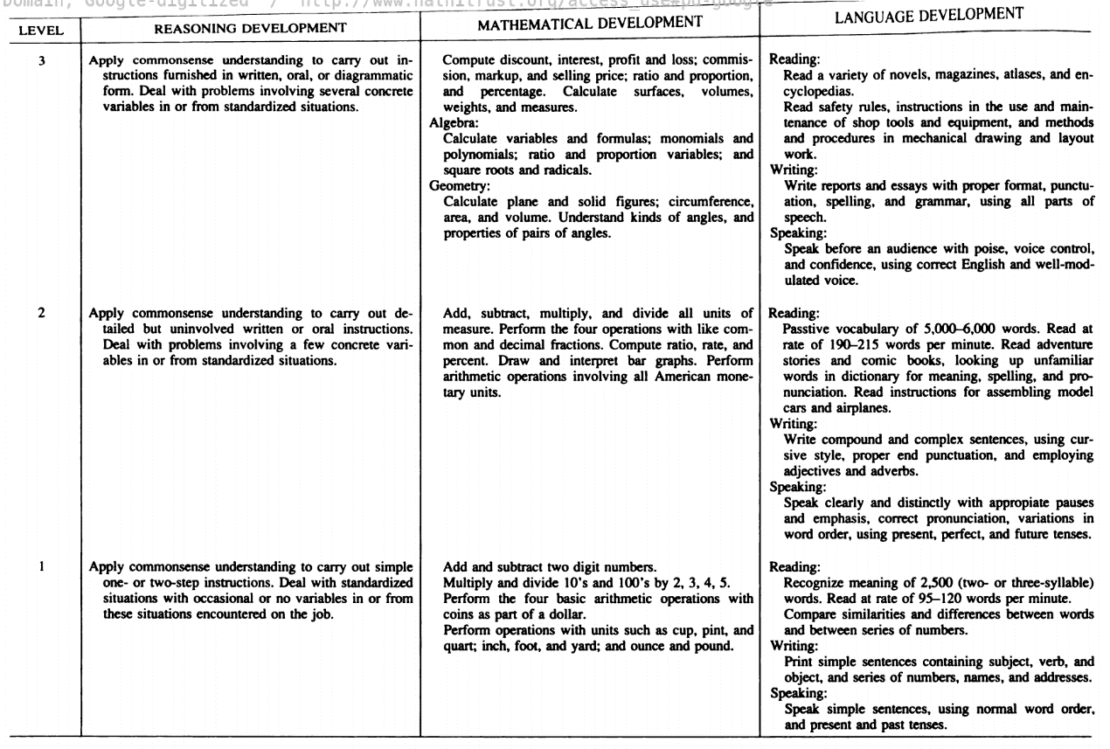

1. **SVP (Specific vocational preparation)**

Defined as the amount of time required by a typical worker for training.

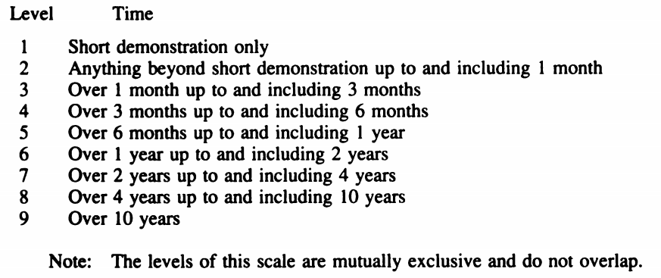

* SVP (DOT) & Job Zone (O*NET)

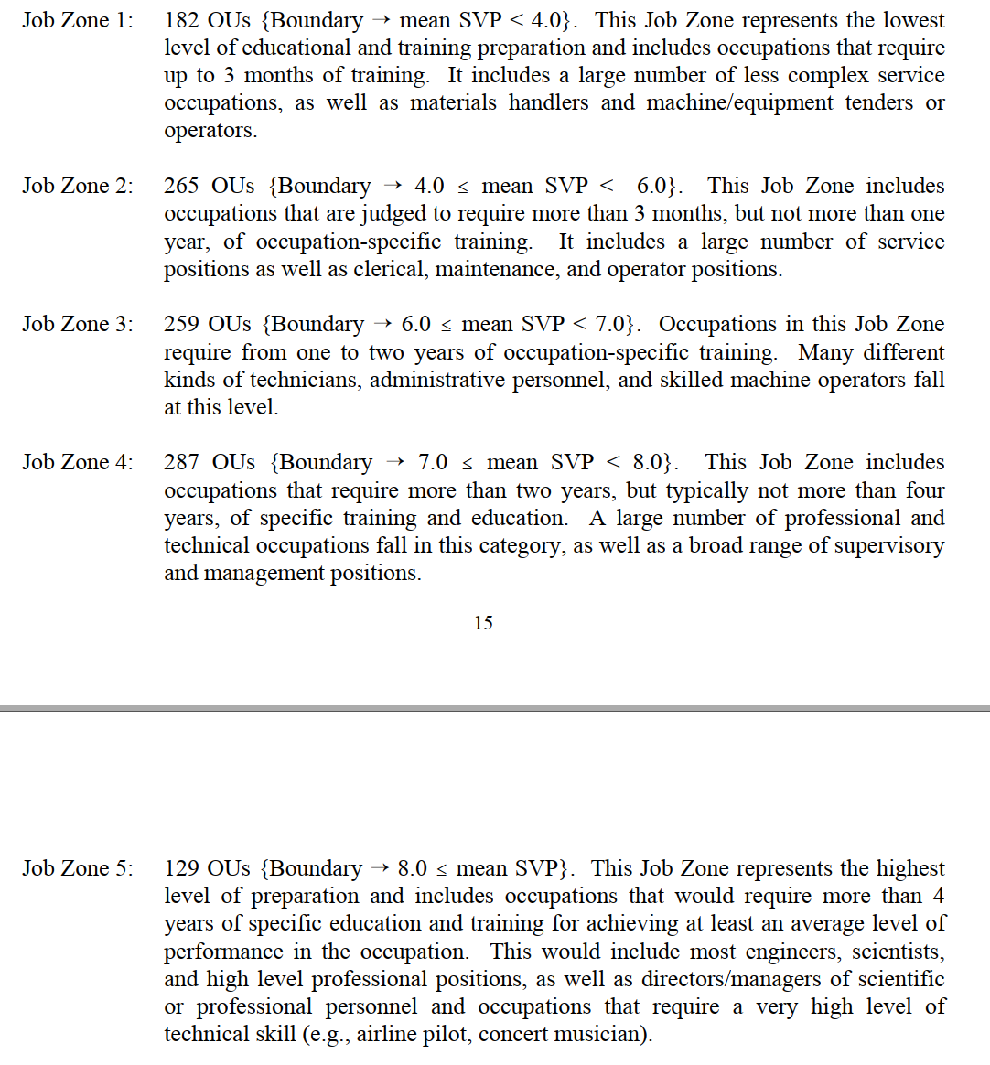[17]

1. **DLU （Date of last update）**

e.g. “77” means that the occupation has not been studies since 1977.

1. **Environmental conditions**

The physical surroundings of an individual in a specific job-worker situation, such as noise, fumes, odors, toxic conditions and so on.



### Characteristics of occupations (1993)[18]

1. **GOE**
2. **SVP**

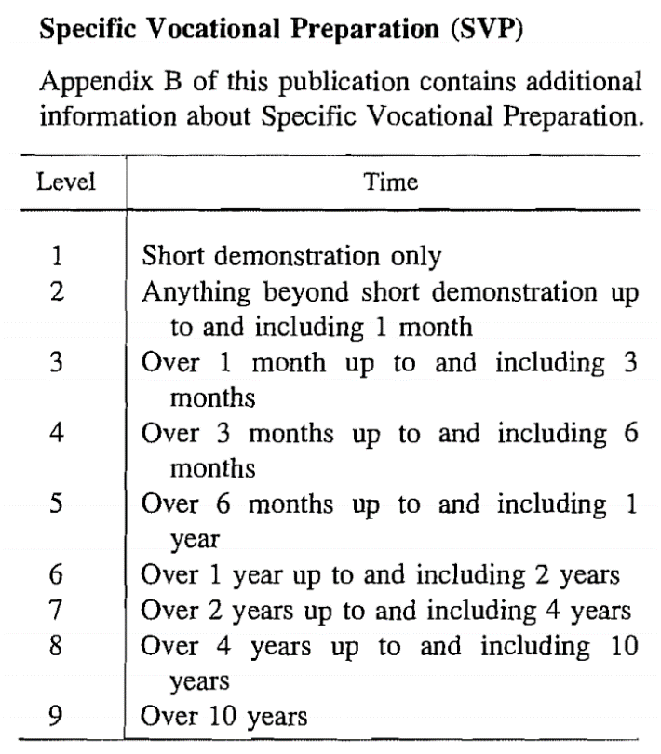

1. **SL**

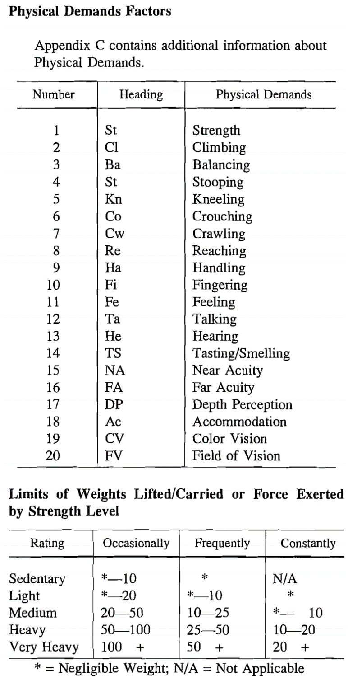

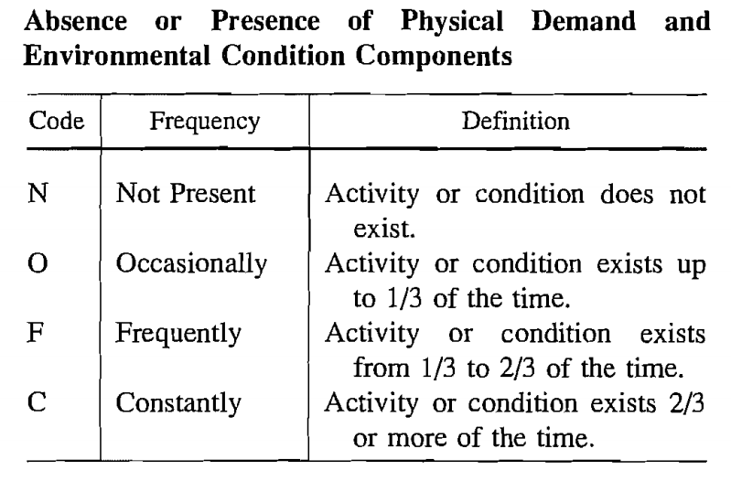

1. **Environmental conditions**

|  |  |
| --- | --- |
|  |  |

### HAJ (Handbook for Analyzing Books)

https://skilltran.com/index.php/support-area/documentation/1991rhaj

# Transition from DOT to the O*NET system

**Phase 1: Homogeneous Occupations** (based on OES)

Evaluated the NOICC crosswalk (DOT & OES[19])

Two stages: ≤4 (OES occupation – DOT job titles), >4

≤4: confirmed the crosswalk evaluation

>4: generated subclusters using 28 variables, Euclidean distance measure, Ward’s Minimum Variance procedure, unstandardized profile variables

Review and modification

|  |  |  |
| --- | --- | --- |
| Variable | DOT Job Component |  |
| Reasoning  Mathematical Language | General Educational Development (GED) | Skills |
| Specific Vocational Preparation | Specific Vocational Preparation (SVP) |
| Data  People Things | Worker Function |
| General Learning Ability  Verbal Aptitude Numerical Aptitude Spatial Aptitude Form Perception Clerical Perception Motor Coordination Finger Dexterity Manual Dexterity Eye-Hand-Foot Coordination Color Discrimination | Aptitude |
| Materials, Products, Subject Matter, and Services (3 Codes) | Materials, Products, Subject Matter, And Services | Work context |
| Work Fields | Work Fields |
| Directing  People Influencing  Expressing | Temperament |

**Phase 2: Task Statements**

**Phase 3: Rating**

Drew connection between OU and O*NET content model based on DOT narratives

Feasibility study (GWAs, Abilities, Knowledges, Skills, Work Context)

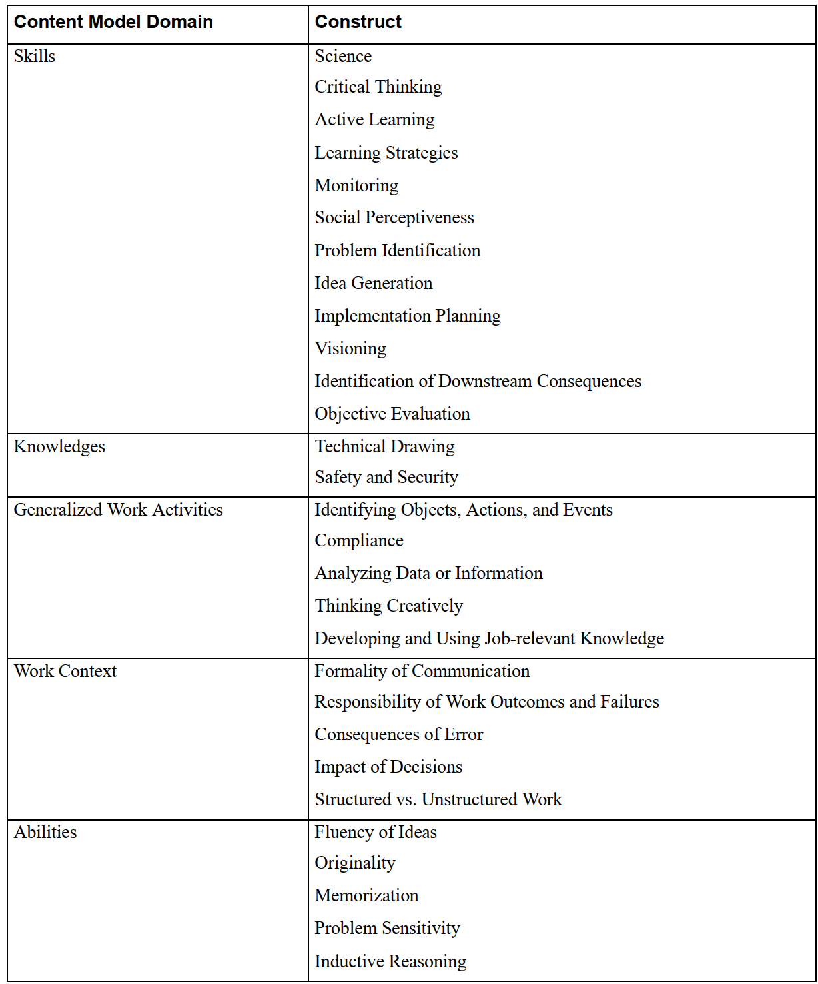

**Phase 4: Evaluating Task Statements**

1. The old code: formerly classified according to the USES occupational classification described in the Employment Office Manual Series Section B, published in July, 1936.
2. SCO, Selected Characteristics of Occupations, provides adjunct data on specific vocational training time, physical demands, and environmental conditions for employers and job-seekers, especially those with disabilities. It has four editions published in 1966, 1968, 1981, and 1993.
3. *Crosswalk\DOT\DOTbook\DOT_1939_Part_I_June.pdf, p30-34.*
4. *Crosswalk\DOT\DOTbook\DOT_1944_Part_IV.pdf*
5. *Crosswalk\DOT\DOTbook\DOT_3ed_1965_v1.pdf, P31-34.*
6. *Crosswalk\DOT\DOTbook\DOT_3ed_1965_v2.pdf, P664-669. (APPENDIX B)*
7. *Crosswalk\DOT\DOTbook\DOT_3ed_rev_1966_Suppl.pdf, p14-15.*
8. *Crosswalk\DOT\DOTbook\DOT_4ed_rev_1991_v2.pdf, p504-509 (APPENDIX C)*
9. *Crosswalk\DOT\DOTbook\DOT_1981_Suppl.pdf, p13-16.*
10. *Crosswalk\DOT\DOTbook\DOT_3ed_rev_1966_Suppl.pdf, p300-301. (APPENDIX A)*
11. *Crosswalk\DOT\DOTbook\DOT_3ed_rev_1966_Suppl.pdf, p302. (APPENDIX A)*
12. *Crosswalk\DOT\DOTbook\DOT_3ed_rev_1966_Suppl.pdf, p304. (APPENDIX A)*
13. *Crosswalk\DOT\DOTbook\DOT_3ed_rev_1966_Suppl.pdf, p304. (APPENDIX A)*
14. *Crosswalk\DOT\DOTbook\ DOT_4ed_rev_1991_v2.pdf, p498 (APPENDIX C)*
15. *Crosswalk\DOT\DOTbook\ DOT_4ed_rev_1991_v2.pdf, p500-502 (APPENDIX C)*
16. For details, see *Crosswalk\DOT\DOTbook\DOT_1981_Suppl.pdf, Part A.*
17. *Crosswalk\ONET\ONET data\onet98ac 1998.12\datadict.pdf, p701-702 (Appendix G)*
18. *Crosswalk\DOT\DOTbook\newly-found books /DOT_1993_Suppl.pdf, p619-620.*
19. OES, Occupational Employment Statistics, a semi-annual survey of approximately 200,000 non-farm business establishments conducted by the Bureau of Labor Statistics (BLS), designed to produce employment and wage estimates for about 800 occupation classifications.