# Conflict Scenario

## **Review**

### Interpersonal Conflict Management Styles

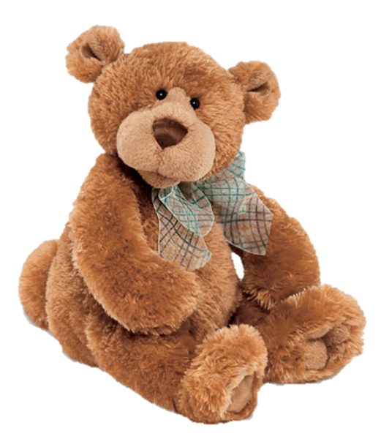

[CC 2.0 BY Matthew](https://www.flickr.com/photos/falcon1961/3304306800/)



[CC SA 3.0 Unported BY Jonathan Zander](https://en.wikipedia.org/wiki/File:Florida_Box_Turtle_Digon3.jpg)



[CC 3.0 BY Superawesomevectors](https://superawesomevectors.deviantart.com/art/Shark-Cartoon-Free-Vector-Illustration-643399222)



[CC0](https://pixabay.com/en/urban-lost-hiding-afraid-1002149/)

Low to High Concern for Other

Concern for Self



CC SA 2.0 Generic BY [Carine06 from UK](https://commons.wikimedia.org/wiki/File:Flickr_-_Carine06_-_%22I_give_up.%22.jpg)



CC 2.0 BY [Zabara Alexander](https://www.flickr.com/photos/zabara_tango/6955720271)



[CC0](https://commons.wikimedia.org/wiki/File:US_Army_53525_Soldiers_compete_in_Tae_Kwon_Do_tournament_for_Warrior_Country_level.jpg)

### **Interpersonal Conflict Resolution**

The following diagram shows a process that can be followed when trying to resolve interpersonal conflict.

### Listening

A considerable proportion of our communication involves listening, yet little attention is devoted to improving listening. HURIER is an acronym for tips that can be used to improve listening.

### “I” Phrases for Conflict Resolution

The “I” phrase is used during conflict resolutions to avoid attacking others. Open the conversation with a statement in first person, passive voice: “I feel … when … because … I would like …”

Adapted from (Dwyer 2012, p. 40)

## **Student Name and ID:** Joseph Hunt 12196064

## **Student Name and ID:** Therisa Mews 12190349

## **Scenario**

Find a partner. Read the scenario below. Choose one partner to be Joe Bloggs, and the other to be Jane Doe. Together, answer the following to help prepare you for the role play.

## **Scenario: Joe did not complete a task by the deadline**

Joe and Jane are working on a report that is due today. Joe was assigned the task of writing the executive summary. Unfortunately, Joe has not completed the task.

What is the most appropriate conflict management strategy for Jane to use in this situation? (Choose one)

Compete/Force

Compromise

Avoid/Withdraw

Collaborate/Confront

Accommodate/Smooth

Why did you choose the above conflict management strategy?

This was chosen because sometimes students are not able to complete the task in the set due date due to reasons that will limit them from working.

### **Listen and Understand**

How could Jane start the conversation?

Hi Joe, the task is due today and you have not completed your part, would you be able to let me know where this task is up to and why it hasn’t been completed yet?

Describe the purpose of the discussion. Describe the conflict. What questions could Jane ask to determine Joe’s perspective of the situation?

Was there something preventing you from completing the task?  
Is there anything I can do to assist the completion of it?

Write sentences that features the “I” phrase, such as in the example below:

“I feel *[your feeling]* when *[their behaviour]* because *[effects on you]*. I would like *[alternative behaviour]*”.

I feel frustrated when you don’t complete the task because it effects other people involved in the report. I would like you to approach me in the future if you require assistance or difficulty in completing the task.

Invent a reason why Joe did not complete the executive summary by the deadline.

Joe got Covid-19.

How could Jane paraphrase Joe’s reason for missing the deadline to ensure that she understands Joe’s perspective?

That is terrible to hear that you’re sick.

### **Empathise**

Now that Jane understands Joe’s perspective, how could Jane empathise with Joe? Write a response that shows that Jane identifies with Joe’s emotions.

I understand what it is like to be sick and have work to complete. How are you feeling today?

### **Apologise**

Include an apology if it is appropriate. n/a

Click or tap here to enter text.

### **Offer Solution**

What question could Jane ask to help build Joe’s involvement with potential solutions?

Do you feel well enough today to work on the executive summary? Is there anyway I can assist you in order to complete it on time? Do you think we should apply for an extension?

Come up with a way for Jane and Joe to settle on a solution.

Joe: “Im actually feeling well enough today to work on it but might not complete it today, do you think we can extend it by one day? Jane and Joe could apply for a 1 day extension.

### **Resolution**

How could Jane resolve the conflict? Jane needs to ensure that Joe agrees. Write a response that outlines appreciation for the solution.

Yeah lets make that the plan, we will request an extension to keep working on it. Joe agrees and appreciates that Jane offers assistance. If this were to happen again would you just make sure to let me know next time?

### **Reconciliation**

How could Joe reconcile the relationship and let Jane know that she is important to him?

Hi Jane, I appreciate that you were looking out for me while I was sick and checking up on my wellbeing. I’m sorry for limiting the task by not communicating to you. You’re a really good teammate to have working with me, Can I take you out for a coffee once we are finished?

How can Jane let Joe know she is listening while Joe is talking?

Move her body to face his direction, look straight ahead at joe, make eye contact, use of appropriate speech tone.

What could Jane do if Joe started to withdraw from the conflict at any stage?

Jane could remind Joe that we are all working as a team to get the task completed, and that he’s an important part of the team.