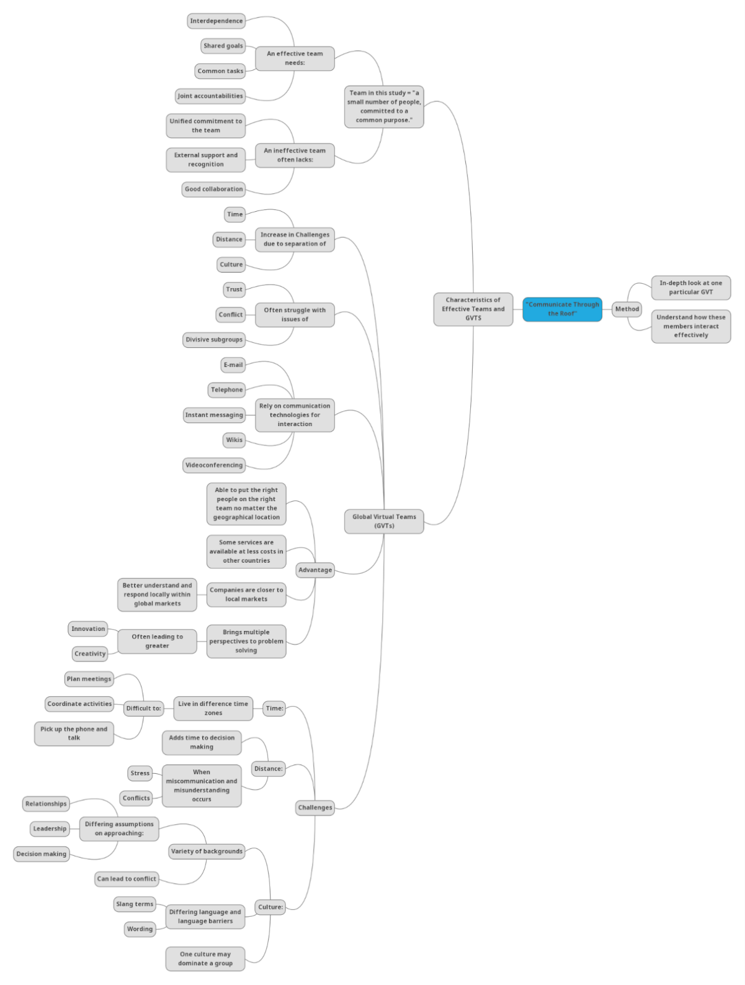

Thomas Kurkowski
Billy Marshall
Joseph Hunt
Levi Munro

Scott’s article explores the difficulties faced by GVTs (global virtual teams) and how they can be mitigated through careful strategic planning by an organisation. The article examines a single business with a pair of dual continent teams to observe how it deals with intercultural and geographic distance. The article observes numerous practices that have allowed the company to thrive despite these differences by instilling a shared culture, creating compromise, and encouraging participation amongst all parties.
Scott concluded in his article that the best practices for GVTs are those which instil a sense of connectedness in the workplace through shared rituals (p. 316). However, Scott indicates that his study can not be too broadly generalised to every workplace and consequently calls for further studies to corroborate his conclusions.

Questions:
Identify and explain the communication challenges that global virtual teams face.

GVTs face challenges due to distance and culture. Members of a team live within different geographical locations and time zones, making it difficult to plan meetings and coordinate (Scott 2013, p. 304). Scott uses the example of picking up a phone call without regard for another member’s timezone to illustrate the issue (p. 304). The distance between each member also adds time to decision-making, leading to miscommunication and misunderstanding that results in stress and conflicts between the group (Scott 2013, p. 303). The lack of face-to-face communication between team members can cause trust issues (Scott 2013, p. 301).

The various backgrounds within groups introduce differing assumptions on relationships, leadership, and decision-making. This may cause conflict as different languages provide barriers through slang terms and words with more than one meaning (Scott 2013, p. 304). The differences in cultures also make it difficult for teams to collaborate effectively, as they have different expectations (Scott 2013, p. 304). GVTs may be dominated by one cultural group, resulting in members having an unequal power status and the inability to comfortably fully participate (Scott 2013, p. 304).

Identify & discuss the benefits that diversity in teams offers for the development of ICT systems
The benefits of a GVT are a larger talent pool, greater creativity, frameworks to structure behaviour, including more people in meetings, and creating data. GVTs provide a larger pool of talent worldwide (Scott 2013, p. 302). A broader employment market allows for financial benefits as software engineers are cheaper in some parts of the world (Scott 2013, p. 303). Having staff in many different countries can help the company better understand markets abroad (Scott 2013, p. 303). Structuration theory allows for examining patterns of communication(pp. 304-305). For example, GVT meetings take place over video conferences. This allows for larger meetings and data collection. Examining these meetings can provide insight into how everyone interacts (pp. 306 – 307). In addition, the use of computer-based communications will easily enable data collection and transcription of the meeting. Data analysis allows the emergence of themes that can guide further decision-making (Scott pp. 306–307).

Provide one recommendation for global virtual team members to improve their communication
Scott had noticed that the group used numerous techniques to support team building. Agile development practices were adapted to fit the pace and challenges of multicultural groups by promoting consistent company culture and emphasising professional bonds(Scott, pp. 308-309.) The “We Are One Team” approach ensured participation and camaraderie were developed among all team members (p.314). A “fist of five” approach allowed team members to express their understanding and perception of a plan and promote democratic decision-making within the group (p.311). The “meet them halfway” method allowed the team to plan in a way that did not privilege either side’s culture or timezone to prevent resentment across geographic distance (Scott, p315). More broadly, Scott recommends regular meetings, communication rituals, and a strong guiding principle to ensure that the group works cohesively (pp. 315-316).

Reference

Scott, M 2013 “Communicate through the roof”: a case study analysis of the communicative rules and resources of an effective global virtual team,” Vol 61, no. 3, pp. 301-318

