Name : Raghav Gade

Roll : 20CS02003

Subject : Computer Networks Lab

Assignment 1

Below is the image of the network topology

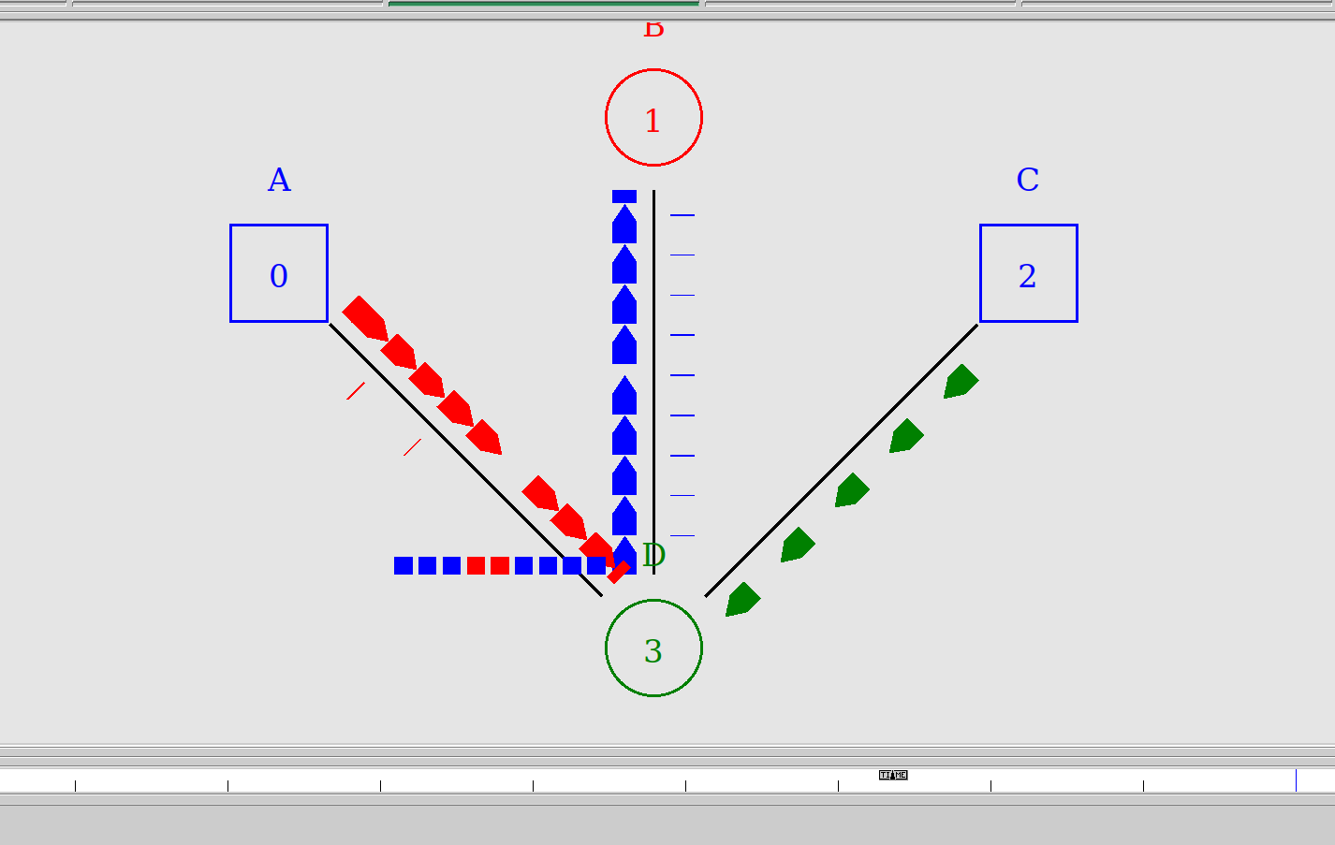

The ns2 file with the following network parameters is as follows:

#Create a new simulator obj

set ns [new Simulator]

#Open the nam file asgn1.nam and variable trace file asgn1.tr

set namfile [open asgn1.nam w]

$ns namtrace-all $namfile

set tracefile [open asgn1.tr w]

$ns trace-all $tracefile

#A finish procedure

proc finish {} {

global ns namfile tracefile

$ns flush-trace

close $namfile

close $tracefile

exec nam asgn1.nam &

exit 0

}

#Create four nodes

set A [$ns node]

set B [$ns node]

set C [$ns node]

set D [$ns node]

$A color Blue

$A label A

$A shape box

$B color Red

$B label B

$D color Green

$D label D

$C color Blue

$C label C

$C shape box

ns duplex-link $A $D 2Mb 40ms DropTail

$ns duplex-link $D $B 2Mb 40ms DropTail

$ns simplex-link $C $D 2Mb 40ms DropTail

$ns color 0 Red

$ns color 1 Blue

$ns color 2 Green

$ns duplex-link-op $A $D orient right-down

$ns simplex-link-op $C $D orient left-down

$ns duplex-link-op $D $B orient up

$ns queue-limit $D $B 10

$ns duplex-link-op $D $B queuePos 0.5

#---------------------------------------

# Setup a TCP connection for A

set tcp1 [new Agent/TCP]

$tcp1 set class_ 1

$ns attach-agent $A $tcp1

# Setup Sink for B

set sink1 [new Agent/TCPSink]

$ns attach-agent $B $sink1

$ns connect $tcp1 $sink1

$tcp1 set fid_ 0

# Setup a FTP over TCP connection

set ftp1 [new Application/FTP]

$ftp1 attach-agent $tcp1

$ftp1 set type_ FTP

#----------------------------------------

# Setup a TCP connection for D

set tcp2 [new Agent/TCP]

$tcp2 set class_ 2

$ns attach-agent $D $tcp2

# Setup Sink for B

set sink2 [new Agent/TCPSink]

$ns attach-agent $B $sink2

$ns connect $tcp2 $sink2

$tcp2 set fid_ 1

# Setup a FTP over TCP connection

set ftp2 [new Application/FTP]

$ftp2 attach-agent $tcp2

$ftp2 set type_ FTP

#----------------------------------------

# Setup a UDP connection

set udp1 [new Agent/UDP]

$ns attach-agent $C $udp1

set null [new Agent/Null]

$ns attach-agent $D $null

$ns connect $udp1 $null

$udp1 set fid_ 2

# Setup a CBR over UDP connection

set cbr1 [new Application/Traffic/CBR]

$cbr1 attach-agent $udp1

$cbr1 set type_ CBR

$cbr1 set packet_size_ 1000

$cbr1 set rate_ 1mb

$cbr1 set random_ false

$ns at 0.0 "$cbr1 start"

$ns at 0.0 "$ftp1 start"

$ns at 0.0 "$ftp2 start"

$ns at 1.0 "$ftp1 stop"

$ns at 1.0 "$ftp2 stop"

$ns at 1.0 "$cbr1 stop"

$ns at 1.1 "finish"

$ns run