Fig.1. My VPC base architecture
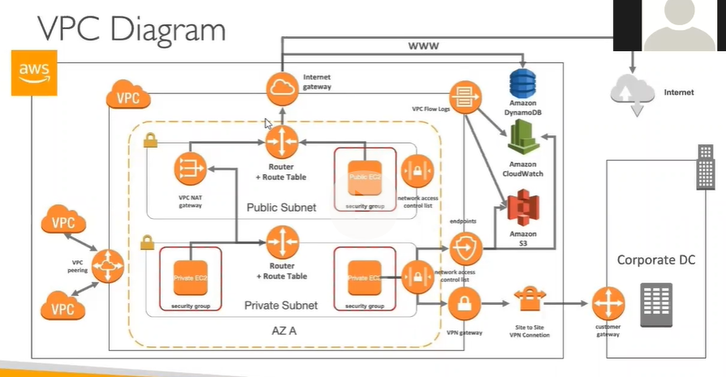

FIG.2 & FIG.3 Next Pages.
Cloud 9 and commits to GitHub
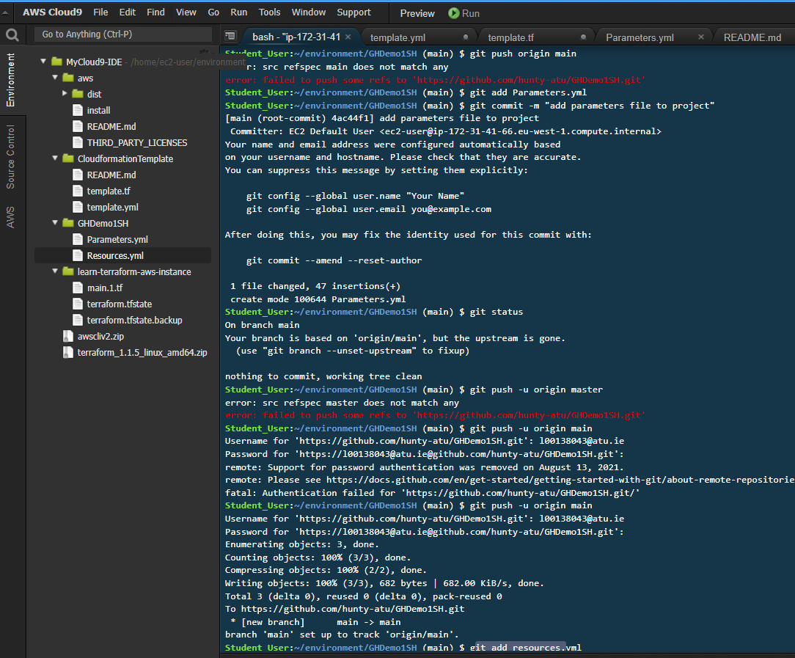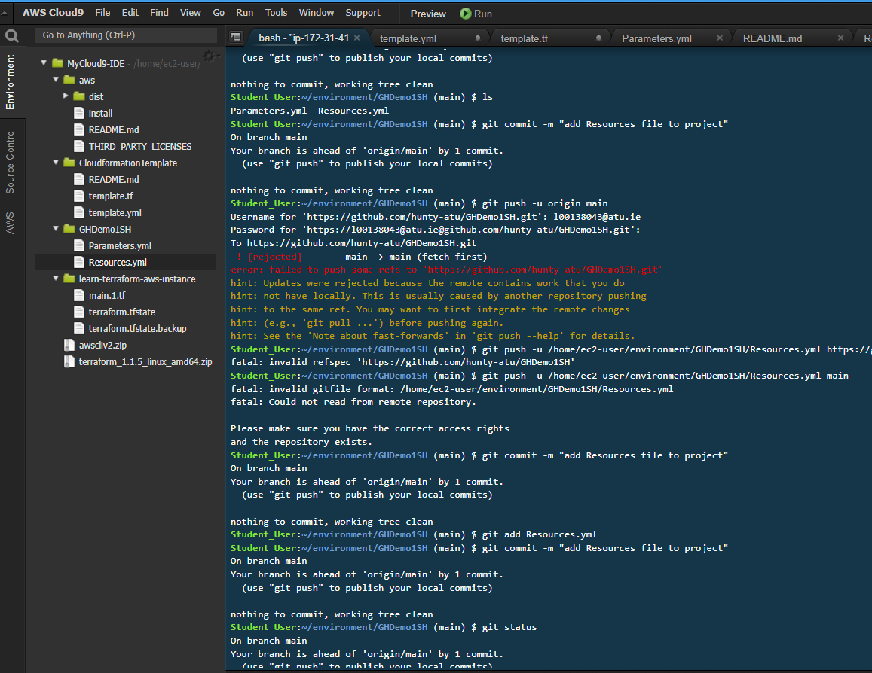
Fig 4. Network YAML file working in Designer view after AWS portal upload .Yaml
