Linux perusteet [TTC1040]

harjoitus 13



Maarit Salo

1.12.2021

1. **What is the current IP address on your Ubuntu?**

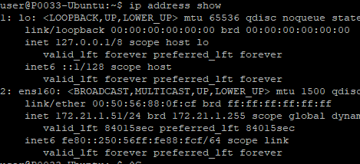

172.21.1.51

1. **Find IP addresses of the websites listed below. Then add alternative names presented inside brackets for these hostnames into the hosts file. Test names with ping command.**
   * **www.ubuntu.com (homepage)**



185.125.190.29

* + **www.linux.org (lforum)**



172.67.153.157

* + **www.kernel.org (karch)**

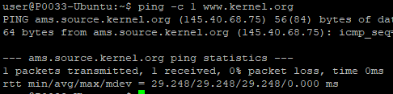

145.40.68.75

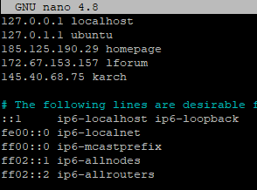

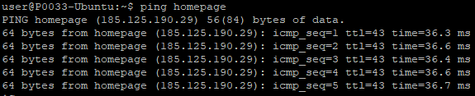

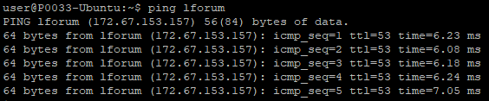

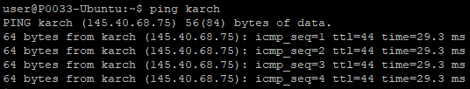

1. **Use netstat to list all UDP ports your computer is listening.**

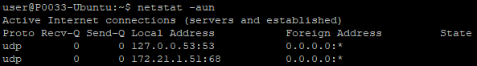

Niitä ei ole paljon.

1. **Test the connectivity to address www.techradar.com with ping command using ten packets. What is the average ping time and what is the name of the server that responds?**

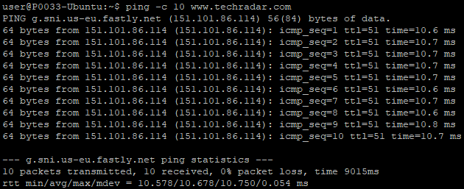

Aika pitkälle 10.7 millisekuntia on keskiarvo.

Serverin nimi on g.sni.us-eu.fastly.net

1. **Install a network monitor tool called NetHogs to your Ubuntu. Open a new SSH connection to your virtual machine (for example using Putty) and start NetHogs tool through this window. Now install MySQL server from the other window using the command presented below. How is this installation process shown in NetHogs and what is approximately the download speed (KB/sec)?**

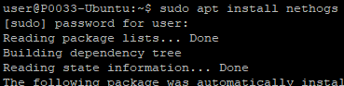

Nethogs sisään ja avaan uuden puttyn ja aloitan nethogsin siinä

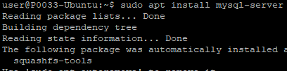

Alkuperäsessä ikkunassa mysql sisään

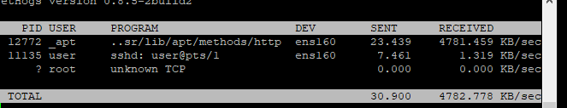

Latausnopeus on suurin piirtein 4781.459 Kb/sekuntia