Linux perusteet [TTC1040]

harjoitus 1



Maarit Salo

1.9.2021

1. **Machine name**



1. **Kernel name, version and release**



1. **Version of uname command**

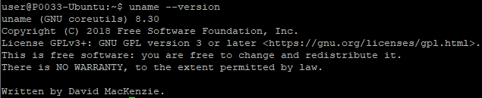

1. **System memory amount (GiB)**

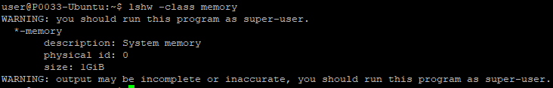

1. **Processor**



1. **Display adapter**

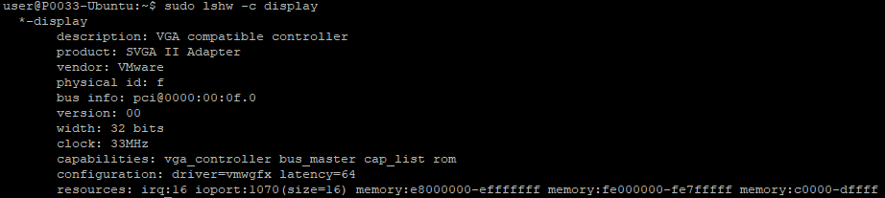

1. **Distribution release and description**



1. **Codename of the distribution**

