Linux perusteet [TTC1040]

harjoitus 2



Maarit Salo

Ke 8.9.2021

1. **List all available shells on your Linux distribution.**

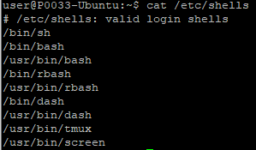

1. **Find general guidelines using man command for user password (Hint: passwd).**

**man passwd**

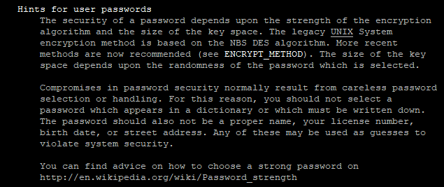

1. **How can you change your user from regular to root user and back to regular?**

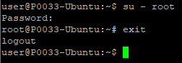

1. **Find out what is the description of the following Linux commands:**
   * Echo

Man echo

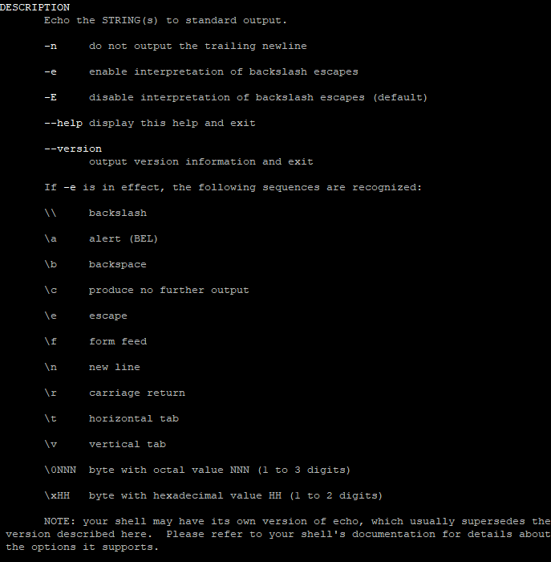

* + Free

Man free

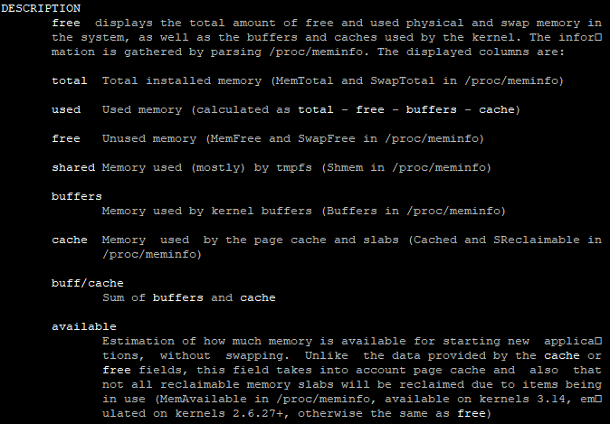

* + History

Man history

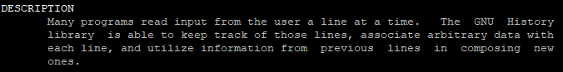

* + W

Man w

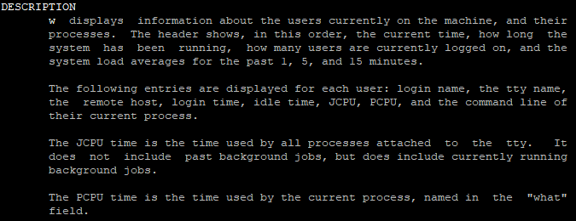

1. **Give an example of all of the above commands and command outputs.**



