Linux perusteet [TTC1040]

harjoitus T3



Maarit Salo

?.9.2021

1. **List only directories and one level from Linux root directory.**

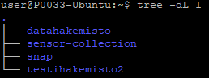

1. **List /var/log directory content with two levels and full path prefix for each file.**

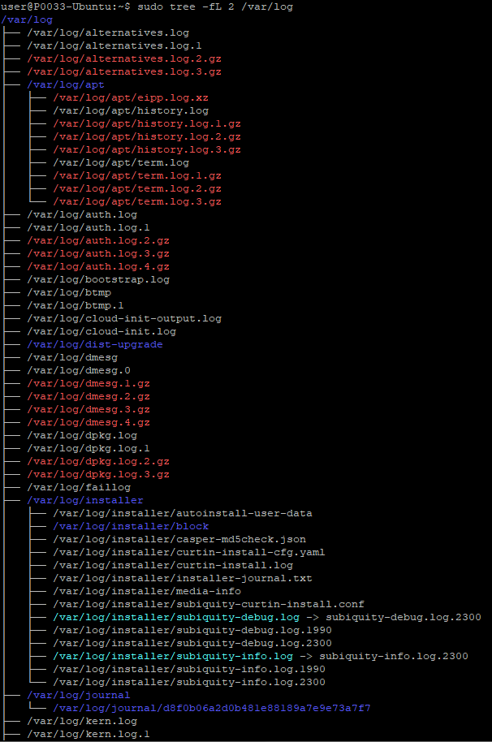

1. **List /bin directory content with owner information, size in human readable format and name starting with 'xs'.**

