Table 1. Descriptive Statistics (N = 623)
Variable | N | Mean | SD | Min | Max
Ln(Labor productivity) | 623 | 11.354 | 1.083 | 7.601 | 15.895
FSTS | 623 | 0.047 | 0.154 | 0.000 | 1.000
TCI | 623 | 0.161 | 0.210 | 0.000 | 1.000
DAI | 617 | 0.700 | 0.258 | 0.000 | 1.000
Foreign licensed technology | 621 | 0.150 | 0.357 | 0.000 | 1.000
Product innovation | 623 | 0.186 | 0.390 | 0.000 | 1.000
R&D spending | 623 | 0.075 | 0.264 | 0.000 | 1.000
Quality certification | 618 | 0.233 | 0.423 | 0.000 | 1.000
Website/social media | 623 | 0.661 | 0.474 | 0.000 | 1.000
E-payment received (%) | 616 | 73.557 | 26.026 | 0.000 | 100.000
Firm size (ln) | 623 | 3.164 | 1.118 | 1.386 | 6.310
Firm age (years) | 623 | 17.698 | 12.262 | 1.000 | 57.000
Foreign-owned | 623 | 0.315 | 0.465 | 0.000 | 1.000
Notes: FSTS = direct export sales / total sales (d3c). TCI and DAI shown before z-standardization.

Table 2. Correlation Matrix
 | (1) | (2) | (3) | (4) | (5) | (6) | (7)
1. Ln(LP) | 1.00
2. FSTS | 0.31** | 1.00
3. TCI | 0.18** | 0.15** | 1.00
4. DAI | 0.15** | 0.18** | 0.28** | 1.00
5. Size | -0.12** | -0.01 | 0.30** | 0.08* | 1.00
6. Age | 0.16** | 0.07 | -0.02 | -0.02 | 0.09* | 1.00
7. Foreign | 0.15** | 0.16** | 0.11** | 0.04 | 0.15** | -0.12** | 1.00
Notes: ** p < .01, * p < .05. N = 617–623 (varies by pairwise availability).

Table 3. Hierarchical OLS Regression Results
Dependent variable: Ln(Labor Productivity). HC1 robust standard errors.
 | (1) | (2) | (3) | (4) | (5) | (6) | (7)
FSTS |  | 3.490*** | 2.797** | 3.106*** | 2.599** | 3.531*** | 3.058**
 |  | (0.903) | (0.925) | (0.920) | (0.936) | (0.947) | (0.943)
FSTS² |  | -2.103† | -1.431 | -1.779 | -1.265 | -3.166** | -2.715*
 |  | (1.087) | (1.115) | (1.092) | (1.120) | (1.100) | (1.101)
TCI |  |  | 0.200*** |  | 0.183*** |  | 0.186***
 |  |  | (0.042) |  | (0.044) |  | (0.044)
DAI |  |  |  | 0.114** | 0.073† | 0.114** | 0.073†
 |  |  |  | (0.037) | (0.038) | (0.038) | (0.040)
FSTS × DAI |  |  |  |  |  | -1.181 | -1.279
 |  |  |  |  |  | (0.913) | (0.893)
FSTS² × DAI |  |  |  |  |  | 2.869* | 3.023*
 |  |  |  |  |  | (1.284) | (1.309)
Firm size | -0.164*** | -0.153*** | -0.207*** | -0.163*** | -0.210*** | -0.152*** | -0.199***
 | (0.037) | (0.036) | (0.036) | (0.036) | (0.036) | (0.036) | (0.037)
Firm age | 0.018*** | 0.015*** | 0.016*** | 0.015*** | 0.016*** | 0.015*** | 0.015***
 | (0.003) | (0.003) | (0.003) | (0.003) | (0.003) | (0.003) | (0.003)
Foreign | 0.463*** | 0.344*** | 0.330*** | 0.346*** | 0.330*** | 0.332*** | 0.315***
 | (0.099) | (0.092) | (0.091) | (0.093) | (0.092) | (0.093) | (0.092)
N | 623 | 623 | 623 | 617 | 617 | 617 | 617
R² | 0.0816 | 0.1620 | 0.1914 | 0.1699 | 0.1932 | 0.1782 | 0.2021
Adj. R² | 0.0772 | 0.1552 | 0.1835 | 0.1618 | 0.1839 | 0.1674 | 0.1902
*** p<.001, ** p<.01, * p<.05, † p<.10. HC1 robust SE in parentheses. TCI and DAI are z-standardized within sample. Model (6) includes DAI direct + FSTS×DAI + FSTS²×DAI interactions. DAI moderation joint F(2,607) = 3.38, p = .035.

Table 4. Marginal Effect of DAI on Productivity across FSTS
FSTS (%) | Marginal Effect | SE | 95% CI | p-value
0 | 0.073† | 0.040 | [-0.004, 0.151] | 0.0643
5 | 0.017 | 0.051 | [-0.082, 0.116] | 0.7381
10 | -0.024 | 0.079 | [-0.179, 0.131] | 0.7585
15 | -0.050 | 0.107 | [-0.260, 0.159] | 0.6378
20 | -0.061 | 0.132 | [-0.320, 0.197] | 0.6410
30 | -0.038 | 0.170 | [-0.371, 0.295] | 0.8226
50 | 0.190 | 0.224 | [-0.248, 0.628] | 0.3959
70 | 0.660* | 0.322 | [0.028, 1.292] | 0.0410
100 | 1.818** | 0.695 | [0.455, 3.181] | 0.0091
Notes: Marginal effect = ∂Ln(LP)/∂DAI = β_DAI + β_FSTS×DAI·FSTS + β_FSTS²×DAI·FSTS². From Model (7). Zero-crossings at FSTS ≈ 3% and 56%.

Figure 1. Marginal Effect of DAI across Export Intensity
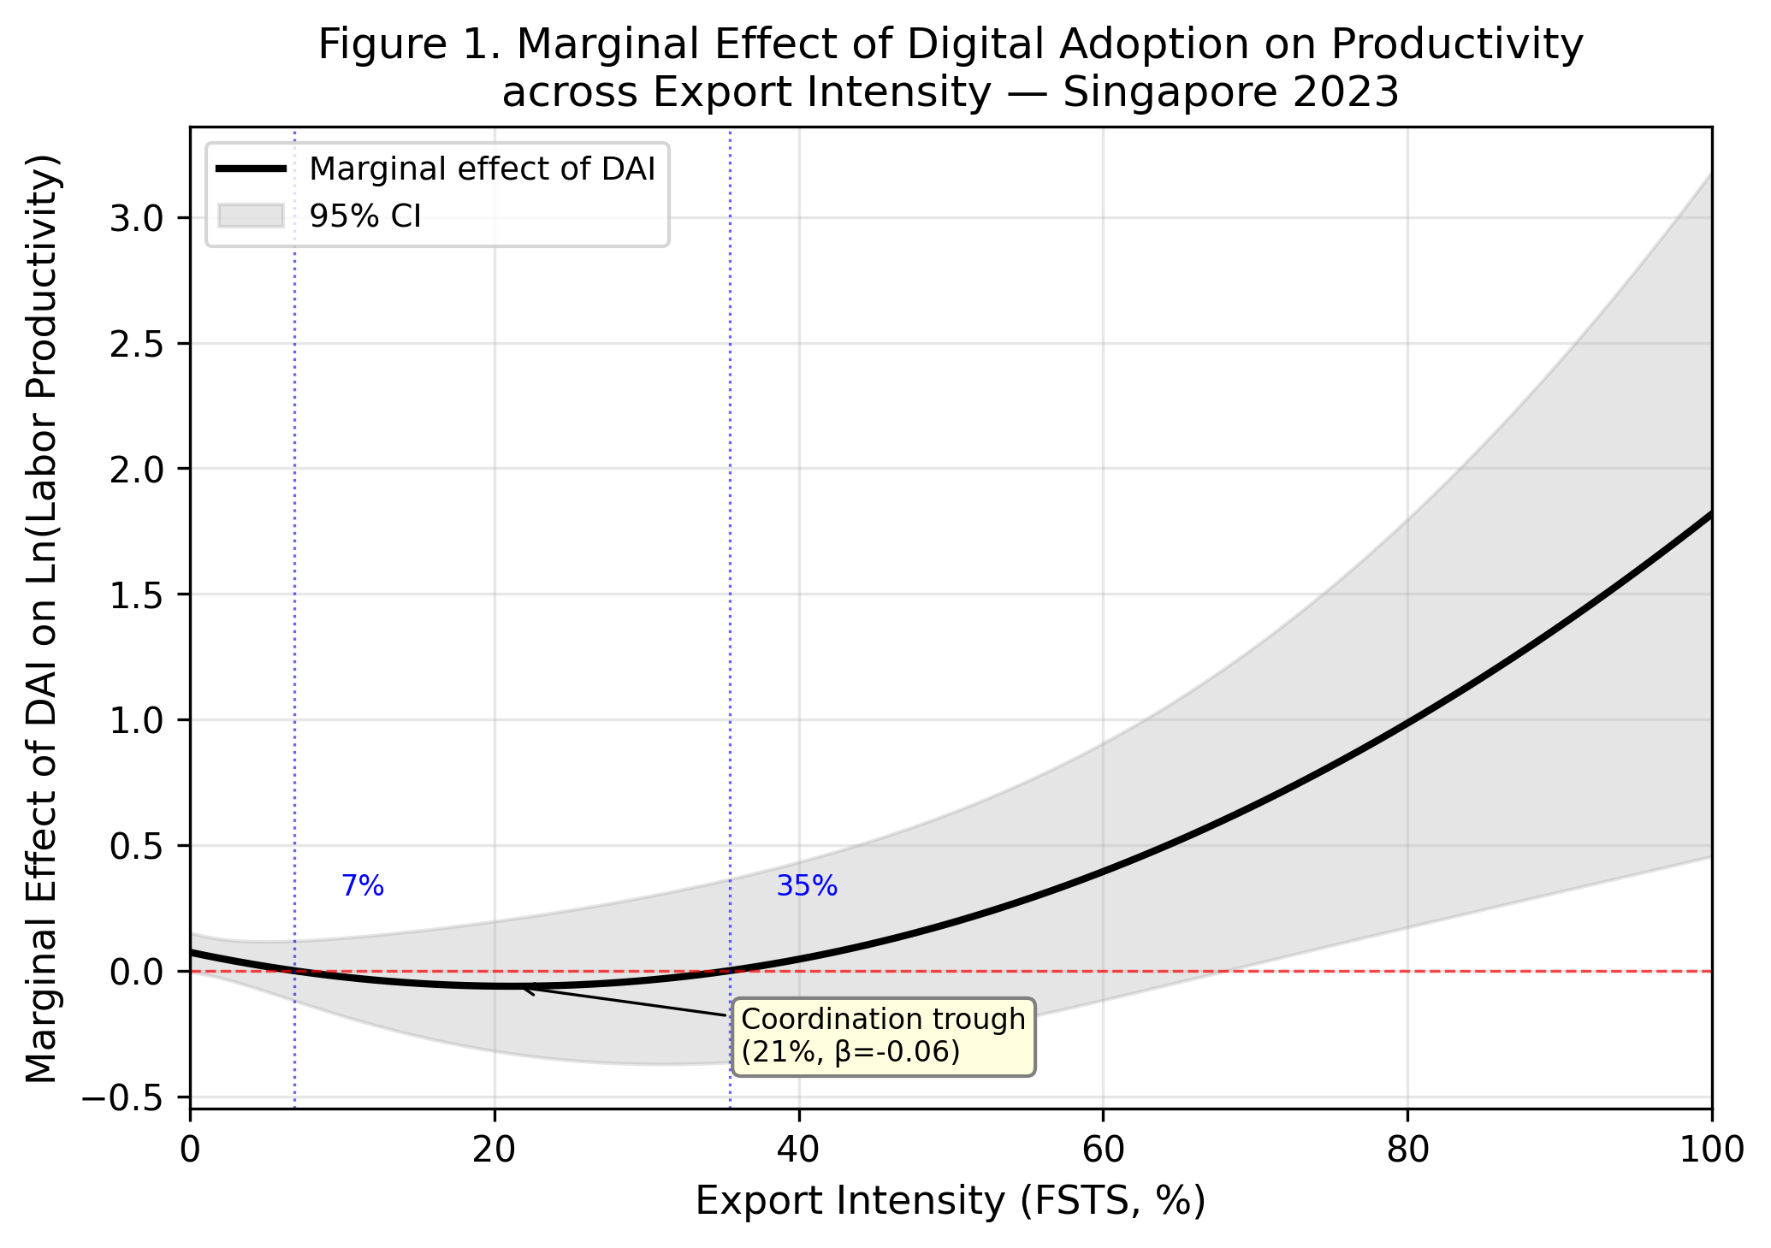
Notes: Solid line = marginal effect of one SD increase in DAI on Ln(LP). Shaded area = 95% CI. Dashed red line = zero effect. DAI is negative for exporters with FSTS 3–56% (coordination trough) and positive for high exporters (scale economies).

Figure 2. Internationalization–Performance Curve
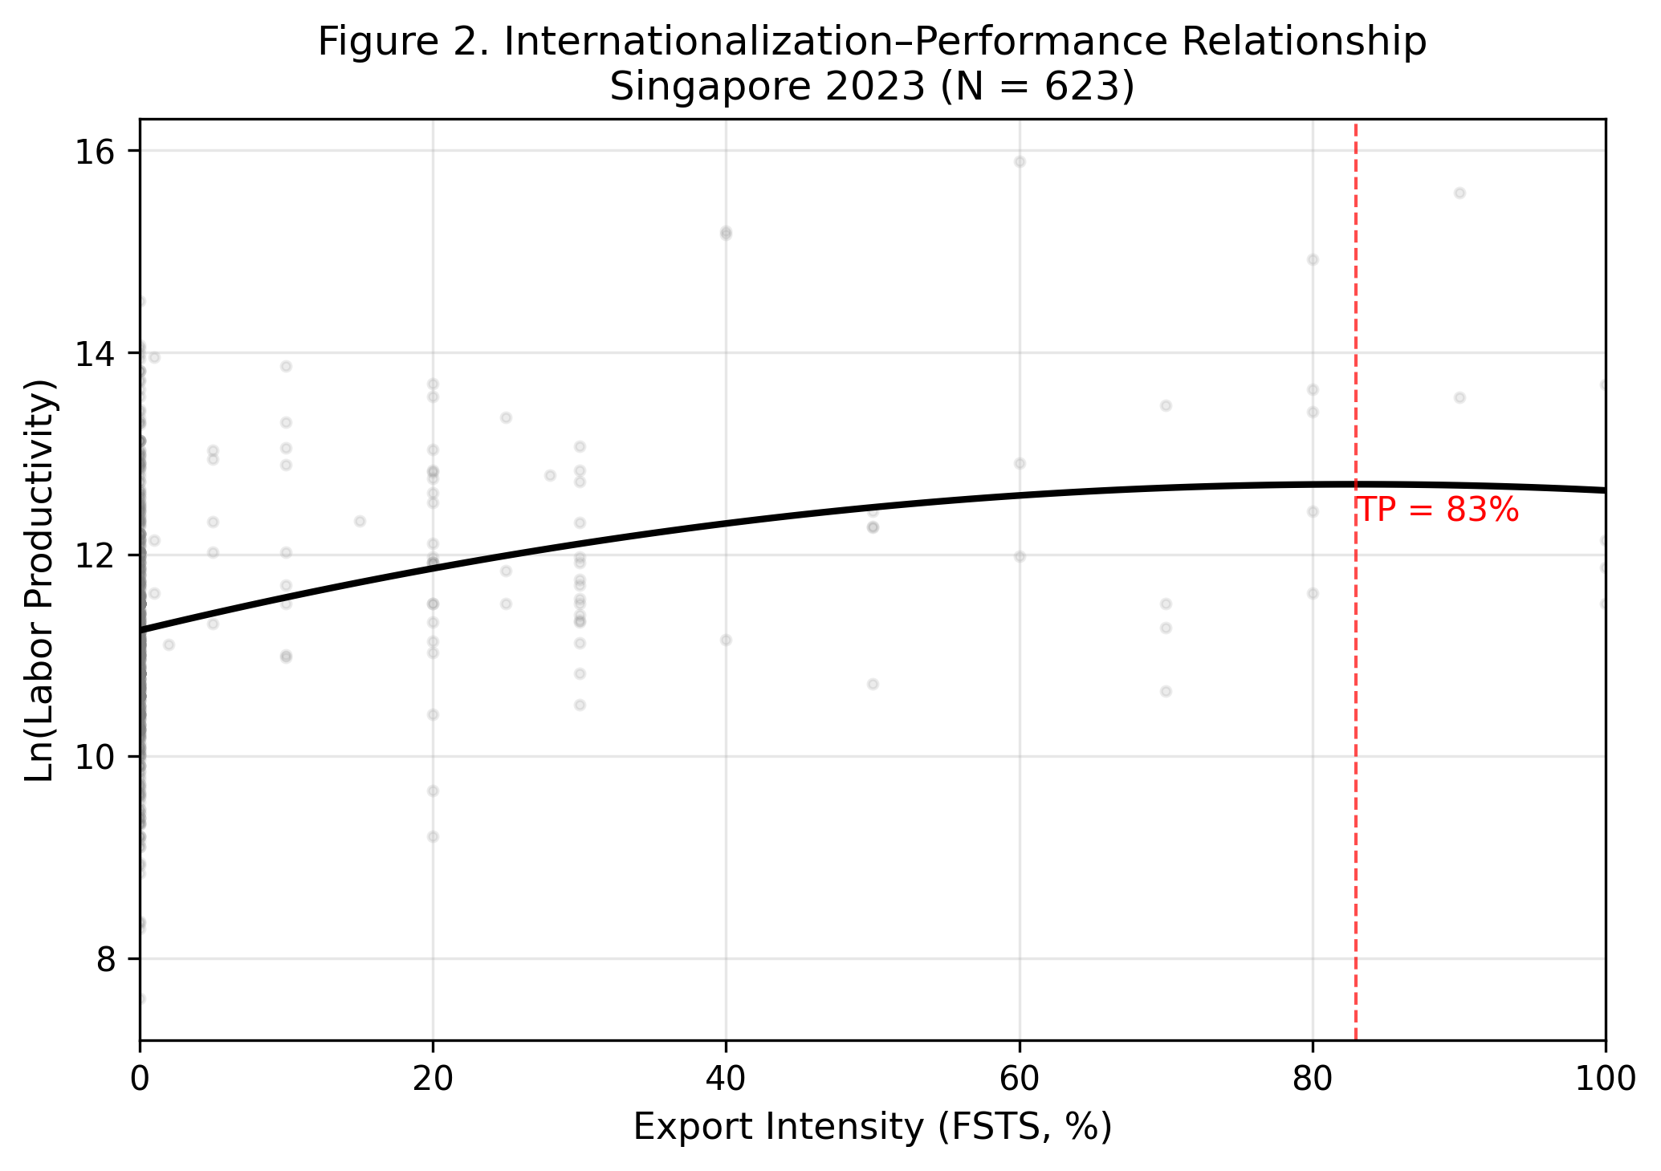
Notes: Predicted values from Model (2) at sample means of controls. TP = 83%. Lind-Mehlum p = .301 (borderline). Gray dots = observed values.

