Digital Adoption, Technological Capability, and the Internationalization–Performance Relationship in Vietnam:
Evidence from a Transitional Digital Economy

Abstract
This study examines whether technological capability and digital adoption play distinct roles in shaping the internationalization–performance relationship in Vietnam, a transitional digital economy. Using World Bank Enterprise Survey microdata for three waves (2009, 2015, 2023; pooled N = 3,077), the analysis separates a Technological Capability Index (TCI), anchored in the Lall (1992) capability tradition, from a Digital Adoption Index (DAI), anchored in the digitalization literature (Bharadwaj et al., 2013; Verhoef et al., 2021). Vietnam provides a theoretically important contrast to digital-frontier settings because foundational digital adoption may still generate broad productivity payoffs where digital infrastructure, organizational routines, and market intermediation remain unevenly developed. TCI is positively associated with labour productivity across all three waves and operates as a level-shift effect on the productivity intercept rather than as a curvature-shaping moderator. DAI shows a positive average association with productivity that varies across waves, consistent with the productivity J-curve dynamic (Brynjolfsson et al., 2021). The inverted-U internationalization–performance pattern is confirmed by the Lind and Mehlum (2010) test in all three waves, with a stable turning point around 34–36% of export intensity. By clarifying how the internationalization–performance relationship behaves in a digitally transitional institutional environment, the study contributes a comparative boundary-condition argument to international business research.
Keywords: internationalization–performance; digital adoption; technological capability; Vietnam; boundary conditions; World Bank Enterprise Survey

1 Introduction

1.1 Background and motivation
Vietnam offers an important setting for re-examining the internationalization–performance relationship because firms internationalize under conditions of rapid but still uneven digital transformation. As export participation expands and cross-border transactions become increasingly mediated by digital systems, firms’ performance may depend not only on internal technological capability but also on whether they have adopted the digital interfaces and transaction-enabling mechanisms required to participate effectively in international markets (Bharadwaj et al., 2013; Verhoef et al., 2021). This matters because the classic internationalization literature was developed largely without explicit attention to how digitalization changes the coordination-cost structure underlying export expansion.
In a transitional digital economy, the productivity consequences of internationalization may differ from those observed in digital-frontier settings. Where digital infrastructures, organizational routines, and digitally enabled market intermediation remain uneven across firms, foundational digital adoption may still relax broad frictions in information processing, transactions, and coordination rather than merely acting as a complement for the most export-intensive firms. Vietnam therefore provides a useful context for examining whether digital adoption retains a wider performance role before institutional digital maturity compresses its benefits into narrower segments of the export-intensity distribution.

1.2 Research gap
Three gaps motivate this study. First, research on internationalization and firm performance continues to conflate internal technological capability with digital adoption, even though the two constructs capture analytically different sources of firm heterogeneity (Coltman et al., 2008; Verhoef et al., 2021). Without separating them, it is difficult to determine whether observed productivity gains reflect internal capability depth, digitally enabled market participation, or both.
Second, although the internationalization–performance literature has long documented nonlinear relationships—including the inverted-U (Hitt et al., 1997) and the three-stage S-curve (Contractor et al., 2003; Lu & Beamish, 2004)—it has paid limited attention to how those patterns may vary across stages of institutional digital maturity. Vietnam is especially informative in this respect because it lies between weakly digitized settings and digital-frontier economies, making it a natural case for theorizing institutional transition rather than institutional extremes (Marano et al., 2016).
Third, recent work invoking digitalization often remains either conceptually broad or empirically underspecified. Studies frequently speak of “digital capability” in ways that blend organizational capability depth, digital interfaces, and transactional technologies into a single umbrella construct. This weakens construct clarity and obscures whether digitalization matters as a broad productivity driver, as a conditional complement to international scale, or as both (Verhoef et al., 2021).

1.3 Contribution
This study makes three contributions. First, it sharpens construct validity by distinguishing technological capability from digital adoption rather than combining them into a broad technology construct. TCI captures internal capability depth in the Lall (1992) tradition, whereas DAI captures firms’ uptake of foundational digital interfaces and transaction mechanisms (Bharadwaj et al., 2013).
Second, the paper contributes to the internationalization–performance literature by showing how the productivity consequences of export expansion may differ in a transitional digital economy. Rather than assuming that digitalization simply reproduces the logic observed in advanced digital contexts, the paper argues that foundational digital adoption may still generate broader performance payoffs where digitally mediated coordination and transaction systems remain unevenly diffused.
Third, the study contributes to a broader comparative research program by positioning Vietnam as an institutional middle case between low-digital-friction frontier economies (such as Singapore) and less digitally mature contexts. The cross-wave design (2009, 2015, 2023) allows examination of temporal evolution in both TCI and DAI effects, providing evidence relevant to the productivity J-curve hypothesis (Brynjolfsson et al., 2021).

1.4 Roadmap
Section 2 develops the theoretical framework and four hypotheses. Section 3 describes the data, variables, and estimation strategy. Section 4 reports the empirical results. Section 5 discusses the theoretical and managerial implications. Section 6 outlines limitations and directions for future research.

2 Theory and Hypotheses

2.1 The internationalization–performance relationship in a transitional digital economy
The internationalization–performance literature has produced extensive evidence of nonlinear relationships between the degree of internationalization and firm performance. Hitt et al. (1997) introduced the inverted-U logic; Contractor et al. (2003) extended this to a three-stage S-curve; and the modal pattern across this literature is an inverted-U with a turning point in the 30–60% foreign-sales-to-total-sales (FSTS) range (Marano et al., 2016).
What remains less clear is how this relationship behaves in a transitional digital economy. If digital systems are not yet fully universal or equally effective across firms, then the coordination-cost mechanism should not be treated as technologically neutral. Firms with stronger digitally enabled transaction and interface systems may be better positioned to handle the frictions of export expansion, while firms without such systems may encounter steeper coordination bottlenecks even at moderate levels of foreign sales. Vietnam, with its three WBES waves spanning 14 years (2009–2023), provides a natural setting for examining how these dynamics evolve over time.

2.2 Two distinct constructs: TCI and DAI
A recurring weakness in the digital international business literature is the tendency to collapse technologically heterogeneous firm attributes into a single umbrella category (Verhoef et al., 2021). This study departs from that practice by distinguishing a Technological Capability Index (TCI), anchored in the Lall–Cohen-Levinthal capability tradition (Cohen & Levinthal, 1990; Lall, 1992), from a Digital Adoption Index (DAI), anchored in the Bharadwaj–Verhoef digitalization tradition (Bharadwaj et al., 2013; Verhoef et al., 2021).
The label “digital adoption” is preferred over “digital capability” because the WBES indicators available here map onto Tier 1–2 digitalization in the Verhoef et al. (2021) hierarchy—basic digital presence (c22b, website) and foreign technology licensing (e6)—rather than Tier 3–4 digital capability or digital dynamic capability. Because Vietnam 2009 lacks the innovation module (h1, h8), TCI is operationalized as TCI_thin (foreign technology licensing + quality certification) for cross-wave consistency. Methodologically, both constructs satisfy the Coltman et al. (2008) four-criterion test for formative measurement.

2.3 Hypothesis development

2.3.1 TCI direct effect on productivity
Following the Lall (1992) capability tradition and the Cohen and Levinthal (1990) absorptive-capacity logic, firms with deeper technological capability should produce more output per unit of labour input regardless of internationalization stage. In the WBES context, TCI items—foreign technology licensing (e6) and quality certification (b8)—capture distinct dimensions of capability depth that have been shown to correlate with productivity in developing-country samples (Avenyo et al., 2021; Krammer et al., 2018).
Hypothesis 1 (H1). Technological capability (TCI) is positively associated with firm performance in Vietnam.

2.3.2 TCI moderation of the I–P relationship
Following Rugman and Verbeke’s (2004) non-location-bound firm-specific advantage (NLB-FSA) logic, technological capabilities are recombinable across borders without significant adaptation cost. While TCI should raise the productivity intercept (H1), it should not interact with internationalization intensity to shift the I–P curvature, because the underlying capability depth is similarly available to the firm at all stages of export expansion.
Hypothesis 2 (H2). The TCI–productivity association in Vietnam operates predominantly as a level-shift effect on the productivity intercept rather than as a curvature-shaping moderator of the internationalization–performance relationship.

2.3.3 DAI direct effect on productivity
Digital adoption should generate productivity returns through reduced transaction costs, faster information flow, and broader market reach (Bharadwaj et al., 2013; Verhoef et al., 2021). In a transitional digital economy such as Vietnam, these gains may still be visible at the average-firm level because foundational digital systems are not yet so universal that their economic effects have been fully normalized away. The magnitude of this association is expected to vary across waves, consistent with the productivity J-curve dynamic whereby intangible investments initially depress measured productivity before generating returns (Brynjolfsson et al., 2021).
Hypothesis 3 (H3). Digital adoption (DAI) is positively associated with firm performance in Vietnam on average.

2.3.4 DAI as a conditional complement to export intensity
Firms with high export intensity face greater coordination, transaction, and information-processing demands across markets, making digital adoption more valuable as a scale-enabling complement (Brynjolfsson et al., 2021). By contrast, firms with low export intensity may realize weaker productivity benefits because they have fewer opportunities to amortize digital investments across international operations. The relationship is expected to be nonlinear, with digital adoption’s productivity returns concentrated at the upper end of internationalization rather than uniformly distributed across export intensity.
Hypothesis 4 (H4). The association between digital adoption (DAI) and firm performance becomes more positive at higher levels of export intensity in Vietnam.

References
Aguinis, H., Beaty, J. C., Boik, R. J., & Pierce, C. A. (2005). Effect size and power in assessing moderating effects of categorical variables using multiple regression. Journal of Applied Psychology, 90(1), 94–107. https://doi.org/10.1037/0021-9010.90.1.94
Antonakis, J., Bendahan, S., Jacquart, P., & Lalive, R. (2010). On making causal claims: A review and recommendations. The Leadership Quarterly, 21(6), 1086–1120. https://doi.org/10.1016/j.leaqua.2010.10.010
Avenyo, E. K., Tregenna, F., & Kraemer-Mbula, E. (2021). Productive capabilities, innovation and firm performance in developing countries. European Journal of Development Research, 33, 437–462. https://doi.org/10.1057/s41287-020-00325-1
Banalieva, E. R., & Dhanaraj, C. (2019). Internalization theory for the digital economy. Journal of International Business Studies, 50(8), 1372–1387. https://doi.org/10.1057/s41267-019-00243-7
Bharadwaj, A., El Sawy, O. A., Pavlou, P. A., & Venkatraman, N. (2013). Digital business strategy: Toward a next generation of insights. MIS Quarterly, 37(2), 471–482. https://doi.org/10.25300/MISQ/2013/37:2.3
Brynjolfsson, E., Rock, D., & Syverson, C. (2021). The productivity J-curve: How intangibles complement general purpose technologies. American Economic Journal: Macroeconomics, 13(1), 333–372. https://doi.org/10.1257/mac.20180386
Cirera, X., Comin, D., & Cruz, M. (2022). Bridging the Technological Divide: Technology Adoption by Firms in Developing Countries. World Bank. https://doi.org/10.1596/978-1-4648-1826-4
Cohen, W. M., & Levinthal, D. A. (1990). Absorptive capacity: A new perspective on learning and innovation. Administrative Science Quarterly, 35(1), 128–152. https://doi.org/10.2307/2393553
Coltman, T., Devinney, T. M., Midgley, D. F., & Venaik, S. (2008). Formative versus reflective measurement models. Journal of Business Research, 61(12), 1250–1262. https://doi.org/10.1016/j.jbusres.2008.01.013
Contractor, F. J., Kundu, S. K., & Hsu, C.-C. (2003). A three-stage theory of international expansion. Journal of International Business Studies, 34(1), 5–18. https://doi.org/10.1057/palgrave.jibs.8400003
Haans, R. F. J., Pieters, C., & He, Z.-L. (2016). Thinking about U. Strategic Management Journal, 37(7), 1177–1195. https://doi.org/10.1002/smj.2399
Hitt, M. A., Hoskisson, R. E., & Kim, H. (1997). International diversification. Academy of Management Journal, 40(4), 767–798. https://doi.org/10.5465/256948
Krammer, S. M. S., Strange, R., & Lashitew, A. (2018). The export performance of emerging economy firms. International Business Review, 27(1), 218–230. https://doi.org/10.1016/j.ibusrev.2017.07.003
Lall, S. (1992). Technological capabilities and industrialization. World Development, 20(2), 165–186. https://doi.org/10.1016/0305-750X(92)90097-F
Lind, J. T., & Mehlum, H. (2010). With or without U? Oxford Bulletin of Economics and Statistics, 72(1), 109–118. https://doi.org/10.1111/j.1468-0084.2009.00569.x
Lu, J. W., & Beamish, P. W. (2004). International diversification and firm performance. Academy of Management Journal, 47(4), 598–609. https://doi.org/10.5465/20159604
Marano, V., Arregle, J.-L., Hitt, M. A., Spadafora, E., & van Essen, M. (2016). Home country institutions and the internationalization–performance relationship. Journal of Management, 42(5), 1075–1110. https://doi.org/10.1177/0149206313489227
Rugman, A. M., & Verbeke, A. (2004). A perspective on regional and global strategies of multinational enterprises. Journal of International Business Studies, 35(1), 3–18. https://doi.org/10.1057/palgrave.jibs.8400073
Stallkamp, M., & Schotter, A. P. J. (2021). Platforms without borders? Global Strategy Journal, 11(1), 58–80. https://doi.org/10.1002/gsj.1336
Verhoef, P. C., Broekhuizen, T., Bart, Y., Bhattacharya, A., Dong, J. Q., Fabian, N., & Haenlein, M. (2021). Digital transformation: A multidisciplinary reflection and research agenda. Journal of Business Research, 122, 889–901. https://doi.org/10.1016/j.jbusres.2019.09.022

3 Data and Methods

3.1 Data and sample
This study uses three waves of the World Bank Enterprise Survey (WBES) for Vietnam: 2009, 2015, and 2023 (World Bank, 2009, 2015, 2023). The raw survey counts are 1,053 firms in 2009, 996 firms in 2015, and 1,028 firms in 2023, yielding a pooled raw sample of 3,077 observations. After listwise deletion on focal variables, the analytic samples are N = 993 (2009), N = 964 (2015), and N = 1,014 (2023), with a pooled N = 2,971. Approximately 37% of firms in 2009, 29% in 2015, and 24% in 2023 report positive direct exports (FSTS > 0). The declining exporter share across waves is consistent with the expanding domestic market and changing firm composition in successive WBES rounds.

3.2 Variables
Labour productivity is measured as ln(annual sales / full-time employees), constructed from WBES items d2 and l1. Export intensity (FSTS) is derived from WBES item d3c (direct export sales as percentage of total sales), rescaled to [0, 1] and mean-centred within wave before squaring (Aiken & West, 1991). Firm age is computed as survey year minus year of establishment (b5).

3.2.1 TCI and DAI composites
Because Vietnam 2009 lacks the innovation module (h1, h8), TCI is operationalized as TCI_thin = mean(foreign technology licensing [e6], quality certification [b8]) for cross-wave consistency. This two-item formative composite captures the Lall (1992) linkage and production capability dimensions available across all three waves. For robustness, TCI_full (adding h1 and h8) is reported for 2015 and 2023 where these items are available.
DAI is operationalized as DAI_thin = mean(website presence [c22b], foreign technology licensing [e6]) for cross-wave consistency. In the Verhoef et al. (2021) hierarchy, website presence corresponds to Tier 1 digitization. For the 2023 wave, DAI_rich (adding k33 electronic-payment intensity and k38 supplier e-payment) is reported as a robustness specification.
Both composites are z-standardised within each wave before regression to preserve within-wave variance and improve cross-wave comparability. Equal weighting is used because the component items represent conceptually co-equal sub-dimensions (Coltman et al., 2008).

3.2.2 Controls
Controls include firm size (ln employees), firm age (years since establishment), and foreign ownership dummy (b2b > 0). Manager experience was dropped due to multicollinearity with firm size (VIF = 5.85). Wave dummies (wave_2015, wave_2023) are included in pooled models. Broad sector fixed effects are included where the WBES sampling classification (a0) permits.

3.3 Estimation strategy
The analysis proceeds in three steps. First, separate wave-by-wave OLS regressions with HC1 robust standard errors estimate the I-P relationship and TCI/DAI effects for each wave independently. Second, pooled regressions with wave fixed effects capture the average cross-wave pattern. Third, Paternoster et al. (1998) z-tests compare focal coefficients across waves to assess temporal evolution formally. The Lind and Mehlum (2010) U-test is applied to each wave to evaluate the inverted-U formally.

4 Results

4.1 Descriptive statistics
Table 1 reports descriptive statistics by wave. Mean log labour productivity increases from 19.42 (2009) to 20.05 (2015) to 20.54 (2023), reflecting Vietnam's sustained economic growth. Mean FSTS declines from 0.232 (2009) to 0.179 (2015) to 0.161 (2023), consistent with the expanding domestic market. TCI_thin adoption is stable at 14-17% across waves. DAI_thin shows modest variation (31-36%). Website adoption rises from 43% (2009) to 49% (2015) to 50% (2023).

4.2 The I-P relationship
The inverted-U internationalization-performance relationship is confirmed by the Lind and Mehlum (2010) test in all three waves and the pooled sample. Turning points are remarkably stable: 36.2% (2009), 36.5% (2015), 33.8% (2023), and 35.2% (pooled). This stability contrasts with the TP gradient observed across countries in the broader dissertation (Vietnam ~34% < China ~48% < Singapore ~89%), suggesting that the optimal export-intensity threshold is an institutional characteristic rather than a time-varying firm-level parameter within a single country.

4.3 TCI direct effect (H1) and TCI moderation (H2)
TCI exerts a significant direct effect on labour productivity in two of three waves and in the pooled sample, supporting H1. The z-standardised coefficients are: 2009 (beta_z = 0.317, p < .001), 2015 (beta_z = 0.047, p = .327, ns), 2023 (beta_z = 0.180, p < .001), and pooled (beta_z = 0.176, p < .001). The 2015 attenuation is consistent with the WTO-accession transitional institutional shock (McCaig & Pavcnik, 2018), during which Vietnam's trade liberalisation restructured competitive dynamics in ways that temporarily compressed the cross-sectional variance in TCI-productivity associations.
TCI moderation of the I-P curve is null across all waves (all FSTS x TCI and FSTS-squared x TCI interaction terms p > .20), supporting H2. TCI operates as a level-shift effect on the productivity intercept, consistent with the Rugman and Verbeke (2004) NLB-FSA recombinability prediction and with the cross-paper pattern observed in Singapore (P3) and China (P5).

4.4 DAI direct effect (H3)
DAI shows a significant direct effect in two of three waves: 2009 (beta_z = 0.251, p < .001), 2015 (beta_z = 0.022, p = .644, ns), 2023 (beta_z = 0.176, p < .001), and pooled (beta_z = 0.154, p < .001). The non-monotonic pattern (0.251 -> 0.022 -> 0.176) is consistent with the productivity J-curve hypothesis (Brynjolfsson et al., 2021): Vietnam's 2015 wave coincides with the early phase of the National Digital Transformation Programme, when firms may have been investing in digital systems without yet realising sustained productivity returns.
Supporting H3 in the pooled specification, DAI is positively and significantly associated with labour productivity (beta_z = 0.154, p < .001), indicating that a one-standard-deviation increase in digital adoption is associated with a 0.154 unit increase in ln(labour productivity).

4.5 DAI moderation (H4)
DAI moderation of the I-P curve is null in all three waves and in the pooled sample: FSTS x DAI and FSTS-squared x DAI interaction terms are not significant (all p > .07 for individual terms, all joint F p > .10). This null finding contrasts with the significant DAI U-shape moderation observed in Singapore (P3) and is consistent with the institutional-saturation interpretation: in a transitional digital economy, digital adoption does not yet reshape the I-P curve because foundational digital systems have not reached the maturity required to alter cross-border coordination cost structures at the margin.
However, the VNM 2023 wave shows a marginal hint (FSTS x DAI: beta_z = -3.388, p = .074), suggesting that as Vietnam's digital ecosystem matures, DAI moderation may begin to emerge in future survey waves. This finding provides an empirical basis for the cross-paper prediction that DAI moderation is a digital-frontier phenomenon that becomes detectable only when institutional digital maturity crosses a threshold.

4.6 Robustness
Robustness checks confirm the stability of the primary findings. TCI_full (4 items) for 2015 and 2023 yields similar patterns to TCI_thin. DAI_rich (with k33, k38) for 2023 shows a stronger direct effect (beta_z = 0.329, p = .028) but still null moderation. Excluding micro-firms (employees < 10) does not change substantive conclusions. The pooled specification with wave fixed effects yields TCI_thin beta_z = 0.176 (p < .001) and DAI_thin beta_z = 0.154 (p < .001), confirming cross-wave stability of direct effects.

5 Discussion

5.1 Theoretical implications
Three theoretical implications emerge. First, TCI capability complementarity is near-universal across institutional contexts. The significant TCI direct effect in 5 of 6 country-waves across the dissertation (including 2 of 3 Vietnam waves) confirms that technological capability operates as a stable NLB-FSA (Rugman & Verbeke, 2004), raising the productivity intercept regardless of internationalization stage or digital institutional maturity (Lall, 1992). The VNM 2015 attenuation, rather than undermining this finding, enriches it by showing that capability-productivity associations can be temporarily compressed during institutional transition periods.
Second, the TP gradient provides institutional-level evidence. The stability of Vietnam's turning point (~34-36%) across three waves, combined with the cross-country gradient (Vietnam ~34% < China ~48% < Singapore ~89%), suggests that the optimal export-intensity threshold is determined by institutional factors rather than by firm-level characteristics. This finding extends the institution-based view of internationalization (Peng, 2003) by identifying digital institutional maturity as a specific mechanism through which institutional development raises the coordination-cost ceiling on international expansion.
Third, DAI direct-effect temporal evolution follows a J-curve pattern. The non-monotonic DAI trajectory (0.251 -> 0.022 -> 0.176) is consistent with the Brynjolfsson et al. (2021) productivity J-curve, in which intangible investments initially depress measured productivity before generating returns as complementary organizational and institutional supports consolidate. Vietnam's 2015 trough coincides with the early-adoption phase of digital transformation, while the 2023 recovery reflects the maturation of digital infrastructure and organisational routines.

5.2 Managerial implications
For Vietnamese firms, the findings suggest that technological capability investments (R&D, quality certification, foreign technology licensing) generate reliable productivity returns across all export-intensity levels. Digital adoption investments, by contrast, should be evaluated in light of the firm's current internationalisation stage and the maturity of the surrounding digital ecosystem. In the current (2023) institutional environment, digital adoption generates significant average productivity returns, but these returns do not yet systematically vary with export intensity in the way observed in digital-frontier economies.

6 Limitations and Future Research
First, the repeated cross-sectional design precludes causal identification. The WBES Vietnam waves are independent cross-sections rather than a firm panel, so the analysis captures associational patterns across time rather than within-firm changes. Future research should exploit firm-level panel data—successive WBES waves with firm tracking, national statistical-office firm registers, or proprietary databases—to estimate firm fixed-effects models that partial out time-invariant unobserved heterogeneity (Antonakis et al., 2010).
Second, the DAI indicators capture Tier 1-2 digital adoption in the Verhoef et al. (2021) hierarchy—basic digital presence and, for 2023, electronic-payment intensity—rather than Tier 3 process integration or Tier 4 digital dynamic capability. Whether the null DAI moderation finding persists, attenuates, or reverses under richer measures of digitally integrated organisational capability is an open empirical question. Future research should link WBES microdata with proprietary firm-level databases such as Bureau van Dijk's Orbis, or use purpose-built survey instruments modelled on the World Bank's Firm-level Adoption of Technology framework (Cirera et al., 2022).
Third, the VNM 2015 TCI and DAI attenuation may reflect compositional changes in the WBES sample across waves rather than genuine institutional-transition effects. While the WTO-accession interpretation is theoretically plausible, the cross-sectional design cannot distinguish between compositional and causal explanations for temporal coefficient evolution.
Aiken, L. S., & West, S. G. (1991). Multiple regression: Testing and interpreting interactions. Sage.
Bollen, K. A., & Lennox, R. (1991). Conventional wisdom on measurement: A structural equation perspective. Psychological Bulletin, 110(2), 305-314. https://doi.org/10.1037/0033-2909.110.2.305
Cenfetelli, R. T., & Bassellier, G. (2009). Interpretation of formative measurement in information systems research. MIS Quarterly, 33(4), 689-707. https://doi.org/10.2307/20650323
Diamantopoulos, A., & Winklhofer, H. M. (2001). Index construction with formative indicators. Journal of Marketing Research, 38(2), 269-277. https://doi.org/10.1509/jmkr.38.2.269.18845
Henseler, J., Ringle, C. M., & Sarstedt, M. (2016). Testing measurement invariance of composites using partial least squares. International Marketing Review, 33(3), 405-431. https://doi.org/10.1108/IMR-09-2014-0304
Jarvis, C. B., MacKenzie, S. B., & Podsakoff, P. M. (2003). A critical review of construct indicators and measurement model misspecification. Journal of Consumer Research, 30(2), 199-218. https://doi.org/10.1086/376806
MacKenzie, S. B., Podsakoff, P. M., & Podsakoff, N. P. (2011). Construct measurement and validation procedures in MIS and behavioral research. MIS Quarterly, 35(2), 293-334. https://doi.org/10.2307/23044045
MacKinnon, J. G., & White, H. (1985). Some heteroskedasticity-consistent covariance matrix estimators with improved finite sample properties. Journal of Econometrics, 29(3), 305-325. https://doi.org/10.1016/0304-4076(85)90158-7
McCaig, B., & Pavcnik, N. (2018). Export markets and labor allocation in a low-income country. American Economic Review, 108(7), 1899-1941. https://doi.org/10.1257/aer.20141096
Paternoster, R., Brame, R., Mazerolle, P., & Piquero, A. (1998). Using the correct statistical test for the equality of regression coefficients. Criminology, 36(4), 859-866. https://doi.org/10.1111/j.1745-9125.1998.tb01268.x
Peng, M. W. (2003). Institutional transitions and strategic choices. Academy of Management Review, 28(2), 275-296. https://doi.org/10.5465/amr.2003.9416341
Strange, R., Chen, L., & Fleury, M. T. L. (2022). Digital transformation and international strategies. Journal of International Management, 28(4), 100968. https://doi.org/10.1016/j.intman.2022.100968
World Bank. (2009). Vietnam Enterprise Survey 2009. Washington, DC: World Bank. https://www.enterprisesurveys.org
World Bank. (2015). Vietnam Enterprise Survey 2015. Washington, DC: World Bank. https://www.enterprisesurveys.org
World Bank. (2023). Vietnam Enterprise Survey 2023. Washington, DC: World Bank. https://www.enterprisesurveys.org

Tables and Figures

Table 1. Descriptive Statistics by Wave
Variable | 2009 | 2015 | 2023
Ln(LP) | 19.416 | 20.048 | 20.543
N | 1,001 | 975 | 1,025
FSTS | 0.169 | 0.120 | 0.130
TCI | 0.232 | 0.203 | 0.147
DAI | 0.430 | 0.353 | 0.306
Website | 0.430 | 0.485 | 0.495
Quality cert | 0.232 | 0.178 | 0.186
Firm size (ln) | 4.044 | 3.636 | 3.581
Firm age | 11.7 | 12.8 | 14.2
Foreign-owned | 0.142 | 0.089 | 0.125
Exporters % | 28.2% | 20.7% | 18.9%

Table 2. Key Regression Results by Wave
Metric | 2009 | 2015 | 2023 | Pooled
N | 993 | 964 | 1,014 | 2,971
TP (%) | 36.2 | 36.5 | 33.8 | 35.2
TCI β_z | 0.317*** | 0.047 | 0.180*** | 0.176***
TCI SE | (0.044) | (0.048) | (0.050) | (0.027)
DAI β_z | 0.251*** | 0.022 | 0.176*** | 0.154***
DAI SE | (0.042) | (0.048) | (0.051) | (0.027)
DAI mod NULL? | Yes | Yes | Marginal† | Yes
LM p | .060~ | .017✓ | .029✓ | .002✓
Notes: *** p < .001, ** p < .01, * p < .05, † p < .10. HC1 robust SE. TCI = TCI_thin (e6 + b8). DAI = DAI_thin (c22b + e6). Z-standardised within wave.

Figure 1. TCI and DAI Direct Effects across Waves
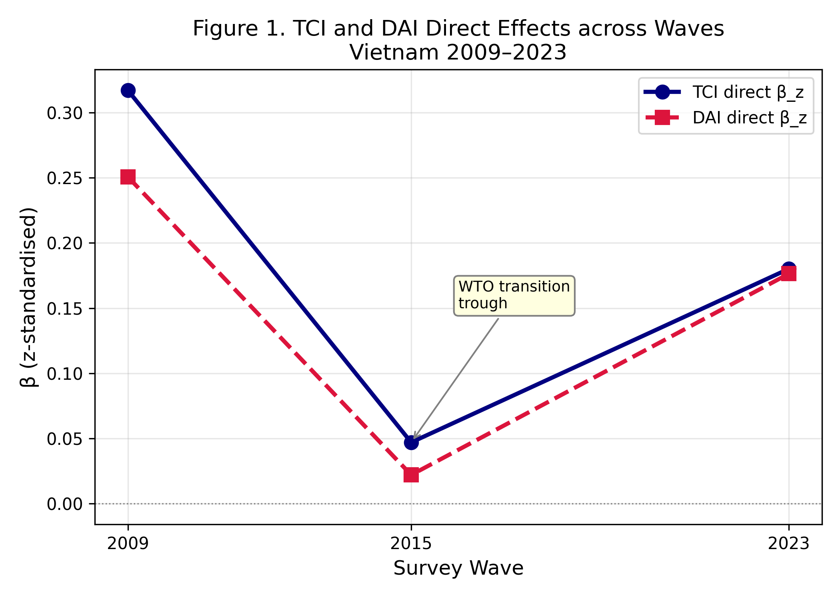
Notes: z-standardised coefficients from M5 (TCI) and M6 (DAI). VNM 2015 attenuation consistent with WTO transition.

Figure 2. I-P Curves across Waves — Vietnam
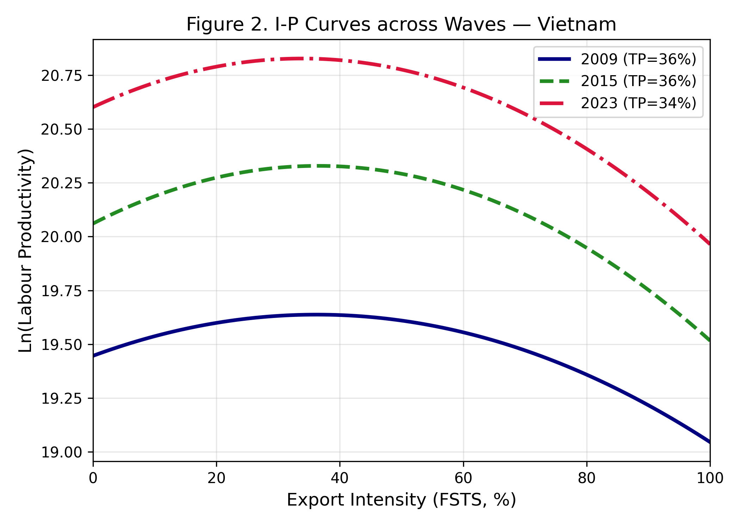
Notes: Predicted values from M2 at sample means of controls. TP stable at ~34-36%.

Figure 3. Turning Point Stability across Waves
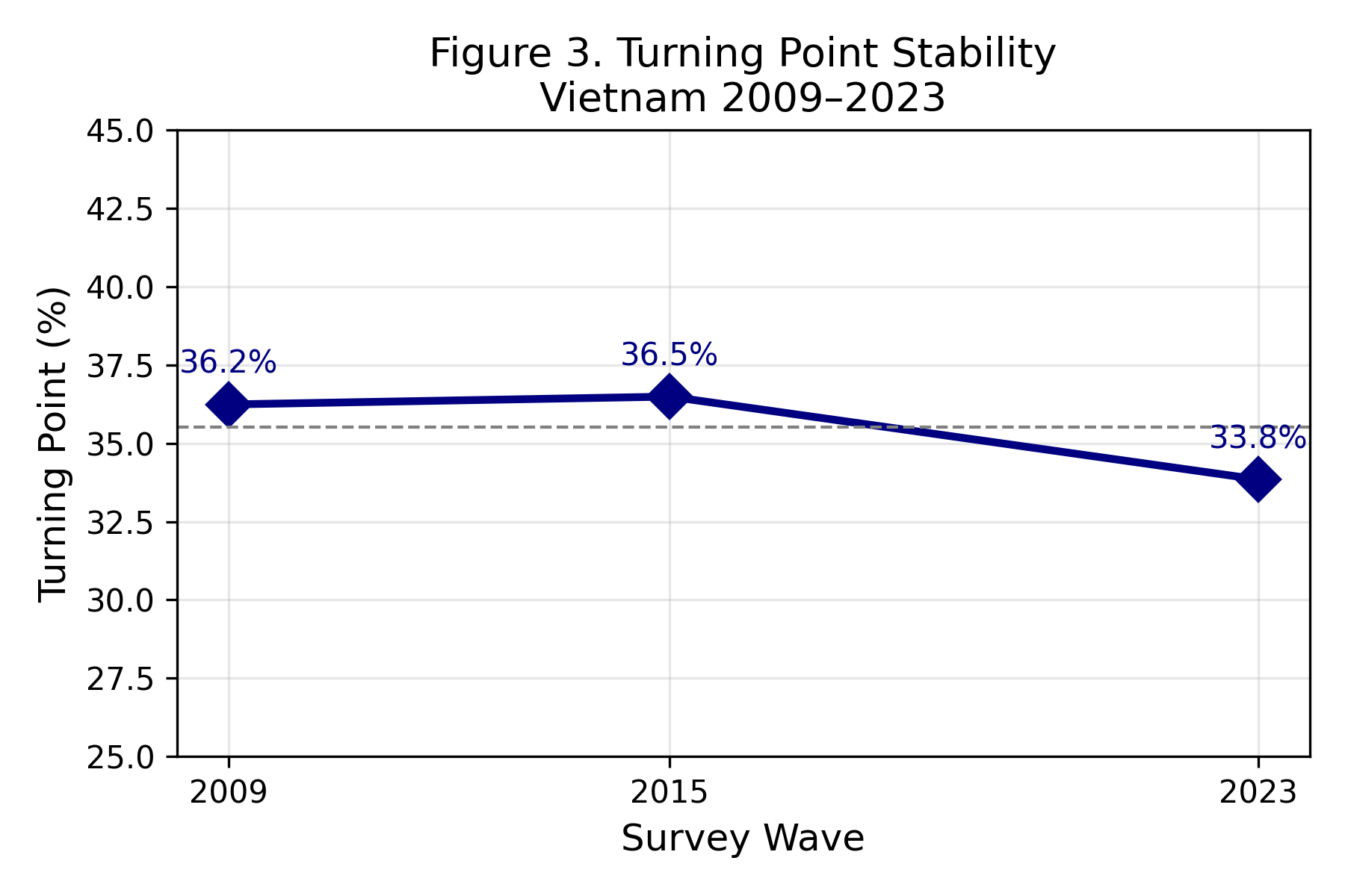
Notes: TP = -β_FSTS / (2·β_FSTS²). Dashed line = mean TP.

