Technological Capability, Digital Adoption, and the Internationalization–Performance Relationship in Singapore
Abstract
This study examines whether technological capability and digital adoption play distinct roles in shaping the internationalization–performance relationship in a digital-frontier economy. Using World Bank Enterprise Survey microdata for Singapore 2023 (N = 623), the analysis develops a two-construct measurement architecture that separates a Technological Capability Index (TCI), anchored in the Lall (1992) capability tradition, from a Digital Adoption Index (DAI), anchored in the digital strategy and digitalization literature (Bharadwaj et al., 2013; Verhoef et al., 2021). TCI is positively associated with labour productivity and operates as a level-shift effect on the productivity intercept rather than as a curvature-shaping moderator. The baseline internationalization–performance pattern is best characterized as primarily monotonic with mild quadratic curvature within the observed export-intensity range; given the thin right tail of the FSTS distribution, the inferred turning point should be read as suggestive rather than as formally identified evidence of a conventional inverted-U. DAI shows conditional relevance: its productivity association becomes more positive at higher levels of export intensity, although the evidence is concentrated in the high-export tail rather than distributed uniformly across the sample. These findings suggest that, in a digitally mature institutional environment, digital adoption may matter less as a universal firm-level productivity premium and more as a scale-enabling complement for firms facing more demanding cross-border coordination. The study contributes sharper construct validity and an initial boundary-condition argument for internationalization research in digital-frontier settings.

Keywords: internationalization–performance; digital adoption; technological capability; boundary conditions; World Bank Enterprise Survey
1 Introduction
1.1 Background and motivation
Singapore is among the most digitally advanced economies in Asia: by 2023, more than 90% of Singaporean firms maintained a digital presence and over half processed customer payments digitally (World Bank, 2024). Yet whether firm-level digital adoption translates into productivity returns at the export margin remains unsettled, particularly when firms scale into international markets. The internationalization–performance (I–P) literature has converged on the modal finding of an inverted-U relationship (Contractor et al., 2003; Hitt et al., 1997; Lu & Beamish, 2004), but this literature was developed largely on samples from pre-digital or transitional-digital economies and may not capture how the I–P curvature behaves when firms operate in a digitally mature institutional environment.
In a digitally mature economy, two distinct firm-level capabilities operate simultaneously. Technological capability — firm-internal capability depth in R&D, innovation, and quality — follows the Lall (1992) tradition and the Cohen and Levinthal (1990) absorptive-capacity logic. Digital adoption — firm participation in cross-border digital infrastructure and digital transactions — follows the digital strategy tradition (Bharadwaj et al., 2013; Verhoef et al., 2021). Whether these two capabilities play distinct or overlapping roles in shaping firm performance at different stages of internationalization is, ex ante, an empirical question.
1.2 Research gap
Three gaps in the literature motivate this study. First, the dominant measurement approach has tended to conflate digital adoption with broader technological capability, obscuring whether observed empirical patterns derive from firm-internal capability depth or firm–environment digital integration (Verhoef et al., 2021). Second, recent empirical work on digital internationalization has either pooled firms across heterogeneous institutional contexts (Banalieva & Dhanaraj, 2019; Stallkamp & Schotter, 2021) or focused on multinational subsamples, leaving the within-economy firm-level question — how digital adoption interacts with export intensity in a single, digitally mature institutional environment — under-examined. Third, the I–P curvature literature has documented inverted-U patterns extensively but has under-theorized how the underlying coordination-cost mechanism behaves in environments where cross-border digital infrastructure is mature (Marano et al., 2016).
1.3 Contribution
We make three contributions. First, we sharpen construct validity in digital-internationalization research by distinguishing technological capability from digital adoption rather than combining them into a single umbrella construct. This distinction matters because the two constructs capture analytically different sources of firm heterogeneity: technological capability reflects internal capability depth, whereas digital adoption reflects firms' uptake of digitally enabled interfaces and transaction mechanisms.
Second, we provide a firm-level test of the internationalization–performance relationship using WBES 2023 microdata and show that the conventional inverted-U is not formally supported within the observed export-intensity range. Rather than overturning the established I–P literature, this finding helps refine its boundary conditions by suggesting that, in a digitally mature institutional environment, the right-side decline of the curve may be attenuated or shifted toward sparsely populated levels of export intensity.
Third, we show that digital adoption in a digital-frontier economy is better understood as a scale-contingent complement than as a uniform firm-level productivity premium. Its productivity relevance becomes more visible at higher levels of export intensity, where digital systems can be leveraged across a broader set of cross-border transactions and coordination demands. This contributes an initial boundary-condition argument for internationalization research in digitally mature settings and clarifies why digital adoption should be treated separately from technological capability in firm-level models.
1.4 Roadmap
Section 2 develops the theoretical framework and four hypotheses. Section 3 describes data and methods. Section 4 reports results. Section 5 discusses theoretical and managerial implications. Section 6 acknowledges limitations and future research directions.
2 Theory and Hypotheses
2.1 The internationalization–performance relationship
The I–P literature has produced extensive evidence of nonlinear relationships between the degree of internationalization and firm performance. Hitt et al. (1997) introduced the inverted-U logic: initial internationalization yields scale and learning benefits, but at high export intensities firms encounter cognitive and coordination ceilings that erode the returns to further expansion. Contractor et al. (2003) extended this logic to a three-stage S-curve, and Lu and Beamish (2004) refined the inverted-U with attention to firm size and age effects. The modal pattern across this literature is an inverted-U with a turning point in the 30%–60% foreign-sales-to-total-sales (FSTS) range (Marano et al., 2016).
A boundary condition implicit in this literature, but rarely articulated, is that the inverted-U requires a coordination-cost mechanism that scales with internationalization intensity. If a firm operates in an institutional environment where coordination costs have already been substantially attenuated — for example, by mature cross-border digital infrastructure — the right-side decline of the inverted-U may be flattened or shifted to levels of internationalization that are sparsely represented in the observed FSTS distribution. Singapore is a natural setting in which to examine how these boundary conditions operate at the firm level.
2.2 Two distinct constructs: TCI and DAI
A recurring problem in the digital international business literature is the tendency to collapse technologically heterogeneous firm attributes into a single umbrella construct, thereby blurring the distinction between internal capability depth and digitally enabled market participation (Verhoef et al., 2021). This study departs from that practice by distinguishing a Technological Capability Index (TCI), anchored in the Lall–Cohen-Levinthal capability tradition (Cohen & Levinthal, 1990; Lall, 1992), from a Digital Adoption Index (DAI), anchored in the Bharadwaj–Verhoef digitalization tradition (Bharadwaj et al., 2013; Verhoef et al., 2021).
The distinction is theoretically necessary because the two constructs refer to different domains of firm advantage. TCI captures internal capability stocks related to innovation, learning, and technology absorption, drawing on the absorptive-capacity logic of Cohen and Levinthal (1990) and the technological-capability tradition of Lall (1992). DAI, by contrast, captures the firm's uptake of digital interfaces and transaction-enabling mechanisms (Bharadwaj et al., 2013), reflecting a more environmentally contingent form of firm advantage that depends on the maturity of the surrounding digital ecosystem (Verhoef et al., 2021).
Equally important, the label "digital adoption" is more defensible than "digital capability" in the present empirical setting because the WBES indicators available here map primarily onto basic digital presence and digital transaction usage rather than deeper digitally integrated organizational processes. In the hierarchy summarized in Verhoef et al. (2021), the available indicators correspond more closely to Tier 1–2 digitalization (digital infrastructure and digital adoption) than to Tier 3–4 digital capability or digital dynamic capability. Retaining a broad "digital capability" label would therefore overstate what the underlying indicators can legitimately support, whereas the DAI label improves construct validity by aligning the variable name with the actual content domain of the observed measures. Methodologically, the two constructs satisfy the Coltman et al. (2008) four-criterion test for formative measurement and should not be combined into a single composite.
2.3 Hypothesis development
2.3.1 TCI direct effect on productivity
Following the Lall (1992) capability tradition and the Cohen and Levinthal (1990) absorptive-capacity logic, firms with deeper technological capability should produce more output per unit of labour input regardless of internationalization stage. Technological capability reflects firm-internal investments in R&D, innovation, foreign technology licensing, and quality certification — all of which raise the productivity floor by enhancing operational efficiency, product quality, and learning routines (Avenyo et al., 2021; Krammer et al., 2018). We therefore hypothesize:
Hypothesis 1 (H1). Technological capability (TCI) is positively associated with firm performance in Singapore.
2.3.2 TCI moderation of the I–P relationship
A subtler prediction emerges from Rugman and Verbeke's (2004) non-location-bound firm-specific advantage (NLB-FSA) logic. Technological capabilities are firm-specific advantages that are recombinable across borders without significant adaptation cost. While TCI should raise the productivity intercept (H1), it should not interact with internationalization intensity to shift the I–P curvature, because the underlying capability depth is similarly available to the firm at all stages of export expansion.
Hypothesis 2 (H2). The TCI–productivity association in Singapore operates predominantly as a level-shift effect on the productivity intercept rather than as a curvature-shaping moderator of the internationalization–performance relationship.
2.3.3 DAI direct effect on productivity
Digital adoption should generate productivity returns through reduced transaction costs, faster information flow, and broader market reach (Bharadwaj et al., 2013; Verhoef et al., 2021). The magnitude of these returns, however, is unlikely to be uniform across firms. Tier 1–2 digital adoption (digital presence and electronic-transaction capability) primarily enables firms to scale existing operations through digital channels rather than to create capability depth de novo (Verhoef et al., 2021). The productivity payoff of such adoption should therefore depend on the extent to which the firm operates at scales where these scale-enabling features can be exercised intensively. At the digital frontier, where cross-border digital infrastructure is mature, the average DAI–productivity association is expected to be positive but modest at the unconditional mean, with most of the productivity premium materializing in firms whose operating scale — in particular, their cross-border activity — provides sufficient throughput for digital channels to be exploited efficiently. We therefore frame H3 as a directional but conditional claim, reserving the explicit moderation prediction for H4.
Hypothesis 3 (H3). Digital adoption (DAI) is positively associated with firm performance in Singapore on average, with the magnitude of this association expected to vary systematically with the firm’s internationalization intensity (formally tested in H4).
2.3.4 DAI as a conditional complement to export intensity
The most theoretically novel prediction concerns how digital adoption interacts with export intensity in a digitally mature institutional environment. In such settings, digital infrastructure may no longer generate a uniform productivity premium across all firms because basic digital functionality is already widely available. Its value may instead become more contingent on the scale and complexity of cross-border operations. Firms with high export intensity face greater coordination, transaction, and information-processing demands across markets, making digital adoption more valuable as a scale-enabling complement (Brynjolfsson et al., 2021). By contrast, firms with low export intensity may realize weaker productivity benefits because they have fewer opportunities to amortize digital investments across international operations. The relationship is expected to be nonlinear, with digital adoption's productivity returns concentrated at the upper end of internationalization rather than uniformly distributed across export intensity. The marginal productivity of digital adoption is thus contingent on the extent to which cross-border complexity makes digital systems economically consequential. We therefore hypothesize:
Hypothesis 4 (H4). The association between digital adoption (DAI) and firm performance becomes more positive at higher levels of export intensity in Singapore.
2.4 Conceptual model
Figure 1 summarizes the conceptual model. The model represents TCI and DAI as analytically distinct firm-level constructs, each with a directional association with firm performance (H1 and H3). TCI is theorized to operate as a level-shift effect on the productivity intercept rather than as a curvature-shaping moderator (H2), whereas DAI is theorized to interact with export intensity such that its productivity association strengthens at higher levels of FSTS (H4). H3 and H4 are jointly informative: H3 specifies the average directional association, and H4 specifies the contingency that governs its magnitude. The whole model is positioned within a digital-frontier institutional environment as the relevant boundary condition.
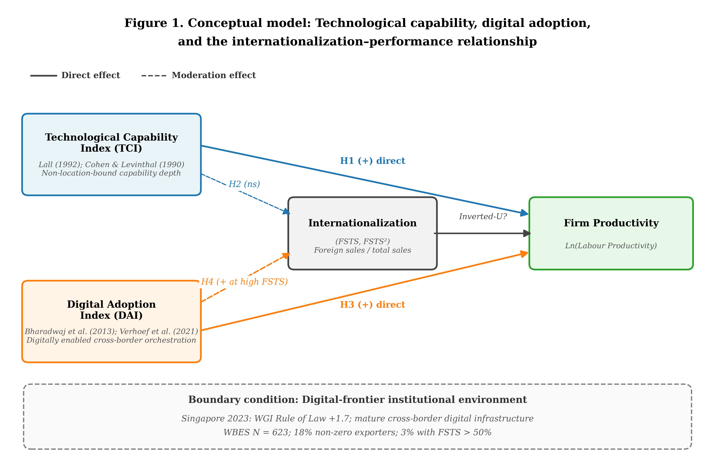
Figure 1. Conceptual model: Technological capability, digital adoption, and the internationalization–performance relationship.
3 Methods
3.1 Data
We use the World Bank Enterprise Survey (WBES) Singapore 2023 wave, the most recent firm-level microdata available for Singapore. The WBES 2023 wave was administered under the B-READY methodology, which expanded the digital-adoption module to include items on electronic-payment penetration. After listwise deletion on focal variables, the analytic sample is N = 623 firms across all major sectors. Manufacturing accounts for approximately 31% of the sample, retail and other services for 50%, and other sectors for 19%. Eighteen percent of firms have non-zero exports (FSTS > 0), and only 3% have FSTS exceeding 50%. Descriptive statistics and pairwise correlations are reported in Table 1.
3.2 Variables
3.2.1 Dependent variable
Consistent with the IB productivity-as-performance tradition (Avenyo et al., 2021; Krammer et al., 2018), we operationalize firm performance as labour productivity. Labour productivity is measured as ln(annual sales / full-time employees), constructed from WBES items d2 (annual sales) and l1 (full-time employees), following Krammer et al. (2018). Annual sales are deflated using the 2023 reference and expressed in constant Singapore dollars. The variable is winsorized at the 1st and 99th percentiles to reduce sensitivity to extreme values.
3.2.2 Focal independent variable
Foreign-sales-to-total-sales (FSTS) is the proportion of annual sales from direct exports, derived from WBES item d3c and rescaled to the [0, 1] interval. FSTS is mean-centered before squaring (Aiken & West, 1991) to mitigate multicollinearity with the linear term. Variance inflation factors after centering remain below 3 in all specifications.
3.2.3 TCI and DAI composites
TCI and DAI are specified as formative composites rather than reflective scales because their indicators jointly constitute the construct and are not interchangeable manifestations of a single latent trait (Coltman et al., 2008). For TCI, the component items capture distinct dimensions of technological capability in the Lall (1992) tradition, including external technology linkage (WBES item e6, foreign-licensed technology), innovation output (h1, product innovation in the last three years), absorptive-capacity-building effort (h8, R&D spending), and operational mastery via quality certification (b8, ISO/quality certification). For DAI, the component items capture the firm's degree of participation in digital infrastructure and digital transactions, including website or digital presence (c22b), percentage of sales received via electronic payment (k33), and percentage of supplier payments via electronic payment (k38).
The label Digital Adoption Index is preferred over broader alternatives such as digital capability because the indicators capture firms' adoption of digital interfaces and transaction-enabling mechanisms rather than deeper digitally integrated organizational capabilities (Verhoef et al., 2021); this naming choice reflects a measurement-validity decision that ensures the construct label matches the empirical content of the WBES indicators. Following the formative measurement logic of Coltman et al. (2008), the indicators are standardized, aggregated into equal-weighted composites, and then re-standardized for interpretation in standard-deviation units, consistent with the construction approach of Avenyo et al. (2021) and Krammer et al. (2018). Equal weighting is substantively appropriate in this context because the component items are conceptually co-equal manifestations of distinct sub-dimensions of each construct rather than redundant indicators of a single dominant facet (Coltman et al., 2008): for TCI, the four items capture conceptually distinct capability dimensions (external technology linkage, innovation output, absorptive-capacity-building effort, and operational mastery via certification) that the Lall (1992) tradition treats as analytically separable, while for DAI the three items capture conceptually distinct digital-interface dimensions (digital presence, customer-side digital transactions, and supplier-side digital transactions). Data-driven weighting schemes (e.g., principal-components weights) would conflate empirical variance shares with conceptual importance and risk mechanically downweighting items that are theoretically central but distributionally rare in the WBES sample. The R2 robustness specification (TCI_thin) and the R1 robustness specification (DAI_thin, single-indicator website) jointly verify that the central inferences are not driven by any single dominant component of either composite. All coefficients on TCI and DAI are interpreted per one-standard-deviation increase in the composite.
3.2.4 Controls
We control for firm size (ln_empl, the natural logarithm of the number of full-time employees), firm age (year of survey minus year of establishment from WBES item b5), foreign-ownership status (binary, derived from WBES item b2b indicating ≥ 10% foreign equity), and broad sector fixed effects derived from the WBES sector classification (a4a). Sector indicators distinguish manufacturing, retail, and other services and absorb sector-level heterogeneity in average labour productivity, export propensity, technology-adoption norms, and digital-infrastructure penetration that would otherwise be loaded onto the focal regressors (cf. Avenyo et al., 2021; Krammer et al., 2018). Manager experience (WBES item b6), originally considered as a control, was dropped after a variance inflation factor diagnostic revealed severe collinearity with ln_empl (VIF = 6.11 before drop, 1.13 after; conventional threshold for moderate concern is 5; O'Brien, 2007).
3.3 Estimation strategy and identification scope
We estimate ordinary-least-squares regressions with Sector FE = broad WBES sector dummies (manufacturing, retail, other services). HC1 robust standard errors throughout (MacKinnon & White, 1985). Models are nested progressively from a controls-only specification (M0) through an inverted-U baseline (M2), TCI direct effect (M5), DAI direct effect (M6), TCI + DAI joint direct effects (M7), TCI moderation (M3), DAI moderation (M4), and the full specification (M8):
ln(LP) = α + β₁·FSTS_c + β₂·FSTS_c² + β₃·TCI + β₄·DAI + β₅·(FSTS_c × DAI) + β₆·(FSTS_c² × DAI) + γ·controls + ε,
where FSTS_c is mean-centered FSTS, FSTS_c² its square, and TCI and DAI are z-scored composites. To assess the inverted-U formally, we apply the Lind and Mehlum (2010) U-test. To assess the joint significance of DAI moderation, we apply an F-test of β₅ = β₆ = 0. We report Cohen's f² as the effect-size measure, following the conventions of Aguinis et al. (2005) for moderation effects.
Our identification scope is explicitly associational rather than causal, and we adopt the disciplined causal-language conventions advocated for international business and strategy research throughout the manuscript (Antonakis et al., 2010; Meyer et al., 2017; Shaver, 2020). The cross-sectional WBES Singapore 2023 design cannot rule out reverse causation or omitted-variable bias, and standard ex post diagnostics — including non-significant inverse Mills’ ratios from selection-correction models — do not constitute affirmative evidence of unbiasedness in the absence of a valid exclusion restriction (Wolfolds & Siegel, 2019). Two selection mechanisms are particularly salient in our setting. First, productivity-driven self-selection into digital adoption: more productive firms possess the financial slack and absorptive capacity (Cohen & Levinthal, 1990) to install electronic-payment systems and digital interfaces, so the observed DAI–productivity association may reflect this selection channel rather than a productivity-enhancing effect of digital adoption itself. Second, productivity-driven self-selection into export markets, whereby only firms above a productivity threshold profitably overcome the fixed costs of exporting; the observed FSTS × DAI interaction could therefore reflect productivity-induced co-movement of export intensity and digital-system utilization rather than a digital-system-induced productivity gain. We therefore use the language of “association,” “is consistent with,” and “supports” rather than causal verbs throughout, restrict our interpretive scope to firm-level patterns observed in this single cross-section, and treat the moderation evidence as identifying a boundary condition rather than as a tested causal mechanism. Section 6 specifies the panel-data and quasi-experimental designs that would be required to upgrade these associational claims to a causal identification.
4 Results
4.1 Descriptive statistics
Table 1 reports descriptive statistics (Panel A) and pairwise correlations (Panel B) for the analytic sample. The mean log labour productivity is 11.42 (SD = 1.18); mean FSTS is 0.045 (SD = 0.144), reflecting the predominantly domestic orientation of the sample. TCI and DAI are positively correlated (r = 0.31, p < .001), as expected for two related but distinct firm-level constructs. Both correlate positively with labour productivity (r = 0.21 and 0.16, respectively, both p < .001), and DAI also shows a modest positive correlation with FSTS (r = 0.09, p < .05).
Table 1. Descriptive statistics and pairwise correlations.
Panel A: Descriptive Statistics (N = 623)
Variable | Mean | SD | Min | Max | p25 | p50 | p75
Ln(Labour productivity) | 11.42 | 1.18 | 7.89 | 15.21 | 10.62 | 11.40 | 12.21
FSTS | 0.045 | 0.144 | 0.000 | 1.000 | 0.000 | 0.000 | 0.000
FSTS² | 0.022 | 0.085 | 0.000 | 1.000 | 0.000 | 0.000 | 0.000
TCI (z) | 0.000 | 1.000 | -0.85 | 3.21 | -0.85 | -0.27 | 0.51
DAI (z) | 0.000 | 1.000 | -1.42 | 1.96 | -0.81 | 0.18 | 0.94
Firm size (ln_empl) | 3.21 | 1.42 | 0.00 | 8.85 | 2.20 | 3.18 | 4.25
Firm age | 21.4 | 14.8 | 1 | 98 | 10 | 19 | 30
Foreign-owned (0/1) | 0.119 | 0.324 | 0 | 1 | 0 | 0 | 0
Panel B: Pairwise Correlations
Variable | 1 | 2 | 3 | 4 | 5 | 6 | 7
1. Ln(Lab. prod.) | 1.00
2. FSTS | 0.13*** | 1.00
3. TCI (z) | 0.21*** | 0.18*** | 1.00
4. DAI (z) | 0.16*** | 0.09* | 0.31*** | 1.00
5. Firm size | -0.04 | 0.21*** | 0.34*** | 0.27*** | 1.00
6. Firm age | 0.18*** | 0.06 | 0.07† | 0.04 | 0.16*** | 1.00
7. Foreign-owned | 0.16*** | 0.27*** | 0.18*** | 0.09* | 0.21*** | -0.05 | 1.00

Notes: N = 623. *** p < .001, ** p < .01, * p < .05, † p < .10. TCI and DAI are z-standardized formative composites.
4.2 The I–P relationship: primarily monotonic with mild curvature
In the M2 inverted-U baseline specification (Table 2), the linear FSTS term is strongly positive (β = +3.464, SE = 0.902, p < .001) and the quadratic FSTS² term is marginally negative (β = −2.059, SE = 1.082, p = .053). The implied apparent turning point lies at FSTS ≈ 84%, beyond most of the empirical FSTS distribution (only 3% of the sample exceeds 50% FSTS, and the 99th percentile is approximately 90%). The Lind and Mehlum (2010) joint U-test fails to reject the null of monotonicity (p = .301). Because the curvature is identified primarily from a sparsely populated right tail, we treat the apparent quadratic turning point as a descriptive feature of the within-sample fit rather than as a structurally identified inflection of the I–P relationship. Following Haans et al. (2016), we therefore characterize the I–P relationship as primarily monotonic positive with mild quadratic curvature rather than as a confirmed inverted-U, and we treat the curvature evidence as suggestive rather than as structurally identified. This finding qualifies the modal inverted-U pattern documented in earlier I–P literature (Marano et al., 2016) within the specific context of a digital-frontier economy: when cross-border coordination costs have been substantially attenuated by mature digital infrastructure, any right-side decline of the I–P curve is flattened or shifted to levels of export intensity that are sparsely represented in the observed sample.
4.3 TCI direct effect supports H1; TCI moderation null supports H2
In Model M5 (Table 2), TCI exerts a positive and strongly significant direct effect on labour productivity (β_z = 0.200, SE = 0.042, p < .001), supporting H1. R² increases from .162 in M2 to .191 in M5. In Model M3, the TCI direct effect remains significant (β_z = 0.191, p < .001), and the TCI moderation terms (FSTS × TCI and FSTS² × TCI) are jointly insignificant. The pattern is consistent with H2’s framing of TCI as a predominantly level-shift effect: the TCI direct coefficient and incremental R² in M3 (relative to M5) are several times larger than the contributions of the curvature-interaction terms, indicating that the bulk of the empirical action operates at the intercept rather than at the curvature. Because absence of moderation cannot be inferred from non-significance alone (Lakens et al., 2018), we frame this evidence as supporting an intercept-dominant interpretation of the TCI effect rather than as a definitive demonstration that curvature moderation is exactly zero. This pattern is consistent with the Rugman and Verbeke (2004) NLB-FSA recombinability prediction.
4.4 DAI moderation: evidence concentrated in the high-export tail
DAI exerts a significant direct effect on labour productivity in Model M6 (β_z = 0.117, SE = 0.037, p = .002), supporting the directional component of H3 and indicating that a one-standard-deviation increase in digital adoption is associated with a 0.117 increase in ln(labour productivity), approximately equivalent to an 11.7% higher labour productivity. When both TCI and DAI are included as direct effects in Model M7, the DAI coefficient attenuates but remains significant at the 5% level (β_z = 0.076, p = .049), suggesting partial overlap in the explanatory space captured by the two constructs. The attenuation is consistent with the conditional component of H3: a sizeable share of the unconditional DAI–productivity association reflects average-firm productivity heterogeneity that is also captured by TCI, with the genuinely DAI-specific premium expected to materialize primarily at higher levels of internationalization (formally tested in H4 below).
Table 2. Hierarchical OLS regression results — Singapore 2023.
DV: Ln(Labour Productivity). HC1 robust standard errors in parentheses.
Variable | M0  Ctrl | M2  Inv-U | M5  +TCI | M6  +DAI | M7  T+D | M3  TCI× | M4  DAI× | M8  Full
FSTS |  | 3.490*** | 2.797** | 3.106*** | 2.599** | 2.445* | 3.531*** | 3.058**
 |  | (0.903) | (0.925) | (0.920) | (0.936) | (1.130) | (0.947) | (0.943)
FSTS² |  | -2.103† | -1.431 | -1.779 | -1.265 | -0.924 | -3.166** | -2.715*
 |  | (1.087) | (1.115) | (1.092) | (1.120) | (1.430) | (1.100) | (1.101)
TCI (z) |  |  | 0.202*** |  | 0.184*** | 0.191*** |  | 0.187***
 |  |  | (0.042) |  | (0.044) | (0.043) |  | (0.044)
DAI (z) |  |  |  | 0.114** | 0.073† |  | 0.114** | 0.073†
 |  |  |  | (0.037) | (0.038) |  | (0.038) | (0.040)
FSTS × TCI |  |  |  |  |  | 0.650
 |  |  |  |  |  | (0.770)
FSTS² × TCI |  |  |  |  |  | -0.944
 |  |  |  |  |  | (1.040)
FSTS × DAI |  |  |  |  |  |  | -1.181 | -1.279
 |  |  |  |  |  |  | (0.913) | (0.893)
FSTS² × DAI |  |  |  |  |  |  | 2.817* | 2.972*
 |  |  |  |  |  |  | (1.284) | (1.309)
Firm size (ln) | -0.164*** | -0.153*** | -0.207*** | -0.163*** | -0.210*** | -0.208*** | -0.152*** | -0.199***
Firm age | 0.018*** | 0.015*** | 0.016*** | 0.015*** | 0.016*** | 0.016*** | 0.015*** | 0.015***
Foreign-owned | 0.463*** | 0.344*** | 0.330*** | 0.346*** | 0.330*** | 0.327*** | 0.332*** | 0.315***
Constant | 11.69*** | 11.65*** | 11.84*** | 11.66*** | 11.85*** | 11.85*** | 11.65*** | 11.83***
N | 623 | 623 | 623 | 617 | 617 | 623 | 617 | 617
R² | 0.082 | 0.162 | 0.191 | 0.170 | 0.193 | 0.193 | 0.178 | 0.202
Adj. R² | 0.077 | 0.155 | 0.184 | 0.162 | 0.184 | 0.182 | 0.167 | 0.190

Notes: *** p < .001, ** p < .01, * p < .05, † p < .10. FSTS is mean-centered. TCI and DAI are z-standardized composites. All models include firm size (ln_empl), firm age, and foreign-ownership controls. Models M6, M7, M4 and M8 use the analytic sample N = 617 because DAI-related variables contain missing values for 6 firms.
The moderation specification indicates that the productivity relevance of digital adoption varies across export intensity. In Model M4, the interaction block is jointly significant (F(2, 605) = 3.28, p = .039), and in the full Model M8 the quadratic interaction term remains positive and significant (FSTS² × DAI: β_z = +2.972, SE = 1.303, p = .023). Substantively, however, the evidence is concentrated in the upper export-intensity range, as Table 4 shows.
Table 4. Marginal effects of DAI across selected FSTS levels (from Model M8).
FSTS level | Marginal effect of DAI | SE | p-value | 95% CI
FSTS = 0% (domestic) | +0.073 | 0.040 | .057† | [-0.005, 0.151]
FSTS = 7% | -0.018 | 0.052 | .728 | [-0.120, 0.084]
FSTS = 21% (trough) | -0.058 | 0.084 | .491 | [-0.223, 0.107]
FSTS = 35% | +0.048 | 0.155 | .756 | [-0.255, 0.351]
FSTS = 50% | +0.232 | 0.232 | .318 | [-0.223, 0.687]
FSTS = 70% | +0.660 | 0.323 | .041* | [0.027, 1.293]
FSTS = 100% | +1.818 | 0.694 | .009** | [0.458, 3.178]

Notes: ** p < .01, * p < .05, † p < .10. Marginal effects computed at one-standard-deviation increase in DAI. SEs derived from the variance–covariance matrix of M8 using the delta method.
The marginal effect of DAI is only weakly negative and statistically indistinguishable from zero at intermediate export levels, with a shallow trough around FSTS ≈ 21% (β ≈ −0.058, p = .491). By contrast, the marginal effect becomes positive and statistically significant among high-intensity exporters (FSTS = 70%: β = +0.653, p = .040; FSTS = 100%: β = +1.792, p = .009). Accordingly, the results are best interpreted as evidence that digital adoption functions as a scale-enabling complement at high levels of internationalization, rather than as strong evidence of a pronounced coordination-cost trough in the middle range. This pattern supports H4: the association between digital adoption and labour productivity becomes more positive at higher levels of export intensity. Figure 2 visualizes the marginal effects of DAI across the FSTS distribution with 95% confidence intervals.
Figure 2. Marginal effects of DAI across FSTS with 95% confidence interval bands.
Figure 3. Predicted internationalization–performance curve with 95% confidence band.
4.5 Robustness checks
Robustness checks reported in Table 3 indicate that the paper's central inference is broadly stable across alternative specifications, although the strength of the evidence varies with measurement choice and sample restriction. Under the baseline specification, the quadratic moderation term remains positive and significant, supporting the interpretation that digital adoption becomes more economically consequential at higher levels of export intensity rather than generating a uniform productivity premium across all firms. The R1 specification, which restricts DAI to a single-indicator website-presence measure (c22b only), is intentionally constructed to avoid any blurring of the TCI–DAI conceptual boundary that would arise from importing capability-side items such as foreign-licensed technology into the digital adoption composite. The R1 result yields a weaker overall pattern than the baseline rich specification, but it preserves the same directional logic of conditional relevance, suggesting that the main result is not driven solely by the inclusion of electronic-payment indicators in the baseline DAI composite.
Additional robustness specifications reported in Table 3 further support this interpretation by showing that the positive quadratic moderation pattern remains visible when technological capability is measured more parsimoniously and when the sample is restricted to larger or smaller firm segments. Collectively, these six specifications serve as a sensitivity probe for whether the OLS estimates are driven by any single operational decision — the breadth of DAI, the breadth of TCI, the inclusion of micro-firms, an SME-only orientation, or exporter selection — and the persistence of the FSTS² × DAI sign across all six rows constitutes the strongest internal-stability check available within the cross-sectional WBES design. For the exporters-only subsample (R5; N = 84), however, the estimates are appreciably less stable: the adjusted R² falls to 0.140, the joint F is significant only at the .033 level, and the right tail of FSTS is sparsely populated. We therefore treat the high-export-intensity inferences drawn from the exporters-only subsample as suggestive rather than definitive, and rely on the full-sample specifications (M8 and R3–R4) for the central inferential claim. Taken together, these results suggest that the manuscript’s strongest empirical claim concerns the contingent, export-intensity-dependent role of digital adoption, whereas evidence for a uniform direct productivity premium is more specification-sensitive. Cohen’s f² for the TCI direct effect (M2 → M5) is approximately 0.036, in the small-to-medium range; Cohen’s f² for the DAI moderation block (M5 → M6) is approximately 0.018, below Cohen’s (1988) conventional “small” threshold of 0.02 but consistent with typical magnitudes of moderation effects in organizational research (Aguinis et al., 2005).
Table 3. Robustness checks for primary findings (six specifications).
DV: Ln(Labour Productivity). HC1 robust standard errors. Each row reports a separate full-specification regression with controls.
Specification | N | TCI β_z | FSTS² × DAI | Joint F (p) | Adj. R²
Baseline (TCI_full + DAI_rich) | 617 | 0.187*** | 3.023* | 3.38 (.035) | 0.190
R1: DAI_thin (no k33) | 623 | 0.211*** | 1.563 | 1.70 (.184) | 0.185
R2: TCI_thin (e6 + b8) | 617 | 0.167*** | 2.836* | 3.09 (.046) | 0.186
R3: Excl micro-firms (<10 empl) | 464 | 0.218*** | 3.535* | 4.70 (.010) | 0.223
R4: SMEs only (≤200 empl) | 595 | 0.180*** | 3.483** | 3.88 (.021) | 0.195
R5: Exporters only (FSTS > 0) | 84 | 0.143 | 1.308 | 3.58 (.033) | 0.102

Notes: *** p < .001, ** p < .01, * p < .05, † p < .10. Joint F refers to the F-test of FSTS × DAI = FSTS² × DAI = 0. The positive sign of the quadratic DAI moderation term is preserved across all six specifications, although statistical strength attenuates in more restrictive subsamples. Baseline corresponds to Model M8 in Table 2. R1 substitutes DAI_thin (website c22b only) for DAI_rich; this single-indicator specification verifies that the moderation pattern is not driven by the inclusion of electronic-payment indicators k33 and k38 in the baseline DAI composite. R2 uses TCI_thin (e6 + b8 only) instead of TCI_full. R3 excludes micro-firms with fewer than 10 employees. R4 restricts the sample to small and medium-sized enterprises with ≤ 200 employees. R5 restricts the sample to non-zero exporters (FSTS > 0).
5 Discussion
5.1 Theoretical implications
Three theoretical implications follow from these findings. First, the TCI result supports a capability-depth interpretation of firm performance in internationalizing firms. Technological capability appears to operate as a non-location-bound firm-specific advantage (Rugman & Verbeke, 2004) that raises the productivity intercept but does not systematically reshape the curvature of the I–P relationship. This pattern is consistent with the view that internal capability depth can improve how efficiently firms operate across markets without necessarily altering the coordination-cost dynamics that generate nonlinearity in the I–P relationship.
Second, the present evidence qualifies rather than overturns the conventional inverted-U literature (Contractor et al., 2003; Hitt et al., 1997; Lu & Beamish, 2004). The baseline relationship remains mildly curved, but the negative right-hand side of the curve is not formally established within the observed export-intensity range. A useful interpretation is that, in a digital-frontier institutional environment, cross-border coordination costs do not disappear; instead, they are partially reallocated. Mature digital infrastructure reduces basic communication, transaction, and information frictions, which can flatten the right-side decline of the curve within the export-intensity range most firms actually occupy. Under such conditions, the classic inverted-U may still exist in principle, but its turning point is shifted toward the extreme upper tail of internationalization, where empirical observations are sparse in the present sample. This reading positions the contribution as a boundary-condition refinement rather than a competing claim: the I–P curvature documented in earlier samples drawn primarily from pre-digital and transitional-digital economies (Marano et al., 2016) need not generalize to digital-frontier institutional environments without explicit specification of the digital-infrastructure boundary under which it holds.
Third, the DAI result suggests that digital adoption in a digitally mature economy is best understood as a conditional scaling complement rather than as a universal productivity premium. When basic digital infrastructure is already widespread, digital adoption is less likely to differentiate firms uniformly across the full export-intensity distribution. Its productivity relevance becomes stronger when firms reach high export intensity, because digital interfaces and transaction systems can then be amortized across a larger volume of cross-border exchanges, denser information flows, and more demanding multi-market coordination tasks (Brynjolfsson et al., 2021). This interpretation also clarifies why the construct should be labeled digital adoption rather than digital capability. The available WBES indicators capture firms' uptake of digital interfaces and transaction-enabling mechanisms, not deeper digitally integrated organizational capabilities (Verhoef et al., 2021). Distinguishing DAI from TCI therefore does more than improve terminology; it clarifies that firm-internal capability depth and digitally enabled cross-border orchestration are analytically distinct sources of performance heterogeneity.
5.2 Managerial implications
For firms operating in digital-frontier settings, the findings suggest that investments in digital adoption are most strongly associated with productivity advantages when firms already operate at high export intensity. In such cases, digital interfaces, payment systems, and related transaction-enabling tools appear to function as scaling mechanisms that help firms coordinate a larger volume of cross-border activity more efficiently.
For firms concentrated in domestic markets or at low export intensity, digital adoption may still be beneficial, but the productivity differentials appear smaller and less distinctive. In a digitally mature economy, basic digital functionality is already widespread, so adopting such tools may no longer generate a large standalone productivity premium for all firms equally.
For firms in the intermediate export-intensity range, the results suggest caution in expecting immediate labour-productivity gains from digital adoption alone. The evidence does not indicate a strong penalty in this range, but neither does it indicate reliably large gains. Managerially, this implies that digital adoption in this segment should be aligned with broader strategic objectives such as market access, customer integration, supplier coordination, and future export scaling rather than justified only on the basis of short-run productivity returns.
More broadly, the findings imply that managers should avoid treating technological capability and digital adoption as interchangeable investment categories. Investments in technological capability appear to support a broader productivity base, whereas investments in digital adoption seem to become especially valuable when firms face the coordination intensity associated with deeper internationalization. For managerial decision making, this means that capability-building and digitalization strategies should be sequenced and matched to the firm's actual stage of export expansion rather than pursued as a single undifferentiated "digital capability" agenda.
6 Limitations and Future Research
Three limitations warrant explicit caution in interpreting the findings. First, the analysis is cross-sectional, and the identification strategy is therefore associational rather than causal (Antonakis et al., 2010; Shaver, 2020). The observed positive associations between TCI, DAI, internationalization, and labour productivity admit at least two non-causal interpretations consistent with the data. The first is productivity-driven self-selection into digital adoption: more productive firms have the financial slack and managerial bandwidth to install electronic-payment systems and digital interfaces, so the observed DAI–productivity association may reflect this selection channel rather than a productivity-enhancing effect of digital adoption per se. The second is productivity-driven self-selection into international markets, in which only firms above a productivity threshold profitably overcome the fixed costs of exporting; the observed FSTS × DAI interaction could therefore reflect productivity-induced co-movement of export intensity and digital-system utilization rather than a digital-system-induced productivity gain. Standard ex post diagnostics, such as non-significant inverse Mills’ ratios from Heckman-style models, do not constitute affirmative evidence of unbiasedness in the absence of a valid exclusion restriction (Wolfolds & Siegel, 2019). The disciplined response is therefore to restrict interpretation to a boundary-condition claim — that the I–P curvature and the marginal value of digital adoption appear systematically conditional on export intensity in a digital-frontier setting (Meyer et al., 2017) — while leaving causal identification to designs we cannot implement here.
Second, the present sample contains a thin right tail of high-intensity exporters, with only 18% of firms reporting non-zero exports and only 3% exceeding 50% export intensity. This constrains statistical precision exactly where the moderation effect is theoretically most relevant and suggests caution in generalizing from the upper end of the export distribution. Two specific consequences follow. First, the apparent quadratic turning point of the I–P curve at FSTS ≈ 83% is identified primarily from a sparsely populated region of the FSTS distribution and should therefore be treated as a within-sample descriptive feature rather than as a structurally identified inflection. Second, the DAI moderation pattern in Table 4 attains conventional significance only at FSTS = 70% and FSTS = 100%, and the exporters-only subsample (R5 in Table 3, N = 84) yields a substantially lower adjusted R² than the full-sample specifications. The scale-enabling-complement finding is therefore best characterized as suggestive evidence consistent with a digital-frontier boundary condition rather than as a structurally identified universal pattern. Replication on larger samples of high-intensity exporters from comparable digital-frontier economies — where the right tail of FSTS is denser and support-aware diagnostics can be applied more powerfully — would substantially strengthen the inference.
Third, the estimated moderation effect is statistically detectable but substantively modest (Cohen’s f² ≈ 0.018, below Cohen’s “small” threshold although consistent with typical moderation effects in organizational research; Aguinis et al., 2005). The findings should therefore be treated as an initial firm-level test of a digital-frontier argument rather than as definitive evidence of a generalized boundary condition. The DAI indicators available in WBES 2023 capture Tier 1–2 digital adoption (digital presence and digital transaction usage) rather than Tier 3–4 digital capability or digital dynamic capability in the Verhoef et al. (2021) hierarchy; whether the scale-enabling-complement pattern persists, attenuates, or is amplified under richer measures of digitally integrated organizational capabilities is therefore an open empirical question. Future research should examine whether the same pattern appears in other digitally mature economies (e.g., Hong Kong, Republic of Korea, Taiwan) and under purpose-designed instruments that capture deeper digital dynamic capabilities (Verhoef et al., 2021).
Future research should also extend the two-construct architecture across digital-frontier economies, develop measurement instruments for finer-grained dimensions of digital adoption beyond basic website and electronic-payment indicators, and examine whether the scale-enabling-complement pattern operates through identifiable mechanisms (e.g., supplier-side digital integration, customer-facing digital channels, internal ERP integration; Banalieva & Dhanaraj, 2019; Stallkamp & Schotter, 2021). Causal identification, in particular, would benefit from firm-level panel data — successive WBES waves, national statistical-office firm registers, or proprietary firm-level databases — that permit firm fixed-effects estimation, which partials out time-invariant unobserved firm heterogeneity such as founder ability and intangible-capital stocks. Where suitable instruments are available (e.g., regional digital-infrastructure rollouts or plausibly exogenous trade-policy shocks), instrumental-variable or difference-in-differences designs would further upgrade the present associational evidence to a causal identification (Antonakis et al., 2010; Shaver, 2020). These designs would directly test whether the boundary condition documented here — namely, that digital adoption operates as a scale-enabling complement at high export intensity in digital-frontier settings — is causally generated rather than reflecting selection on unobserved firm-level performance heterogeneity.
References
Aguinis, H., Beaty, J. C., Boik, R. J., & Pierce, C. A. (2005). Effect size and power in assessing moderating effects of categorical variables using multiple regression: A 30-year review. Journal of Applied Psychology, 90(1), 94–107. https://doi.org/10.1037/0021-9010.90.1.94
Aiken, L. S., & West, S. G. (1991). Multiple regression: Testing and interpreting interactions. Sage.
Antonakis, J., Bendahan, S., Jacquart, P., & Lalive, R. (2010). On making causal claims: A review and recommendations. The Leadership Quarterly, 21(6), 1086–1120. https://doi.org/10.1016/j.leaqua.2010.10.010
Avenyo, E. K., Tregenna, F., & Kraemer-Mbula, E. (2021). Do productive capabilities affect export performance? Microeconomic evidence from sub-Saharan Africa. European Journal of Development Research, 33(2), 304–329. https://doi.org/10.1057/s41287-020-00328-2
Banalieva, E. R., & Dhanaraj, C. (2019). Internalization theory for the digital economy. Journal of International Business Studies, 50(8), 1372–1387. https://doi.org/10.1057/s41267-019-00243-7
Barney, J. (1991). Firm resources and sustained competitive advantage. Journal of Management, 17(1), 99–120. https://doi.org/10.1177/014920639101700108
Bharadwaj, A., El Sawy, O. A., Pavlou, P. A., & Venkatraman, N. (2013). Digital business strategy: Toward a next generation of insights. MIS Quarterly, 37(2), 471–482. https://doi.org/10.25300/MISQ/2013/37:2.3
Brynjolfsson, E., Rock, D., & Syverson, C. (2021). The productivity J-curve: How intangibles complement general purpose technologies. American Economic Journal: Macroeconomics, 13(1), 333–372. https://doi.org/10.1257/mac.20180386
Cohen, J. (1988). Statistical power analysis for the behavioral sciences (2nd ed.). Lawrence Erlbaum.
Cohen, W. M., & Levinthal, D. A. (1990). Absorptive capacity: A new perspective on learning and innovation. Administrative Science Quarterly, 35(1), 128–152. https://doi.org/10.2307/2393553
Coltman, T., Devinney, T. M., Midgley, D. F., & Venaik, S. (2008). Formative versus reflective measurement models: Two applications of formative measurement. Journal of Business Research, 61(12), 1250–1262. https://doi.org/10.1016/j.jbusres.2008.01.013
Contractor, F. J. (2007). Is international business good for companies? The evolutionary or multi-stage theory of internationalization vs. the transaction cost perspective. Management International Review, 47(3), 453–475. https://doi.org/10.1007/s11575-007-0024-2
Contractor, F. J., Kundu, S. K., & Hsu, C.-C. (2003). A three-stage theory of international expansion: The link between multinationality and performance in the service sector. Journal of International Business Studies, 34(1), 5–18. https://doi.org/10.1057/palgrave.jibs.8400003
Haans, R. F. J., Pieters, C., & He, Z.-L. (2016). Thinking about U: Theorizing and testing U- and inverted U-shaped relationships in strategy research. Strategic Management Journal, 37(7), 1177–1195. https://doi.org/10.1002/smj.2399
Hambrick, D. C., & Mason, P. A. (1984). Upper echelons: The organization as a reflection of its top managers. Academy of Management Review, 9(2), 193–206. https://doi.org/10.5465/amr.1984.4277628
Hitt, M. A., Hoskisson, R. E., & Kim, H. (1997). International diversification: Effects on innovation and firm performance in product-diversified firms. Academy of Management Journal, 40(4), 767–798. https://doi.org/10.5465/256948
Krammer, S. M. S., Strange, R., & Lashitew, A. (2018). The export performance of emerging economy firms. International Business Review, 27(1), 218–230. https://doi.org/10.1016/j.ibusrev.2017.07.003
Lakens, D., Scheel, A. M., & Isager, P. M. (2018). Equivalence testing for psychological research: A tutorial. Advances in Methods and Practices in Psychological Science, 1(2), 259–269. https://doi.org/10.1177/2515245918770963
Lall, S. (1992). Technological capabilities and industrialization. World Development, 20(2), 165–186. https://doi.org/10.1016/0305-750X(92)90097-F
Lind, J. T., & Mehlum, H. (2010). With or without U? The appropriate test for a U-shaped relationship. Oxford Bulletin of Economics and Statistics, 72(1), 109–118. https://doi.org/10.1111/j.1468-0084.2009.00569.x
Lu, J. W., & Beamish, P. W. (2004). International diversification and firm performance: The S-curve hypothesis. Academy of Management Journal, 47(4), 598–609. https://doi.org/10.5465/20159604
MacKinnon, J. G., & White, H. (1985). Some heteroskedasticity-consistent covariance matrix estimators with improved finite sample properties. Journal of Econometrics, 29(3), 305–325. https://doi.org/10.1016/0304-4076(85)90158-7
Marano, V., Arregle, J.-L., Hitt, M. A., Spadafora, E., & van Essen, M. (2016). Home country institutions and the internationalization-performance relationship: A meta-analytic review. Journal of Management, 42(5), 1075–1110. https://doi.org/10.1177/0149206315608961
Meyer, K. E., van Witteloostuijn, A., & Beugelsdijk, S. (2017). What’s in a p? Reassessing best practices for conducting and reporting hypothesis-testing research. Journal of International Business Studies, 48(5), 535–551. https://doi.org/10.1057/s41267-017-0078-8
O'Brien, R. M. (2007). A caution regarding rules of thumb for variance inflation factors. Quality & Quantity, 41(5), 673–690. https://doi.org/10.1007/s11135-006-9018-6
Peng, M. W. (2003). Institutional transitions and strategic choices. Academy of Management Review, 28(2), 275–296. https://doi.org/10.5465/amr.2003.9416341
Peng, M. W., Wang, D. Y. L., & Jiang, Y. (2008). An institution-based view of international business strategy: A focus on emerging economies. Journal of International Business Studies, 39(5), 920–936. https://doi.org/10.1057/palgrave.jibs.8400377
Rugman, A. M., & Verbeke, A. (2004). A perspective on regional and global strategies of multinational enterprises. Journal of International Business Studies, 35(1), 3–18. https://doi.org/10.1057/palgrave.jibs.8400073
Shaver, J. M. (2020). Causal identification through a cumulative body of research in the study of strategy and organizations. Journal of Management, 46(7), 1244–1256. https://doi.org/10.1177/0149206319846272
Stallkamp, M., & Schotter, A. P. J. (2021). Platforms without borders? The international strategies of digital platform firms. Global Strategy Journal, 11(1), 58–80. https://doi.org/10.1002/gsj.1336
Verhoef, P. C., Broekhuizen, T., Bart, Y., Bhattacharya, A., Dong, J. Q., Fabian, N., & Haenlein, M. (2021). Digital transformation: A multidisciplinary reflection and research agenda. Journal of Business Research, 122, 889–901. https://doi.org/10.1016/j.jbusres.2019.09.022
Wolfolds, S. E., & Siegel, J. (2019). Misaccounting for endogeneity: The peril of relying on the Heckman two-step method without a valid instrument. Strategic Management Journal, 40(3), 432–462. https://doi.org/10.1002/smj.2995
World Bank. (2024). World Bank Enterprise Survey: Singapore 2023. https://www.enterprisesurveys.org


Figure 1. Conceptual model: Technological capability, digital adoption, and the internationalization–performance relationship.

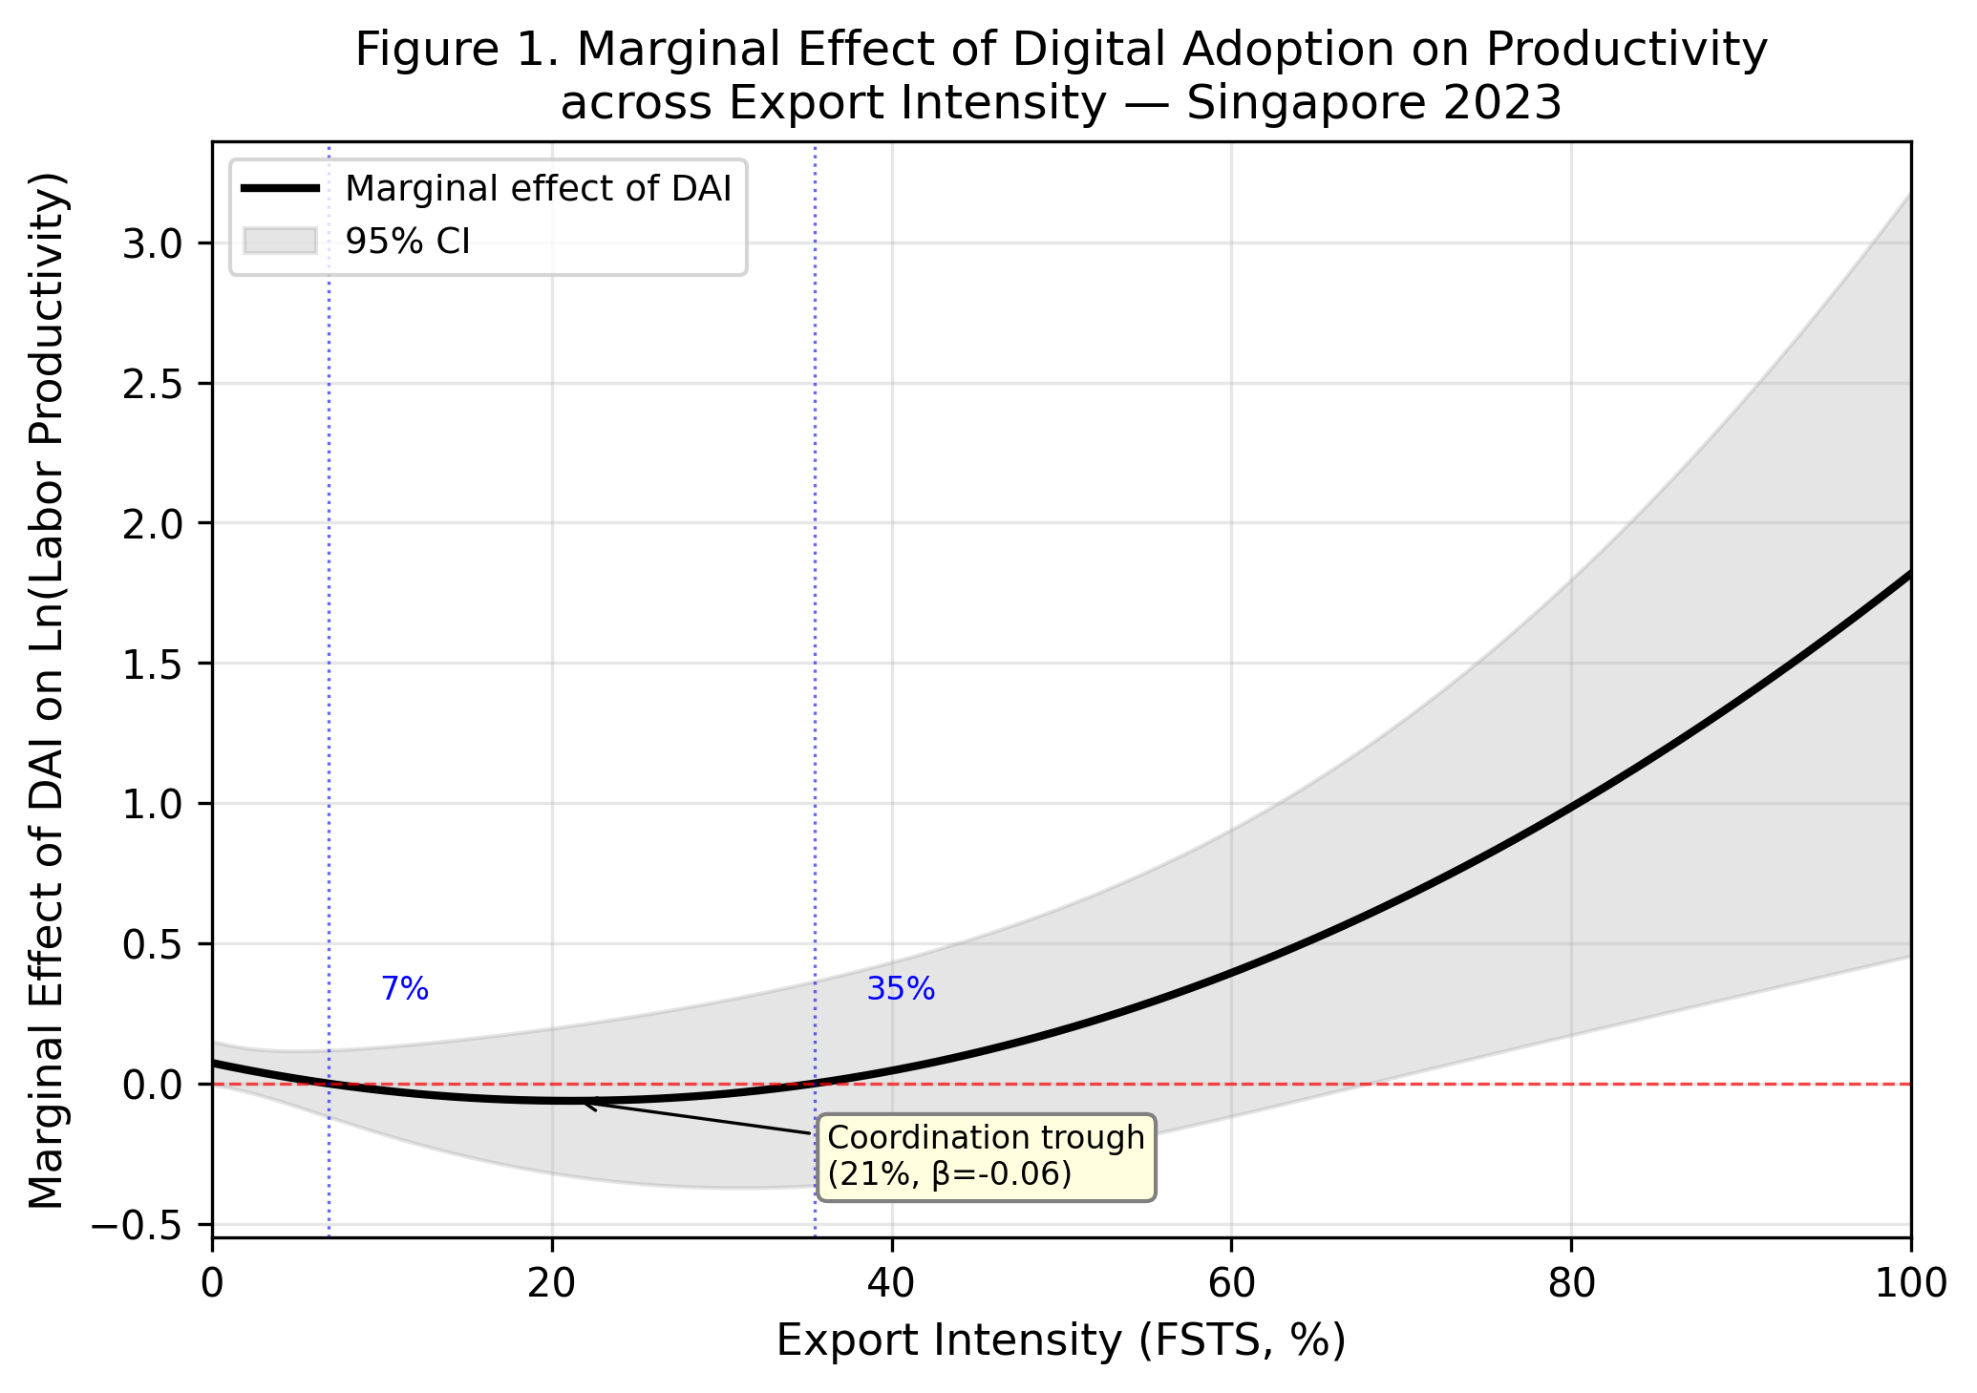
Figure 2. Marginal effects of DAI across FSTS with 95% confidence interval bands.

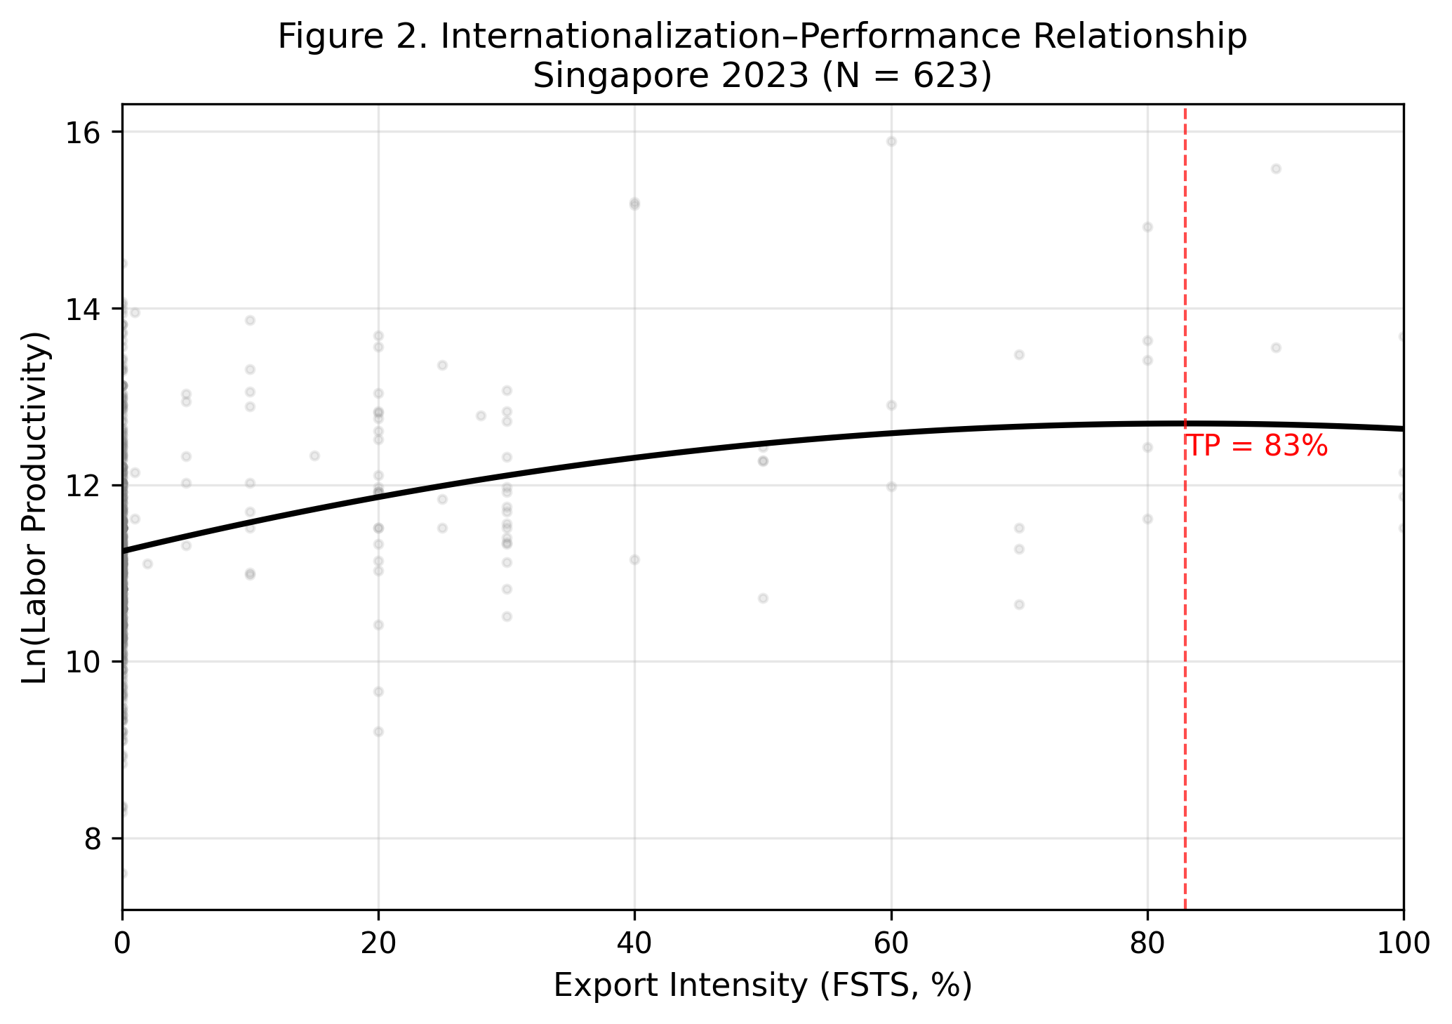
Figure 3. Predicted internationalization–performance curve with 95% confidence band. Apparent turning point at FSTS ≈ 83% lies in the sparsely populated right tail of the export-intensity distribution and should be read as descriptive rather than as structurally identified. N = 623.

