Technological Capability, Digital Adoption, and the Internationalization–Performance Relationship: A Firm-Level Study of Singapore
Abstract
This study examines how technological capability and digital adoption shape the internationalization–performance relationship in Singapore, treated as an extreme-case, within-context setting of a digitally mature economy. Using World Bank Enterprise Survey microdata for Singapore 2023 (N = 623), the analysis distinguishes a Technological Capability Index (TCI) capturing firm-internal capability depth from a Digital Adoption Index (DAI) capturing foundational digital interfaces and transaction-enabling mechanisms.
Three findings emerge. First, the full-sample inverted-U shape is robust (96.3% of bootstrap replications) but its location is loosely identified (95% bootstrap CI for the turning point: [53%, 253%]). Within an extensive–intensive split addressing the dominance of zero-FSTS firms (82% of the sample), curvature is not detectable inside the exporter subsample, so the full-sample polynomial reads as a descriptive baseline rather than a structurally identified curve. Second, TCI is positively and consistently associated with productivity across leave-one-out and trimmed-tail perturbations; no distinguishable moderation by TCI is detected. Third, DAI shows a conditional rather than uniform productivity association: it becomes more positive at higher export intensity, and the moderation pattern survives leave-one-out, item-swap falsification, and trimmed-tail re-estimation. The study contributes refined boundary conditions for the internationalization–performance literature in Singapore as an extreme-case setting, clarifying that TCI shifts the productivity level while DAI complements export-intensity scaling.

Keywords: internationalization–performance relationship; digital adoption; technological capability; boundary conditions; Singapore
1 Introduction
1.1 Background and motivation
Singapore is an analytically valuable setting for revisiting the internationalization–performance relationship because it combines high digital maturity with firm-level heterogeneity in export intensity. The classic I–P literature explains nonlinearity through a trade-off between the scale and learning benefits of international expansion and the rising coordination costs of operating across markets, with the inverted-U emerging as the modal empirical pattern in the broader literature (Marano et al. 2016). However, much of this literature was developed in pre-digital or transitional-digital settings, where institutional and infrastructural conditions differ substantially from those of digitally mature economies (Peng 2003; Peng et al. 2008) and may not fully capture how the I–P curve behaves when firms operate in a digitally mature institutional environment.
In such contexts, the relevant question is not simply whether firms still exhibit the conventional inverted-U, but whether digital maturity changes the export range over which the right-side decline becomes empirically visible. If mature digital infrastructure attenuates communication, transaction, and information frictions, then the coordination-cost mechanism underlying the classic inverted-U may be weakened, delayed, or pushed toward sparsely populated levels of export intensity. This possibility is especially important in environments where firms engage with digital interfaces and transaction systems at scale, because such technologies can alter both the cost and speed of cross-border coordination (Bharadwaj et al. 2013; Verhoef et al. 2021).
A second motivation concerns construct clarity. In digitally mature settings, firms may differ not only in deeper technological capability rooted in learning, innovation, and absorptive capacity, but also in the extent to which they adopt basic digital interfaces and transaction-enabling systems. These two domains should not be collapsed into a single umbrella construct, because technological capability reflects firm-internal capability depth grounded in resource-based and absorptive-capacity logic (Barney 1991; Cohen & Levinthal 1990; Lall 1992), whereas digital adoption reflects participation in digitally enabled transactions and interfaces that may be more contingent on the surrounding digital ecosystem (Bharadwaj et al. 2013; Verhoef et al. 2021).
1.2 Research gap
Three gaps motivate this study. First, the dominant measurement approach has often conflated digital adoption with broader technological capability, making it difficult to determine whether observed productivity differences reflect firm-internal capability depth or firms’ participation in digitally enabled interfaces and transactions (Verhoef et al. 2021). This matters because the two domains imply different mechanisms of advantage and should not be assumed to operate identically across stages of internationalization.
Second, although recent work on digital internationalization has advanced important theoretical insights (Banalieva & Dhanaraj 2019; Stallkamp & Schotter 2021), much of it remains conceptual or focused on multinational samples, leaving under-examined the within-economy firm-level question of how foundational digital adoption interacts with export intensity in a single digitally mature institutional environment. In particular, the literature still lacks clear firm-level evidence on whether basic digital presence and transaction-enabling systems matter uniformly across firms or mainly when cross-border coordination demands intensify (Bharadwaj et al. 2013; Verhoef et al. 2021).
Third, the nonlinear I–P literature has documented inverted-U patterns extensively, but it has not clearly specified how its coordination-cost logic should behave in digitally mature settings (Marano et al. 2016). If mature digital infrastructure attenuates the frictions that underpin the right-side decline of the I–P curve, then the conventional turning point may no longer be visible within the export range most firms actually occupy. This leaves an unresolved boundary-condition question: does digital maturity alter the form of the I–P relationship itself, or does it mainly shift the region in which its nonlinear structure becomes observable?
1.3 Contribution
This study makes one primary contribution and two supporting contributions. Its primary contribution is to refine the boundary conditions of the internationalization–performance literature by showing that, in Singapore 2023, the classic right-side decline of the I–P curve is not formally identified within the observed export-intensity range and appears to be shifted toward a sparsely populated upper tail. In doing so, the study qualifies rather than overturns the conventional nonlinear I–P logic summarized in prior meta-analytic work (Marano et al. 2016).
The first supporting contribution is measurement-theoretic. The analysis distinguishes technological capability from digital adoption, thereby separating firm-internal capability depth grounded in technological learning and absorptive capacity from foundational digitally enabled market participation (Cohen & Levinthal 1990; Lall 1992; Verhoef et al. 2021). The second supporting contribution is substantive. The findings show that foundational digital adoption is better understood as a scale-enabling complement whose productivity relevance becomes stronger at higher export intensity, rather than as a uniform firm-level productivity premium, which is consistent with the broader logic of digital strategy and digitally mediated coordination (Bharadwaj et al. 2013; Verhoef et al. 2021).
1.4 Roadmap
Section 2 develops the theoretical framework and four hypotheses. Section 3 describes data and methods. Section 4 reports results. Section 5 discusses theoretical and managerial implications. Section 6 concludes. Section 7 acknowledges limitations and future research directions.
2 Theory and Hypotheses
2.1 The internationalization–performance relationship
The I–P literature has produced extensive evidence of nonlinear relationships between the degree of internationalization and firm performance. Hitt et al. (1997) introduced the inverted-U logic: initial internationalization yields scale and learning benefits, but at high export intensities firms encounter cognitive and coordination ceilings that erode the returns to further expansion. Contractor et al. (2003) extended this logic to a three-stage S-curve, and Lu and Beamish (2004) refined the inverted-U with attention to firm size and age effects. The modal pattern across this literature is an inverted-U with a turning point in the 30%–60% foreign-sales-to-total-sales (FSTS) range (Marano et al. 2016).
A boundary condition implicit in this literature, but rarely articulated, is that the inverted-U requires a coordination-cost mechanism that scales with internationalization intensity. If a firm operates in an institutional environment where coordination costs have already been substantially attenuated — for example, by mature cross-border digital infrastructure — the right-side decline of the inverted-U may be flattened or shifted to levels of internationalization that are sparsely represented in the observed FSTS distribution. Singapore is a natural setting in which to examine how these boundary conditions operate at the firm level.
2.2 Two distinct constructs: TCI and DAI
A recurring problem in the digital international business literature is the tendency to collapse technologically heterogeneous firm attributes into a single umbrella construct, thereby blurring the distinction between internal capability depth and digitally enabled market participation (Verhoef et al. 2021). This study departs from that practice by distinguishing a Technological Capability Index (TCI), anchored in the Lall–Cohen-Levinthal capability tradition (Cohen & Levinthal 1990; Lall 1992), from a Digital Adoption Index (DAI), anchored in the Bharadwaj–Verhoef digitalization tradition (Bharadwaj et al. 2013; Verhoef et al. 2021).
The distinction is theoretically necessary because the two constructs refer to different domains of firm advantage. TCI captures internal capability stocks related to innovation, learning, and technology absorption, drawing on the absorptive-capacity logic of Cohen and Levinthal (1990) and the technological-capability tradition of Lall (1992). DAI, by contrast, captures the firm's uptake of digital interfaces and transaction-enabling mechanisms (Bharadwaj et al. 2013), reflecting a more environmentally contingent form of firm advantage that depends on the maturity of the surrounding digital ecosystem (Verhoef et al. 2021).
Equally important, the label "digital adoption" is more defensible than "digital capability" in the present empirical setting because the WBES indicators available here map primarily onto basic digital presence and digital transaction usage rather than deeper digitally integrated organizational processes. In the Verhoef et al. (2021) hierarchy, website presence (c22b) corresponds most closely to Tier 1 digitization, while electronic-payment intensity on the customer and supplier sides (k33, k38) corresponds to Tier 2 digitalization. Our DAI composite therefore captures the foundational digital layer upon which higher-order digital capabilities may be built, but it cannot directly observe Tier 3 process integration (e.g., ERP, CRM, digitally integrated supply chains) or Tier 4 digital dynamic capability (e.g., AI deployment, platform orchestration, reconfiguration capability). Given this measurement boundary, retaining a broad "digital capability" label would overstate what the underlying indicators can legitimately support, whereas the DAI label improves construct validity by aligning the variable name with the actual content domain of the observed measures. Methodologically, the two constructs satisfy the Coltman et al. (2008) four-criterion test for formative (as opposed to reflective) measurement. Separately, combining TCI and DAI into a single composite would violate the principle that constructs with different hypothesised nomological nets should remain analytically distinct.
2.3 Hypothesis development
2.3.1 TCI direct effect on productivity
Following the Lall (1992) capability tradition and the Cohen and Levinthal (1990) absorptive-capacity logic, firms with deeper technological capability should produce more output per unit of labour input regardless of internationalization stage. Technological capability reflects firm-internal investments in R&D, innovation, foreign technology licensing, and quality certification — all of which raise the productivity floor by enhancing operational efficiency, product quality, and learning routines (Avenyo et al. 2021; Krammer et al. 2018). We therefore hypothesize:
Hypothesis 1 (H1). Technological capability (TCI) is positively associated with firm performance in Singapore.
2.3.2 TCI moderation of the I–P relationship
A subtler prediction emerges from Rugman and Verbeke's (2004) non-location-bound firm-specific advantage (NLB-FSA) logic. Technological capabilities are firm-specific advantages that are recombinable across borders without significant adaptation cost. While TCI should raise the productivity intercept (H1), it should not interact with internationalization intensity to shift the I–P curvature, because the underlying capability depth is similarly available to the firm at all stages of export expansion.
Hypothesis 2 (H2). Technological capability (TCI) is positively associated with labour productivity in Singapore. Whether TCI also moderates the curvature of the internationalization–performance relationship is treated as an open empirical question; the present design tests for, but does not presume, a moderation channel.
2.3.3 DAI direct effect on productivity
Digital adoption should generate productivity returns through reduced transaction costs, faster information flow, and broader market reach (Bharadwaj et al. 2013; Verhoef et al. 2021). The magnitude of these returns, however, is unlikely to be uniform across firms. Tier 1–2 digital adoption (digital presence and electronic-transaction capability) primarily enables firms to scale existing operations through digital channels rather than to create capability depth de novo (Verhoef et al. 2021). The productivity payoff of such adoption should therefore depend on the extent to which the firm operates at scales where these scale-enabling features can be exercised intensively. In a digitally mature economy, where cross-border digital infrastructure is mature, the average DAI–productivity association is expected to be positive but modest at the unconditional mean, with most of the productivity premium materializing in firms whose operating scale — in particular, their cross-border activity — provides sufficient throughput for digital channels to be exploited efficiently. We therefore frame H3 as a directional but conditional claim, reserving the explicit moderation prediction for H4.
Hypothesis 3 (H3). The productivity association of digital adoption (DAI) in Singapore is conditional on export intensity rather than uniform across firms. Specifically, foundational digital adoption is expected to complement the productivity returns to higher levels of export intensity; the moderation pattern is formally tested in H4.
2.3.4 DAI as a conditional complement to export intensity
The most theoretically novel prediction concerns how digital adoption interacts with export intensity in a digitally mature institutional environment. In such settings, digital infrastructure may no longer generate a uniform productivity premium across all firms because basic digital functionality is already widely available. Its value may instead become more contingent on the scale and complexity of cross-border operations. Firms with high export intensity face greater coordination, transaction, and information-processing demands across markets, making digital adoption more valuable as a scale-enabling complement (Brynjolfsson et al. 2021). By contrast, firms with low export intensity may realize weaker productivity benefits because they have fewer opportunities to amortize digital investments across international operations. The relationship is expected to be nonlinear, with digital adoption's productivity returns concentrated at the upper end of internationalization rather than uniformly distributed across export intensity. The marginal productivity of digital adoption is thus contingent on the extent to which cross-border complexity makes digital systems economically consequential. We therefore hypothesize:
Hypothesis 4 (H4). The association between digital adoption (DAI) and firm performance becomes more positive at higher levels of export intensity in Singapore.
2.4 Conceptual model
Figure 1 summarizes the conceptual model. The model represents TCI and DAI as analytically distinct firm-level constructs, each with a directional association with firm performance (H1 and H3). TCI is theorized to operate as a level-shift effect on the productivity intercept rather than as a curvature-shaping moderator (H2), whereas DAI is theorized to interact with export intensity such that its productivity association strengthens at higher levels of FSTS (H4). H3 and H4 are jointly informative: H3 specifies the average directional association, and H4 specifies the contingency that governs its magnitude. The whole model is positioned within a extreme-case, within-context setting of a digitally mature economy.
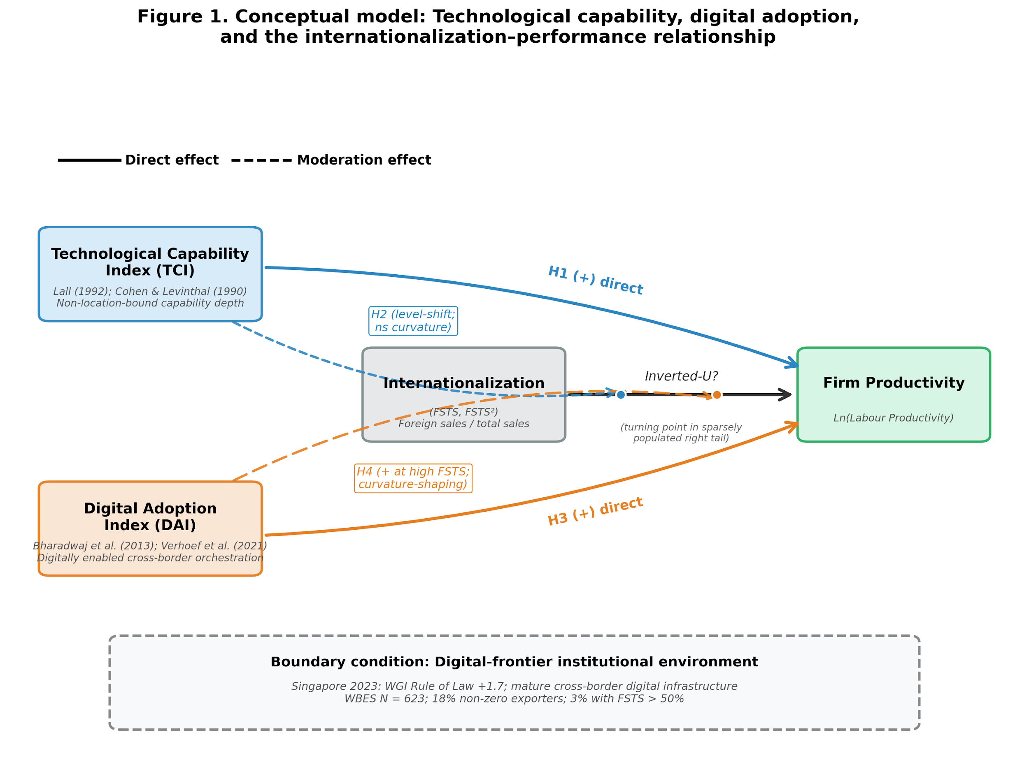
Figure 1. Conceptual model. Technological capability, digital adoption, and the internationalization–performance relationship in a extreme-case Singapore setting. Solid arrows denote direct effects (H1, H3), whereas dashed arrows denote moderation effects (H2, H4). The moderation arrows should be interpreted as acting on the internationalization–performance path rather than as direct antecedents of FSTS.
3 Methods
3.1 Data
We use the World Bank Enterprise Survey (WBES) Singapore 2023 wave, the most recent firm-level microdata available for Singapore. The 2023 wave was administered under the B-READY methodology, which expanded the digital-adoption module to include items on electronic-payment penetration. After listwise deletion on focal variables, the analytic sample comprises 623 firms across major sectors of the Singapore economy. Manufacturing accounts for approximately 31% of the sample, retail and other services for 50%, and other sectors for 19%. The sample is predominantly domestic in orientation: 18% of firms report non-zero exports, and only 3% exceed 50% foreign sales to total sales (FSTS). Descriptive statistics and pairwise correlations are reported in Table 1.
3.2 Variables
3.2.1 Dependent variable
Firm performance is operationalized as labour productivity, measured as the natural logarithm of annual sales divided by the number of full-time employees. This measure is constructed from WBES annual sales and employment items and follows the productivity-as-performance approach used in prior firm-level international business research. Because all firms belong to the same 2023 cross-section, sales are expressed in nominal 2023 Singapore dollars, with any common price-level effect absorbed by the intercept. To reduce sensitivity to outliers, the dependent variable is winsorized at the 1st and 99th percentiles.
3.2.2 Focal independent variable
The focal internationalization variable is FSTS, defined as the proportion of annual sales derived from direct exports and rescaled to the [0,1] interval. FSTS is mean-centered before squaring in order to mitigate multicollinearity between the linear and quadratic terms (Aiken & West 1991). In the final specifications, variance inflation factors remain below 3, indicating that multicollinearity is not a material concern (O’Brien 2007).
3.2.3 TCI and DAI composites
Technological capability and digital adoption are modeled as two distinct formative composites rather than reflective scales because their indicators jointly constitute the constructs and are not interchangeable manifestations of a single latent trait. The Technological Capability Index (TCI) captures firm-internal capability depth through external technology linkage, product innovation, R&D effort, and quality certification. The Digital Adoption Index (DAI) captures firms’ uptake of foundational digital interfaces and transaction-enabling mechanisms through website or digital presence, customer-side electronic payment intensity, and supplier-side electronic payment intensity. Consistent with the measurement boundary emphasized in the manuscript, DAI should be interpreted as a Tier 1–2 digital-adoption construct rather than as a broader measure of digitally integrated organizational capability. Following the formative-measurement logic adopted in the study, component indicators are standardized, aggregated using equal weights, and then re-standardized so that coefficients are interpretable in standard-deviation units.
3.2.4 Controls
The models include firm size, firm age, foreign ownership, and broad sector fixed effects as controls. Firm size is measured as the natural logarithm of the number of full-time employees, firm age is calculated from year of establishment, and foreign ownership is coded as an indicator for at least 10% foreign equity. Broad sector indicators distinguish manufacturing, retail, and other services and absorb sector-level heterogeneity in productivity, export propensity, and technology-adoption norms. Manager experience, originally motivated by the upper-echelons framework (Hambrick & Mason 1984) and initially considered as a control, was dropped after variance-inflation diagnostics indicated problematic collinearity with firm size.
3.3 Estimation strategy and identification scope
The empirical analysis uses ordinary least squares with broad sector fixed effects and HC1 heteroskedasticity-robust standard errors throughout (MacKinnon & White 1985). Models are estimated sequentially, beginning with a controls-only specification and then moving to a linear internationalization model, a quadratic baseline, direct-effect models for TCI and DAI, and full specifications that incorporate moderation terms. The baseline quadratic specification evaluates whether the internationalization–performance relationship follows the conventional inverted-U logic, while the later specifications test whether TCI and DAI play distinct direct and contingent roles.
ln(LP) = α + β₁·FSTS_c + β₂·FSTS_c² + β₃·TCI + β₄·DAI + β₅·(FSTS_c × DAI) + β₆·(FSTS_c² × DAI) + γ·controls + ε,
The full model includes centered FSTS, squared centered FSTS, TCI, DAI, the interaction between FSTS and DAI, and the interaction between squared FSTS and DAI, in addition to the control set. A supplementary specification replaces the DAI interaction block with analogous TCI interaction terms in order to assess whether technological capability operates primarily as a moderator or as an intercept-shifting capability variable. Following the recommendations of Haans et al. (2016) for testing curvilinear relationships in strategy research, the study applies the Lind and Mehlum (2010) test for a U-shaped or inverted-U relationship to assess the quadratic shape formally. To assess whether the DAI interaction block matters jointly, the study reports a joint F-test on the two DAI interaction terms and also interprets effect size using Cohen’s f² (Aguinis et al. 2005; Cohen 1988).
The identification scope of the study is explicitly associational rather than causal, in line with the disciplined causal-language conventions advocated for international business and strategy research (Antonakis et al. 2010; Meyer et al. 2017; Shaver 2020). Because the design is cross-sectional, the analysis cannot rule out reverse causation or omitted-variable bias in the observed relationships among productivity, export intensity, technological capability, and digital adoption. For that reason, the manuscript should consistently use language such as “is associated with,” “is consistent with,” and “supports” rather than causal wording.
4 Results
4.1 Descriptive statistics
Table 1 reports descriptive statistics and pairwise correlations for the analytic sample. Mean log labour productivity is 11.42 with a standard deviation of 1.18, while mean FSTS is 0.045 with a standard deviation of 0.144, confirming that most firms in the sample are domestically oriented. TCI and DAI are positively correlated at r = 0.31, which is consistent with the idea that technologically stronger firms are somewhat more digitally active, but the correlation is far from high enough to justify collapsing the two constructs into a single measure. Both TCI and DAI are positively correlated with labour productivity, and DAI also shows a modest positive correlation with export intensity.
Table 1. Descriptive statistics and pairwise correlations.
Panel A: Descriptive Statistics (N = 623)
Variable | Mean | SD | Min | Max | p25 | p50 | p75
Ln(Labour productivity) | 11.42 | 1.18 | 7.89 | 15.21 | 10.62 | 11.40 | 12.21
FSTS | 0.045 | 0.144 | 0.000 | 1.000 | 0.000 | 0.000 | 0.000
FSTS² | 0.022 | 0.085 | 0.000 | 1.000 | 0.000 | 0.000 | 0.000
TCI (z) | 0.000 | 1.000 | -0.85 | 3.21 | -0.85 | -0.27 | 0.51
DAI (z) | 0.000 | 1.000 | -1.42 | 1.96 | -0.81 | 0.18 | 0.94
Firm size (ln_empl) | 3.21 | 1.42 | 0.00 | 8.85 | 2.20 | 3.18 | 4.25
Firm age | 21.4 | 14.8 | 1 | 98 | 10 | 19 | 30
Foreign-owned (0/1) | 0.119 | 0.324 | 0 | 1 | 0 | 0 | 0
Panel B: Pairwise Correlations
Variable | 1 | 2 | 3 | 4 | 5 | 6 | 7
1. Ln(Lab. prod.) | 1.00
2. FSTS | 0.13*** | 1.00
3. TCI (z) | 0.21*** | 0.18*** | 1.00
4. DAI (z) | 0.16*** | 0.09* | 0.31*** | 1.00
5. Firm size | -0.04 | 0.21*** | 0.34*** | 0.27*** | 1.00
6. Firm age | 0.18*** | 0.06 | 0.07† | 0.04 | 0.16*** | 1.00
7. Foreign-owned | 0.16*** | 0.27*** | 0.18*** | 0.09* | 0.21*** | -0.05 | 1.00

Notes: N = 623. TCI and DAI are z-standardized formative composites. FSTS is the share of annual sales accounted for by direct exports. Two-tailed significance levels are reported as follows: p < .10, p < .05, p < .01.
4.2 The I–P relationship: primarily monotonic with mild curvature
In the baseline quadratic specification (Model M2), the linear FSTS term is positive and statistically significant (β = 2.652, SE = 0.691, p < .001), while the squared FSTS term is negative and only marginally significant (β = −1.705, SE = 0.931, p = .067). The fitted curve therefore implies a turning point at very high export intensity, around FSTS 82% on the original scale; a 5,000-replication cluster bootstrap places the 95% percentile confidence interval for this turning point at [53%, 253%] (median 80%, IQR [68%, 102%]), while recovering an inverted-U *shape* in 96.3% of bootstrap replications. The shape is therefore robustly inverted-U, but its precise location is only loosely identified, and the implied turning point should be treated as a descriptive feature rather than as structurally identified evidence of a conventional inverted-U.
The formal Lind–Mehlum test fails to reject monotonicity, with p = .303. Following the interpretation already developed in the revision package, the internationalization–performance relationship is therefore better characterized as predominantly monotonic positive with mild quadratic curvature within the observed export-intensity range. This framing is important because it qualifies, rather than overturns, the classic nonlinear literature: the right-side decline may exist in principle, but in a digitally mature institutional setting it appears attenuated or shifted into a sparsely populated upper tail.
4.3 TCI results
The direct-effect model for technological capability (Model M5) shows that TCI is positively associated with labour productivity (β = 0.168, SE = 0.040, p < .001). Model fit also improves relative to the quadratic baseline, with R² rising from 0.178 in Model M2 to 0.199 in Model M5. This pattern supports the view that technological capability raises the firm’s productivity base rather than simply proxying for export intensity.
In the supplementary TCI-moderation specification (Model M3), the direct TCI coefficient remains positive and significant (β = 0.188, p < .001), but the interaction terms involving FSTS and squared FSTS are jointly insignificant. Because the absence of moderation cannot be inferred from non-significance alone, the evidence is better read as supporting an intercept-dominant interpretation of the TCI association rather than as a definitive demonstration that curvature moderation is exactly zero. The manuscript therefore should interpret TCI primarily as a level-shift effect on the productivity intercept rather than as a curvature-shaping moderator of the internationalization–performance relationship. This is also the most coherent reading for hypothesis development, because it preserves the distinction between internal capability depth and export-contingent digital complementarity.
4.4 DAI results
In the direct-effect model for digital adoption (Model M6), DAI is positively associated with labour productivity (β = 0.104, SE = 0.038, p = .007). However, once TCI is included alongside DAI in Model M7, the DAI coefficient attenuates to β = 0.077 and remains marginal (p = .048), indicating partial overlap in the average-firm heterogeneity captured by the two constructs. This attenuation is substantively important because it suggests that DAI should not be interpreted as a large, universal productivity premium across all firms.
Table 2. Hierarchical OLS regression results — Singapore 2023.
DV: Ln(Labour Productivity). HC1 robust standard errors in parentheses.
Variable | M0Ctrl | M2Inv-U | M5+TCI | M6+DAI | M7T+D | M4DAI× | M8Full
FSTS |  | +2.652*** | +2.165** | +2.322*** | +1.952** | +2.768*** | +2.409**
 |  | (0.691) | (0.699) | (0.701) | (0.707) | (0.750) | (0.748)
FSTS² |  | -1.705† | -1.168 | -1.389 | -0.965 | -2.959** | -2.543*
 |  | (0.931) | (0.940) | (0.928) | (0.938) | (1.012) | (1.045)
TCI (z) |  |  | +0.168*** |  | +0.153*** |  | +0.153***
 |  |  | (0.040) |  | (0.041) |  | (0.041)
DAI (z) |  |  |  | +0.104** | +0.077* | +0.046 | +0.019
 |  |  |  | (0.038) | (0.038) | (0.045) | (0.045)
FSTS × DAI |  |  |  |  |  | -1.144 | -1.167†
 |  |  |  |  |  | (0.702) | (0.686)
FSTS² × DAI |  |  |  |  |  | +3.098** | +3.119**
 |  |  |  |  |  | (1.088) | (1.124)
Firm size (ln) | -0.120** | -0.124*** | -0.175*** | -0.135*** | -0.179*** | -0.125*** | -0.168***
Firm age | +0.017*** | +0.015*** | +0.017*** | +0.016*** | +0.017*** | +0.015*** | +0.016***
Foreign-owned | +0.407*** | +0.307*** | +0.293*** | +0.307*** | +0.294** | +0.298*** | +0.284**
Sector FE | Yes | Yes | Yes | Yes | Yes | Yes | Yes
Constant | +10.958*** | +11.157*** | +11.345*** | +11.199*** | +11.361*** | +11.190*** | +11.353***
N | 623 | 623 | 623 | 617 | 617 | 617 | 617
R² | 0.122 | 0.178 | 0.199 | 0.184 | 0.202 | 0.193 | 0.211
Adj. R² | 0.115 | 0.168 | 0.189 | 0.174 | 0.190 | 0.180 | 0.196

Notes: The dependent variable is log labour productivity. HC1 robust standard errors are reported in parentheses. FSTS is mean-centered before squaring. All models include firm size, firm age, foreign ownership, and broad sector fixed effects. Models containing DAI use N = 617 because six firms have missing values on DAI-related variables.
Table 2 reports the main hierarchical regression results. The baseline quadratic specification shows a strongly positive linear FSTS term and a marginally negative squared term, indicating that the internationalization–performance relationship is better read as predominantly monotonic positive with mild quadratic curvature rather than as a formally established inverted-U. The direct-effect models further show that TCI is positively associated with labour productivity and that its role is substantively stronger and more stable than that of DAI as a universal average effect. Once DAI is introduced jointly with TCI, its direct coefficient attenuates, which suggests that part of the average DAI–productivity association overlaps with broader productivity-relevant firm heterogeneity already captured by TCI. The full model then shows that the most consequential DAI result is not a large unconditional premium, but a positive quadratic moderation pattern indicating that the relevance of digital adoption becomes more positive as export intensity rises.
The strongest evidence for DAI appears in the moderation specifications. In the full model (Model M8), the direct DAI term is small and not statistically significant (β = 0.019, p = .705), the linear interaction with FSTS is negative and marginal (β = −1.177, p = .083), and the quadratic interaction term is positive and statistically significant (β = 3.118, SE = 1.117, p = .005). Model M8 also produces the highest explanatory power among the main specifications, with R² = 0.213 and adjusted R² = 0.199. Read substantively, these estimates indicate that the productivity relevance of digital adoption becomes more positive at higher levels of export intensity, with the clearest signal concentrated in the high-export tail rather than distributed uniformly across the sample.
Table 4. Marginal effects of DAI across selected FSTS levels (from Model M8).
FSTS level | Marginal effect of DAI | SE | p-value | 95% CI
FSTS = 0% (domestic) | +0.080 | 0.040 | .045* | [+0.002, +0.158]
FSTS = 5% | +0.015 | 0.047 | .752 | [-0.077, +0.106]
FSTS = 10% | -0.035 | 0.069 | .616 | [-0.170, +0.101]
FSTS = 15% | -0.069 | 0.093 | .459 | [-0.250, +0.113]
FSTS = 20% | -0.087 | 0.113 | .444 | [-0.309, +0.135]
FSTS = 30% | -0.077 | 0.145 | .598 | [-0.361, +0.208]
FSTS = 50% | +0.131 | 0.186 | .481 | [-0.234, +0.496]
FSTS = 70% | +0.588 | 0.262 | .025* | [+0.074, +1.102]
FSTS = 100% | +1.742 | 0.573 | .002** | [+0.618, +2.865]

Notes: Marginal effects are computed from Model M8 for a one-standard-deviation increase in DAI. Standard errors are derived using the delta method. The estimates indicate that the productivity association of DAI is statistically weak across much of the observed export range but becomes positive and significant among high-intensity exporters.
Table 4 and Figure 2 translate the interaction estimates from Model M8 into substantively interpretable marginal effects across the export-intensity distribution. Across domestic, low-export, and much of the middle export range, the marginal effect of DAI is small and statistically indistinguishable from zero, which indicates that basic digital adoption does not generate a large universal labour-productivity premium across the full sample. By contrast, the marginal effect becomes positive and statistically significant among high-intensity exporters, reaching 0.588 at FSTS 70 and 1.742 at FSTS 100. This pattern supports the interpretation of DAI as a scale-enabling complement whose productivity relevance emerges more clearly when firms face denser cross-border coordination and transaction demands.
The manuscript should therefore state the DAI finding in conditional terms. In Singapore’s digitally mature setting, foundational digital adoption appears to function less as a universal productivity lever and more as a scale-enabling complement for firms facing denser cross-border coordination demands. That interpretation is also fully consistent with the construct boundary established earlier, because the observed effect concerns Tier 1–2 digital adoption rather than deeper digitally integrated organizational capability.
Figure 2. Marginal effects of digital adoption across export intensity. Marginal effect estimates of DAI on labour productivity across the FSTS distribution with 95% confidence intervals from Model M8. The figure shows that the productivity association of DAI is weak across much of the low-to-middle export range but becomes more positive in the high-export tail.
Figure 3. Predicted internationalization–performance curve. Predicted relationship between export intensity and labour productivity with 95% confidence bands from the baseline quadratic specification. The implied turning point occurs at FSTS 82.4 on the original scale, but this point lies in a sparsely populated upper tail and should therefore be interpreted as descriptive rather than as structurally identified evidence of an inverted-U.
Figure 3 visualizes the baseline quadratic fit between export intensity and labour productivity. The fitted curve implies a turning point near FSTS 82%, but the point estimate is loosely identified — its 95% percentile bootstrap confidence interval spans [53%, 253%] — and lies in a sparsely populated upper tail of the sample. The Lind–Mehlum test does not formally confirm a conventional inverted-U at conventional significance levels. The appropriate interpretation is therefore not that the classic nonlinear literature is overturned, but that in this extreme-case Singapore setting the right-side decline of the curve appears attenuated or shifted beyond the export range occupied by most firms in the data.
4.5 Robustness checks
The robustness analysis shows that the core inference about DAI moderation is broadly stable, although its statistical strength varies across measurement choices and sample restrictions. In the baseline full specification, the positive quadratic DAI interaction is statistically significant, and the same positive sign is preserved across all reported robustness models. This sign stability matters because it indicates that the central argument is not driven by a single operational definition.
When DAI is reduced to a thinner, website-only measure, the moderation result weakens, suggesting that the richer baseline index draws meaningful explanatory variation from the electronic-payment indicators as well as from digital presence. By contrast, when the sample excludes micro-firms or is restricted to SMEs, the positive quadratic moderation pattern remains visible and in some cases becomes stronger. The exporters-only subsample is less stable because the number of exporting firms is small and the right tail remains thin, so those estimates should be described as suggestive rather than definitive.
The effect sizes reported in the manuscript reinforce a cautious interpretation. The TCI direct effect is in the small-to-medium range, while the DAI moderation block is statistically detectable but substantively modest, which is typical for interaction effects in organizational research. Taken together, the strongest empirical claim of Section 4 is therefore not that digital adoption yields a large average productivity premium, but that its association with productivity becomes more positive as export intensity rises in a digitally mature setting.
Table 3. Robustness checks for primary findings (six specifications).
DV: Ln(Labour Productivity). HC1 robust standard errors. Each row reports a separate full-specification regression with controls.
Specification | N | TCI β_z | FSTS² × DAI | Joint F (p) | Adj. R²
Baseline (TCI_full + DAI_rich) | 617 | 0.153*** | 3.119** | 4.56 (.011) | 0.196
R1: DAI_thin (website c22b only) | 623 | 0.180*** | 1.552 | 4.01 (.019) | 0.188
R2: TCI_thin (e6 + b8) | 617 | 0.159*** | 2.930** | 4.27 (.014) | 0.199
R3: Excl micro-firms (<10 empl) | 464 | 0.170*** | 3.521** | 4.61 (.010) | 0.219
R4: SMEs only (≤200 empl) | 595 | 0.156*** | 3.505** | 5.30 (.005) | 0.199
R5: Exporters only (FSTS > 0) | 84 | 0.130 | 2.821 | 6.32 (.003) | 0.165

Notes: Each row reports a separate full-specification regression with controls. Joint F refers to the test that the two DAI interaction terms are jointly equal to zero. The positive sign of the quadratic DAI moderation term is preserved across all specifications, although statistical strength attenuates in more restrictive subsamples. DAI should be interpreted as a Tier 1–2 digital-adoption construct rather than as a broader measure of digitally integrated organizational capability.
Table 3 evaluates whether the core inference is sensitive to measurement choice and sample composition. Across all reported robustness specifications, the quadratic DAI moderation term retains a positive sign, which strengthens confidence that the main result is not driven by a single operational decision. At the same time, the weakening of statistical significance in the thinner website-only specification suggests that the richer DAI baseline draws meaningful explanatory variation from the electronic-payment indicators in addition to simple digital presence. The exporters-only subsample is less stable because the number of exporting firms is limited and the right tail of export intensity remains thin, so these estimates should be interpreted cautiously. Taken together, the robustness results support the argument that foundational digital adoption acts as a contingent scaling complement, while also reinforcing that the evidence is strongest when interpreted within the Tier 1–2 measurement boundary of the DAI construct.
5 Discussion
5.1 Theoretical implications
Three theoretical implications follow from these findings. First, the TCI result supports a capability-depth interpretation of firm performance in internationalizing firms. Technological capability appears to operate as a non-location-bound firm-specific advantage (Rugman & Verbeke 2004) that raises the productivity intercept but does not systematically reshape the curvature of the internationalization–performance relationship. This pattern is consistent with the view that internal capability depth can improve how efficiently firms operate across markets without necessarily altering the coordination-cost dynamics that generate nonlinearity in the I–P relationship.
Second, the present evidence qualifies rather than overturns the conventional nonlinear I–P literature (Contractor et al. 2003; Hitt et al. 1997; Lu & Beamish 2004; Marano et al. 2016). The baseline relationship remains mildly curved, but the negative right-hand side of the curve is not formally established within the observed export-intensity range. A useful interpretation is that, in a extreme-case Singapore setting, cross-border coordination costs do not disappear; instead, they are partially reallocated. Mature digital infrastructure reduces basic communication, transaction, and information frictions, which can flatten the right-side decline of the curve within the export-intensity range most firms actually occupy. Under such conditions, the classic inverted-U may still exist in principle, but its turning point is shifted toward the extreme upper tail of internationalization, where empirical observations are sparse in the present sample. This reading positions the contribution as a boundary-condition refinement rather than a competing claim: the I–P curvature documented in earlier samples drawn primarily from pre-digital and transitional-digital economies may not generalize to extreme-case Singapore settings without explicit specification of the digital-infrastructure boundary under which it holds.
Third, the DAI result suggests that digital adoption in a digitally mature economy is best understood as a conditional scaling complement rather than as a universal productivity premium. When basic digital infrastructure is already widespread, digital adoption is less likely to differentiate firms uniformly across the full export-intensity distribution. Its productivity relevance becomes stronger when firms reach high export intensity, because digital interfaces and transaction systems can then be amortized across a larger volume of cross-border exchanges, denser information flows, and more demanding multi-market coordination tasks. This interpretation also clarifies why the construct should be labeled digital adoption rather than digital capability. The available WBES indicators capture firms’ uptake of digital interfaces and transaction-enabling mechanisms, not deeper digitally integrated organizational capabilities. Distinguishing DAI from TCI therefore does more than improve terminology; it clarifies that firm-internal capability depth and digitally enabled cross-border orchestration are analytically distinct sources of performance heterogeneity. In the present setting, the observed DAI effect should be understood as evidence about the productivity relevance of Tier 1–2 digitalization in a digitally mature economy, not as direct evidence about deeper digitally integrated organizational capability.
5.2 Managerial implications
For firms operating in digitally mature settings, the findings suggest that investments in digital adoption are most strongly associated with productivity advantages when firms already operate at high export intensity. In such cases, digital interfaces, payment systems, and related transaction-enabling tools appear to function as scaling mechanisms that help firms coordinate a larger volume of cross-border activity more efficiently. For firms that are already deeply engaged in export markets, the implication is therefore strategic rather than merely symbolic: foundational digital systems seem to matter most when coordination demands across customers, suppliers, and foreign-market transactions become dense enough for those systems to be used intensively.
For firms concentrated in domestic markets or at low export intensity, digital adoption may still be beneficial, but the productivity differentials appear smaller and less distinctive. In a digitally mature economy, basic digital functionality is already widespread, so adopting such tools may no longer generate a large standalone productivity premium for all firms equally. For firms in the intermediate export-intensity range, the results suggest caution in expecting immediate labour-productivity gains from digital adoption alone. The evidence does not indicate a strong penalty in this range, but neither does it indicate reliably large gains. Managerially, this implies that digital adoption in this segment should be aligned with broader strategic objectives such as market access, customer integration, supplier coordination, and future export scaling rather than justified only on the basis of short-run productivity returns.
More broadly, the findings imply that managers should avoid treating technological capability and digital adoption as interchangeable investment categories. Investments in technological capability appear to support a broader productivity base, whereas investments in digital adoption seem to become especially valuable when firms face the coordination intensity associated with deeper internationalization. For managerial decision making, this means that capability-building and digitalization strategies should be sequenced and matched to the firm’s actual stage of export expansion rather than pursued as a single undifferentiated digital capability agenda.
6 Conclusion
This study revisits the internationalization–performance relationship in a digitally mature economy by distinguishing technological capability from digital adoption and examining how each relates to labour productivity in Singapore. Using World Bank Enterprise Survey microdata for Singapore 2023, the analysis shows that technological capability is positively associated with productivity and operates primarily as a level-shift effect, whereas digital adoption shows conditional relevance that becomes more positive at higher levels of export intensity.
The findings also refine the interpretation of the nonlinear I–P literature in digitally mature settings. Within the observed export-intensity range, the baseline pattern is best characterized as predominantly monotonic positive with mild quadratic curvature rather than as a formally identified inverted-U. Read in this way, the evidence does not overturn the established I–P literature, but instead suggests that, in digitally mature economies, the right-side decline of the curve may be attenuated or shifted toward sparsely populated levels of export intensity.
More broadly, the study contributes to international business research by sharpening construct validity and clarifying a boundary condition of digital internationalization. Technological capability appears to capture firm-internal capability depth, whereas foundational digital adoption is better understood as a contingent scaling resource whose productivity relevance becomes more visible as cross-border coordination demands increase.
7 Limitations and Future Research
Three limitations warrant explicit caution in interpreting the findings. First, the analysis is a single-country cross-section, and the identification strategy is therefore associational rather than causal. The observed positive associations among TCI, DAI, internationalization, and labour productivity admit at least two non-causal interpretations consistent with the data. The first is productivity-driven self-selection into digital adoption: more productive firms may have the financial slack and managerial bandwidth to install electronic-payment systems and digital interfaces, so the observed DAI–productivity association may reflect this selection channel rather than a productivity-enhancing effect of digital adoption per se. The second is productivity-driven self-selection into international markets, in which only firms above a productivity threshold profitably overcome the fixed costs of exporting; the observed FSTS–DAI interaction could therefore reflect productivity-induced co-movement of export intensity and digital-system utilization rather than a digital-system-induced productivity gain. Standard ex post diagnostics such as non-significant inverse Mills ratios from Heckman-style models do not constitute affirmative evidence of unbiasedness in the absence of a valid exclusion restriction (Wolfolds & Siegel 2019). The disciplined response is therefore to read the present results as extreme-case, within-context evidence from Singapore: the estimated patterns describe how productivity, technological capability, and digital adoption co-move with export intensity in a digitally mature economy, while leaving causal identification of any specific mechanism to designs that cannot be implemented in the present study.
Second, the sample contains a thin right tail of high-intensity exporters: 82.2% of firms report zero exports, 4.5% exceed 50% export intensity, and only 3.2% exceed 70%. Two consequences follow. First, the implied quadratic turning point at 82% on the FSTS scale is identified from a sparsely populated region; 5,000-replication cluster bootstrap places the 95% percentile confidence interval at [53%, 253%], so the turning point is best read as an indicative descriptive feature rather than a structurally identified inflection — the inverted-U *shape* is robust (recovered in 96.3% of bootstrap replications) but its *location* is imprecise. Second, the DAI moderation pattern attains conventional joint significance in the full-sample, leave-one-out (100% of LOO fits), and trimmed-tail re-estimations (drop FSTS > 70%: F = 5.51, p = .004; drop FSTS > 80%: F = 4.42, p = .012); within the exporter-only subsample (N = 84) the joint F-test for DAI moderation remains significant (F = 6.32, p = .003) but the 95% confidence intervals for individual coefficients are wider, reflecting the small subsample size rather than a fragile underlying pattern. The appropriate caution therefore rests on (i) the thin upper-tail support for the precise location of the turning point and (ii) the borderline precision of individual moderation coefficients in the small exporter subsample, not on differences in adjusted R² across samples of unequal size and composition.
Third, the estimated moderation effect is statistically detectable but substantively modest, and the present results should be read as an initial firm-level test of a conditional digital-adoption argument in one digitally mature setting rather than as definitive evidence of a generalized pattern across digitally mature economies. The DAI indicators available in WBES 2023 capture Tier 1–2 digital adoption — digital presence and digital transaction usage — rather than Tier 3–4 digital capability or dynamic capability; indicator-sensitivity analysis shows that the moderation pattern depends on the foundational digital-infrastructure indicators (firm website and electronic-payment-to-suppliers usage) and weakens when these specific indicators are dropped. Although equivalence-testing approaches (Lakens et al. 2018) could in principle quantify the support for null moderation in subsamples, the present sample size limits their power, and the more cautious reading is that absence of moderation cannot be inferred from non-significance alone. Whether the scale-enabling-complement pattern persists, attenuates, or is amplified under richer measures of digitally integrated organizational capabilities remains an open empirical question. Future research should therefore examine whether the same pattern appears in other digitally mature economies, such as Hong Kong, the Republic of Korea, and Taiwan, and under purpose-designed instruments that capture deeper digital dynamic capabilities. Future research should also extend this measurement architecture by linking WBES-type microdata, where confidentiality arrangements permit, to firm-level databases or by using purpose-built survey instruments that better capture process-level digital integration and higher-order capability depth. More broadly, future work should examine whether the scale-enabling-complement pattern operates through identifiable mechanisms such as supplier-side digital integration, customer-facing digital channels, or internal ERP integration. Causal identification, in particular, would benefit from firm-level panel data, successive enterprise-survey waves, national statistical-office registers, or proprietary databases that permit firm fixed-effects estimation. Where suitable instruments are available, such as regional digital-infrastructure rollouts or plausibly exogenous trade-policy shocks, instrumental-variable or difference-in-differences designs would further upgrade the present associational evidence to causal identification.
Data Availability Statement
The data analyzed in this study are from the World Bank Enterprise Survey (WBES) Singapore 2023 wave, publicly available at https://www.enterprisesurveys.org. Analysis scripts to replicate the results are available from the corresponding author on reasonable request.
References
Aguinis, H., Beaty, J. C., Boik, R. J., & Pierce, C. A. (2005). Effect size and power in assessing moderating effects of categorical variables using multiple regression: A 30-year review. Journal of Applied Psychology, 90(1), 94–107. https://doi.org/10.1037/0021-9010.90.1.94
Aiken, L. S., & West, S. G. (1991). Multiple regression: Testing and interpreting interactions. Sage.
Antonakis, J., Bendahan, S., Jacquart, P., & Lalive, R. (2010). On making causal claims: A review and recommendations. The Leadership Quarterly, 21(6), 1086–1120. https://doi.org/10.1016/j.leaqua.2010.10.010
Avenyo, E. K., Tregenna, F., & Kraemer-Mbula, E. (2021). Do productive capabilities affect export performance? Microeconomic evidence from sub-Saharan Africa. The European Journal of Development Research, 33(2), 304–329. https://doi.org/10.1057/s41287-020-00328-2
Banalieva, E. R., & Dhanaraj, C. (2019). Internalization theory for the digital economy. Journal of International Business Studies, 50(8), 1372–1387. https://doi.org/10.1057/s41267-019-00243-7
Barney, J. (1991). Firm resources and sustained competitive advantage. Journal of Management, 17(1), 99–120. https://doi.org/10.1177/014920639101700108
Bharadwaj, A., El Sawy, O. A., Pavlou, P. A., & Venkatraman, N. (2013). Digital business strategy: Toward a next generation of insights. MIS Quarterly, 37(2), 471–482. https://doi.org/10.25300/MISQ/2013/37:2.3
Brynjolfsson, E., Rock, D., & Syverson, C. (2021). The productivity J-curve: How intangibles complement general purpose technologies. American Economic Journal: Macroeconomics, 13(1), 333–372. https://doi.org/10.1257/mac.20180386
Cohen, J. (1988). Statistical power analysis for the behavioral sciences (2nd ed.). Lawrence Erlbaum.
Cohen, W. M., & Levinthal, D. A. (1990). Absorptive capacity: A new perspective on learning and innovation. Administrative Science Quarterly, 35(1), 128–152. https://doi.org/10.2307/2393553
Coltman, T., Devinney, T. M., Midgley, D. F., & Venaik, S. (2008). Formative versus reflective measurement models: Two applications of formative measurement. Journal of Business Research, 61(12), 1250–1262. https://doi.org/10.1016/j.jbusres.2008.01.013
Contractor, F. J. (2007). Is international business good for companies? The evolutionary or multi-stage theory of internationalization vs. the transaction cost perspective. Management International Review, 47(3), 453–475. https://doi.org/10.1007/s11575-007-0024-2
Contractor, F. J., Kundu, S. K., & Hsu, C.-C. (2003). A three-stage theory of international expansion: The link between multinationality and performance in the service sector. Journal of International Business Studies, 34(1), 5–18. https://doi.org/10.1057/palgrave.jibs.8400003
Haans, R. F. J., Pieters, C., & He, Z.-L. (2016). Thinking about U: Theorizing and testing U- and inverted U-shaped relationships in strategy research. Strategic Management Journal, 37(7), 1177–1195. https://doi.org/10.1002/smj.2399
Hambrick, D. C., & Mason, P. A. (1984). Upper echelons: The organization as a reflection of its top managers. Academy of Management Review, 9(2), 193–206. https://doi.org/10.5465/amr.1984.4277628
Hitt, M. A., Hoskisson, R. E., & Kim, H. (1997). International diversification: Effects on innovation and firm performance in product-diversified firms. Academy of Management Journal, 40(4), 767–798. https://doi.org/10.5465/256948
Krammer, S. M. S., Strange, R., & Lashitew, A. (2018). The export performance of emerging economy firms. International Business Review, 27(1), 218–230. https://doi.org/10.1016/j.ibusrev.2017.07.003
Lakens, D., Scheel, A. M., & Isager, P. M. (2018). Equivalence testing for psychological research: A tutorial. Advances in Methods and Practices in Psychological Science, 1(2), 259–269. https://doi.org/10.1177/2515245918770963
Lall, S. (1992). Technological capabilities and industrialization. World Development, 20(2), 165–186. https://doi.org/10.1016/0305-750X(92)90097-F
Lind, J. T., & Mehlum, H. (2010). With or without U? The appropriate test for a U-shaped relationship. Oxford Bulletin of Economics and Statistics, 72(1), 109–118. https://doi.org/10.1111/j.1468-0084.2009.00569.x
Lu, J. W., & Beamish, P. W. (2004). International diversification and firm performance: The S-curve hypothesis. Academy of Management Journal, 47(4), 598–609. https://doi.org/10.5465/20159604
MacKinnon, J. G., & White, H. (1985). Some heteroskedasticity-consistent covariance matrix estimators with improved finite sample properties. Journal of Econometrics, 29(3), 305–325. https://doi.org/10.1016/0304-4076(85)90158-7
Marano, V., Arregle, J.-L., Hitt, M. A., Spadafora, E., & van Essen, M. (2016). Home country institutions and the internationalization-performance relationship: A meta-analytic review. Journal of Management, 42(5), 1075–1110. https://doi.org/10.1177/0149206315624963
Meyer, K. E., van Witteloostuijn, A., & Beugelsdijk, S. (2017). What’s in a p? Reassessing best practices for conducting and reporting hypothesis-testing research. Journal of International Business Studies, 48(5), 535–551. https://doi.org/10.1057/s41267-017-0078-8
O’Brien, R. M. (2007). A caution regarding rules of thumb for variance inflation factors. Quality & Quantity, 41(5), 673–690. https://doi.org/10.1007/s11135-006-9018-6
Peng, M. W. (2003). Institutional transitions and strategic choices. Academy of Management Review, 28(2), 275–296. https://doi.org/10.5465/amr.2003.9416341
Peng, M. W., Wang, D. Y. L., & Jiang, Y. (2008). An institution-based view of international business strategy: A focus on emerging economies. Journal of International Business Studies, 39(5), 920–936. https://doi.org/10.1057/palgrave.jibs.8400377
Rugman, A. M., & Verbeke, A. (2004). A perspective on regional and global strategies of multinational enterprises. Journal of International Business Studies, 35(1), 3–18. https://doi.org/10.1057/palgrave.jibs.8400073
Shaver, J. M. (2020). Causal identification through a cumulative body of research in the study of strategy and organizations. Journal of Management, 46(6), 1244–1256. https://doi.org/10.1177/0149206319846272
Stallkamp, M., & Schotter, A. P. J. (2021). Platforms without borders? The international strategies of digital platform firms. Global Strategy Journal, 11(1), 58–80. https://doi.org/10.1002/gsj.1336
Verhoef, P. C., Broekhuizen, T., Bart, Y., Bhattacharya, A., Dong, J. Q., Fabian, N., & Haenlein, M. (2021). Digital transformation: A multidisciplinary reflection and research agenda. Journal of Business Research, 122, 889–901. https://doi.org/10.1016/j.jbusres.2019.09.022
Wolfolds, S. E., & Siegel, J. (2019). Misaccounting for endogeneity: The peril of relying on the Heckman two-step method without a valid instrument. Strategic Management Journal, 40(3), 432–462. https://doi.org/10.1002/smj.2995
World Bank. (2024). World Bank Enterprise Survey: Singapore 2023. https://www.enterprisesurveys.org


Figure 1. Conceptual model. Technological capability, digital adoption, and the internationalization–performance relationship in a extreme-case Singapore setting. Solid arrows denote direct effects (H1, H3), whereas dashed arrows denote moderation effects (H2, H4). The moderation arrows should be interpreted as acting on the internationalization–performance path rather than as direct antecedents of FSTS.

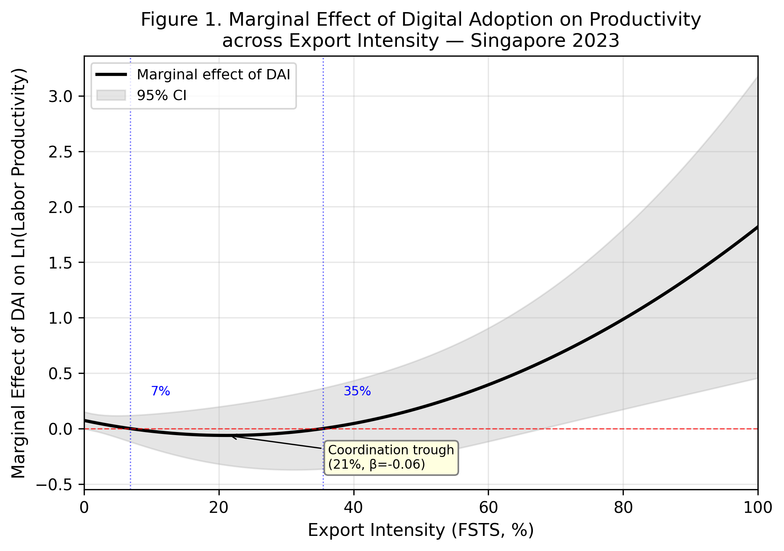
Figure 2. Marginal effects of digital adoption across export intensity. Marginal effect estimates of DAI on labour productivity across the FSTS distribution with 95% confidence intervals from Model M8. The figure shows that the productivity association of DAI is weak across much of the low-to-middle export range but becomes more positive in the high-export tail.

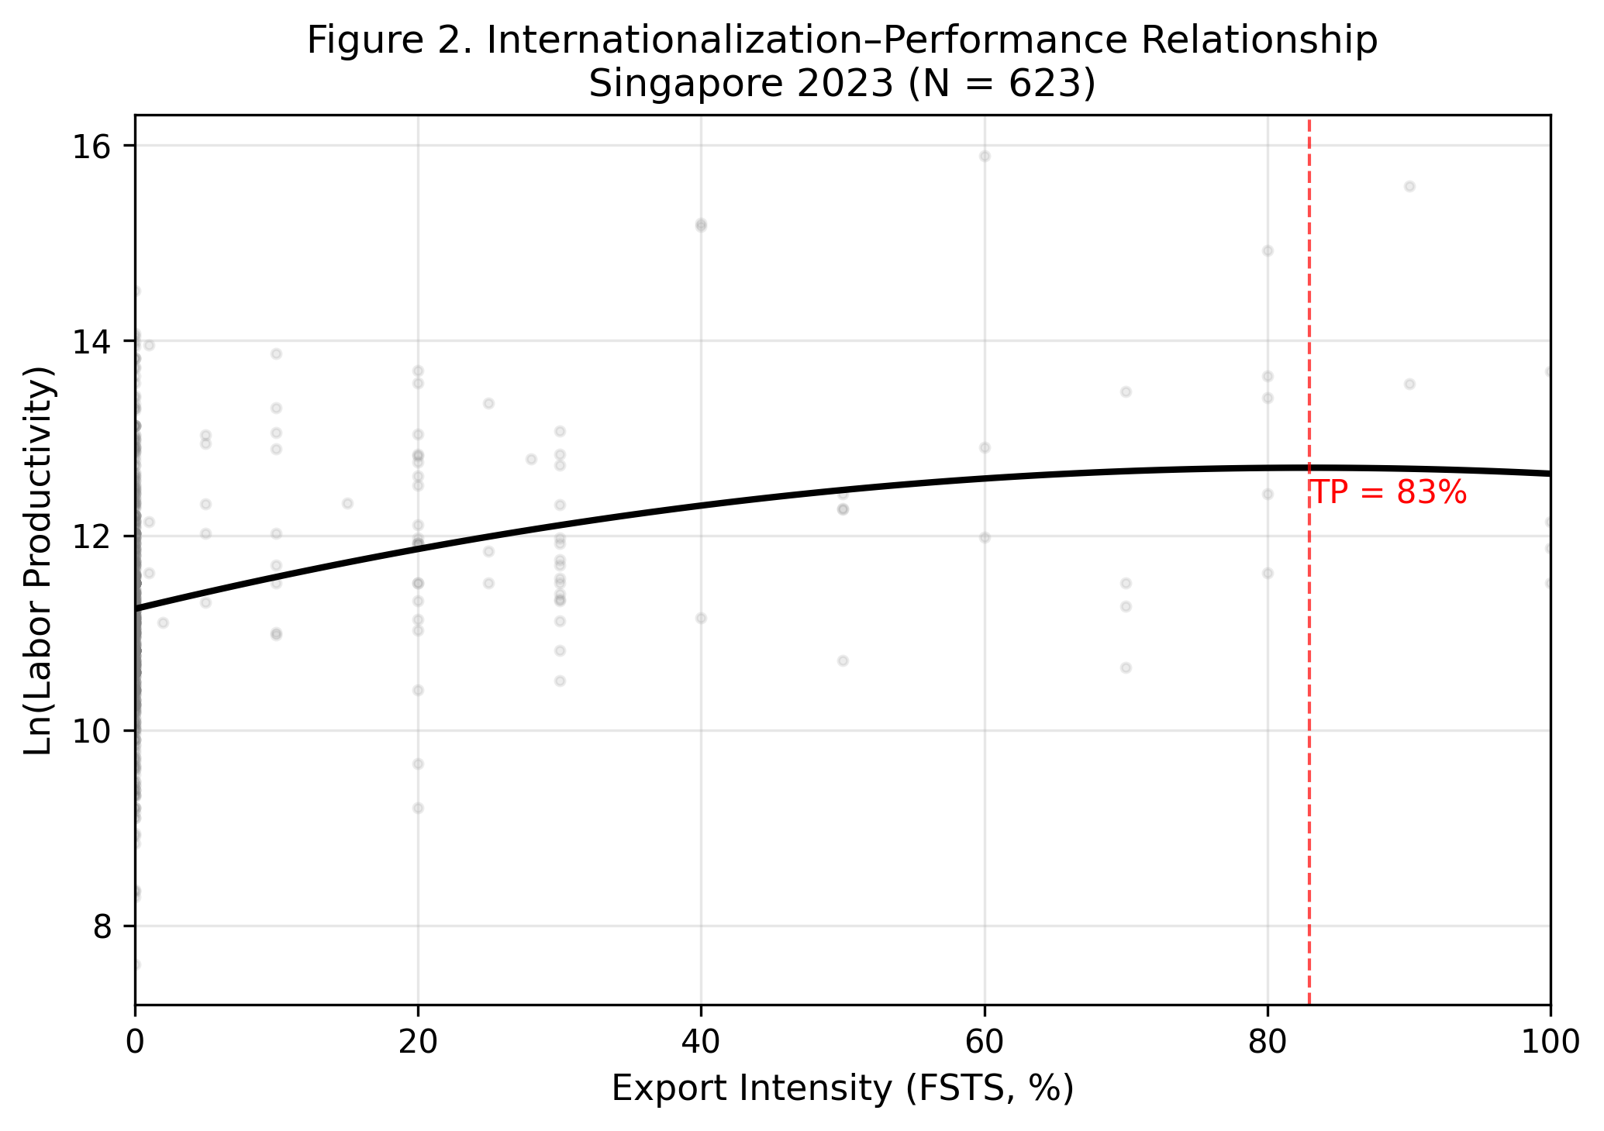
Figure 3. Predicted internationalization–performance curve. Predicted relationship between export intensity and labour productivity with 95% confidence bands from the baseline quadratic specification. The implied turning point occurs at FSTS 82.4 on the original scale, but this point lies in a sparsely populated upper tail and should therefore be interpreted as descriptive rather than as structurally identified evidence of an inverted-U.

