APRS Tracking and Cut-Down Box

**Battery Connections**

There are 4 Batteries in the unit. Two are left connected, as no current will flow unless the relay is energized. Looking at the unit from the top, with the batteries on the wall nearer to you, from LEFT to RiGHT:

Cutdown Battery: Connected

Heater Battery: Connected

DTMF Transceiver Battery: Two Power-Pole connectors need to be connected. A red light on the DTMF unit will flash once or twice, and the red lights on the relays may briefly illuminate.

LightAPRS Battery (thin, silver, on right wall): Smal white female battery plug needs to be inserted into a small breakout board with a male socket. Before you connect, tune a radio to 144.390 MHz. When the unit comes on, it should send a status squawk within about 10 seconds.

The box is now operational. APRS may not show up until we get some altitude, unless there is a close digipeater or iGate.

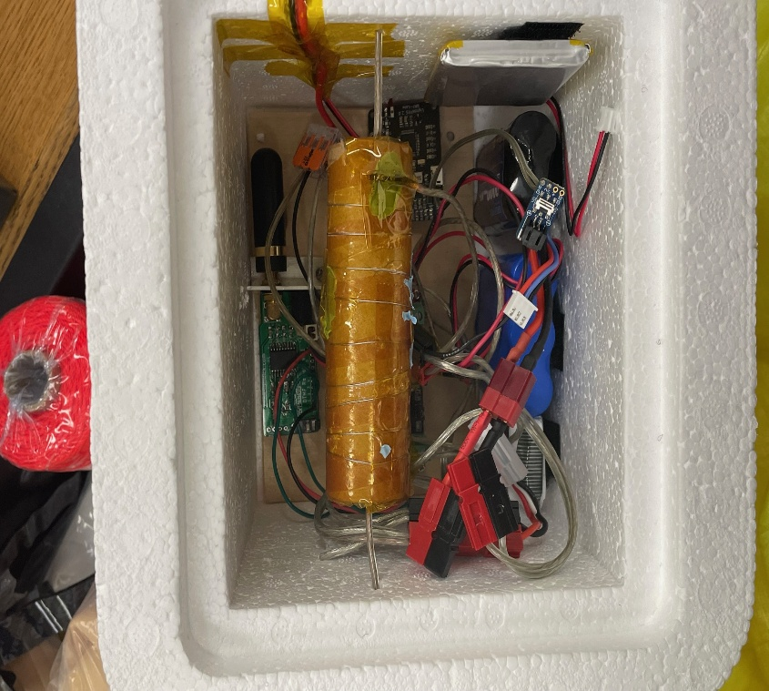

**GPS Tracking**

On your cellphones, go to [http://aprs.fi](http://aprs.fi/) and search for AB1JC-12 to see the balloon’s position. Accuracy of the position is +/- 60 feet in Latitude, and +/- 45 feet in Longitude. Note that the FINAL position report may not be picked up by the APRS System, if no receivers are nearby.  I can lend equipment to a HAM on the recovery team to get the final position.

**DTMF Control**

The DTMF REMOTE Receives and transmits on 144.330 MHz. Basically there are seven output signals you can control remotely three ways:

1. Turn Function ON only as long as I hold the button, then OFF
2. Turn function ON
3. Turn function OFF

You must FIRST hit the push-to-talk button on your Baofeng (144.330 MHz), Then select the A,B, or C button, then the number of the output you wish to control. (Yes, first you must know on YOUR radio, which button gives the A,B, and C DTMF tones)

**FUNCTION No. 1: The HEATER** (5-3.5 Watts, depending on battery) Should provide heat for 6 hours. Read the inside box temperature on APRS. When less than 5 degrees C,  **turn on the heater with B, then 1.** Unit will respondwith a single beep (function 1), a **HIGH** beep (function ON), and my callsign AB1JC in morse code.

If the temperature exceeds 32 degrees C, **turn off the heater with C, then 1.**  Unit will respondwith a single beep (function 1), a **LOW** beep, and my callsign AB1JC in morse code.

**FUNCTION No. 2: The CUTDOWN** is a MOMENTARY function. Activate Cutdown with A, then 2, and HOLD your finger on the 2 for 6 seconds. Unit will respondwith TWO beeps (function 2), then my callsign AB1JC in morse code. There won’t be a high or low beep in the middle because the function went ON then OFF.

**FUNCTION No. 4: TESTING** If you want to make sure you can communicate to the DTMF REMOTE, then **Try the command C, then 4.** The unit will respond with 4 beeps, a **LOW** beep (function OFF), and my callsign AB1JC in morse code.

**The LOCK Function**

If you send the command **\***, The DTMF remote will respond with **3 Descending beeps.** It will not respond to any further commands until it is **UNLOCKED.**

**To UNLOCK the device,** send the command: **\*, 5, 4, 7, 7.**  The DTMF remote will respond with **3 Ascending beeps. It will now respond to commands**